|  |  |  |  |
| --- | --- | --- | --- |
| **AUP RFD Cavity Cleanroom Assembly** | | | |
| **Document Number:** | AUPPS-PR-CLRNRM-RFD-ASSY-HHOM | **Effective Date:** | 30 Nov 2023 |
| **Revision Number:** | 1 | **Periodic Review Date:** | 30 Nov 2025 |
| **Document Owner:** | Alex Castilla Loeza | **Department Owner:** | SRF Operations |

# Purpose

This procedure lists the assembly sequence for the HOM dampers and testing equipment onto a bare RFD cavity in preparation for the vertical test.

# Scope

This procedure lists the assembly sequence for the HOM dampers and testing equipment onto a bare RFD cavity in preparation for the vertical test. Figure 1 shows the cavity and port names.

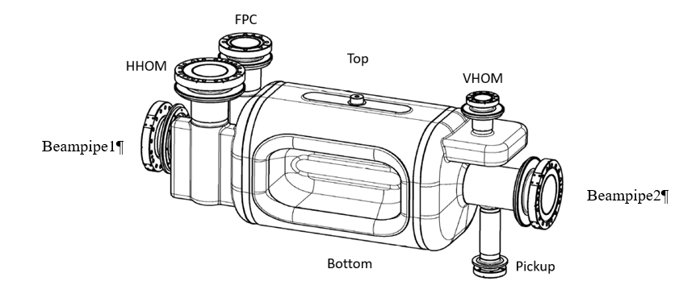

Fig. 1: Schematic of the cavity ports.

The cavity must be positioned on the back-tech in a way that allows all the ports to accessible when rotated clockwise in reference to Fig. 1, following the steps described in the following Table 2.

Table 1 Sub-assembly sequence.

|  |  |  |  |  |
| --- | --- | --- | --- | --- |
| **Step** | **Ancillary** | **Cavity port** | **Hardware** | **Gasket** |
| 2.1 | HHOM coupler + HHOM Feedthru (FT) | NA | Ag/SS studs + SS nuts (M6) | DN40 CERN |
| 2.2 | VT input hook antenna on DN63 feedthru. | NA | NA | NA |
| 2.3 | VT pick up hook antenna on DN40 feedthru. | NA | NA | NA |
| 2.4 | Burst disc on DN100/DN16 ZL reducer. | NA | Ag/SS 12-point screws (M4) | DN16 |
| 2.5 | Angle valve on DN100/DN40 ZL reducer. | NA | Ag/SS 12-point screws (M6) | DN40 |

Table 2 Assembly sequence.

|  |  |  |  |  |
| --- | --- | --- | --- | --- |
| **Step** | **Ancillary** | **Cavity port** | **Hardware** | **Gasket** |
| 1 | Burst disc on DN100/DN16 ZL reducer. | Beampipe2 | SS HHCSs + Si-Br nuts (M8) | DN100 CERN |
| 2 | VT pick up hook antenna on DN40 feedthru. | Pickup | Ag/SS studs + SS nuts (M6) | DN40 CERN |
| 3 | Angle valve on DN100/DN40 ZL reducer. | Beampipe1 | SS HHCSs + Si-Br nuts (M8) | DN100 CERN |
| 4 | VHOM coupler. | VHOM | Ag/SS studs + SS nuts (M6) | DN40 CERN |
| 5 | VT input hook antenna on DN63 feedthru. | FPC | SS studs + Si-Br nuts (M8) | DN63 CERN |
| 6 | HHOM coupler subassembly (HHOM+PU). | HHOM | 16 5/16-18 A286 SHCSs + Ag/A286 5/16-18 nuts | DN100 CERN |

In all the steps described in Tables 1 and 2, SS washers are used.

# Terms and Definitions

The following terms have specific meanings within this procedure.

|  |  |
| --- | --- |
| **Term** | **Definition** |
| <Term 1> | <Definition> |
| <Term 2> | <Definition> |
|  |  |

# Roles and Responsibilities

The following roles have responsibilities described in this document.

|  |  |
| --- | --- |
| **Role** | **Responsibility** |
| <Job Title> | <Very short summary of activities this job title performs in this procedure.> |
|  |  |
|  |  |
|  |  |

# Procedure

## RFD Cavity Sub-Assemblies

Assembly steps of the independent sub-assemblies (see Table 1, steps 2.1 through 2.5)

**HHOM -FT**

**Flange 6 –**

**CERN DN40 CF**

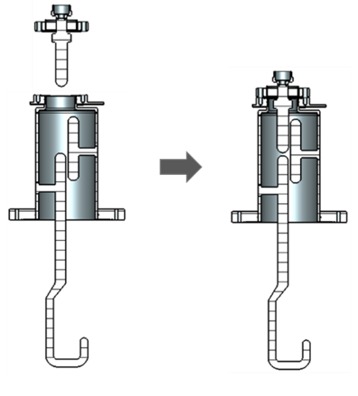

**HHOM**

**Flange 4 –**

**EN DN100 CF**

**Flange 5 –**

**CERN DN40 CF**

Fig. 2: AUP HHOM damper sub-assembly.

The AUP HHOM damper assembly includes the HHOM damper with the demountable HHOM feedthrough as shown in Fig. 2. The steps needed for the HHOM pre-assembly and its posterior assembly onto the cavity are described below:

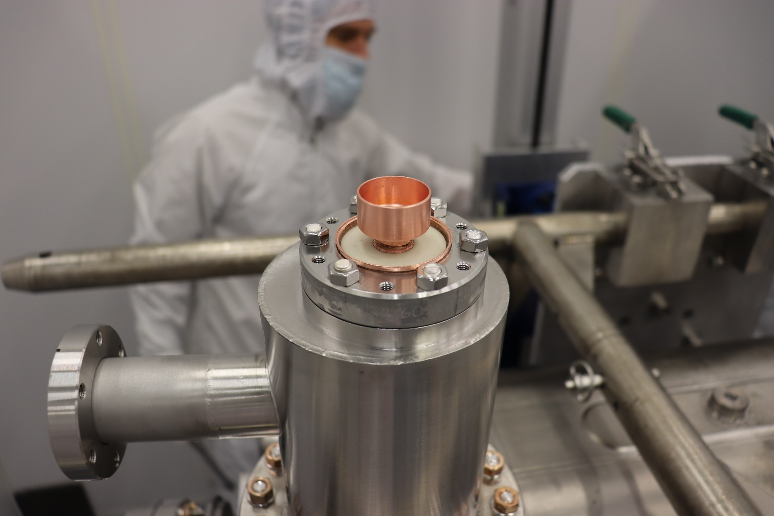

Fig. 3: HHOM damper subassembly mounted on the cavity.

### Install the HHOM-FT (Flange 6) to Flange 5 on the HHOM using the silver plated M6 threaded rods and SS hex nuts using the CERN DN40 gasket (see Fig. 3). Torque the nuts in the pattern shown in Fig. 4, and the steps below

* 1. Finger tight in a consecutive pattern.
  2. Using a feeler gauge to fix the place with the smaller gap, finger tighten the nuts until the gap is even all around the flange.
  3. Start the modified pattern (Figure 4) at 30 in.lbs.
  4. After completing the pattern, using a feeler gauge, make sure that the flange-to-flange gap is even within a 0.002" maximum difference across two sides. If not, undo the flange and start from step 1 using a fresh gasket.
  5. Once the gap is even (within a 0.002: difference), repeat the pattern (Figure 4 increasing the torque by 10 in.lbs and moving the No.1 position.
  6. Continue until the run with 90 in.lbs is complete
  7. Increase the torque by 10 in.lbs (in the pattern shown in Fig. 4) until 130 in.lbs or until there is flange-to-flange contact
     1. Check that there is no gap between the two flanges with a 0.002" feeler gauge

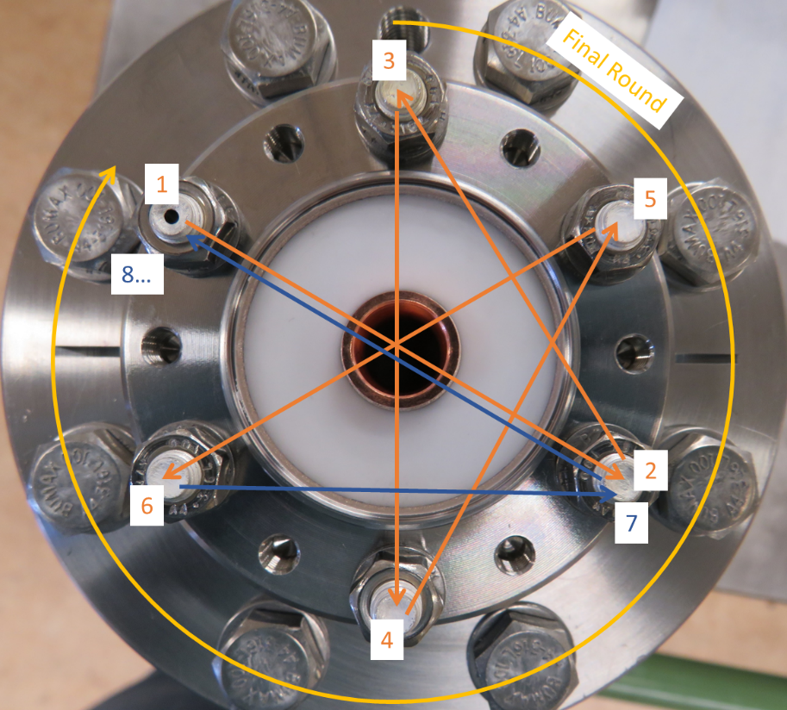

Fig. 4: Modified star pattern for tightening the HHOM feedthrough.

### Screw in VT input probe hook to DN63 feedthrough (see Fig.5-left).

### Screw in VT pickup probe hook to DN40 feedthrough (see Fig.5-right).

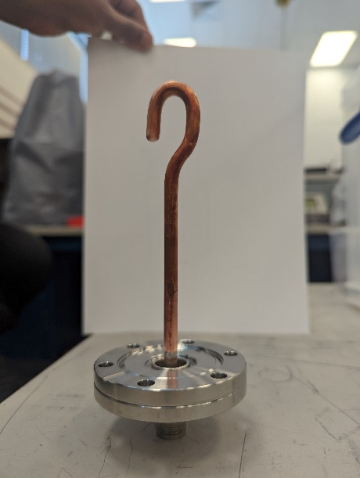

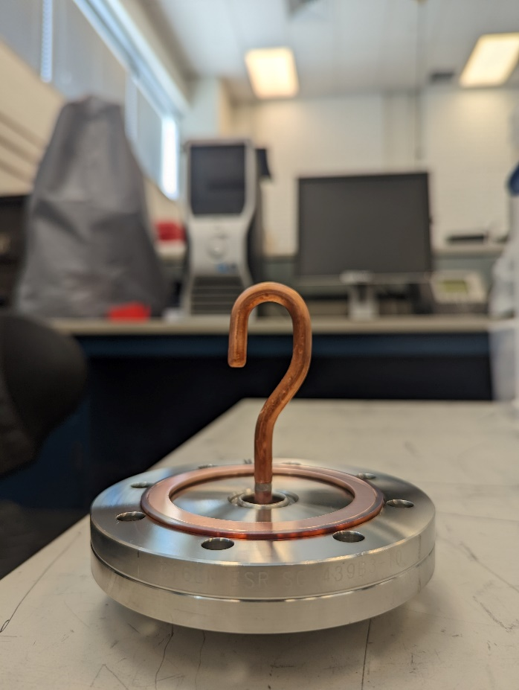

Fig. 5: Input hook antenna (left) and Pickup hook antenna (right)

### Assembly burst disk to the DN100/DN16 zero length reducer using provided hardware (silver-plated M4 12-point screws) and a 1-1/3 copper gasket.

1. Finger tight in a consecutive pattern.
2. Use a wrench to snug the nuts.
3. Torque the hardware to 30 in.lbs using the standard star pattern.
4. Increase the torque by 10 in.lbs.
5. Torque the hardware to 80 in.lbs.

### Before the installation of the right-angle valve (RAV), place 3 M8 SS HHCSs bolts in the DN100/40 zero length reducer (once the angle valve and the reducer are bolted in, it is not possible to place the bolts immediately under the vacuum line port of the valve).

1. Assemble the RAV to the DN100/DN40 zero length reducer using silver coated bolts and a 2-3/4 CF copper gasket.
2. Finger tighten the bolts in a consecutive manner.
3. Torque the hardware in a star pattern.
4. After completing the pattern, using a feeler gauge, make sure that the flange-to-flange gap is even within a 0.002" maximum difference. If not, undo the flange and start again using a fresh gasket.

## Final-Assembly

Now we will describe in more detail the steps laid down in Table 1. Special care is necessary to ensure that the flanges are being closed in a levelled and even manner, if necessary, the use of clamps or jacks is encouraged. All the bolts, unless explicitly stated otherwise, must be first tightened by hand in a consecutive manner, then lightly tightened one by one with wrenches until snug. This must precede starting with the star-pattern. Start torquing at 60 in.lbs, increasing by 10 in.lbs until reaching 120 in.lbs or until the flanges' faces are in contact, whatever comes first. Check contact using a 0.002” feeler gauge.

### Install the burst disc sub-assembly onto Beampipe2 using the M8 stainless steel HHCSs and Silicon Bronze nuts provided with the cavity, and a 6” CERN RF copper gasket.

* 1. Torque the hardware to 60 in.lbs in a star pattern.
  2. Repeat the star pattern increasing the torque by 10 in.lbs.
  3. Torque the hardware to 180 in.lbs

### Install the pickup antenna sub-assembly following the markings on the cavity and feedthrough flanges, using the M6x1.0 x 40mm LG silver-plated studs, stainless-steel nuts, and standard DN40 Cu-gasket.

1. Finger tighten first.
2. Make the nuts snug using a wrench.
3. Torque the hardware to 60 in.lbs in a star pattern.
4. Repeat the star pattern increasing the torque by 10 in.lbs.
5. Then torque to 120 in.lbs using a standard star pattern.

### Using the M8 Stainless steel HHCSs, Silicon Bronze nuts, and a 6” CERN RF copper gasket, install the RAV subassembly on Beampipe 1.

1. Make sure that the flange to the vacuum line is facing the FPC port side. (see Fig. 6-left).
2. Special care must be taken to ensure that the starting gap between the flanges is even; the use of clamps or jacks are encouraged to ease the assembly.
3. Once the flange has been secured, the bolts need to be finger-tightened in a consecutive manner (circular pattern).
4. Then, using wrenches they must be tightened slightly until snug, this is done also in a consecutive manner.
5. Use a standard star pattern to fully tighten the bolts to 60 in.lbs.
6. Repeat the star pattern, increasing the torque to a minimum of 180 in.lbs in increments of 10 in.lbs.

### Install the M6x1.0 x 40mm LG silver-plated studs on the VHOM and VHOM-Flange (see Fig. 6).

1. Install the stainless-steel nuts and finger tighten.
2. Torque to 30 in.lbs using the pattern shown in Figure 4
3. Repeat the pattern increasing the torque by 10 in.lbs and moving the No.1 position.
4. Continue until the run with 90 in.lbs is complete
5. Increase the torque by 10 in.lbs (in the pattern shown in Fig. 4) until 130 in.lbs or until there is flange-to-flange contact
6. If there is no flange-to-flange contact, check that there is no gap between the two flanges with a 0.002" feeler gauge

There should not be more than one or two threads from the studs protruding above the nuts.

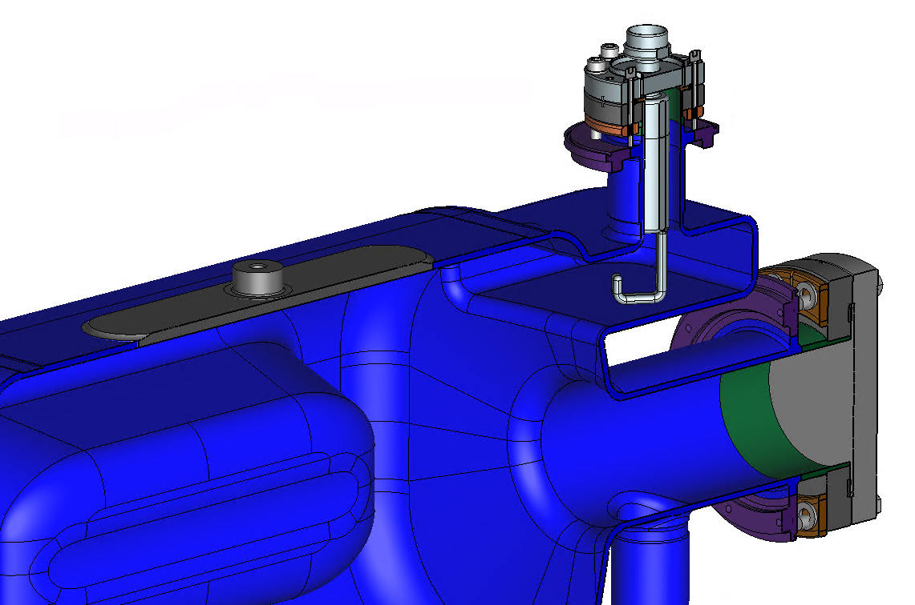

**Hook and bolt holes orientation**

Fig. 6: VHOM hook and relative bolt holes orientation.

### Install input antenna sub-assembly following the markings on the cavity and feedthrough flanges onto the FPC port

1. Use the DN63 gasket and the hardware provided with the cavity (M8 studs and Si-Br nuts).
2. Finger tighten first.
3. Make the nuts snug using a wrench.
4. Start at 60 in.lbs in a star pattern.
5. Repeat the pattern increasing the torque by 10 in.lbs and moving the No.1 position.
6. Continue until the run with 90 in.lbs is complete.
7. Increase the torque by 10 in.lbs (in the star pattern) until 137 in.lbs or until there is flange-to-flange contact.

### Install the subassembly (Flange 4) to the HHOM port on the cavity, according to Fig. 7, the He-outlet can be used as an external reference for the assembly orientation. A CERN 6” RF gasket should be used.

1. Use sixteen 5/16-18 A286 SHCSs, Silver-Plated A286 5/16-18 Hex Nuts, and stainless steel washers to connect Flange 4 (see Fig. 2) on the HHOM to the HHOM port flange on the cavity.
2. Finger tighten first.
3. Make the nuts snug using a wrench.
4. Start at 60 in.lbs in a star pattern.
5. Repeat the pattern increasing the torque by 10 in.lbs and moving the No.1 position.
6. Continue until the run with 90 in.lbs is complete.
7. Torque the nuts in a star pattern until there is flange-flange contact – verify with a feeler gauge.

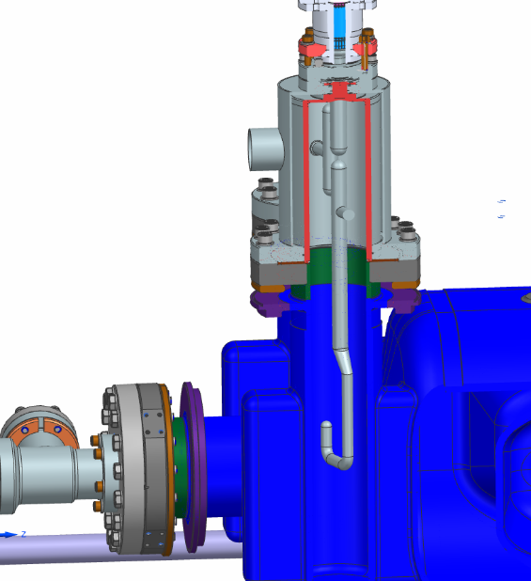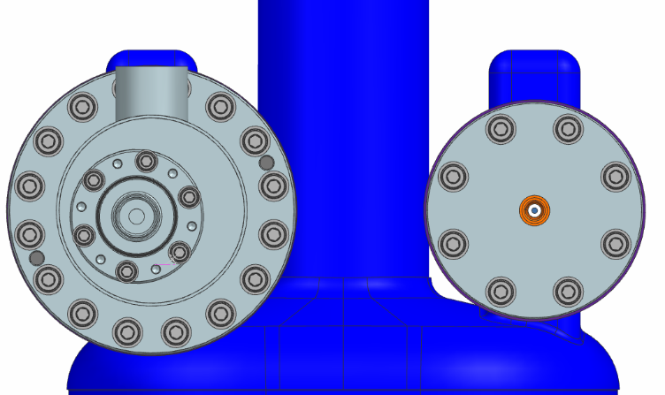

**He outlet orientation**

Fig. 7: HHOM hook and relative He-outlet orientation.

## Final Steps

### Check all the torques and proceed to leak check.

### Once the HOM feedthroughs and their flange connections have been leak checked, the provided plastic protective covers need to be put in place using the provided socket brass bolts.

### A minimum of two people is required when maneuvering the cavity through a doorway. This approach serves to minimize the potential for accidents, equipment damage, and personal injuries.

# References

|  |  |
| --- | --- |
| **Document No.** | **Title** |
| SRF-01-ML-001 | SRF Quality Manual |
|  |  |
|  |  |

# Release and Revision History

|  |  |  |
| --- | --- | --- |
| **Rev #** | **Major Changes** | **Effective Date:** |
| 1 | Initial version | 11/30/2023 |
|  |  |  |
|  |  |  |
|  |  |  |

# Approvals

|  |  |  |  |
| --- | --- | --- | --- |
| **Approved by:** | **Name:** | **Signature:** | **Date:** |
| Author | Alex Castilla | In Docushare | |
| Project Leader | Naeem Huque | In Docushare | |
| SME | Danny Forehand | In Docushare | |
| SRF Department Head | Tony Reilly | In Docushare | |