|  |  |  |  |
| --- | --- | --- | --- |
| L2HE SPQA Installation Procedure | | | |
| **Document Number:** | LCLS-HE-CM-SPQA-INSTALL | **Effective Date:** | DD Mmm YYYY |
| **Revision Number:** | 1 | **Periodic Review Date:** | DD Mmm YYYY |
| **Document Owner:** | Mike Murphy | **Department Owner:** | SRF Operations |

# Purpose

The purpose of this document is to assist a qualified technician in the installation of the L2HE Split Quad Magnet onto the beam pipe spool at WS2.

# Scope

This document applies to the installation of the Quad Magnet used for SRF Cryomodule Assembly L2HE production project only.

# Terms and Definitions

The following terms have specific meanings within this procedure.

|  |  |
| --- | --- |
| **Term** | **Definition** |
| SPQA | Split Quad Magnet- Large magnet attached to the BPM flange surrounding the beam pipe. |

# Roles and Responsibilities

The following roles have responsibilities described in this document.

|  |  |
| --- | --- |
| **Role** | **Responsibility** |
| Crane Operator | Control crane during the lifting of the magnet halves |
| Technicians | Perform the install as per this procedure (2 person min) |
|  |  |
|  |  |

# Procedure

Required Materials:

* Quad Magnet lifting fixtures (shackles, strap, turnbuckles.)
* Magnet tray
* 5/16-18mm studs
* 5/16-18 Silicon Bronze nuts
* 5/16 SS washers
* 243 Loctite
* Jeweler’s flat head screwdriver
* 8mm Allen wrench
* 13mm wrench
* 7/16th wrench
* Torque wrench
* Overhead Crane

**This Procedure is to be performed by trained personnel ONLY**

**\*PPE needed during procedure: Hard Hat, Steel toe or safety shoe, Beamline/Bellows protection\***

* Before work begins, be sure to record the beamline vacuum
* Install the lollipop and magnet tray assembly
* The beam line spool has been pre-aligned and is ready for the magnet to be installed
* Crane certified technicians are authorized to operate the overhead crane.
* SPQA fiducials have been verified by the JLAB Alignment team.

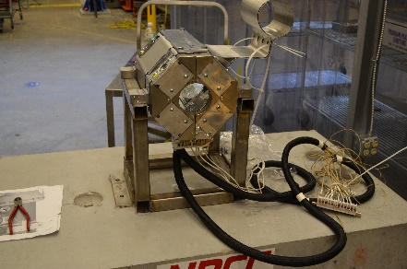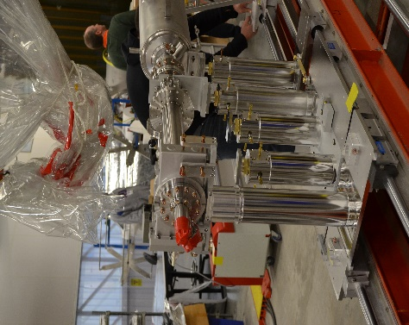

1. Inspect magnet for defects and remove the top plate by loosening the 4 HHd bolts securing it to the magnet. Make sure the holes are free of stycast material, use a tap to clean out the holes if required.
2. Attach the lifting fixture to the magnet while the magnet is on the cart. The 4 lifting eyes attach at the 4 bolt holes where the top plate was screwed in. Before the magnet is lifted, a technician must use a jeweler’s flat head screwdriver to remove the magnet leads from the wooden block and carefully cut the cable ties.
3. Once the lifting fixture is installed, have the crane operator lower the hook and attach the strap.
4. There are 4 SHCS keeping the magnet halves together, these need to be removed once the magnet is ready to be lifted and separated.
5. With a technician on either side of the magnet, move the magnet over the beam pipe spool.
6. As the operator lowers the magnet, separate the halves to be sure they clear the beampipe.
7. Once the magnet halves are sitting on the magnet tray, slide the halves in towards the beampipe, while being sure the ID does not contact the OD of the beam pipe spool.
8. The tolerance is very small between the beampipe and the magnet, adjustments may be needed to ensure this tolerance is uniform.
9. Loosely install the 4 SHCS that held the magnet halves together, making the magnet whole again surrounding the beampipe. Monitor the gap around the beam pipe.
10. When the magnet to the BPM flange gap is close to being uniform, check to see if the studs will go in through the BPM flange to the magnet. (In some installs, technicians preinstall the studs and slide the magnet with studs through the BPM flange.)

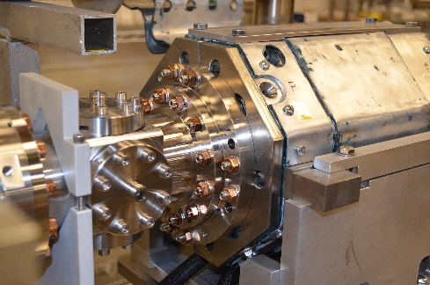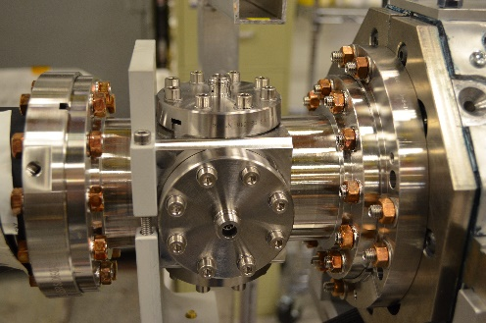

1. When all the studs are installed, install washers and nuts onto studs and snug. During this time make sure the magnet isn’t resting on the beam pipe, adjust the lollipop tooling as needed.
2. When the magnet is secured to the BPM flange and the gap is uniform between the magnet and beam pipe, tighten the 4 SHCS holding magnet halves together and torque to 60 ft/lbs.

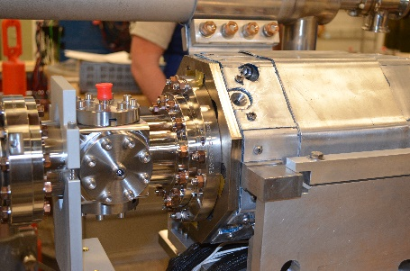

1. Ensure that all parts of the magnet tooling are tight and holding the weight of the magnet in preparation for the Alignment crew to align the magnet to the string.
2. Remove the lifting fixture from magnet and reinstall the top plate making sure to apply Blue 243 Loctite to the bolts and tighten.
3. Return crane to upright and locked position and turn off crane controls.
4. Recheck the beamline pressure and fill out Fastener Spreadsheet as needed.

# References

|  |  |
| --- | --- |
| **Document No.** | **Title** |
| SRF-01-ML-001 | SRF Quality Manual |
| [F10009375-U-Magnet Dwgs](https://misportal.jlab.org/jlabDocs/items/186042) | FNAL dwgs for the L2HE SPQA Assembly |

# Release and Revision History

|  |  |  |
| --- | --- | --- |
| **Rev #** | **Major Changes** | **Effective Date:** |
| 1 | Initial version | 20 Dec 2023 |

# Approvals

|  |  |  |  |
| --- | --- | --- | --- |
| **Approved by:** | **Name:** | **Signature:** | **Date:** |
| Document Owner | Mike Murphy | In Docushare | |
| Subject Matter Expert | Jared Martin | In Docushare | |
| Work Center Lead | John Fischer | In Docushare | |
| Project Leader | Adam Grabowski | In Docushare | |