|  |  |  |  |
| --- | --- | --- | --- |
| **Downstream End Cap Installation Procedure for LCLS-II Cryomodules** | | | |
| **Document Number:** | L2HE-PR-CMA-EDCP-INST | **Effective Date:** | DD Mmm YYYY |
| **Revision Number:** | R1 | **Periodic Review Date:** | DD Mmm YYYY |
| **Document Owner:** | J. Fischer | **Department Owner:** | SRF Operations |

# Purpose

The purpose of this document is to describe the installation of downstream end caps for LCLS-II Cryomodules

# Scope

This procedure applies to End Caps for LCLS-II Cryomodules

# Terms and Definitions

The following terms have specific meanings within this procedure.

|  |  |
| --- | --- |
| **Term** | **Definition** |
| <Term 1> | <Definition> |
| <Term 2> | <Definition> |
|  |  |

# Roles and Responsibilities

The following roles have responsibilities described in this document.

|  |  |
| --- | --- |
| **Role** | **Responsibility** |
| <Job Title> | <Very short summary of activities this job title performs in this procedure.> |
|  |  |
|  |  |
|  |  |

# Procedure

## Preliminary Notes

* Installation of the End Cap should be completed before the End Cap Level 2 Bullet
* Ensure that the SPINDLE PUSH ROD (F10054584) has anti-seize applied to its threads prior to installation into the PLUG THREADED COLLAR (F10054537)

## Hardware List

|  |  |  |
| --- | --- | --- |
| **Description** | **Material** | **Quantity** |
| **SG1** | | |
| Screw Clamp | B7 Steel | 24 |
| **SG2** | | |
| 3/8-16 UNC x 1-3/4LG SHCS | Black Oxide Alloy Steel | 12 |
| 1/3” Flat Washer | Zinc Y-C Grade-8 Steel | 12 |
| 5/16-18 UNC x 1-1/2LG HHCS | 18-8 Stainless Steel | 4 |
| 5/16” Flat Washer | Zinc Y-C Grade-8 Steel | 4 |
| **SG3** | | |
| 3/8-16 UNC x 1-1/4LG SHCS | Grade-5 Steel | 16 |
| 3/8-16 UNC x 3-1/4LG SHCS | Grade-5 Steel | 8 |
| 3/8-16 UNC x 4-1/2LG HHCS | Grade-5 Steel | 1 |
| 3/8” Split Lock Washer | 18-8 Stainless Steel | 16 |

## Assembly Overview

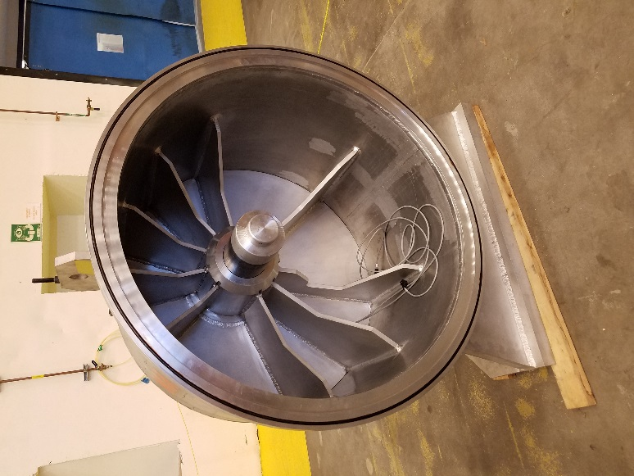

**Sub-Group 1 (SG1): End Cap**

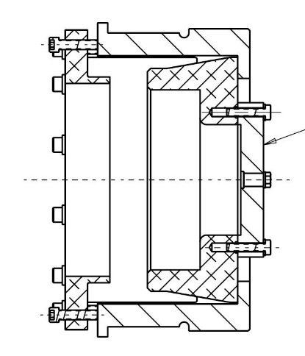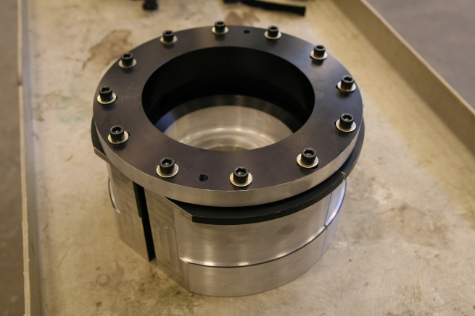

**Sub-Group 2 (SG2): HeGRP Attachment**

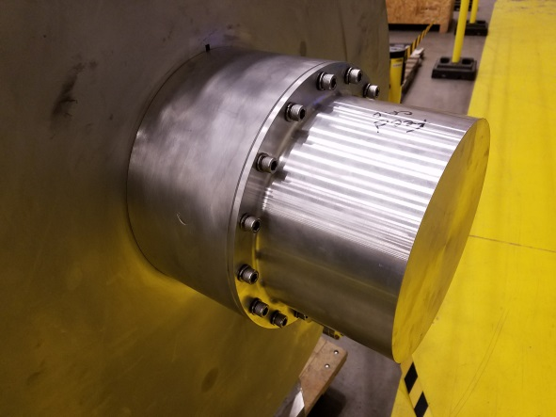

**Sub-Group 3 (SG3) Spindle Push Rod Cover**

## SG2 Assembly

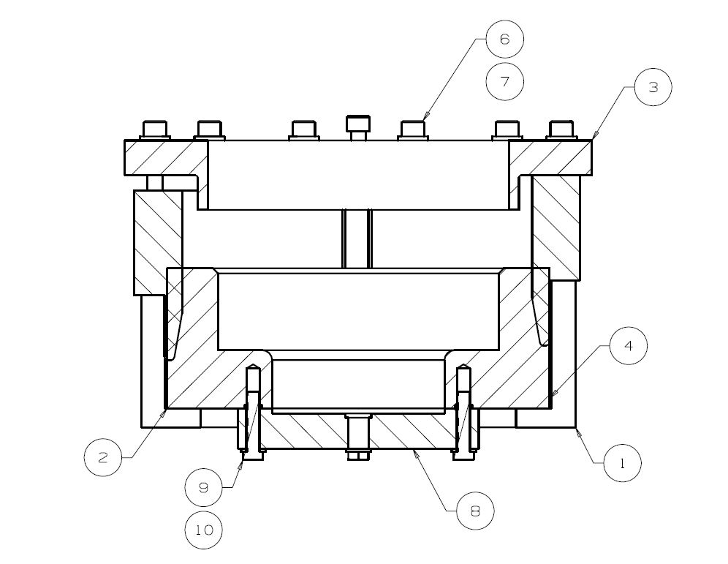

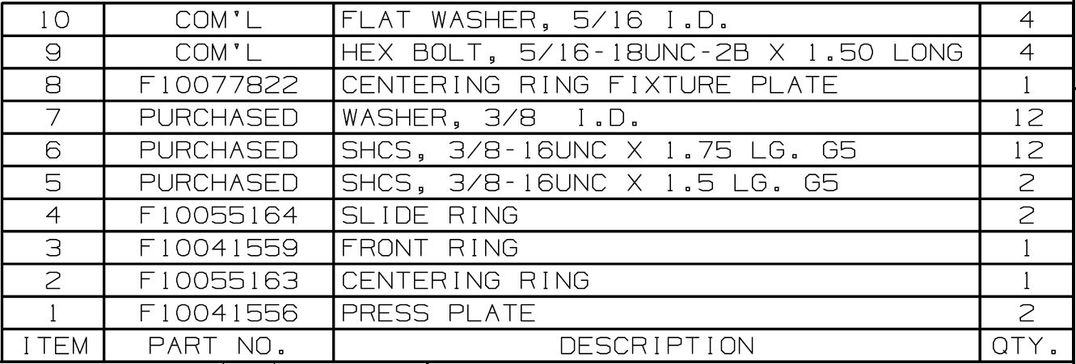

## Step 1: Bottom Press Plate of SG2

### 1.0 Ensure Protective Cover is installed on the bellows convolutions.

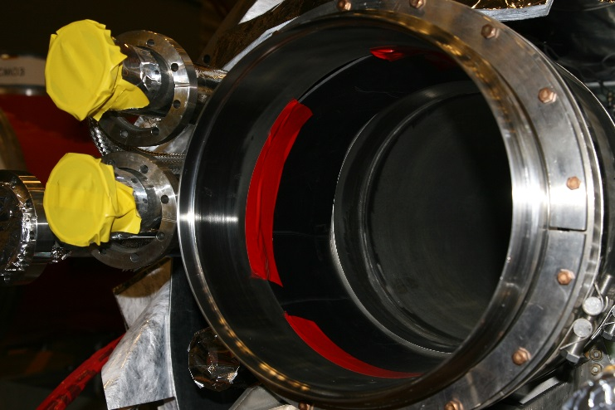

## Step 2: Install Top Press Plate of SG2

### Insert the Press Plates in the GHRP in the Vertical orientation

### The flats should be at the 12 and 6 o’clock positions

### Outer lip of Press Plate should be on the rim behind the bellows convolution

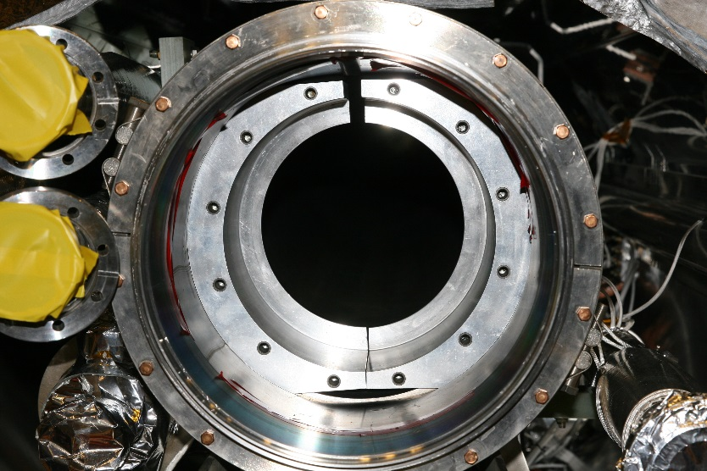

## Step 3: Install Centering of SG2

### Insert Centering Ring between Press Plates

### Tabs on the Centering Ring should be aligned Horizontally

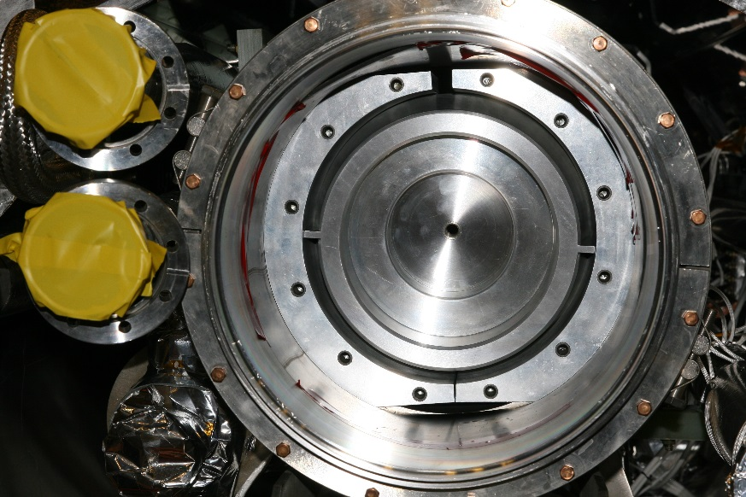

## Step 4: Install Bottom Slide Ring of SG2

### Insert Slide Ring on Bottom half of GHRP

### Tab on the Slide Ring should be at 6 o’clock position

### Tab should fit between the Press Plates

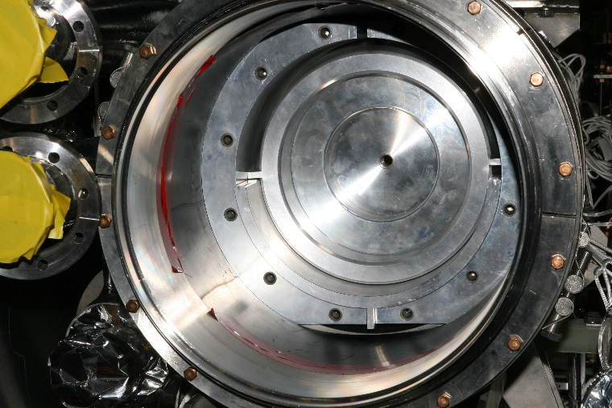

## Step 5: Install Top Slide Ring of SG2

### Insert Slide Ring on the Top half of GHRP

### Tab on the Slide Ring should be at 12 o’clock position

### Tab should fit between the Press Plates

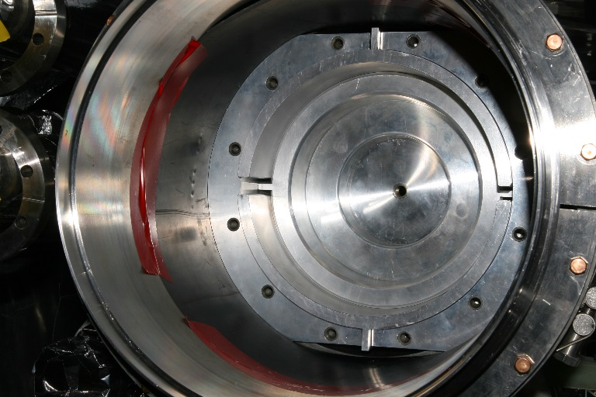

## Step 6: Position Front Ring of SG2

### Place Front Ring on SG1

### Hold Front Ring in place using some 3/8-16 SHCS and one washers

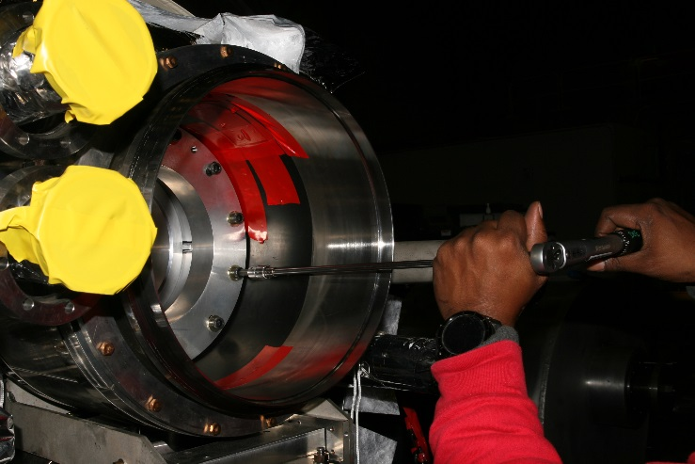

## Step 7: Fix screws of SG2

### Fix the Front Ring in place using the remaining eleven 3/8-16 SHCS, along with washers

### Lightly tighten only

### Make note if the assembly does not allow all the screws to be installed

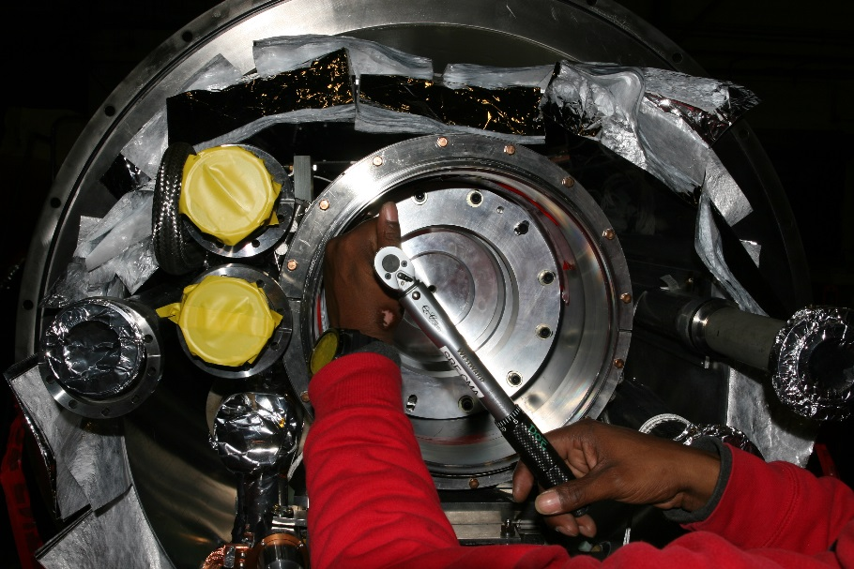

## Step 8: Torque screws of SG2

### Torque screws to 5 ft/lbs in a star pattern

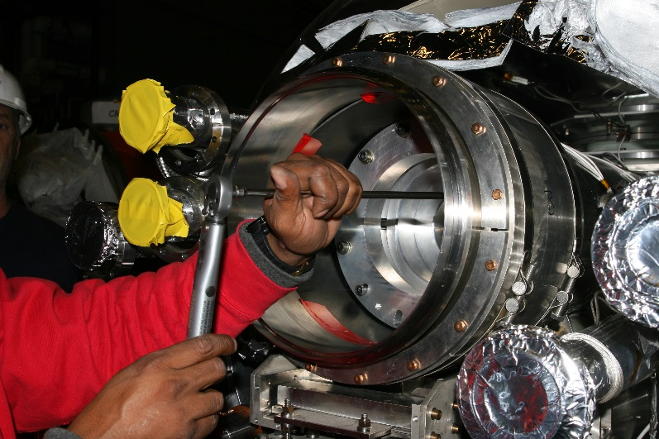

## Step 9: Completed SG2 Installation

### Ensure that the assembly does not axially rotate.

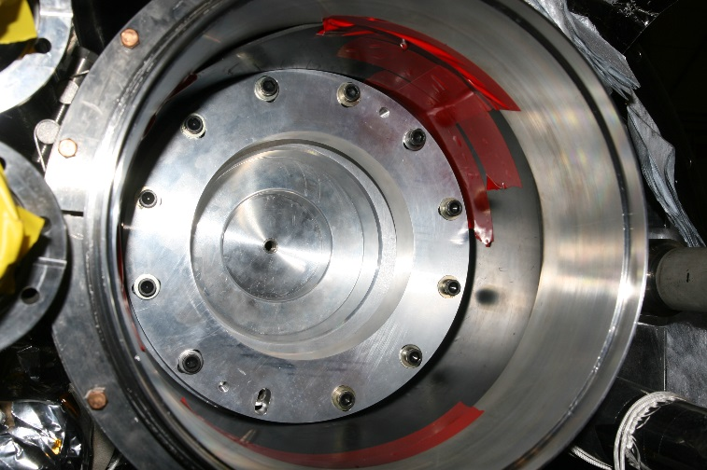

## Step 10: Setup of SG1

### Ensure the parts and hardware for the Feed Cap (F10054679) are all available

### Apply Anti-Seize to the Spindle Push Rod threads if not already present

### Ensure the O-rings on the CM vacuum vessel are in place

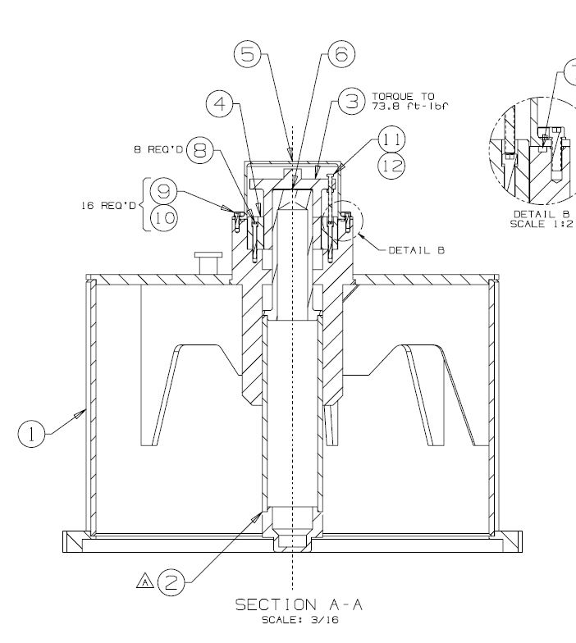

## Step 11: Assembled SG1

### Assemble End Cap as per F10054678

### Ensure that the Glacier Plate (Item 6) is in place

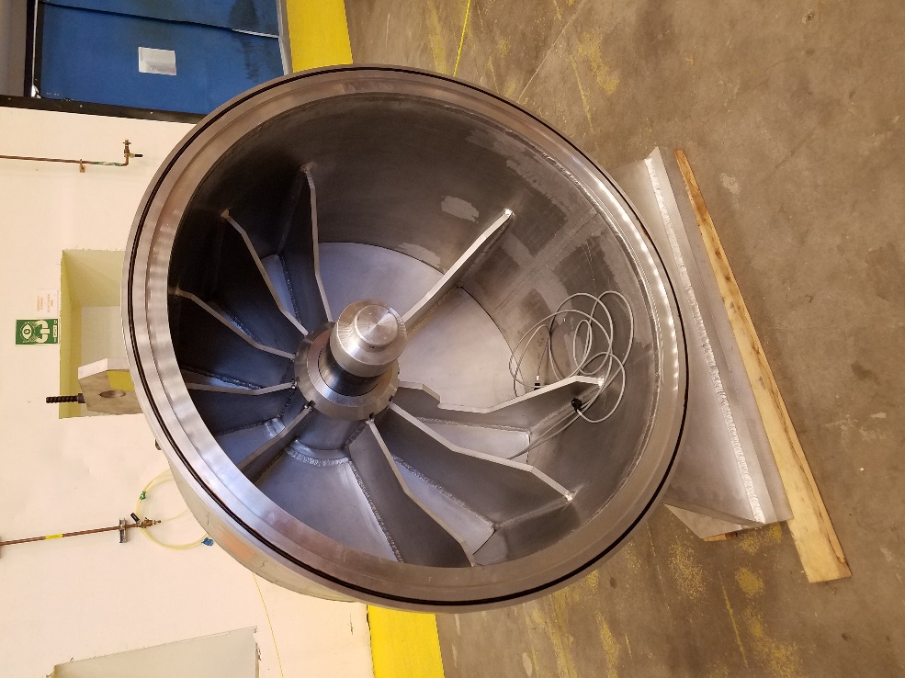

## Step 12: Remove Spindle Push Rod Cover from SG3

### Remove the Spindle Push Rod Cover

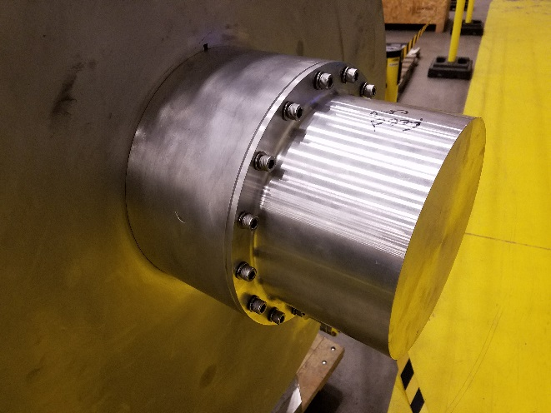

## Step 13: Adjust SG3 Spindle Push Rod

### Adjust the Spindle Push Rod until it is 4” – 5” from the base of the cap.

### Hand tighten the SHCS to ensure that the Feed Cap Spindle is coupled to the Spindle Push Rod

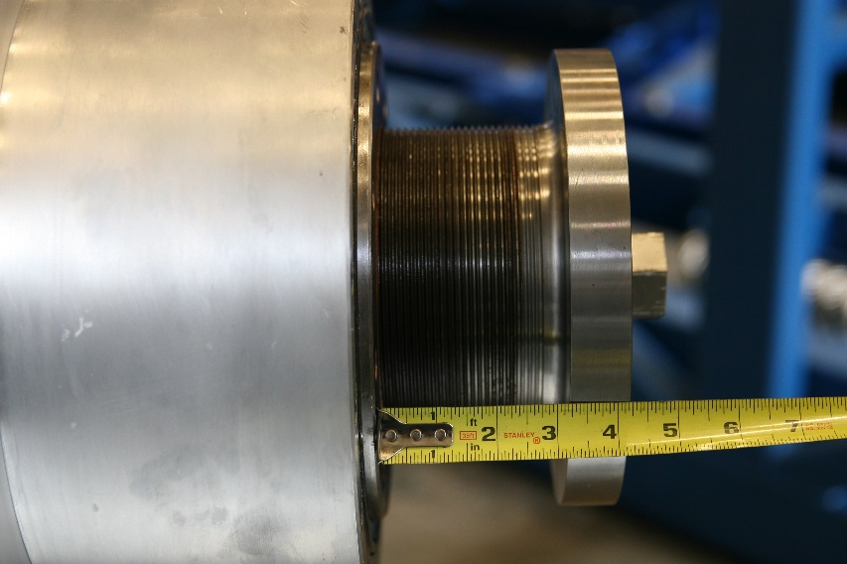

## Step 14: Lift SG1 Assembly

### Attach clevis with sling and scale to the Feed Cap lifting lug

### Lift the End Cap to the approximate height of the GHRP

### Note the weight on the scale; it should read ~900lb. It may vary by 10%

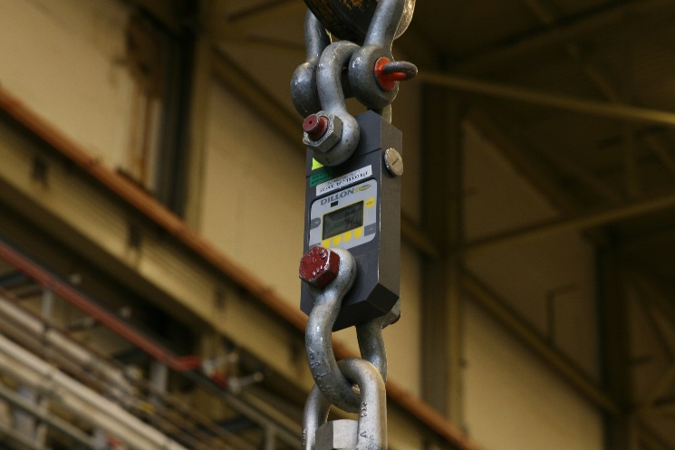

## Step 15: SG1 Height Setting

### Measure the distance from the center of the GHRP to the ground

### Adjust the height of the End Cap until the center of the spindle is at an equal height from the ground

### Use a long level rule to ensure that the spindle is aligned to the center of the HeGRP Insert (SG2)

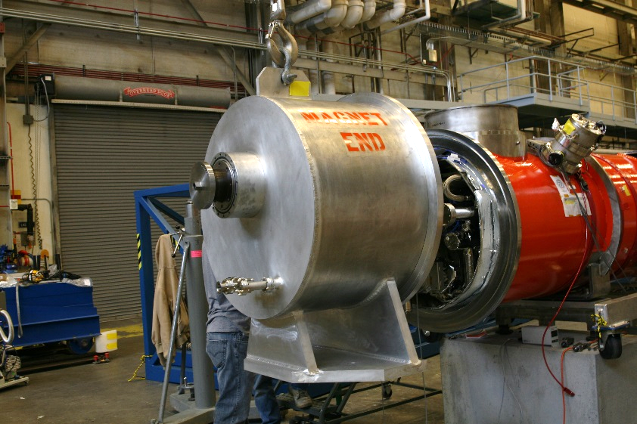

## Step 16: SG1 Positioning

### Carefully bring the End Cap towards the vacuum vessel until the flanges meet.

### If the spindle comes into contact with the HeGRP Insert first, turn back the Spindle Push Rod

### Monitor the scale; if the weight increases, it indicates that the spindle has hit the top of the insert and the cap needs to be lowered, and vice-versa.

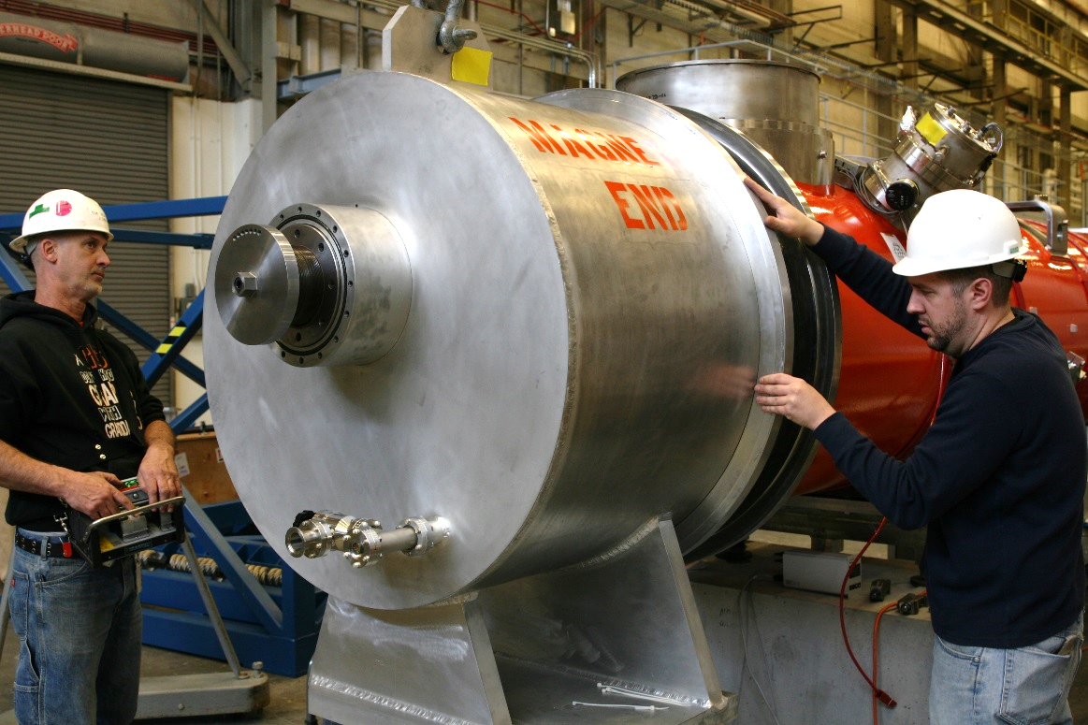

## Step 17: Install Flange Hardware

### Turn the rotatable flange on the vacuum vessel until the holes in both the inner and outer bolt pattern line up. Mark this orientation

### Install the 16 Screw clamps and torque the nuts to 63 ft.lbs

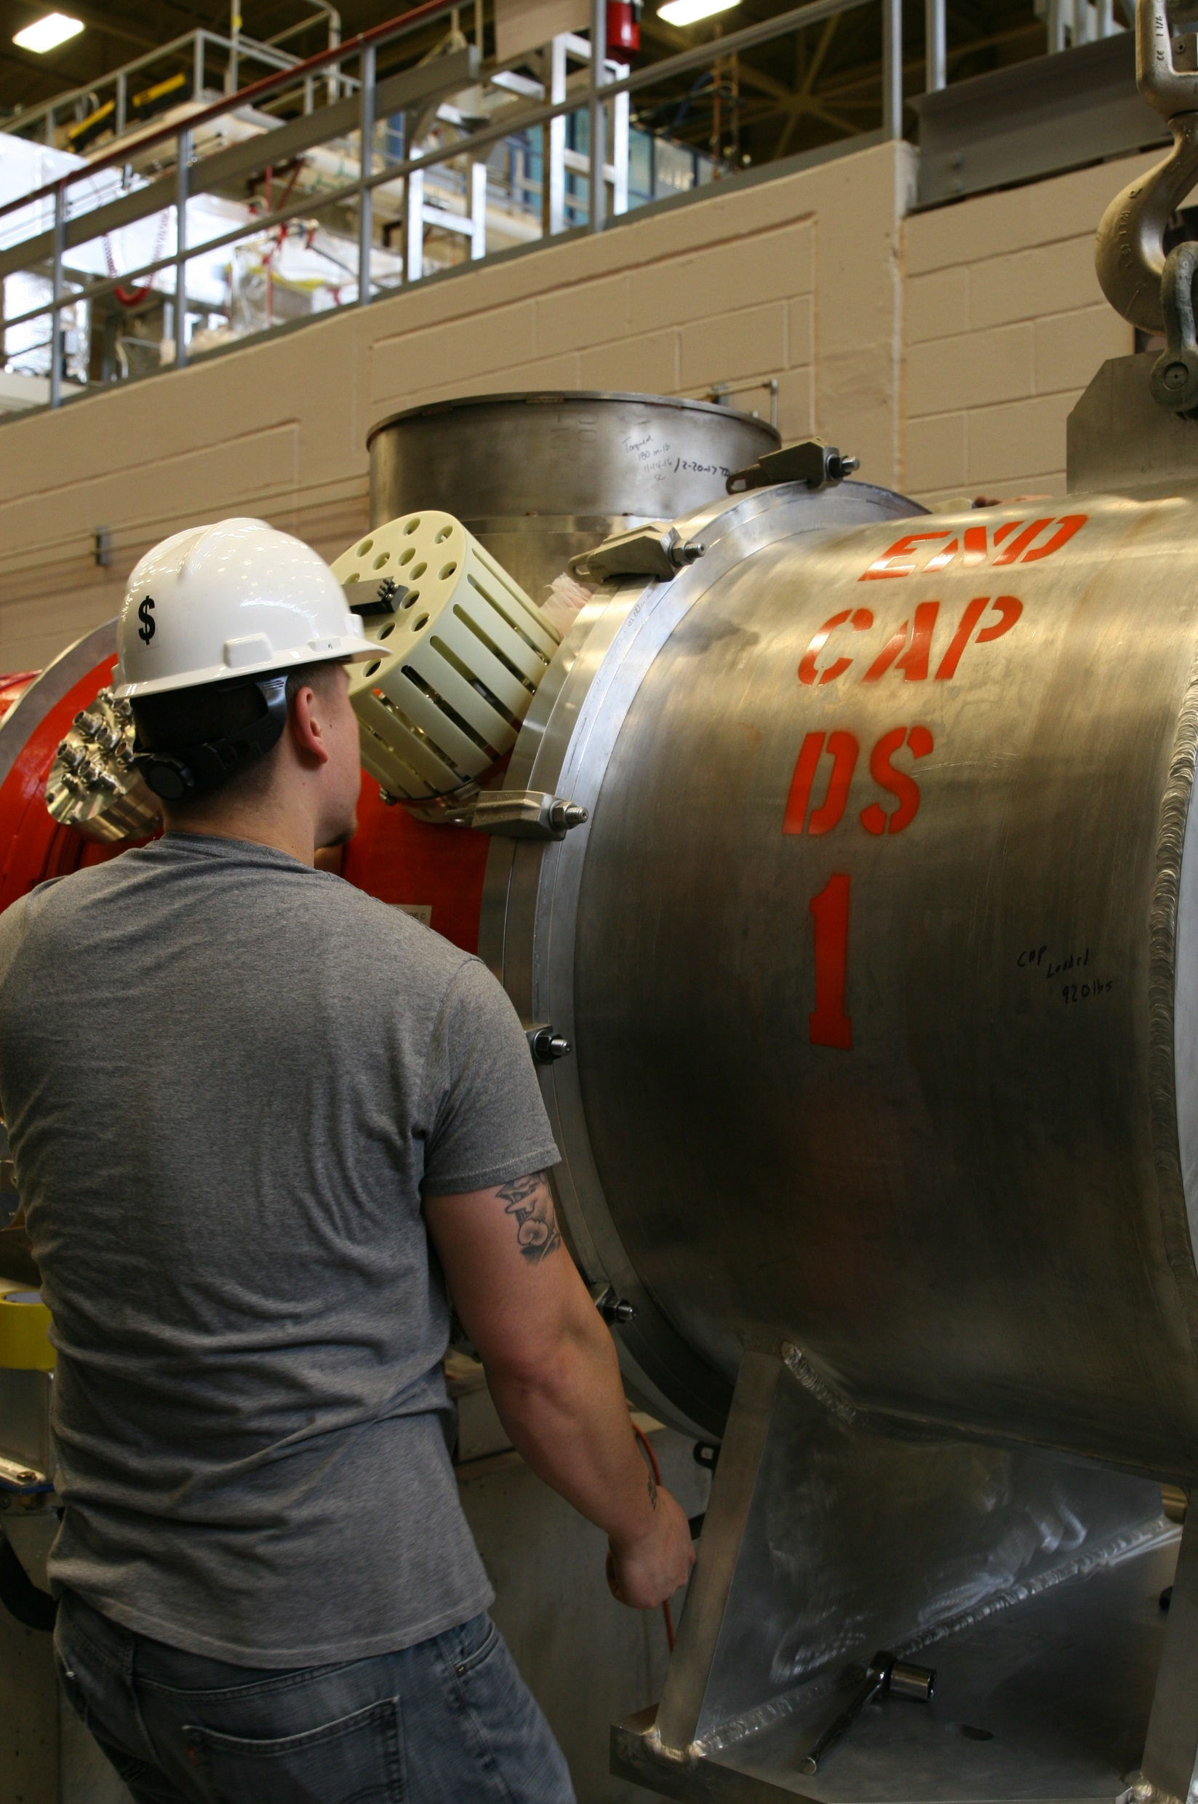

## Step 18: Spindle Push Rod Positioning

### Turn the Spindle Push Rod clockwise by hand to move the spindle into the HeGRP Insert. Stop once there is resistance.

### Torque the SHCS t0 20 ft.lbs

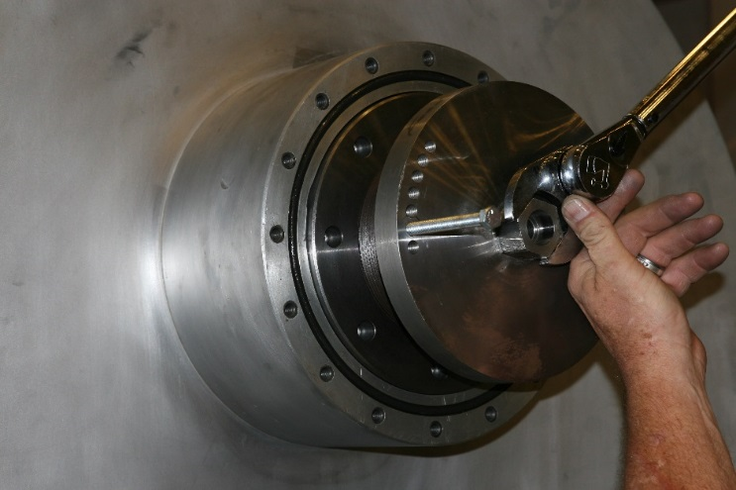

## Step 18: Spindle Push Rod Lock

### Use the 3/8-16 UNC x 4-1/2” HHCS to lock the Spindle Push Rod in Place

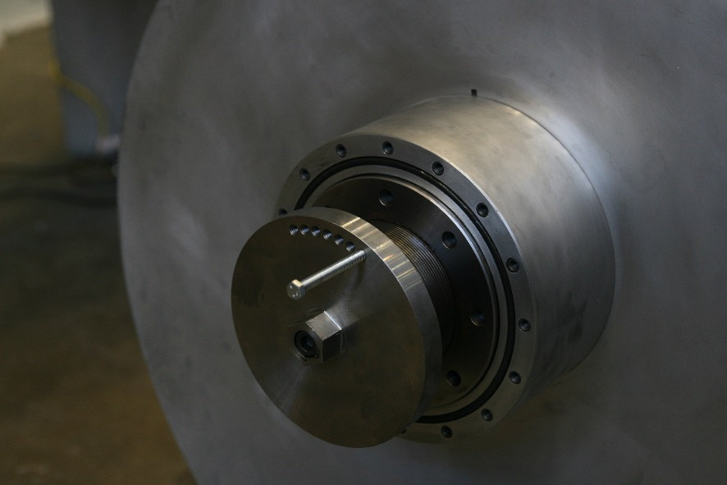

## Step 19: Install Cover

### Reinstall the Spindle Push Rod Cover

### Use a single split lock washer for each 3/8-16 UNC SHCS

### Torque the SHCS to 31 ft.lbs

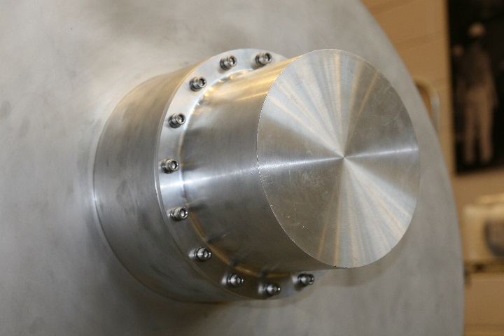

# References

|  |  |
| --- | --- |
| **Document No.** | **Title** |
| SRF-01-ML-001 | SRF Quality Manual |
|  |  |
|  |  |

# Release and Revision History

|  |  |  |
| --- | --- | --- |
| **Rev #** | **Major Changes** | **Effective Date:** |
| 1 | Initial version | DD Mmm YYY |
|  |  |  |
|  |  |  |
|  |  |  |

# Approvals

|  |  |  |  |
| --- | --- | --- | --- |
| **Approved by:** | **Name:** | **Signature:** | **Date:** |
| Document Owner | <First Last Name> | In Docushare | |
| Subject Matter Expert | <First Last Name> | In Docushare | |
| Work Center Lead | <First Last Name> | In Docushare | |
| Project Leader | <First Last Name> | In Docushare | |