|  |  |  |  |
| --- | --- | --- | --- |
| **Upstream Feed Cap Installation Procedure for LCLS-II Cryomodules** | | | |
| **Document Number:** | L2HE-PR-CMA-FDCP-INST | **Effective Date:** | DD Mmm YYYY |
| **Revision Number:** | R1 | **Periodic Review Date:** | DD Mmm YYYY |
| **Document Owner:** | J. Fischer | **Department Owner:** | SRF Operations |

# Purpose

The purpose of this document is to describe the installation of the upstream feed caps for LCLS-II Cryomodules

# Scope

This procedure applies to Feed Caps for LCLS-II Cryomodules

# Terms and Definitions

The following terms have specific meanings within this procedure.

|  |  |
| --- | --- |
| **Term** | **Definition** |
| <Term 1> | <Definition> |
| <Term 2> | <Definition> |
|  |  |

# Roles and Responsibilities

The following roles have responsibilities described in this document.

|  |  |
| --- | --- |
| **Role** | **Responsibility** |
| <Job Title> | <Very short summary of activities this job title performs in this procedure.> |
|  |  |
|  |  |
|  |  |

# Procedure

## Preliminary Notes

### Installation of the Feed Cap should only be completed after the End Cap has been installed

### Ensure that the SPINDLE PUSH ROD (F10054584) has anti-seize applied to its threads prior to installation into the PLUG THREADED COLLAR (F10054537)

## Hardware List

|  |  |  |
| --- | --- | --- |
| **Description** | **Material** | **Quantity** |
| **SG1** | | |
| ½-13 UNC x 5-1/2LG SHCS | Alloy Steel | 24 |
| M12 x 1.75 x 110mm LG HHCS | 316 Stainless Steel | 24 |
| M12 Flat Washer | Zinc Y-C Grade-8 Steel | 24 |
| ½” Flat Washers | Zinc Y-C Grade-8 Steel | 48 |
| ½” Bellville Washer | 18-8 Stainless Steel | 48 |
| **SG2** | | |
| 3/8-16 UNC x 1-3/4LG SHCS | Black Oxide Alloy Steel | 12 |
| 1/3” Flat Washer | Zinc Y-C Grade-8 Steel | 12 |
| 5/16-18 UNC x 1-1/2LG HHCS | 18-8 Stainless Steel | 4 |
| 5/16” Flat Washer | Zinc Y-C Grade-8 Steel | 4 |
| **SG3** | | |
| 3/8-16 UNC x 1-1/4LG SHCS | Grade-5 Steel | 16 |
| 3/8-16 UNC x 3-1/4LG SHCS | Grade-5 Steel | 8 |
| 3/8-16 UNC x 4-1/2LG HHCS | Grade-5 Steel | 1 |
| 3/8” Split Lock Washer | 18-8 Stainless Steel | 16 |

## Assembly Overview

### Sub-Group 1 (SG1): Feed Cap

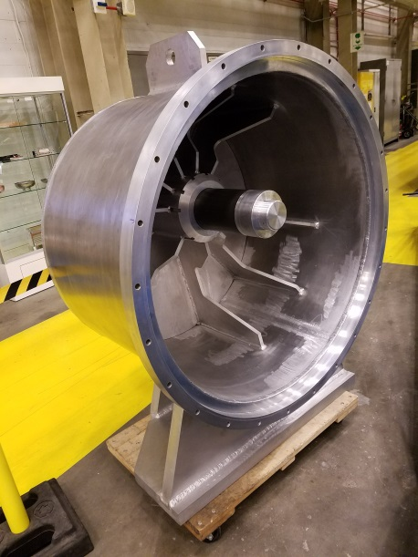

### Sub-Group 2 (SG2): HeGRP Attachment

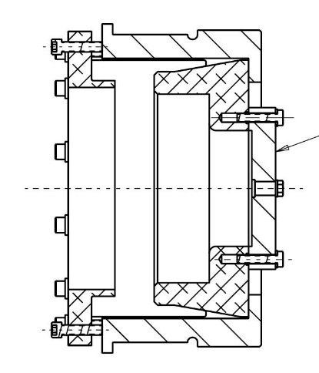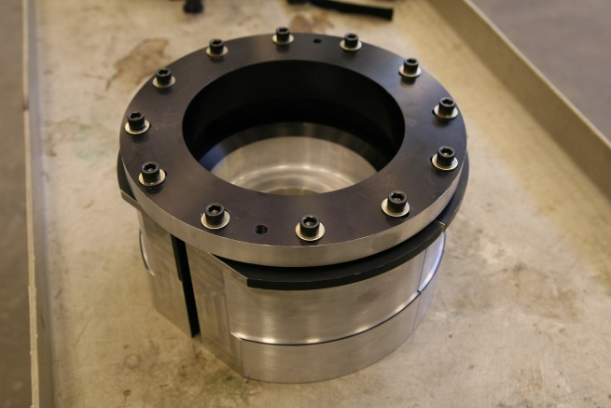

### Sub-Group 3 (SG3) Spindle Push Rod Cover

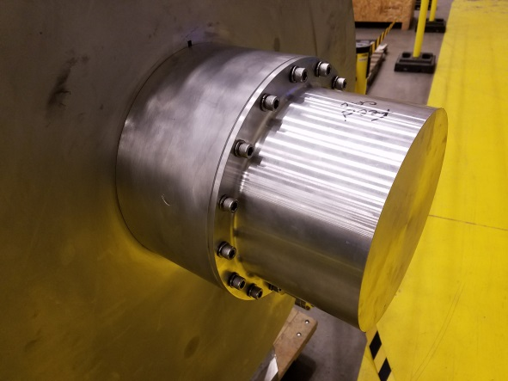

## SG2 Assembly

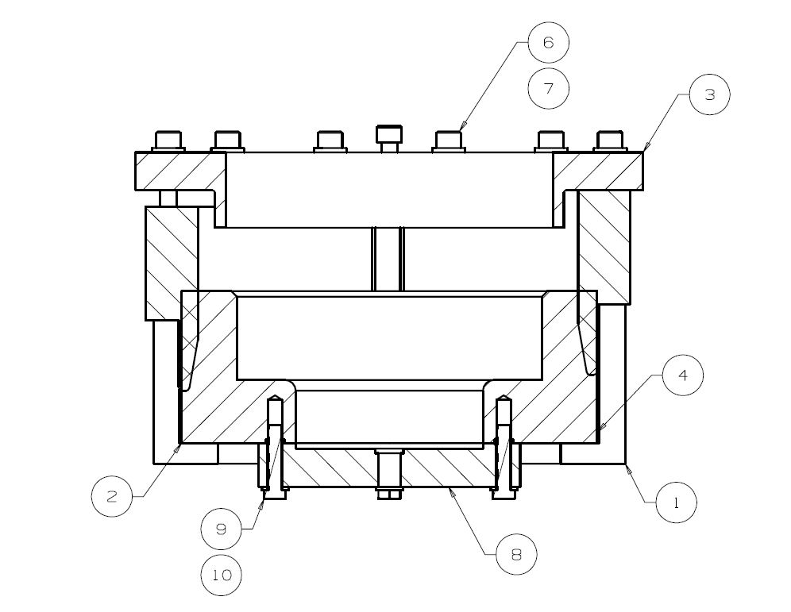

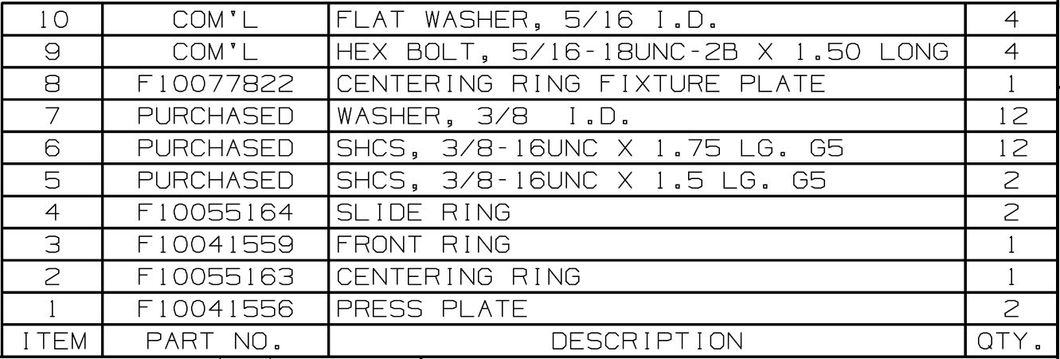

## Step 1: Press Plates of SG2

### Insert the two Press Plates on the GHRP in the vertical orientation

### Flat surfaces should be at 12 and 6 o’clock positions

### Outer lip of Press Plate should be outside GHRP rim

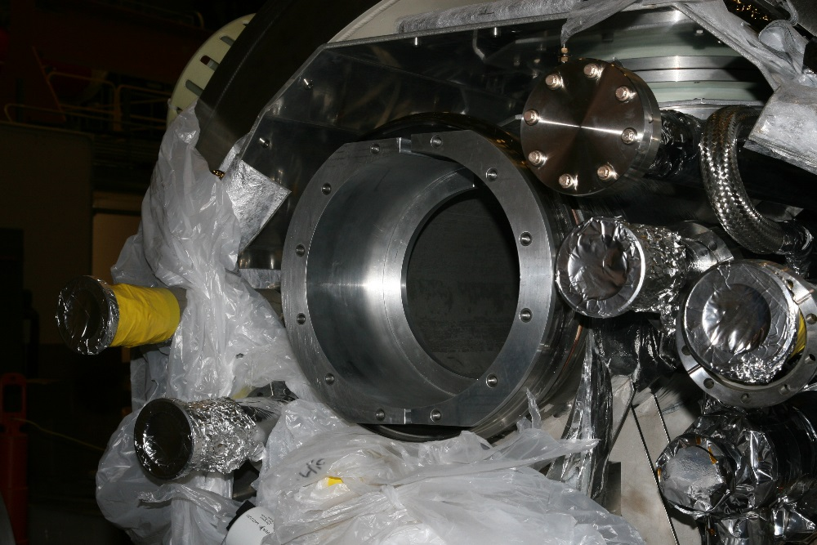

## Step 2: Install Centering of SG2

### Insert Centering Ring between Press Plates

### Tabs on the Centering Ring should be aligned Horizontally

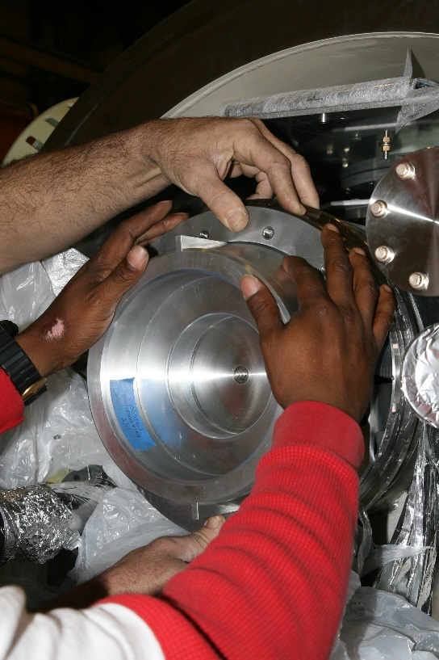 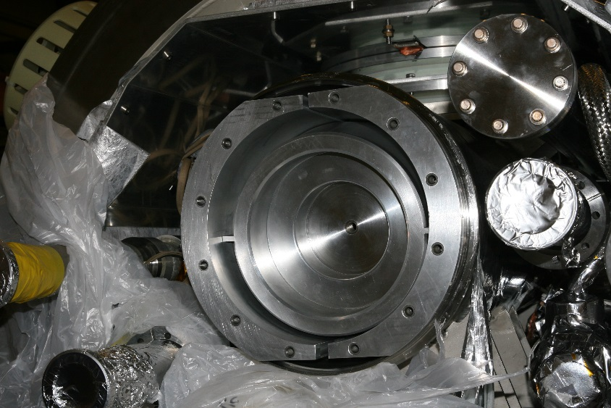

## Step 3: Install Bottom Slide Ring of SG2

### Insert Slide Ring on Bottom Half of GHRP

### Tab on the Slide Ring should be at 6 o’clock position

### Tab should fit between the Press Plates

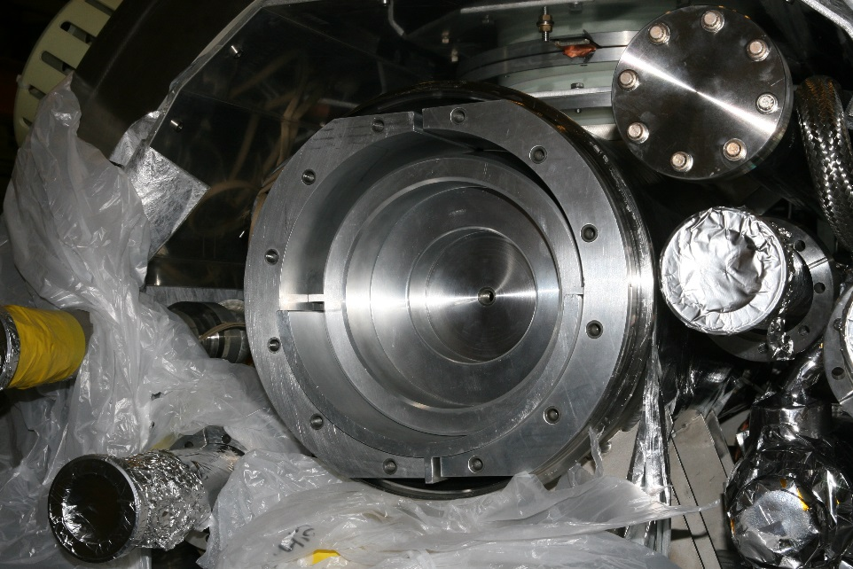

## Step 4: Install Top Slide Ring of SG2

### Insert Slide Ring on Top half of GHRP

### Tab on the Slide Ring should be at 12 o’clock position

### Tab should fit between the Press Plates

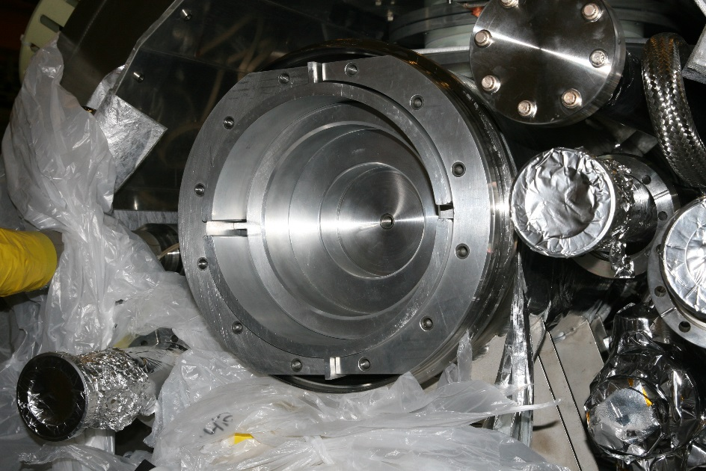

## Step 5: Position Front Ring of SG2

### Place Front Ring on SG2

### Hold Front Ring in place using two 3/8-16 SHCS and washers

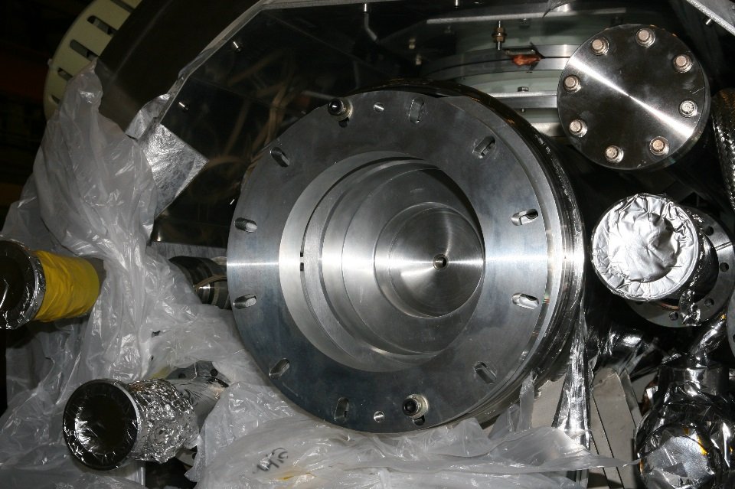

## Step 6: Fix screws of SG2

### Fix the Front Ring in place using the remaining ten 3/8-16 SHCS, along with washers

### Finger tighten only

### Make note if the assembly does not allow all the screws to be installed

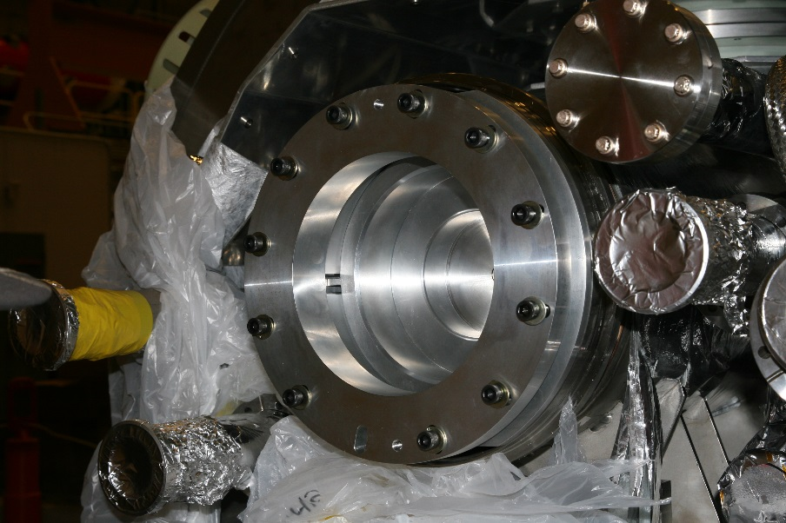

## Step 7: Torque screws of SG2

### Torque screws to 5 ft/lbs in a star pattern

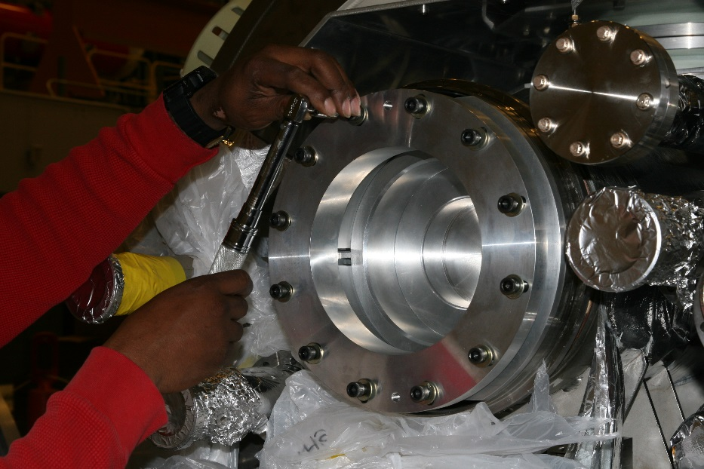

## Step 8: Completed SG2 Installation

### Ensure that the assembly does not axially rotate.

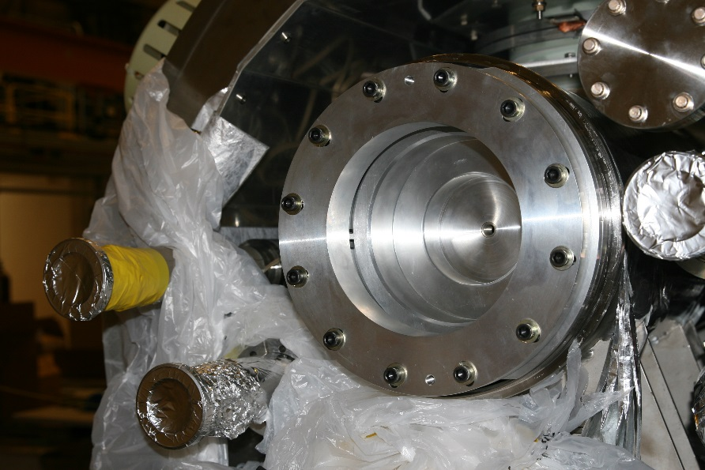

## Step 9: Setup of SG1

### Ensure the parts and hardware for the Feed Cap (F10054678) are all available

### Apply Anti-Seize to the Spindle Push Rod threads

### Ensure the O-rings on the CM vacuum vessel are in place

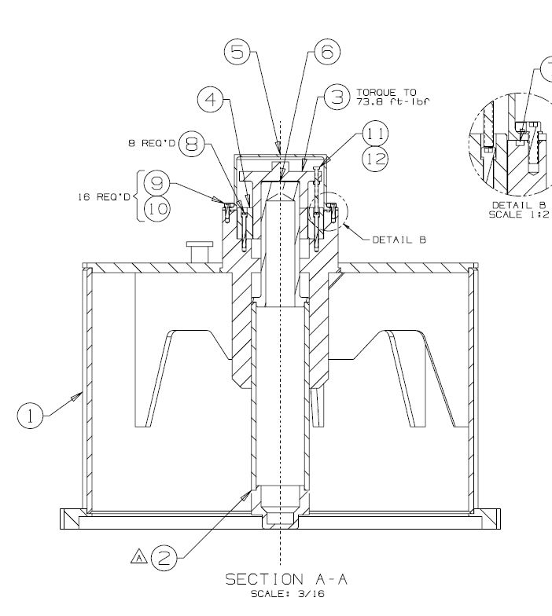

## Step 10: Assembled SG1

### Assemble Feed Cap as per F10054678

### Ensure that the Glacier Plate (Item 6) is in place

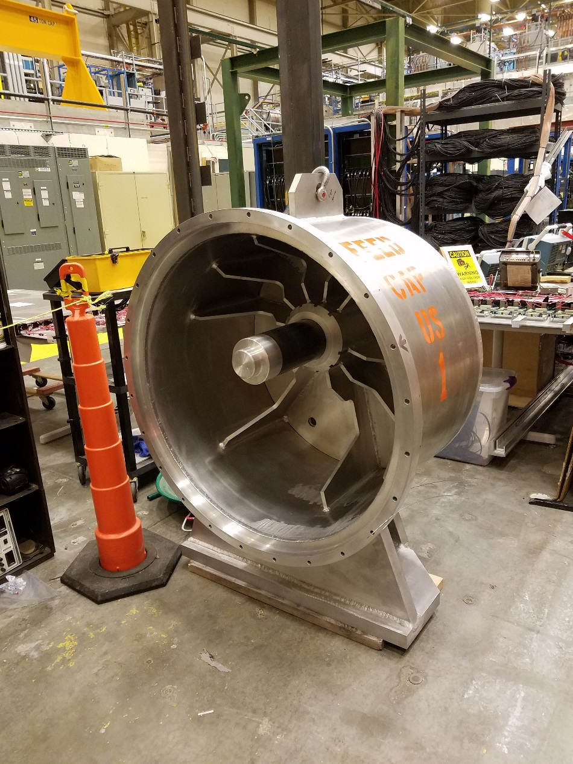

## Step 11: Remove Spindle Push Rod Cover from SG3

### Remove the Spindle Push Rod Cover

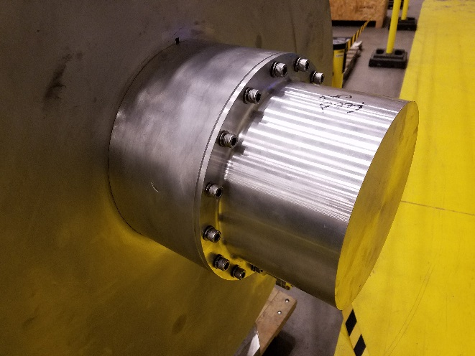

## Step 12: Adjust SG3 Spindle Push Rod

### Adjust the Spindle Push Rod until it is 4” – 5” from the base of the cap.

### Hand tighten the SHCS to ensure that the Feed Cap Spindle is coupled to the Spindle Push Rod

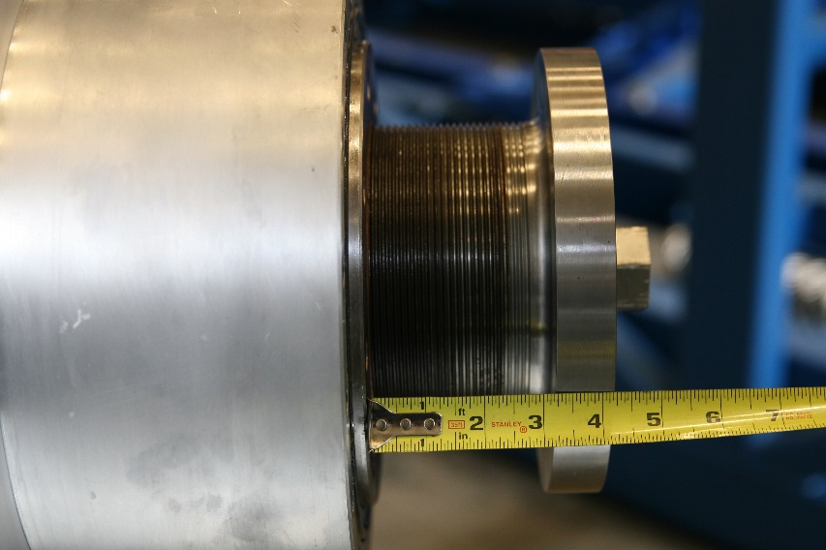

## Step 13: Lift SG1 Assembly

### Attach clevis with sling and scale to the Feed Cap lifting lug

### Lift the Feed Cap to the approximate height of the GHRP

### Note the weight on the scale; it should read ~900lb. It may vary by 10%

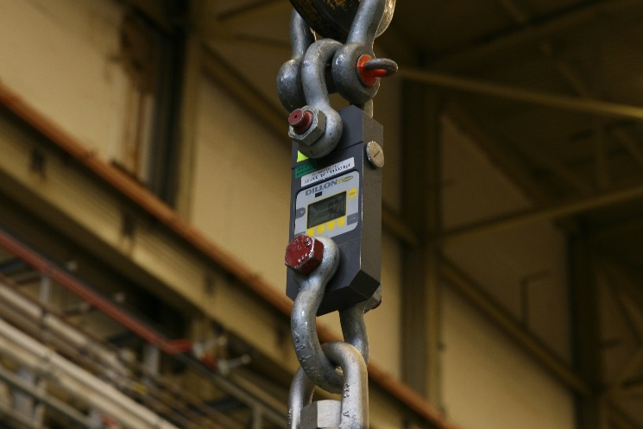

## Step 14: SG1 Height Setting

### Measure the distance from the center of the GHRP to the ground

### Adjust the height of the Feed Cap until the center of the spindle is at an equal height from the ground

### Use a long level rule to ensure that the spindle is aligned to the center of the HeGRP Insert (SG2)

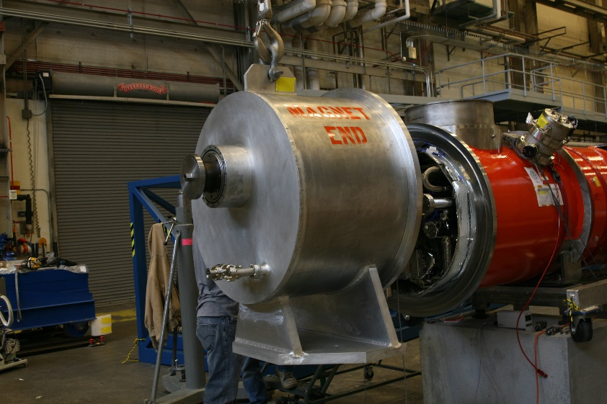

## Step 15: SG1 Positioning

### Carefully bring the Feed Cap towards the vacuum vessel until the flanges meet.

### If the spindle comes into contact with the HeGRP Insert first, turn back the Spindle Push Rod

### Monitor the scale; if the weight increases, it indicates that the spindle has hit the top of the insert and the cap needs to be lowered, and vice-versa.

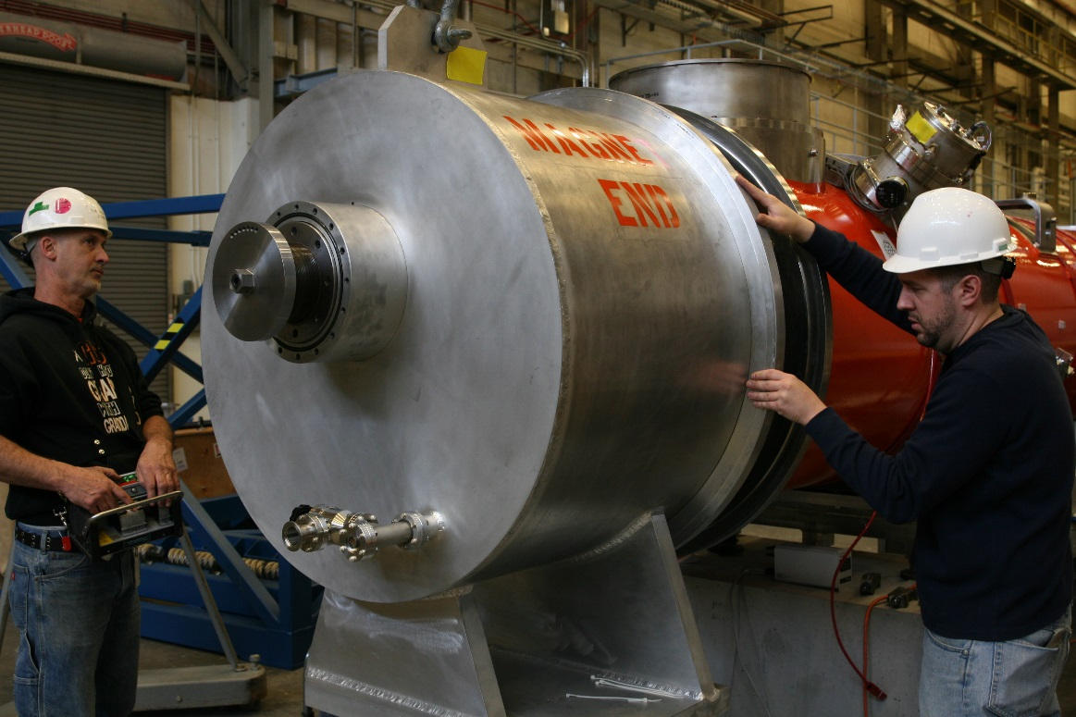

## Step 16: Install Flange Hardware

### Turn the rotatable flange on the vacuum vessel until the holes in both the inner and outer bolt pattern line up. Mark this orientation

### Install the ½-13 UNC Alloy Steel SHCS with a flat washer on both the head and nut side, and two Bellville washers in a series on the head side.

### Use a single flat washer with each of the M12 x 1.75 SS HHCS

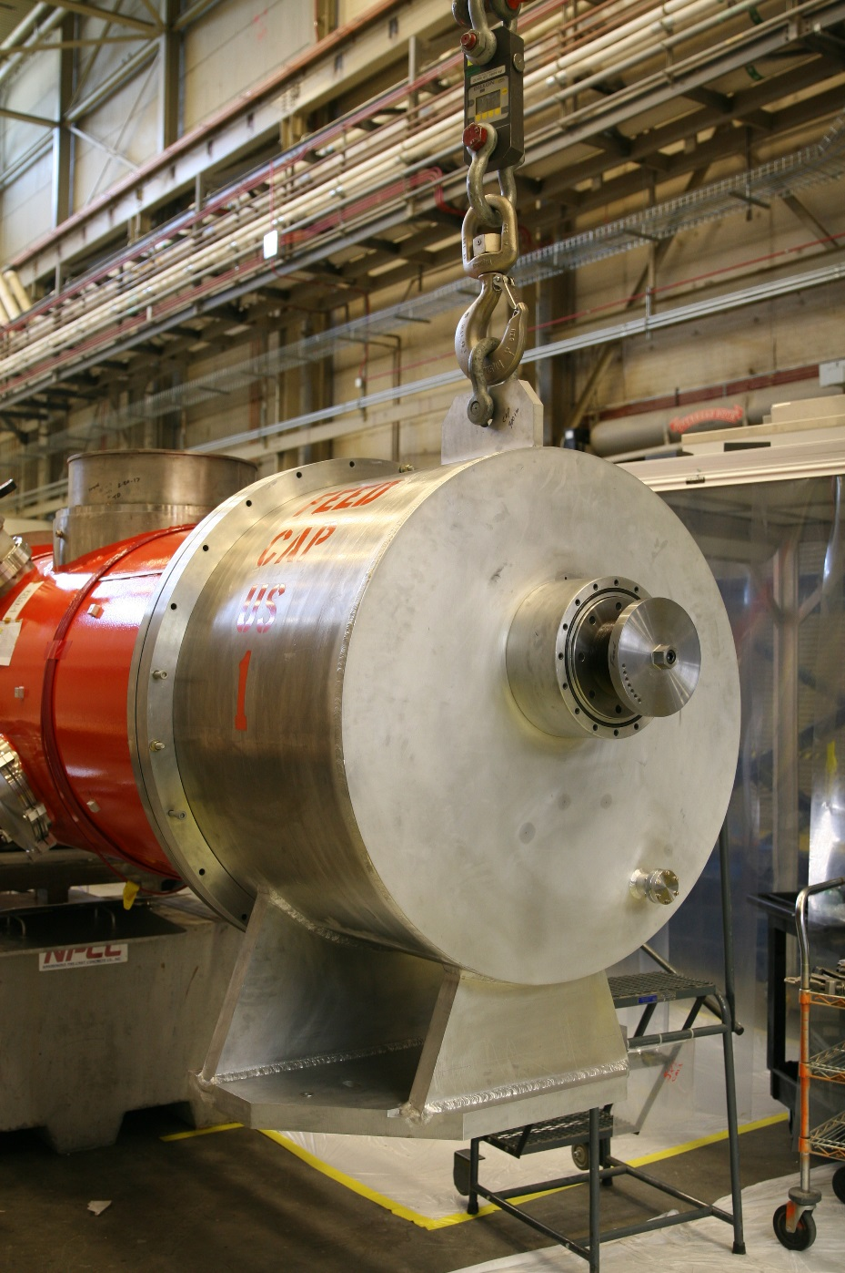

## Step 17: Spindle Push Rod Positioning

### Turn the Spindle Push Rod clockwise by hand to move the spindle into the HeGRP Insert. Stop once there is resistance.

### Tighten the SHCS by hand

### Using the hex feature, torque the Spindle Push Rod to 74 ft.lbs

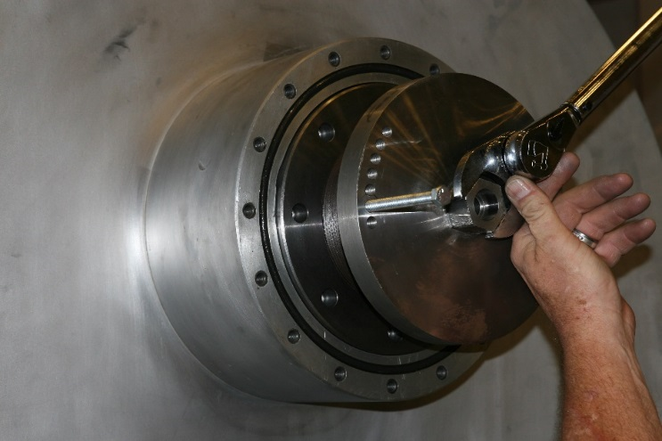

## Step 18: Spindle Push Rod Lock

### Use the 3/8-16 UNC x 4-1/2” HHCS to lock the Spindle Push Rod in Place

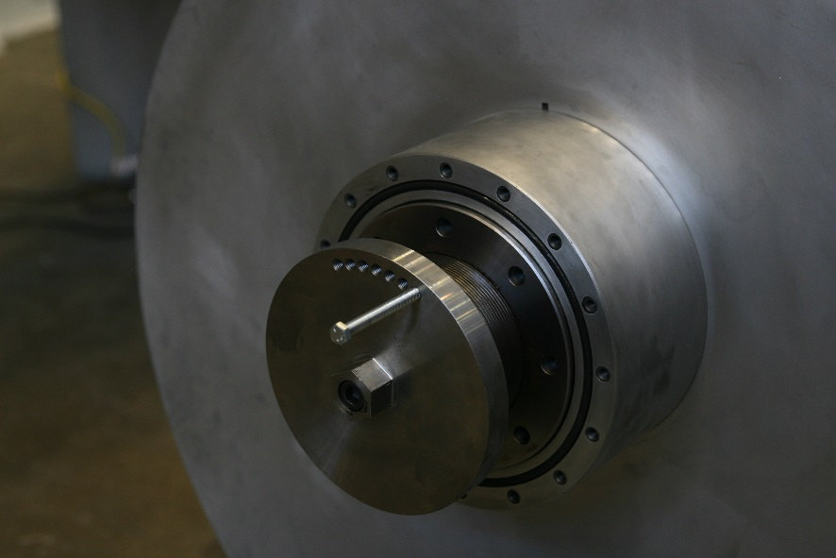

## Step 19: Install Cover

### Reinstall the Spindle Push Rod Cover

### Use a single split lock washer for each 3/8-16 UNC SHCS

### Torque the SHCS to 31 ft.lbs

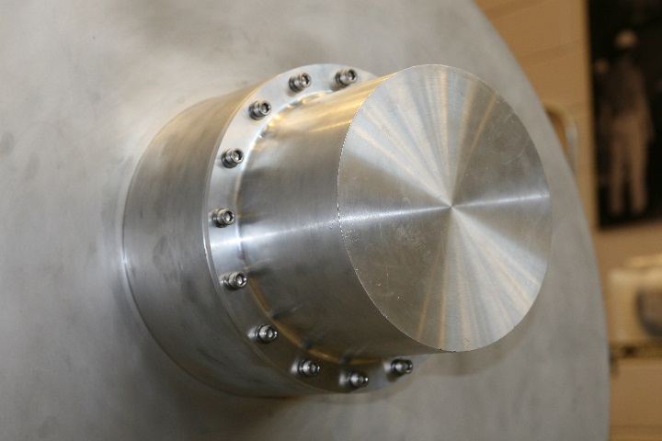

# References

|  |  |
| --- | --- |
| **Document No.** | **Title** |
| SRF-01-ML-001 | SRF Quality Manual |
|  |  |
|  |  |

# Release and Revision History

|  |  |  |
| --- | --- | --- |
| **Rev #** | **Major Changes** | **Effective Date:** |
| 1 | Initial version | DD Mmm YYY |
|  |  |  |
|  |  |  |
|  |  |  |

# Approvals

|  |  |  |  |
| --- | --- | --- | --- |
| **Approved by:** | **Name:** | **Signature:** | **Date:** |
| Document Owner | <First Last Name> | In Docushare | |
| Subject Matter Expert | <First Last Name> | In Docushare | |
| Work Center Lead | <First Last Name> | In Docushare | |
| Project Leader | <First Last Name> | In Docushare | |