|  |  |  |  |
| --- | --- | --- | --- |
| **Shipping Procedure for LCLS Cryomodules** | | | |
| **Document Number:** | L2HE-PR-CMA-CM-SHIP | **Effective Date:** | DD Mmm YYYY |
| **Revision Number:** | R1 | **Periodic Review Date:** | DD Mmm YYYY |
| **Document Owner:** | J. Fischer | **Department Owner:** | SRF Operations |

# Purpose

The purpose of this document is to describe the loading procedure to ship LCLS Cryomodules

# Scope

This procedure applies to LCLS Cryomodules

# Terms and Definitions

The following terms have specific meanings within this procedure.

|  |  |
| --- | --- |
| **Term** | **Definition** |
| <Term 1> | <Definition> |
| <Term 2> | <Definition> |
|  |  |

# Roles and Responsibilities

The following roles have responsibilities described in this document.

|  |  |
| --- | --- |
| **Role** | **Responsibility** |
| <Job Title> | <Very short summary of activities this job title performs in this procedure.> |
|  |  |
|  |  |
|  |  |

# Procedure

## Trucking company will proceed to back shipping trailer into test lab north roll up door. A technician will be needed to guide the truck into the building.

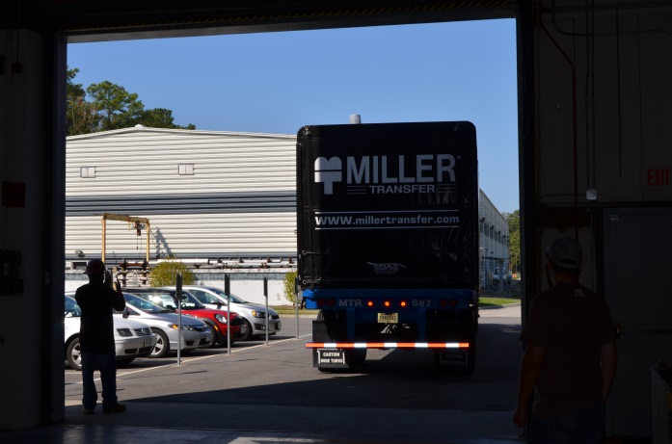

## Once the trailer is safely inside the building, place wheel chocks on both sides of trailer.

## Roll up back cover and slide trailer cover forward as shown on trailer instructional DVD.

## Using shipping frame lift plan have technicians rig the shipping frame to be removed from trailer.

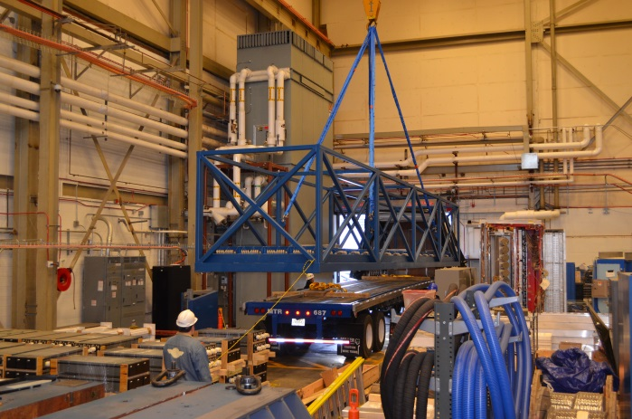

## Once frame is rigged slowly lift empty shipping frame so it just clears the bed of the trailer. Once frame is suspended above trailer, remove chocks and have driver pull the now empty trailer outside.

## Lower empty shipping frame to the ground and unhook slings from crane.

## Continuing to follow the frame lift plan, rig the top section of the frame for removal and pull the quick release pins. Remove top section of frame and set in a safe and secure spot.

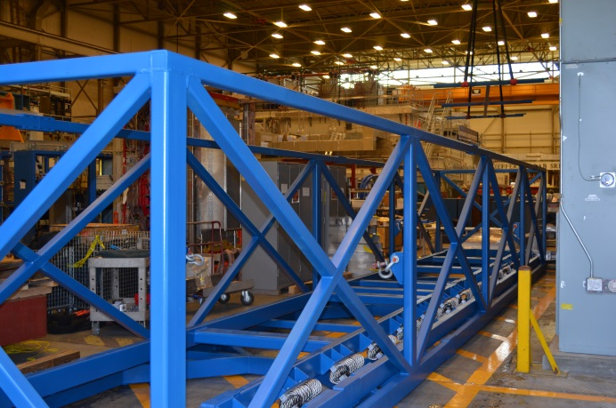

## Using the yellow spreader bar and appropriate lift plan prepare to hoist the completed LCLS cryomodule. Be sure to have people stationed at all walkways and doorways to keep bystanders away.

## Once spreader bar is properly connected to the module proceed to lift the module. Crane the module down to the shipping frame and begin to slowly lower it into the shipping frame.

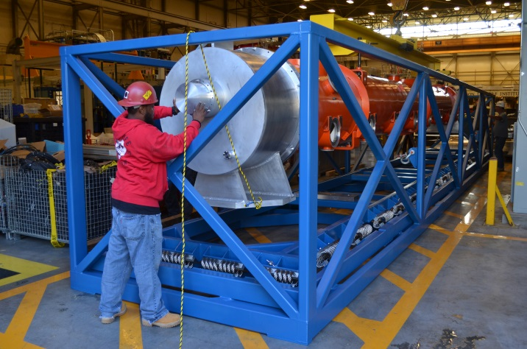

## Slowly insert the cryomodule into the shipping frame making sure to have enough people to watch every side of the module as it is a tight fit.

## The two baseplates of the cryomodule will align with large aluminum blocks inside the shipping frame. Making sure these are lined up properly is important because if incorrect the lockdown plates will not fit.

## Now that the cryomodule is properly lined up you may unhook the crane and use it to re-install the top section “lid” of the shipping frame.

## Install the 4 lockdown plates between the aluminum baseplates and the cryomodule base. Make sure the hardware is torqued to spec and is checked by at least 2 people.

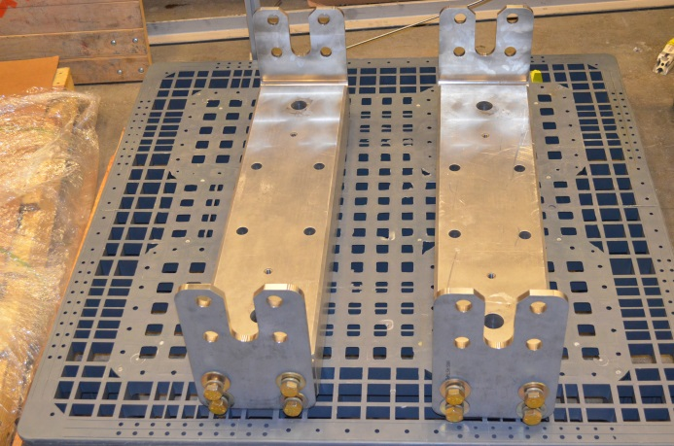

## Going back to the shipping frame lift plan, follow the steps again to pick up the fully loaded shipping frame.

## Once the frame is lifted high enough to clear the trailer a technician can then guide the driver back into the building and under the shipping frame.

## Slowly lower the shipping frame on to the trailer and shim the backside of it with wooden wedges if needed.

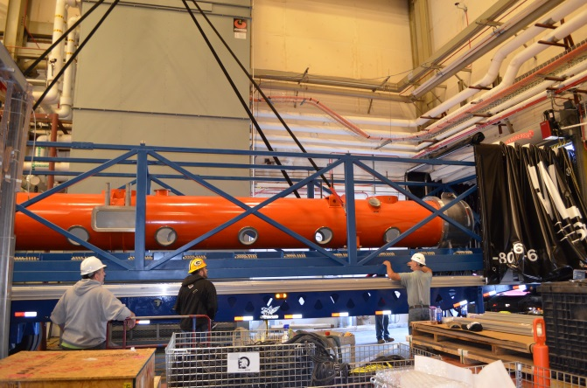

## Verify with the Shipping SOTR that the cryomodule is positioned and fastened correctly before closing up the trailer.

## Once everyone is satisfied, place one of the supplied ratchet straps every 8 ft along the shipping frame as shown in the pictures.

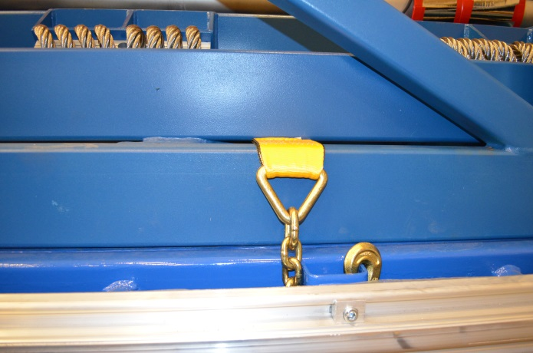

## Now that the frame is locked to the trailer the tarp may be fully closed.



## The trailer is now ready for shipment.

# References

|  |  |
| --- | --- |
| **Document No.** | **Title** |
| SRF-01-ML-001 | SRF Quality Manual |
|  |  |
|  |  |

# Release and Revision History

|  |  |  |
| --- | --- | --- |
| **Rev #** | **Major Changes** | **Effective Date:** |
| 1 | Initial version | DD Mmm YYY |
|  |  |  |
|  |  |  |
|  |  |  |

# Approvals

|  |  |  |  |
| --- | --- | --- | --- |
| **Approved by:** | **Name:** | **Signature:** | **Date:** |
| Document Owner | <First Last Name> | In Docushare | |
| Subject Matter Expert | <First Last Name> | In Docushare | |
| Work Center Lead | <First Last Name> | In Docushare | |
| Project Leader | <First Last Name> | In Docushare | |