Inspection Procedure for LCLS-II-HE Cold Fundamental Power Coupler

Document Number: | L2HE-PR-INSP-FPCC | Effective Date: | 26 Apr 2024
Revision Number: | R9 | Periodic Review Date: | 26 Apr 2027
Document Owner: | Naeem Huque | Department Owner: | SRF Operations

Purpose

This procedure outlines the steps for performing incoming inspections on Fundamental Power Coupler Cold pairs

This procedure supports the Quality Management System as described in SRF-01-ML-001 Quality Manual.

Terms and Definitions

The following terms have specific meanings within this procedure.

Term | Definition
LCLS-II-HE | Linear Coherent Light Source-II High Energy
FPC | Fundamental Power Coupler
SLAC | Stanford Linear Accelerator Center
CM | Cryomodule
RF | Radiofrequency
SSA | Solid State Amplifier
RAV | Right Angle Value
UHV | Ultra-High Vacuum
TWG | Test Waveguide
CF | ConFlat

Roles and Responsibilities

The following roles have responsibilities described in this document.

Role | Responsibility
Assembly Technicians | Knowledgeable persons authorized by the Group Lead to inspect FPCs

Procedure

Introduction

The LCLS-II-HE FPCs are UHV components which are designed to transmit RF power from SSAs to cavities, within a CM. The FPC assembly is made up of three parts: the warm FPC (FPCW), cold FPC (FPCC) and the FPC Push Rod (FPPR); this procedure covers the incoming inspection steps for the FPCCs.

FPCCs (Figure 1.1) are delivered to partner labs from the vendor, CPI. A pair of FPCCs are installed on a Test Waveguide (TWG) box (Figure 1.2). The internal space of the FPCCs and the waveguide box are under UHV. Each of the pair and waveguide box assemblies are packed within two bags made from MIL-PRF-131K, Class 1 (>4mils thick) bagging material.

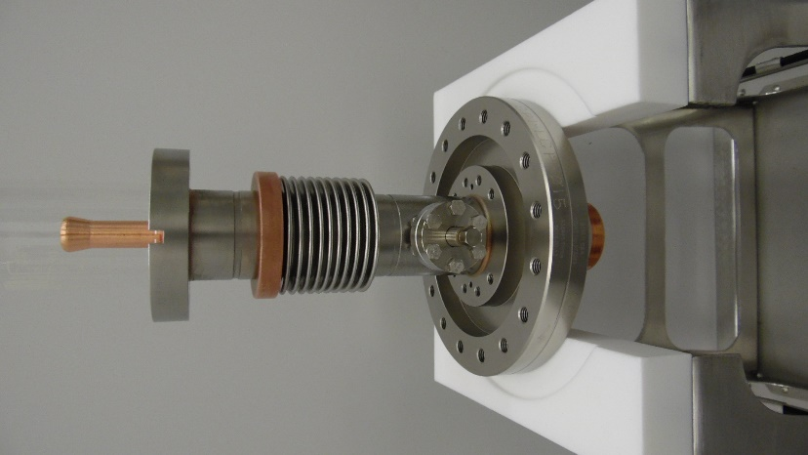
Figure 1.1: FPCC

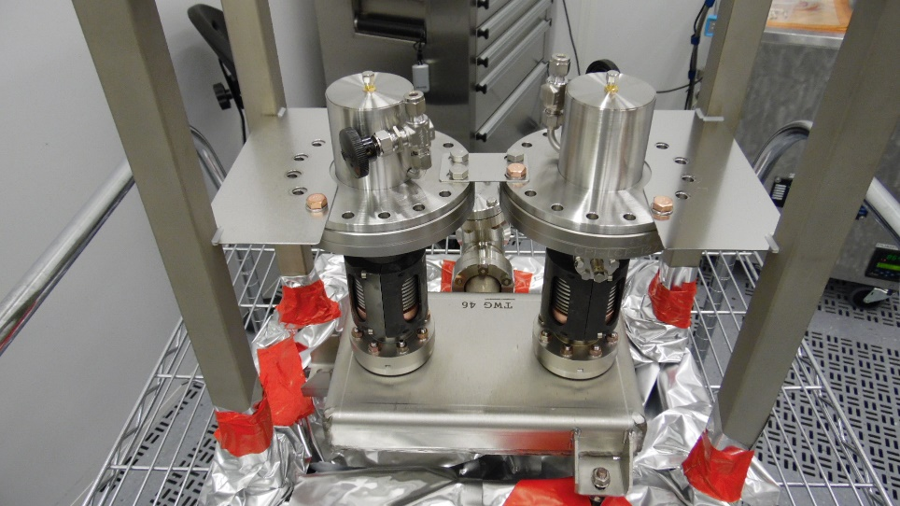
Figure 1.2: Two FPCCs on a TWG

Pre-Inspection

Perform the following tasks prior to the FPCC/TWG assemblies being taken into the chemistry area. Record the applicable information in L2HE-CLNRM-FPCC-INSP

Record the inspection date and technician name in the traveler

Visually inspect the outer plastic bag

Record the Pair number and FPCC serial numbers in the traveler

Chemistry

Remove the FPCC pair from the crate and place on a cart; the weight of the assembly requires a two-person lift. Move the cart into the chemistry room.

Record the chemistry room admission date and technician name in the traveler

Wipe down the outer plastic bag with isopropyl alcohol

Push the cart into the pass-thru area

Remove and discard the outer plastic bag

Wipe inner plastic bag down with isopropyl alcohol and spray with dry nitrogen

Push the cart into the cleanroom vacuum pumping area

Vacuum leak check and rga scan

Prior to starting the bag leak check, the following tools and hardware will be required:
- Pump cart
- Filtered, de-ionized N2 source
- 2-3/4 CF gasket
- 2-3/4 CF Flange hardware
- Wrenches
- Scissors

Move the cart into the particulate counter area. Prepare the area as per CP-L2PRO-CST-CHEM-CLN-ION-R1.

Blow down the bag with nitrogen until 0.3μm counts are below 1000, or for 15 minutes (whichever comes first).

Vacuum Leak Check

Record the date and the vacuum leak check technician in the traveler.

Clean vacuum components as per CP-L2PRO-CST-CHEM-CLN-ION-R1.

Cut the plastic in front of the RAV and attach the hose for the vacuum pumping system (Figure 4.1).

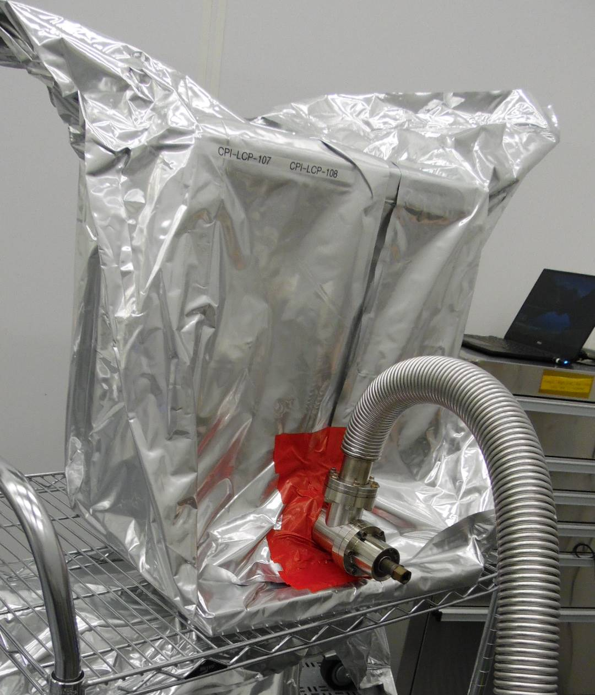
Figure 4.1: Pumping line installed on RAV

Open the RAV and record the static vacuum in the traveler.

Pump down the FPCC and TWG assembly as per CP-L2PRD-CLN-PUMP.

Check the CF joints on the RAV and vacuum line by spraying He gas as per CP-L2PRD-CLN-PUMP.

Open the N2 valve on the ceramic protection cap.

Seal the plastic bag using cleanroom tape as shown in Figure 4.1.

Perform the bag leak check as per CP-C100-CAV-LKTS. Upload the data file into the traveler and generate an NCR if a leak higher than 2.76x10⁻¹⁰ torr-l/sec He is found.

If a leak is found, remove the bag and conduct a He spray leak test to identify the leak location, then inspection work on the pair.

Record analog RGA data in the traveler.

Remove the plastic bag from the assembly.

Level 4 Heading

Check that the electron probes are properly installed using a multimeter.

Connect the multimeter cable to each FPCC in turn. The resistance value should indicate an Open Loop (Figure 5.1). Otherwise, generate an NCR.

Generate an NCR if the threads are damaged.

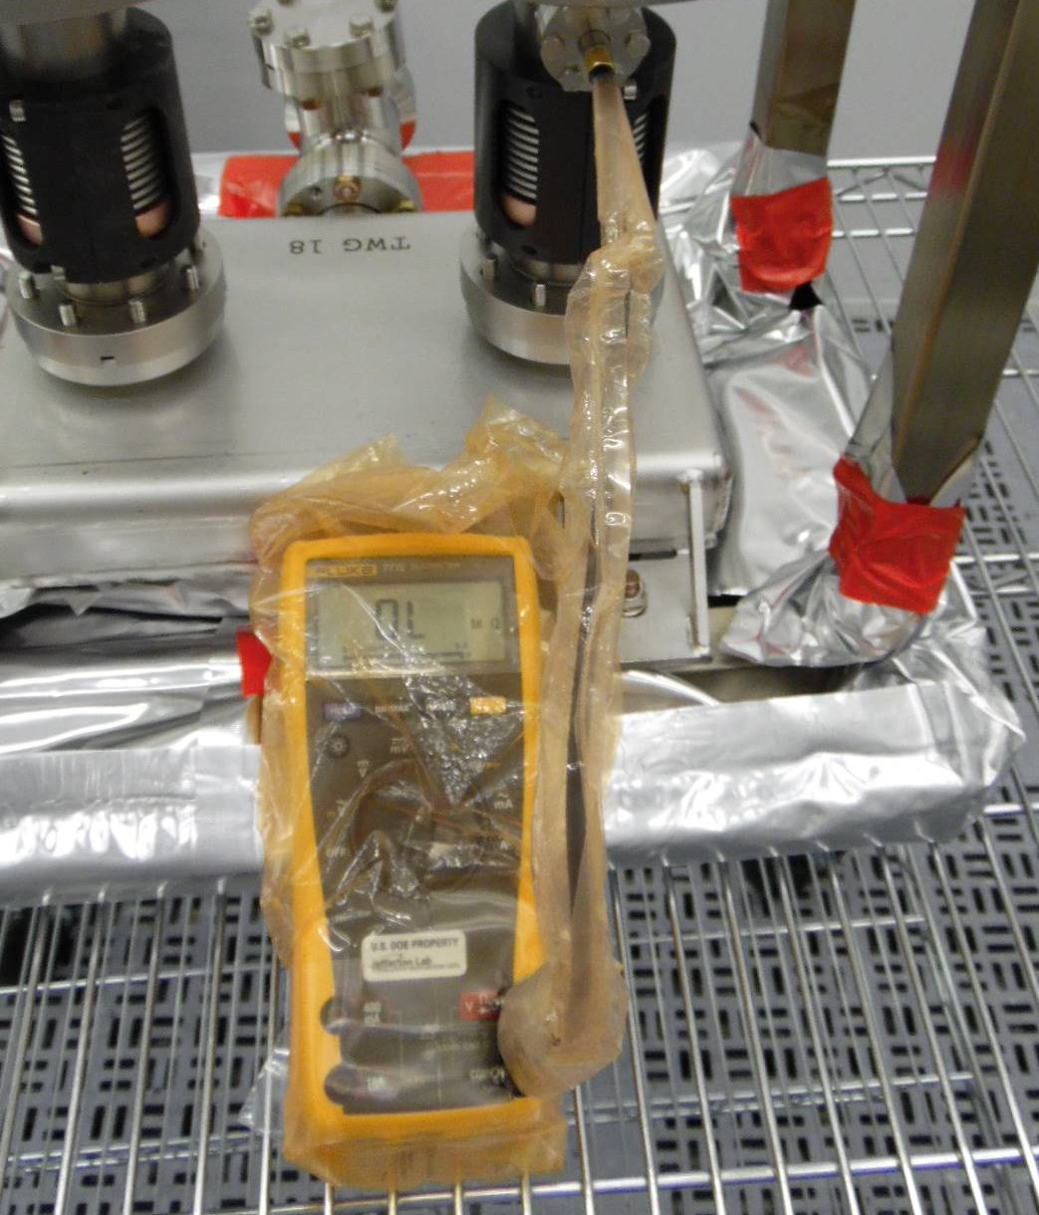
Figure 5.1: Multimeter reading of Electron Probe

Visual inspection after removing protection caps

Perform a particulate count of the FPCC-1 external surfaces. Generate an NCR if the 0.3μm count cannot be brought below 1000 counts after 15 minutes of spraying.

Wipe down the assembly.

Remove the ceramic protection caps on each FPCC (Figure 6.1) using the following steps:

Hold the large flange in place using the 10mm Stainless Steel Rod. This must be in place whenever the HHCSs on the top section of the FPCC are tightened or loosened.

Remove only the M8 HHCSs holding the Support Bracket on to CF100 flange. Remove the support bracket, but do not replace the M8 HHCSs.

Install a minimum of four FPC Tophat Alignment Rods (JL0128795) into the empty M8 threaded holes on the DN100 flange (evenly spaced, see Figure 6.1).

If the alignment of the cap holes do not allow the alignment rods to be threaded in, then loosen (but do not remove) the HHCSs and adjust the position of the protective cap laterally.

Loosen the M8 x 1.25 HHCSs holding down the protective cap

Remove the M8 HHCSs.

Lift the protective cover upwards using the Alignment Rods as guides, while minimizing contact between the rods and the IDs of the cover’s clearance holes.

If the cap is stuck on to the flange, pry it at the leak check groove. Do not try to force or twist the cap.

Once the cap is clear of the FPC ceramic, remove the alignment rods from the threaded holes.

Generate an NCR if any damage is noted on the threads.

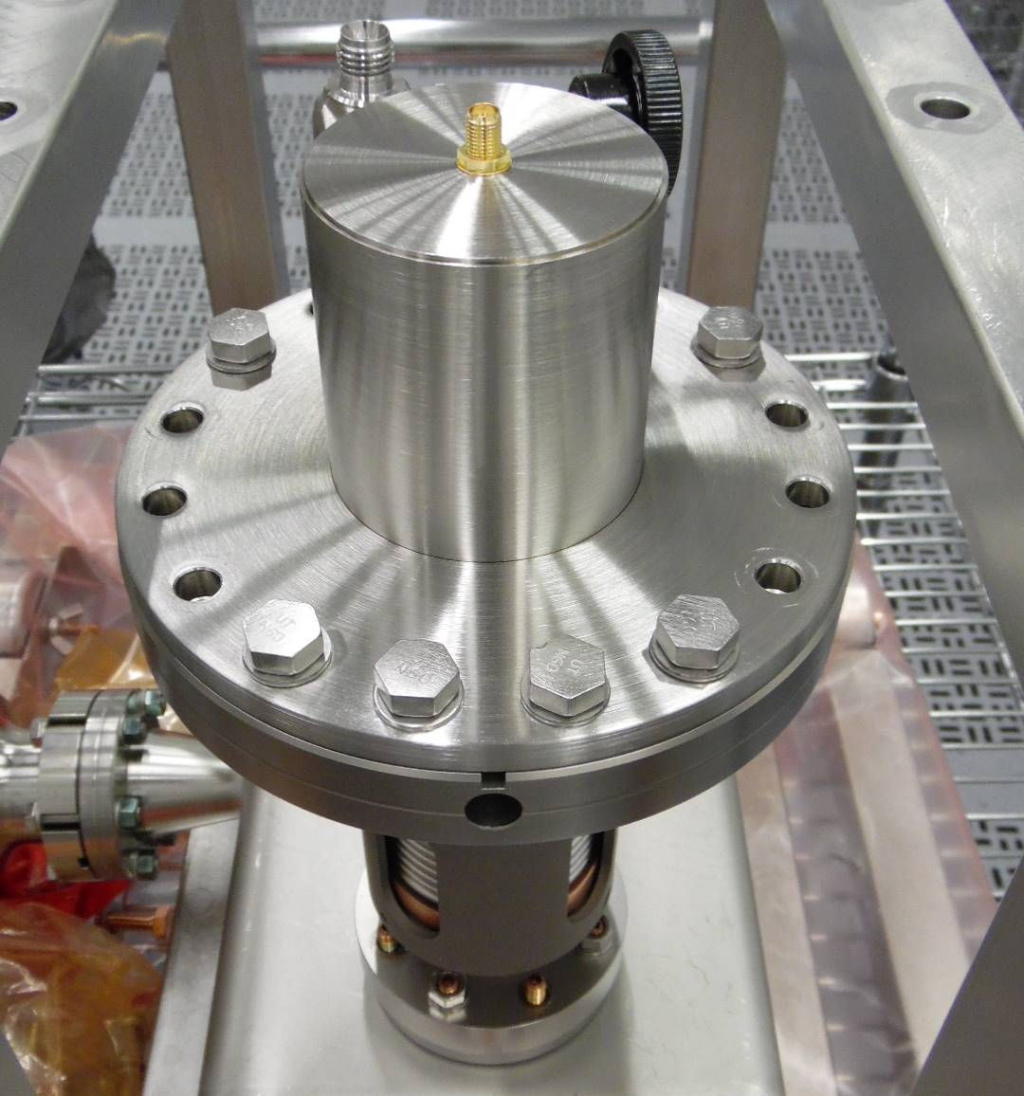 | 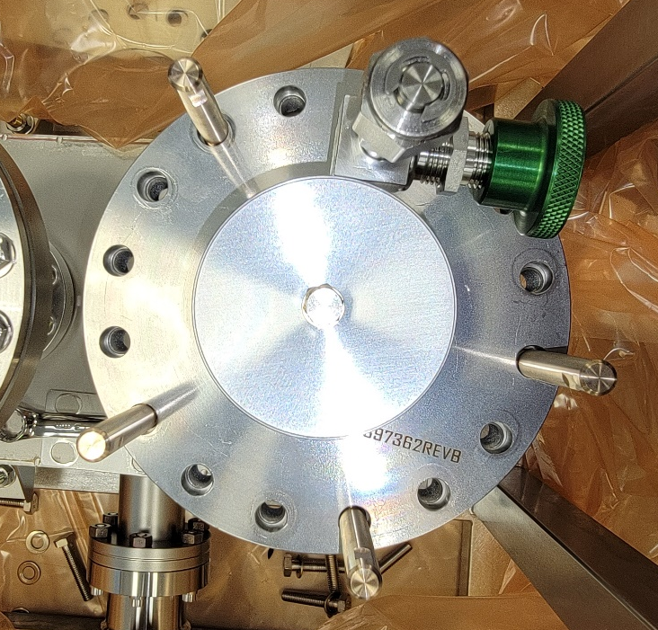
Figure 6.1: Ceramic Protection Cap (left) and example of Alignment Rod positions (right)

Visually inspect and photograph the ceramics (Figure 6.2). Generate an NCR if there are any scratches, dark spots, chips, or stains

Photos should be taken on all sides at 90-degree rotations.

Take additional close-up images of the upper and lower edges of the ceramic.

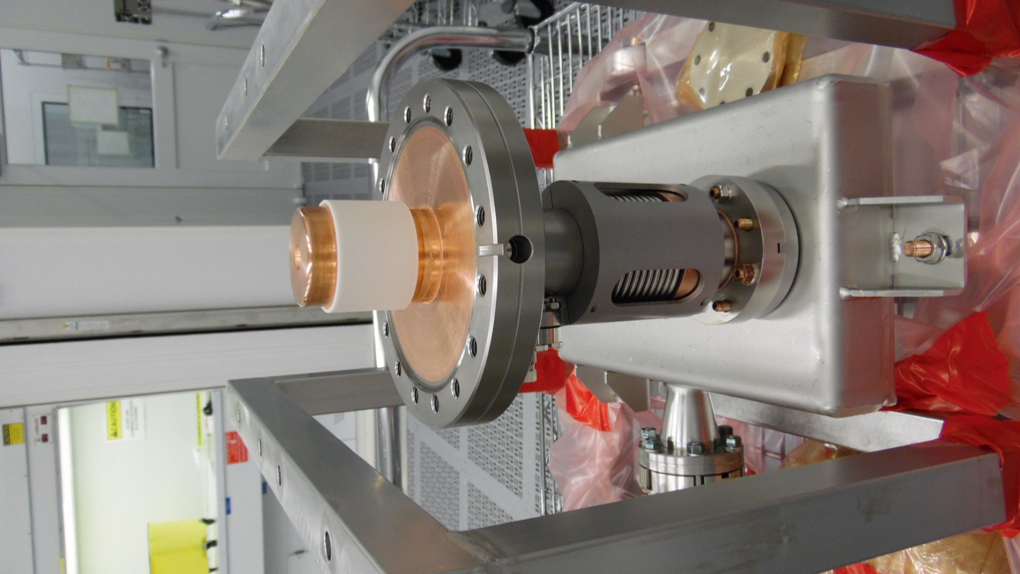
Figure 6.2: FPCC Ceramic

Visually inspect and photograph the knife edges on the CF100 flanges on each FPC (Figure 6.3). Generate an NCR if there are any defects on the knife edges
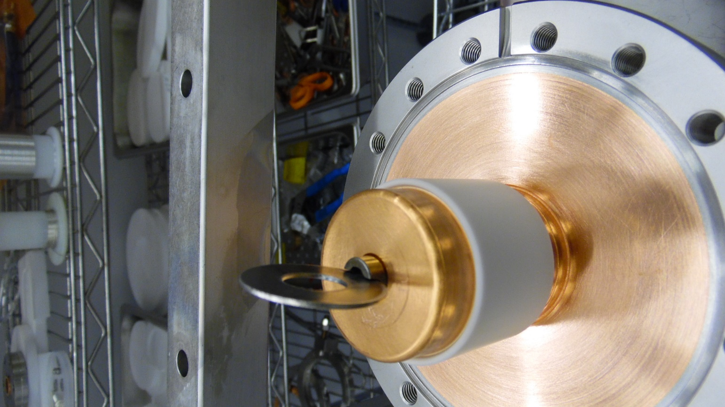
Figure 6.3: CF100 Flange Knife Edge

Visually inspect and photograph the copper plating on the flange surface (Figure 6.4). Generate an NCR if there are any pits, blisters, or flaking copper. Generate an NCR if there is any Viton residue on the copper.

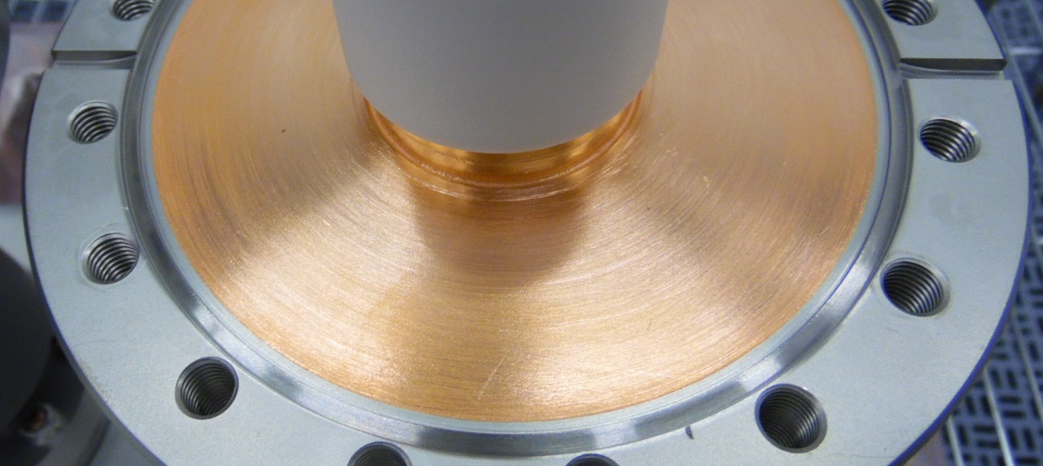
Figure 6.4: Copper plating on CF100 Flange

Visually inspect and photograph the RF contact surface above the ceramic (Figure 6.5). Generate an NCR if there are any dents or scratches on the surface.

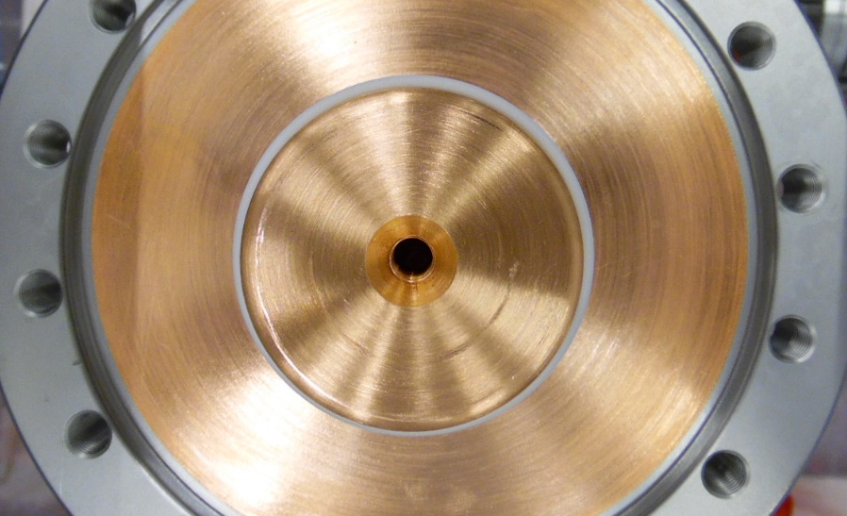
Figure 6.5: RF Contact Surface

If the RF pin is present, remove it and check that the threads are clean and intact (Figure 6.6), and take photos. Generate an NCR if there is damage to the threads or if there is excessive dirt or oil.

Visually inspect the M8 threaded holes on the flange and check for dirt or grease. Run one of the provided M8 HHCSs through the holes to check for smooth motion. Generate an NCR if any damage is found on the threads.

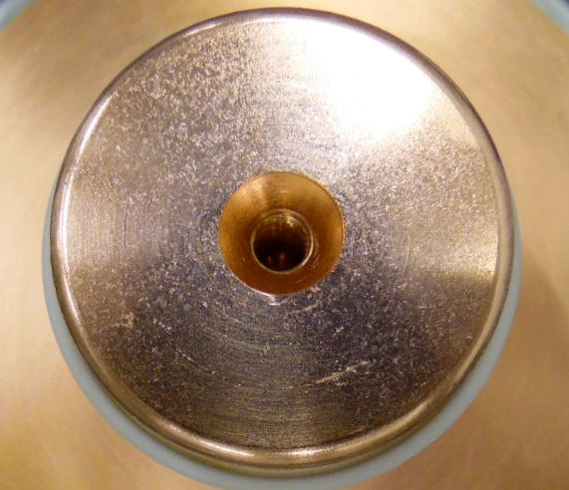
Figure 6.6: RF Pin threaded hole

Reinstall the two ceramic protection caps and RF pins using the following steps:

Install the RF Pin in the center hole of the conductor. If a pin did not come installed in the assembly, collect one from inventory.

Install four Alignment Rods (JL0125795) in the threaded holes on the first FPCC, in the positions shown in Figure 6.7

Position the o-ring on the CF100 Flange

Clock the protective cap in the final position for installation on the string (Figure 6.8). The location of the probe must be used as a reference.

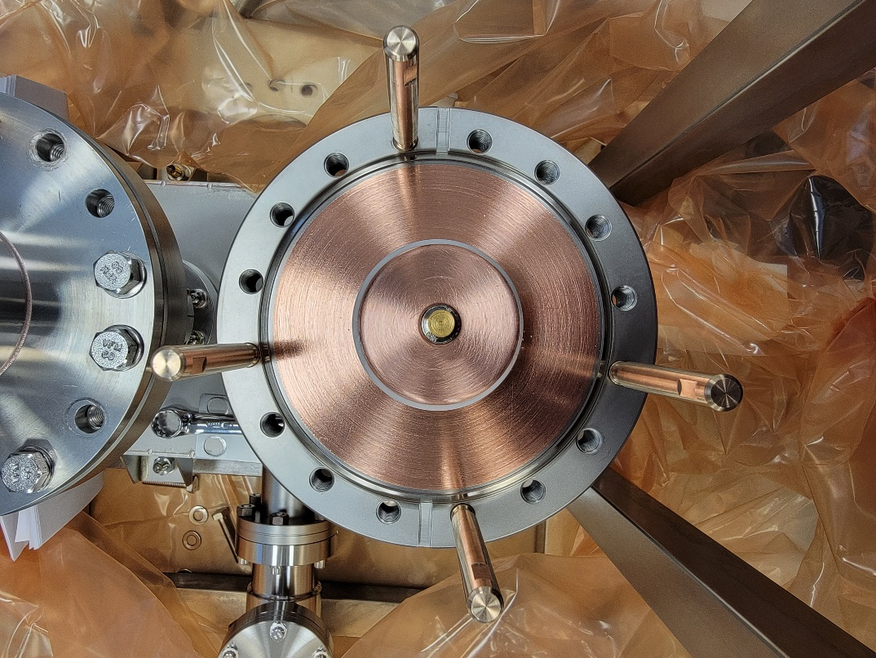
Direction of Electron Probe
Figure 6.7: Positions of Alignment Rods

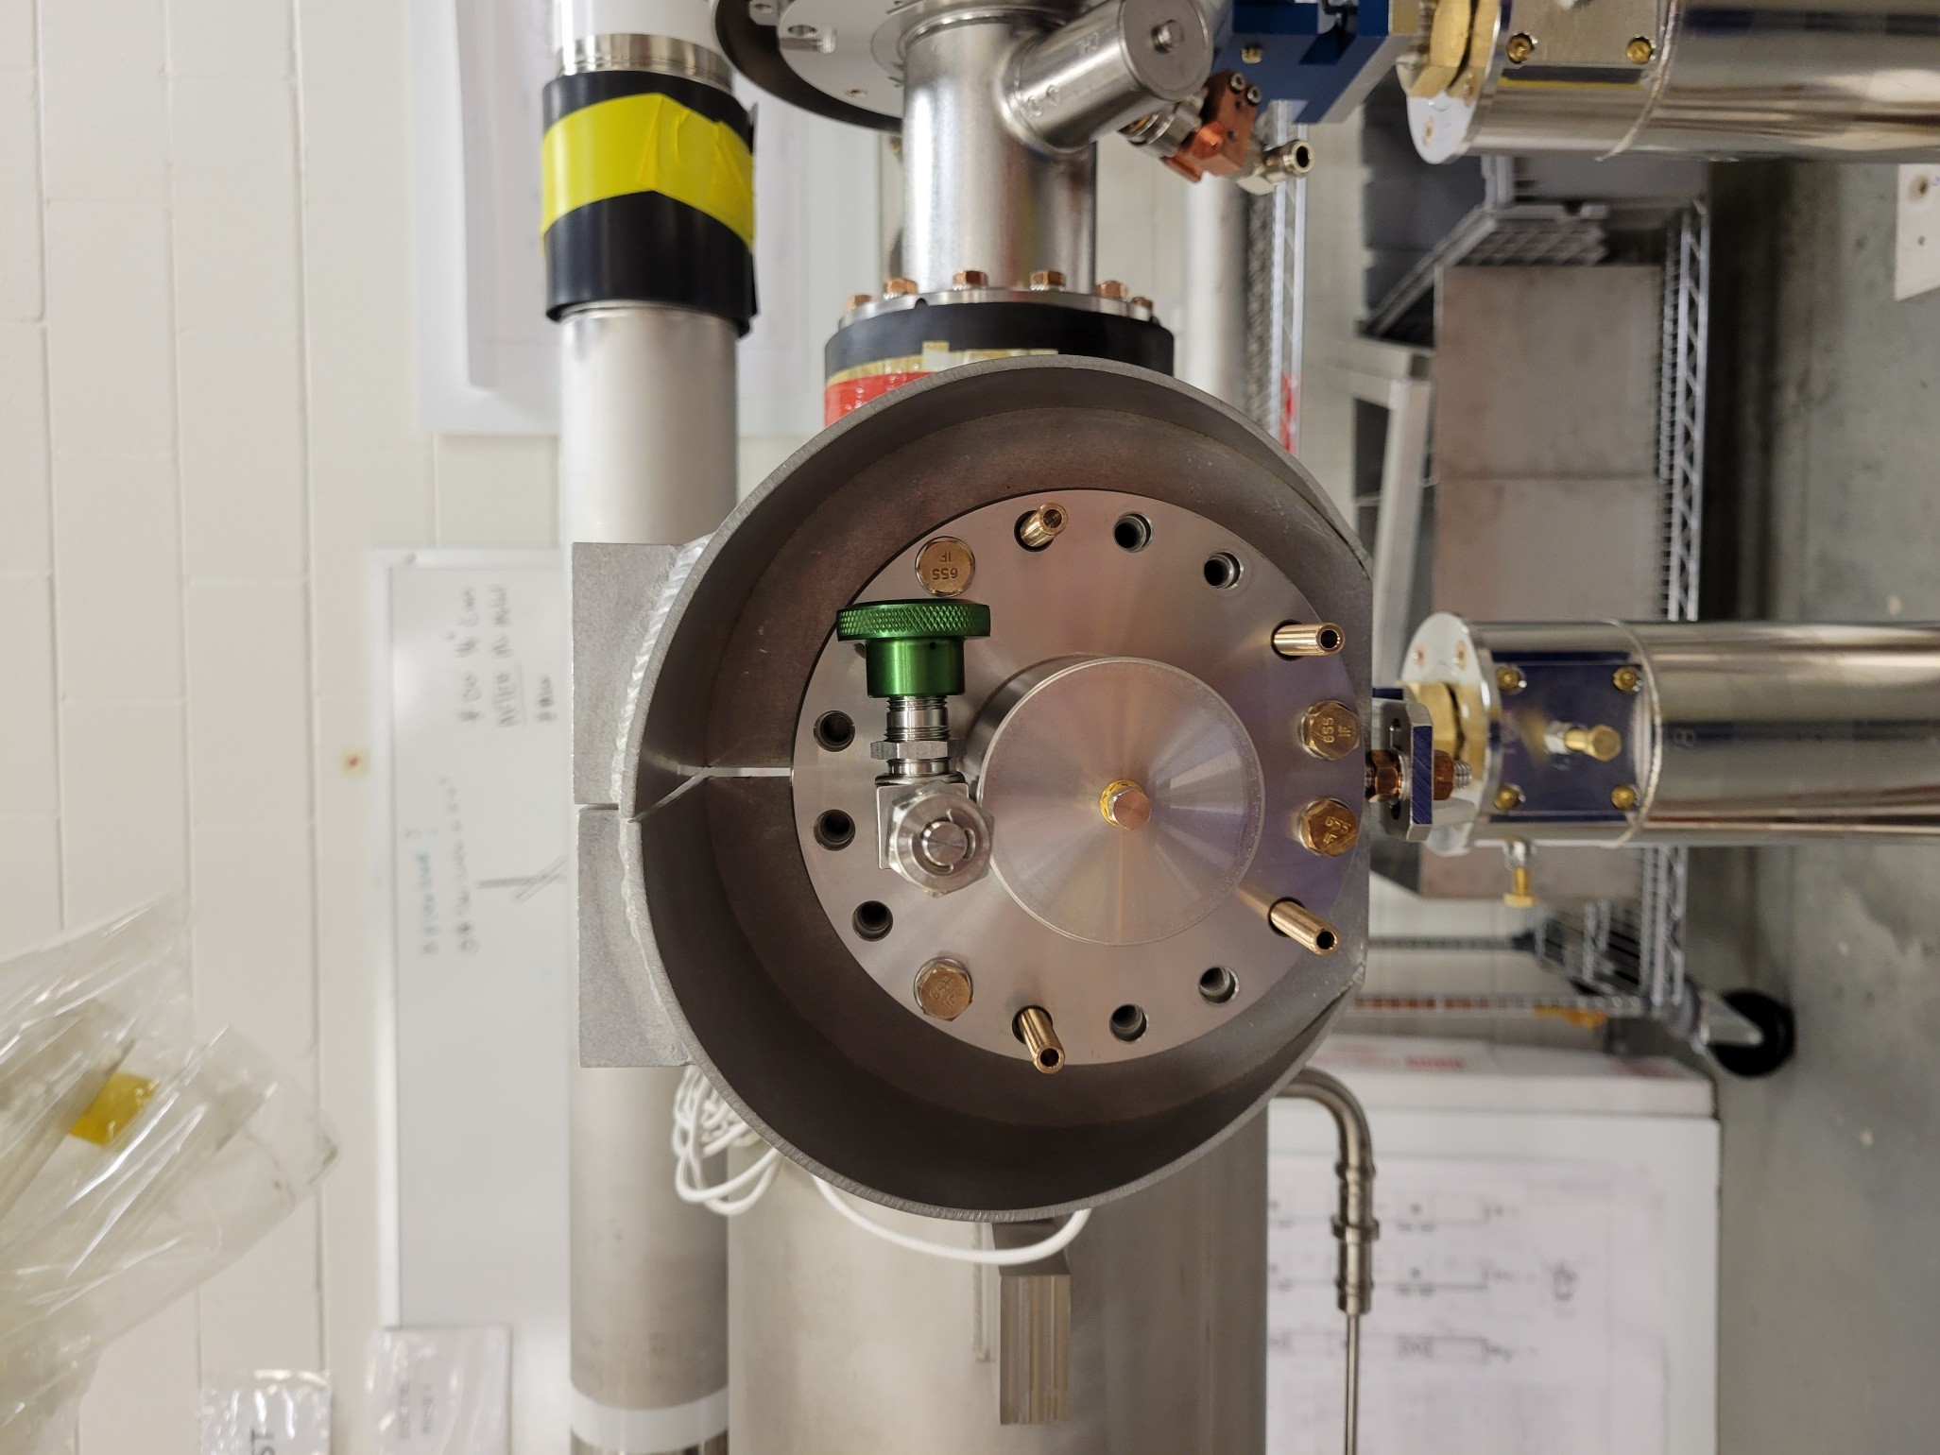
Direction of Electron Probe
Figure 6.8: Clocking of the protective cap and valve

Slowly lower the cap down to the CF100 flange using the Rods as guides; minimize contact between the Rods and the clearance hole IDs.

Once the cap is sitting on the flange, start threading the shorter M8 x 1.25 HHCSs and washers in the positions shown in Figure 6.8.

Remove the Alignment Rods.

Finger tighten the four HHCSs

Install the 10mm Stainless Steel Rod to hold the flange in place.

Torque the four HHCSs to 10 in.lbs. Do not overtighten.

Repeat the process for the other FPCC

Slightly unscrew the SMA connector (Figure 6.9) and back-fill the space under the caps with dry, filtered nitrogen.

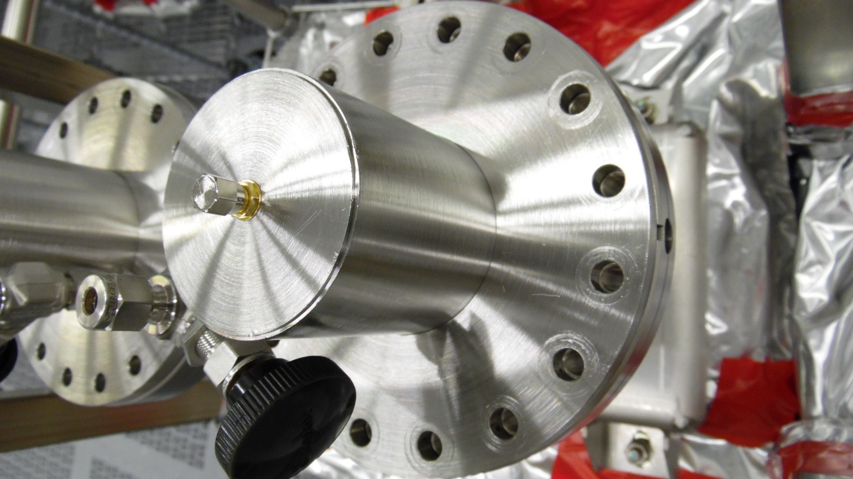
Figure 6.9: SMA connector on ceramic protection cap

Tighten the SMA connector to seal the space

Individual FPCC Visual Inspections

Bleed up the test box with dry, filtered nitrogen with the following steps:

Close the RAV.

Connect the controlled bleed-up device to the pumping system.

Pump down the bleed-up hose.

Open the RAV.

Start pumping down the assembly and controlled bleed-up system.

Close valve on the pumping system.

Start controlled bleed-up process.

Remove FPCC-1 from the TWG using the following steps:

Remove all bolts from the FPCC cavity flange (Figure 7.1).

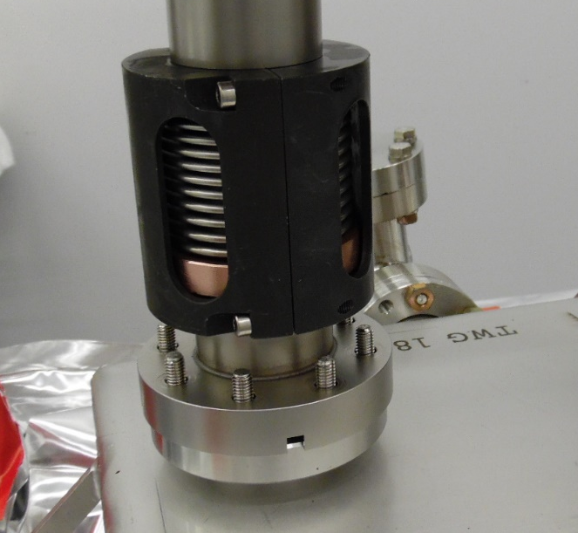
Figure 7.1: Removing hardware from Cavity Flange

Wipe down the external surface of the cavity flange with isopropyl alcohol.

Dry the surfaces using dry, filtered nitrogen.

With the TWG under continuous positive nitrogen flow, remove FPCC-1 from the TWG and place it on the inspection stand.

Visually inspect the FPCC-1 and record the findings in the traveler.

Remove the bellows protection bracket (Figure 7.3) and inspect the bellows convolutions. Photograph the O.D. of the bellows with a (maximum) 90 degree separation. Generate an NCR if there are any dents or scratches larger than 1/16”, or any other signs of damage.

Wipe down and reinstall the protection bracket once finished

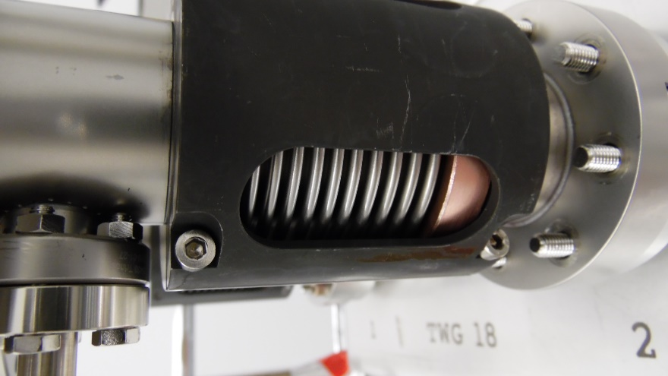
Figure 7.3: Bellows protection bracket

Visually inspect and photograph the cavity flange sealing surface (Figure 7.4). Generate an NCR if there are any traces of the AlMg seal or any scratches or residue

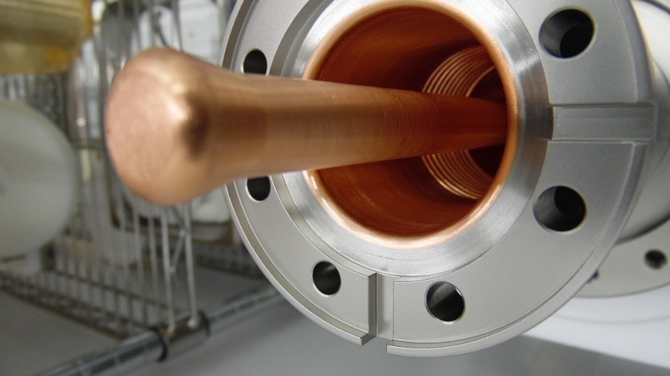
Figure 7.4: Sealing surface of the FPCC cavity flange

Visually inspect and photograph the regions of copper plating on the inside of the FPCC (Figure 7.5) which are visible through the cavity flange. Generate an NCR if there are any scratches, pits, blisters, or flaking copper.

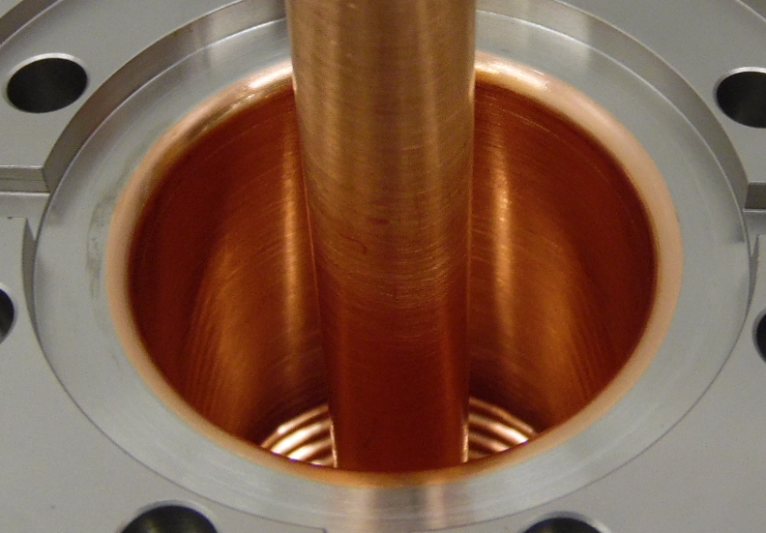
Figure 7.5: Inner copper plating of FPCC

Visually inspect and photograph the end of the copper antenna (Figure 7.6). Generate an NCR if there are any scratches, chemical residue or erosion spots.

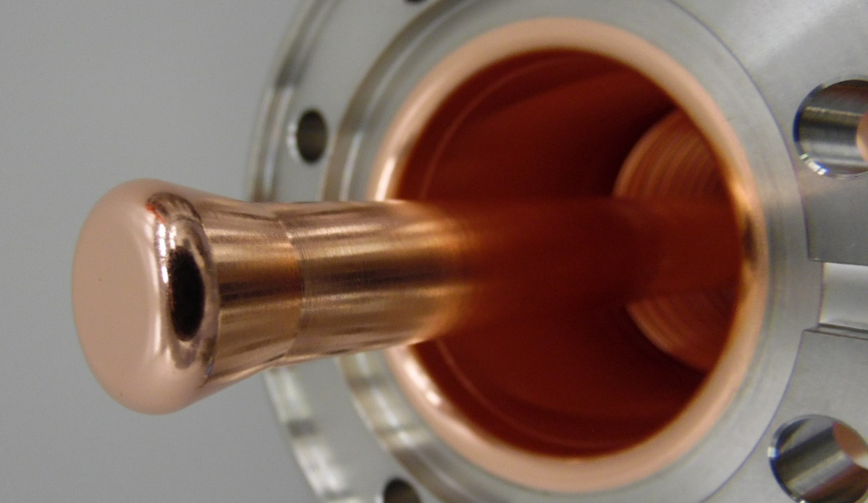
Figure 7.6: Copper antenna tip

Perform a particulate count on the internal surfaces of FPCC-1

Generate an NCR if the 0.3μm count cannot be brought below 10 counts after 15 minutes of spraying.

Record the results in the traveler.

Reinstall FPCC-1 into the TWG.

Use the same NW40 aluminum seal and Nitronic-60 hardware.

Repeat Steps 7.2 – 7.5 for FPCC-2

Storage

Store the FPCC pair in the cleanroom in preparation of string assembly

Disconnect the pumping and bleed-up systems.

Pressurize the internal space with filtered N2.

Close the RAV.

Blank off the RAV.

Move the assembly to the storage area in the cleanroom.

Record the storage date in the traveler.

Process Flow

<Related Process Outside this Procedure>
<Starting Condition>
<Step 2>
<Related Step 1>
<Step 4>
<Decision>
<Related Step 2>
<Related Step 4>
<Ending Condition>
<Step 1>
YES
NO
<Related Decision>
<Related Step 3>
YES
NO
<Step 3>

References

Document No. | Title
SRF-01-ML-001 | SRF Quality Manual
SRF-MSPR-CLNRM-PUMP-R1 | Clean Room Production Pump System Operation
SRF-MSPR-CLNRM-CST-ION-R3 | Ionized Nitrogen Parts cleaning
SRF-MSPR-CLNRM-LEAK-R1 | Leak testing with an RGA
L2HE-PR-CMA-CM-SLBUP-R1 | LCLS-II Production Slow bleed up/pump down Procedure
Vacuum-005-2008 | Guidelines for UHV-Components at DESY
L2HE-PR-CHEM-CAV-DEGR-R1 | Standard Cavity, Components, or Parts Degreasing Procedure
Solair 3100 Gen E Manual | S3100/S5100/Boulder Counter Gen E Operating Manual
LCLSII-HE-1.2-ES-0059 | Document Title: LCLSII-HE Fundamental Power Coupler ESD

Release and Revision History

Rev # | Major Changes | Effective Date:
1 | Initial version | 5/10/2021
2 | Removed kit parts and RGA criteria | 7/23/2021
3 | Added instructions to upload photographs at multiple steps, regardless of whether defects are present. | 9/26/2021
4 | Added instructions for removing and installing Protective Cap using Alignment Rods (6.3 and 6.6). Added ceramic photo requirements (6.4). Shorter M8 HHCSs are used to replace caps instead of the original long ones (6.6.6) | 5/13/2022
5 | Updated Figure 6.1. Section 6.3.2 changed three rods to a minimum of four rods. Added locations for installing alignment rods (section 6.6.2). Updated Figure 6.7 as per 6.6.2. Added locations of M8 HHCSs (section 6.6.6). Updated Figure 6.8 as per 6.6.6. Removed specific number of alignment rods in 6.6.7. | 5/26/2022
6 | Add instructions (6.3.1 and 6.6.9) for using the 10mm Stainless Steel Rod to aid in removing/installing the tophat | 10/17/2022
7 | Replaced Figure 6.8 showing new positions for hardware | 7/20/2023
8 | Altered sections 6.5.3 and 6.6.1 to account for units that arrive from the vendor without RF pins. | 3/14/2024
9 | Added sections 5.1.2, 6.3.8, and 6.5.4 to check for damage to threaded holes | 4/25/2024

Approvals

Approved by: | Name: | Signature: | Date:
Document Owner | Naeem Huque | In DocuShare
Production Team Lead | Danny Forehand | In DocuShare
Production Group Lead | Kirk Davis | In DocuShare
Reviewer | Chris Dreyfuss | In DocuShare
CAM | Adam Grabowski | In DocuShare
Quality Representative | Jacob Harris | In DocuShare
SRF Department Head | Tony Reilly | In DocuShare

Form Release and Revision History

Rev # | Major Changes | Effective Date:
1 | Initial version | 30 Apr 2021

Form Approvals

Approved by: | Name: | Signature: | Date:
Document Owner | Jacob Harris
Quality Representative | Anne McEwen
SRF Department Head | Tony Reilly

