|  |  |  |  |
| --- | --- | --- | --- |
| **Inspection Procedure for LCLS-II-HE Warm Fundamental Power Coupler** | | | |
| **Document Number:** | L2HE-PR-INSP-FPCW | **Effective Date:** | 09 May 2024 |
| **Revision Number:** | R2 | **Periodic Review Date:** | 09 May 2027 |
| **Document Owner:** | Naeem Huque | **Department Owner:** | SRF Operations |

# Purpose

This procedure outlines the steps for performing incoming inspections on warm Fundamental Power Coupler pairs

This procedure supports the Quality Management System as described in SRF-01-ML-001 Quality Manual.

# Terms and Definitions

The following terms have specific meanings within this procedure.

|  |  |
| --- | --- |
| **Term** | **Definition** |
| LCLS-II-HE | Linear Coherent Light Source-II High Energy |
| FPC | Fundamental Power Coupler |
| SLAC | Stanford Linear Accelerator Center |
| CM | Cryomodule |
| RF | Radiofrequency |
| SSA | Solid State Amplifier |
| UHV | Ultra-High Vacuum |
| LFH | Laminar Flow Hood |
| SHCS | Socket Head Cap Screw |

# Roles and Responsibilities

The following roles have responsibilities described in this document.

|  |  |
| --- | --- |
| **Role** | **Responsibility** |
| Project Manager/CAM | Approves procedure and scope. |
| Procedure Author | Develops procedure and revises as necessary. Ensures technical staff has access to latest procedure revision. |
| Technical Staff | Follows operation steps in accordance with this procedure. Obeys all safety requirements of the room/workcenters. Fills out travelers and writes NCRs as necessary. |
| Workcenter Lead | Reviews procedure. Assigns technical staff to complete tasks outlined in the procedure. Ensures technical staff performs tasks in accordance with room/workcenter safety requirements. |

# Procedure

## Introduction

The LCLS-II-HE FPCs are UHV components which are designed to transmit RF power from SSAs to cavities, within a CM. The FPC assembly is made up of three parts: the warm FPC (FPCW), cold FPC (FPCC) and the FPC Push Rod (FPPR); this procedure covers the incoming inspection steps for the FPCW assemblies, which include the FPPR.

FPCWs (Figure 1.1) are delivered to partner labs from the vendor, CPI. The internal space of the FPCWs and the waveguide box are under UHV. Each of the pair and waveguide box assemblies are packed within two bags made from MIL-PRF-131K, Class 1 (>4mils thick) bagging material (Figure 1.2).

This inspection may be carried during the warm FPC installation process. In this case, the Storage steps will not apply

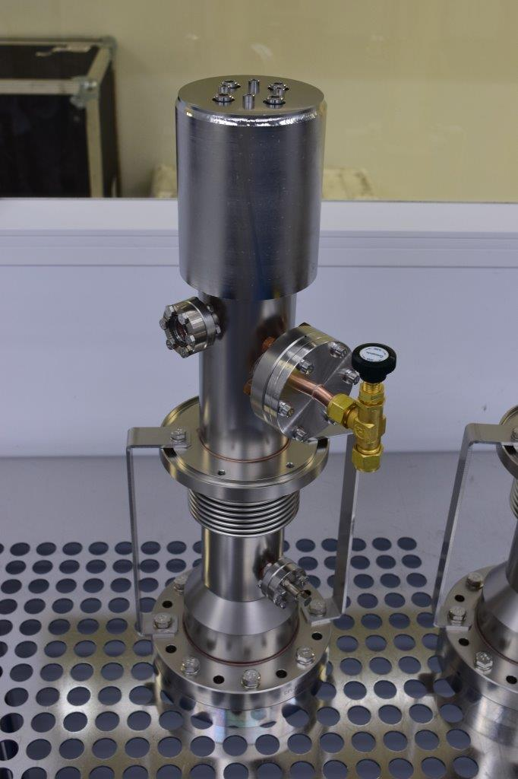

Figure 1.1: FPCW

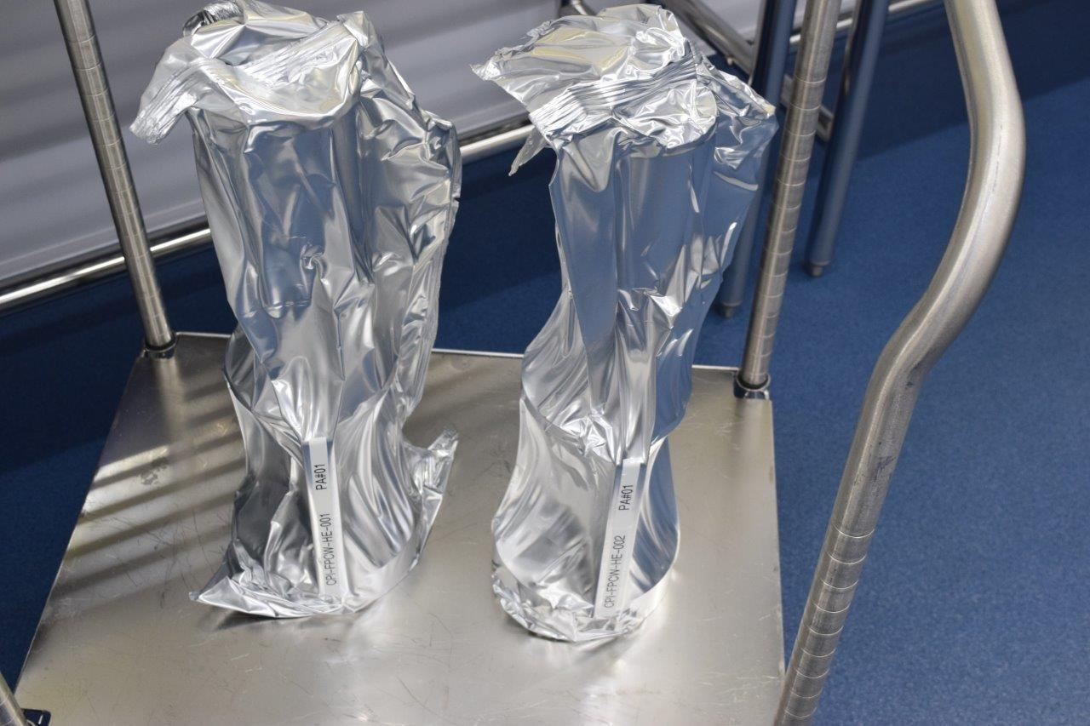

**Figure 1.2: Two FPCWs in bags**

## Pre-Inspection

### The inspection must be carried out under a LFH

#### Record the inspection date and technician name in the traveler

#### Visually inspect the outer plastic bag

#### Check that all kit parts are present

##### Adjustment Mechanism (Figure 2.1)

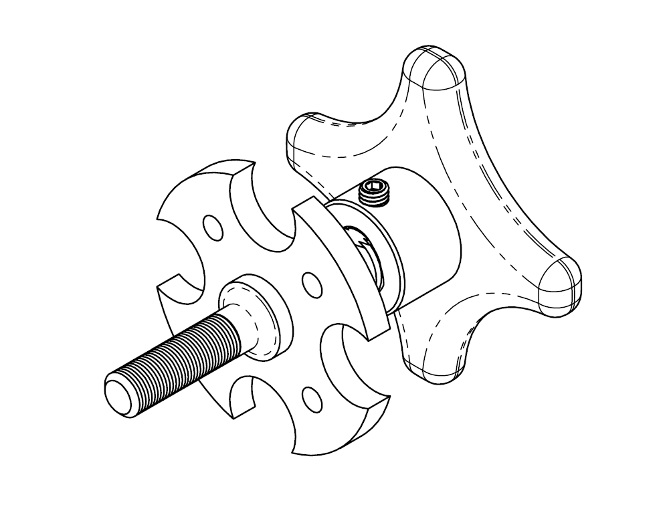

Figure 2.1 – Adjustment Mechanism

Axle, Bellows Holder (Figure 2.2)

##### Holder, Bellows (Figure 2.2)

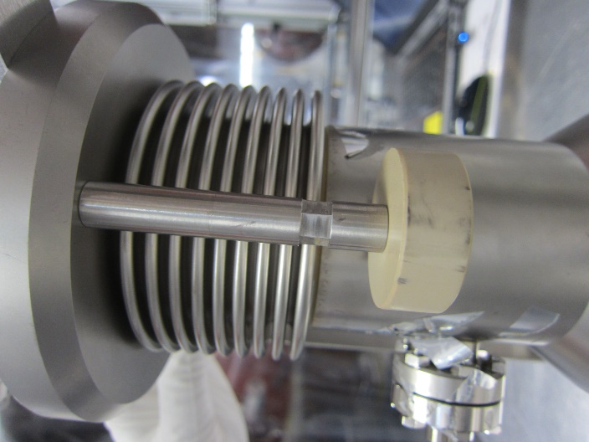

Figure 2.2 – Axle and Bellows Holder

##### M5 x 0.8 x 16LG SHCS

#### Record the FPCW serial number in the traveler

#### Wipe down the outer plastic bag, then open and remove it

#### Open the inner plastic bag and remove the FPCW (Figure 2.3)

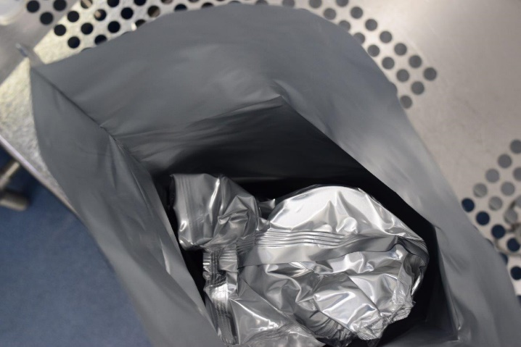

Figure 2.3. Inner and Outer Bags of the FPCW

## Ceramic Inspection

### After removing the FPCW from the bags, position it upright (on a cleanroom tissue) on the inspection table under the LFH

### Remove the M4 bolts holding down the ceramic protection cap (Figure 3.1)



Figure 3.1 – Ceramic protection cap with M4 screws

### Remove the ceramic protection cap and Kapton Sleeve and visually inspect the ceramic (Figure 3.2). Generate an NCR if there are any chips, cracks, dark spots or staining. Upload photos of any areas of interest into the traveler

|  |  |
| --- | --- |
| IMG_3937 |  |

Figure 3.2 – FPCW ceramic (right) with Kapton sleeve (left)

### Visually inspect the RF contact regions on the outer conductor (Figure 3.3). Generate an NCR if there is any damage e.g. gouges, scratches, dents etc. Upload photos of any areas of interest into the traveler

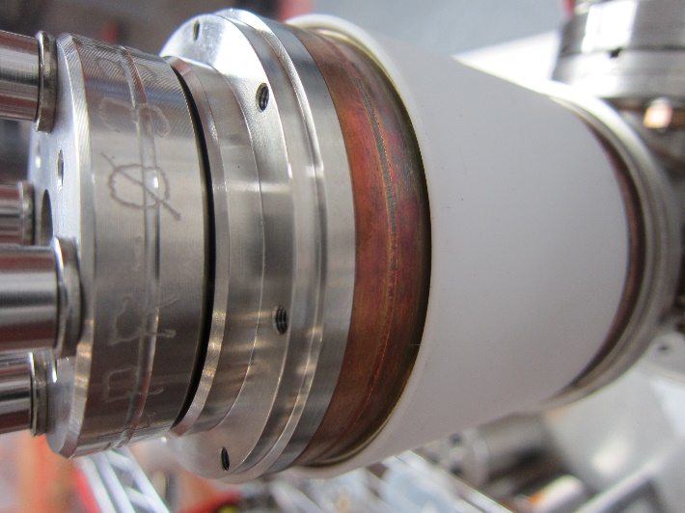

Figure 3.3 – RF Contact region and copper rings

### Visually inspect the copper rings (Figure 3.3) and generate an NCR if there is excessive oxidation

### Replace the Kapton protective sleeve

## DN40 Flange Inspection

### Remove the DN40 Flange with the N2 valve.

#### Visually inspect the knife edge on the DN40 CF flange (Figure 4.1). Generate an NCR if there is any damage or copper deposits on the knife edge. Upload photos of any areas of interest.

### Reinstall the DN40 flange using a new copper gasket

### Connect a nitrogen line to the valve on the DC40 flange and begin flowing filtered N2 (Figure 4.2). This positive purge will remain in place throughout the inspection.

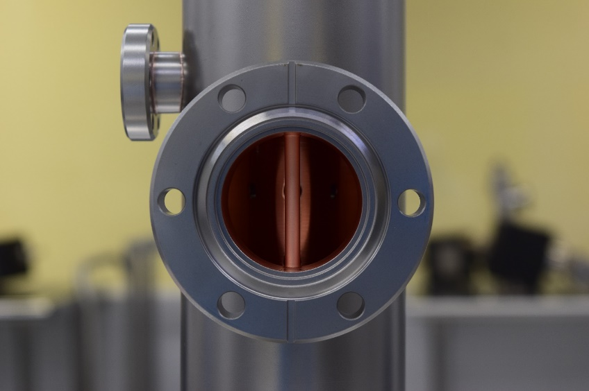

Figure 4.1 – DN40 CF Flange Knife Edge

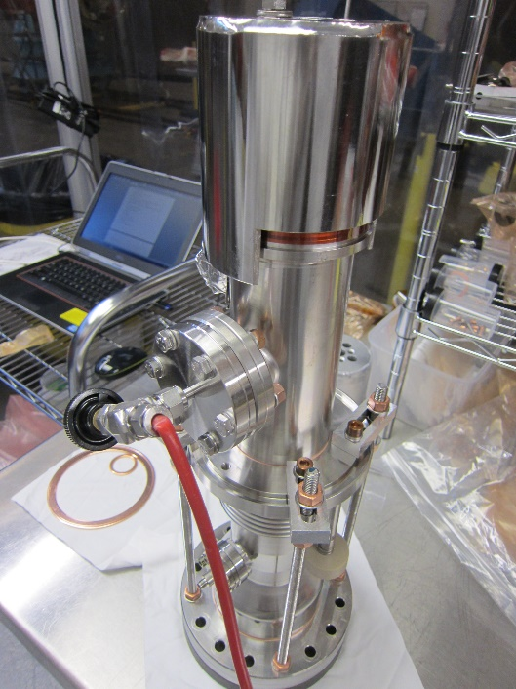

Figure 4.2 – Nitrogen line attached to the valve

## Push Rod Inspection

### Remove the push rod (FPPR) from the FPCW assembly

#### Install the strain relief tool (Figure 5.1)

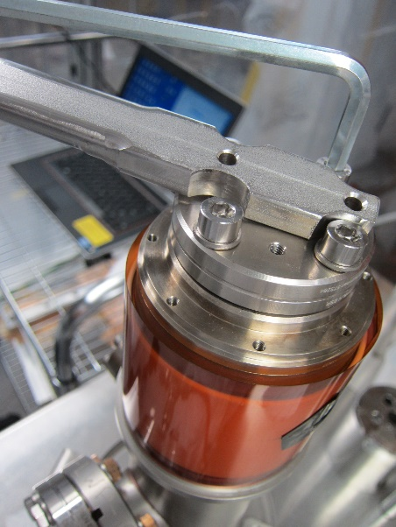

Figure 5.1 – Strain relief tool

#### Loosen the M6 screws holding the FPPR flange to the assembly

#### Remove the strain relief tool and install the Push-Rod Tool (Figure 5.2)

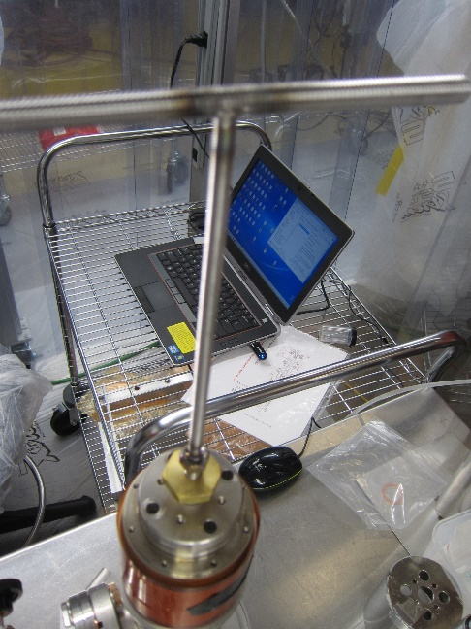

Figure 5.2 – Push Rod tool

#### Using the Push-Rod Tool, rotate the FPPR 90 degrees (anti-clockwise) to disengage the pin from the FPCW’s Inner Conductor

#### Remove the FPPR and store it in the storage unit

### Visually inspect the knife edge on the Push Rod flange and the 2-1/8 CF flange on the main body (Figure 5.3). Generate an NCR if there is any damage or copper deposits on the knife edge. Upload photos of any areas of interest into the traveler

|  |  |
| --- | --- |
|  | C:\Users\huque\AppData\Local\Microsoft\Windows\INetCache\Content.Word\IMG_4457.JPG |

Figure 5.3 – 2-1/8 CF flange on main body (left) and FPPR (right)

### Visually inspect the bellows on the Push Rod assembly (Figure 5.4). Generate an NCR if there are any scratches, dents, and/or any other damage. Upload photos of any areas of interest.

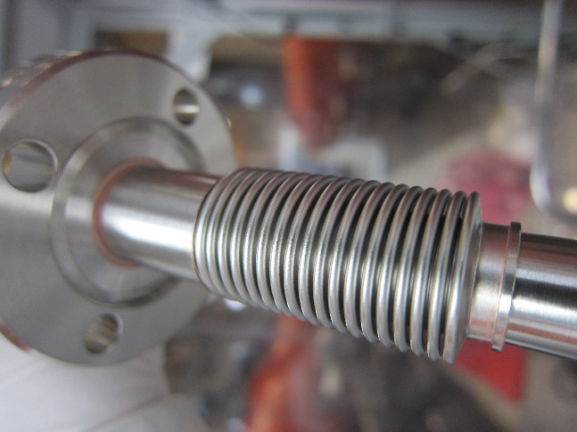

Figure 5.4 – Push Rod bellows

### Visually inspect the spring contacts on the FPPR (Figure 5.5). Generate an NCR if they are damaged, loose, or detached from the FPRR

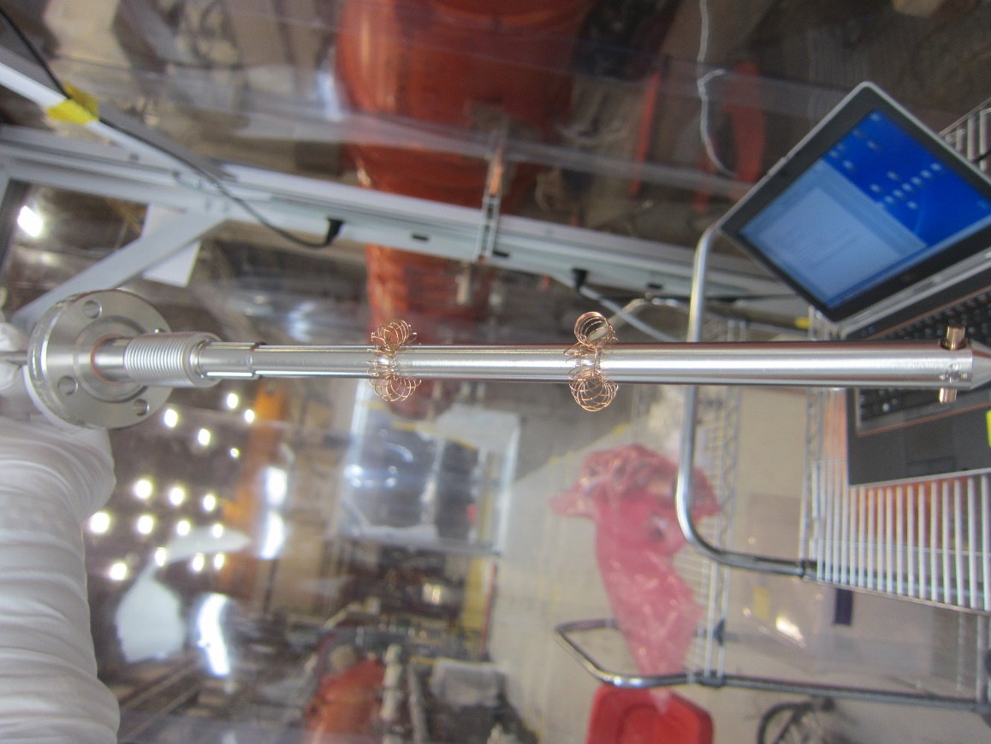

Figure 5.5 – Spring Contacts on the Push Rod

## DN100 Flange Inspection

### Remove the DN100 CF blank flange assembly

#### Use the Tee-Handle drive to loosen the M6 Antenna Screw (Figure 6.1)

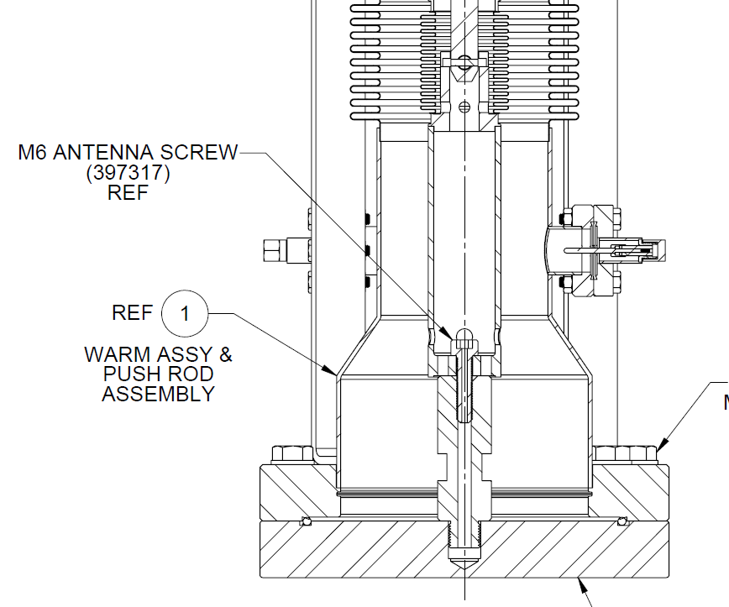

Figure 6.1 – Location of M6 Antenna Screw

#### Bring the FPC into a vertical position (DN100 flange up) and remove the M6 Antenna Screw

#### Place the FPCW on the table vertically (Figure 6.2)



Figure 6.2 – M8 screws on DN100 CF flange

#### Remove the M8 screws, apart from those holding the bellows restraints (Figure 6.3)

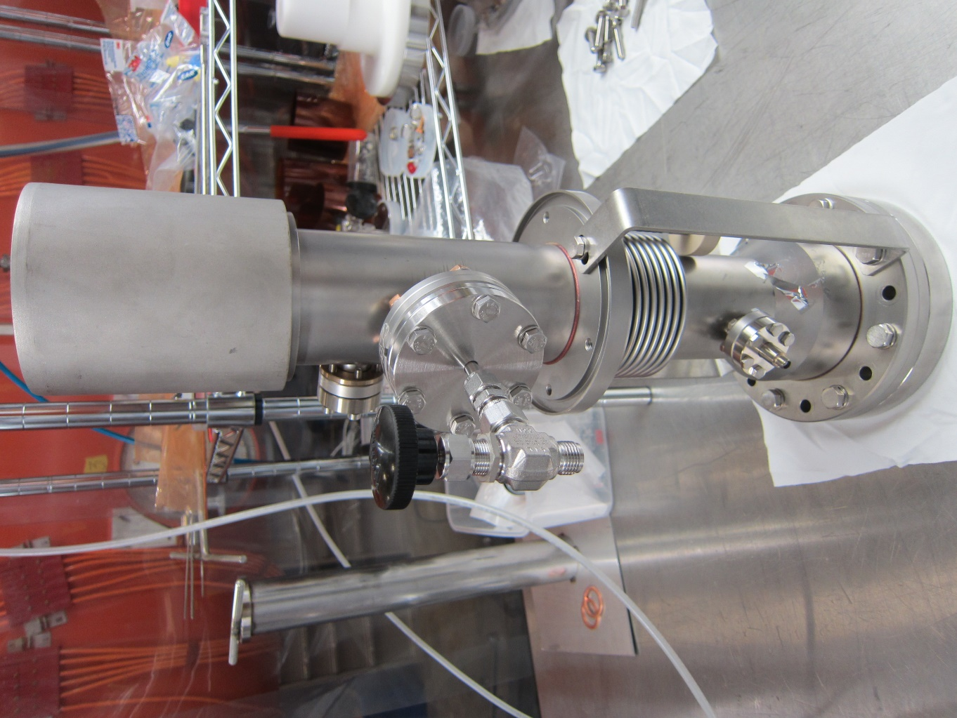

Figure 6.3 – Bellows restraint

#### Remove the bellows restraints while supporting the bellows

#### Lift the FPCW vertically off the base (Figure 6.4)

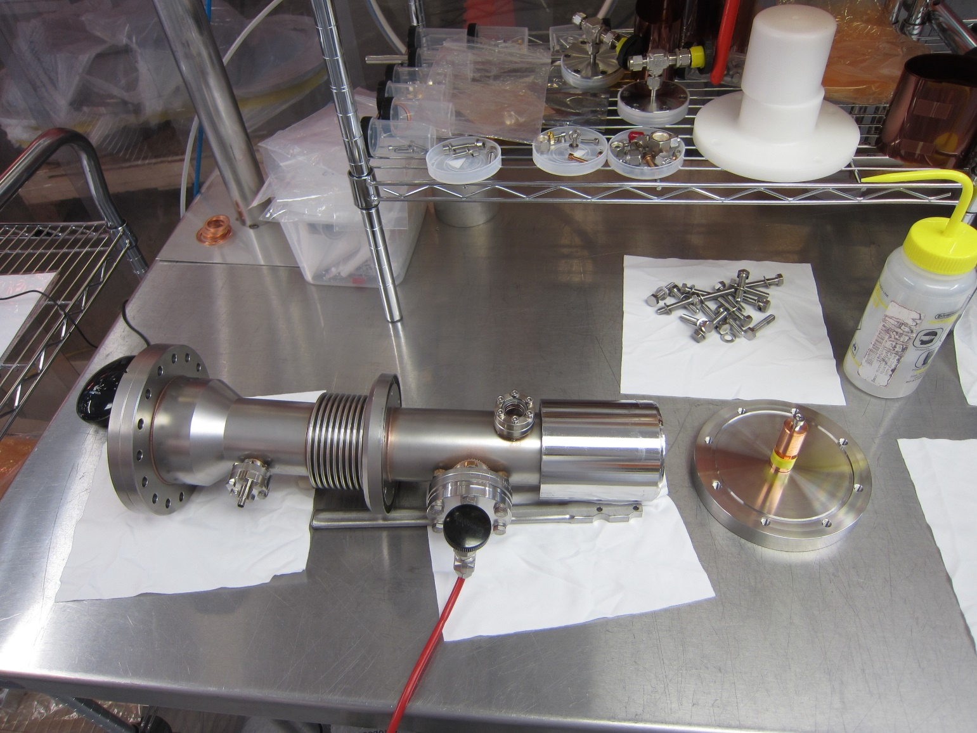

Figure 6.4 – DN100 Shipping Flange removed from the assembly

### Visually inspect the knife edge on the DN100 CF flange (Figure 6.5). Generate an NCR if there is any damage or copper deposits on the knife edge. Upload photos of any areas of interest into the traveler.

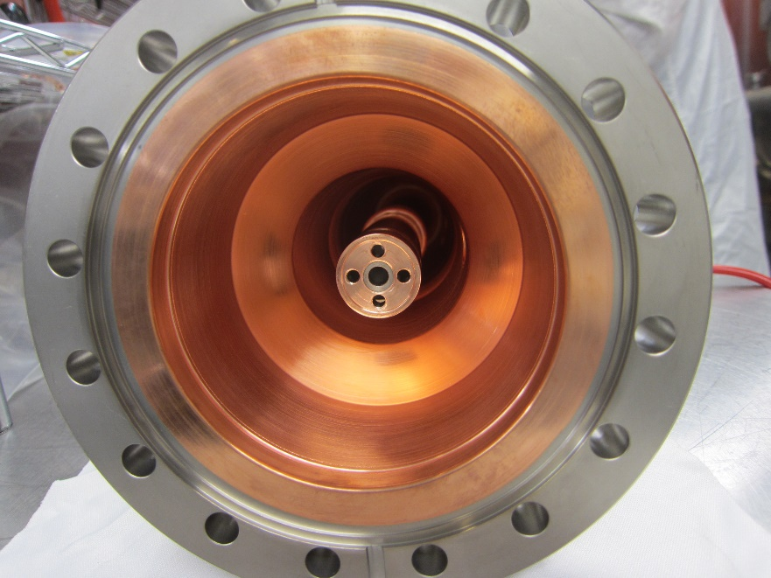

Figure 6.5 – Knife edge on DN100 CF flange on the main FPCW body

### Visually inspect the optical viewport. Generate an NCR if there are any scratches or cracks

## Bellows Visual Inspections

### Visually inspect the outer bellows on the FPCW assembly (Figure 7.1). Generate an NCR if there are any scratches, dents larger than 1/16”, and/or any other damage. Upload photos of any areas of interest.

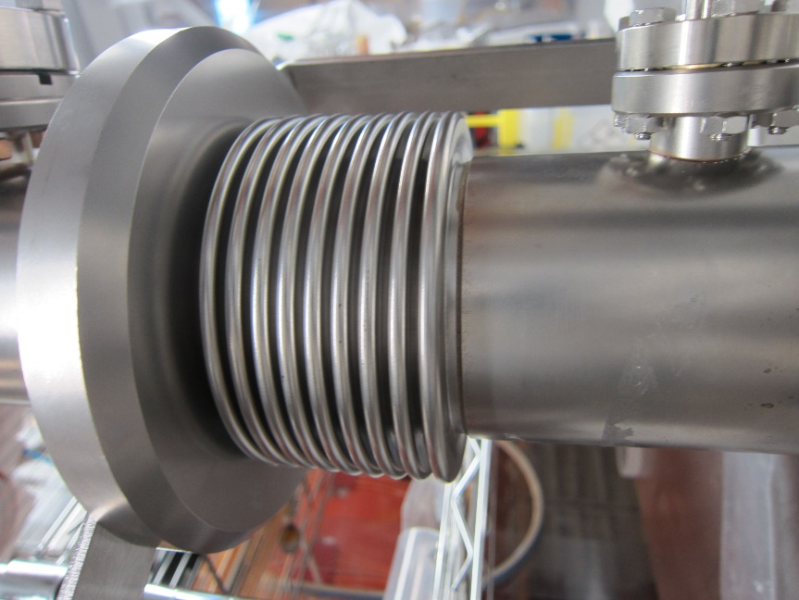

Figure 7.1 – FPCW Outer Conductor bellows

### Visually inspect the inner conductor bellows (Figure 7.2) on the FPCW assembly (visible area). Generate an NCR if there are any scratches, dents larger than 1/16”, and/or any other damage. Upload photos of any areas of interest.

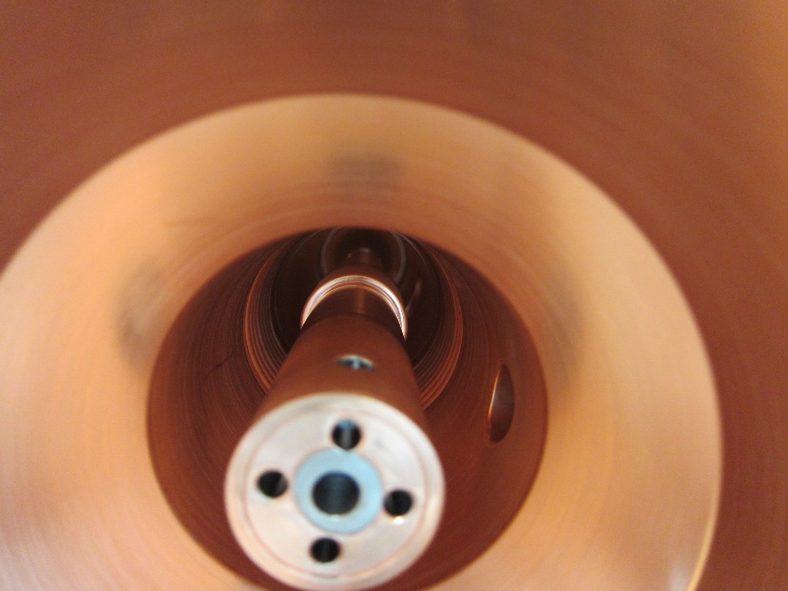

Figure 7.2 – FPCW Inner Conductor bellows

## Copper plating and Contact Surface Inspection

### Inspect the copper plating (the visible areas) on the outer conductor of the main FPCW assembly (Figure 8.1) and the plating on the CF100 flange surface. Generate an NCR if there are any pits, blisters, flaking copper, and/or other damage. Upload photos of any areas of interest.

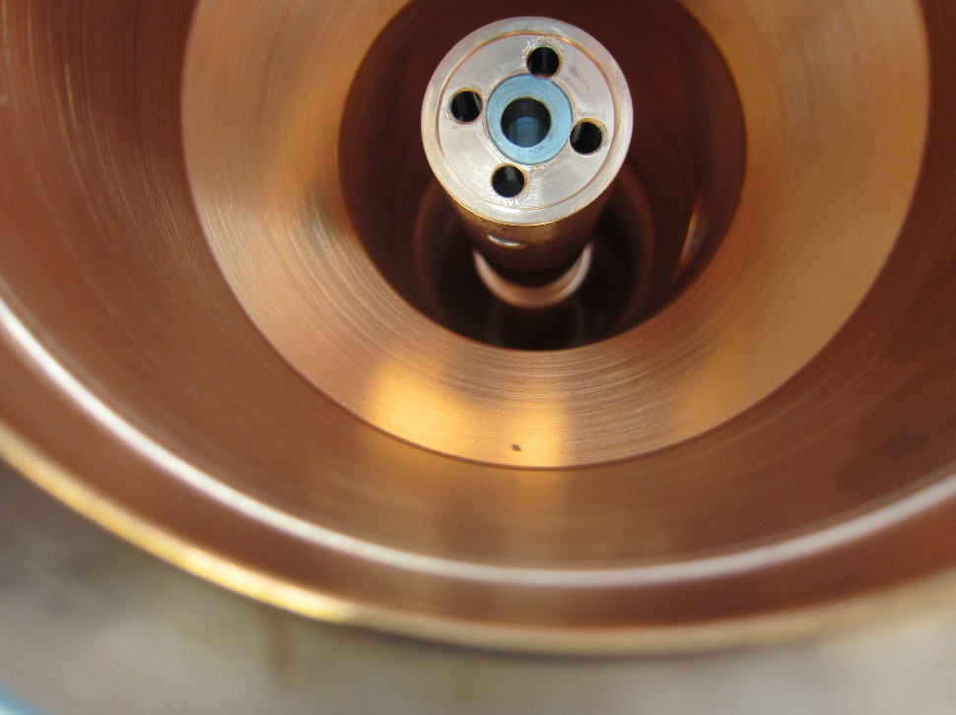

Figure 8.1 – FPCW Outer Conductor copper plating

### Inspect the copper plating (the visible areas) on the inner conductor of the main FPCW assembly (Figure 8.2). Generate an NCR if there are any pits, blisters, flaking copper, and/or other damage. Upload photos of any areas of interest.

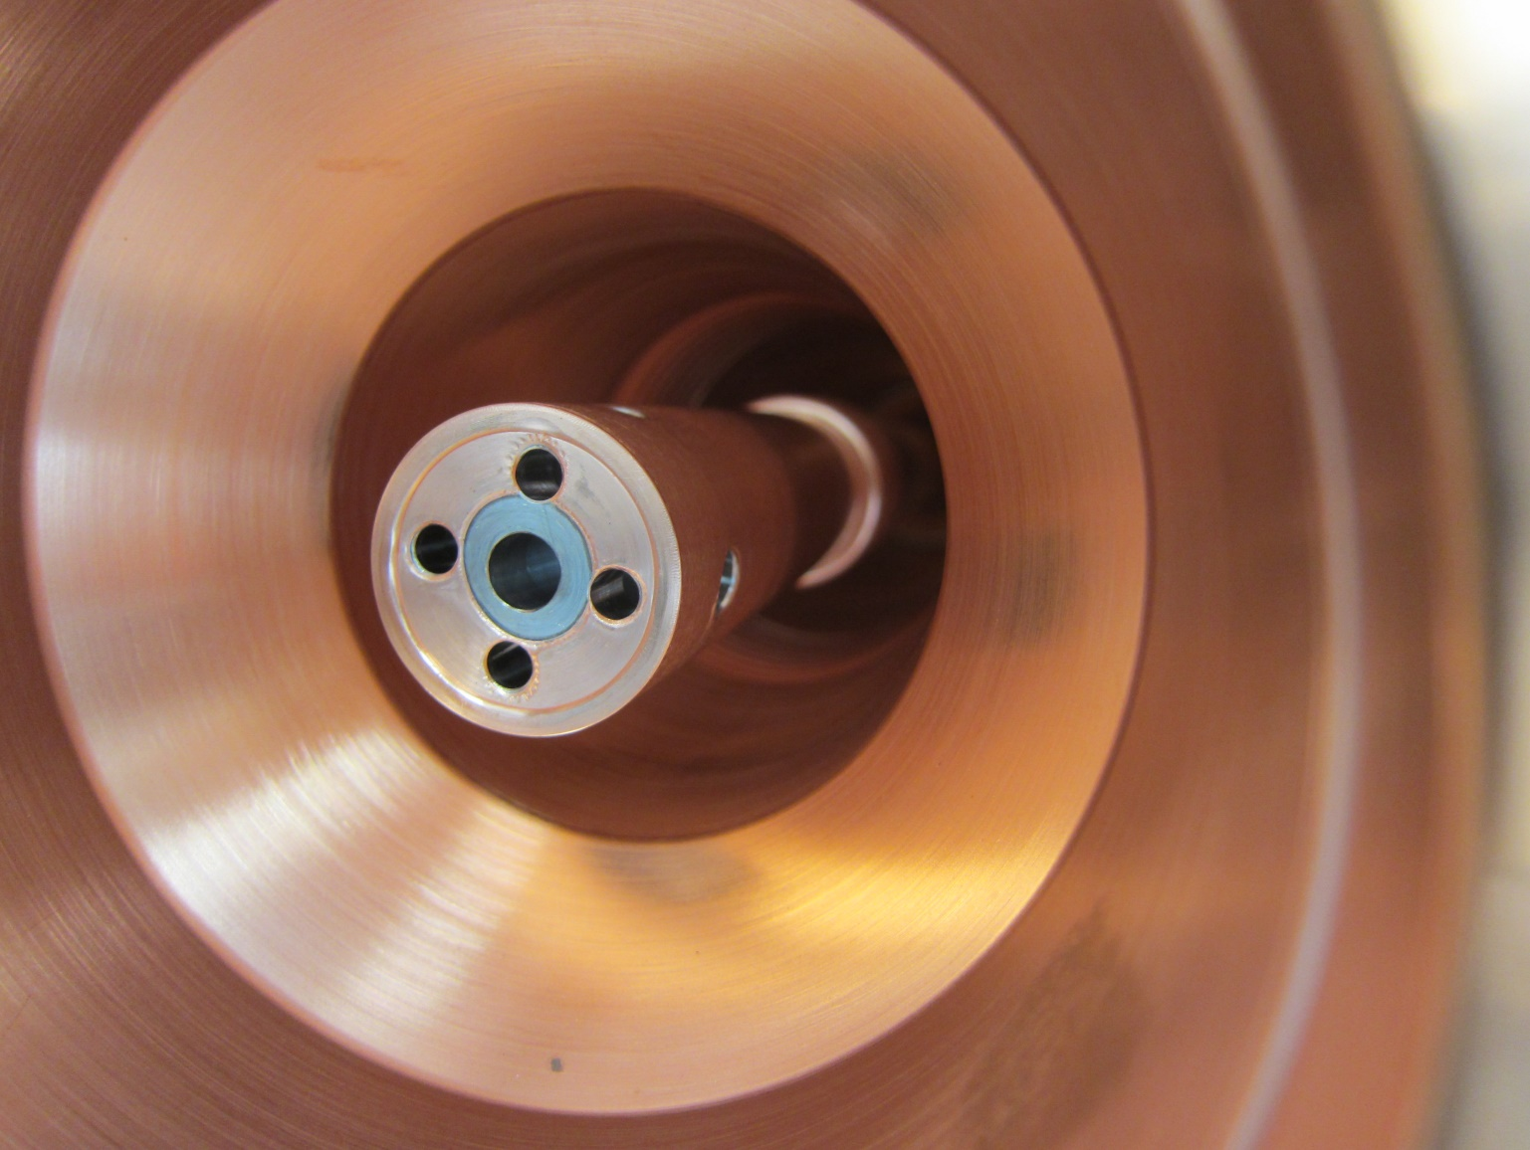

Figure 8.2 – FPCW Inner Conductor copper plating

### Visually inspect the RF contact area on the inner conductor of the main FPCW assembly (Figure 8.3). Generate an NCR if there is any damage on the contact surface or any defects on the copper plating. Upload photos of any areas of interest.

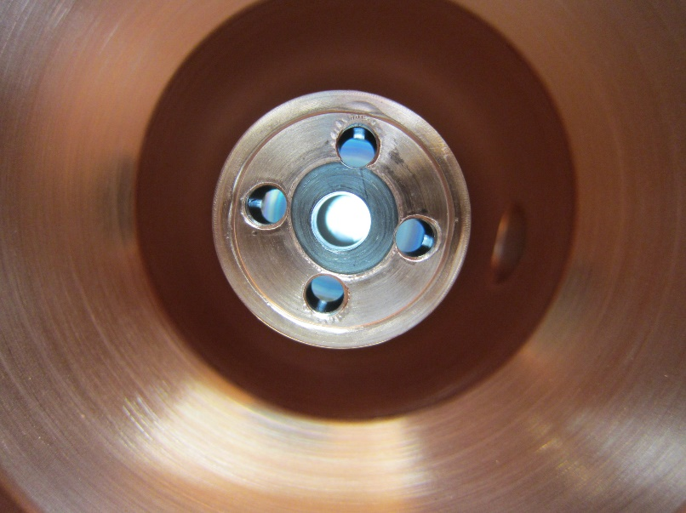

Figure 8.3 – Inner Conductor RF Contact Surface

## Electrical Checks

### Use a multimeter to check the electron probe (Figure 9.1). The resistance measurement should be above 20MΩ. Otherwise, generate an NCR. Also generate an NCR if the electron probe is not installed or is in the wrong position.

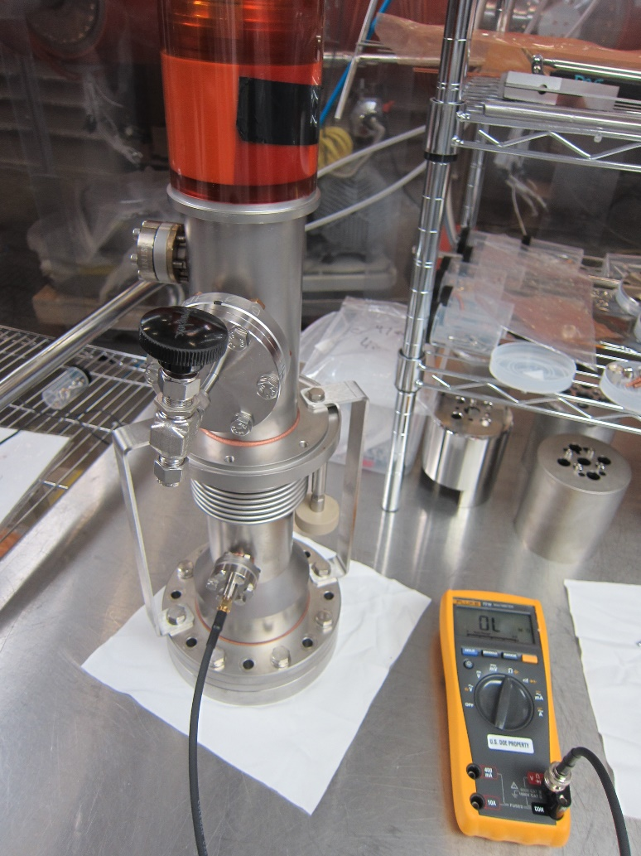

Figure 9.1 – Checking Electron Probe

## Storage (if the FPCw is not being immediately installed)

### Reinstall the DN100 Shipping Flange

#### Place the Shipping Flange (Figure 10.1) on a table with the O-ring in place

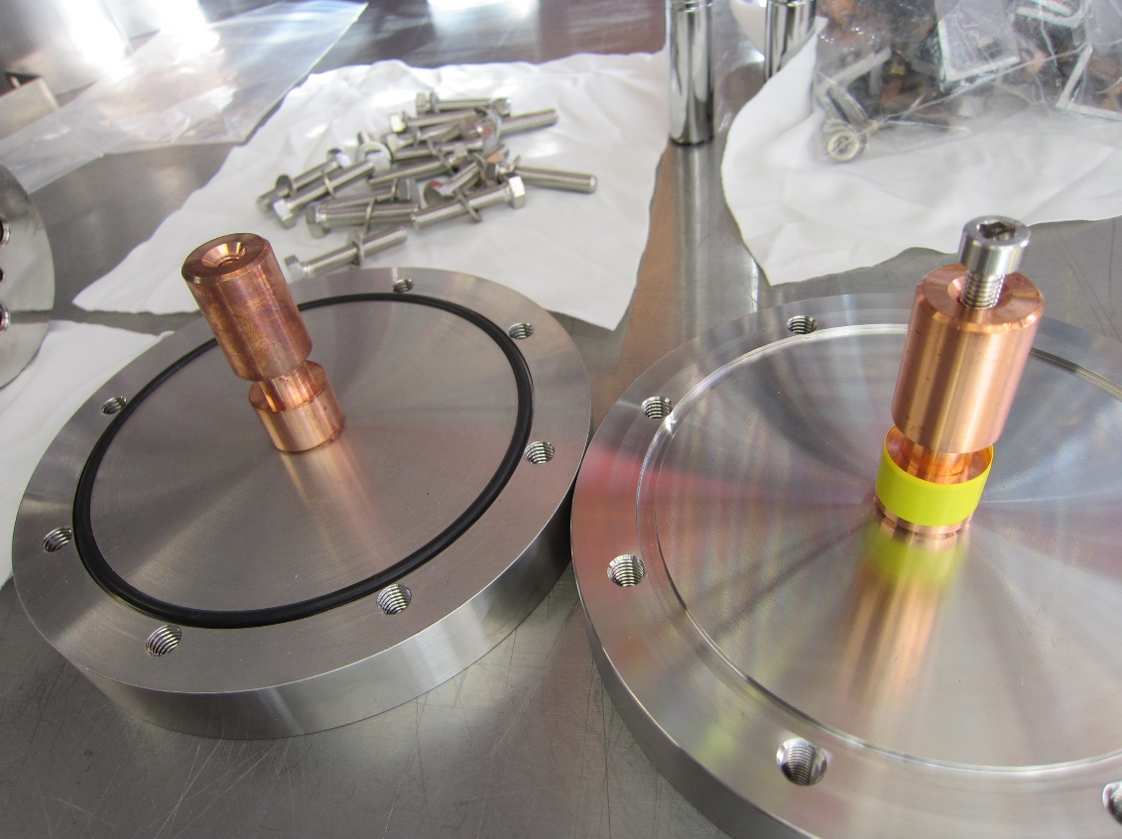

Figure 10.1 – Shipping Flange with Center Pin

#### Place the FPCW assembly over the shipping fixture and secure with bolts

#### Install bellows restraint

#### Pick up the assembly and hold it with the DN100 CF flange upwards

#### Attach the Antenna Screw on the Tee-Handle Driver and install the screw into the center pin of the shipping flange

#### Flip the assembly and place it on the table, resting it on the DN100 flange

#### Tighten the M6 Antenna Screw using the Tee Handle Driver

### Install FPPR

#### Position a new 2-1/8 CF gasket on the flange

#### Insert FPRR into the FPCW body and turn 90 degrees (clockwise) to lock it into place

#### Finger tighten the M6 screws

#### Install the strain relief tool and tighten the M6 screws

### Replace the ceramic protection cap and fix in place using the M4 screws

### Turn off the N2 flow and disconnect the line

### Store the assembly in the N2 cabinet

# References

|  |  |
| --- | --- |
| **Document No.** | **Title** |
| SRF-01-ML-001 | SRF Quality Manual |
| LCLSII-HE-1.2-ES-0059 | [LCLSII-HE Fundamental Power Coupler ESD](https://jlabdoc.jlab.org/docushare/dsweb/Get/Document-242797/LCLSII-HE-1.2-ES-0059.pdf) |
|  |  |

# Release and Revision History

|  |  |  |
| --- | --- | --- |
| **Rev #** | **Major Changes** | **Effective Date:** |
| 1 | Initial version | 10 Jun 2021 |
| 2 | Updated Roles and Responsibilities. Replaced Jacob Harris with Ashley Mitchell as reviewer. Replaced Katherine Wilson with Adam Grabowski for reviewer. Replaced Mike Murphy with Mark Weihl as reviewer. Removed Kirk Davis as reviewer. Updated bullet and figure numbering throughout. | 2 May 2024 |
|  |  |  |
|  |  |  |

# Approvals

|  |  |  |  |
| --- | --- | --- | --- |
| **Approved by:** | **Name:** | **Signature:** | **Date:** |
| **Document Owner** | Naeem Huque | In DocuShare | |
| **Production Group Lead** | John Fischer | In DocuShare | |
| **Reviewer** | Mark Weihl | In DocuShare | |
| **Quality Engineer** | Ashley Mitchell | In DocuShare | |
| **CAM** | Adam Grabowski | In DocuShare | |