Traveler Title | C100 Disassembly Traveler
Traveler Abstract | This Traveler outlines the steps necessary to disassemble a C100 Cryomodule, including removing the endcans, extracting the spaceframe, positioning the lollipops, and delivering a bare cavity string back to the Cavity Group. Work within this Traveler is to be performed by trained and authorized Assembly Technicians. All Cryomodule materials shall be kept inside the established RADCON barrier until they have been surveyed and released.  ** Radiation surveys shall be performed and information recorded at traveler hold points.**  ** Radiological controls are a critical component of the cryomodule rework disassembly and assembly process. Dose rate, as well as contamination surveys (where indium gaskets or seals are present) shall be performed and analyzed, with information communicated to all involved personnel. Results will be recorded at traveler hold points. RW-II training will be required where contamination is identified**
Traveler ID | C100R-CMA-CM-DISA
Traveler Revision | R3
Traveler Author | John Fischer
Traveler Date | 04-Jun-2024
NCR Informative Emails | Areilly,hamlett
NCR Dispositioners | Fischer,jjcamp,ganey
D3 Emails | areilly,fischer,Hamlette,jjcamp
Approval Names | John Fischer | Jeff Campbell | John Fischer | Tony Reilly
Approval Signatures
Approval Dates
Approval Title | Author | Reviewer | Work Center Lead | Project Representative

References | List and Hyperlink all documents related to this traveler. This includes, but is not limited to: safety (THAs, SOPs, etc), drawings, procedures, and facility related documents.  All materials linked below and throughout this traveler are for reference only and should be verified for latest version at time of use.
C100 Cryomodule Top Assembly Dwg | C100 Process Piping Dwg | C100 Cavity String Dwg | Radcon RAM Control Doc | C100 Warm Tuner Dwg
C100 Cold Tuner Dwg | REC Warm to Cold Beam Pipe Dwg | SEC Warm to Cold Beam Pipe Dwg | Left Wave Guide Spool Assy Dwg | Right Wave Guide Spool Assy Dwg
C100 Instrumentation Flange Dwg | CRM1207030-1000sh1 Instrumentation | CRM1207030-1001sh2- Instrumentation | CRM1207030-1001sh3- Instrumentation | C100 Pictorial Disassembly Reference

Revision Note
R1 | Initial release of this Traveler.
R2 | File Uploads added
R3 | Modified step 39- Discard removed 8 pin feedthrus, and changed Doc approvers to match WCD Register

Step No. | Instructions | Data Input
1 | RADCON shall survey the Cryomodule and setup perimeter with signage identifying requirements for entry and work in that area. Upload the survey map.  Enter Cryomodule SN. | [[RadconTech]] <<RAD>>  [[RadconDate]] <<TIMESTAMP>>  [[RadconComment]] <<COMMENT>>  [[RadconPictures]] <<FILEUPLOAD>>  [[CMSN]] <<CMSN>>  [[SurveyMap]] <<FILEUPLOAD>>
2 | Position the Cryomodule on transfer carts, install rail lockdowns.  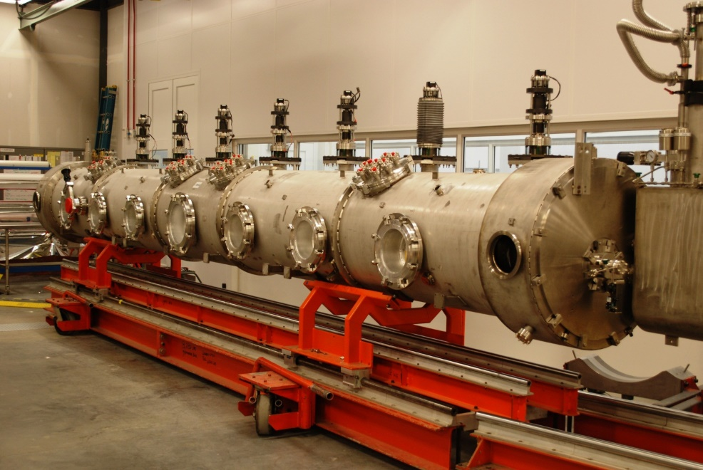 | [[TransferTech]] <<SRFCMP>>  [[TransferDate]] <<TIMESTAMP>>  [[TransferComment]] <<COMMENT>>
3 | Bleed up all circuits with filtered Nitrogen; insulating vacuum, helium circuits, and beamline.  **The beamline may require controls if Particulate Sampling is to be performed.** | [[BleedUpTech]] <<SRFCMP>>  [[BleedUpDate]] <<TIMESTAMP>>  [[BleedUpComment]] <<COMMENT>>  [[ParticulateSampling]] <<YESNO>>

Step No. | Instructions | Data Input
4 | Remove the warm tuners, feedthrough plates, and secondary waveguide assemblies. Record the serial numbers, then place materials into the RADCON bins for survey. Items are to remain inside the defined barrier until they are surveyed.  Only RADCON personnel can release parts. | [[RemovalTech]] <<SRF>>  [[RemovalDate]] <<TIMESTAMP>>  [[RemovalComment]] <<COMMENT>>
Warm Tuner S/N | Secondary Waveguide S/N | Feedthru Plate S/N
[[TUNWSN1]] <<TUNWSN>> [[TUNW1RAM]] {{RAM,RCA,NO}} <<RADIO>>  [[TUNWSN2]] <<TUNWSN>> [[TUNW2RAM]] {{RAM,RCA,NO}} <<RADIO>>  [[TUNWSN3]] <<TUNWSN>> [[TUNW3RAM]] {{RAM,RCA,NO}} <<RADIO>>  [[TUNWSN4]] <<TUNWSN>> [[TUNW4RAM]] {{RAM,RCA,NO}} <<RADIO>>  [[TUNWSN5]] <<TUNWSN>> [[TUNW5RAM]] {{RAM,RCA,NO}} <<RADIO>>  [[TUNWSN6]] <<TUNWSN>> [[TUNW6RAM]] {{RAM,RCA,NO}} <<RADIO>>  [[TUNWSN7]] <<TUNWSN>> [[TUNW7RAM]] {{RAM,RCA,NO}} <<RADIO>>  [[TUNWSN8]] <<TUNWSN>> [[TUNW8RAM]] {{RAM,RCA,NO}} <<RADIO>> | [[GVWGSN1]] <<GVWGSN >> [[GVWG1RAM]] {{RAM,RCA,NO}} <<RADIO>>  [[GVWGSN2]] <<GVWGSN>> [[GVWG2RAM]] {{RAM,RCA,NO}} <<RADIO>>  [[GVWGSN3]] <<GVWGSN>> [[GVWG3RAM]] {{RAM,RCA,NO}} <<RADIO>>  [[GVWGSN4]] <<GVWGSN>> [[GVWG4RAM]] {{RAM,RCA,NO}} <<RADIO>>  [[GVWGSN5]] <<GVWGSN>> [[GVWG5RAM]] {{RAM,RCA,NO}} <<RADIO>>  [[GVWGSN6]] <<GVWGSN>> [[GVWG6RAM]] {{RAM,RCA,NO}} <<RADIO>>  [[GVWGSN7]] <<GVWGSN>> [[GVWG7RAM]] {{RAM,RCA,NO}} <<RADIO>>  [[GVWGSN8]] <<GVWGSN>> [[GVWG8RAM]] {{RAM,RCA,NO}} <<RADIO>> | [[INFFSN1]] <<INFFSN>> [[INFF1RAM]] {{RAM,RCA,NO}} <<RADIO>>  [[INFFSN2]] <<INFFSN>> [[INFF2RAM]] {{RAM,RCA,NO}} <<RADIO>>  [[INFFSN3]] <<INFFSN>> [[INFF3RAM]] {{RAM,RCA,NO}} <<RADIO>>  [[INFFSN4]] <<INFFSN>> [[INFF4RAM]] {{RAM,RCA,NO}} <<RADIO>>

Step No. | Instructions | Data Input
5 | Install the End Can carts onto the mobile rails. Fasten the carts to the endcans. Lead to verify all connections and hardware torques before proceeding with disassembly work.  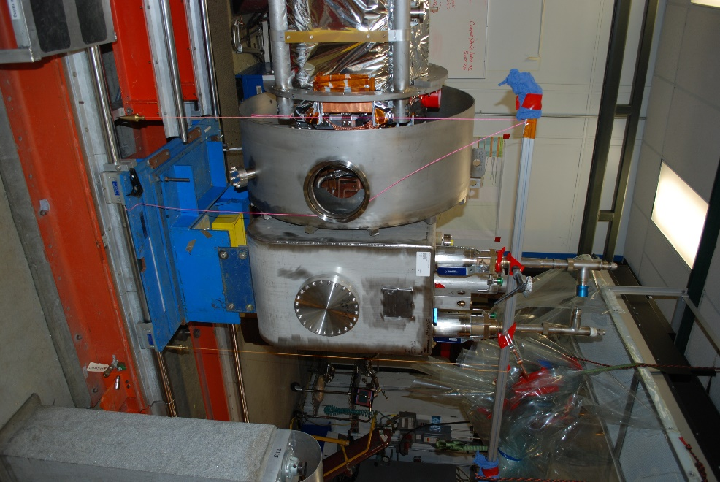 | [[EndCanTech]] <<SRF>>  [[CMALeadVerify]] <<SRFCMP>>  [[EndCanDate]] <<TIMESTAMP>>  [[EndCanComment]] <<COMMENT>>
6 | Cover the Endcans, valves, and exposed openings with plastic to shield from grinding debris. | [[ShieldTech]] <<SRF>>  [[ShieldDate]] <<TIMESTAMP>>  [[ShieldComment]] <<COMMENT>>

Step No. | Instructions | Data Input
7 | Begin grinding, remove the outboard tuner stacks (x2), and free but leave the lockdowns installed (x18). Contain the grinding debris within the established boundary, debris will be collected and sampled by RADCON. Wear proper PPE, safety glasses, faceshield, long sleeves, hearing protection, gloves, and EHSQ defined breathing protection. Work area is recognized as a HOT WORK AREA, outlined in the Weld Shop OSP.  **Contact RADCON for local measurements prior to beginning grinding**  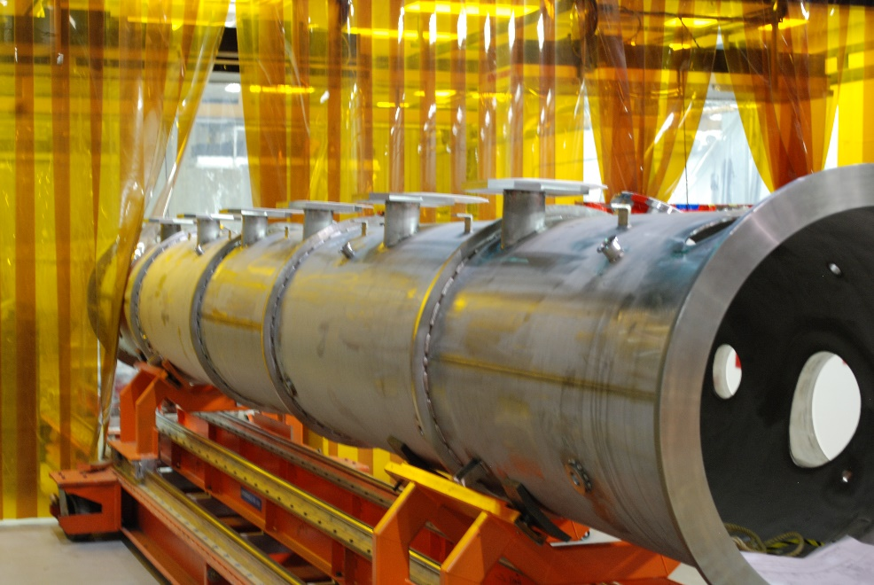 | [[GrindTech]] <<SRF>>  [[GrindDate]] <<TIMESTAMP>>  [[GrindComment]] <<COMMENT>>

Step No. | Instructions | Data Input
8 | Install the Wach's cutter onto the Vacuum Vessel and cut the 2 bridging ring welds. This work will happen after hours due to the measured noise level during cutter operation. This equipment is too be used by trained Technicians only.  **All chips generated during the cutting operation are to go to RADCON for disposal**  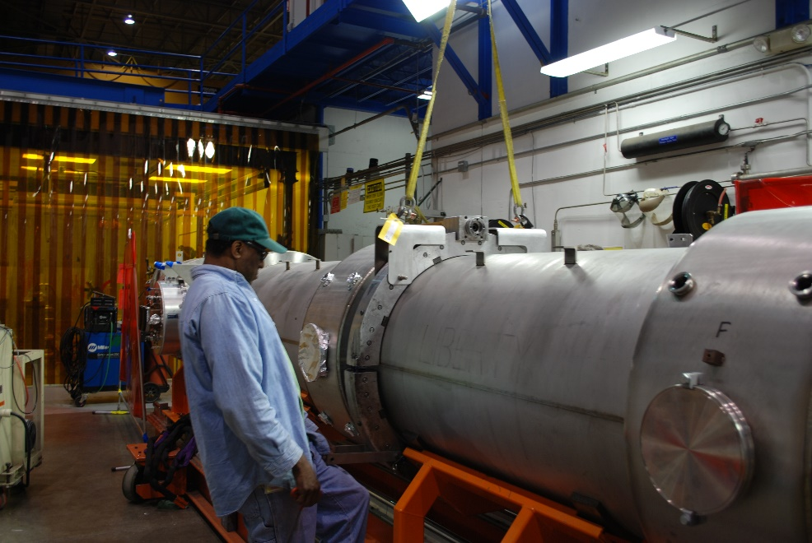 | [[CutterTech]] <<SRF>>  [[CutterDate]] <<TIMESTAMP>>  [[CutterComment]] <<COMMENT>>
9 | Slide the bridging rings back, remove the bridging area magnetic shielding, MLI, and 50k shielding, exposing the warm to cold beampipes.  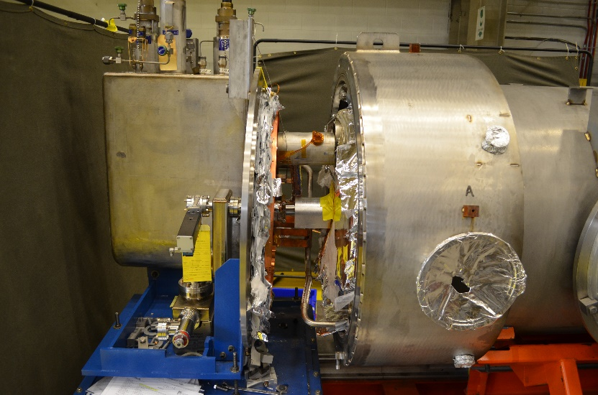 | [[BridgingTech]] <<SRF>>  [[BridgingDate]] <<TIMESTAMP>>  [[BridgingComment]] <<COMMENT>>  [[BridgingPictures]] <<FILEUPLOAD>>
10 | HOLD POINT FOR RADCON SURVEY OF OPEN BRIDGING AREAS. RECORD FINDINGS IN COMMENT BOX.  ** Radiological controls are a critical component of the cryomodule rework disassembly and assembly process. Dose rate, as well as contamination surveys (where indium gaskets or seals are present) shall be performed and analyzed, with information communicated to all involved personnel. Results will be recorded at traveler hold points. RW-II training will be required where contamination is identified**  - If survey reveals radioactive materials, items shall be tagged in accordance with RadCon Memo. Survey results (i.e. Ram # and dose rates) to be recorded in Data input column by technicians.  - Proceed to next step if no radioactive materials are identified.  - If RAM are found, RadCon to define work restrictions.  - Indium may be found on the Warm to Cold beam pipe heat station clamp, Notify RADCON prior to disassembly. They will swipe the area prior to proceeding. | [[HP1Tech]] <<SRF>>  [[HP1Date]] <<TIMESTAMP>>  [[HP1RadconTech]] <<RAD>>  [[HP1RadconDate]] <<TIMESTAMP>>  [[HP1Comment]] <<COMMENT>>  [[HP1RAM_File]] <<FILEUPLOAD>>
11 | Remove the Endcans  - Remove the 2K MLI  - Disconnect the 50K heat stationing clamps and diodes  - Support then unhook the warm to cold beampipes.  - Cut all process piping, minimize the cutting debris by using tubing cutters or portabands.  - Remove the end can and cart  - Record the end can serial numbers and RAM status  Place materials in bins for survey within RADCON defined barrier. Only RADCON personnel can release parts.  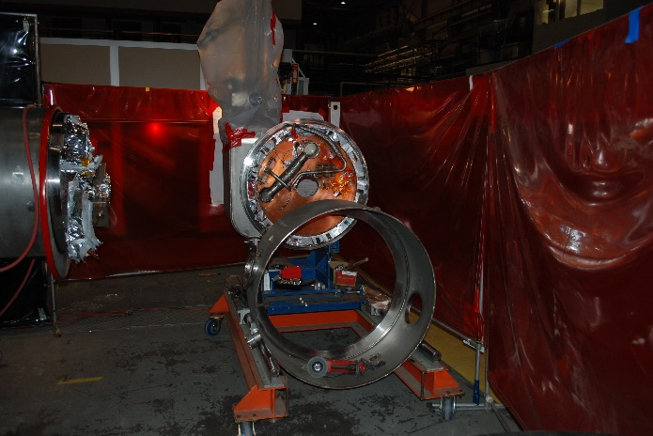 | [[EndCanRemovalTech]] <<SRF>>  [[EndCanRemovalDate]] <<TIMESTAMP>>  [[ElectricalTech]] <<SRF>>  [[ElectricalDate]] <<TIMESTAMP>>  [[EndCanRemovalComment]] <<COMMENT>>  [[SECSN]] <<SECSN>>  [[SECRAM]] {{RAM,RCA,NO}} <<RADIO>>  [[RECSN]] <<RECSN>>  [[RECRAM]] {{RAM,RCA,NO}} <<RADIO>>
12 | Verify the spaceframe lockdowns are in place, then transfer the Cryomodule to the fixed assembly rail.  Cryomodule Assembly area to be defined as RAM Work area. | [[FixedAssyRailLeadTech]] <<SRF>>  [[FixedAssyRailDate]] <<TIMESTAMP>>  [[FixedAssyRailComment]] <<COMMENT>>
13 | Remove the Tophats and record the serial numbers and RAM status.  [[THTSSN1]] <<THTSSN>> [[THTSRAM1]] {{RAM,RCA,NO}} <<RADIO>>  [[THTSSN2]] <<THTSSN>> [[THTSRAM2]] {{RAM,RCA,NO}} <<RADIO>>  [[THTSSN3]] <<THTSSN>> [[THTSRAM3]] {{RAM,RCA,NO}} <<RADIO>>  [[THTDSN4_5]] <<THTSSN>> [[THTSRAM4_5]] {{RAM,RCA,NO}} <<RADIO>>  [[THTSSN6]] <<THTSSN>> [[THTSRAM6]] {{RAM,RCA,NO}} <<RADIO>>  [[THTSSN7]] <<THTSSN>> [[THTSRAM7]] {{RAM,RCA,NO}} <<RADIO>>  [[THTSSN8]] <<THTSSN>> [[THTSRAM8]] {{RAM,RCA,NO}} <<RADIO>> | [[TophatRemovalTech]] <<SRF>>  [[TophatRemovalDate]] <<TIMESTAMP>>  [[TophatRemovalComment]] <<COMMENT>>
14 | Position the ¼ point spaceframe tooling onto the assembly area rails.  **Ensure the pillow blocks needed for the Space Frame tooling are in between the ¼ point tooling.** | [[SFTooling1Tech]] <<SRF>>  [[SFTooling1Date]] <<TIMESTAMP>>  [[SFTooling1Comment]] <<COMMENT>>
15 | Remove the spaceframe lockdowns, verify all rail lockdowns are in place and tight, and the Vacuum Vessel is tied to the Assembly Tooling. | [[LockdownTech]] <<SRF>>  [[LockdownDate]] <<TIMESTAMP>>  [[LockdownComment]] <<COMMENT>>
16 | Begin extracting the Cold Mass from the Vacuum Vessel, remove the Mu wheel covers, position the ¼ point tooling, raise slightly to take load, and lock in place prior to wheels disengaging from the vacuum tank.  Place materials in bins for survey within RADCON defined barrier. Only RADCON personnel can release parts.  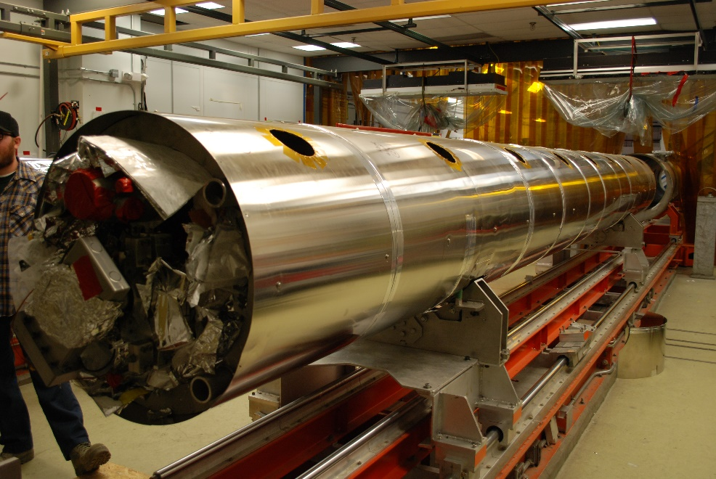 | [[ColdMassExtractLeadTech]] <<SRF>>  [[ColdMassExtractDate]] <<TIMESTAMP>>  [[ColdMassExtractComment]] <<COMMENT>>
17 | Repeat the process for the second set of ¼ point tooling. Finish removing the Cold Mass from the Vacuum Vessel.  Record the Vacuum Vessel and Space Frame serial numbers, and RAM status. | [[SFTooling2LeadTech]] <<SRF>>  [[SFTooling2Date]] <<TIMESTAMP>>  [[SFTooling2Comment]] <<COMMENT>>  [[VVSN]] <<VVSN>>  [[VVRAM]] {{RAM,RCA,NO}} <<RADIO>>  [[SFRSN]] <<SFRSN>>  [[SFRRAM]] {{RAM,RCA,NO}} <<RADIO>>
18 | Notify RADCON for survey, then relocate the Vacuum Vessel from the Assembly rail to the designated storage area  . Only RADCON personnel can release parts. | [[VVRadconLeadTech]] <<RAD>>  [[VVRadconDate]] <<TIMESTAMP>>  [[VVRadconComment]] <<COMMENT>>

Step No. | Instructions | Data Input
19 | Uninstall the outer Mu shield. Properly store the material.  Place materials in bins for survey within the RADCON defined barrier.  Only RADCON personnel can release parts.  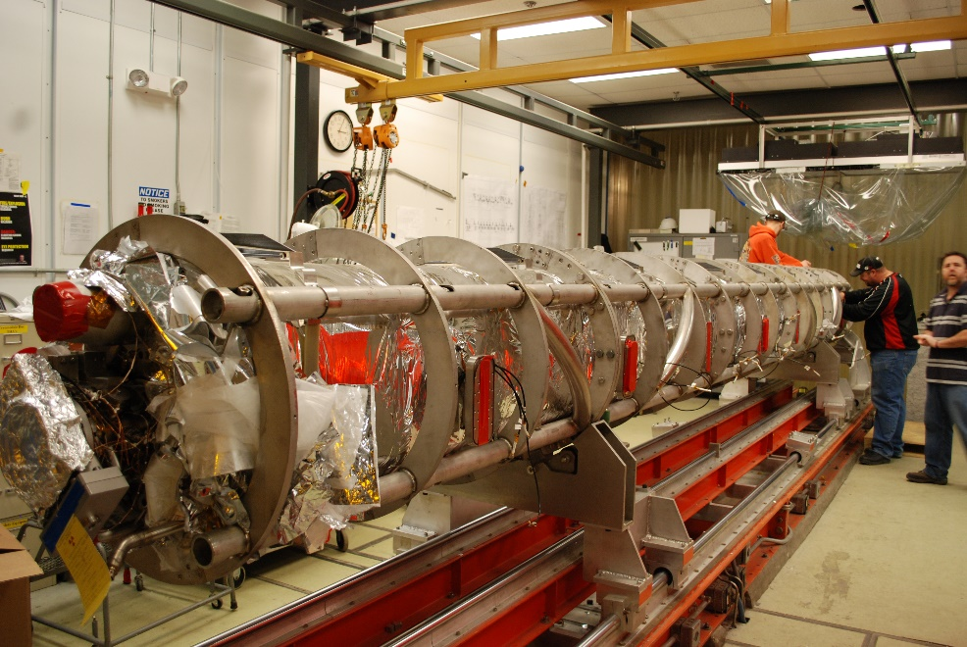 | [[OuterMuTech]] <<SRF>>  [[OuterMuDate]] <<TIMESTAMP>>  [[OuterMuComment]] <<COMMENT>>  [[OuterMuPicture]] <<FILEUPLOAD>>

Step No. | Instructions | Data Input
20 | Install the lollipop carriages into their proper positions. Orientation is important to provide the proper clearances for future disassembly actions. Do not install the lollipops at this time. | [[LollipopTech]] <<SRF>>  [[LollipopDate]] <<TIMESTAMP>>  [[LollipopComment]] <<COMMENT>>
21 | Open all of the beamline access panels; Mu metal, mli, 50k shield.  Place materials in bins for survey within RADCON defined barrier. Only RADCON personnel can release parts.  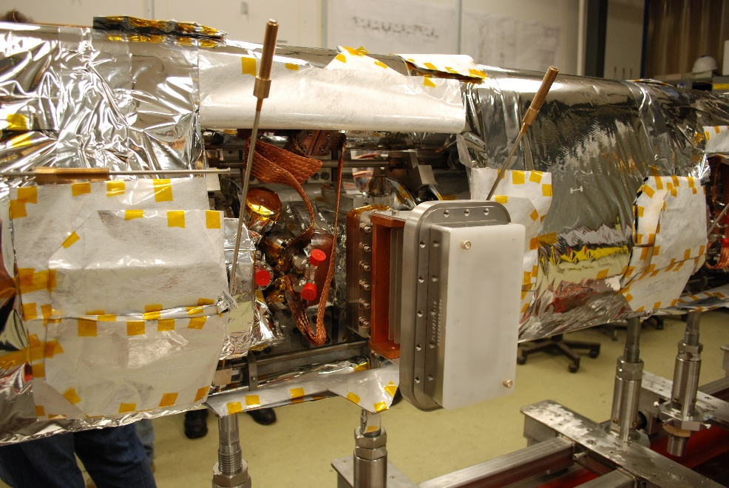 | [[BLAccessPanelTech]] <<SRF>>  [[BLAccessPanelDate]] <<TIMESTAMP>>  [[BLAccessPanelComm]] <<COMMENT>>
22 | HOLD POINT FOR RADCON SURVEY OF INTERNAL BEAMLINE AREA. RECORD FINDINGS IN COMMENT BOX.  - If the survey reveals radioactive materials, items shall be tagged in accordance with the RadCon Memo. Survey results (i.e. Ram # and dose rates) to be recorded in Data input column by technicians.  - Proceed to the next step if no radioactive materials are identified.  - If RAM materials are found, RadCon will define work restrictions. | [[HP2LeadTech]] <<SRF>>  [[HP2Date]] <<TIMESTAMP>>  [[HP2RadconTech]] <<RAD>>  [[HP2RadconDate]] <<TIMESTAMP>>  [[HPComment2]] <<COMMENT>>  [[HP2RAM_File]] <<FILEUPLOAD>>
23 | Install the lollipops  - Install "L" brackets onto the cavity helium vessel heads  - Install the lollipop into the carriage and "L" bracket  - Adjust the lollipop to take the weight of the cavity  - Tighten all fasteners  - Lockdown the carriages to the rail  Repeat this process for all of the lollipops.. | [[LollipopInstallTech]] <<SRFCMP>>  [[LollipopInstallDate]] <<TIMESTAMP>>  [[LollipopInstallComm]] <<COMMENT>>
24 | Verify all of the lollipop tooling is tight and carriages are locked down. | [[VerifyToolingLeadTech]] <<SRF>>  [[VerifyToolingDate]] <<TIMESTAMP>>  [[VerifyToolingComment]] <<COMMENT>>
25 | Assemble the spaceframe tooling  - Install the stais tooling under the Space Frame sections, then lower the spaceframe to contact tooling  - Install the “Bat Wing” tooling and affix to the Space Frame.  - Apply the weight of the Space Frame to the tooling  - Lead to verify before proceeding  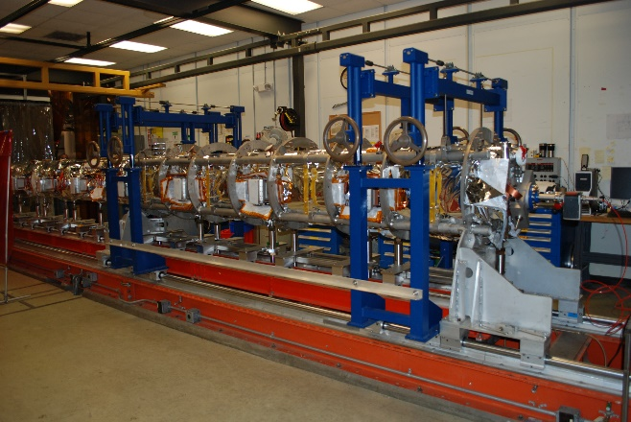 | [[AssySFToolTech]] <<SRF>>  [[AssySFToolLeadTech]] <<SRFCMP>>  [[AssySFToolDate]] <<TIMESTAMP>>  [[AssySFToolComm]] <<COMMENT>>

Step No. | Instructions | Data Input
26 | Unfasten all of the Nitronic rod heat stationing clamps. Indium may be found, careful inspection required and RADCON to be consulted. Place materials into the bins for survey within RADCON defined barrier. Only RADCON personnel can release parts.  ** Radiological controls are a critical component of the cryomodule rework disassembly and assembly process. Dose rate, as well as contamination surveys (where indium gaskets or seals are present) shall be performed and analyzed, with information communicated to all involved personnel. Results will be recorded at traveler hold points. RW-II training will be required where contamination is identified** | [[NitroClampTech]] <<SRF>>  [[NitroClampDate]] <<TIMESTAMP>>  [[NitroClampComment]] <<Comment>>  [[NitroClamp_File]] <<FILEUPLOAD>>
27 | Remove the Nitronic rods, check for excess movement while doing so.  - First, remove center axial rods (4)  - Next, remove bottom Nitronic rods (32)  - Finally, remove top Nitronic rods (32)  Place hardware into bags, place in bin. | [[NitroRodTech]] <<SRF>>  [[NitroRodDate]] <<TIMESTAMP>>  [[NitroRodComment]] <<COMMENT>>
28 | Unanchor the HOM and FPC coaxial cable from thermal shield intercept blocks. Indium may be found at the heat station interfaces. Careful inspection required and Notify RADCON prior to disassembly.  Verify all instrumentation wiring is free from MLI and shields. Coil cables and wiring inside shields. Do not damage cables. Place materials in bins for survey within RADCON defined barrier. Only RADCON personnel can release parts.  ** Radiological controls are a critical component of the cryomodule rework disassembly and assembly process. Dose rate, as well as contamination surveys (where indium gaskets or seals are present) shall be performed and analyzed, with information communicated to all involved personnel. Results will be recorded at traveler hold points. RW-II training will be required where contamination is identified** | [[UnanchorTech]] <<SRF>>  [[UnachorDate]] <<TIMESTAMP>>  [[UnanchorElectricalTech]] <<SRF>>  [[UnanchorElectricalDate]] <<TIMESTAMP>>  [[UnanchorComm]] <<COMMENT>>  [[Unanchor_File]] <<FILEUPLOAD>>
29 | Unanchor the waveguide and tuner 50K thermal strapping, Do not damage waveguide bellows. Indium may be found at heat station interfaces. Careful inspection required and Notify RADCON prior to disassembly.  Place materials in bins for survey within RADCON defined barrier. Only RADCON personnel can release parts.  ** Radiological controls are a critical component of the cryomodule rework disassembly and assembly process. Dose rate, as well as contamination surveys (where indium gaskets or seals are present) shall be performed and analyzed, with information communicated to all involved personnel. Results will be recorded at traveler hold points. RW-II training will be required where contamination is identified**  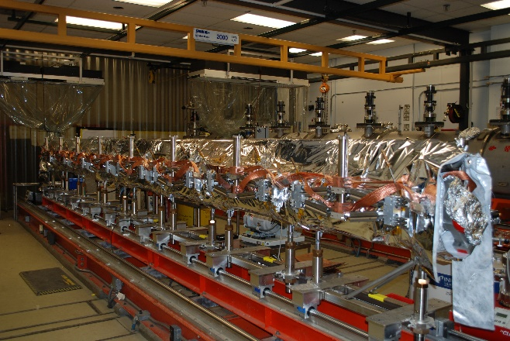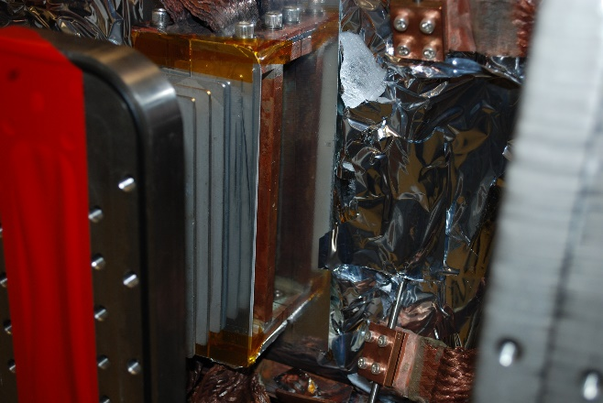 | [[Unanchor50KTech]] <<SRF>>  [[Unanchor50KDate]] <<TIMESTAMP>>  [[Unanchor50KComm]] <<COMMENT>>  [[Unanchor50K_File]] <<FILEUPLOAD>>

Step No. | Instructions | Data Input
30 | Install the waveguide support brackets. Do not damage bellows.  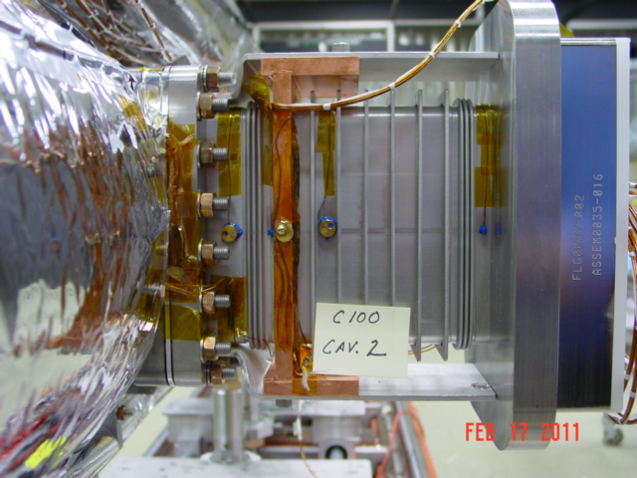 | [[InstallWGTech]] <<SRF>>  [[InstallWGDate]] <<TIMESTAMP>>  [[InstallWGComment]] <<COMMENT>>
31 | Cut the bellows cuff weld between shield sections, making shields and Space Frame halves independent.  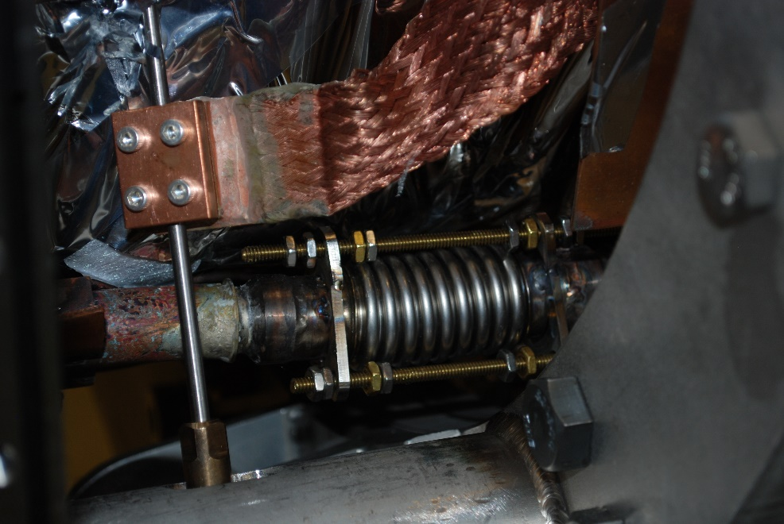 | [[BellowCutTech]] <<SRF>>  [[BellowCutDate]] <<TIMESTAMP>>  [[BellowCutComment]] <<COMMENT>>
32 | Remove the Space Frame  - Remove the Lower Frame ties, wheel assemblies, and locking hardware from half of the Space Frame.  - Slowly open the Space Frame using the tooling, watch for interferences.  - Once the Space Frame is fully open, slide it off of the Cavity String.  - Remove the center spool by supporting it with the OHC and unbolting from the remaining Space Frame half.  - Repeat the process for the remaining Space Frame unit.  - Evaluate if the 50k MLI needs to be replaced, then perform required work.  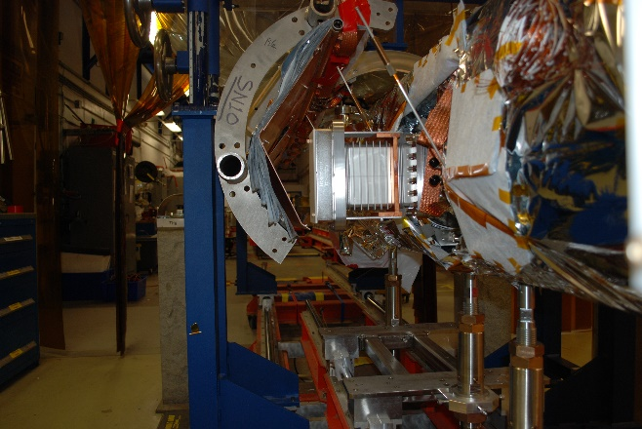 | [[SFRemovalTech]] <<SRF>>  [[SFRemovalLeadTech]] <<SRFCMP>>  [[SFRemovalDate]] <<TIMESTAMP>>  [[SFRemovalComm]] <<COMMENT>>

Step No | Instructions | Data Input
33 | Reassemble the Space Frame, re-install into the Vacuum Vessel for storage. This assembly will be surveyed then moved to an appropriate storage area. | [[SFReAssyTech]] <<SRF>>  [[SFReAssyDate]] <<TIMESTAMP>>  [[SFReAssyComment]] <<COMMENT>>
34 | Remove outer 2K MLI blankets, preserve if possible.  Place materials in bins for survey within RADCON defined barrier. Only RADCON personnel can release parts.  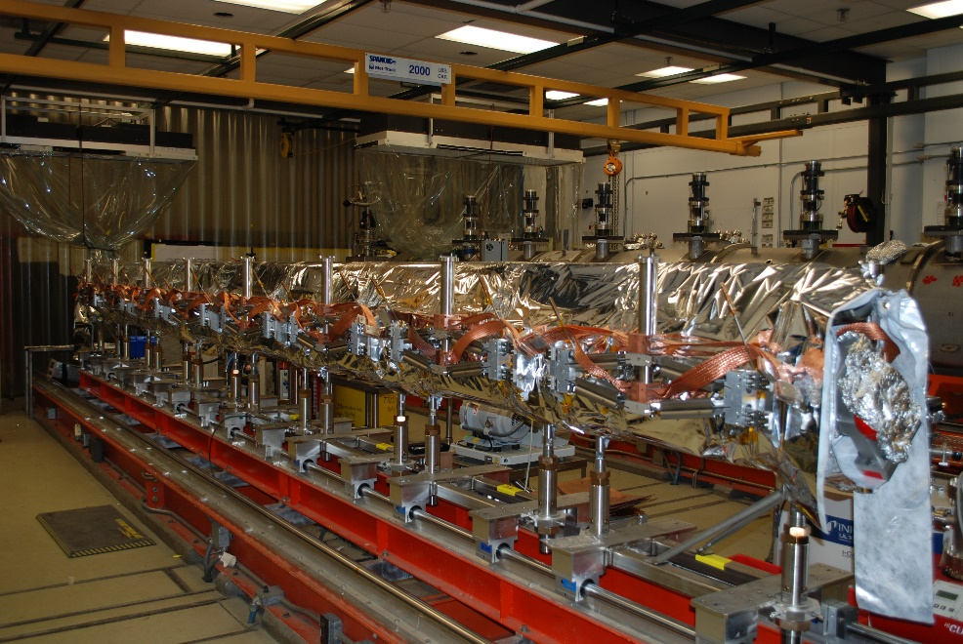 | [[Removal2KTech]] <<SRF>>  [[Removal2KDate]] <<TIMESTAMP>>  [[Removal2KComm]] <<COMMENT>>
35 | HOLD POINT FOR RADCON SURVEY OF INTERNAL BEAMLINE AREA. RECORD FINDINGS IN COMMENT BOX.  - If survey reveals radioactive materials, items shall be tagged in accordance with RadCon Memo. Survey results (i.e. Ram # and dose rates) to be recorded in Data input column by technicians.  - Proceed to next step if no radioactive materials are identified.  - If RAM are found, RadCon to define work restrictions. | [[HP3LeadTech]] <<SRF>>  [[HP3Date]] <<TIMESTAMP>>  [[HP3RadconTech]] <<RAD>>  [[HP3RadconDate]] <<TIMESTAMP>>  [[HP3Comment]] <<COMMENT>>  [[HP3RAM_File]] <<FILEUPLOAD>>

Step No. | Instructions | Data Input
36 | Remove the HOM and FPC coaxial cables.  Place materials in bins for survey within RADCON defined barrier. Only RADCON personnel can release parts.  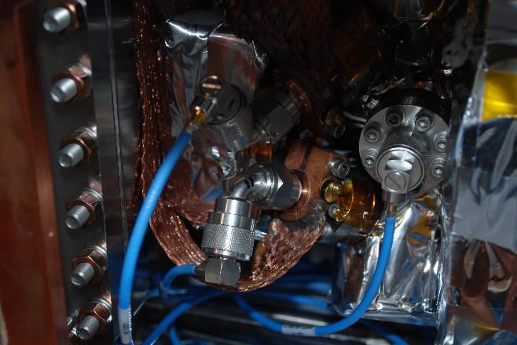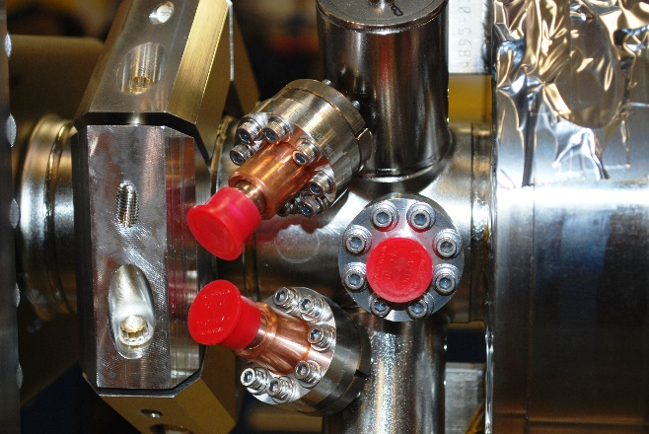 | [[RemoveCablesTech]] <<SRF>>  [[RemoveCablesDate]] <<TIMESTAMP>>  [[RemoveCablesComment]] <<COMMENT>>
37 | Carefully remove the HOM 2K feedthru thermal anchoring straps. Indium may be found at heat station interfaces. Careful inspection required and Notify RADCON prior to disassembly.  ** Radiological controls are a critical component of the cryomodule rework disassembly and assembly process. Dose rate, as well as contamination surveys (where indium gaskets or seals are present) shall be performed and analyzed, with information communicated to all involved personnel. Results will be recorded at traveler hold points. RW-II training will be required where contamination is identified**  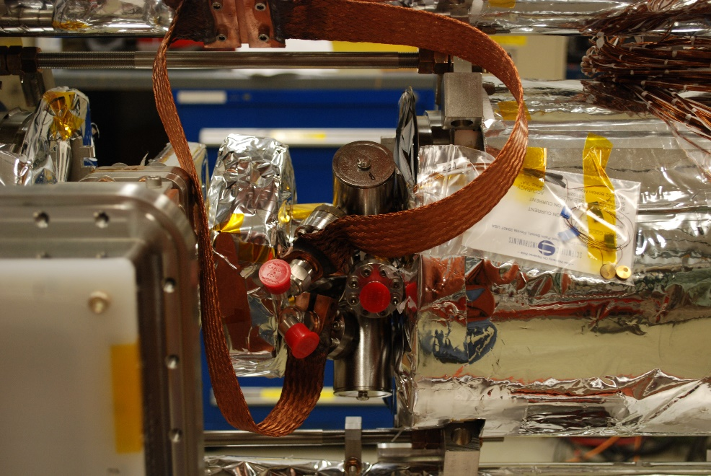 | [[RmvHOM2KTech]] <<SRF>>  [[RmvHOM2KDate]] <<TIMESTAMP>>  [[RmvHOM2KComm]] <<COMMENT>>  [[RADCONUpload37]] <<FILEUPLOAD>>
38 | Remove the Cold Tuners Scissors Assemblies.  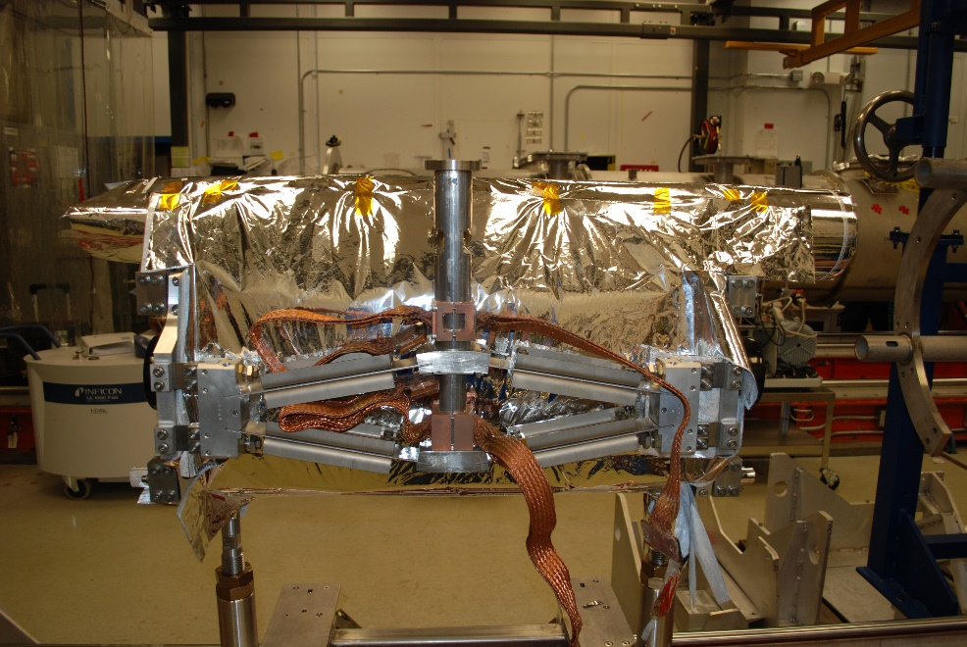  Place materials in bins for survey within RADCON defined barrier. Only RADCON personnel can release parts. | [[RmvColdTunersTech]] <<SRF>>  [[RmvColdTunersDate]] <<TIMESTAMP>>  [[RmvColdTunersComm]] <<COMMENT>>

Step No. | Instructions | Data Input
39 | Remove the inner 2K MLI blankets, wiring harnesses, and 8 pin cryogenic feedthrus (x4). Preserve the wiring harness if possible.  The removed 8 pin cryogenic feedthrus (x4) shall be discarded following RADCON protocols, new validated feedthrus will be used for the Cryomodule refurbishment.  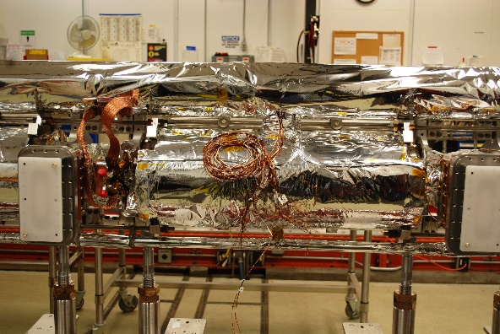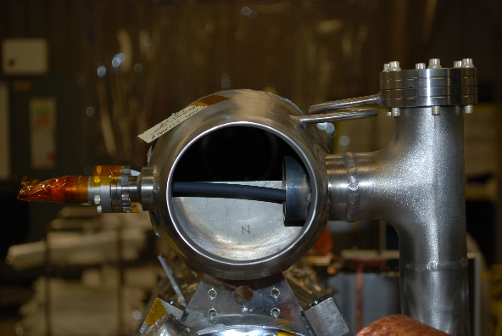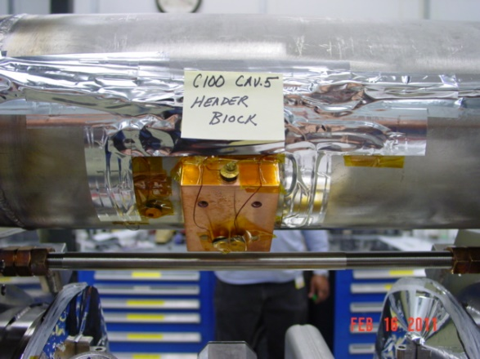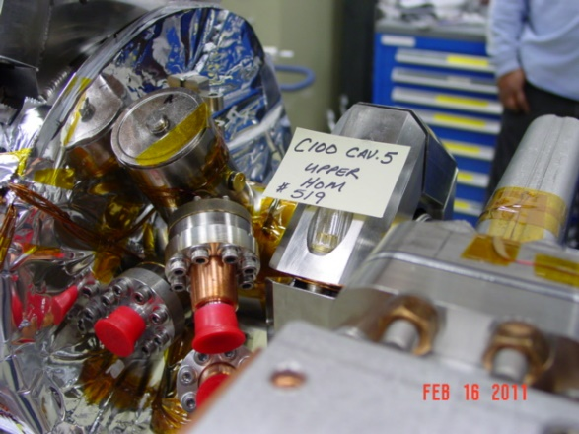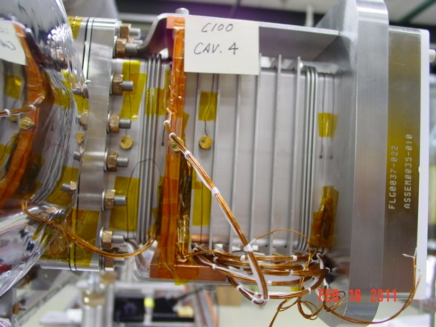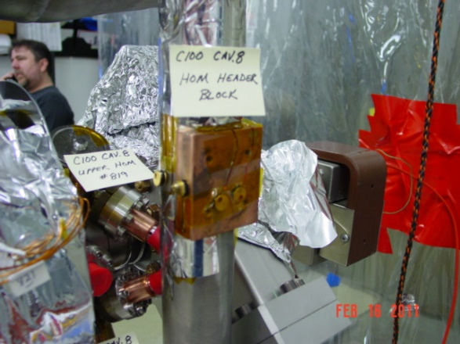  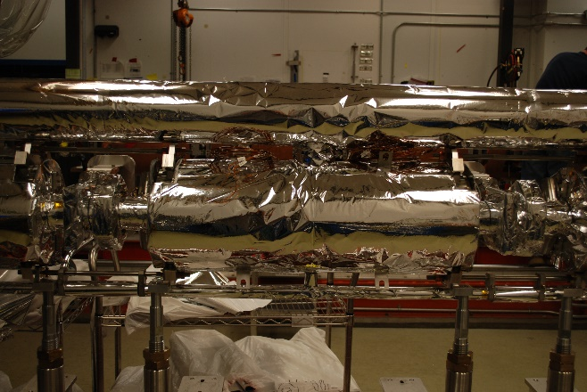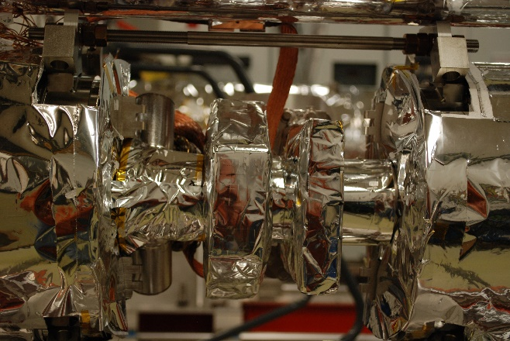 | [[Rmv2KMLITech]] <<SRF>>  [[Rmv2KMLIElecTech]] <<SRF>>  [[Rmv2KMLIDate]] <<TIMESTAMP>>  [[Rmv2KMLIComm]] <<COMMENT>>

Step No. | Instructions | Data Input
40 | Remove the remaining Tuner End Plates.  Catalogue all parts, store in bags, then bins. | [[RmvTunerEndPlateTech]] <<SRF>>  [[RmvTEPDate]] <<TIMESTAMP>>  [[RmvTEPComment]] <<COMMENT>>
41 | Remove the inner helium vessel Mu shields.  Place materials in bins for survey within RADCON defined barrier. Only RADCON personnel can release parts.  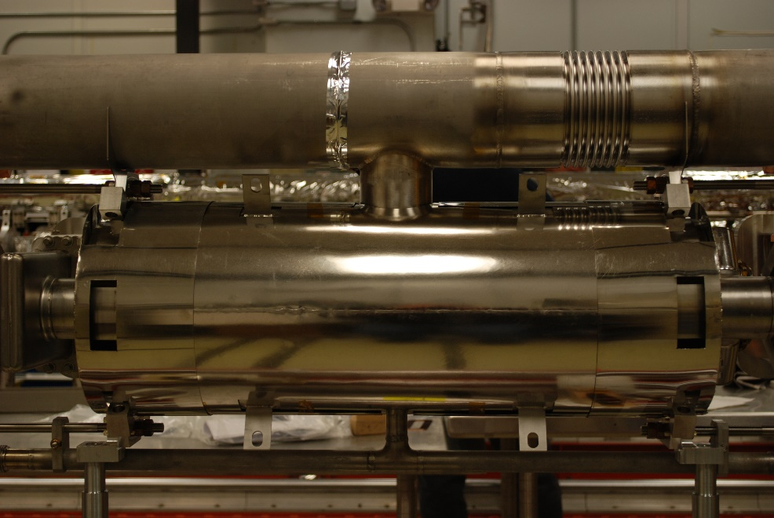 | [[RmvHELVTech]] <<SRF>>  [[RmvHELVDate]] <<TIMESTAMP>>  [[RmvHELVComment]] <<COMMENT>>
42 | Cut and remove all process piping. Minimize the amount of cutting debris getting into the helium vessel as much as possible, use rags or plugs to block piping.  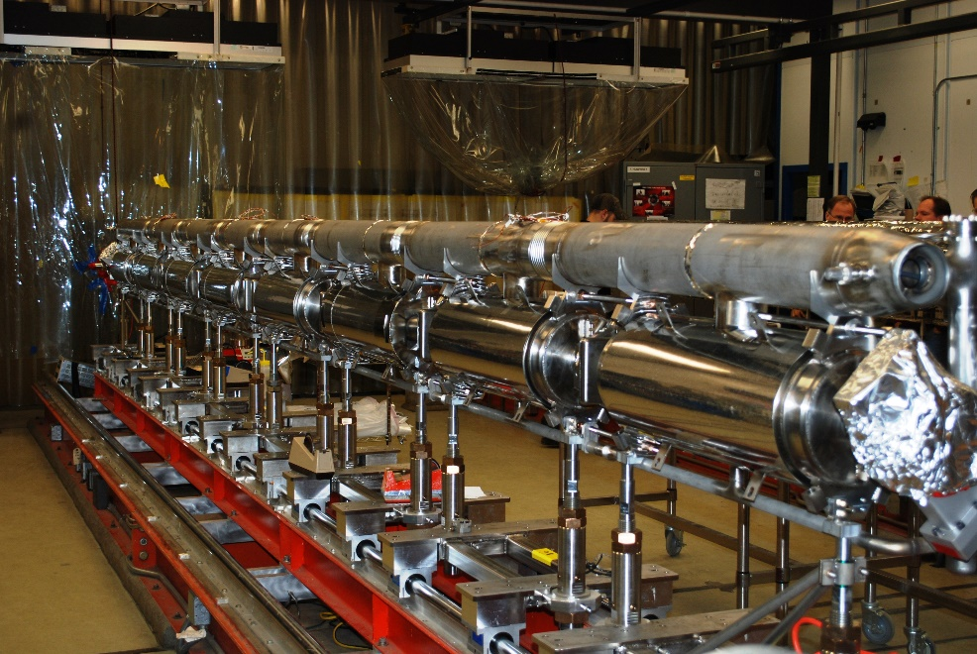 | [[RmvPipingTech]] <<SRF>>  [[RmvPipingDate]] <<TIMESTAMP>>  [[RmvPipingComment]] <<COMMENT>>
43 | Debur all sharp edges, and cover openings in helium vessels. | [[DeburTech]] <<SRF>>  [[DeburDate]] <<TIMESTAMP>>  [[DeburComment]] <<COMMENT>>
44 | Install cross members (if required) between lollipop carriages; ensure all tooling hardware is tight. | [[InstallCrossTech]] <<SRF>>  [[InstallCrossDate]] <<TIMESTAMP>>  [[InstallCrossComment]] <<COMMENT>>

Step No. | Instructions | Data Input
45 | Perform final RADCON survey on the Cavity String and any remaining parts. | [[FinalTech]] <<SRF>>  [[FinalDate]] <<TIMESTAMP>>  [[FinalComment]] <<COMMENT>>  [[FinalRadconTech]] <<RAD>>  [[FinalRadconDate]] <<TIMESTAMP>>  [[FinalRadconComment]] <<COMMENT>>  [[FinalRAM_File]] <<FILEUPLOAD>>
46 | Turn the bare cavity string over to Cavity Group once RADCON has released it.  Record the Cavity SN's  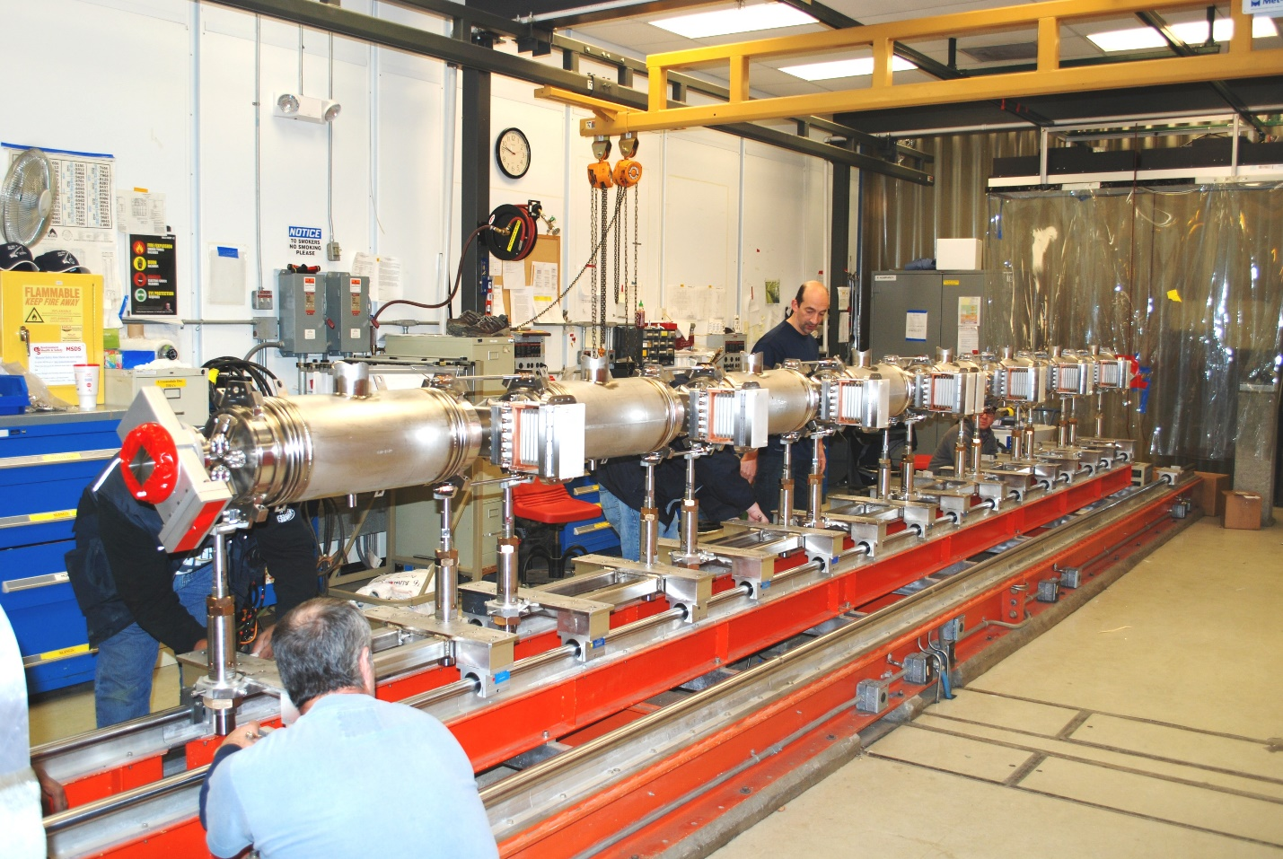 | [[CavTech]] <<SRF>>  [[CavDate]] <<TIMESTAMP>>  [[CavComment]] <<COMMENT>>  [[CAVSN1]] <<CAVSN>>  [[CAVSN2]] <<CAVSN>>  [[CAVSN3]] <<CAVSN>>  [[CAVSN4]] <<CAVSN>>  [[CAVSN5]] <<CAVSN>>  [[CAVSN6]] <<CAVSN>>  [[CAVSN7]] <<CAVSN>>  [[CAVSN8]] <<CAVSN>>

