|  |  |  |  |
| --- | --- | --- | --- |
| **Prepare for Cryomodule Plasma Processing** | | | |
| **Document Number:** | PLACLN-PR-CM-PREP | **Effective Date:** | 1 Jun 2024 |
| **Revision Number:** | 3 | **Periodic Review Date:** | N/A |
| **Document Owner:** | T. Ganey | **Department Owner:** | SRF Operations |

# Purpose

This procedure provides instructions for preparing for plasma processing CEBAF cryomodule in the Test Lab, Cryomodule Test Facility (CMTF), or CEBAF. It references other procedures that provide detailed instructions on specific portions of the process. Connecting and disconnecting the plasma vacuum and gas supply carts will be performed by technicians specifically trained for beamline work within a portable cleanroom. Cable calibrations and RF equipment setup will be performed by the plasma processing technicians. At the end of this procedure, the cryomodule will be ready to begin plasma processing.

This procedure supports the Quality Management System as described in SRF-01-ML-001 Quality Manual.

# Scope

This procedure applies to <enter text>.

This procedure does not apply to <enter text>.

# Safety

Individuals must keep safety as the first priority in the process; before beginning any job, the user must assure they have the correct PPE for the individual job. Maintaining the level of safety and secure nature of the work area is paramount.

The work area may be a Radiologically Controlled Area (RCA), and dosimetry must be worn at all times while in an RCA.

Refer to the plasma processing and work-center ePas for specifics.

# Table of Contents

1 Purpose 1

2 Scope 1

3 Safety 1

4 Table of Contents 1

5 Terms and Definitions 2

6 Roles and Responsibilities 2

7 Connect Vacuum Cart 2

8 Connect Gas Supply Cart 4

9 Establish Gas Flow 5

10 Prepare Software and RF 7

11 Process Flow 9

12 Appendix A: AutoCAD Diagrams of the Plasma Carts 10

13 References 11

14 Release and Revision History 11

15 Approvals 11

# Terms and Definitions

The following terms have specific meanings within this procedure.

|  |  |
| --- | --- |
| **Term** | **Definition** |
| Computer / RF Cart | Cart with computer, signal generator, power meters, amplifier, etc. and RF components (directional coupler, circulator, power sensors, cables, etc.) used for plasma processing. |
| Gas Supply Cart | Cart with gas supply used for plasma processing. |
| Mass Flow Controller (MFC) Valve | Controller on gas supply cart that regulates the gas flow; controlled and monitored on the MKS 946 Vacuum System. |
| PlasmaMain | The LabVIEW software that runs the plasma processing program; located in the D:\Labview VIs folder. |
| Setpoint Pressure | The pressure that the plasma processing will be done. This is typically between 50 – 300 mTorr. Contact the SME for guidance on the setpoint pressure if needed. |
| Vacuum Cart | Cart with two turbo pumps used for plasma processing. |
| Verify | If an instruction specifies to "verify" and the item is not true, stop and seek help unless instructed otherwise in the specific line. |

# Roles and Responsibilities

The following roles have responsibilities described in this document.

|  |  |
| --- | --- |
| **Role** | **Responsibility** |
| Vacuum Technician | Personnel trained to perform particulate-free work on beamline components inside a portable cleanroom. |
| Plasma Processing Technician | Personnel trained to set up the plasma processing carts and to perform plasma processing. |
| PI/PM | Principle Investigator / Project Manager |

# Connect Vacuum Cart

The vacuum cart will be connected to the ion pump valve on the Supply End Can side.

## Clean connect and leak check the vacuum cart to the cryomodule in accordance with PLACLN-PR-CM-CONN. The clean connection shall be performed by personnel trained to perform vacuum connections in the portable cleanroom. Plasma processing technicians may assist with operating the plasma cart valves and/or software as needed.

* The cryomodule gate valves shall be closed and on local control only prior to connecting the plasma processing carts.
* The girder and cryomodule ion pumps shall be turned off and unplugged prior to opening the plasma processing gas supply cart to the cryomodule.
* Clean Nitrogen gas may flow through the cart during the connection.
* The portable cleanroom shall remain in place until the connection to the cryomodule has been verified to be leak tight.
* The capacitive manometer takes 2-3 hours to warm up.
* The lower end of the capacitive manometer’s range is 1E-4 Torr.
* The lower end of the piezo gauges range is 0.1 Torr.

|  |  |
| --- | --- |
| Figure 6‑a: Vacuum A Valves | Figure 6‑b: Vacuum B Valves |

# Connect Gas Supply Cart

The gas supply cart will be connected to the ion pump valve on the girder on the Return End Can side.

**NOTES:**

* Process gases other than Helium may be used. Substitute the process gas to be used where "Helium" (or "He") is used throughout this procedure.
* "Gas line" refers to the combination of flex hose and tubing from the gas supply cart to the gas supply manifold.

## Clean connect and leak check the gas supply manifold to the girder in accordance with PLACLN-PR-CM-CONN. The clean connect shall be performed by personnel trained to perform vacuum connections in the portable cleanroom.

* The cryomodule gate valves shall be closed and on local control only prior to connecting the plasma processing carts. The appropriate cryomodule gate valves shall be opened after the plasma carts have been connected and verified to be leak tight.
* The girder and cryomodule ion pumps shall be turned off and unplugged prior to opening the plasma processing gas supply cart to the cryomodule.
* The portable cleanroom shall remain in place until the connection to the cryomodule has been verified to be leak tight.
* The capacitive manometer takes 2-3 hours to warm up.
* The lower end of the capacitive manometer’s range is 1E-4 Torr.
* The lower end of the piezo gauges range is 0.1 Torr.

## Verify the process gas tank regulators are set to approximately 5 psi and open the tank valves.

## Pump and purge the gas supply cart and manifold with the girder isolation valve closed. Leave the cart and manifold under vacuum and pumping.

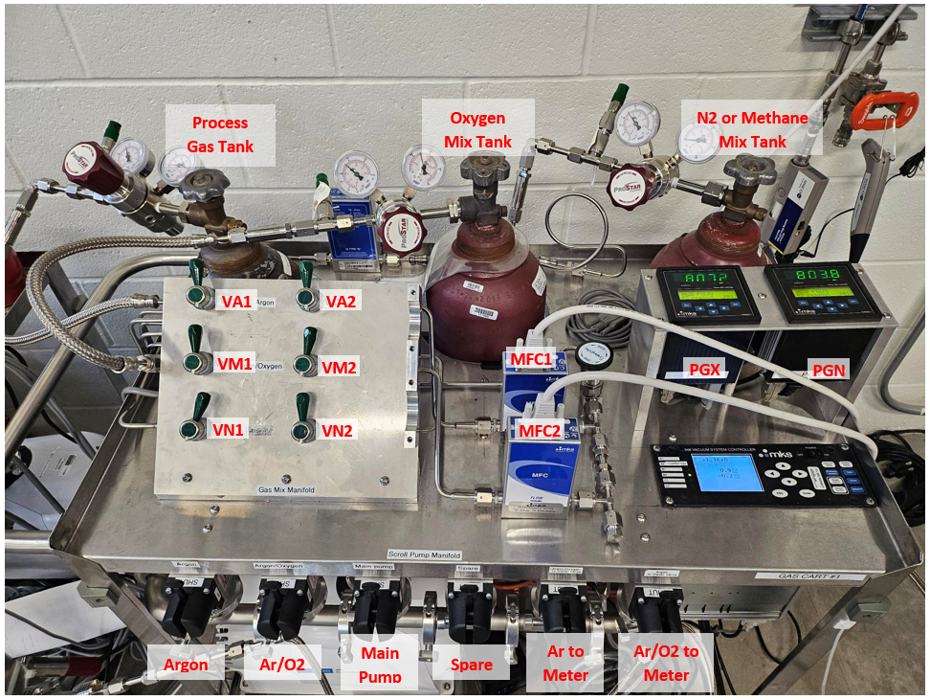

Figure 7‑a: Gas Cart System

# Establish Gas Flow

## Verify:

* The cryomodule isolation valve to the vacuum cart is open and the vacuum cart is pumping the cryomodule.
* Vacuum cart V17 is open and the RGA filament is warmed up.
* The girder isolation valve to the gas supply cart is closed.
* The Gas supply cart is pumping on the space up to the closed girder isolation valve.
* The Gas supply cart MFC valves are closed.
* The piezo gauges on the gas supply cart and manifold are reading 0.1 Torr.
* The capacitive manometer on the gas supply manifold is reading the bottom of its range (typically near 1E-4 Torr).
* The cryomodule and girder ion pumps are turned off and unplugged.
* The cryomodule gate valve near the vacuum cart is closed and the gate valve near the gas supply cart is open.
* The gate valves are disconnected from EPICS and are controllable only locally.

## Log into EPICS and start a Live Plot of the cavity vacuum for the adjacent cryomodules (upstream and downstream of the cryomodule being processed). If the pressures increase when you establish gas flow in the cryomodule being processed, stop the gas flow and assess the situation before continuing. Continue to monitor the adjacent cryomodules' pressure throughout plasma processing.

* The EPICS variable is in the format VIPxxxxB, where xxxx is the adjacent cryomodule in the example format "2L24".
* A slight pressure increase (up to the mid E-7 Torr range) in an adjacent warm cryomodule may be acceptable. Evaluate the situation and further cryomodule pressures to determine the extent of the pressure increase.
* A pressure increase in an adjacent cold cryomodule may cause the plasma processing gas to freeze out on the beamline surface.

## Zero the capacitive manometers on the vacuum and gas supply manifolds.

## Set up the PlasmaMain graphs to monitor mass flow (MF), pressure (PCav (Torr)), and %O2.

## Fully open V22 while leaving V23 in its nominal operating position and close V21.

## Fully open V13 while leaving V12 in its nominal operating position and close V11.

## Close the gas supply cart VN2, Argon to Meter, and Ar/O2 to Meter valves.

## Slowly close the gas supply manifold valve.

## Slowly open the girder isolation valve to the gas supply cart. Verify there is no significant change in the cryomodule pressure.

## Slowly open the gas supply manifold valve.

## Monitor the pressure reading on EPICS, the Capacitive Manometer(s), and the vacuum cart turbo controllers.

* The pressure readings may increase slightly on the capacitive manometer and on the pumps.
* If a large increase in the pressure is observed, stop and assess the situation.

## If not done, verify the tank regulators are set to 5 psi and open the processing gas tanks.

## Open the gas supply cart valves VA1, VA2, VM1, and VM2.

### On PlasmaMain, select the Vac Cntl tab.

### On the PlasmaMain yellow screen, set the Pressure Setpoint to the setpoint pressure that will be maintained for plasma processing.

### Set the MFC 1 and MFC 2 Setpoints and Mass Flow Max to starting values. Verify that the total Mass Flow (MFC 1 Setpoint + MFC 2 Setpoint) is less than 20 SCCM.

* The total Mass Flow should remain below 20 SCCM to the extent practical. Running the system with MF > 20 SCCM for an extended period may cause the pump(s) to fail. Running the system with MF > 20 SCCM may be permitted for short durations (for example, when first starting gas flow to raise the pressure in the cavity to the desired set point).
* A Mass Flow Setpoint cannot be set to a value lower than its control range lower limit.

|  |  |
| --- | --- |
| MFC Full Scale Flow Range (SCCM) | MFC Control Range Lower Limit (SCCM) |
| 20 | 0.4 |
| 100 | 2 |
| 200 | 4 |

### Set the Mass Flow modes to “False”. The toggle button light will be dark when the Mass Flow modes are set to False.

### Click the Pressure Loop button to turn on the PlasmaMain pressure control loop. The button will turn green when the pressure control loop has been turned on.

### Monitor the pressure of the cryomodule being processed, which should slowly start to rise and reach a steady state.

* Continue to monitor the adjacent cryomodules' pressure in EPICS. If any increase in pressure is observed in the adjacent cryomodule(s), stop the gas flow and assess the situation.
* Adjust the MFC Setpoints as needed to achieve the pressure and O2% setpoints.
* It may be necessary to adjust the vacuum cart B valves (V22, V21, and V23) to achieve the desired mass flow and pressure.

## Verify that the Cavity Pressure is regulating at the Cavity Pressure setpoint with 10 - 20 SCCM gas flow as measured on PlasmaMain screen "Mass Flow" indicator.

### If the mass flow is too low, increase the pumping through Turbo B. Try the following options in the order listed below.

#### Start opening V23 until the mass flow increases and stabilizes in the target range.

#### If mass flow does not increase until V23 is fully open:

* Open V21 fully.
* Close V23.
* Set MF Set 1 to 18 SCCM and set PID/Set Pres to False.
* Slowly start closing V21 until the cavity pressure begins to increase.
* Continue to adjust V21 until the cavity pressure and mass flow stabilizes in the target range.

### If the mass flow is too high, decrease the pumping through Turbo B. Start closing V23 until the mass flow decreases and stabilizes in the target range.

## If the O2% is not within the target range:

### Verify that the process gas [Ar (AMU 40) or He (AMU 4)] partial pressure at the RGA is in the 2E-5 range.

* If the process gas partial pressure is lower than 2E-5, slowly open V12 until the partial pressure is approximately 2E-5. Wait 5 minutes and check the O2%.

## When the Cavity Pressure approaches the setpoint pressure, toggle the PIDs to “True”. The toggle button light will be green when the PIDs are set to True.

## Once the pressure, gas flow, O2%, and valve positions are stable, leave the system purging with the RGA on and recording data with PlasmaMain until ready to begin plasma processing. At minimum, the RGA values should be relatively stable at a baseline partial pressure. This ensures that any increase in hydrocarbons due to plasma processing can be observed.

# Prepare Software and RF

## Verify gauge, controller, RGA connections to computer rack, including:

* RGA
* MKS and MFC
* Capacitive Manometers
* Piezo Gauges [Optional]
* Turbo Controllers [Optional]

## Verify RF connections on rack. The RF should not be connected to the cavity at this time.

## Calibrate the network analyzer in accordance with PLACLN-PR-NA-CAL.

* For C100 cavities: Add a cable similar to the type of cable installed in the cryomodule to the end of the Forward Power cable during the network analyzer calibrations to simulate the cable inside of the cryomodule. Remove the cable once the calibration is complete

## For C100 cavities: For each cavity, determine the Phase Shifter settings in accordance with PLACLN-PR-CAV-PHASE.

* Connect the network analyzer port 1 cable to the HOM to be used for plasma processing, the network analyzer port 2 cable to the FPC or FPC extension cable, and connect the phase shifter to the cavity's other HOM.

## For each cavity, create a new HOM modes file and copy the modes file into the correct folder with a file title indicating the cavity (and phase shifter setting for C100 cavities). During plasma processing, the correct modes file for the cavity being processed will need to be selected in PlasmaMain.

## Perform cable calibrations in accordance with PLACLN-PR-CAV-CCAL.

* Prior to performing the cable calibrations connect RF output to an FPC extension cable and/or an N-type elbow connectors, if needed.
* RF PWR calibration must be performed for cryomodules.
* For C100 cavities: Add a cable similar to the type of cable installed in the cryomodule to the end of the Forward Power cable during the cable calibrations to simulate the cable inside of the cryomodule. Remove the calibration cable once the calibration is complete.
* For 5-Cell cavities: If an FPC extension cable is being used, add a similar cable to the end of the Forward Power cable during cable calibrations to simulate the additional cable to the FPC. Remove the calibration cable once the calibration is complete.
* If multiple adjacent cryomodules are being plasma processed consecutively without the plasma processing RF racks being moved beyond the adjacent cryomodule and if changes to the cables and RF components are not made between cryomodules, the cable calibrations do not need to be performed again.

## Launch the appropriate Network Analyzer program.

* If using a 2 port Network Analyzer or if only a single cavity is being processed, use the program E5080 Network Analyzer S21.
* If using a 4 port Network Analyzer to process two cavities simultaneously, use the program E5080 Network Analyzer S21 S31.
* If this is the first time the program has been launched for plasma processing the current cavity, in the popup window select “Set up Network Analyzer”. Else, select “Network Analyzer OK”.
* If error messages are displayed, click Continue.

## Open PlasmaMain software, setup the Instrument Setup tab, and run the program.

* PlasmaMain will append the current date to the file name and save the file to the appropriate directory on the computer's D drive.
* If multiple computers will be running PlasmaMain, start the PlasmaMain program on the computer that will be the primary data source first. This will be the computer that is connected to the MKS and RGA, and will be used to set the gas flow.

## For C100 cavities: Connect the plasma processing RF input cable to the HOM to be used for plasma processing, connect the plasma processing RF output cable to the FPC or FPC extension cable, and connect the phase shifter to the cavity's other HOM.

## For 5-Cell cavities: Connect the plasma processing RF input cable to the FPC or FPC extension cable and connect the RF output cable to the FP.

# Process Flow

Cryomodule Isolated and Plasma Processing Manifolds Installed

Connect Vacuum Cart to Supply End Can side ion pump valve

Connect Gas Supply Cart to Return End Can side ion pump valve

Pump down carts to closed cryomodule isolation valves

Open cryomodule valve to vacuum cart, allowing vacuum cart to pump cryomodule

Close gas supply manifold valve

Open Girder isolation valve to cryomodule

Open gas supply manifold valve

Establish gas flow, pressure, and O2%

Ready to begin Plasma Processing

Calibrate Network Analyzer

For C100 cavities: Take phase shifter data

Create HOM mode files for each cavity

Perform cable calibrations

# Appendix A: AutoCAD Diagrams of the Plasma Carts

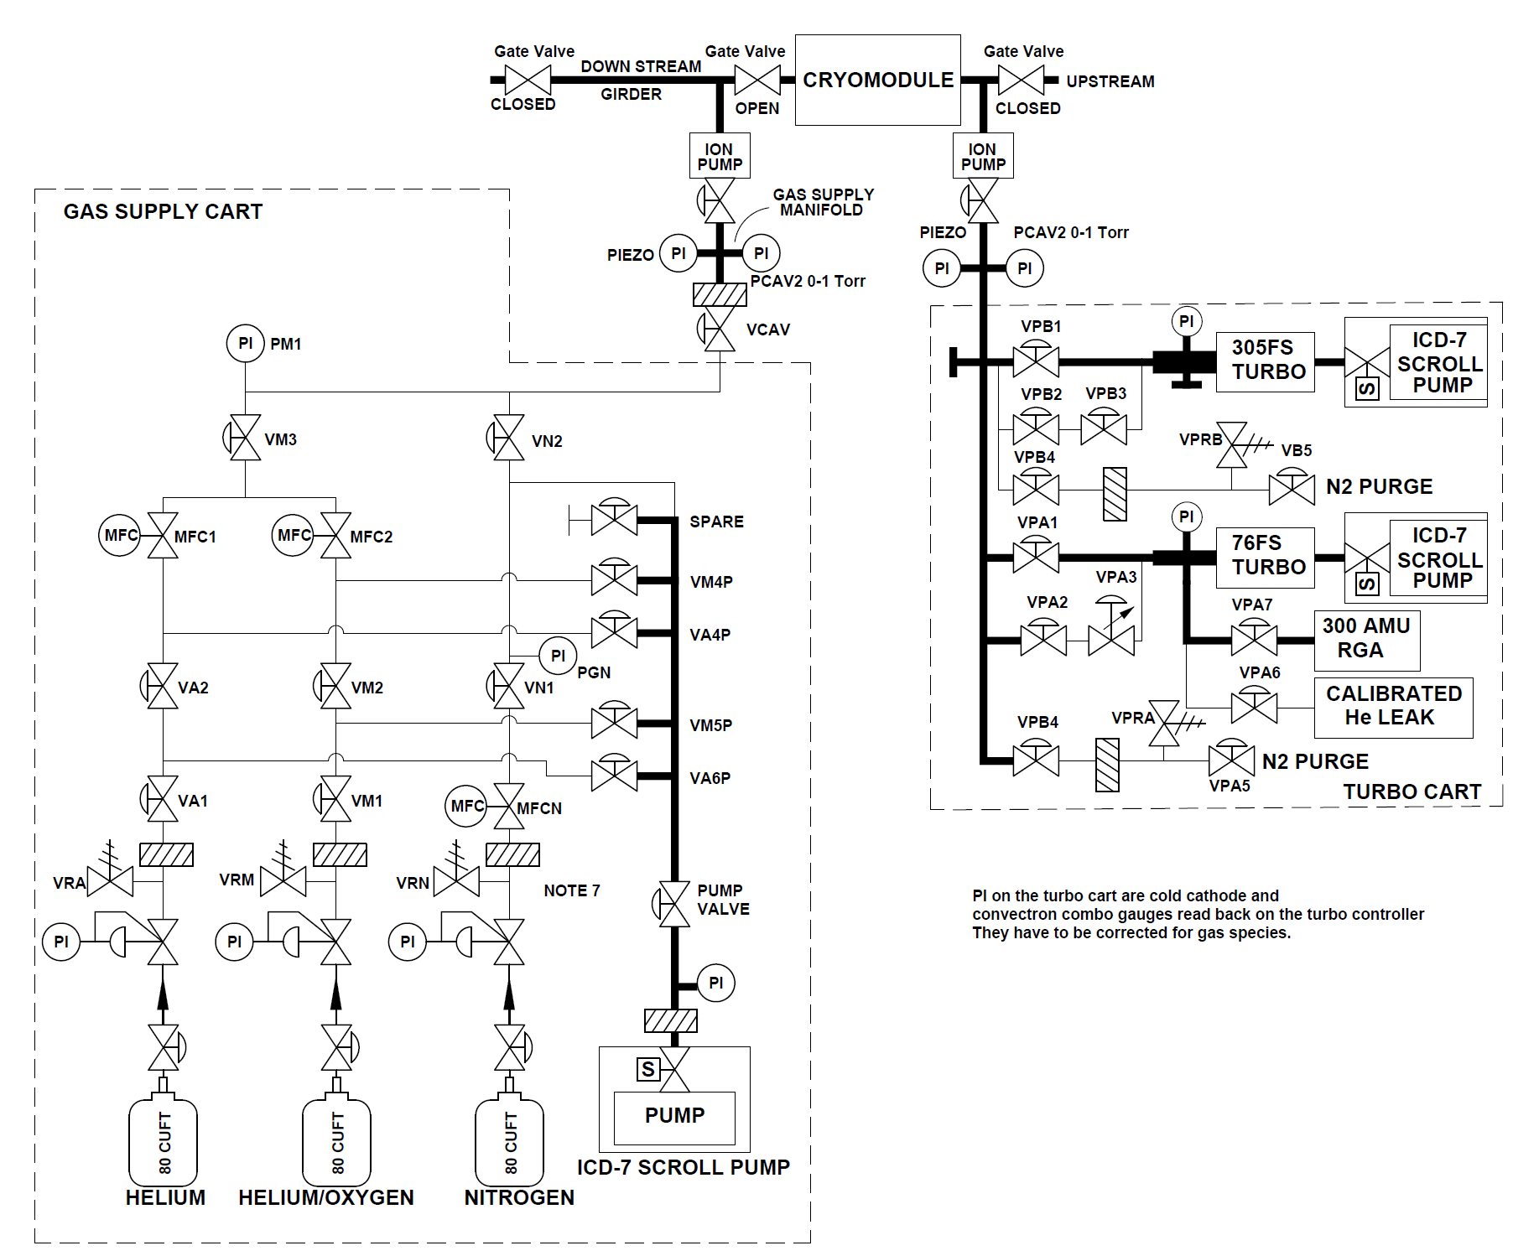

# References

|  |  |
| --- | --- |
| **Document No.** | **Title** |
| SRF-01-ML-001 | SRF Quality Manual |
| PLACLN-FM-CM-LIST | Cryomodule Plasma Processing Checklists |
| PLACLN-PR-CM-PREP | Prepare for Vertical Plasma Processing |
| PLACLN-PR-CM-CONN | Connect Plasma Processing Carts to Cryomodule |
| PLACLN-PR-CAV-CCAL | Plasma Processing Cable Calibrations |
| PLACLN-PR-CAV-PHASE | Phase Shift for Plasma Processing C100 Cavities |
| PLACLN-PR-CM-DISC | Disconnect Plasma Processing Carts from Cryomodule |
| PLACLN-CMTF-CM-PLSM | Cryomodule Plasma Processing Traveler |

# Release and Revision History

|  |  |  |
| --- | --- | --- |
| **Rev #** | **Major Changes** | **Effective Date:** |
| 1 | Initial version | 28 Mar 2023 |
| 2 | Incorporated changes throughout based on lessons learned after plasma processing cryomodules during SAD 2023. | 11 Sep 2023 |
| 3 | Updated gas cart configuration for 2 MFCs and instructions for setting gas flow. Updated to include instructions for 5-Cell cavities. Rearranged procedure steps. Added Process Flow section. | 21 Jun 2024 |
|  |  |  |

# Approvals

|  |  |  |  |
| --- | --- | --- | --- |
| **Approved by:** | **Name:** | **Signature:** | **Date:** |
| Procedure Author | Tiffany Ganey | In DocuShare | |
| Process Owner | Tom Powers | In DocuShare | |
| Quality Representative | Ashley Mitchell | In DocuShare | |
| SRF Department Head | Tony Reilly | In DocuShare | |