SAES NEG Activation Process using CapaciTorr HV 200 PS + VIP Starting.
Document Number: | SRFOPS-PR-ACC-NEG-PREP | Approval Date: | 05 Aug 2024
Revision Number: | 1 | Periodic Review Date: | N/A
Document Owner: | Gregory Marble | Department Owner: | SRF Operations

Purpose

This procedure covers the correct safe turn-on of the SAES NEG (Non Evaporable Getter) activation process using the CapaciTorr HV 200 power supply in accelerator enclosure.

This procedure supports the quality management system as described in SRF-01-ML-001 quality manual.

Scope

SRFOPS Services Traveler/Procedure:
This accelerator WCA Procedure can be generalized such that it could be applied to all linac girders where NEG CapaciTorr HV 200 are used. The PI/PM is encouraged to provide project specific instruction to supplement this procedure, which are to be attached to the applicable traveler. In general, a paper and digital log of turn-on is only needed, not a specific traveler.
Safety:
Properly review the manufactures NEG CapaciTorr HV 200 controller and installation manual and fully understand the operation before starting. These controllers can produce localized high heat to component housing and proper installation of cable is mandatory. Signage is mandatory to alert personnel of high heat zone.

Terms and Definitions

The following terms have specific meanings within this procedure.

Term | Definition
NEG | Non Evaporable Getter
VIP | Vacuum Ion Pump
Activation | Process Heating of Non Evaporable Getter
VRV | Vacuum Right Angle Valve
CF | Conflat
IPPS | Ion Pump Power Supply
GN2 | Gas Nitrogen

Roles and Responsibilities

The following roles have responsibilities described in this document.

Role | Responsibility
SAES NEG Activation Process | Heating of NEG up to 500C and pumping away/removal of the desorbed gas from Getter material.
Reduced Particle Generation Ion Pump Turn-on | Vacuum ion pump starting after NEG activation is complete

Procedure

Note: NEG mounted on 2 ¾” CF Flange use Pre-Activation Mode “Working CF35” and NEG mounted on 4 ½” CF Flange use “Working CF63” and for Full Activation Mode use “Activation”.

- Connect Turbo Pump Cart to VRVxLxxA/B and start Turbo Pump cart, then Pumpdown and Leak-check Connection at VRVxLxxA/B.

Note: Step #1; Turbo Pump Cart may already be installed and VIP is on; Also Step #9 When Full Activation is complete, closing VRVxLxxA/B immediately is a must; It keeps NEG from pumping on Turbo Pump Cart.

- Connect CapaciTorr HV 200 Controller Cable to NEG HV 200 connector.
- Close Large Manual All-Metal Gate Valve just above NEG assembly.
- Open VRVxLxxA/B.
- If VIP is on, turn off at IPPS (Ion Pump Power Supply).
- Start CapaciTorr Power Supply in Mode: Working 35CF or Working 63CF; Watch pressure rise on Turbo Pump Cart Pressure Gauge. Once Pressure Rise maxes out and pressure starts to get better, continue activation for 10 minutes more, then stop Pre-Activation.
- Wait 30 minutes for vacuum pressure to recover.
- Change Mode: Activation and start Full Activation at Power Supply for a run-time of 1hr.
- After 1hr turn Off activation at Power Supply. When Turbo Pressure Gauge drops below 1.0e -5 Torr immediately Valve-out Turbo Pump Cart at VRVxLxxA/B then wait ~ 15 to 30 minutes before starting VIP.

Note: Use Procedure- Reduce Particle Generation Ion Pump Turn-on

- If vip reaches full voltage of 5000 Vdc, all is good. If not, turn-off and try again in 10 minutes.
- Once VIP is back under vacuum/pressure of < 3.0e -7 Torr, valve-out turbo at main isolation Valve and bleed-up with GN2 turbo manifold watching VIPxLxxA/B for any pressure change.
- If no change to VIPxLxxA/B is seen: slowly open manual large all-metal gate valve just above NEG Assembly to girder beamline.
- NEG activation is complete: turbo pump cart can be removed from VRVxLxxA/B.

References

Document No. | Title
SRF-01-ML-001 | SRF Quality Manual
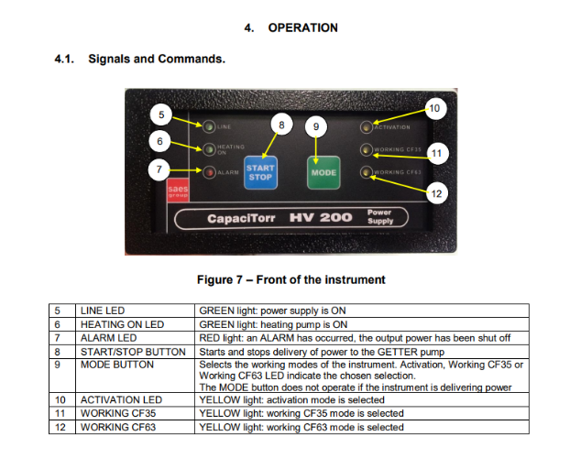 | CapaciTorr HV 200 Power Supply

Release and Revision History

Rev # | Major Changes | Approval Date:
1 | Initial version | 05 Aug 2024

Approvals

Approved by: | Name: | Signature: | Date:
Document Owner | Greg Marble | In DocuShare
Document Reviewer | <NAME> | In DocuShare
Management Approver | Roger Ruber | In DocuShare

