|  |  |  |  |
| --- | --- | --- | --- |
| **Ozone Processing**  **of Vacuum Enclosures** | | | |
| **Document Number:** | SRF-MSPR-ACC-BL-OZPRO | **Effective Date:** | 7-Aug-2024 |
| **Revision Number:** | 1 | **Periodic Review Date:** | 7-Aug-2026 |
| **Document Owner:** | Roger Ruber | **Department Owner:** | SRF Operations |

# Purpose

The purpose of this procedure is to provide instructions for the ozone processing of beamline vacuum enclosure.

# Scope

This procedure applies to beamline vacuum enclosures such as the CEBAF warm girders or the vacuum chambers of the warm parts of the CEBAF facility.

# Terms and Definitions

The following terms have specific meanings within this procedure.

|  |  |
| --- | --- |
| **Term** | **Definition** |
| Ozone cart | Cart with ozone generator, ozone destruct unit, gas manifold, gas bottle, etc. used for the ozone processing. |
| Mass flow control valve | Valve on the ozone cart that regulates the gas flow. |
| Pressure control valve | Valve on the ozone cart that regulates the gas pressure. |
| Verify | If an instruction specifies to "verify" an item and that item is not true, stop and seek help unless instructed otherwise in the specific instruction. |

# Roles and Responsibilities

The following roles have responsibilities described in this document.

|  |  |
| --- | --- |
| **Role** | **Responsibility** |
| Vacuum Technician | Trained vacuum personnel performing work outlined in this procedure. |
| Principle Investigator/Project Manager | Contact the PI/PM with any questions or concerns with this procedure. |
|  |  |

# Procedure

An ozone enriched gas mixture is used to remove hydrocarbons from the interior surfaces of vacuum enclosures such as SRF cavities or beamline vacuum vessels. Ozone is a strong oxidant gas which can oxidize many other chemicals. Oxygen gas will be supplied through an ozone generator into the vacuum enclosure to be processed. The return gas flow is blown off through an ozone destruct unit that removes all ozone from the gas stream.

## Initial preparation and required hardware

Ozone cart and gas cylinder

* + Ozone cart with ozone generator
  + High-pressure gas cylinder with 99.999% pure oxygen
    - Verify the pressure:
      * Approximately 200 psi pressure drop per hour can be expected at a gas flow of roughly 0.5 l/min (1 SCFH).
    - Replace the cylinder if the pressure is deemed too low

Assembly hardware

* + 2 pc. particulate filter, UHV cleaned
    - Lighthouse purge filter, 0.2 μm, 1.0 SCFM or compatible

Connect the ozone cart to the object to be processed

Make a clean connection between the ozone cart supply and return lines to the object to be processed. The clean connection shall be performed by personnel trained to perform clean vacuum connections in a mobile cleanroom.

* Verify that the flow valves on the supply and return lines are closed;
* Make a clean connection of supply and return lines to the object to be processed;
  + install a particulate filter in each of the supply and return lines
  + observe gas flow direction as indicated on the filter
* Verify that all connections and the object to be processed are leak tight;
* The mobile cleanroom shall remain in place until the connections have been verified to be leak tight.

If the ozone cart is connected to the high-pressure water rinsing station in the Test Lab, the supply line can be connected before the second stage pressure regulator while the return line is not connected.

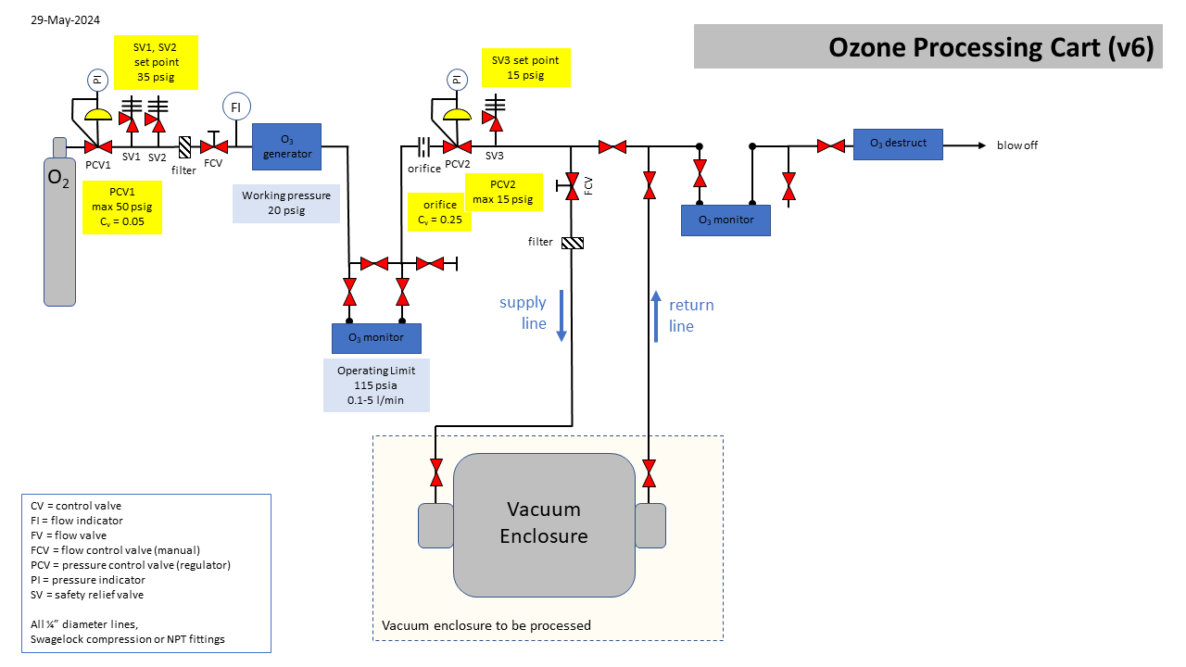

**Figure 5-1:** *Layout of the ozone cart and connections to a vacuum enclosure.*

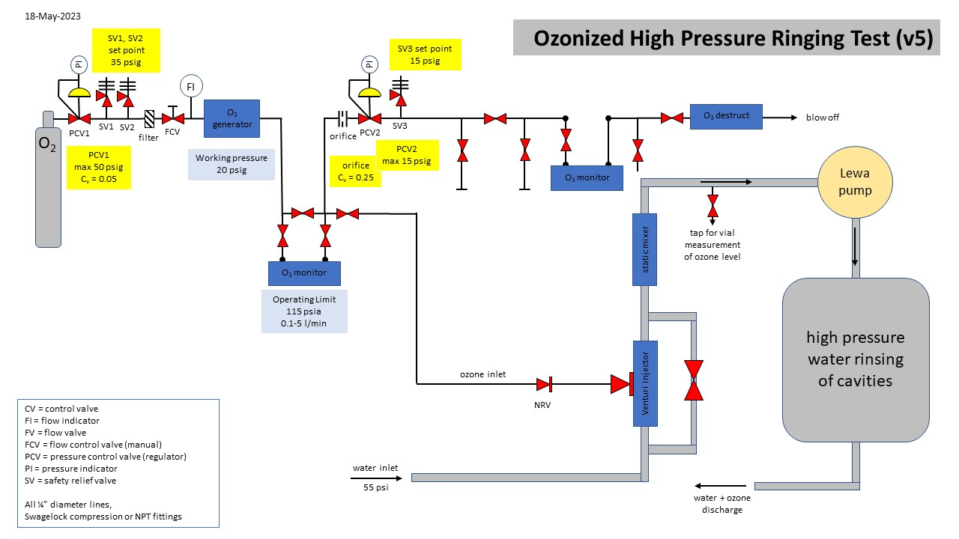

**Figure 5-2:** *Layout of the ozone cart and connections to the high-pressure ultra-pure water rinsing station at the Test Lab.*

## Pressure relief device on object to be processed

If the object will be heated and the ozone allowed to dwell in the object, ensure that a pressure relief device is available on the pressure system connected to the object.

The ozone cart has a 15 psig safety valve installed after the 2nd pressure regulator. If the object to be process is an SRF cavity, ensure a rupture disk is installed according SRF standards for the specific cavity. If the ozone will flow through the object and is blown off through an ozone destruct unit to atmosphere, no additional pressure relief device is required.

## Leak testing

Where possible, perform a leak check of the whole system or parts that were recently connected.

## Prepare the ozone area monitors

Area monitors are used for personnel protection while in-line monitors are used for process monitoring. For personnel protection, only monitors with an audible alarm shall be used.

Some types of portable ozone monitors are sensitive to pure oxygen and can be damaged by continuous exposure to pure oxygen.

Warm-up time

* + Aeroqual 500:
    - 10 minutes
  + Eco Sensors C-30ZX:
    - 24 hours, if not powered on for more than 1 week;
    - 1 hour, if not powered on since 3 to 7 days;
    - 10 minutes, if powered on last since less than 3 days.
  + Eco Sensors OS-4:
    - 1 hour.
  + Eco Sensors OG-3 calibration checker:
    - 30 minutes.
  + Teledyne 454H:
    - 15 minutes.

Ozone area monitor testing

* + Use the OG-3 calibration checker as "bump" tester to verify adequate response from the portable ozone monitors to be used;
  + Each ozone monitor must show a response above 0.1 ppm.

## Prepare heating

If using a bake-out box, in-line gas heater, or other equipment to heat the vacuum enclosure and/or the gas stream during processing:

1. Program the heating equipment, if available:
   1. desired temperature, maximum range up to 120 oC;
   2. desired time period.
2. Start the heating program to pre-heat to the desired temperature.

## Verify interlocks

Ozone interlock testing

* + If an OS-4 is connected to the ozone generator, verify that it switches off the ozone generator when the response is >0.1 ppm.

Remote switch-off testing

* + Step outside the immediate processing area;
  + Verify that the remote switch off device does switch off the ozone generator.

## Swipe the area

Remove ignition sources

* + Verify that all possible ignition sources are removed from the immediate area were pure oxygen gas will flow.

Post warning signage

* + "Authorized personnel only, Oxygen/Ozone in use, Emergency contact number XXX";
    - Verify that the contact phone number is assigned to an available team member familiar with the all steps of the process.
  + "Caution, Hot surface", in case heating equipment is used.

## Establish the gas flow

Ozone processing requires a flow of oxygen gas supplied from the high-pressure gas cylinder on the ozone cart. Valves on the ozone cart allow for control of the mass flow and to maintain the required pressure. For some development tasks, other manual valves may be used.

Gas exhaust

* + Verify that all gas exhausts are as far away as reasonable possible from the operator and not pointing towards the operator;
  + Verify that ozone destruct units are installed at each gas exhaust, except if the system is connected to inject into the high-pressure water rinsing station of the Test Lab.

Gas supply

* + Open the valve on the high-pressure gas cylinder;
  + Adjust the pressure regulator of the gas cylinder to around 20 psig:
    - nominal operating pressure of the ozone generator is 20 psig but can be lower for the UV-source generator;
    - a pressure below some 15 psig or above some 25 psig might cause the ozone generator's control unit to generate a fault which disables the generator power;
  + Open other valves on the ozone cart as required for the gas flow;
  + Adjust the second stage pressure regulator to around 10 psig or lower;
    - if the ozone cart is connected to the high-pressure water rinsing station in the Test Lab, this setting is not relevant as the supply line is connected before the second stage pressure regulator.
  + Adjust the gas flow to 0.5 l/min (1 SCFH).

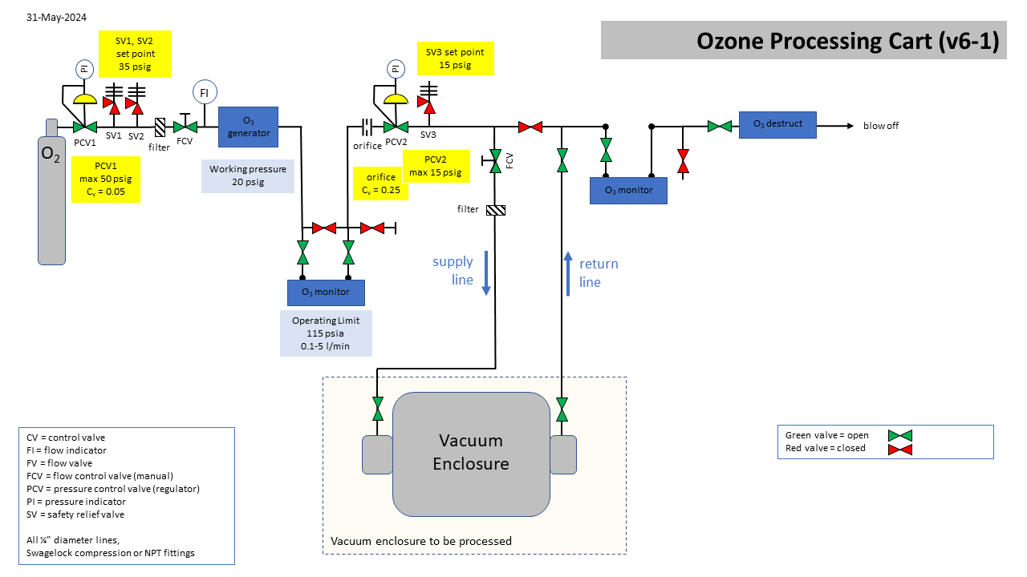

**Figure 5-1:** *Layout of the ozone cart valve settings to enable the gas supply to a vacuum enclosure.*

## Prepare the in-line ozone monitors

Warm-up time

* + Teledyne 454H:
    - 15 minutes.

Zero-calibration

* + Teledyne 454H:
    - Verify that the front panel "sensor ok" indicator is green;
    - Purge the monitor with a gas stream without ozone;
      * minimum flow rate of 0.5 LPM for at least 2 minutes.
    - Press the two "zero" keys on the front panel simultaneously;
      * this will start an automatic zero calibration.
    - Verify that the front panel displays zero and does not indicate any errors.

## Start Ozone generation

Either one of the following ozone generator equipment is used:

* Electric discharge generator:
  + Absolute Ozone, Nano 15;
  + Absolute Ozone, ATLAS UHC;
* Ultra-violet (UV) source:
  + RBD Instruments, UVB-100.

Monitor ozone concentration measurements on the ozone monitors.

If any ozone area monitor alarm activates:

* Immediately switch off the ozone generator if not stopped by an interlock;
* Evacuate the area until the ozone level is <0.1 ppm;
* Determine the source of the leak and correct.

Absolute Ozone Nano 15 or ATLAS UHC

* + Flip the power switch next to the cooling fan outlet to the ON position;
  + Select "ON" on the touch screen;
  + Select the desired power by controlling the slider on the touch screen.

RBD Instruments UVB-100

* + Turn the key lock power switch to ON position;
  + Flip the manual override switch to ON position;
  + Full intensity is reached in 2 to 3 minutes.

## Ozone processing

Monitor the following instruments and measurements:

* Oxygen high-pressure gas cylinder pressure;
* Oxygen gas flow rate;
* Ozone generator voltage, current, power output, cell pressure;
* Ozone in-line monitors ozone concentration;

If any ozone area monitor alarm activates:

* Immediately switch off the ozone generator if not stopped by an interlock;
* Evacuate the area until the ozone level is <0.1 ppm;
* Determine the source of the leak and correct.

### Ozone generator operation

Operate the ozone generator for the amount of time required for the specified processing.

If the system is to be kept under static ozone atmosphere

* Pause the oxygen flow;
* Switch off the ozone generator;
* Close the main valve on the high-pressure oxygen gas bottle;
* Wait for the required dwell time.

#### If leaving the processing area

* Assure the area is secure and posted.

Pre-task safety review meeting were conducted on the following dates:

1. April 29, 2024: Philip Stanley, Roger Ruber - Discussed electrical aspects of the existing cavity bake box and XTreme Flex heating tape (Model BS0051100L, 120V, 2.18 Amps, Watts 261, Phase 1, Size - 0.5x 10Ft, Frequency 50-60 Hz.) Conclusion: Equipment used is considered standard equipment.
2. May 14, 2024: Harry Fanning, Roger Ruber, Dainnya Busbin, Imani Burton - Covered the use and volume of oxygen cylinders in the tunnel, warning signage, engineering controls (ozone destruction, remote safety shut-offs, ozone monitors), auto shut-off for bake box, and timer for heat tape. Discussed unattended overnight operations in the tunnel and in SRF High Bay/Clean Room. Conclusion: Additional risk was not identified due to the low volume and quantity of oxygen, low temperatures (80°C-120°C), and the presence of engineering and administrative controls.
3. May 14, 2024: Robert Myles, Roger Ruber, Greg Marble, Joshua Thomason, Dainnya Busbin - Conducted visual inspection of heat-producing elements in the bake box and heat tape. Conclusion: Coordination of testing for sprinklered and Vesda monitored spaces (clean room, tunnel) to be done by Roger Ruber, Dainnya Busbin, and Robert Myles, TBD as tests proceed.

## End of Ozone processing

Switch off the ozone generator:

Absolute Ozone Nano 15 or ATLAS UHC

* + Shift the power down to 0% on the touch screen;
  + Select "OFF" on the touch screen;
  + Flip the power switch next to the cooling fan outlet to the OFF position.

RBD Instruments UVB-100

* + Flip the manual override switch to OFF position;
  + Turn the key lock power switch to OFF position.

### Switch-off Heating equipment

Bake-out box and in-line gas heater:

* Switch-off the bake-out box and/or in-line gas heater, if used;
* Let all devices cool down before touching or removing.

## Purge the system

* Route a gas stream through any external piping/tubes/hoses or vacuum enclosure previously containing ozone on towards an ozone destruct unit;
* Purge by flowing oxygen without ozone for at least 5 minutes or until the inline ozone monitor at the gas exit indicates a rate <0.1%.

## Stop the gas flow

Switch off the oxygen flow

* Close the flow valve after the gas cylinder's pressure regulator;
* Close the main valve at the top of the high-pressure gas cyclinder;
* Let the system depressurize through the outlet valve and ozone destruct unit, if possible;
* Close any additional valves on the ozone cart as desired, e.g. close the inlet and outlet valve of the cart to keep the internal system clean.

## Disconnect the ozone cart

Disconnect the gas lines between the ozone cart and the object that was processed.

## Open the system

If the system has been heated, wait for it to cool down.

If the system is still under oxygen atmosphere, and has not been purged or pumped vacuum and subsequently bled up to atmosphere:

* Carefully open the system while using a portable ozone monitor and verify that the ozone concentration is <0.1 ppm.
* If the ozone concentration is higher, immediately stop opening the system and leave the area until the ozone concentration is <0.1 ppm.

Note that some ozone monitors are also sensitive to pure oxygen atmosphere.

# Process Flow

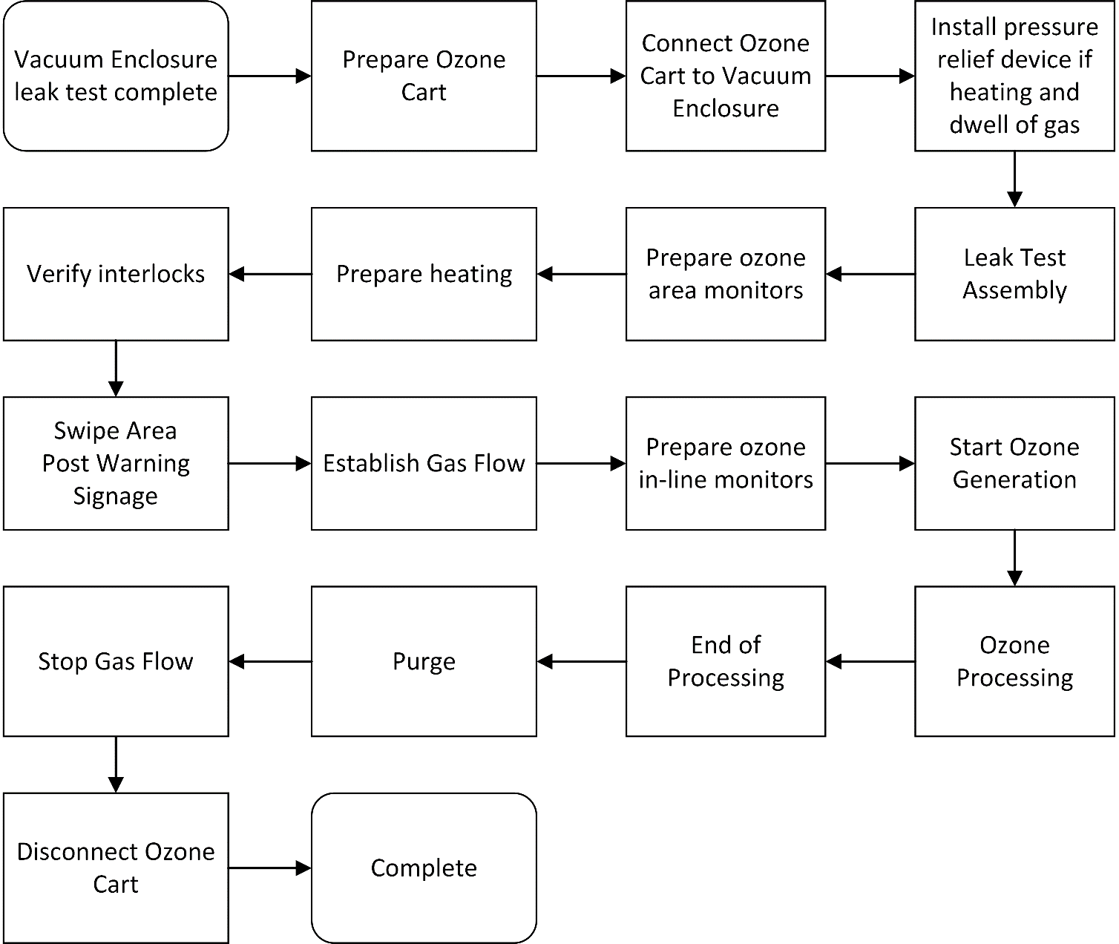

# References

|  |  |
| --- | --- |
| **Document No.** | **Title** |
| SRF-01-ML-001 | SRF Quality Manual |
|  |  |
|  |  |

# Release and Revision History

|  |  |  |
| --- | --- | --- |
| **Rev #** | **Major Changes** | **Effective Date:** |
| 1 | Initial version | 7 Aug 2024 |
|  |  |  |
|  |  |  |
|  |  |  |

# Approvals

|  |  |  |  |
| --- | --- | --- | --- |
| **Approved by:** | **Name:** | **Signature:** | **Date:** |
| Document Owner | Roger Ruber | In DocuShare | |
| Reviewer | Dainnya Busbin | In DocuShare | |
| Project Representative |  | In DocuShare | |