Shipping Procedure for LCLS Cryomodules
Document Number: | L2HE-PR-CMA-CM-SHIP | Effective Date: | 27 Aug 2024
Revision Number: | R1 | Periodic Review Date: | 27 Aug 2024
Document Owner: | J. Martin | Department Owner: | SRF Operations

Purpose

The purpose of this document is to describe the loading procedure to ship LCLSll/HE Cryomodules

Scope

This procedure applies to LCLSII/HE Cryomodules and shall be performed by trained Cryomodule Assembly Technicians only.

Terms and Definitions

The following terms have specific meanings within this procedure.

Term | Definition
Shipping Frame | Specially designed shipping fixture used for LCLSII and HE Cryomodules
Spreader Bar | Designed lifting fixture used with the OHC, specific to LCLSII and HE Cryomodule assemblies
Lock down Plates | Fastening method which is added between the Cryomodule and shipping frame, locking them together for transit

Roles and Responsibilities

The following roles have responsibilities described in this document.

Role | Responsibility
Cryomodule Assembly Technician | Is trained and executes this Procedure performing described mechanical tasks
Cryomodule Assembly Lead/SME | Overlooks the execution of this Procedure and documents the results and any lessons learned

Procedure

Trucking company will proceed to back the shipping trailer into test lab north roll up door. A minimum of 4 technicians will be needed to guide the truck safely into the building.
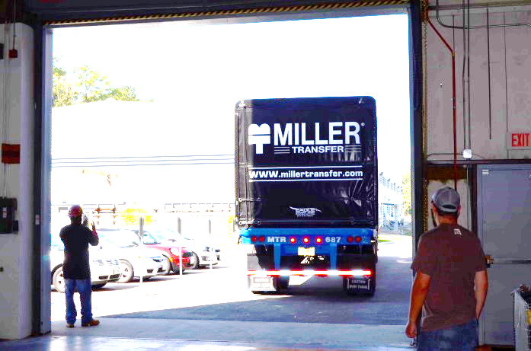

Once the trailer is inside the building, place wheel chocks around the wheels of trailer.

Roll up the back door of the Conastoga cover and slide the trailer cover forward. Exposing the flatbed and shipping frame.

There are two approaches in this Procedure for loading a Cryomodule into the Shipping Frame for Shipment. It is the SMEs choice at time of loading.

Unloading the Shipping Frame prior to loading the Cryomodule

Using shipping frame lift plan have technicians rig the shipping frame to be removed from trailer.
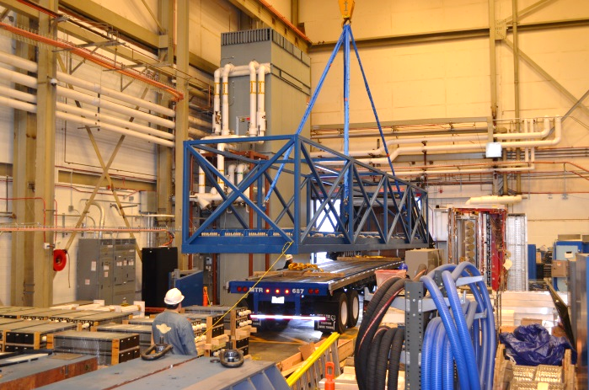

Once frame is rigged slowly lift empty shipping frame so it just clears the bed of the trailer. Once frame is suspended above the trailer, remove the chocks and have driver pull the now empty trailer outside.

Lower the empty shipping frame to the ground and unhook the slings from the crane.

Continuing to follow the frame lift plan, rig the top section of the frame for removal and pull the quick release pins. Remove the top section of frame and set in a safe and secure spot.
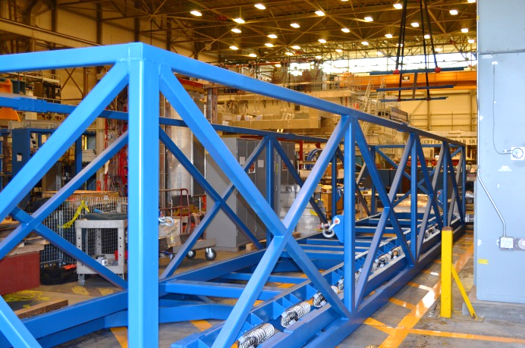

Using the yellow spreader bar and appropriate lift plan prepare to hoist the completed LCLS cryomodule. Be sure to have people stationed at all walkways and doorways to keep bystanders away.

Once the spreader bar is properly connected to the module proceed to lift the module. Crane the module down to the shipping frame and begin to slowly lower it into the shipping frame.

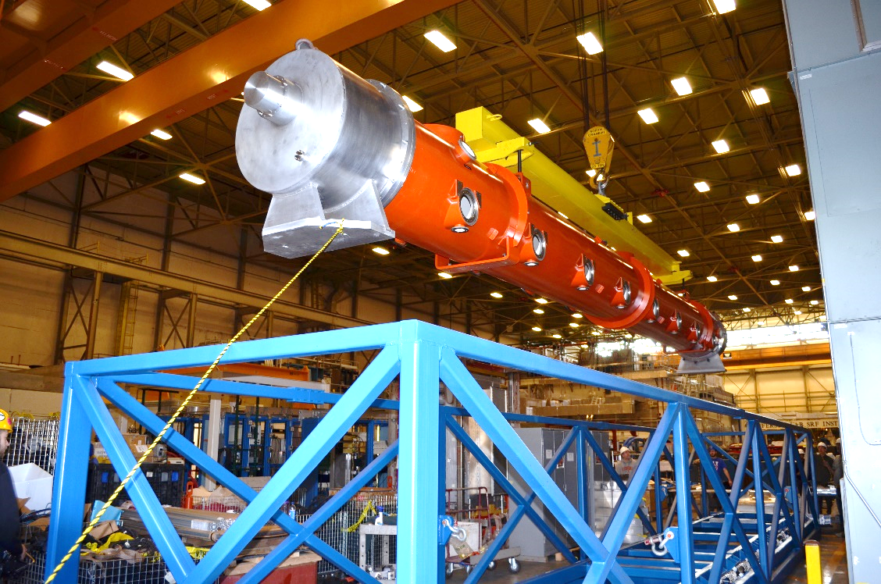
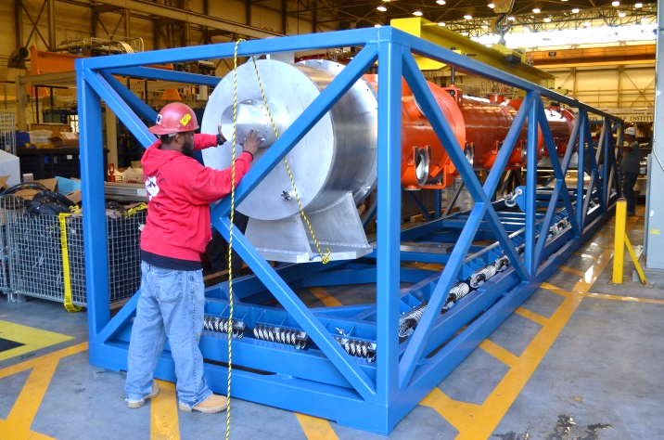

Slowly insert the cryomodule into the shipping frame making sure to have enough people to watch every side of the module as it is a tight fit.

The two baseplates of the cryomodule will align with large aluminum blocks inside the shipping frame. Making sure these are lined up properly is important because if incorrect the lockdown plates will not fit.

Now that the cryomodule is properly lined up you may unhook the crane and use it to re-install the top section “lid” of the shipping frame.

Install the 4 lockdown plates between the aluminum baseplates and the cryomodule base. Make sure the hardware is torqued to spec and is checked by at least 2 people.
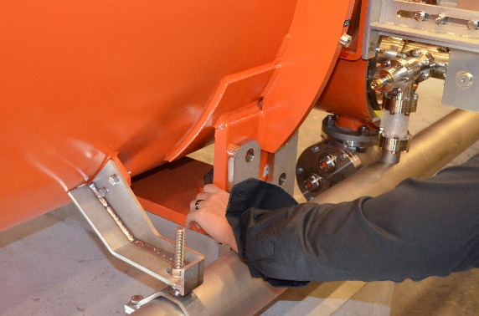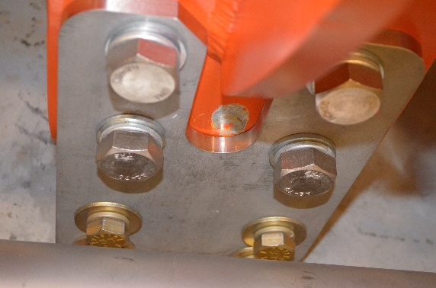

Going back to the shipping frame lift plan, follow the steps again to pick up the fully loaded shipping frame.

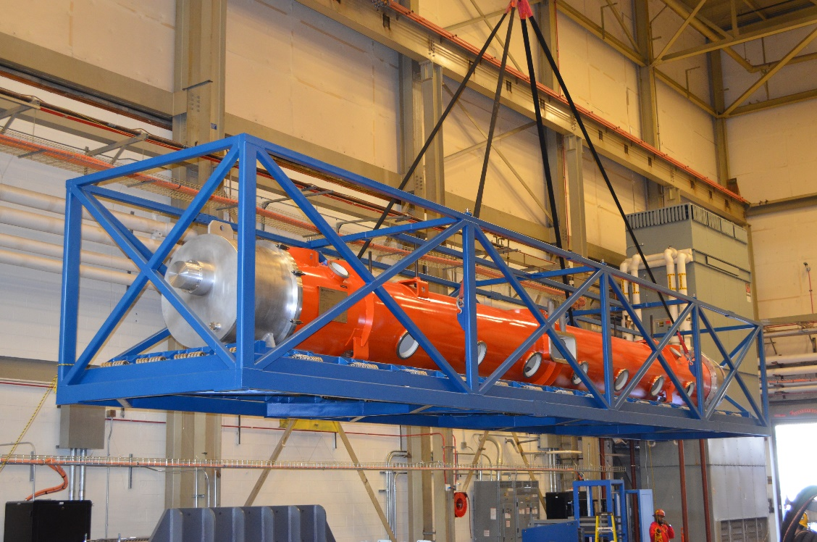

Once the frame is lifted high enough to clear the trailer a technician can then guide the driver back into the building and under the shipping frame.

Slowly lower the shipping frame on to the trailer and shim the backside of it with wooden wedges if needed.
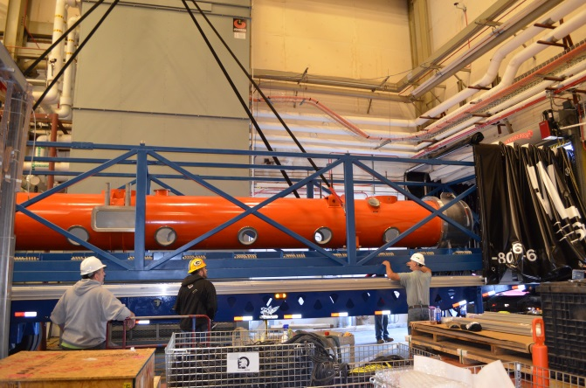

Verify with the Shipping SOTR that the cryomodule is positioned and fastened correctly.

Once satisfied, place the ratchet straps every 8 ft along the shipping frame as shown in the picture.
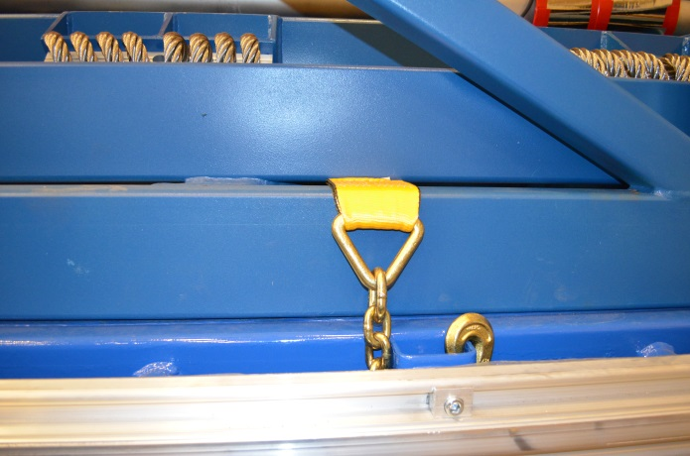

Now that the frame is locked to the trailer the Conastago may be fully closed.

Loading the Cryomodule into the shipping frame on the trailer

Trailer is backed in, using four Technicians to guide

5.21 Wheel chocks are added around trailer wheels, driver drops trailer.

5.22 Conastoga is opened
5.23 Frame is left on the Trailer, ratchet straps in place
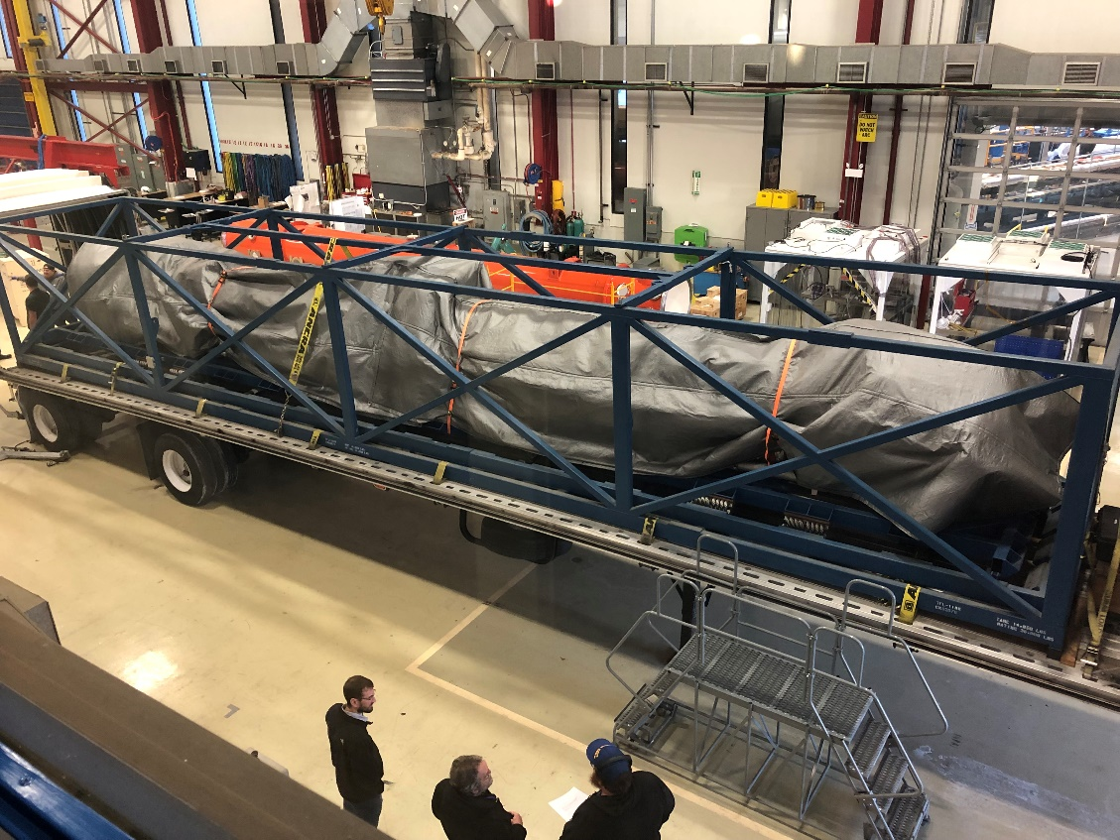
5.24 Top section of shipping frame is removed
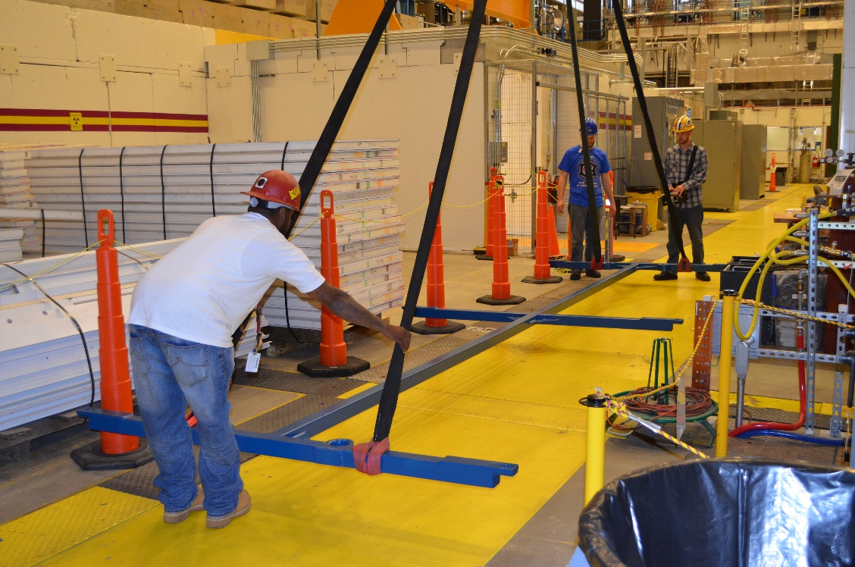
5.25 Cryomodule is loaded and locked in place similar to previous description in this Procedure
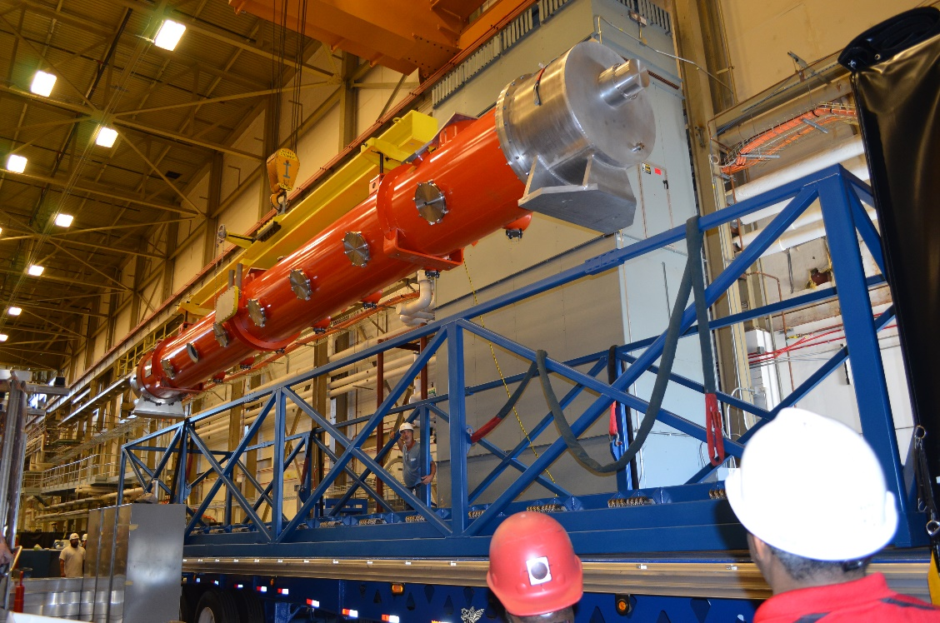
5.26 Top frame of the shipping fixture is added
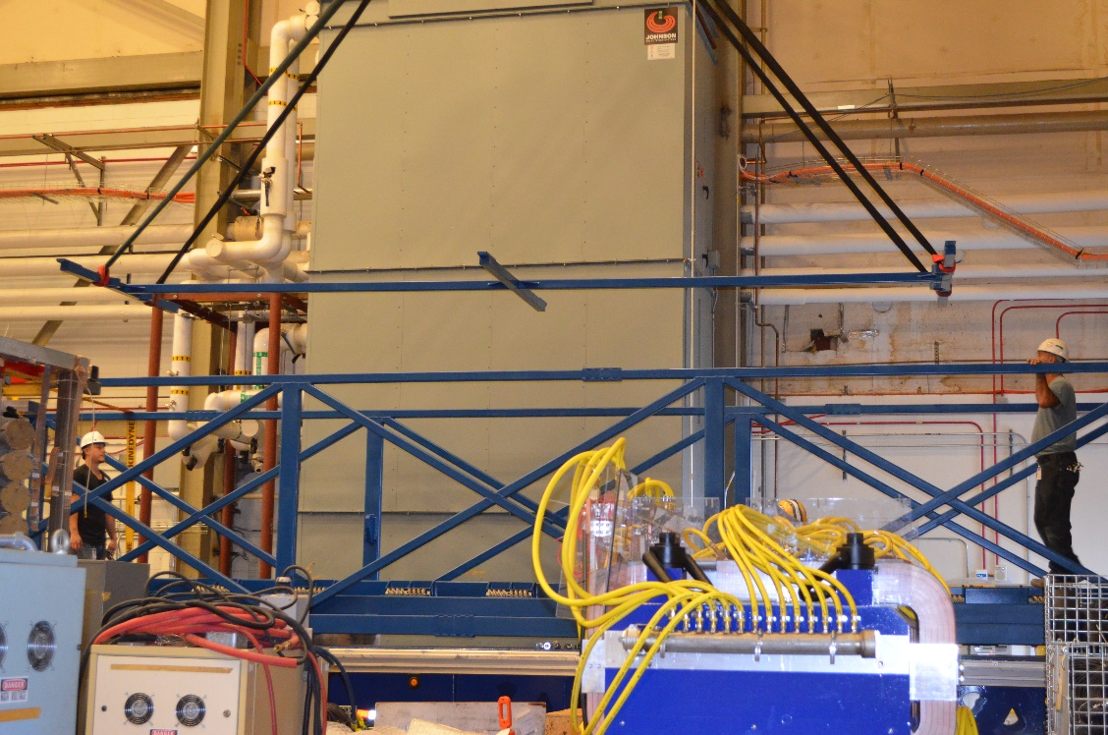
5.27 Installation is reviewed
5.28 Conastoga cover is fully closed



The trailer is now ready for shipment.

References

Document No. | Title
SRF-01-ML-001 | SRF Quality Manual

Release and Revision History

Rev # | Major Changes | Effective Date:
1 | Initial version, added to Procedure template | 27 Aug 2024

Approvals

Approved by: | Name: | Signature: | Date:
Document Owner | Jared Martin | In Docushare
Subject Matter Expert | Jared Martin | In Docushare
Work Center Lead | John W. Fischer | In Docushare
Project Leader | Adam Grabowski | In Docushare

