Traveler Title | All metal right angle valve leak check traveler for L2HE BLA
Traveler Abstract | Leak check traveler
Traveler ID | L2HE-CLNRM-BLAVV-LEAK
Traveler Revision | R1
Traveler Author | A. Grabowski
Traveler Date | 18-Jan-24
NCR Informative Emails | D.Forehand,
NCR Dispositioners | A. Grabowski, G. Cheng
D3 Emails | D.Forehand, A. Grabowski, G. Cheng
Approval Names | A.Grabowski | D. Forehand | M. Bevins
Approval Signatures
Approval Dates
Approval Title | Author | Reviewer | Project Manager

References | List and Hyperlink all documents related to this traveler. This includes, but is not limited to: safety (THAs, SOPs, etc), drawings, procedures, and facility related documents.

Revision Note
R1 | Initial release of this Traveler.

Step No | Instructions | Data Input
1 | Incoming leak check.  The L2HE project uses the VAT all metal right angle vacuum valve in many different areas.  BLA assembly will require one of these valves. Because the valve in the BLA assembly will remain in the unit permanently, the leak tightness is critical. Therefore, we leak check the valve before the assembly.  - This leak test will be performed by Inficon leak detector in the tuning room.  - Wear gloves while handling vacuum valves.  - Connect vacuum pump as shown in the figure.  - Check the valve and confirm the valve is closed. Use the valve as received.  - Start pump down for leak check. If pump down rate is too slow, tighten the valve by a quarter turn and record the torque value.  - Start leak test.  - Leak check by spraying all joints as shown in figure.  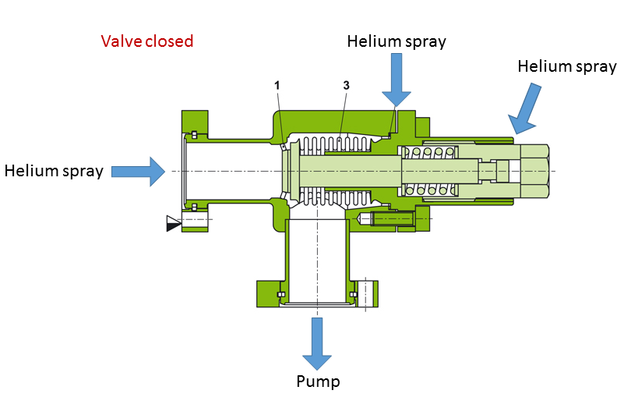  Enter leak check date and name.  Select the valve serial number  Is the unit leak tight?  Upload the RGA data  Please provide comment if any. | [[BLAVV_DATE]] <<TIMESTAMP>>  [[BLAVV_Operator]] <<SRF>>  [[BLAVVSN]] <<BLAVVSN>>  [[Leakcheck_Pass]] <<YESNO>>  [[BLAVV_RGA]] <<FILEUPLOAD>>  [[BLAVV_Comment]] <<COMMENT>>
2 | Review by responsible engineer.  After review select YES or NO.  If valve is YES send to chemistry for metal valve cleaning and baking, chemroom will send into pass thru ready for use.  If valve is NO contact supervisior for next step. | [[Reviewer]] <<YESNO>>  [[HP1]] {{Grabowski}}<<HOLDPOINT>>

