|  |  |  |  |
| --- | --- | --- | --- |
| **Downstream End Cap Installation Procedure for LCLS-II Cryomodules** | | | |
| **Document Number:** | L2HE-PR-CMA-EDCP-INST | **Effective Date:** | 27 Aug 2024 |
| **Revision Number:** | R2 | **Periodic Review Date:** | 27 Aug 2025 |
| **Document Owner:** | J. Fischer | **Department Owner:** | SRF Operations |

# Purpose

The purpose of this document is to describe the installation of downstream end cap for LCLS-II/HE Cryomodules

# Scope

This procedure applies to End Caps for LCLS-II Cryomodules and shall be performed by trained Cryomodule Assembly Technicians only.

# Terms and Definitions

The following terms have specific meanings within this procedure.

|  |  |
| --- | --- |
| **Term** | **Definition** |
| End Cap | Used for Cryomodule shipping and to support the GHRP. |
| GHRP | The supporting structure for the cavity string, gaseous helium return pipe, part of the Upper Cold Mass |
| Spindle | Inner mandrel, link between shipping insert and End cap |
| Shipping Insert | Assembly which is installed into the GHRP end to support the cavity string during transit |

# Roles and Responsibilities

The following roles have responsibilities described in this document.

|  |  |
| --- | --- |
| **Role** | **Responsibility** |
| Cryomodule Assembly Technician | Is trained and executes this Procedure performing described mechanical tasks |
| Cryomodule Assembly Lead/SME | Overlooks the execution of this Procedure and documents the results and any lessons learned |

# Procedure

## Preliminary Notes

* Installation of the End Cap should be completed before the Upstream Feed Cap
* Ensure that the Spindle Push Rod has anti-seize applied to its threads prior to installation into the Plug Threaded Collar.

## Assembly Overview

**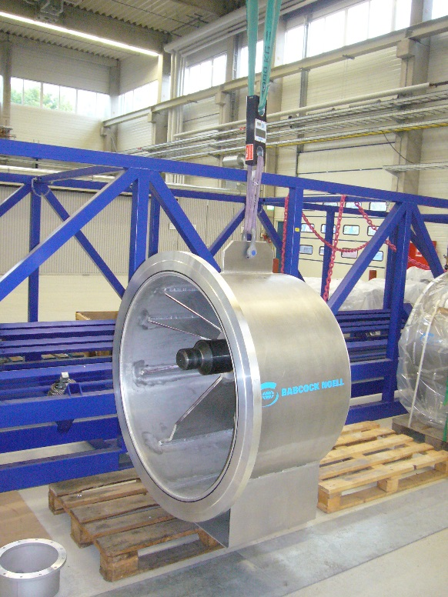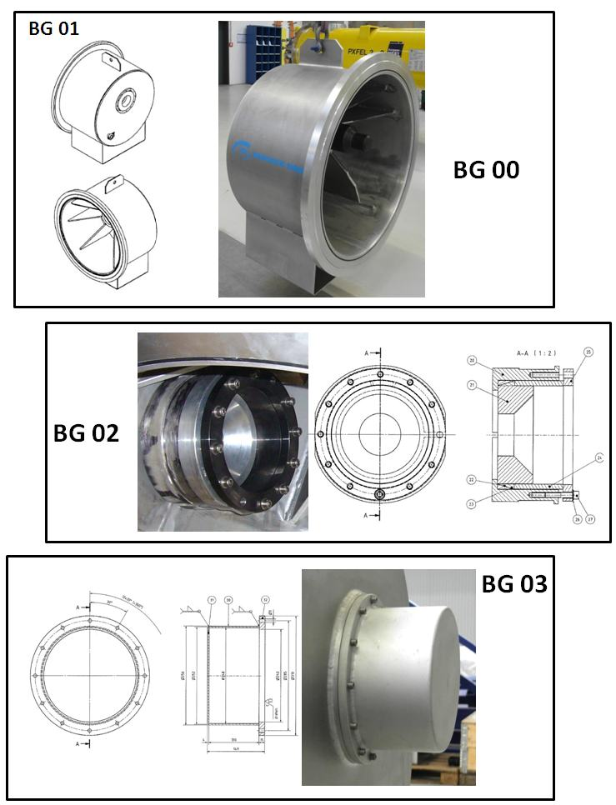**

**Sub-Group 1 (SG1): End Cap**

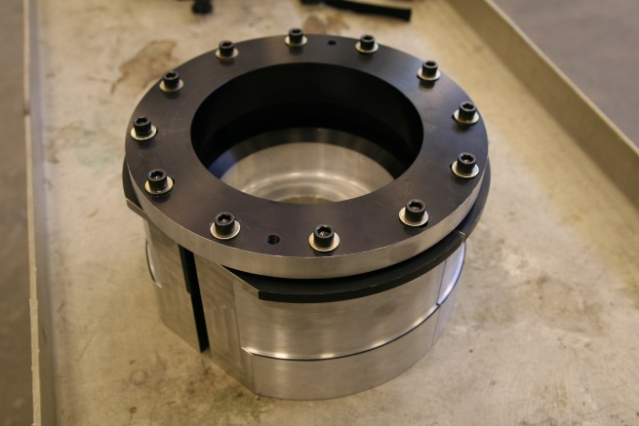****

**Sub-Group 2 (SG2): HeGRP Attachment, shipping insert**

****

**Sub-Group 3 (SG3) Spindle Push Rod Cover**

## SG2 Assembly

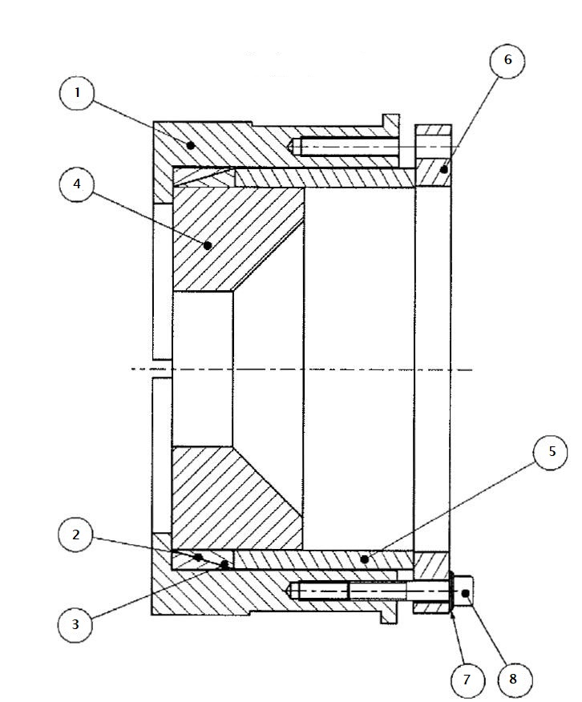

|  |  |  |
| --- | --- | --- |
| **Item** | **Description** | **Qty** |
| **1** | **Press Plates (top and bottom half shells)** | **2** |
| **2** | **Centering wedge (inner wedge)** | **1** |
| **3** | **Centering wedge (outer wedge)** | **1** |
| **4** | **Centering stop** | **1** |
| **5** | **Centering tube** | **1** |
| **6** | **Centering flange** | **1** |
| **7** | **M12 Flat washers** | **10** |
| **8** | **M12-65 SHCS** | **10** |

## Step 1: Press Plates of SG2

### Insert the two Press Plates (Item 1) on the GHRP in the horizontal orientation

### The flats should be at the 3 and 9 o’clock positions

### Outer lip of Press Plate should be on the rim of the GHRP end

*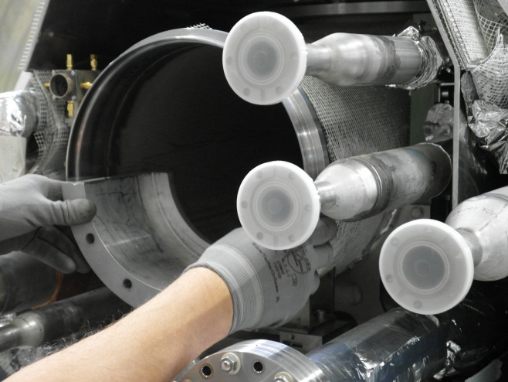*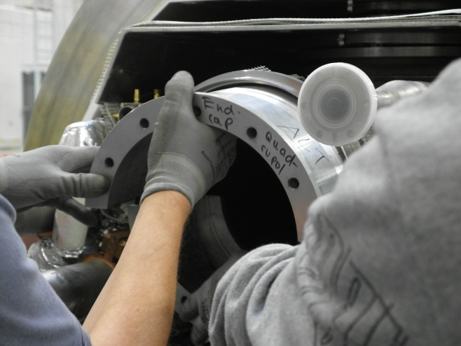

## Step 2: Install Centering Wedges (Items 2 and 3) of SG2

* + 1. **Insert the Centering Wedges between the Press Plates, item 2 first, then item 3**

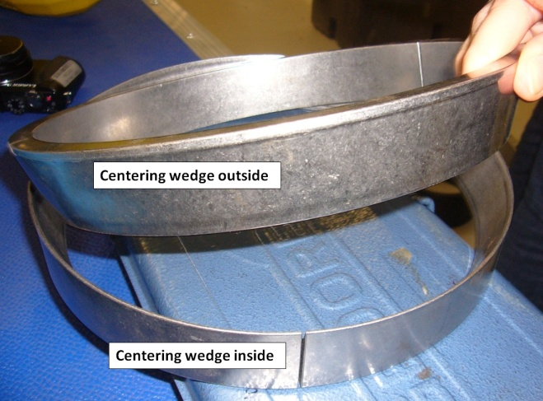

### First insert the inner Centering Wedge (Item 2)

#### 

### Important : Ensure that the slot on the inner Centering Wedge is at the 12 o’clock position as shown in the image

#### 

### Insert the outer Centering Wedge (Item 3) with its slot 45 degrees offset from the inner Centering Wedge.

#### 

### Insert the Centering Stop (Item 4)

**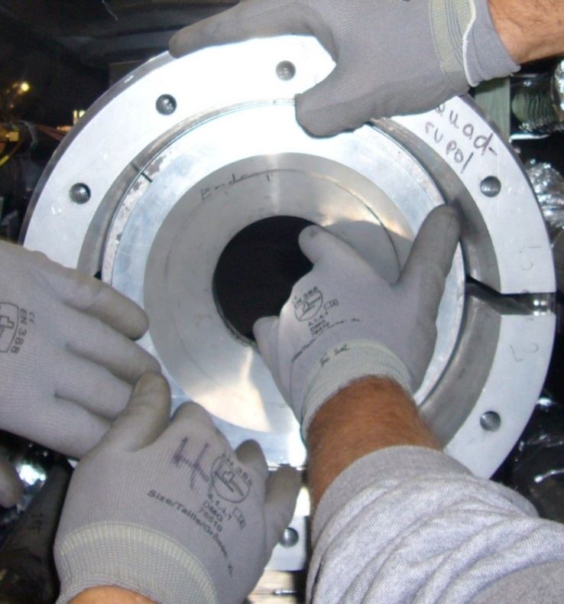**

### Insert the Centering Tube (Item 5)

**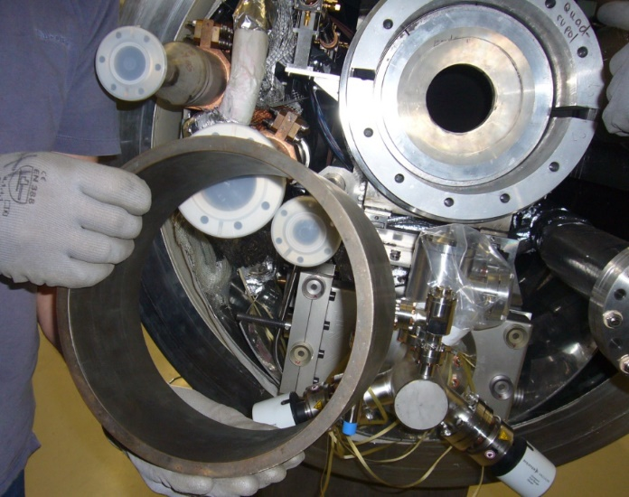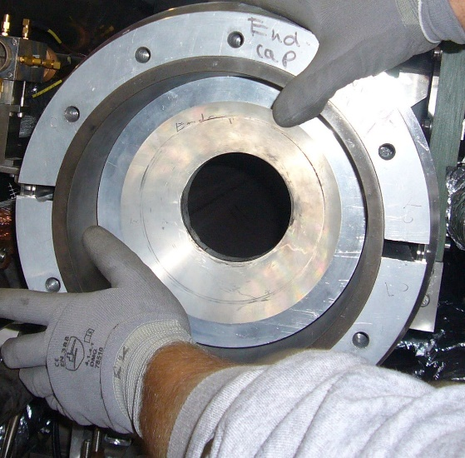**

### Install the Centering Flange (Item 6)

**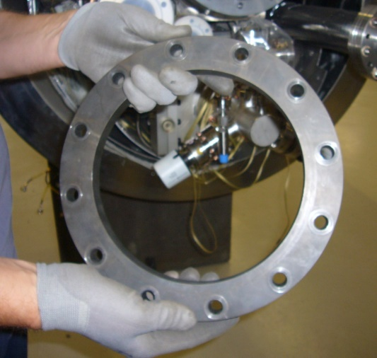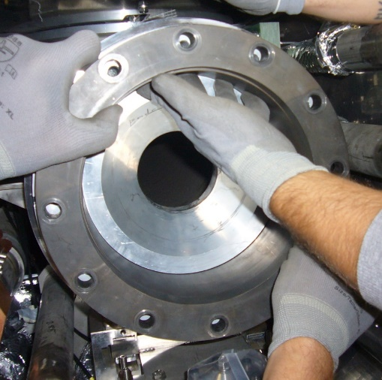**

### Insert the M12-65 SHCS and washers through the centering flange holes. Finger tighten all 10 screws.

**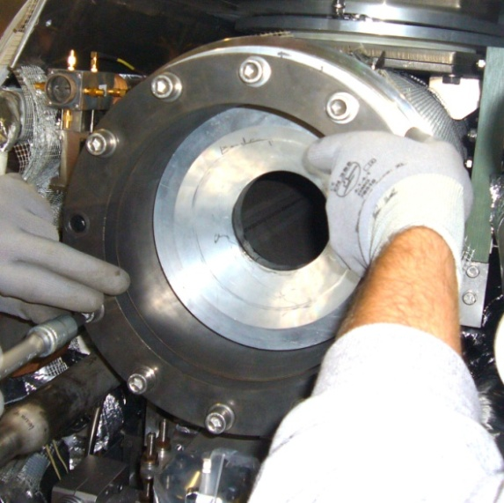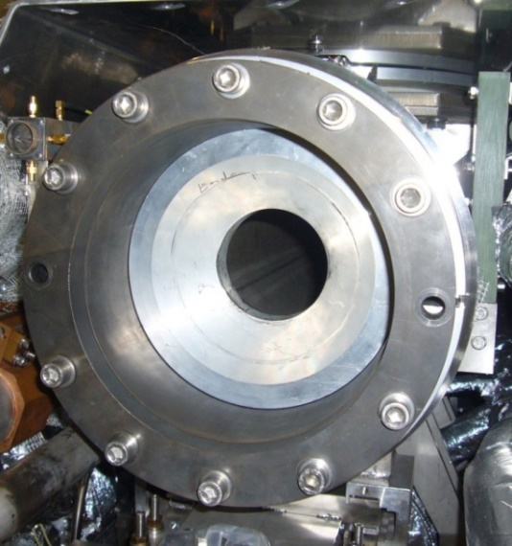**

### Torque the SHCS hardware to 60 ft/lbs

**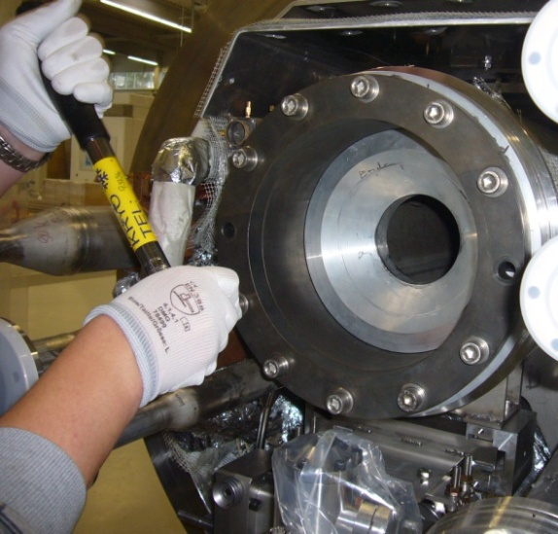**

## Step 3: Setup of SG1

### Ensure the parts and hardware for the End Cap are all available

### Apply Anti-Seize to the Spindle Push Rod threads if not already present

### Ensure the O-ring on the CM vacuum vessel are in place

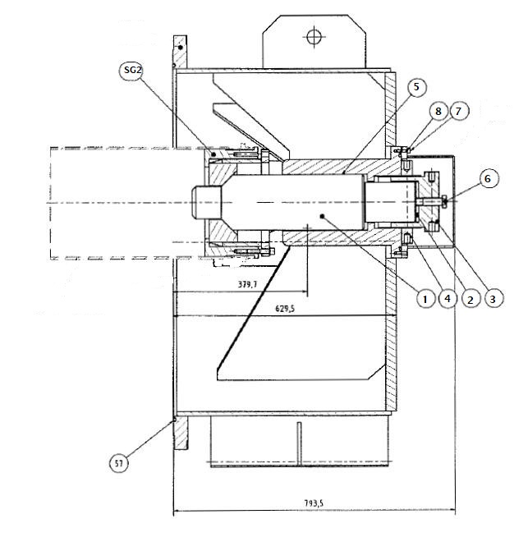

|  |  |  |
| --- | --- | --- |
| **Item** | **Description** | **Qty** |
| **1** | **Spindle** | **1** |
| **2** | **Belleville Washers** | **5** |
| **3** | **Spindle Nut** | **1** |
| **4** | **Spindle Lock Ring** | **1** |
| **5** | **Spindle Shim** | **1** |
| **6** | **Spindle Lock Bolt** | **1** |
| **7** | **Shipping Cap Cover Bolt** | **10** |
| **8** | **Shipping Cap Cover Flat Washer** | **10** |
| **57** | **Vacuum Vessel O-ring** | **1** |
| **N/A** | **JAYCO Clamps (Vacuum Vessel to End Cap)** | **8** |

## Step 4: Assembled SG1

### Prepare Feed Cap

#### Remove the Spindle Cap Cover

#### Wipe down interior surfaces with isopropyl alcohol

### C:\ANSYS Files\LCLS II\Shipping Frame\Procedures\20170220_181852.jpg

## Step 5: Adjust SG3 Spindle Push Rod

### Take mating feature measurements of shipping cap, spindle depth, and installed SG2 assembly. Adjust the M145 screw (Item 3) so that it will not interfere with the GHRP Insert (SG2) when installed. Hand tighten the SHCS (Item 6) to ensure that the End Cap Spindle is coupled to the Spindle Push Rod

#### 

## Step 6: Lift SG1 Assembly

### Attach clevis with sling and scale to the End Cap lifting lug

### Lift the End Cap to the approximate height of the GHRP

### Note the weight on the scale; it should read ~660lb.

#### 

## Step 7: SG1 Positioning

### Carefully bring the End Cap towards the vacuum vessel until the flanges meet, avoid contact with piping and instrumentation.

### If the spindle comes into contact with the GHRP Insert back-off the Spindle Assembly using the spindle nut (Item 3).

* + 1. **Monitor the scale readout. If the weight increases, it means that the central section of the spindle is touching the top of the conical surface of the GHRP insert (SG2), and the cap should be lowered slightly via the crane. If the weight decreases, the cap should be raised slightly. The weight should remain +/- 10% of the original value**

**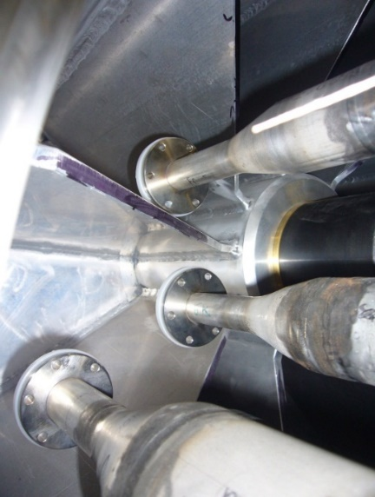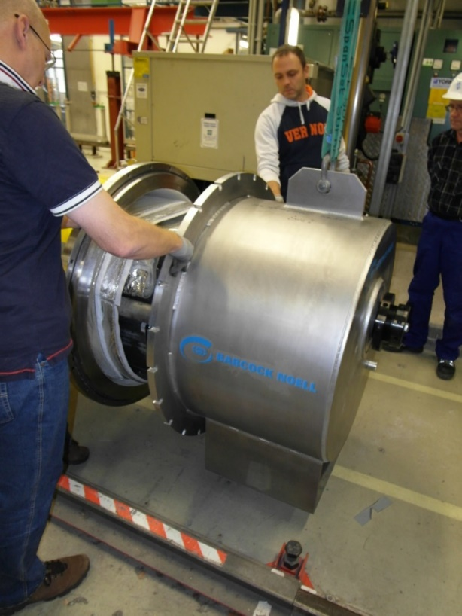**

## Step 8: Install Flange Hardware

### Once the end cap is positioned and outside edge aligned with the Vacuum Vessel flange, install the 8 JAYCO clamps. Clamps should be evenly spaced for proper clamping. Torque the nuts to 63 ft.lbs

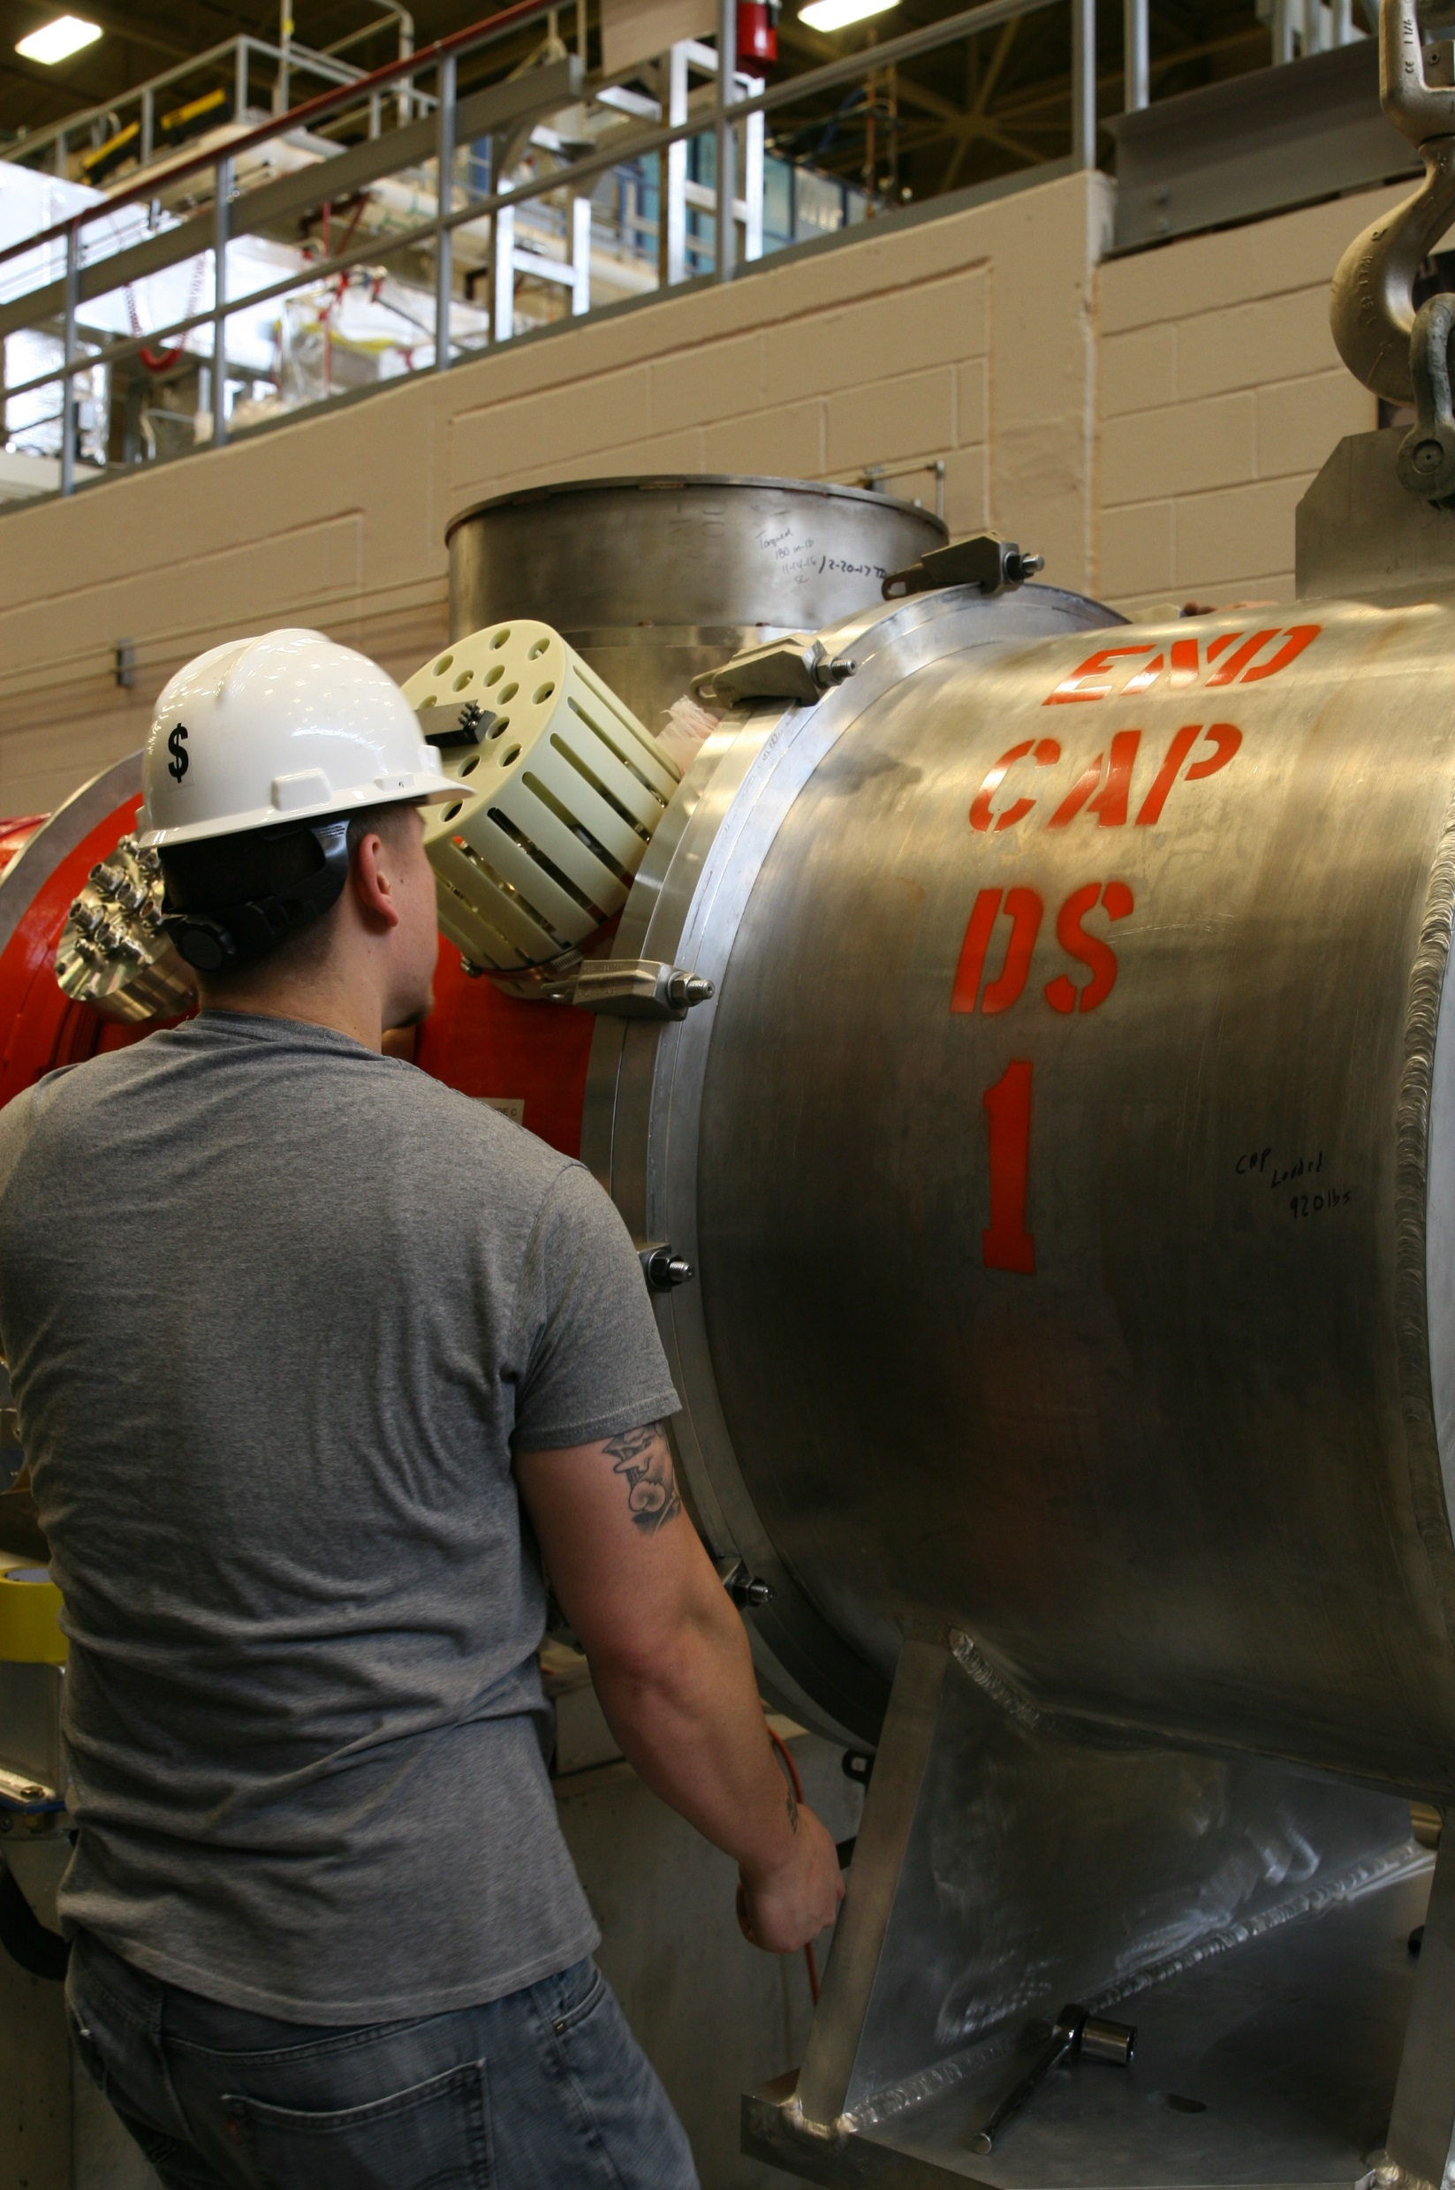

## Step 9: Spindle Push Rod Positioning

### See L2HE-PR-CMA-FDCP-INST-R2 for instructions on Positioning and Installation of the shipping cap cover (5.17-5.18)

# References

|  |  |
| --- | --- |
| **Document No.** | **Title** |
| SRF-01-ML-001 | SRF Quality Manual |
|  |  |
|  |  |

# Release and Revision History

|  |  |  |
| --- | --- | --- |
| **Rev #** | **Major Changes** | **Effective Date:** |
| 1 | Initial version, added to Procedure Template | 27 Aug 2024 |
| 2 | New pictures and step re-alignment | 25 Sept 2024 |
|  |  |  |
|  |  |  |

# Approvals

|  |  |  |  |
| --- | --- | --- | --- |
| **Approved by:** | **Name:** | **Signature:** | **Date:** |
| Document Owner | John W. Fischer | In Docushare | |
| Subject Matter Expert | Jared Martin | In Docushare | |
| Work Center Lead | John W. Fischer | In Docushare | |
| Project Leader | Adam Grabowski | In Docushare | |