|  |  |  |  |
| --- | --- | --- | --- |
| **JT Actuator Installation and Calibration** | | | |
| **Document Number:** | SRF-MSPR-CMA-EVA-INST-R1 | **Effective Date:** | 10 Oct 2024 |
| **Revision Number:** | 1 | **Periodic Review Date:** | 10 Oct 2026 |
| **Document Owner:** | John Fischer | **Department Owner:** | SRF Operations |

# Purpose

The purpose of this document is to define the installation and calibration of the JT Actuator during Cryomodule assembly and Testing.

This procedure supports the Quality Management System as described in SRF-01-ML-001 Quality Manual.

# Scope

This procedure contains the information needed to install, calibrate, and test the JT Actuator and stem. The units will be installed onto the Cryomodule Supply end can during the Assembly and Testing efforts. Work is to be performed by knowledgeable Technicians that are familiar with the required components.

# Terms and Definitions

The following terms have specific meanings within this procedure.

|  |  |
| --- | --- |
| **Term** | **Definition** |
| JT Actuator (Fig 3) | Electronic valve actuator that regulates cryogenic flow to the Cryomodule circuits |
| Supply End Can (Fig 4) | Part of the Cryomodule that receives and introduces cryogenic flow to the cryomodule innards |
| Force gauge (Fig 1) | Tool used to measure the seating force supplied by the JT Actuator to the JT stem and seat |
| JT Stem and bullet  (75600-0165) | Stem and bullet are one integral piece that regulate flow when adjusted by the JT Actuator |
| JT Seat  (75600-0165) | Mating article to the bullet, a matched set, used when regulating the cryogenic flow |

# Roles and Responsibilities

The following roles have responsibilities described in this document.

|  |  |
| --- | --- |
| **Role** | **Responsibility** |
| Cryomodule Group SME | Responsible for overseeing the correct application of this Procedure and review of the work performed. |
| Cryomodule Group Assembly Technician | Will perform the required steps from this Procedure. Is properly trained and knowledgeable on the information in this document. |

# Procedure

## JT Actuator Calibration

Tools Needed

0-250/lb force gauge with 3/16 ball

Dial indicator with clamping attachment

3/8, 9/16, and 1"wrenches

JT actuator power supply

LVDT readout screwdriver 1/16 allen wrench

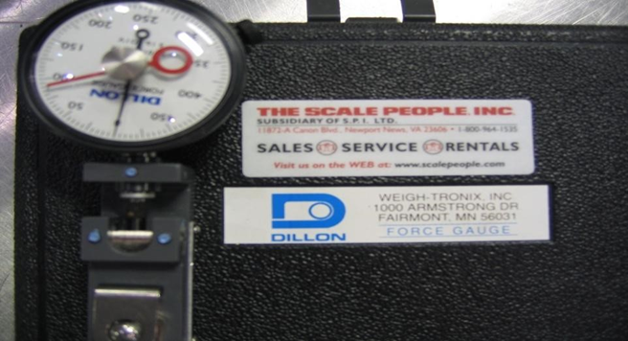

Fig 1

## Procedure

Actuator must first be set to provide a 200-pound seating force

### Screw down the actuator stud and move the movable plate up to allow clearance for the force gauge.

### Place force gauge with 3/16 ball under the actuator stud and actuate to provide 200 pounds of downward force.

### Adjust spring tension and actuator until snap rings under the top plate (2 places) have a 1/16 gap above the snap rings, keeping the 200 pounds of force.

### Setting the limit switch; turn the top 10-32 screw limit switch screw until it triggers the limit switch and lock screw in place. Actuate the cylinder up and then down. The cylinder should shut off near 200 pounds of force. Fine tune the limit switch until it shuts off at 200 pounds, keeping the lock nut tight.

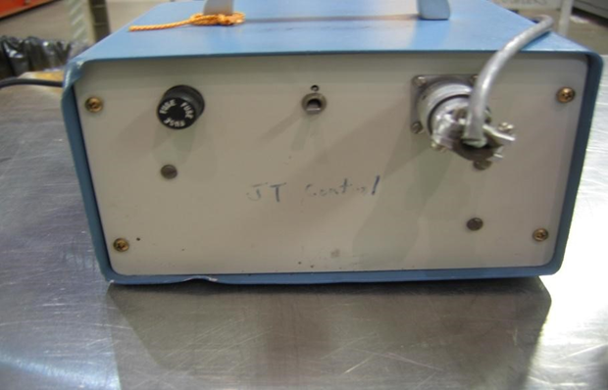

Fig 2

## Installing on JT valve:

### Adjusting the actuator stud; Drive the actuator to the fully closed position (the gears will stop the motion); by hand, push the JT valve closed. Set the actuator on top of the JT valve. (JT Stem already installed into end can) Adjust the actuator stud until the actuator sits flat and the stud touches the top of the closed JT stem.

### Mounting the actuator; Connect the JT stem to the actuator using a 9/16-long 10-32 stud and 10-32 kep nut. When assembling, be careful not to twist the JT stem bellows. Drive the actuator up until the actuator sits flat on the JT flange. Install the actuator mounting screws.

### Setting the actuator stroke and over travel limit; Drive the actuator to the fully closed position. (The 200 pound limit switch should turn off the actuator and the “C" clips should have a 1/16 gap above them). Install a dial indicator to measure movable plate stroke. Open the JT value to .562". Adjust the position of the middle plate so it about 1/8" from hitting the “C" clips and lock in place. BE CAREFUL NOT TO ROTATE THE ACTUATOR TUBE

### Setting the bottom limit switch; Adjust the bottom 10-32 limit switch screw until it triggers the limit switch and lock in place. Check the actuator travel and adjust the limit switch screw until the actuator has a .562" travel.

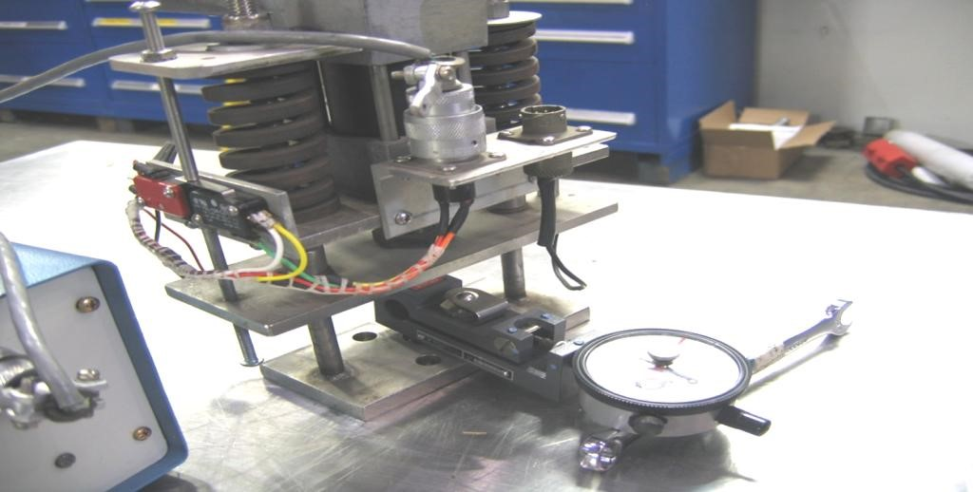

Fig 3

## JT Actuator installed onto a Supply End Can

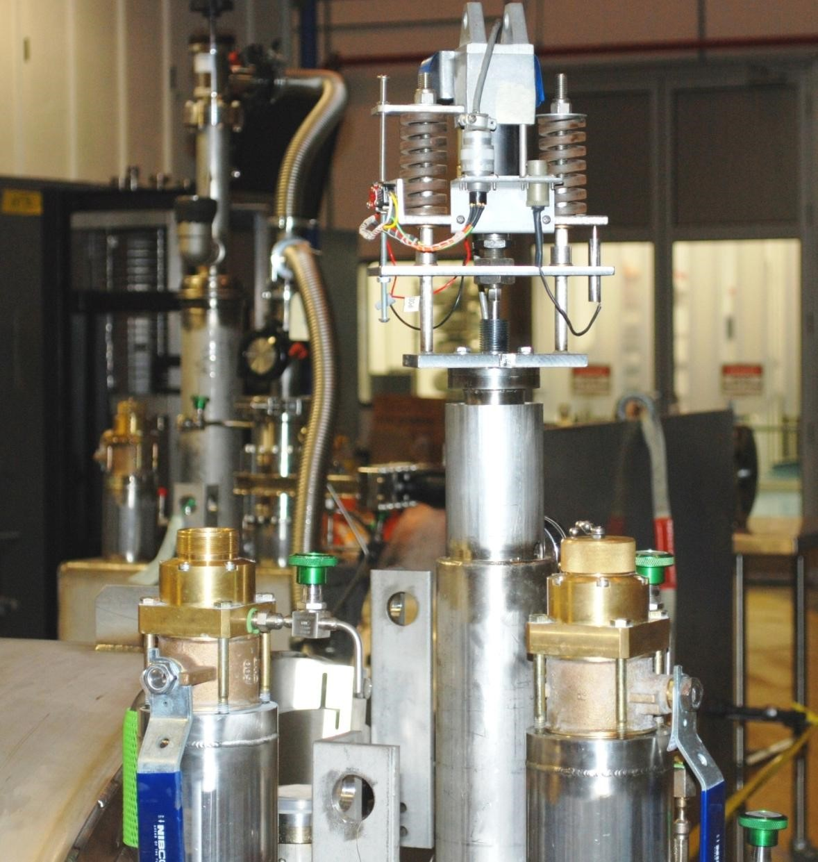

Fig 4

## Verify the JT bullet seals in the end can seat (IF REQUIRED).

Using the most current End Can or Cryomodule Pressure Testing OSP, verify the stem seals.

### Close the JT valve, verify snap rings are off the seats.

### Install the high pressure manifold with the appropriate gauge onto the peanut relief spigot for the primary circuit.

### Pressurize the inlet side of the JT valve to 200 psig, valve off the supply, snoop connections to verify there are no leaks.

### Record pressure every 15 minutes for a duration of 2 hours.

### If pressure change is >2 psig, seat and/or bullet shall be reworked

#### 

Supply End Can Pressure Test Setup Fig 6

## Setting of the JT Actuator

### Purpose

##### The purpose of this Procedure is to ensure a proper setting of the JT Valve Actuator on the Cryomodule.

### Scope

#### This Procedure is used for individuals responsible for setting the Actuator. Setting stroke, seating force, limit switches, and mounting.

### Equipment Required

* 0-250/lbs force gauge with 3/16” ball
* Dial indicator with clamping attachment
* 3/8”, 9/16” and 1” wrenches
* JT actuator power supply
* LVDT readout
* Screwdriver
* 1/16” allen wrench

### Procedure

When tightening or loosening the stud lock nuts be careful to not rotate the valve stem. This could compromise the internal bellows.

#### Screw down the actuator stud and move the movable plate up to provide clearance for the force gauge.

#### Place the force gauge with the 3/16” ball under the actuator stud and actuate to provide 200 pounds of downward force. Do not exceed force on the force gauge.

#### Adjust the spring tension and actuator until the snap rings undor the top plate (2 places) have 1/16” gap above the snap rings with 200 lbs of force.

#### Setting the limit: turn the top 10-32 limit switch screw until it triggers the limit switch open and lock in place. Actuate the cylinder up and then down. The cylinder should shut off near the 200 lbs of force. Fine tune as needed locking the screw jamb nut when done.

#### The actuator is now set to provide 200 lbs of seating force.

#### After the seating force has been set it can be installed onto a JT stem.

#### Adjust the actuator stud: Drive the actuator to the fully closed position, by hand pushing the JT stem closed. Set the actuator on top of the JT Valve. Adjust the stud until the actuator sits flat and the stud touches the top of the closed JT stem.

* + - 1. Mounting the actuator: Connect the JT stem to the actuator using a 9/16” long 10-32 stud and kep nut. When assembling, be careful not to twist the JT stem. Drive the actuator up until the actuator sits flat on the JT flange. Install the actuator mounting screws.
      2. Setting the actuator stroke and limit switches: Drive the actuator to the fully closed position. The 200lb limit switch should stop the actuator and the snap rings should be off the above plate. Install a dial indicator to measure the plate stroke. Open the JT valve to .562”. Adjust the position of the middle plate so it is about 1/8” from hitting the “c” clips and lock in place. Again be careful to not rotate the JT stem.
      3. Setting the bottom limit switch: Adjust the bottom 10-32 limit switch screw until it triggers the limit switch and lock in place. Check the actuator travel and adjust the limit switch screw until the actuator has .562” travel.
      4. Calibrating the LVDT
* Plug in the LVDT readout
* Close the JT valve then open it slightly until the gap above the 2 snap rings is eliminated
* Loosen the LVDT set screw and adjust until it reads “zero” on the readout. Tighten the set screw to lock the LVDT in place. Do not over tighten.
* Checking the LVDT readback: In the fully closed position (200 lbs of seating force) the readback should indicate ~10%, and in the fully open position the readback should indicate 100% or better.

# Process Flow

* There is no Process Workflow chart included.

# References

|  |  |
| --- | --- |
| **Document No.** | **Title** |
| SRF-01-ML-001 | SRF Quality Manual |
| CRM1208010-  0000 SHTS 1-3 | Supply End Can |
| 75600-0005 | JT Actuator Assy |
| 75600-0165 | JT Valve Assy |
| 75600-0165 | JT Stem, bullet, and seat |

# Release and Revision History

|  |  |  |
| --- | --- | --- |
| **Rev #** | **Major Changes** | **Effective Date:** |
| 1 | Initial version | 10 Oct 2024 |

# Approvals

|  |  |  |  |
| --- | --- | --- | --- |
| **Approved by:** | **Name:** | **Signature:** | **Date:** |
| Document Owner | John Fischer | In DocuShare | |
| Subject Matter Expert | Jared Martin | In DocuShare | |
| CMA Group Lead | John Fischer | In DocuShare | |