|  |  |  |  |
| --- | --- | --- | --- |
| **MLI Fabrication and Installation** | | | |
| **Document Number:** | SRF-MSPR-CMA-MLI -INST-R1 | **Effective Date:** | 15 Oct 2024 |
| **Revision Number:** | 1 | **Periodic Review Date:** | 15 Oct 2026 |
| **Document Owner:** | John Fischer | **Department Owner:** | SRF Operations |

# Purpose

The purpose of this document is to define the installation techniques for multi layer insulation during Cryomodule assembly applications.

This procedure supports the Quality Management System as described in SRF-01-ML-001 Quality Manual.

# Scope

This procedure will outline how MLI is to be handled, blankets fabricated and installed. Proper MLI installation techniques are necessary to minimize thermal influence on temperature sensitive systems. These systems require a multi layer, highly reflective foil with separating material; such as Cerex or equivalent polyester web-type spacer. Materials must meet JLAB Specs-11141S0038 (DAM) and 11141S0039 (Reemay-2250). Work is to be performed by knowledgeable Technicians that are familiar with the required materials.

# Terms and Definitions

The following terms have specific meanings within this procedure.

|  |  |
| --- | --- |
| **Term** | **Definition** |
| MLI | Multi layer insulation |
| DAM | Double aluminized mylar-a highly reflective insulating material |
| Reemay | Polyester spun separator material- used to prevent shorting between DAM layers |
| Cerex | Similar product to Reemay |

# Roles and Responsibilities

The following roles have responsibilities described in this document.

|  |  |
| --- | --- |
| **Role** | **Responsibility** |
| Cryomodule Group SME | Responsible for overseeing the correct application of this Procedure and review of the work performed. |
| Cryomodule Group Assembly Technician | Will perform the required steps from this Procedure. Is properly trained and knowledgeable on the information in this document. |

# Procedure

## Material Handling and Blanket Fabrication

#### Visually inspect the materials to be used consisting of DAM and Polyester spun (Reemay).

##### Materials should be free of oils and dust, without tears or missing aluminized coating, and rolled onto 3” cardboard cores as defined in the pre-referenced Procedures.

##### 5.1.1.2 Materials are to be loaded into the Rolling Rack for blanket fabrication. Use proper lifting techniques and verify all fasteners are tight once rolls are installed. Loose materials and the rolling rack should be covered when not in use to preserve cleanliness.

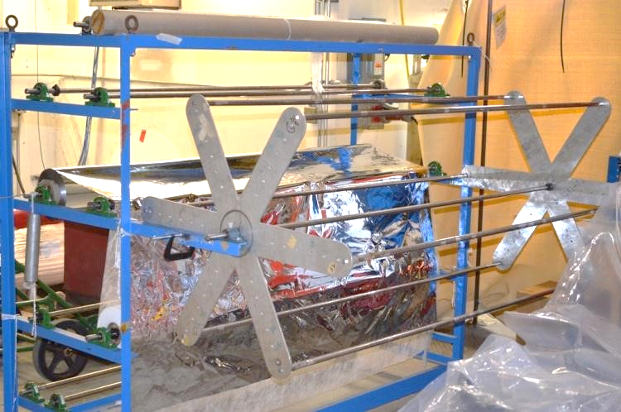

#### Adjust the outer rolling frame to achieve the proper blanket size. Move the threaded rods where needed. Tighten hardware.

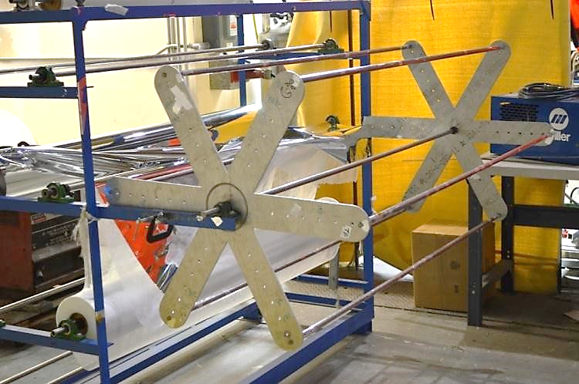

#### Secure 1 ply of DAM and Poly Spun material to the rolling frame spanner rod with mylar tape. Roll the required number of layers, (typically defined on the assembly drawing) forming the “blanket”. (One layer = 1 ply of each material)

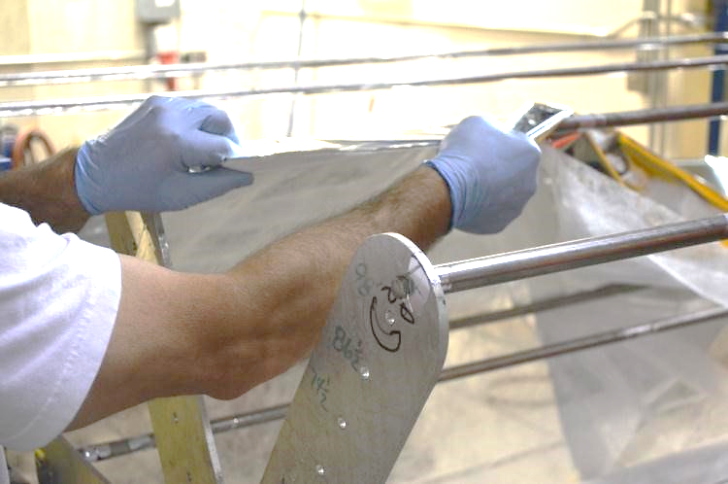

#### Verify the layer count, once satisfied; install nylon tags around all edges and sporadically throughout to hold the blanket together. Mark and cut the blanket from the rolling spit.

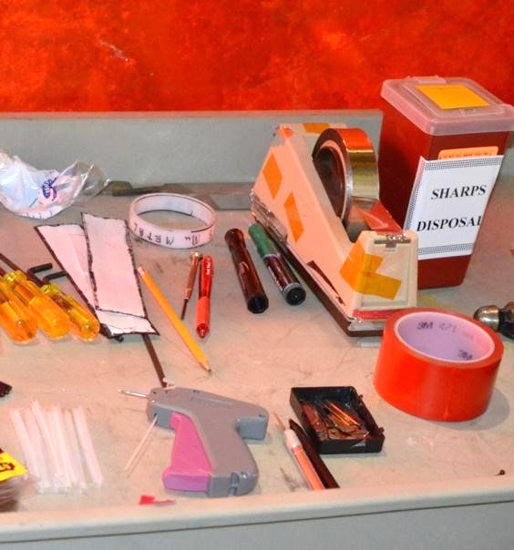

#### Lay blanket on clean surface and trim to finish size and shape. When trimming, use sharp xacto blade and straight edge. Dispose of used blades properly. (work area blade disposal containers) Add nylon tags where required.

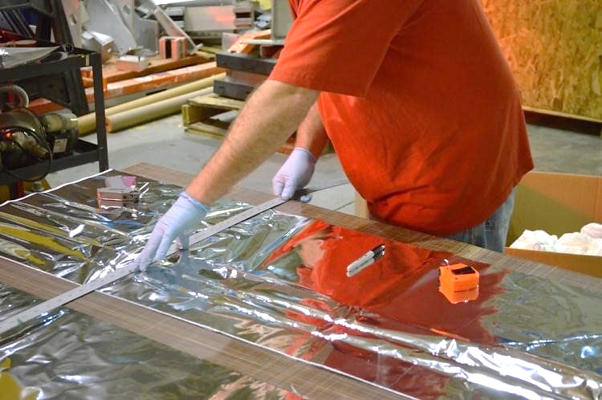

5.1.1.7 Store blankets in cleans containers until used.

***Blanket Installation***

#### Wearing clean gloves, wrap the blanket around the surface to be covered.

#### When possible, use multiple blankets and stagger the seams a minimum of 2”. Example: if the requirement is 10 layers, fabricate 2 blankets consisting of 5 layers.

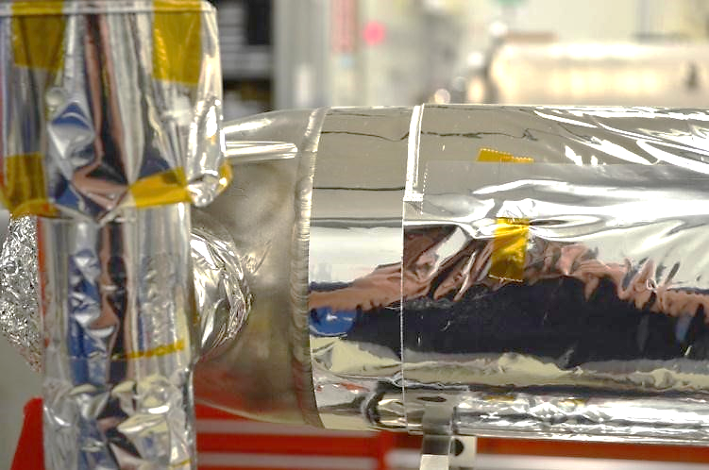

#### Tack similar layers of blankets together, verify the final fit. Reduce thermal shorts by butting the edges against one another, (DO NOT OVERLAP) and taping only to the same layer.

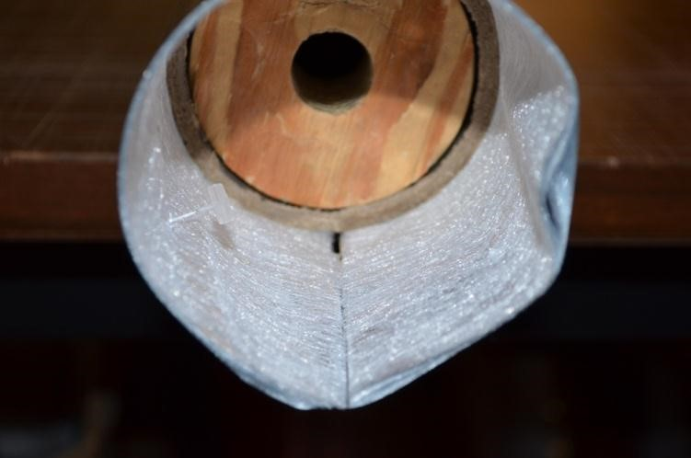

#### Add nylon tacks where needed to hold the blankets in position or keep edges together.

#### Tape all butted seams with Mylar tape.

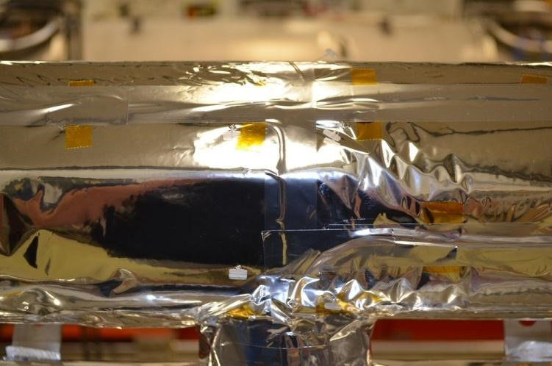

#### At areas where access doors or openings are required in the MLI, it is acceptable to use minimal Kapton tape around edges across unsimilar layers.

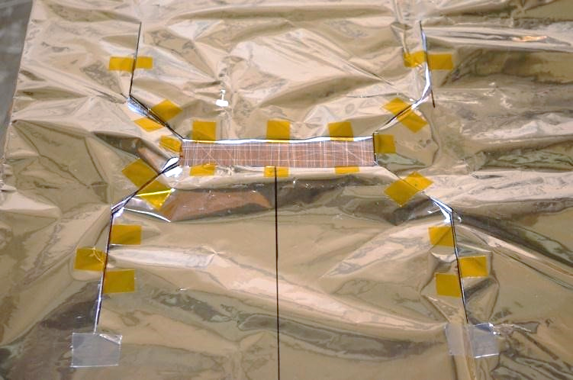

#### This picture is a representation of a completed 2K circuit MLI layer on a C100 Cold Mass.

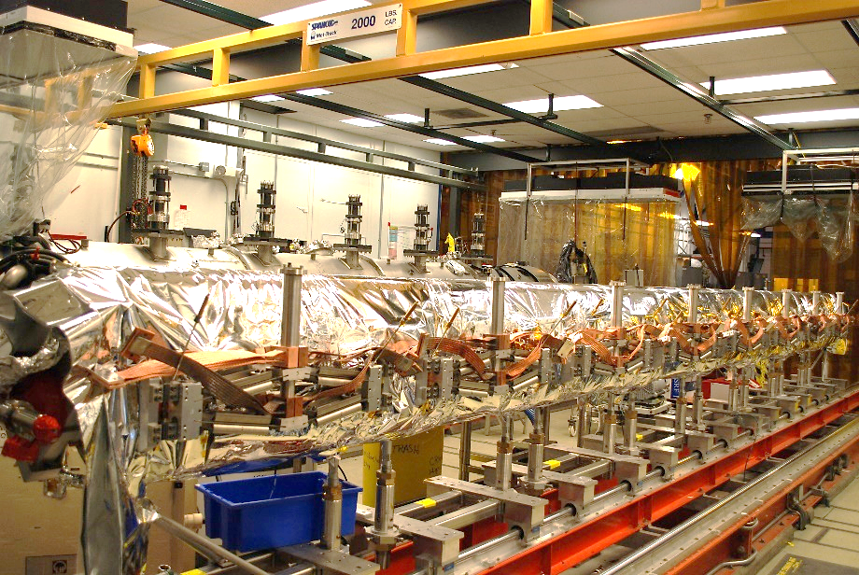

# Process Flow

* There is no Process Workflow chart included.

# References

|  |  |
| --- | --- |
| **Document No.** | **Title** |
| SRF-01-ML-001 | SRF Quality Manual |
| 11141S0038 | Double Aluminized Mylar Specification |
| 11141S0039 | Poly spun Separator Material (Reemay or Cerex) |

# Release and Revision History

|  |  |  |
| --- | --- | --- |
| **Rev #** | **Major Changes** | **Effective Date:** |
| 1 | Initial version | 15 Oct 2024 |

# Approvals

|  |  |  |  |
| --- | --- | --- | --- |
| **Approved by:** | **Name:** | **Signature:** | **Date:** |
| Document Owner | John Fischer | In DocuShare | |
| SME Technical Lead | Jeff Campbell | In DocuShare | |
| CMA Technical Lead | Jared Martin | In DocuShare | |