|  |  |  |  |
| --- | --- | --- | --- |
| **Cryomodule Assembly Alignment Procedure- C20/C50/C75** | | | |
| **Document Number:** | SRF-MSPR-CMA-ALIGN-INST-R1 | **Effective Date:** | 15 Oct 2024 |
| **Revision Number:** | 1 | **Periodic Review Date:** | 15 Oct 2026 |
| **Document Owner:** | John Fischer | **Department Owner:** | SRF Operations |

# Purpose

The purpose of this document is to define the alignment procedure for CEBAF C20, C50, and C75 Cryomodule types.

This procedure supports the Quality Management System as described in SRF-01-ML-001 Quality Manual.

# Scope

This procedure will define how alignment is to be performed to align the cavities relative to our alignment grid and monuments. This information is then used by the JLAB Alignment Team to position the Cryomodule in the Accelerator vault. Work is to be performed by knowledgeable Technicians that are familiar with the Cryomodule components, tooling, and this Procedure.

# Terms and Definitions

The following terms have specific meanings within this procedure.

|  |  |
| --- | --- |
| **Term** | **Definition** |
| Alignment grid | A system of control points used to create a repeatable matrix |
| Monument | A granite pier fixed to the floor, outfitted with precision bases used to accurately support alignment tooling |
| Alignment scope | A calibrated piece of equipment that establishes our line of sight, with adjustable reticles |
| Reference ball | A precision piece of alignment tooling that contains a graduated see thru window |
| Alignment arm | A specially designed article of tooling that transposes the beam line flange location to the dual scope average positions |

# Roles and Responsibilities

The following roles have responsibilities described in this document.

|  |  |
| --- | --- |
| **Role** | **Responsibility** |
| Cryomodule Group SME | Responsible for overseeing the correct application of this Procedure and review of the work performed. |
| Cryomodule Group Assembly Technician | Will perform the required steps from this Procedure. Is properly trained and knowledgeable on the Cryomodule components, required tooling, and information contained in this document. |

# Procedure

## Cryomodule Alignment Procedure

**5.1 Equipment Required**

Two (2) alignment scopes

Reference target

WD-40

Lint-free wipes

Single alignment arm fixture with target

Double alignment arm fixture with fixture

Torque wrench with 3/8" Allen socket

1/8" and 5/16" Allen wrenches

Two (2) lights on stands (shaded)

Computer with printer

Precision level

Standard level

3/16" and 9/16" wrenches

## Rough alignment of Cryounits

#### Roll the cryounit onto the assembly bench and plumb the top hat.

#### Install both alignment scopes and reference balls (clean first with WD-40 and a lint-free wipe). Viewing the reference target, ensure the scopes are within +/- .020". If they are not, ensure the scopes and mounting fixtures are clean. Lighting will be required to properly view the targets. If the reference target is still not +/- .020", the scope or monument alignment may need to be verified and adjusted.

**\*\*Adjustments are only to be made by the JLAB Alignment Group\*\***

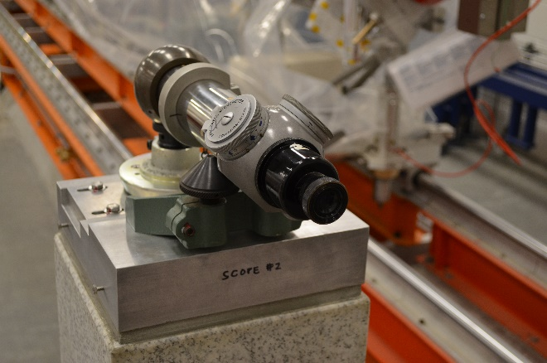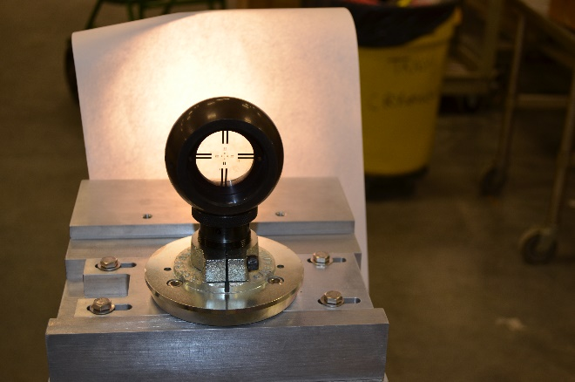

#### Install the dual extension arm on the left beam line valve vacuum flange. Install targets in the extension arm.

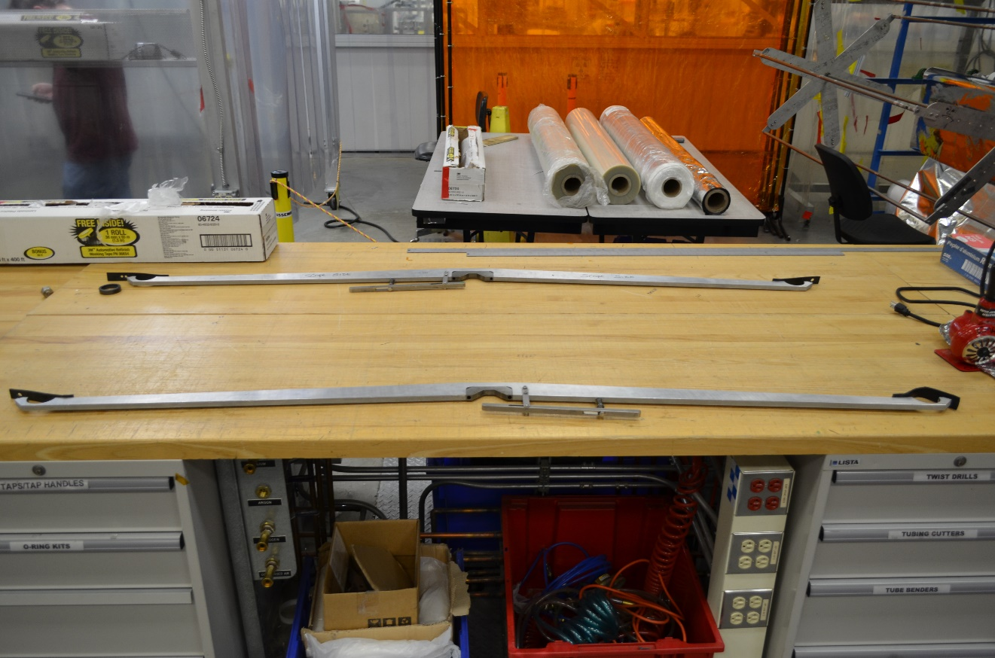

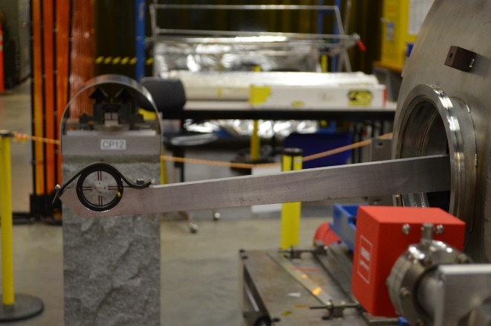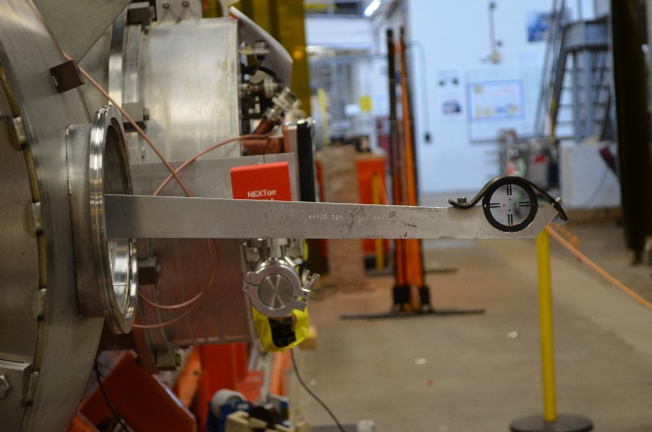

#### Level the extension arm using the two scopes to view the targets (lights may be required to view the targets). Adjust the two (2) saddle pads nearest the extension arm until the beam line flange is +/- .020" between scopes and +/- .020" from the scope height.

#### Move the extension arm to the right beam line valve vacuum flange and repeat Step 5.2.1.4

#### Ensure the top hat is still plumb and repeat Steps 5.2.1.3, 5.2.1.4, and 5.2.1.5 until the unit beam line flanges are aligned to +/- .020" and the top hat is plumb.

#### Repeat the above process for each of the 4 Cryounits as they are delivered from the CU Assembly Area.

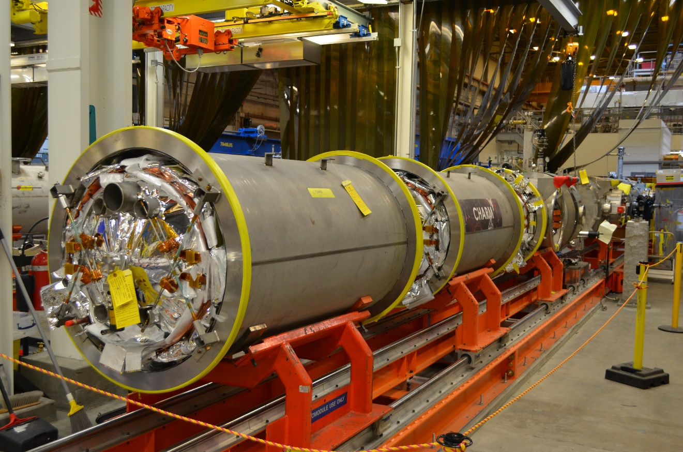

## Install and align the End Cans

#### Install the previously qualified Supply and Return end cans onto the Assembly bench in the correct orientation.

#### Align the end cans by adjusting the End Can stands to achieve average plumb of the bayonets and the end plate center relative to scope +/- .020”, similar to the Cryounits. There is specific tooling required, a “dummy” male bayonet with level supporting surface, and a single sided alignment arm with centering disc.

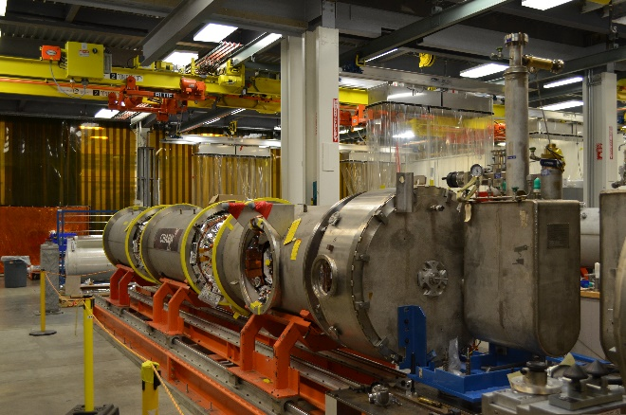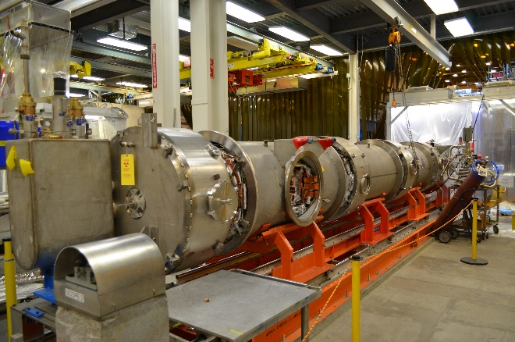

#### Once the pre alignment of the 6 large components (4 Cryounits, 1 Supply End Can, and 1 Return End Can) is completed and verified, Cryomodule assembly will proceed until the Final Alignment defined next in this Procedure.

## Final Alignment Preparation

#### Ensure all the bridging rings have been completely welded and the end can support stands have been released or removed.

#### Tighten the four (4) support pads on the module saddles where the aluminum support stands are to be mounted. Loosen the remaining twelve (12) support pads. The weight of the module is now in two (2) locations mimicking the module support stands after installation in the Accelerator Vault.

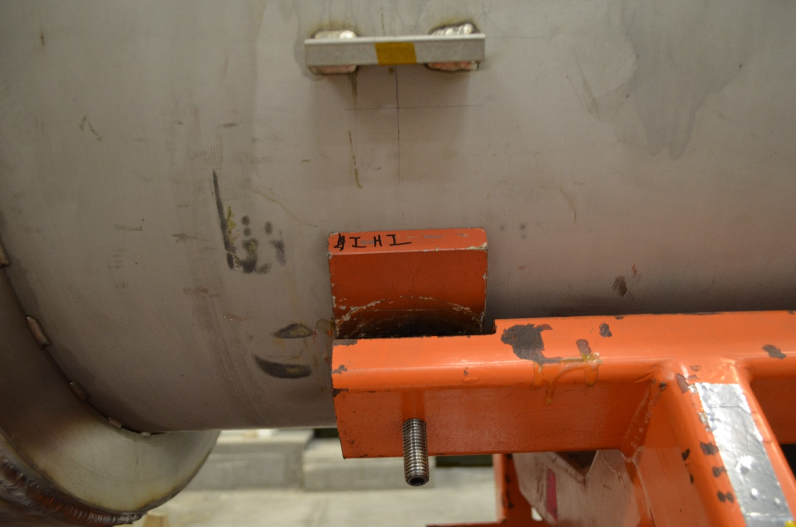

#### Install both alignment scopes and reference balls (clean first with WD-40 and a lint-free wipe). Viewing the reference target, ensure the scopes are within +/- .020". If they are not, ensure the scopes and mounting fixtures are clean. Lighting will be required to properly view the targets. If the reference target is still not +/- .020", the scope or monument alignment may need to be verified and adjusted. **Adjustments are only to be made by the JLAB Alignment Group**

#### Adjust the alignment reticles to zero, zero on the reference balls. Record the values of the reticle movements into the correct computer alignment spreadsheet. Pay close attention to the axis (X or Y) and direction of the reticle dials (Plus or Minus)

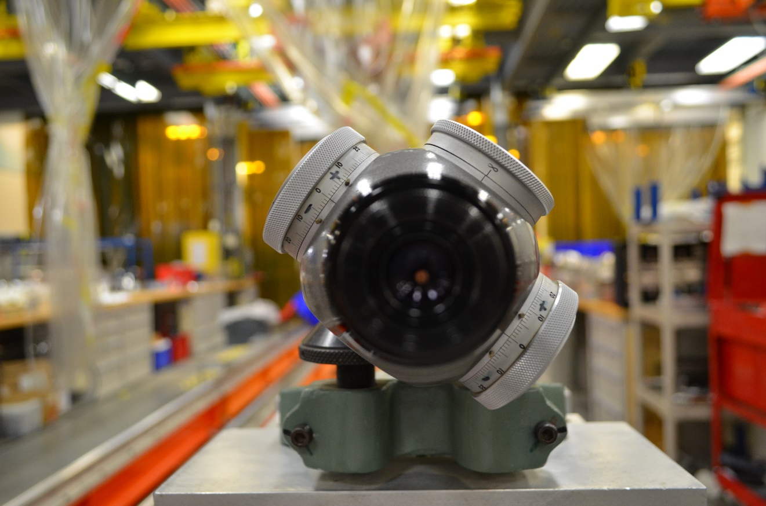

#### Install the alignment dual target extension arm (with targets) onto the Conflat #2 beam line flange. Level the alignment arm, setting it to average when looking through both scopes. Enter the target position numbers into the computer. If the targets are out of scope range estimate the number. Repeat this for Conflats #3, 8, and 9.

#### Using the four adjustment pads on which the module is sitting, adjust the module position to bring it on scope by repeating the computed position of the alignment Conflats defined in the previous step.

5.5 **Final Alignment**

**\*\*CAUTION\*\***

**When adjusting the Nitronic support rods, care must be taken to not rotate the Helium vessel. The bellows of the fundamental waveguides and bridging areas are sensitive and movement must be minimal.**

5.5.1.1Install the alignment dual target extension arm with targets onto one of the cryounits. Level the arm using the scopes. Adjust the four (4) Helium vessel support rods until the computed conflat position is +/- .010". The Helium vessel support rods should have a torque range between 75-150 in./lbs when finished.

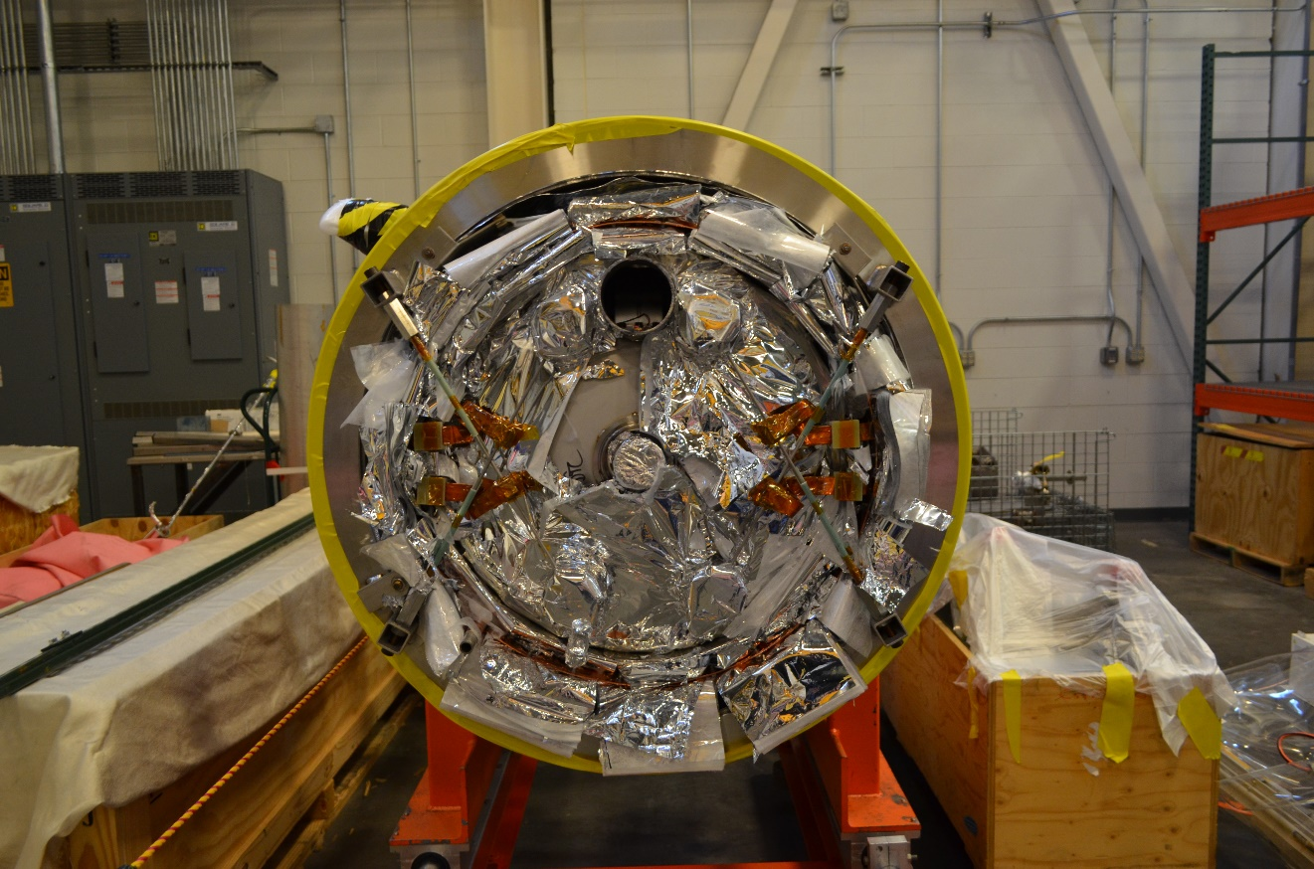

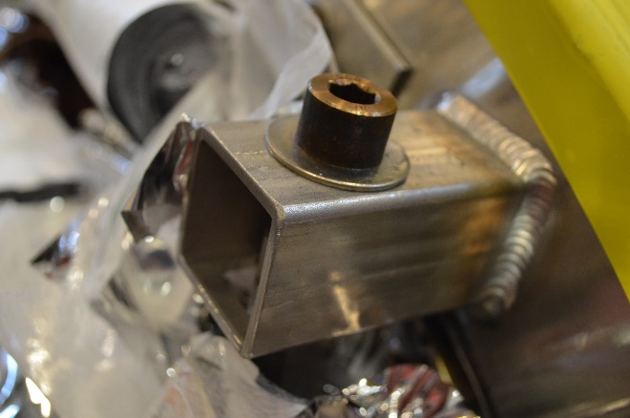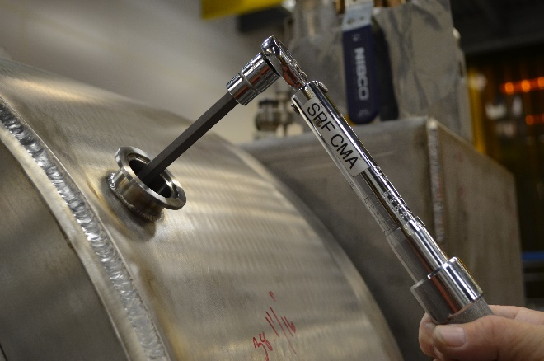

5.5.1.2 Move the extension arm to the opposite end of the cryounit. Repeat Step 5.5.1.1. The movement of a flange at one end of a cryounit will affect the position of the flange at the other end of the cryounit. Because of this, the alignment of both ends must be repeated until both ends are +/- .010".

5.5.1.3 Repeat Steps 5.5.1.1 and 5.5.1.2 for all four (4) cryounits.

5.5.1.4 Align the warm to cold beam pipe flanges, install the alignment single extension arm with target onto Conflats #1 and #10 and level the alignment arm using the precision level. Sight the target and adjust the warm to cold beam tubes until the computed position is +/- .010".

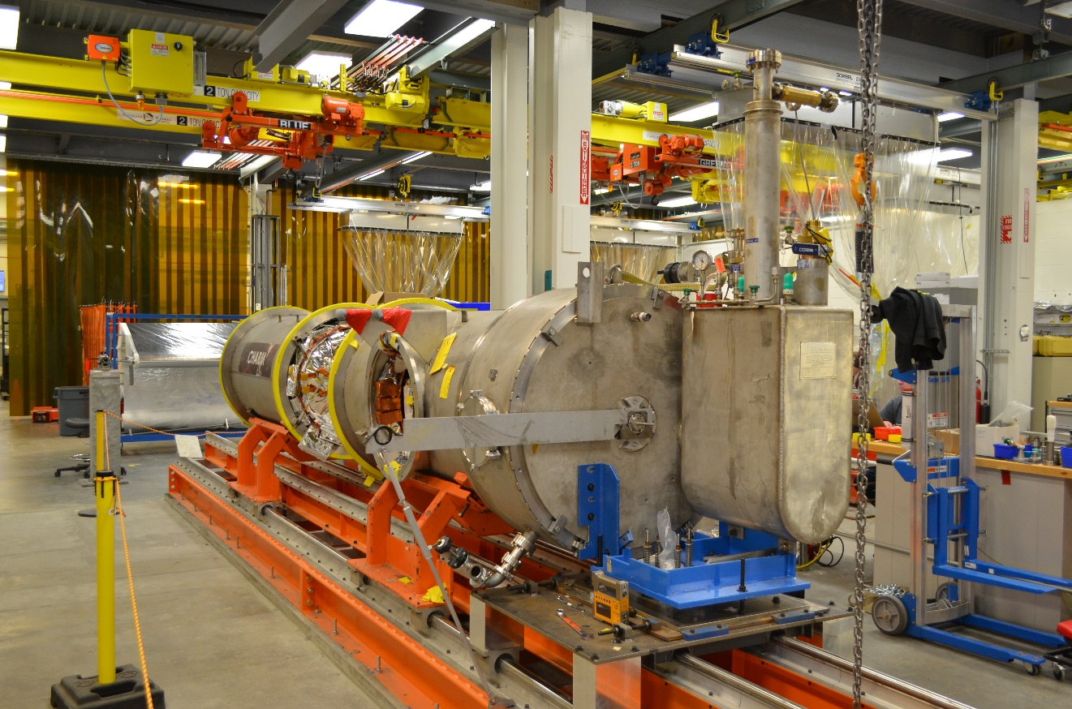

5.5.1.5 Once a final run of all 10 flanges is completed (without any nitronic rod adjustments) and the computed numbers meet this Procedures values (torque range and alignment tolerance) Alignment is complete. Save the working Spreadsheet as “FINAL” and upload it into the respective Traveler. Example shown below.

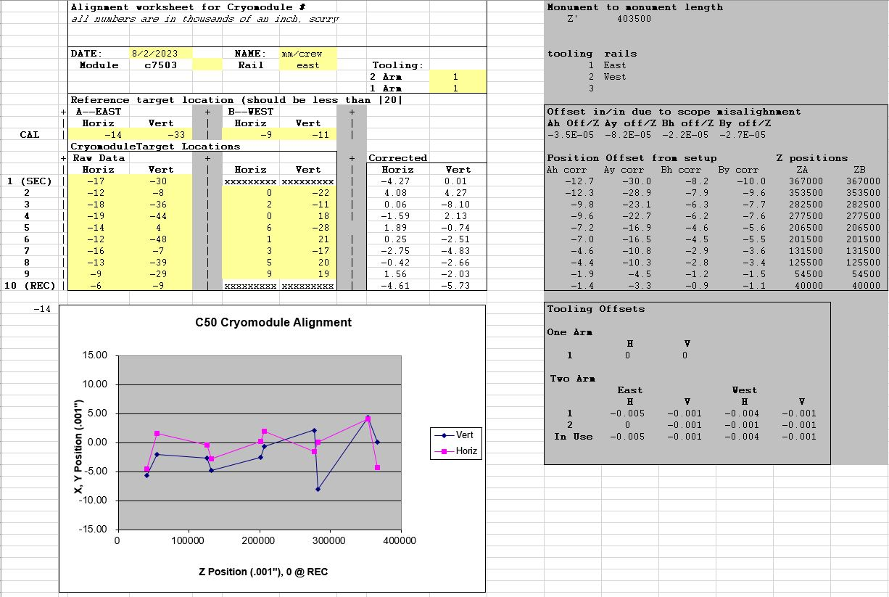

5.5.1.6 **Do not move the Cryomodule**, the JLAB Alignment crew will fiducialize the Cryomodule in reference to the alignment control system. This information along with the “FINAL” spreadsheet will be used to set the Cryomodule in the Accelerator Vault once installed.

#### 

# Process Flow

* There is no Process Workflow chart included.

# References

|  |  |
| --- | --- |
| **Document No.** | **Title** |
| SRF-01-ML-001 | SRF Quality Manual |
| 11100-0008 | Cryomodule Interface Control Dwg |

# Release and Revision History

|  |  |  |
| --- | --- | --- |
| **Rev #** | **Major Changes** | **Effective Date:** |
| 1 | Initial version | 15 Oct 2024 |

# Approvals

|  |  |  |  |
| --- | --- | --- | --- |
| **Approved by:** | **Name:** | **Signature:** | **Date:** |
| Document Owner | John Fischer | In DocuShare | |
| SME Technical Lead | Jeff Campbell | In DocuShare | |
| CMA Technical Lead | Jared Martin | In DocuShare | |