Traveler Title | End Group 2 Assembly Traveler
Traveler Abstract | Outlines the inspection and fabrication steps for the End Group 2 for the EIC 197Mhz Crab Cavity
Traveler ID | EIC197-FAB-EG2-ASSY
Traveler Revision | R1
Traveler Author | Eduard Drachuk
Traveler Date | 22-Oct-24
NCR Informative Emails | AREILLY,GEORGED,O'BRIEN,KDAVIS
NCR Dispositioners | DRACHUK,BUTTLES,HUQUE
D3 Emails | AREILLY,GEORGED,BUTTLES, O'BRIEN,KDAVIS,DRACHUK,HUQUE
Approval Names | E. DRACHUK | A. O'BRIEN | J. BUTTLES | N. HUQUE
Approval Signatures
Approval Dates
Approval Title | Author | Reviewer | Group Leader | Project Manager

References | List and Hyperlink all documents related to this traveler. This includes, but is not limited to: safety (THAs, SOPs, etc), drawings, procedures, and facility related documents.
JL0129594 | JL0135965 | JL0134212 | JL0136179 | JL0143978
EIC197-PR-CHEM-CAV-ACID-R1 | JL0143260 | JL0136180 | JL0136181 | JL0147503
JL0170550 | JL0136182 | JL0146916 | JL0134243 | JL0136183
11141-S-0033 | JL0145103

Revision Note
R1 | Initial release of this Traveler.

Step No. | Instructions | Data Input
PART IDENTIFICATION
0 | Enter Serial Number of Finished Part | [[EG2SN]] <<SN>>  [[New part SN dropdown]] <<NOTE>>
  PAGE | WORK CENTER AREAS | ACTIONS
  2 | MACHSHOP | Part Forming
  3 | INSP | CMM
  4 | CHEM | BCP
  5 | EBW | EBW
  6 | INSP | CMM
  7 | CHEM | BCP
  8 | EBW | EBW
  9 | INSP | CMM
  10 | CHEM | BCP
  11 | EBW | EBW
  12 | CHEM | BCP
  13 | CMA | Leak Check
  14 | CMA | Assemble
  15 | INSP | CMM

FORMING
1 | Form JL0129594 End Dish. | [[FormingTech]] <<SRF>>  [[FormingTime]] <<TIMESTAMP>>  [[FormingComment]] <<COMMENT>>

DIMENSIONAL INSPECTION
2 | Verify dimensions in red for JL0129594 End Dish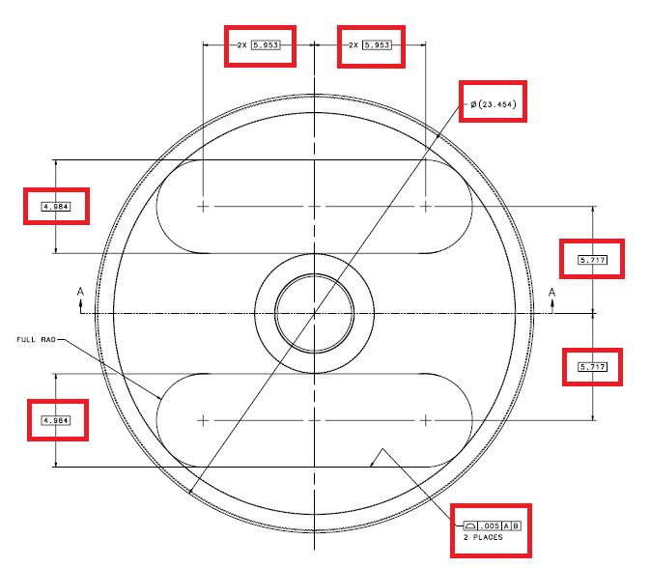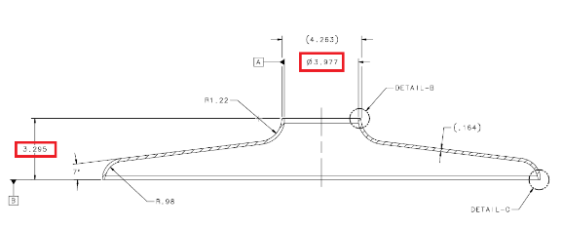 | [[DISHSN]] <<SN>>  [[Incoming part SN dropdown]] <<NOTE>>  [[InspectionTech1]] <<SRF>>  [[InspectionTime1]] <<TIMESTAMP>>  [[InspectionComment1]] <<COMMENT>>  [[InspectionUpload1]] <<FILEUPLOAD>>

CHEMISTRY
3a | BCP JL0129594 End Dish to a depth of 15 microns  According to EIC197-PR-CHEM-CAV-ACID-R1 Acid Etching Proceedure | [[DISHSN]] <<SN>>  [[Incoming part SN dropdown]] <<NOTE>>  [[ChemistryTech1]] <<SRFCVP>>  [[ChemistryTime1]] <<TIMESTAMP>>  [[ChemistryComment1]] <<COMMENT>>  [[ChemistryUpload1]] <<FILEUPLOAD>>
3b | BCP JL0143260 Boss (x2) to a depth of 15 microns  According to EIC197-PR-CHEM-CAV-ACID-R1 Acid Etching Proceedure | [[BSINSN]] <<SN>>  [[Incoming part SN dropdown]] <<NOTE>>  [[ChemistryTech2]] <<SRFCVP>>  [[ChemistryTime2]] <<TIMESTAMP>>  [[ChemistryComment2]] <<COMMENT>>  [[ChemistryUpload2]] <<FILEUPLOAD>>
3c | BCP JL0135965 Boss (x2) to a depth of 15 microns  According to EIC197-PR-CHEM-CAV-ACID-R1 Acid Etching Proceedure | [[BSOUTSN]] <<SN>>  [[Incoming part SN dropdown]] <<NOTE>>  [[ChemistryTech3]] <<SRFCVP>>  [[ChemistryTime3]] <<TIMESTAMP>>  [[ChemistryComment3]] <<COMMENT>>  [[ChemistryUpload3]] <<FILEUPLOAD>>
3d | BCP JL0134212 End Plate 2 to a depth of 15 microns  According to EIC197-PR-CHEM-CAV-ACID-R1 Acid Etching Proceedure | [[PLATE2SN]] <<SN>>  [[Incoming part SN dropdown]] <<NOTE>>  [[ChemistryTech5]] <<SRFCVP>>  [[ChemistryTime5]] <<TIMESTAMP>>  [[ChemistryComment5]] <<COMMENT>>  [[ChemistryUpload5]] <<FILEUPLOAD>>
3e | BCP JL0136180 HHOW Waveguide Assembly to a depth of 15 microns  According to EIC197-PR-CHEM-CAV-ACID-R1 Acid Etching Proceedure | [[HWGFASN]] <<SN>>  [[Incoming part SN dropdown]] <<NOTE>>  [[ChemistryTech6]] <<SRFCVP>>  [[ChemistryTime6]] <<TIMESTAMP>>  [[ChemistryComment6]] <<COMMENT>>  [[ChemistryUpload6]] <<FILEUPLOAD>>
3f | BCP JL0136179 FPC Waveguide Assembly to a depth of 15 microns  According to EIC197-PR-CHEM-CAV-ACID-R1 Acid Etching Proceedure | [[FPCWASN1]] <<SN>>  [[Incoming part SN dropdown]] <<NOTE>>  [[ChemistryTech7]] <<SRFCVP>>  [[ChemistryTime7]] <<TIMESTAMP>>  [[ChemistryComment7]] <<COMMENT>>  [[ChemistryUpload7]] <<FILEUPLOAD>>
3g | BCP JL0136181 FPC Beampipe Assembly to a depth of 15 microns  According to EIC197-PR-CHEM-CAV-ACID-R1 Acid Etching Proceedure | [[FPCBPASN]] <<SN>>  [[Incoming part SN dropdown]] <<NOTE>>  [[ChemistryTech8]] <<SRFCVP>>  [[ChemistryTime8]] <<TIMESTAMP>>  [[ChemistryComment8]] <<COMMENT>>  [[ChemistryUpload8]] <<FILEUPLOAD>>
3h | BCP JL0143978 Nut (x4) to a depth of 15 microns  According to EIC197-PR-CHEM-CAV-ACID-R1 Acid Etching Proceedure | [[ChemistryTech9]] <<SRFCVP>>  [[ChemistryTime9]] <<TIMESTAMP>>  [[ChemistryComment9]] <<COMMENT>>  [[ChemistryUpload9]] <<FILEUPLOAD>>

EBW
4a | Using fixture JL0147503, EBW JL0143260 Boss (x2) and JL0135965 Boss (x2) to JL0129594 End Dish to create part JL0136183 | [[DISHSN]] <<SN>>  [[Incoming part SN dropdown]] <<NOTE>>  [[BSOUTSN]] <<SN>>  [[Incoming part SN dropdown]] <<NOTE>>  [[BSINSN]] <<SN>>  [[Incoming part SN dropdown]] <<NOTE>>  [[DISHNBSSN]] <<SN>>  [[New part SN dropdown]] <<NOTE>>  [[EBWTech1]] <<SRF>>  [[EBWTime1]] <<TIMESTAMP>>  [[EBWComment1]] <<COMMENT>>  [[EBWFile1]] <<FILEUPLOAD>>
4b | EBW JL0136180 HHOM Waveguide Assembly and JL0136179 FPC Waveguide Assembly to JL0134212 End Plate 2 | [[PLATE2SN]] <<SN>>  [[Incoming part SN dropdown]] <<NOTE>>  [[FPCWASN1]] <<SN>>  [[Incoming part SN dropdown]] <<NOTE>>  [[HWGFASN]] <<SN>>  [[Incoming part SN dropdown]] <<NOTE>>  [[FULPLT2SN]] <<SN>>  [[New part SN dropdown]] <<NOTE>>  [[EBWTech2]] <<SRF>>  [[EBWTime2]] <<TIMESTAMP>>  [[EBWComment2]] <<COMMENT>>  [[EBWFile2]] <<FILEUPLOAD>>

DIMENSIONAL INSPECTION
5a | Verify dimensions in red for JL0136183  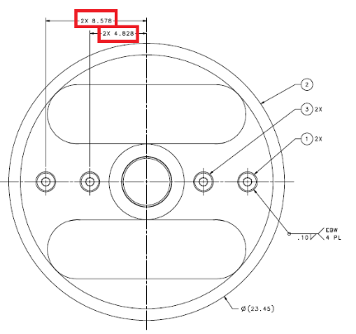 | [[DISHNBSSN]] <<SN>>  [[Incoming part SN dropdown]] <<NOTE>>  [[InspectionTech2]] <<SRF>>  [[InspectionTime2]] <<TIMESTAMP>>  [[InspectionComment2]] <<COMMENT>>  [[InspectionUpload2]] <<FILEUPLOAD>>
5b | Verify dimensions in red for JL0136182 End Plate 2 With HHOM Waveguide And FPC Waveguide  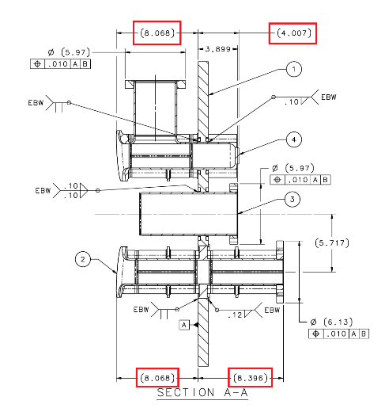 | [[FULPLT2SN]] <<SN>>  [[Incoming part SN dropdown]] <<NOTE>>  [[InspectionTech3]] <<SRF>>  [[InspectionTime3]] <<TIMESTAMP>>  [[InspectionComment3]] <<COMMENT>>  [[InspectionUpload3]] <<FILEUPLOAD>>

CHEMISTRY
6a | Optional BCP JL0136183 to a depth of 15 microns  According to EIC197-PR-CHEM-CAV-ACID-R1 Acid Etching Proceedure | [[DISHNBSSN]] <<SN>>  [[Incoming part SN dropdown]] <<NOTE>>  [[ChemistryTech10]] <<SRFCVP>>  [[ChemistryTime10]] <<TIMESTAMP>>  [[ChemistryComment10]] <<COMMENT>>  [[ChemistryUpload10]] <<FILEUPLOAD>>
6b | BCP JL0136182 End Plate 2 With HHOM Waveguide And FPC Waveguide to a depth of 15 microns  According to EIC197-PR-CHEM-CAV-ACID-R1 Acid Etching Proceedure | [[FULPLT2SN]] <<SN>>  [[Incoming part SN dropdown]] <<NOTE>>  [[ChemistryTech11]] <<SRFCVP>>  [[ChemistryTime11]] <<TIMESTAMP>>  [[ChemistryComment11]] <<COMMENT>>  [[ChemistryUpload11]] <<FILEUPLOAD>>

EBW
7 | Using fixture JL0170550, EBW JL0136181 FPC Beampipe Assembly to JL0136182 End Plate 2 With HHOM Waveguide and FPC Waveguide to create part JL0136182 | [[FULPLT2SN]] <<SN>>  [[Incoming part SN dropdown]] <<NOTE>>  [[FPCBPASN]] <<SN>>  [[Incoming part SN dropdown]] <<NOTE>>  [[EBWTech4]] <<SRF>>  [[EBWTime4]] <<TIMESTAMP>>  [[EBWComment4]] <<COMMENT>>  [[EBWFile4]] <<FILEUPLOAD>>

DIMENSIONAL INSPECTION
8 | Verify dimensions in red for JL0136182 FPC End Plate Assembly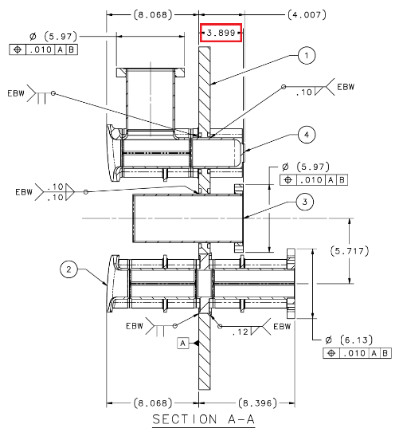 | [[FULPLT2SN]] <<SN>>  [[Incoming part SN dropdown]] <<NOTE>>  [[InspectionTech5]] <<SRF>>  [[InspectionTime5]] <<TIMESTAMP>>  [[InspectionComment5]] <<COMMENT>>  [[InspectionUpload5]] <<FILEUPLOAD>>

CHEMISTRY
9 | BCP JL0136182 FPC End Plate Assembly to a depth of 15 microns  According to EIC197-PR-CHEM-CAV-ACID-R1 Acid Etching Proceedure | [[FULPLT2SN]] <<SN>>  [[Incoming part SN dropdown]] <<NOTE>>  [[ChemistryTech13]] <<SRFCVP>>  [[ChemistryTime13]] <<TIMESTAMP>>  [[ChemistryComment13]] <<COMMENT>>  [[ChemistryUpload13]] <<FILEUPLOAD>>

EBW
10 | Using fixture JL0146916, EBW JL0136182 to JL0136183 to create part JL0134243 | [[DISHNBSSN]] <<SN>>  [[Incoming part SN dropdown]] <<NOTE>>  [[FULPLT2SN]] <<SN>>  [[Incoming part SN dropdown]] <<NOTE>>  [[EBWTech6]] <<SRF>>  [[EBWTime6]] <<TIMESTAMP>>  [[EBWComment6]] <<COMMENT>>  [[EBWFile6]] <<FILEUPLOAD>>

CHEMISTRY
11 | BCP JL0134243 to a depth of 15 microns  According to EIC197-PR-CHEM-CAV-ACID-R1 Acid Etching Proceedure | [[ChemistryTech15]] <<SRFCVP>>  [[ChemistryTime15]] <<TIMESTAMP>>  [[ChemistryComment15]] <<COMMENT>>  [[ChemistryUpload15]] <<FILEUPLOAD>>

LEAK CHECK
12 | Leak check the assembly (JL0134243) in accordance with 11141-S-0033  Vendor Standard Helium Leak Check Procedure  Upload any relevant images/comments | [[LeakCheckTech]] <<SRF>>  [[LeakCheckTime]] <<TIMESTAMP>>  [[LeakCheckPass]] <<YESNO>>  [[LeakCheckComment]] <<COMMENT>>  [[LeakCheckUpload]] <<FILEUPLOAD>>  [[LeakCheckEmail]] {{DRACHUK}} <<EMAIL>>  [[LeakCheckEmail]] {{Pansophy: End Group 2 Passed The Leak Check}} <<EMAILSUBJ>>

ASSEMBLY
13 | Assemble JL0145103 (x4) Rod with JL0143978 (x4) Nut to JL0134243 | [[AssemblyTech]] <<SRF>>  [[AssemblyTime]] <<TIMESTAMP>>  [[AssemblyComment]] <<COMMENT>>  [[AssemblyUpload]] <<FILEUPLOAD>>

DIMENSIONAL INSPECTION
14 | Verify dimensions in red for JL0134243  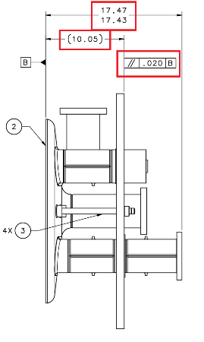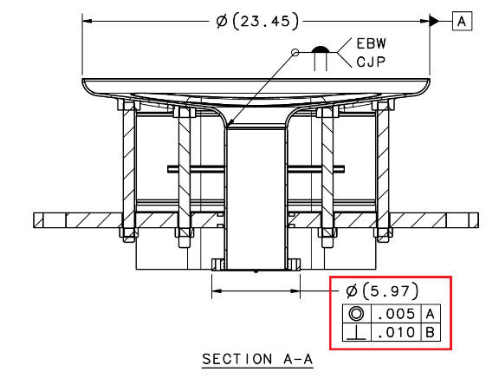 | [[InspectionTech7]] <<SRF>>  [[InspectionTime7]] <<TIMESTAMP>>  [[InspectionComment7]] <<COMMENT>>  [[InspectionUpload7]] <<FILEUPLOAD>>

