Downloading, Installing and Using the DocuShare Windows Client Software
Author: Bonnie Madre (madre@jlab.org)

Introduction:
In using DocuShare, it is possible to upload documents from any browser. This involves creating the document, saving it to disk, then getting into the web browser, logging on to DocuShare, accessing the desired web browser, and uploading the document. In this case, the user has to know the location of the file to be uploaded. There is an easier way for Windows users.

Getting the Client:
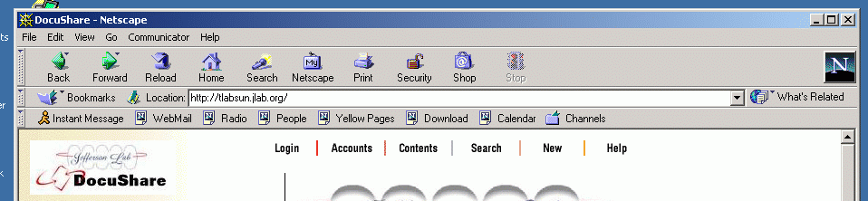
Log on to DocuShare. Click on the "Help" link on the top right of the Main Page
Figure 1: The top tool bar on the DocuShare Main Page
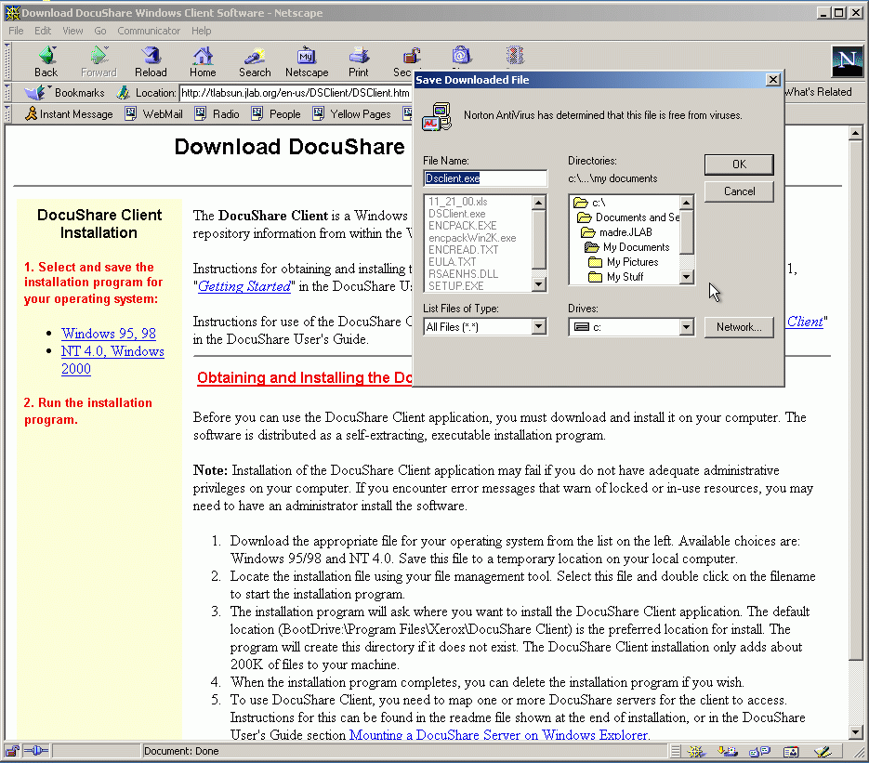
Somewhere on the page there is a link called "DocuShare Windows Client". Click on that link. It will bring up the download/save dialog box. Save it to a location you will remember, then double-click it to start the installation script.
Figure2: Locating the DSClient.exe file to download

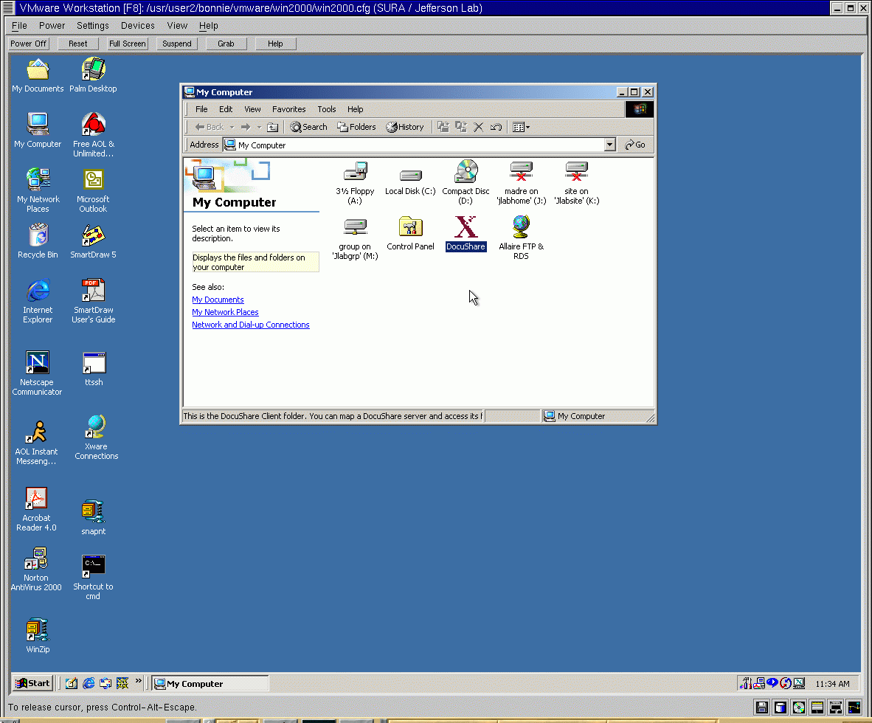
Follow the instructions in the installation script. Once the software is installed, if you double-click once again on "My Computer", you should see the DocuShare client symbol (a large red "X" - see Figure 3 below).

Figure 3: DocuShare Windows Client as a destination "drive"
This means that for some applications (including MS-Word, and PowerPoint), DocuShare is a destination to which documents can be saved. The next section deals with setting up a server, to which you can save documents.

Configuring a Server
Next you will have to configure a server (the Jlab DocuShare server), and you can add some collections that you use often to save time in saving documents.
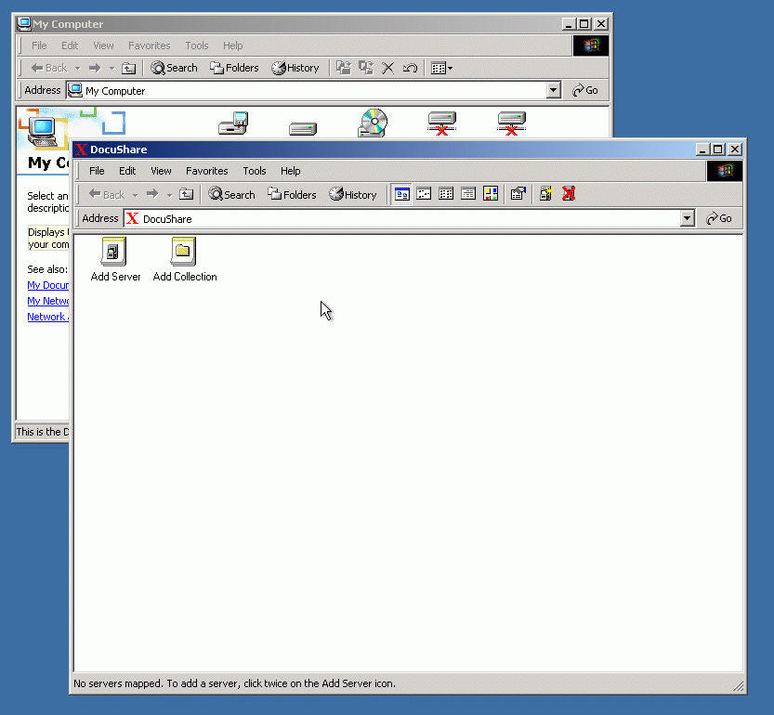
Double-click on the DocuShare Client icon. This will bring up a folder that looks like the illustration in Figure 4.

Figure 4: The DocuShare Client folder
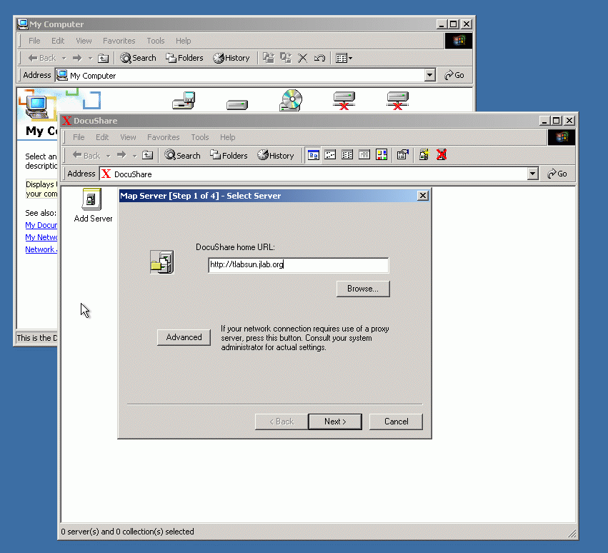
Double-click on "Add Server", and the following dialog will appear: Enter the name of the Jlab DocuShare Server ("tlabsun.jlab.org"). Click "Next"

Figure 5: Entering the Server URL

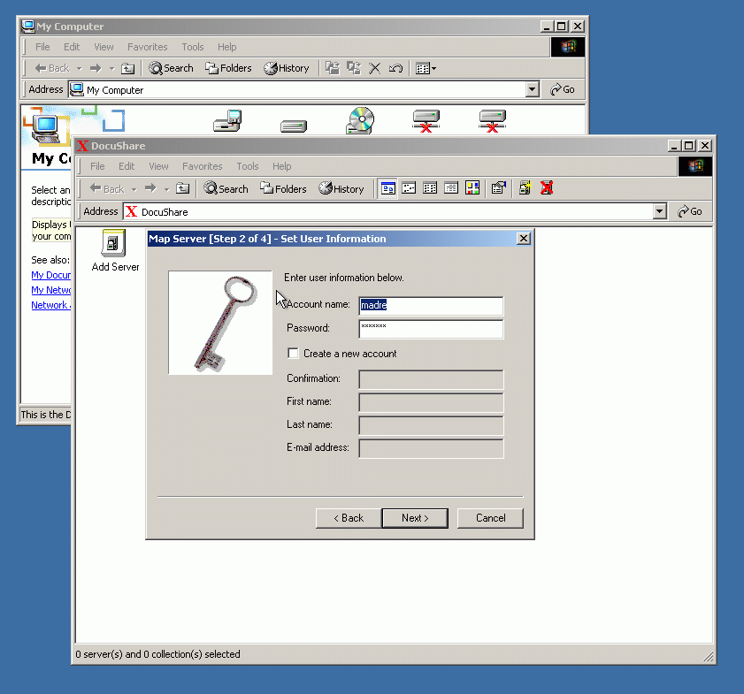
The next dialog that you see will ask you for your DocuShare account name and password. Enter these and click "Next"

Figure 6: Entering the DocuShare account name and password
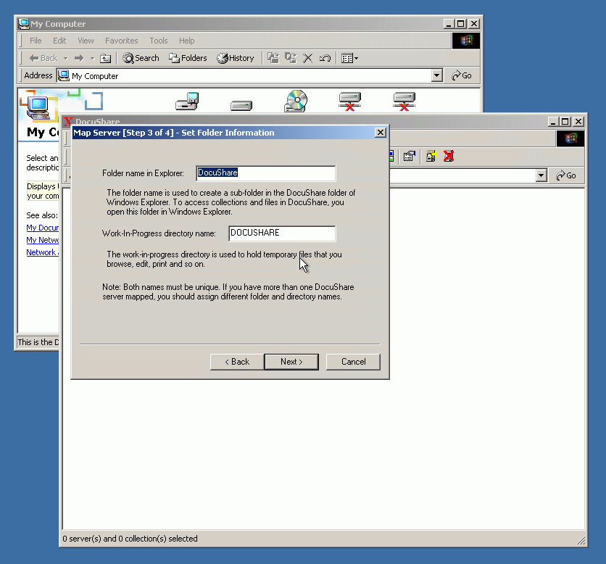
Next you will need to enter a folder name for Explorer and for a work-in-progress directory. Default is the server name. I called them "DocuShare" and "DOCUSHARE". You may call them "Rosencrantz" and "Guildenstern" if you like. Enter your choices and click "Next".

Figure 7: Entering Folder and Work-In-Progress directory names

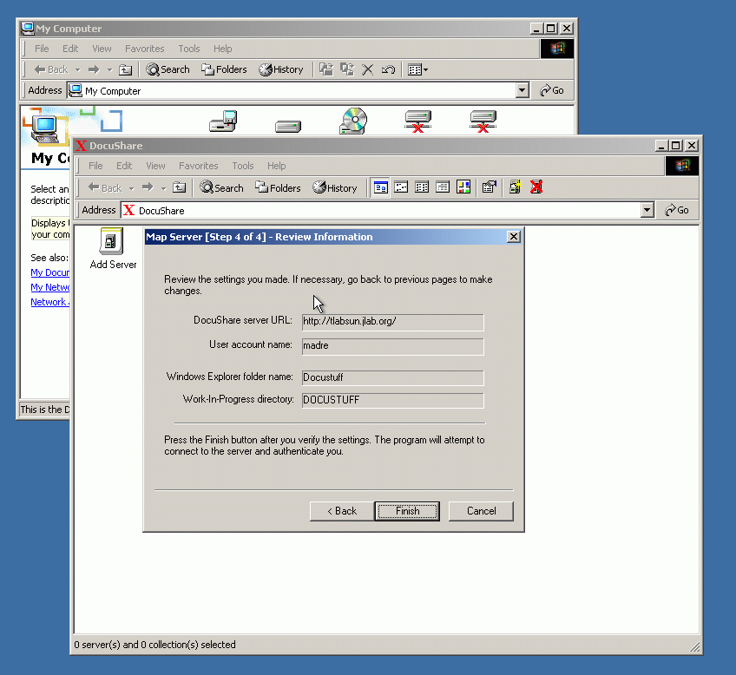
Next, you will be given a chance to review the settings that you entered. If everything is correct, click "Finish".

Figure 8: Review settings and finish adding the server
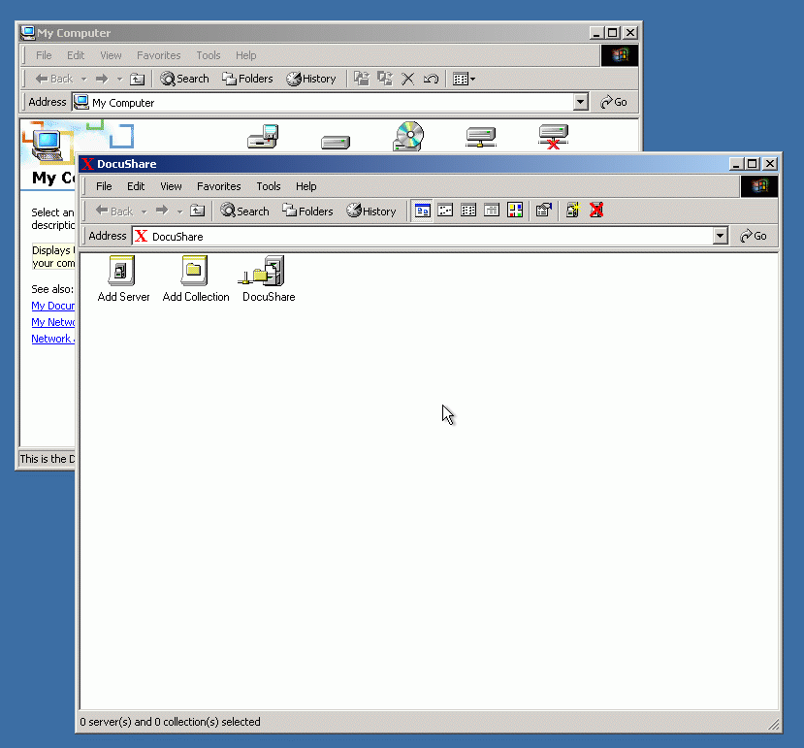
The program will then attempt to connect to the server, and authenticate your login information. If it is successful, the DocuShare client "drive" should look like the sreen pictured in Figure 9.

Figure 9, Successful addition of a DocuShare server

Adding Collections:
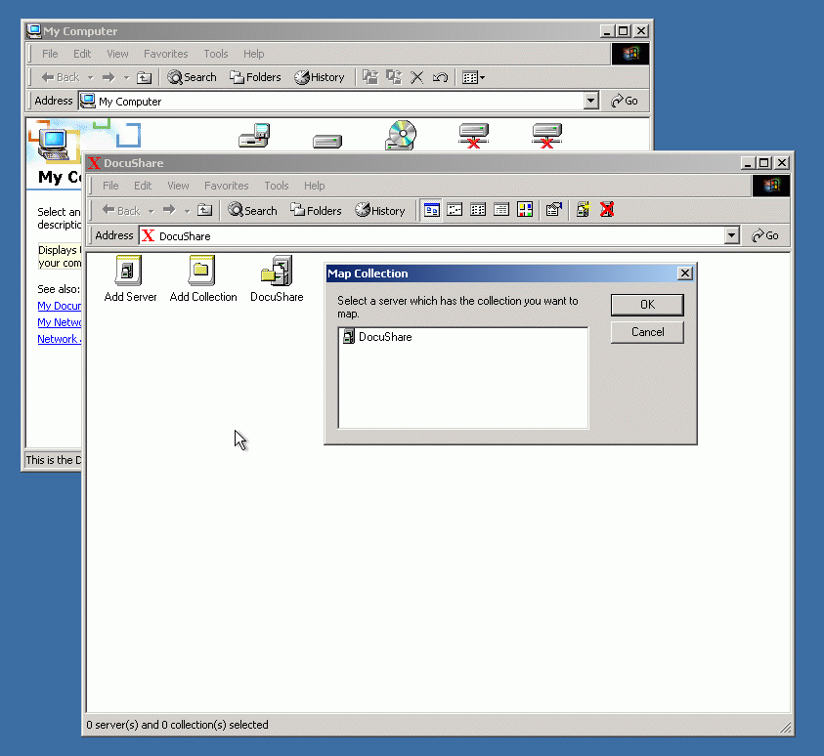
Now you are ready to start adding collections. It is not absolutely necessary to do this, because you will have access to all of DocuShare (at least the areas you are authorized to use), but it speeds things up to be able to go directly to a DocuShare collection (folder). Determine the collections that you use most, configure them in the DocuShare Windows Client. Double-click on the DocuShare icon in "My Computer", then double-click on "Add Collection".

Figure 10: Selecting the server which contains the collection that you want to add.

Highlight the server that contains the collection that you want to add (at Jlab we only have one at this time), and click "OK".

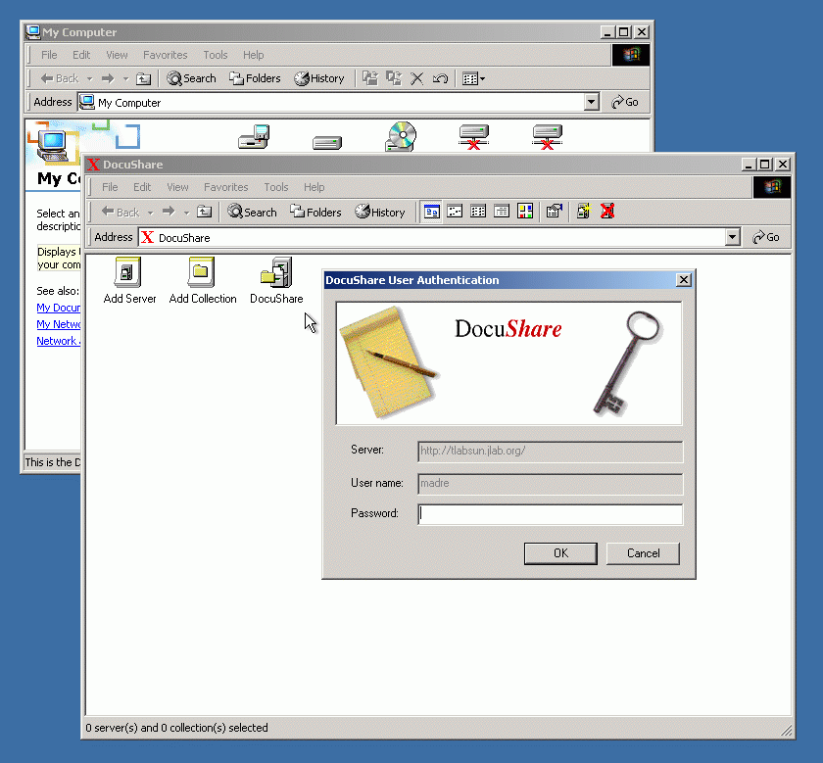
If you have not already signed in, the DocuShare login screen will appear.

Figure 11: Sign-in screen to connect and add a DocuShare collection to the Windows Client
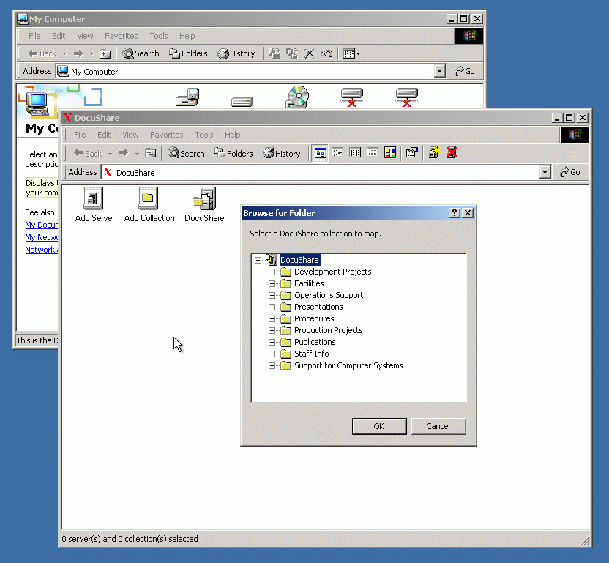
Sign in using your DocuShare username and password. The root collections menu will appear.

Figure 12: DocuShare root collections menu
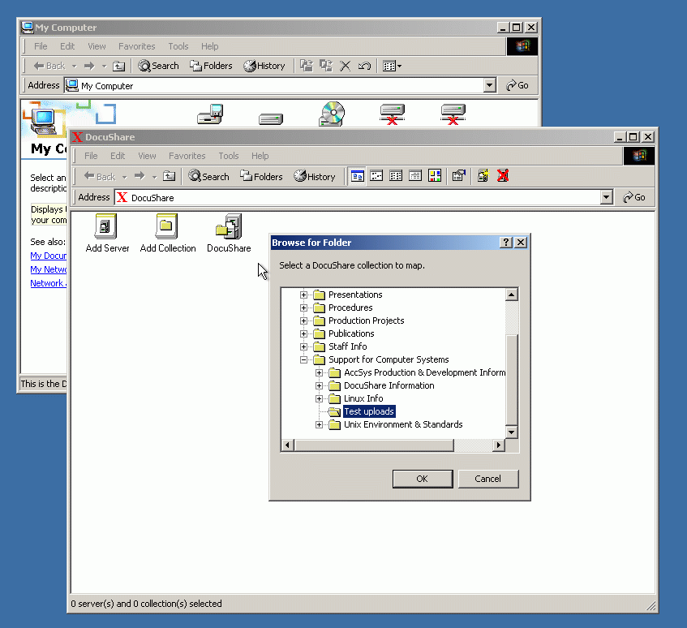
Navigate to the collection that you want to add by clicking on the "+" signs or by double-clicking on the folders.

Figure 13: Navigating and selecting the DocuShare collections

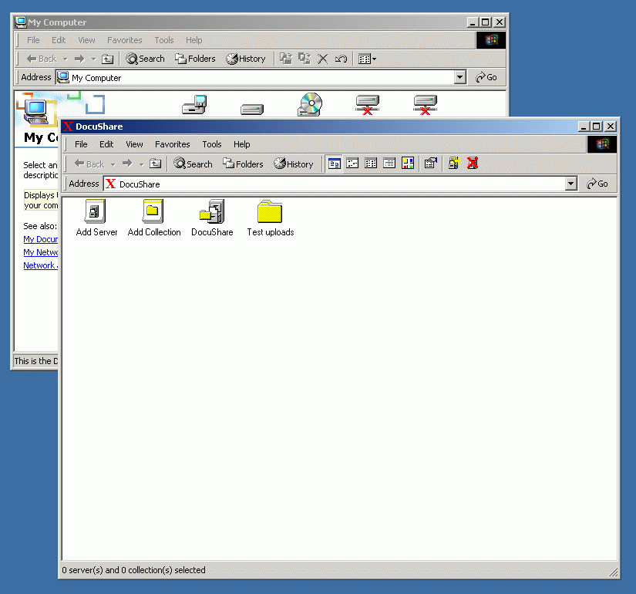
Highlight the collection that you want to add, and click "OK". The collection that you have selected should appear in the DocuShare client window.

Figure 14: Successful addition of a DocuShare collection

Adding documents with Microsoft Word:
There are two ways of saving documents to DocuShare from Microsoft Word. One is to have Word ask you each time you save a document if you want it to go to DocuShare. We will go through the instructions for that method first.
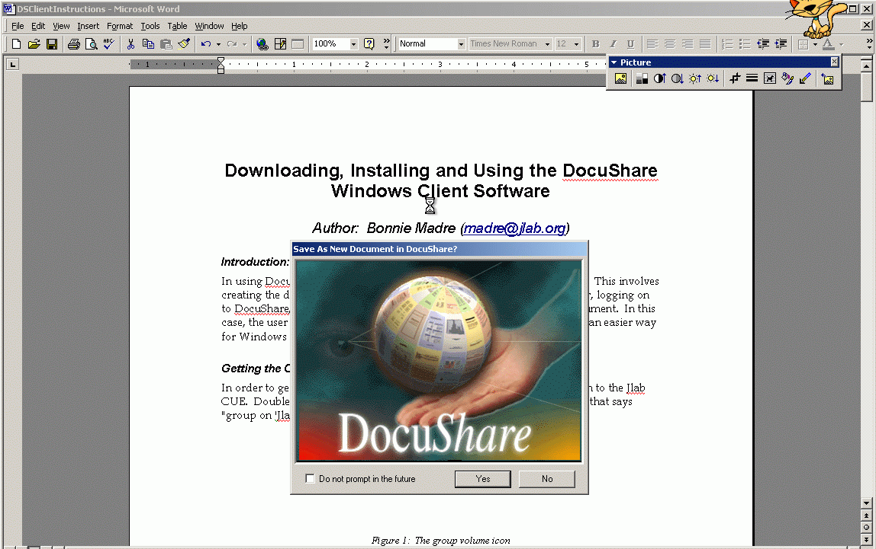
Create your document, then, click "File", and "Save as", just as you normally would. The first time you do this after you have installed the Client, you should see the following (Excuse the little cat up in the right-hand corner...):

Figure 15: Automatic DocuShare dialog when saving a word document
If you look closely, you can see that there is a check box where you can decide if you want the dialog to come up each time you save a document ("Do not prompt in the future"). If you check that box, Word will no longer ask you, but you can still save it to DocuShare. More on that later.
If you are saving to DocuShare, click "Yes" and the dialog box in Figure 16 should appear.

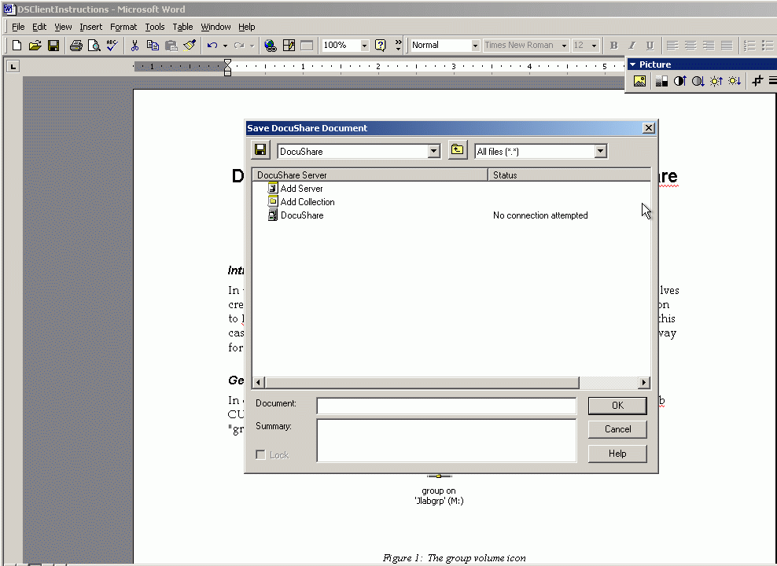
If you have turned off the query seen above, when you save a document for the first time, the DocuShare Open/Save dialog (Figure 16) will appear automatically. If you are, in fact, saving to DocuShare, then follow the instructions from here. If not, click on the little floppy disk icon in the upper left corner of the dialog box, and the Microsoft native Open/Save dialog will appear. From here you can save as you normally would, to network or local directories.

Figure 16: The DocuShare/Word save dialog.

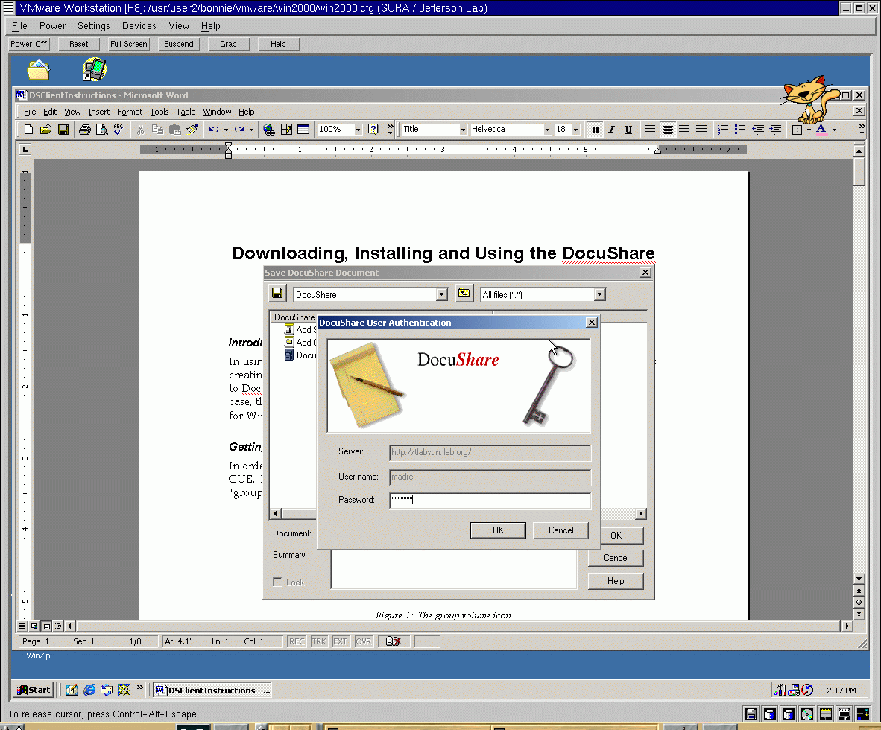
Double-click on the collection to which you want to add the document, if you have already set it up. Otherwise, double-click on "DocuShare" (the server), and navigate to the desired collection. If you have not already signed on to DocuShare, the sign-on screen will appear (see Figure 17).

Figure 17: The DocuShare sign-on screen

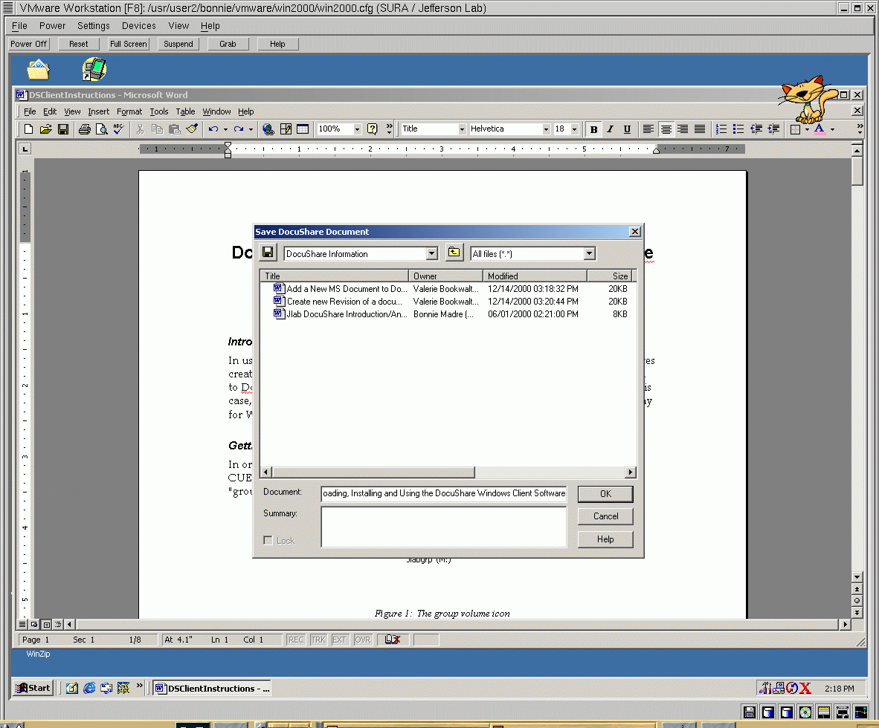
Enter your DocuShare password, and click "OK". If you have already signed on, Word will just go to the collection you request, and you can enter your document name and summary information and click "OK" (Figure 18).

Figure 18: Save document to a collection

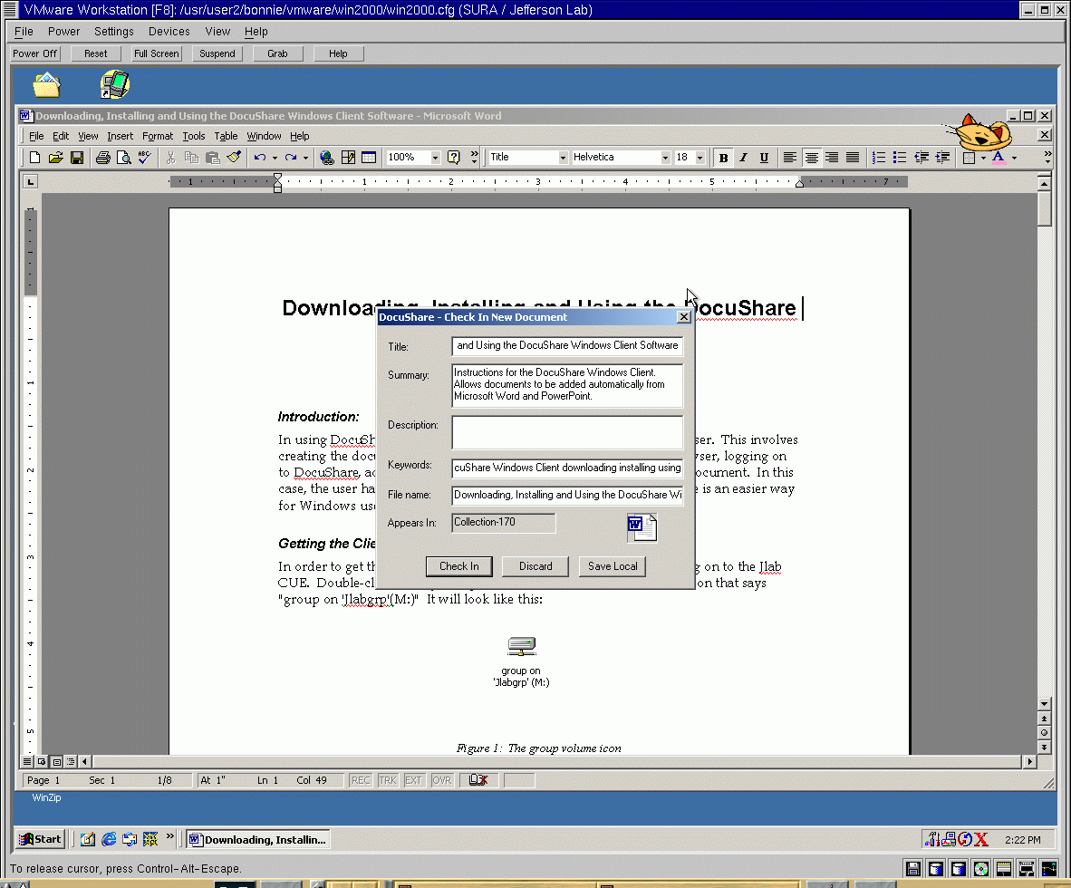
The dialogs will disappear, until you close the document. When you do that, a more "standard" DocuShare dialog will appear, with your title and summary already entered. (Figure 19)

Figure 19: Entering the DocuShare information

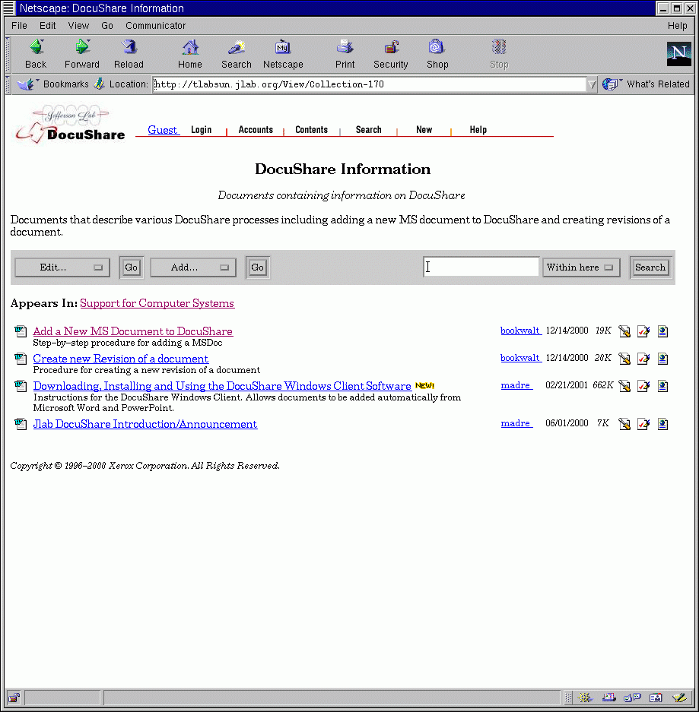
Enter the description and keywords, if desired, and click "OK". The document will be loaded into DocuShare - you will get a progress dialog, and a message if the load was successful. As you can see in Figure 20, the document has been added to the collection.

Figure 20 - The document has been successfully added to DocuShare

The procedure for adding documents is similar with Microsoft PowerPoint

