Traveler Title | C75 Helium Vessel Assembly Traveler
Traveler Abstract | This traveler outlines the necessary steps and checkpoints to install and assemble the cavity pair into the helium vessel assembly. Work within this Traveler is to be performed by trained and authorized Assembly Technicians ONLY. All Cryomodule materials shall be kept inside the established RADCON barrier until they have been surveyed and released.  ** Radiation surveys shall be performed and information recorded at traveler hold points.**  ** Radiological controls are a critical component of the cryomodule rework disassembly and assembly process. Dose rate, as well as contamination surveys (where indium gaskets or seals are present) shall be performed and analyzed, with information communicated to all involved personnel. Results will be recorded at traveler hold points. RW-II training will be required where contamination is identified**
Traveler ID | NB3SN-CMACU-HELV-ASSY
Traveler Revision | R2
Traveler Author | John Fischer
Traveler Date | 11-Nov-24
NCR Informative Emails | areilly,weaksmc,fischer
NCR Dispositioners | fischer,cheng
D3 Emails | areilly,fischer,weakmc,cheng
Approval Names | John Fischer | Jeff Campbell | John Fischer | Matt Weaks
Approval Signatures
Approval Dates
Approval Title | Author | Technical Reviewer | Work Center Lead | Project Representative

References | List and Hyperlink all documents related to this traveler. This includes, but is not limited to: safety (THAs, SOPs, etc), drawings, procedures, and facility related documents.  All materials linked below and throughout this traveler are for reference only and should be verified for latest version at time of use.
11141S0029 Leak Check Procedure | 11126-0015 HV Instrumentation FT Plate Dwg | Magnetic Hygiene Record Spreadsheet | CP-C75-CU-RBLD-RTFT- Rotary Feedthru Rework Procedure | 11126-0001 Helium Vessel Assembly Dwg
 |  | 11126-0012 Helium Vessel Rotary Feedthru Dwg | 11126-0045 Helium Vessel Instrumentation Wiring Dwg
 | C75-01Assembly Activities Logbook | JL0044108 Cavity Hanger Spacer Dwg | JL0044109 Cavity Hanger Support Spacer Dwg | JL0044518 Cavity Hanger Dwg
JL0043573-Cavity Hanger Bottom | JL0044517 Center Cavity Hanger Dwg | CRM0882010-0001 Drive Shaft Assembly Dwg

Revision Note
R1 | Initial release of this Traveler.
R2 | Updated from ER5C-CMACU-HELV-ASSY-R2

Step No. | Instructions | Data Input
1 | Record the Cryounit serial number which is being built.  ***Follow the Magnetic Hygiene protocols when performing the steps in this traveler. Record the date, starting and finishing time of the major assembly steps identified in the spreadsheet "C75-01 assembly activities logbook" while going through the helium vessel assembly steps. Enter the data to the worksheet corresponding to the cryounit being worked on. This sheet will be uploaded at the end of this Traveler.  C75-01Assembly Activities Logbook *** | [[CUSN]] <<CUSN>>  [[CUCMATech]] <<SRFCMP>>  [[CUDate]] <<TIMESTAMP>>  [[CUComment]] <<COMMENT>>
2 | Verify the Tuner assembly traveler is complete and signed off. | [[VerTunerAssyCMATech]] <<SRF>>  [[VerTunerAssyDate]] <<TIMESTAMP>>  [[VerTunerAssyComment]] <<COMMENT>>
3 | Prepare the helium vessel for use.  - Clean the Helium Vessel and Heads  - Measure the cavity end dish to cavity end dish OAL to verify whether or not backing rings need to be added to the helium vessel heads.  - Install the HV rounding fixtures, then test fit and match mark the HV heads into the HV. (It may be necessary to bend the HV ends to achieve a good fit and minimize the amount of weld required.)  - Inspect the Indium seal surfaces and the mini conflats in the HV instrumentation plate. Repair and note any defects in the comment section.  - Weld in the wire retaining clips  - Add the liquid level wire washers as shown in pic below  - Extend the hanger block as shown it the isometric view below. JL0044108 Cavity Hanger Spacer Dwg, JL0044109 Cavity Hanger Support Spacer Dwg  - Weld in the reworked rotary feed thrus, making sure they are perpendicular to the HV instrumentation plate. HV Rotary Feedthru Dwg | [[HELVPrepCMATech]] <<SRF>>  [[HELVPrepDate]] <<TIMESTAMP>>  [[HELVCleaned]] <<YESNO>>  [[HELVBackRing]] <<YESNO>>  [[HELVTestFit]] <<YESNO>>  [[HELVSealSurfaces]] <<YESNO>>  [[HELVWireClipsIn]] <<YESNO>>  [[HELVWashers]] <<YESNO>>  [[HELVHangerBlocksExtended]] <<YESNO>>  [[HELVRotaryFeedThrus]] <<YESNO>>  [[HELVComment]] <<COMMENT>>
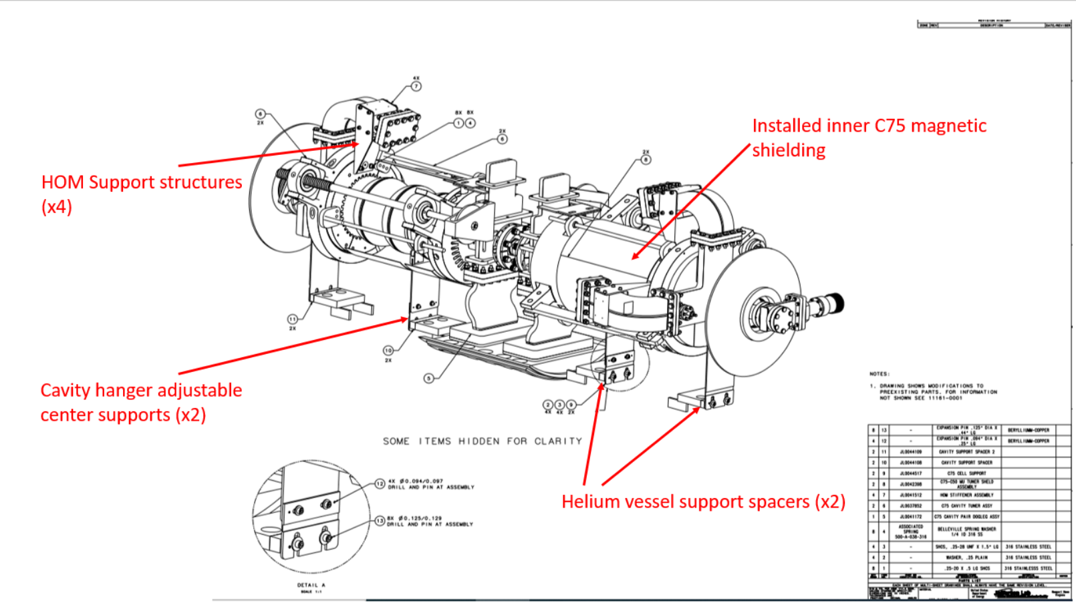
4 | Attach the .06" d. indium seals to the helium vessel feedthru plate using the indium former and associated clamping hardware. Donning gloves, the indium and sealing surface shall be wiped with a lint free cloth soaked with Acetone, then Isopropyl Alcohol to clean. | [[IndiumCMATech]] <<SRF>>  [[IndiumDate]] <<TIMESTAMP>>  [[IndiumComment]] <<COMMENT>>
5 | Secure the HV into the shell holding fixture. Be sure the instrumentation flange is up and level. Lock the rotation with a twist clamp. See below pic. | [[SecureHVCMATech]] <<SRF>>  [[SecureHVDate]] <<TIMESTAMP>>  [[SecureHVComment]] <<COMMENT>>

Step No | Instructions | Data Input
6 | Install the Thompson block insertion fixtures on both ends of  scissor table, then insert the Thompson rail extension bars into  the pillow blocks and level the assembly. | [[ThompsonCMATech]] <<SRF>>  [[ThompsonDate]] <<TIMESTAMP>>  [[ThompsonComment]] <<COMMENT>>
7 | Align the completed cavity assembly and adjust the scissors  table height, then engage 4' Thompson rail extension shafts  into the bottom rail of the Cavity Assembly tooling. Thread the lower rails together. | [[AlignCavCMATech]] <<SRF>>  [[AlignCavDate]] <<TIMESTAMP>>  [[AlignCavComment]] <<COMMENT>>
8 | Slowly transfer the cavity pair into the helium vessel.  **CAUTION**  Do Not Force. Find the Obstruction and Move It! | [[TsfrPairCMATech]] <<SRF>>  [[TsfrPairDate]] <<TIMESTAMP>>  [[TsfrPairComment]] <<COMMENT>>
9 | Once the cavity is in position, insert the locator pins through  the corner holes in the helium vessel feedthrough flange, then  thread into the cavity pair Dogleg flange holes. | [[LocatorPinCMATech]] <<SRF>>  [[LocatorPinDate]] <<TIMESTAMP>>  [[LocatorPinComment]] <<COMMENT>>
10 | Raise the cavity to the feedthru flange, install the hardware.  Procedure:  Starting with an 1/8" shim, slowly raise the cavity pair, check  the gap (between the HV feedthrough plate and Dogleg face)  frequently. Repaeat the process with a .06" shim, all 8 corners  should be equal. Mount dial indicators on both ends of the  fixture, zero out. Slowly raise the cavity pair the last .055"  evenly. The indium seal with be about  .005" thick once fully torqued. | [[FTHrdwrCMATech]] <<SRF>>  [[FTHrdwrDate]] <<TIMESTAMP>>  [[FTHrdwrComment]] <<COMMENT>>
11 | Torque the bolts in the shown sequence to 40,60,and finally, 70 in/lbs. (+/- 5 in/lbs)  REPEAT THIS PROCESS A MINIMUM OF 3 TIMES!!!! | [[TorqueCMATech]] <<SRF>>  [[TorqueDate]] <<TIMESTAMP>>  [[TorqueComment]] <<COMMENT>>

Step No. | Instructions | Data Input
12 | Once fully torqued, Leak check the FPC to HV flange indium seals. Record  Findings. 11141S0029 Leak Check Procedure | [[HVLkChkCMATech]] <<SRF>>  [[HVLkChkDate]] <<TIMESTAMP>>  [[HVLkChkComment]] <<COMMENT>>  [[HVFlangeLeakCheck]] <<FILEUPLOAD>>
13 | Install the 4 Ti cavity hangers, shim if necessary to achieve plumb. Drill two 1/8" holes and install  3/32" roll pins to secure. Torque the hanger 1/4"-20 SHCS to 90 in/lbs.  JL0044518 Cavity Hanger Dwg, JL0043573-Cavity Hanger Bottom, JL0044517 Center Cavity Hanger Dwg | [[CavHangerCMATech]] <<SRF>>  [[CavHangerDate]] <<TIMESTAMP>>  [[CavHangerComment]] <<COMMENT>>
14 | Remove the cavity pair installation fixture. Be careful not to disturb the cavity pair alignment.  Procedure:  - All Cavity hangers are installed and pinned.  - Remove the cavity fixture caps from all three cavity supports.  - Lower the cavity assembly fixture evenly.  - Remove all the thumb screws, aluminum cavity support uprights, and rail end plate.  - Slowly slide the cavity fixture out of the helium vessel, then reassemble. | [[RmvFixCMATech]] <<SRF>>  [[RmvFixDate]] <<TIMESTAMP>>  [[RmvFixComment]] <<COMMENT>>
15 | Rotate the helium vessel to 90˚, plumb the feedthru flange, then lock down. | [[RotateHVCMATech]] <<SRF>>  [[RotateHVDAte]] <<TIMESTAMP>>
16 | Assemble the tuner drive shaft components as shown in drawing 11161E0001. Align  and install the 3/32" roll pins and tighten the Helical coupling SHCS"s. (x2)  CRM0882010-0001 Drive Shaft Assembly Dwg | [[DriveShaftCMATech]] <<SRF>>  [[DriveShaftDate]] <<TIMESTAMP>>  [[DriveShaftComment]] <<COMMENT>>
17 | Install wiring and instrumentation in accordance with drawings  11126D0015 and 11126D0018, then test wiring and instrumentation circuits. Record the  manufacturer and S/N for the new qualified 8 pin cryogenic feedthrus.  11126-0045 Helium Vessel Instrumentation Wiring Dwg, 11126-0015 HV Instrumentation FT Plate Dwg | [[WiringElectricalTech]] <<SRF>>  [[WiringDate]] <<TIMESTAMP>>  [[WiringComment]] <<COMMENT>>  [[WiringElectricalDate]] <<FILEUPLOAD>>  [[FTManufacturer]] <<FILEUPLOAD>>  [[FT08PSN1]] <<FT08PSN>>  [[FT08PSN2]] <<FT08PSN>>  [[FT08PSN3]] <<FT08PSN>>  [[FT08PSN4]] <<FT08PSN>>
18 | Install the co-axial cables and supports. Perform a TDR check on all connections.  Record findings. | [[CoAxElectricalTech]] <<SRF>>  [[CoAxDate]] <<TIMESTAMP>>  [[CoAxComment]] <<COMMENT>>  [[TDRLeft]] <<FILEUPLOAD>>  [[TDRRight]] <<FILEUPLOAD>>
19 | Install the Heater on the 2 studs located at bottom of He vessel using (4) 1/4-28 nuts,  One on top and one on bottom of the heater card on each stud. | [[InstHeaterCMATech]] <<SRF>>  [[InstHeaterDate]] <<TIMESTAMP>>  [[InstHeaterComment]] <<COMMENT>>
20 | At this time, if the helium vessel gets a liquid level probe, install it on the right end and  run wires to left end. The brackets should be facing inboard and the probe should be  centered vertically in the helium vessel. | [[InstLLCMATech]] <<SRF>>  [[InstLLDate]] <<TIMESTAMP>>  [[InstLLComment]] <<COMMENT>>
21 | Tighten the instrumentation feed thru's on the HV saddle to 30 in/lb. | [[TightenIFTCMATech]] <<SRF>>  [[TightenIFTDate]] <<TIMESTAMP>>  [[TightenIFTComment]] <<COMMENT>>
22 | Hold-point for supervisor's inspection, before the helium vessel is closed up. | [[HP1CMASupervisor]] <<SRF>>  [[HP1Date]] <<TIMESTAMP>>  [[HP1Comment]] <<COMMENT>>23  [[SuperHoldPoint1]] {{fischer,jjcamp}} <<HOLDPOINT>>

Step No. | Instructions | Data Input
23 | Position the Helium vessel heads on the shell as shown on the assembly Drawing  11126E0001.Make sure that the 4 inch diameter outlet tube is oriented at the top of  the helium vessel using the head orientation fixture. Weld the heads to shell (2  places). 11126-0001 Helium Vessel Assembly Dwg  **CAUTION**  Minimize heat transfer to bellows during welding; finish welding dish to head. | [[Welder]] <<SRF>>  [[HVHDCMATech]] <<SRF>>  [[HVHDDate]] <<TIMESTAMP>>  [[HVHDComment]] <<COMMENT>>
24 | Leak check the helium vessel in accordance with Specification 11141S0029. Bag  both heads, both dishes, both bellows, saddle, and all 4 helium ports. Record  findings.11141S0029 Leak Check Procedure | [[FullHVLkChkCMATech]] <<SRF>>  [[FullHVLkChkDate]] <<TIMESTAMP>>  [[FullHVLkChkComment]] <<COMMENT>>  [[FullHVLeakCheck]] <<FILEUPLOAD>>
25 | Review, then upload the spreadsheet "C75-01 assembly activities logbook". | [[ReviewCMATech]] <<SRF>>  [[ReviewDate]] <<TIMESTAMP>>  [[ReviewComment]] <<COMMENT>>
26 | Hold-point for supervisor's inspection.  Helium vessel assembly is complete, move onto the next assembly phase. | [[HP2CMASupervisor]] <<SRF>>  [[HP2Date]] <<TIMESTAMP>>  [[HP2Comment]] <<COMMENT>>  [[SuperHoldPoint2]] {{fischer,jjcamp}} <<HOLDPOINT>>

