|  |  |  |  |
| --- | --- | --- | --- |
| **C75 Ball Screw Drive Assembly Rebuild Procedure** | | | |
| **Document Number:** | ER5C-WCA-CU-ACTON | **Effective Date:** | DD Mmm YYYY |
| **Revision Number:** | 1 | **Periodic Review Date:** | N/A |
| **Document Owner:** | John Fischer | **Department Owner:** | SRF Operations |

# Purpose and Scope

The purpose of this document is to outline the necessary steps to be taken when refurbishing the CEBAF style cold tuner drive assembly. The article has been removed from a Cryomodule that has been selected for refurbishment. It will be disassembled, modified to the latest revision (if required), cleaned, reassembled, and the operation verified. It will then be re-installed into a Cryomodule.

# Definitions and Diagrams

The following terms have specific meanings within this procedure.

|  |  |
| --- | --- |
| **Term** | **Definition** |
| Ball Screw | <Definition> |
| Ball Nut | <Definition> |
| Drive Shaft |  |
| Gimbal Housing |  |
| Bearing Housing |  |
| Gear Box |  |
| Shaft Fixed End |  |

# Roles and Responsibilities

The following roles have responsibilities described in this document.

|  |  |
| --- | --- |
| **Role** | **Responsibility** |
| <Job Title> | <Very short summary of activities this job title performs in this procedure.> |
|  |  |

# Safety

The following safety items …

# Procedure

Preparing the components:

* + Lay the drive assembly on a table or large work surface.
  + Disassemble the drive screw assembly by removing the 1/8” roll pin holding the 100:1 reduction gear box assembly from the ball drive shaft. (Do not bend the assembly when removing the pin)
  + Separate the two pieces and then remove the spanner nut and lock tab washer.
  + Slide the bearing housing assembly off of the tail shaft.
  + The other end of the ball screw has a G-10 washer on it. (**** Do not remove the G-10 washer; ball drive assembly has 80 – 86 small ball bearings in it that will fall out. ****)
  + Take the bearing housing to the vise and tap out both old bearings without scarring the housing walls.
  + Then proceed to remove the 2 bronze roll pins which are holding the brass pivot pins and shims in place. The bearing housing should then separate from the aluminum gimbal unit.
  + The bearing housing now needs to be set up in a lathe to be bored to a diameter of 1.851” – 1.852”. This dimension will give the slip fit clearance required when the bearings are re-installed. (Earlier designs froze during cold testing due to the interference fit between the bearing and housing.) Ref Drawing 11161-0012
  + Tail shaft diameter should be turned to a diameter of .785”-.786”, which will provide a slip fit for the inner bearing race. (Some shafts are made to an interference fit so the bearings would need to be pressed on. That is no longer the case.) Ref Drawing 11161-0022
  + The tail shaft assembly also needs the interfacing hole to the gear box moved outboard (towards the gear box) .867” to correct the cavity cell offset introduced by new cell design.

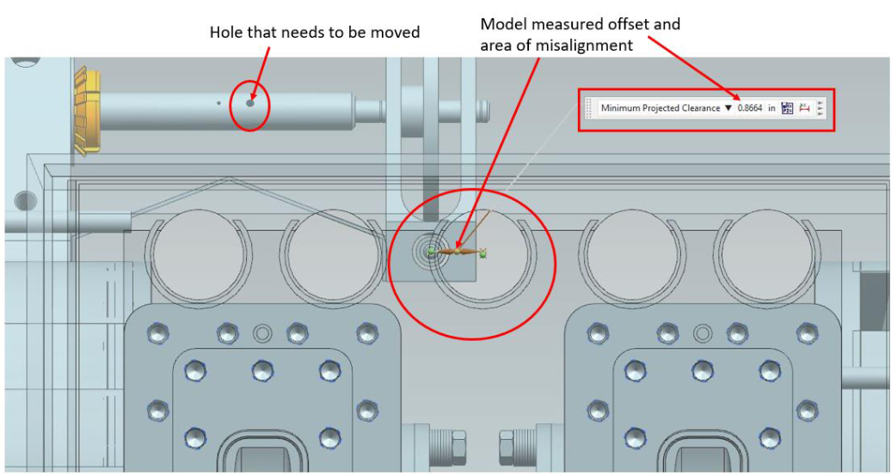

* + The aluminum gimbal unit bearings (2 places per unit) need to be hand reamed with the 1 1/8 “ t–handled reamer provided.
  + On the ball screw nut, make sure the stainless steel 1/8” pin is in place, this prevents the ball nut from spinning during operation.
  + The lock nut and shaft threads need to be cleaned and sprayed with moly-lube to prevent galling.
  + The 100:1 brass gear box assembly needs to be rotated in both directions to make sure there is no teeth damage that causes binding or dragging while easily turning the ¼" shaft. If the drive does not function properly, file the problem teeth or adjust the laminated shims to fix the problem.

Reassembly is as follows: (Reference drawing 1116-E-0001)

* + Assemble the bearing housing and gimbal assembly just the opposite of how it was separated, be sure to install the laminated shims between the 2 housings. Item 54 on drawing 11161-E-0001
  + Install the brass pivot pins and tap in new roll pins making sure that the 2 pieces swivel freely.
  + Slide the bearing housing assembly with new bearings on to the tail shaft and install the lock washer and nut. Tighten the nut while spinning the assembly until the assembly slows because of resistance. Then loosen the nut to the next available lock tab. Bend the lock tab to prevent the nut from moving.
  + Reinstall the gear box and install a new 1/8” roll pin. Verify the OAL matches the C75 footprint as shown above. The Drive screw is now ready for re-installation.

**(Note: All the bearings being used are new and dicronited. They have been cleaned by spinning the bearing while spraying with electra-wash solvent before being installed. This removes all the tiny particles that have been left behind by the dicroniting process.)**

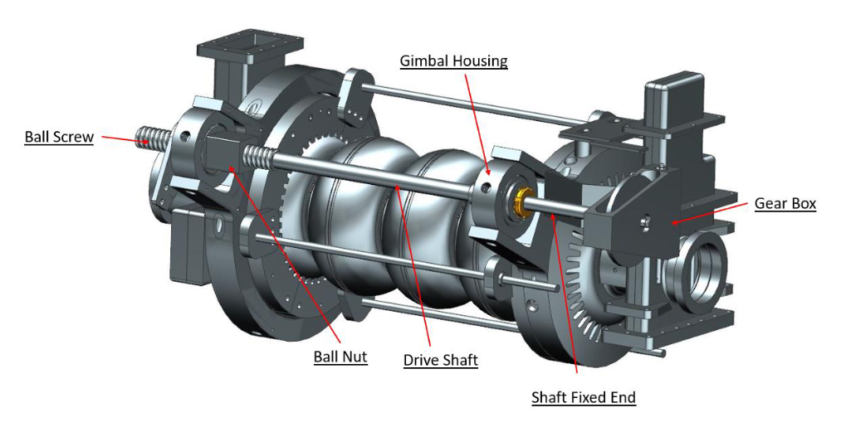

# References

|  |  |
| --- | --- |
| **Document No.** | **Title** |
| SRF-06-PR-001 | Records Management Procedure |
| SRF-07-PR-001 | Document Management Procedure |
| 11161-0001 | [LINAC CRYOUNIT Final assembly tuner assembly](https://misportal.jlab.org/jlabDocs/documents/versions/184753/download) |
| JL0041503 | [SRF C75 CRYOOMODULE TUNER C75 HELIUM VESSEL ASSEMBLY](https://misportal.jlab.org/jlabDocs/documents/versions/105713/download) |
| 11161-0003 | [Tuner assembly ball screw shaft](https://misportal.jlab.org/jlabDocs/documents/versions/6941/download) |
| 11161-0030 | [Tuner assembly ball nut](https://misportal.jlab.org/jlabDocs/documents/versions/6966/download) |
| 11161-0021 | [Cavity tuner assembly rod](https://misportal.jlab.org/jlabDocs/documents/versions/6957/download) |
| 11161-0002 | [Tuner assembly - gearbox assembly](https://misportal.jlab.org/jlabDocs/documents/versions/6940/download) |
| 11161-0009 | [Tuner assembly gimbal](https://misportal.jlab.org/jlabDocs/documents/versions/6946/download) |
| 11161-0022 | [Tuner assembly shaft fixed end](https://misportal.jlab.org/jlabDocs/documents/versions/6958/download) |
| 11161-0012 | [Tuner assembly](https://misportal.jlab.org/jlabDocs/documents/versions/6949/download) |

# Release and Revision History

|  |  |  |
| --- | --- | --- |
| **Rev #** | **Major Changes** | **Revision Date:** |
| 1 | Initial version (Utilizing SRF-07-FM-005 SRF OPS Procedure Template, R1). Converted from CP-C75-CU-RWRK-TUNC-R1 | 07 Apr 2025 |

# Approvals

|  |  |
| --- | --- |
| **Approved by:** | **Name:** |
| Document Owner | <First Last Name> |
| Document Reviewer 1  JLab SME or SRFOPS WCL | <First Last Name> |
| Document Approver 2  SRFOPS WCL or GL | <First Last Name> |

For Project Procedures: Refer to the Project Execution Procedure SRF-11-PR-001

*Document Processor Instructions:*

* *Put valid dates everywhere DD is found and verify they are accurate*
* *Attach DocuShare Approval Picture here*