|  |  |  |  |
| --- | --- | --- | --- |
| **CMTF Cryomodule Acceptance Test Procedure** | | | |
| **Document Number:** | SRF-MSPR-CMTF-CM-ACC | **Effective Date:** | DD Mmm YYYY |
| **Revision Number:** | 1 | **Periodic Review Date:** | DD Mmm YYYY |
| **Document Owner:** | Michael McCaughan | **Department Owner:** | SRF Operations |

# Purpose and Scope

This document will outline the testing procedure for the acceptance testing of CEBAF Cryomodules in the Cryomodule Testing Facility (CMTF).

This procedure assumes the following prerequisite procedures for testing have been completed:

* The Personnel Safety System (PSS) has been configured to send RF to the CMTF.
* RF Cable Calibrations: Calibrations have been completed, and the data updated in the Labview .vi
* Interlock tests: Interlock tests have been completed and all the interlocks verified. (Appendix I)

The testing regimen in the CMTF may differ slightly from module to module, but generally there is a battery of tests that occur for every module:

Low / Control Power Measurements:

* Individual cavity tuner performance tests: Measurement of **passbands** (See Appendix II) and **frequency range** by running tuner to its upper (limit switch A) and lower (limit switch B) frequency limits as well as measuring **tuner hysteresis** in a +/- 200 kHz and +/- 2 kHz range around the resonant frequency. The frequency range and hysteresis tests may be executed with RF power, though passband measurements require a Network Analyzer and local amplifiers.
* **Heater functionality test**: Verify the heater measures the appropriate resistance and functions properly.

High Power Measurements:

* **Emax** to determine maximum gradient of each cavity, including a 1-hour run at that top gradient to ensure the cavity can operate stably there. As a matter of convenience this will be coupled with a measurement of field emission **[FE measurement]** (if any) vs. gradient.
* Measurement of Quality Factor (**Qo) versus gradient** for each cavity. As the cryogenic pressure will vary with the test, the **Pressure Sensitivity** (df/dP; or change in frequency per change in pressure) for each cavity is measured parasitically.
* '**Punch list**': Following the initial battery of measurements, the data will be analyzed by a cognizant expert (usually the Testing Coordinator) and they will determine if any of the measurements look like outliers where there may have been a transient condition or instrument malfunction. If necessary, specific data may be re-measured based on their recommendations.

Notes:

* VTA testing data may provide helpful guidance in interpreting CMTF data and should be requested from the Testing Coordinator before beginning high power testing.
* The group srs-ee account password will be required by all individuals who are testing to access computers running Labview. Personal Accelerator (ACE) network Linux accounts are required.
* If while testing there are any issues or you have any questions, please contact the Testing Coordinator or SRF Beam Support Manager.

# Definitions and Diagrams

The following terms have specific meanings within this procedure.

|  |  |
| --- | --- |
| **Term** | **Definition** |
| <Term 1> | <Definition> |
| <Term 2> | <Definition> |
|  |  |

# Roles and Responsibilities

The following roles have responsibilities described in this document.

|  |  |
| --- | --- |
| **Role** | **Responsibility** |
| SRF Beam Support Manager | Ownership of process / Escalation & decisions on problems. |
| SRF Test & Measurement Group Leader | Ownership of repair escalation process for module under test. |
| Testing Coordinator | Oversee process in lieu of SRF Beam Support Manager |
| Cryo operator on-duty | Asst. conductor of Qo measurement testing. |
| RF Operator on-duty | Conductor of testing. |

# Procedure

## Low / Control Power Testing: Tuner Testing

To perform tuner testing, please follow the steps outlined below:

Setup:

1. Turn on the Network Analyzer in the CMTF control room. (Rack TL06B10)
2. Configure the Network Analyzer using the following settings:
   * Sweep setup > Power > RF Out: Off.
   * Measurement (Meas) > S2,1. Connect port 2 of the analyzer to the Probe port on the patch panel for the module of interest. Port 1 should be connected to the Reflected Power port for the same cavity.
   * Span > Span 20 MHz.
   * Center: Set the resonant frequency for the module. (ex.: 1497 MHz for CEBAF)
3. Turn on the RF power from the Network Analyzer (Sweep Setup > Power > RF Out: On).
   * Verify that you can observe a peak on the analyzer for each cell in the cavity. For instance, a C-100 style cavity will have 7 different pi modes / peaks (one for each of its 7 cells), while a C-75 cavity will have 5 modes.
   * Press the Marker button: Turn on Marker 1.
   * Use Marker Search and select 'Max' to locate the maximum peak.
   * Enable tracking by turning on 'Tracking: On'. This will provide a reference frequency to assess the overall frequency behavior of the cavity.

Tuner Testing:

Screens:

To access the EPICs/EDM screens to control the tuner, please follow the steps below:

* Login to the Linux machine with your Accelerator (ACE) user id and password (note that this is not the same as your Common User Environment [CUE] password)
* An instance of JMenu should pop up automatically, if not from your Applications tab select Accel Tools > JMenu. If you are not on a machine within the SRF fiefdom from ‘Standalone Menus’ option select JMenu (srfl00)
* From this new instance of JMenu, select EDM (SRF Main) to launch the SRF Main Menu. From here select 'CMTF Main' and this will provide another specialized menu (known as the 'CMTF Main Screen') which contains the relevant controls for testing.
  + - From the 'CMTF Main Screen' click on the blue button next to 'CMTF RF Combo' to launch the RF Combo Screen.

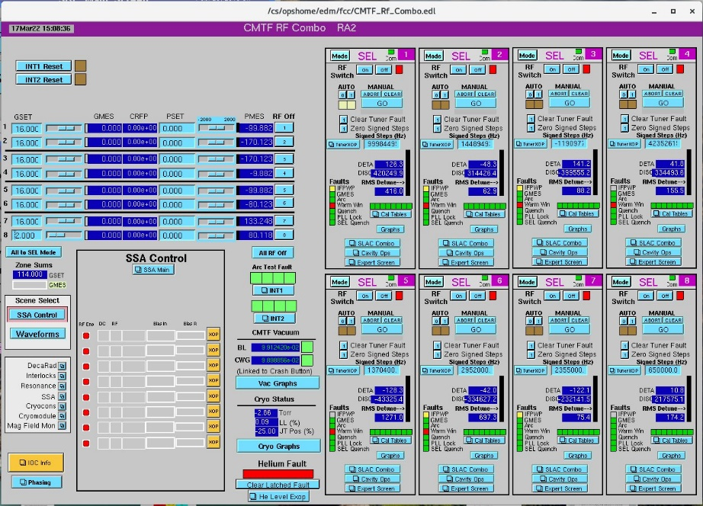

**(Fig. 1: The Combo Screen)**

* From the 'CMTF Main Screen' click on the blue button next to 'CMTF Resonance' to access the Resonance Control screen. Select either 'Res 1: Cavities 1 to 4' or 'Res 2: Cavities 5 to 8' based on which of the eight cavities is being tested.

**(Fig. 2: CMTF Resonance Control Screen)**

**Note: The stepper motor controls correspond to the cavities mentioned in the selection. For example: The 'Step 2' selection from Res1 corresponds to cavity 2, whereas from Res2 the 'Step 2' selection is for cavity 6. From the 'Resonance' drop-down menu select the stepper motor control for the cavity under test. From the launched screen the 'Abort' button will be the only one required if you need to halt tuner motion. This button will soon be transferred to the next screen referenced below.**

* From the Combo screen, select the 'TunerXOP' screen for the tuner of interest:

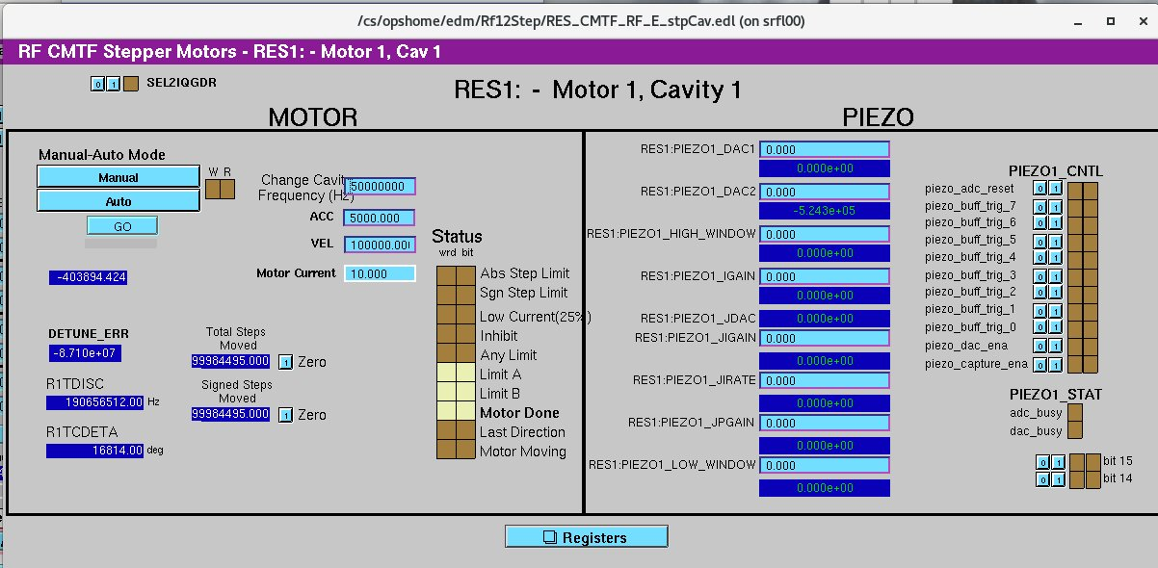

**(Fig. 3: Tuner XOP Screen)**

* On the tuner XOP screen, configure the controls as follows:
  + - Verify the tuner is in manual mode: Locate the 'W' and 'R' boxes at the top left of the screen next to the 'Manual'/'Auto' buttons. In MANUAL mode these boxes will be brown (as above in Fig. 3), while in AUTO mode the R box will be green. If the R box is green, press the 'Manual' button to switch to manual mode and verify both boxes are brown.
    - Set 'Change Cavity Frequency (Hz) (aka the Step size): Enter a value of -50,000 in the ‘Change Cavity Frequency (Hz) field. Please note for CMTF that this field is not well calibrated, and the number of steps does not actually correspond to the frequency change in Hz.
    - ACC (Tuner Acceleration): 10,000 [usteps/s2]
    - VEL (Tuner Velocity): 10,000 [usteps/s] [Note: Values above 30K unacceptable to motor]
    - Motor current: Enter a value of ‘1’ for CEBAF style modules. [Arbitrary Units; Max:10]
* Zero the two step counters (absolute steps moved, and signed steps moved) using the (!) button by each field. Start a LivePlot and add both the ‘Total Steps Moved’ and ‘Signed Steps moved’ signals. (You can use the middle mouse button to drag and drop signals from fields.)

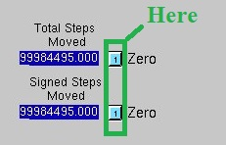

**(Fig. 4: Zeroing Step Counters)**

**Note: The sign of the 'Change Cavity Frequency' field should agree with the actual frequency direction the tuner travels. Positive steps should make the cavity rise in frequency, and vice-versa. If this is not the case, record the results and report them to the Testing Coordinator.**

* Does the cavity presently actuate its upper limit switch (Limit Switch A)?

1. Yes: Is 'Limit B' also illuminated as in the figure below?

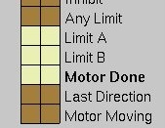

**(Fig. 5: Tuner Disconnected)**

* + - * Yes: The tuner controls aren't connected – contact the SRF Test & Measurement Group Leader for assistance connecting them if required.
      * No: Proceed to step 4: Measuring Pass Bands.

1. No: If ‘Limit A’ is not illuminated, step the cavity in the positive / up frequency direction by pressing the GO button until it does OR the motor does not appear to step positive any further a.k.a. The step count on your live plot stops rising. Do you now encounter the Upper limit switch (Limit A)?
   * + - Yes – Proceed to step 4: Measuring Pass Bands.
       - No- Proceed to step 3 – Troubleshooting Tuner Issues.

* Troubleshooting tuner issues: Change the sign of the Frequency Change (hereafter referred to as ‘step size’) to +50,000 and press GO. Did the cavity shift down in frequency? (You should observe the corresponding movement of the cavity motor on the LivePlot as well.)

1. Yes: The tuner moves appropriately, but the upper limit switch does not appear to be actuating. Record this in the logbook for later action and proceed to step 4.
2. No: Did the cavity shift up in frequency while taking steps in the positive direction?
   * + Yes: The tuner appears to be wired backwards for CEBAF conventions. Note the behavior until it can be fixed, and step positively until you reach the upper frequency limit switch. In subsequent steps switch the mentioned sign to correspond with how the tuner is working. Move onto step 4: Measuring Pass Bands.
     + No: The tuner does not appear to be functioning. Note this, turn the RF power off on the Network Analyzer, and move onto the next cavity restarting this procedure from the beginning on the next cavity.

* Measuring Pass Bands: Using Appendix VII – perform passband measurements of the cavity Pi modes. Once data collection and recording of the pass band frequencies and QLs at the upper limit switch (Limit Switch A) is complete, set the sign of the step size to negative [or positive if you found in step 3 the motor polarity was reversed] and proceed to step 5: Defeating the limit switch.
* Defeating the limit switch: When a limit switch is encountered the motion of the tuner motor is disabled. By convention, cavities are parked against their upper frequency limit switches before they are cooled down, so the thermodynamic frequency shift due to cavity cooling and thermal contraction can be observed and studied in a reproducible manner.

1. Once a tuner switch is actuated it will need to be defeated / over-ridden so the tuner controls are operational again and the cavity may be tuned down in frequency.

Attaching the tuner over-ride box:

* Go to the back of rack TL06B04 in the CMTF control room. There will be a patch panel (see below) of tuner cables.
  + Each cable is labeled with the tuner it controls:

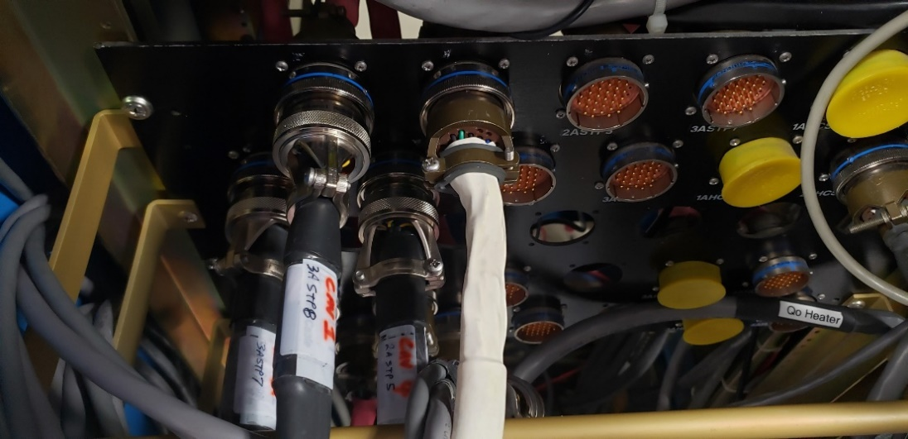

**(Fig. 6: CMTF Tuner Cable Patch Panel in the back of rack TL06B04)**

* + Disconnect the Mil-spec. connector for the cavity tuner of interest and connect it to the Tuner Limit Switch bypass box (aka ‘CMTF 9-pair Breakout Box’).

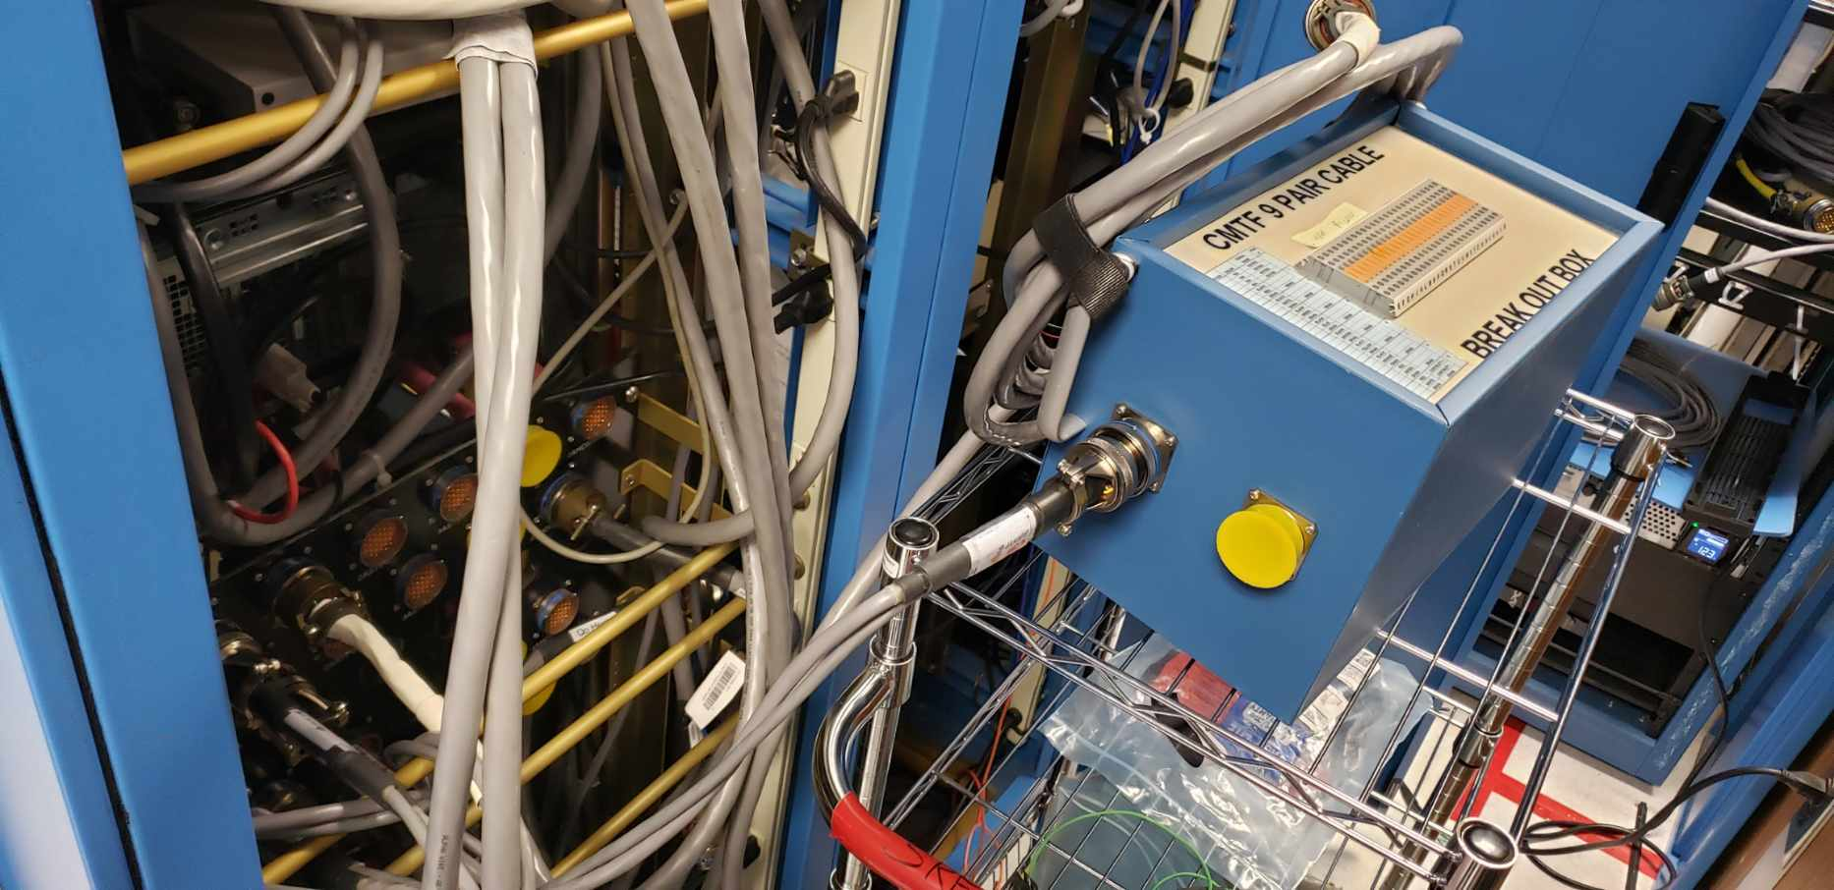

**(Fig. 7: Connecting Tuner Bypass Box)**

* + Connect the Mil-spec. connector exiting from the Tuner Limit Switch Bypass Box back to the spot on the patch panel you removed the tuner motor cable from.
  + Check the EPICs/EDM screen for the tuner Limit Switch A. It should no longer be actuated as in the figure below:

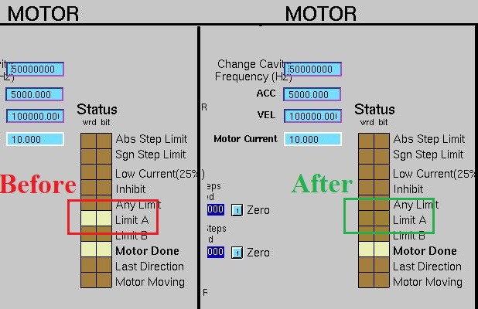

**(Fig. 8: Defeating the Limit Switch w/ the Break-out Box)**

* Is this the case?
  + Yes: Proceed to step 6.
  + No: Record the event and notify the SRF Test & Measurement Group Leader to investigate further. Move on to the next cavity requiring testing.
* Press the Go button, you should observe the cavity move down frequency.
  + You may adjust the step size, velocity, and acceleration as desired for this part of the procedure as desired. The motor does have limitations in place, but if you observe you observe the number of steps changing in your LivePlot you should be okay. (If not, reduce the number you used.)
  + When the frequency has gone down by 20 or 30 kHz stop and restore the original tuner cable configuration you changed in step 5 – you want to be able to see/actuate the lower frequency limit switch (Limit Switch B) when you encounter it.
* After restoring nominal tuner operations, continue driving the cavity down frequency until you encounter the lower frequency limit switch (Limit Switch B) or until the cavity stops moving.

Did the cavity actuate its lower limit switch (Limit Switch B)?

* + Yes: Proceed to step 8.
  + No: Reduce the step size to 50,000 and press GO. Did the cavity shift down in frequency (You should see the cavity motor step accordingly on the LivePlot as well)?
    - Yes: Repeat this step from the beginning. If this is your second time through proceed as the line below (NO) instructs.
    - No: The tuner moves appropriately, but the lower limit switch does not appear to be actuating. Record this and notify the SRF Test & Measurement Group Leader and proceed to step 8.
* Repeat step 4: Measuring passbands with Appendix VII, now that the lower limit switch (Limit Switch B) is actuated, or the cavity will no longer move down frequency.
* Change the sign of your step size and repeat step 5 and 6 to defeat the lower limit switch and to drive the cavity up frequency towards resonance.
* Step the cavity ~30 kHz up frequency and remove the limit switch bypass established in step 9 to restore the tuner to normal operation.
* Tune the cavity to its resonant frequency. Record a final set of QLs / pass bands here as is enumerated in Appendix 7 once again. After completion of the data recording, add the data to the traveler for this project and module test. Typically the traveler only requests test data on resonance. In addition, please email the frequency / pass band / QL data to the Testing coordinator, CMTF Manager, and leader of the SRF assembly work center for off-line analysis.

**Note: The 'Max' is usually the second Pi mode, and you know the approximate difference in frequency between the two from the above measurement. You should be able to use that to get close to the target frequency and then reduce the span on the network analyzer and select the Pi mode peak optimize final tuning.**

Low Power Testing – Tuner Passbands & Hysteresis Tests:

In this test the tuner will be driven through a +/- 200 kHz loop about the resonant frequency, followed by a smaller +/- 2 kHz loop to ascertain the difference in the number of steps required to reach resonance when approaching it from up-frequency vs. down-frequency; also known as the amount of 'slop' in the tuner.

* Open the Labview screen (LCLS Stepper-V2.vi) from the Library Manager to execute the Tuner Hysteresis Test:

**

+/- 200 kHz Hysteresis Loop:

* Establish ~5MV/m in the cavity of interest in SEL mode.
* Graphical user interface

  AI-generated content may be incorrect.Note the 'Target Frequency' field on the bottom right-hand side of the Stepper.vi:

**(Fig. 10: Target Frequency Field)**

* Set step size on the tuner screen to -50,000 if it is not already. Type in the frequency of cavity resonance +200 kHz in the Target Frequency (MHz) field outlined in red above and press the 'AutoTune' button. (For example: CEBAF = 1497 MHz, so type in 1497.2) This will cause the cavity to travel up to 1497.2 MHz in the desired motor step increment.
* After reaching the desired upper frequency limit, change the step size to +50,000, type in the target frequency of cavity resonance - 200kHz, and press the 'AutoTune' button. (For example: CEBAF = 1497 MHz, so type in 1496.8) This will cause the cavity to travel down to 1496.8 MHz in the desired motor step increment.
* Type in the frequency of cavity resonance +200kHz with a step size of -50,000 and press the 'AutoTune' button. (For example: CEBAF = 1497 MHz, so type in 1497.2) This will cause the cavity to travel up to 1497.2 MHz in the desired motor step increment.
* Type in the resonant frequency of the cavity with a step size of +50,000 and press the 'AutoTune' button. This will complete the test and return the cavity to resonance for the next portion of testing.

+/-2 kHz Hysteresis Loop:

* Repeat steps 3-6 above, but now with +/- 2 kHz targets (For example: CEBAF: 1497.002, 1496.998, 1497.002, and finally 1497 MHz) and step sizes of +/- 2,000.
* After executing the Hysteresis test, verify the cavity Pi mode is at the resonant frequency so the cavity is prepared for high power testing.

Heater Testing:

All heater testing will be conducted by the SRF Test & Measurement Group Leader to ensure functionality for the Cryo Operator and Qo measurement testing.

High Power Testing: Emax, 1-hour Run, and Field Emission Measurements

For these measurements the following are assumed:

* CMTF will need to be closed and swept per the PSS procedure.
  + Sweep Diagram:[misportal.jlab.org/docushare/dsweb/View/Collection-27494](https://misportal.jlab.org/docushare/dsweb/View/Collection-27494)
  + Procedure: <https://jlabdoc.jlab.org/docushare/dsweb/View/Collection-27531>
* Klystron power has been configured to the CMTF, rather than the window test stand.
* RF is free of errors, the CPS may be turned on, and High Voltage and RF may be reset and turned on from the Human-Machine Interface (HMI) in rack TL06B13 of the CMTF control room. (See Appendix 1: Troubleshooting Interlock Faults in event of any issue.)
* Boonton Power Meters have been turned on and the individual calibrated at the start of the current shift. (See Appendix 2 for calibration instructions if required.)
* Pulse parameters on the 40MS/s Universal Waveform Generator in the top of rack TL06B11 should be configured appropriately for the module frequency under test. (See Appendix 3 for common configurations.)

Emax, 1-hour run, and field emission measurements:

Preparation:

* + Verify all the above listed assumptions for high power measurements are correct.
  + LivePlot the following (see signal list at the end of the document):
  + Go to Plots > LivePlot > (right click on chart) > Load a configuration > CMTF (Configuration of Interest from Appendix V.)
    - HOM clamp temperature
    - Coupler temperatures
    - CARM channels rad301_p3, rad302_p1, rad302_p2, rad303_p1 (in OPS space) and Decarads DRADCMTASRF## (## = 01 – 10). (CMTFDRAD heading in DEV space)

Setting up the Cavity under Test:

* + Log in into the Linux computer in front of rack TL06B12 with your accelerator computing environment (ACE) password & configure the necessary screens.

1. Setting up screens:
   * + An instance of JMenu should pop up, if not from your Applications tab select Accel Tools > JMenu.
     + From your instance of JMenu, select EDM (SRF Main) to launch the SRF Main Menu. From here select 'CMTF Main' and this will provide another specialized menu (the 'CMTF Main Screen') with the relevant controls for testing.
     + From the 'CMTF Main Screen' select the blue button next to 'CMTF RF Combo' to launch the RF Combo Screen.
   * Log in into the Windows computers in TL06B10 & 11 with the srs-ee group id and password & configure the required screens. (Contact the Testing Coordinator if necessary for the login information.)
2. Setting up screens:

TL06B10:

* + - The DAQ .vi should be present and functional. It is essential this is the case, and this .vi serves data into the EPICs control system. If it is not running, you will not be able to access the Linux / EPICS / EDM controls. If it is not set up, contact the Testing Coordinator and they can advise you how to proceed.
    - You may configure the graphs on this computer to monitor parameters of interest. Generally, one is set up for cryogenic monitoring (He Pressure, Liquid Level, JT Position) & Vacuum (Beam line vacuum, Waveguide vacuum for the cavity under test) while the other graph is configured to monitor relevant CARM and Decarad heads to monitor radiation production.

TL07B11:

On the main windows machine if LabView is closed for any reason, launch the appropriately labeled LabView icon on the desktop for the type of module under test.

* + - From LabView library manager run Loader.vi Make sure to select a correct module type in a pop-up window.
    - From LabView library manager open HTB_LCLSIImain.vi with the latest date. Verify CM type and cavity number.
    - Make sure both EPICS and LV loggers are running (button with flash yellow if they are not. Click “Open (EPICS) logger” button and start that .vi with the arrow button at top left; you may close logger .vi screen once it has been initiated.

1. If RF is on in rack TL06B13, turn it off using the Human-Machine Interface (HMI):

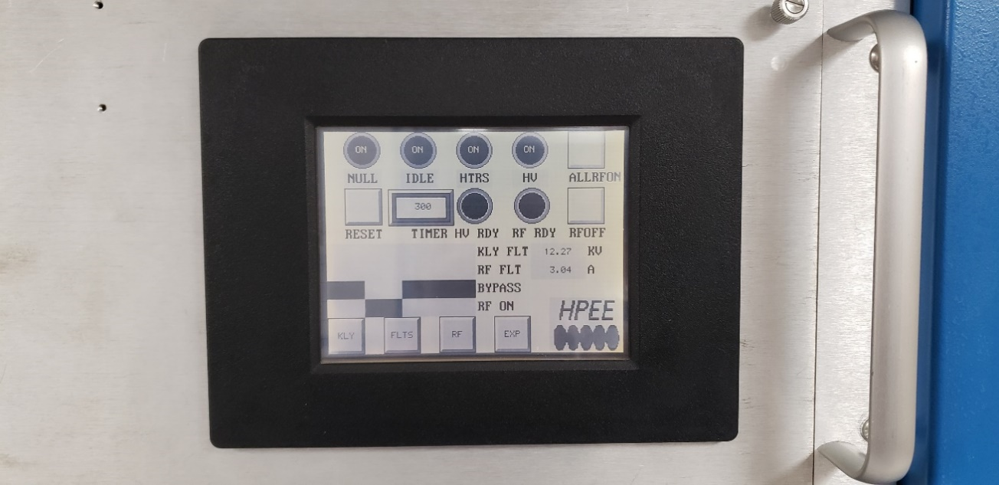

**(Fig. 11: RF Klystron & High-Power Amplifier [HPA] HMI)**

1. In rack TL06B09 select the button for the relevant cavity to be tested from the '1497 MHz RF Distribution Network' chassis. Once the button for the cavity number is illuminated press the 'RF Reset' button below that.

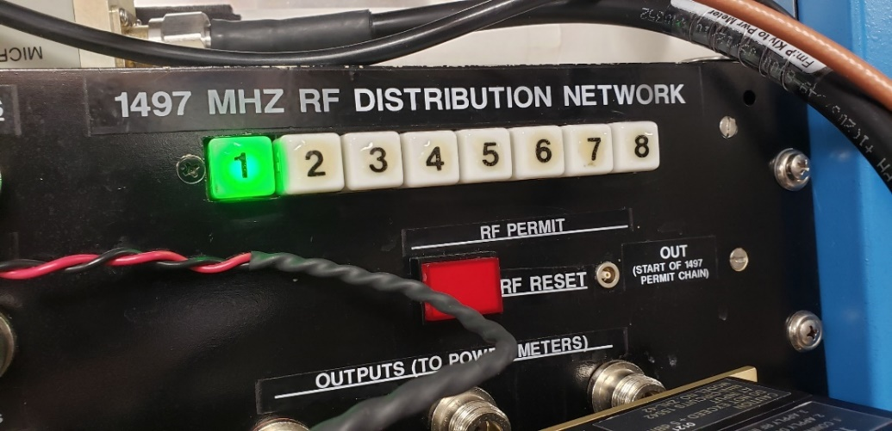

**(Fig. 12: RF Distribution Network)**

1. Using the 'Remote Microwave Measurement System Relay Switching' boxes in rack TL06B09, switch the illuminated relays to the cavity number under test using the knobs.

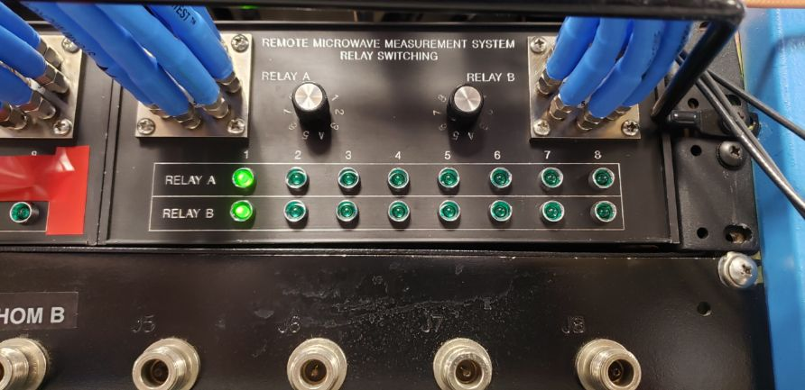

**(Fig. 13: Microwave Relays)**

1. In rack TL06B04, adjust the tuner relay buttons one by one. Press 'KSW Run' after each so the buttons show their depressed sides directed towards the cavity of interest.

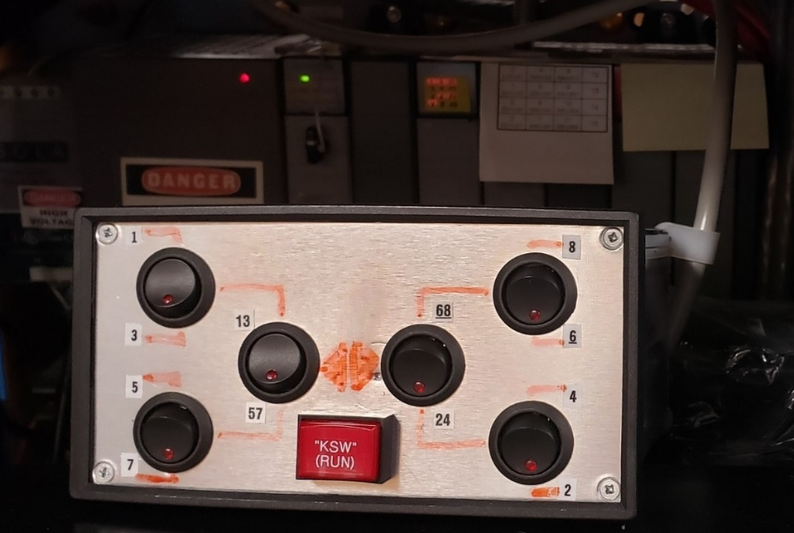

**(Fig. 14: Tuner Relay Box)**

**Example: In Fig. 4, cavities 1 and 2 are selected by the switch positions (Depressed ^^ and vv respectfully). The left-hand side of the box controls selection for odd cavities, and the right-hand side even cavities. It is important to only change 1 relay at a time to avoid damage to the system. To change to cavity 5 say from the above configuration – one would need to flip the position of the 13,57 switch and press ‘KSW RUN’ and then flip the position of the 5,7 switch and press ‘KSW RUN’ again. To change to cavity 4 above – one would only need to flip the 4,2 switch and press ‘KSW RUN’ once. With each switch change you will notice the change in light configurations on the PLC display behind the box after the ‘KSW RUN’ button is depressed – wait for this to complete before flipping the next switch. (Or press ‘KSW RUN’ again if it does not).**

**(Fig. 15: Waveguide Switch PLC Relays)**

**Note: The chart by the PLC indicates which lights should illuminate for which switches. Caution: if changes are not occurring contact the Head of Test & Measurement for guidance on how to proceed.**

1. 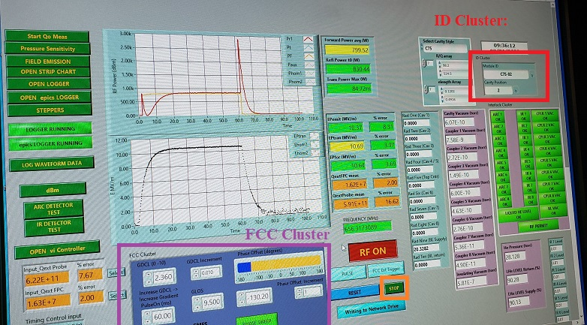On the computer in rack TL06B11, ensure the correct Module ID is selected on the top right of the RF Main Labview .vi screen. If the Module ID is incorrect, stop the RF Main.vi screen with the Green 'STOP' button in the bottom middle of the screen, select the appropriate Module ID in the Identification Cluster, and restart the screen with the arrow at the top left of the LabView screen.

**16**

1. Verify that the correct Cavity Position for the cavity to be tested is selected on RF Main LabView .vi screen. If it is incorrect, change it in the same manner as you would the Module ID in the previous step.
2. In the 'FCC cluster' section, ensure that GLOS is set to 9.50.
3. Ensure that PLSGHI is set to 9.50.
4. Ensure GDCL is set to 0.0.
5. Make sure the cavity is in Pulsed mode before initial turn on: The button below the large Green RF Off button should display '**PULSE**' to indicate the mode of operation.
6. Close the 'RF On' switch on the Labview Main or the EPICS Operator screen [JMenu > EDM (SRF Main) > CMTF Main > CMTF RF Combo > Cavity Ops]

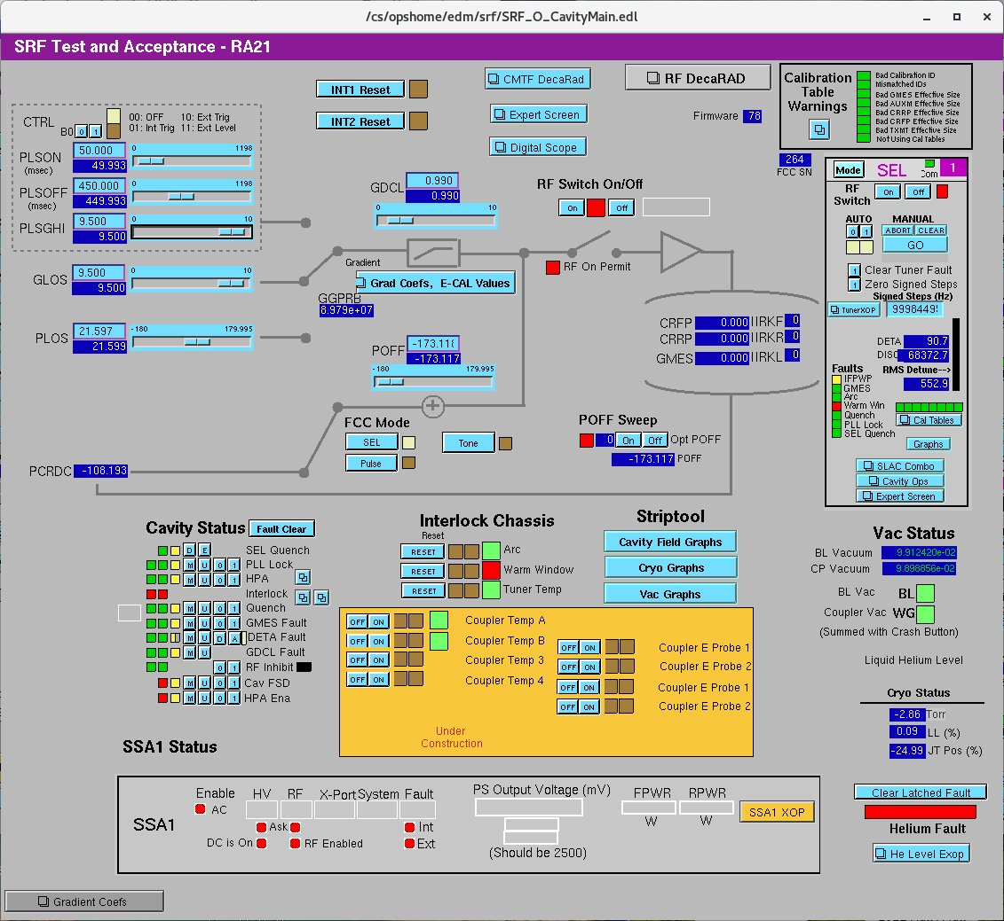

**(Fig. 17: The Cavity Ops Screen)**

1. Clear faults if necessary and turn RF On using the HMI in rack TL06B13.
2. Activate the RF by turning the RF Kill button clockwise and pulling it on the Tektronix Oscilloscope in rack TL06B11. The button should be illuminated red if RF is permitted.
3. In the CMTF, power to the cavity is controlled by adjusting the gradient clamp. (GDCL / 0-10V). Starting at 0.0 with a GDCL step of 0.01, increase GDCL until Forward Power (Avg) reads between 200-300W.
4. Press the 'PHASE SWEEP' button. This will sweep the cavity phase a full 360°. Observing the oscilloscope while adjusting POFF, one may then iterate to make sure the reflected power trace in LabView is fully visible and near 0 at the lowest point.

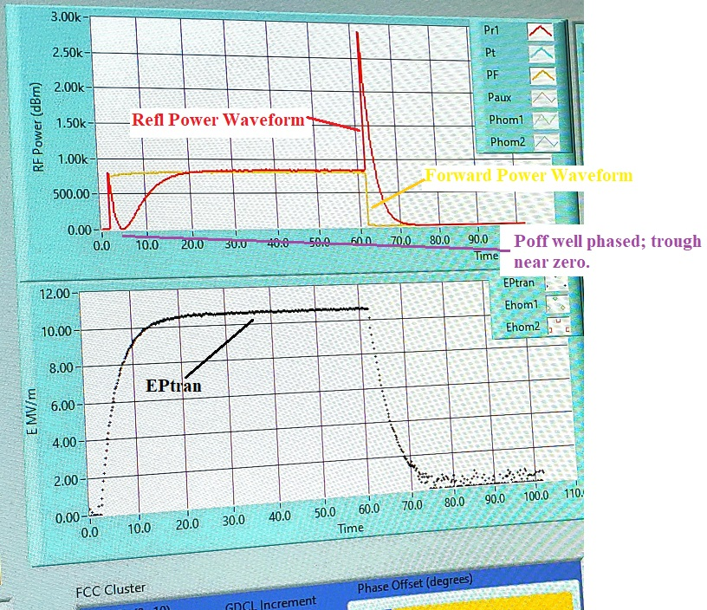**(Fig. 18: Optimized Pulsed RF Waveforms)**

1. Press the SEL button. Use POFF Sweep (in SEL mode) to ensure proper RF phasing after reaching desired power.
2. Check that the cavity frequency (above the RF ON/OFF button) is close to resonance. (< +/- 1kHz.

**Note: If cavity frequency is several hundred kHz below resonance, it may have locked on to the wrong mode. In this case, go back to pulse mode and repeats steps 16-19. Note the phase will likely change by 60-90 degrees for a different mode.**

Measuring Qext,Probe & Qext,FPC:

Set the RF back to Pulse mode:

1. Locate the Timing Control Input Cluster (lower left-hand corner of Main screen)
2. Increase the Sample Rate by an order of magnitude (x10)
3. Increase Post Trigger Points by an order of magnitude (x10) Note: You may need to fine tune the Sample Rate to display one full waveform displayed on graphs.
4. Once the Waveforms have updated, click Select buttons for the Qext Cluster (just above the Timing Control Cluster) Allow time for updating (can be as long as ten seconds in this mode)
5. EPemit and EPtran should now be equal to about 1%. If they are not, repeat the process.
6. Click the 'LOG WAVEFORM DATA' button to save the waveform data in Labview
7. Decrease the Sample Rate by an order of magnitude (x10).
8. Decrease Post Trigger Points by an order of magnitude (x10)
9. Record QextFPC, QextFP, QextHOMA and QextHOMB in the logbook and spreadsheet.
10. Record the phase setting in logbook.

Switch RF to SEL mode:

1. Repeat the POFF Sweep to verify the cavity is still at the optimal phase.
2. Record gradient (EPtrans) at which the measurements were made.
3. Raise EPtran to at least 5 MV/m using the GDCL if it is not already there.
4. Record GMES / EPtran and frequency.

Calibrating the GMES signal:

1. From RF Combo > Cavity Ops screen - Press the 'Grad Coefs, E-CAL Values' button in the center of the screen.
2. Record the present probe calibration (GGPRB) value in the Gradient Cal. Factors column.
3. We are going to scale the probe calibration so the GMES = EPtran which is measured from the power meter. To do this we will compute the following: GGPRBnew = (Eptrans / GMES) * GGPRBold
4. Enter the calculated GGPRBnew value into the GGPRB Probe field.
5. Verify GMES is about equal to EPtran. If the difference is greater than ~5% repeat this step. Record the new value of GGPRB in the logbook.
6. After scaling, only set new values of Qext,FPC, Qext,FP or GGProb in software at higher gradients if divergence is greater than 5% from initial settings. Always record any chanc
7. Set the RF back to Pulse mode.

Emax Testing and the 1-hour run.

Setup: Using Appendix V of this document, load the following shared plot configurations from: /usr/opssite/alha_config/plot.shared/cmtf/ to monitor the cavity and cryomodule under test.

* + Configuration (LivePlot): CMTF_Cav# (# == cavity number of interest)
  + Configuration (LivePlot): CMTF_Cryo.xml
  + Configuration (LivePlot): CMTF_Radmon.xml
  + Configuration (LivePlot): CMTF_vacuum.xml

1. Set the RF up in Pulse mode at around 7MV/m. Note: If in doubt of calibration validity, check waveforms in pulse mode as described in step 18 of setup. Using 300-500 W of forward power should give you around 4-5 MV/m and 1kW around 10-12MV/m.
2. Open the Field Emission Measurement .vi from the RF Main .vi screen by selecting the 'FIELD EMISSION' button.

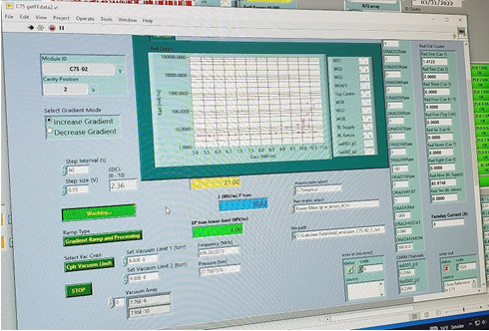

**(Fig. 19: Field Emission Measurement GUI)**

1. Verify the following settings:
   * GDCL Step size (V): 0.05 [Note: If gradient step is less than 0.2 MV/m, increase GDCL step in 0.01 increments until the gradient step is greater than 0.2 MV/m.] Step Interval(s): 60
2. 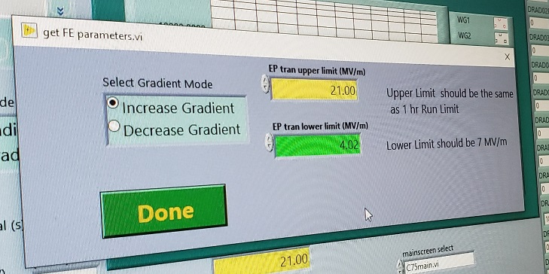Click the 'Start FE Measurement' button and select the 'Increase Gradient' option under Select Gradient Mode. Maximum gradient attainable can be found in parallel with the field emission profile.

**(Fig. 20: The get FE parameters.vi launched by the FE GUI)**

1. Enter either 0.5 MV/m above the VTA performance OR the cavity administrative limit for this module (as directed by the Testing Coordinator) into the EPtran upper limit field. Set a lower limit of 7 MV/m and click DONE.
2. Mask quench faults (see appendix 1 for details) and carefully observe the wave forms carefully on the oscilloscope. Turn RF off quickly if quench occurs using the red ‘RF Kill’ button on the oscilloscope.
3. At the first signs of sustainable Field Emission: pause FE VI and run cavity at constant gradient while monitoring DRAD signals for up to 30 minutes.
   * Has the field emission rate here showed improvement over the time run (aka has it gone down)?
   * Yes: continue running at the same gradient until no further improvement is noticeable after about 15-20 minutes time.
   * No: If cavity shows no improvement after about 30 minutes, proceed gradient ramping with FE VI (see step 9)

Quench limits and pulse processing:

1. Did the cavity quench before reaching the lesser of the VTA Emax or the admin limit for the cavity?
   * Yes: Was the quench limit more than 2 MV/m below the VTA/Admin limit?
   1. Yes: Proceed to step 10 and attempt to process your way through the quench limit there.
   2. No: Proceed to Step 14: The 1-hour run
   * No: Proceed to Step 14: The 1-hour run
2. Contact the Testing Coordinator: Notify them you have encountered a quench limit well below the VTA performance of the cavity and will attempt to pulse-process the cavity.

They will guide you through reconfiguration of the Waveform from the Universal generator in rack TL06B11 if necessary. The idea is to use a higher instantaneous pulse power while keeping the same average pulse power in an attempt to process through whatever possible contaminant or field emitter may be resulting in the Quench. See Appendix 4 for common pulse reconfigurations.

1. Once the pulse width has been reconfigured, approach the previously determined quench gradient with small steps of GDCL = 0.01 – 0.02. If the cavity quenches, keep RF On.

**Note: The lower pulse width and duty cycle may allow cavity to recover from quench between RF pulses. In this case, the Quench may manifest as wave forms with unstable shape and shifting decay times. Allow this behavior to continue until the behavior ceases or Helium pressure or liquid level become unstable.**

(**Fig. 21: A Cavity on the edge of Quenching)**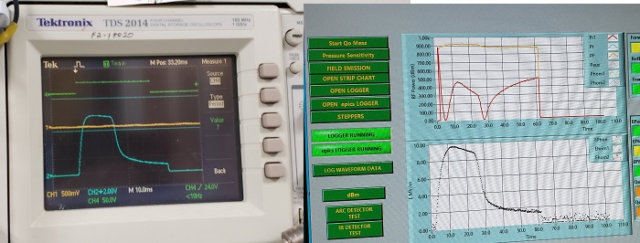

Has the unstable behavior stopped?

* + Yes: Is the cavity running normally again at this GDCL setting?
* Yes: Pulse processing is going successfully; slowly increase the GDCL and repeat step 11. Continue this process until you reach a hard limitation (i.e., you can process no higher after 30 minutes of trying) or you reach your target gradient.
* No: Check if the pressure level is rising; the cavity may still Quenched. Lower the GDCL by 0.05 and repeat this step 11.

1. No: If after ~30 minutes, no progress can be made, move on to step 12.

**Note: If quench gradient is within 0.5 MV/m of the cavity admin limit - skip the processing steps. Principal Investigator will decide later whether processing time is necessary during ‘Punch List'.**

1. Upon demonstration of a hard limit – either the quench limit is still present, has somewhat improved through processing, or has reached the VTA Emax or the Administrative limit – it must be verified with a CW duty structure. Reduce the gradient by 2 MV/m and change the cavity to SEL mode.
2. Slowly approach the limit with small steps: 0.05 GDCL every 60 seconds. Continue until you can reach the limit or can proceed no further. Upon reaching the maximum possible gradient allowed, return the waveform generator to its nominal configuration as outlined in Appendix III and proceed with the 1-hour run.

The 1-hour run and determination of Emax,op

1. From the maximum possible achievable gradient (if other than the admin limit) reduce gradient by 0.5 MV/m. From the Admin limit no reduction in gradient is required. Attempt to run the cavity for a continuous hour to establish an operating limit:
   * Establish RF to the cavity in SEL/CW; record EPtran, GMES, Pfwd, Prefl, frequency, and time.
   * As the test progresses it is normal if the gradient sags or swells slightly. GDCL adjustments should be made in 0.01 increments as necessary to maintain the gradient selected. Be careful not to overshoot and reach your earlier determined limit.
   * If the cavity trips for some reason, reduce the gradient by another 0.5 MV/m and start again. If this is your 3rd reduction contact the Testing Coordinator for guidance on how to proceed.
   * At the conclusion of the hour run record EPtran, GMES, Pfwd, Prefl, frequency, and the time once again.
2. After completion of 1hour run, initiate the field emission .vi again with the following settings:

If the sustained Field Emission is present:

* + Emax gradient down to 8 MV/m or lower if onset gradient is lower.
  + GDCL step = 0.05
  + Time interval = 60 sec
  + Record the gradient at which the onset of field emission begins.

If there is no field emission, run .vi anyway (for Lorentz data):

* + Emax gradient down to 10 MV/m
  + GDCL step = 0.1
  + Time interval 20 sec

1. Once the field emission .vi has completed its run in pulse mode at 8 MV/m, Eop(1hr run), and 16 MV/m [if below Emax,op] record QextFPC, QextFP, QextHOMA and QextHOMB in logbook and spreadsheet. Go to SEL mode at each gradient as well and record the cavity frequency before taking the next data point in pulse mode.
2. At the end of this process, ensure that the following is clearly recorded in logbook and SRFlog (attach a screenshot of the summary spreadsheet to an elog entry):
   * All Qext’s & frequencies from step 16.
   * Emax and 1hr run gradients, as well as any limiting or mitigating factors. (i.e. quenching, the admin limit, multipacting, etc.)
   * The gradient at which the onset of Field emission occurred (if it did) from step 15.

If a cryomodule performance summary document is open on the windows computer in TL06B11, please update the document there with the shift’s progress as well.

High Power Testing: Qo & Pressure Sensitivity Measurements:

Preface: Qo is the inherent quality factor of the cavity and is an intrinsic measure of how perfect or imperfect a conductor it is. (i.e. How much heat the cavity will evolve relative to its stored energy at a specific gradient). To measure Qo, we will be turning the cryomodule into a giant bomb calorimeter. The inlet JT valve and outlet RT valve are closed, and the various sources of heat monitored via the changing temperature and pressure over time.

The 3 heat sources considered are as follows:

* Static – This is continuous heat leakage into the module and is constant at a given cavity location. This is the background on top of which we must make the other measurements.
* Electric Heater – There is a calibrated heater which conducts to the Helium bath which the cryogenics group uses to maintain a constant stable heat load in the module and which trades off load against the RF heat of the cavity when it is on. This is done to maintain a constant heat load on the Helium plant and avoid cryogenic heat and pressure oscillations which would make the plant harder to control. For this measurement, it is a calibrated heat source to compare against.
* RF Heat – By comparison of the rate of pressure rise relative to that of the calibrated source (the electric heater) one can calculate the heat evolved into the Helium bath, and from there calculate the Qo.

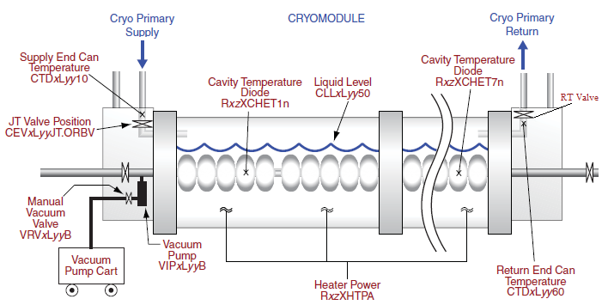

**(Fig. 22: Cryomodule Diagram)**

The Q measurement has 5 stages:

1. Static Heat measurement
2. Dynamic Heat measurement from the RF cavity
3. Static Heat measurement
4. Electric Heat measurement from the Heater.
5. Static heat measurement

Static Heat Measurements are 15-30 seconds in length, with the Heater/RF steps at 20-60 seconds in length depending on the module.

Preparation:

* + Ensure the appropriate module style and cavity number are selected on the RF Main .vi
  + Set up the cavity to be tested at 4MV/m. Refer to the cavity setup section of the Emax procedure if necessary. GGPRB and Qs may be re-surveyed and adjusted if EPtran and GMES differ by more than 5%.
  + Measurements taken above 33 Torr tend to not yield sensible results, there is also a pressure interlock at 34 Torr above which cryogenics do not behave well and faults. Please be mindful of the Helium pressure while testing for this reason.

In addition to Qo measurements, we will opportunistically take advantage of the pump down between Qo data points to perform a **Pressure Sensitivity** measurement. While operating a cavity at some fixed gradient with a change in pressure there will be a change in frequency. A cavity is set up at some gradient in SEL mode once the JT valve is opened and pressure begins to drop and df/dP is measured as the pressure drops with the pump down. Once pumped down, the cavity is turned off and the cryo operator will close the JT valve for the next Qo measurement.

Qo measurements:

* + Contact the designated SRF Cryogenic operator on the shift schedule put out by the Testing Coordinator (If one is not on the schedule, contact them for guidance.). Inform the operator you are ready to start Qo measurements.
  + The Cryo operator will over-fill the amount of liquid in the module to 92-94% and then close the JT down and let the pressure in the module pump down before closing it completely. When the operator gives the go-ahead, close the RT valve using the switch located in rack TL06B14. [Switch up: RT closed; switch down: RT open]

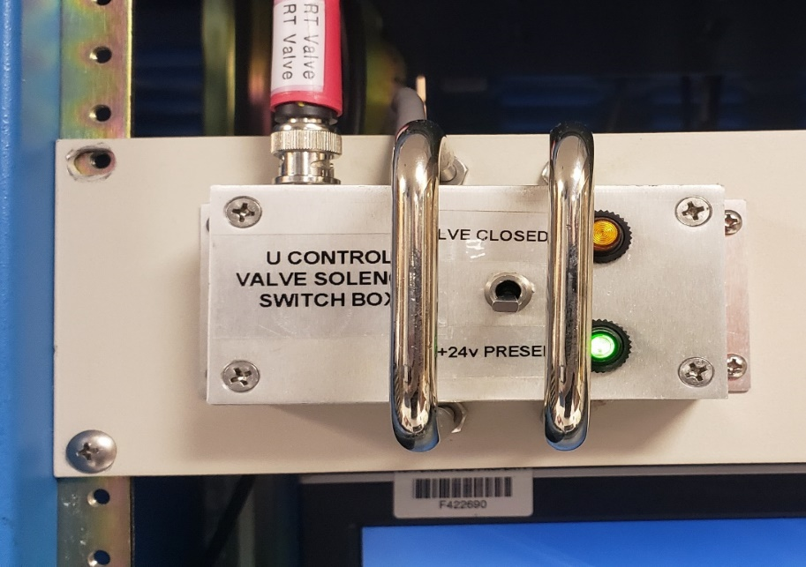

**(Fig. 23: RT Valve Controls)**

**(Note: If doing repeated measurements, starting liquid levels of between 86-95% are acceptable to perform the measurement)**

* + Launch the Qo measurement .vi via the 'Start Qo Meas' button at the top left of the RF Main .vi. Click the 'Start Qo Measurement' button on the .vi to begin the measurement.

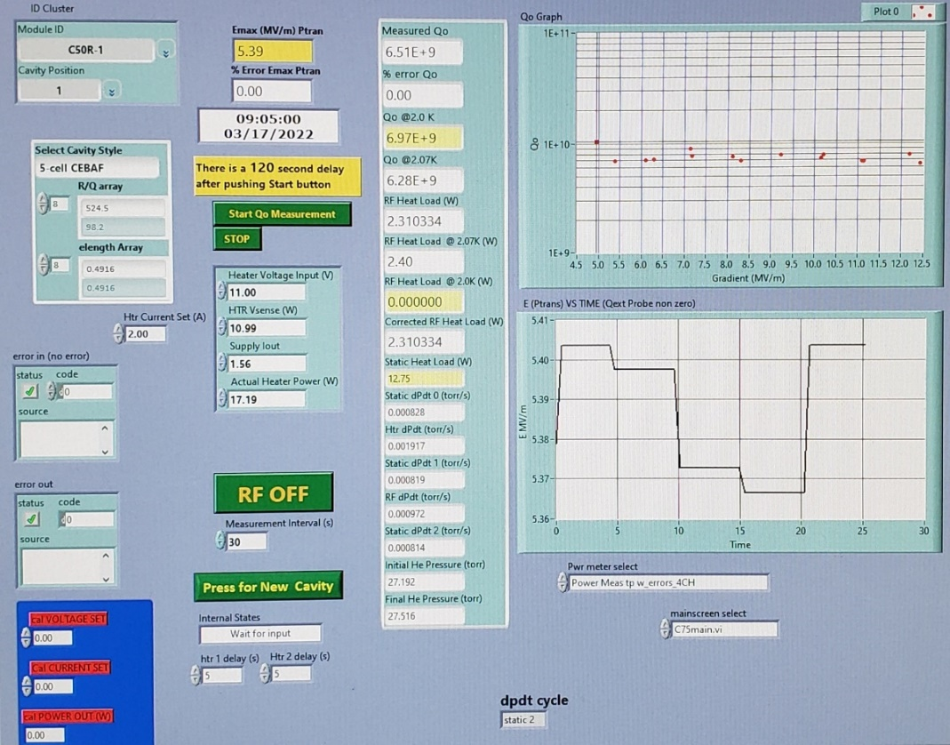

**(Fig. 24: Qo Measurement .vi)**

**Note: Do not begin a measurement if your pressure is over 32 Torr. Once one passes 33 Torr the data is generally invalid. It is better to pump the module down and begin again.**

* + A countdown clock will launch indicating a cryogenic settling time for the module. Once the designated period has elapsed, the DPDt .vi will launch and allow you to execute the first static heat measurement. Click the 'Start Timer' button in the center of the screen to execute the measurement.

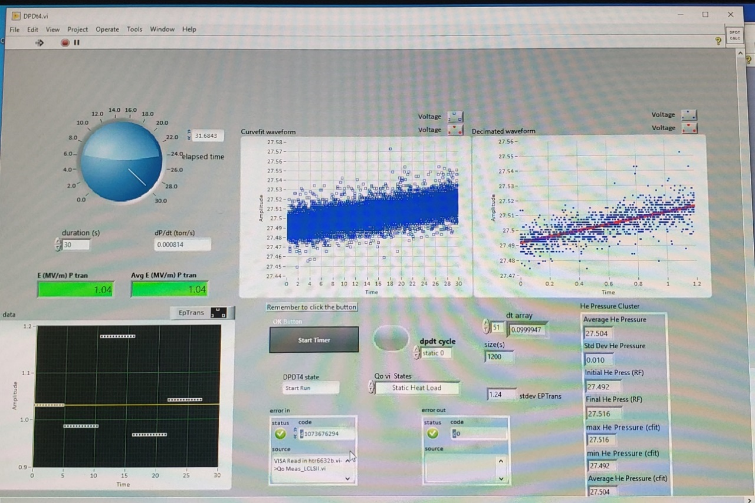

**(Fig. 25: DPDt .vi)**

**Note: If you lose track of the process step, the ‘Qo vi States’ box in the center of the screen will apprise you of which step is being executed.**

* + In the second step, the .vi will start the electric heater. Confirm the heater is on via the green light on the front of the power supply in rack TL06B03 - visible from the measurement workstation and click 'Start Timer' to collect the dP/dt data.
  + Once the electric heat measurement completes, the heater will turn off and the .vi will ask for another static heat measurement to be completed. Click 'Start Timer' to execute it.
  + Following the second static heat measurement, the cavity will be turned on in pulse mode. Verify it is tuned and raise the GDCL to reach the next desired Qo measurement gradient and then switch the cavity to SEL mode. Once the graphs on the RF Main .vi update, click 'Continue' to confirm the setting. Click 'Start Timer' on the DPDt .vi to execute the RF heat measurement. The .vi will automatically open the RF switch and stop RF after completing the measurement.
  + After the RF measurement, the .vi will guide the execution of a third and final static heat measurement. Click 'Start Timer' to execute it.
  + Following the completion of the final static heat measurement, the Qo .vi will deliver the results of the analysis of your measurement. Record the time, EPtran (MV/m), Qo@2.07K, RF Heat@2.07K (W), Static Heat load (W), and final He Pressure (ATM or Torr) in the logbook.
  + Is the module pressure less than 32 Torr?
    - Yes: Proceed to step 11
    - No: Open the RT valve and contact the Cryo Operator. Inform them the module is ready to pump down. They will open the RT valve (and potentially crack the JT to get a little flow to lower the module pressure substantially.
      * While the RT valve is opening and the pressure is beginning to drop, turn RF on in SEL at the gradient of the last Qo measurement performed.

**(Fig. 26: Pressure Sensitivity Measurement)**

* + Press the ‘Pressure Sensitivity’ button on the Main .vi. That will launch this psens.vi which will automatically start to perform the pressure sensitivity measurement.
  + As the pressure drops the GUI will record the change in frequency with pressure at a fixed gradient. Allow the process to continue across at least 3 Torr of pressure. After spanning this range, one may stop the measurement using the green STOP button.
  + Go to Pulse mode and raise the GDCL to reach the necessary gradient for the next Qo data point. Once complete, terminate RF until the cryo operator verifies the pump down has completed. Afterwards proceed to step 11.

**Note: At some point the Cryo Operator will need to refill the module as you will lose a few percent of liquid with each pump down. (Liquid Level will fall below 85% and become unsuitable for testing.) The refill process takes ~1 hour. Bear this in mind when considering whether to start another Qo measurement if time is growing late on a swing shift.**

* + Raise the gradient by 1 MV/m (or up to Emax,op) and repeat steps 3-10 until all of the data points have been gathered or stopping due to a time constraint at the end of your shift.
  + Ensuring data quality: In general, the magnitude of Qo will drop monotonically (one-after-another) as one rises in gradient. If after gathering the data there are any points which depart significantly from this trend, these are good candidates for remeasurement if time allows. Gathering the data now will save time in analysis later and eliminate the need to come measure again during the completion of the punch list.
  + Record that Qo measurements have been completed and at what gradients in the logbook, along with any issues encountered while taking the measurements.
  + When Qo measurements have been completed, contact the cryo operator and let them know they may open the valve.

# Appendix I: Troubleshooting Interlock Faults: [Revise this section; currently written for LCLS2]

Interlocks and faults

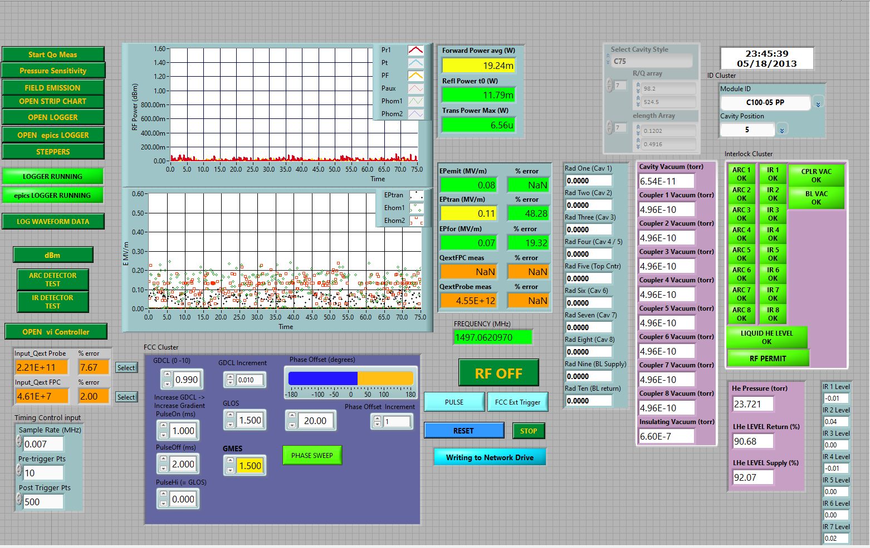

**(Fig. 26: The Interlock screen)**

1. **Default fault masking in LabView:** Coupler temperatures, Eprobes and stepper motor temperatures have been removed in LabView from previous LCLS module testing. (Which is not in the scope of this document. The remaining interlocks relevant for CEBAF style cryomodules are visible in the interlock cluster at the right side of the main.vi screen. If one right-clicks on an interlock in the cluster, one may disable the labview interlock if desired. Never bypass an interlock without notifying the Testing Coordinator.
2. **Default fault masking in EPICS:** From EPICS Operator screen [JMenu > EDM (SRF Main) > CMTF Main > CMTF RF Combo > Cavity Ops] (Fig. 2 below): Mask all interlocks under the **Cavity Status** section except quench, HPA, and HPA Ena(ble). Only mask the Quench interlock during the initial ramp up in pulse mode when determining a hard quench limit or while performing Pulse Processing. Never run SEL with quench masked, unless specifically told so by the Testing Coordinator. The High-Power Amplifier (HPA) and HPA enable faults should never be masked under any circumstances. Coupler Temp and Coupler E Probe signals should all be OFF. These are leftovers from testing in previous projects and have not yet been removed from the screens/software.

**(Fig. 27: The Cavity Ops Screen)**

1. **IR Monitors:** IRs signals should be unmasked and monitored via strip tool. Cold (CWWT) and Warm (CWWTW; if present) IR sensors trip off at 20mV with the voltage rising until reaching that value on C75 and C100 modules. If one reaches the 20 mV trip point, contact the Testing Coordinator for instructions on how to proceed. Let them know the Qext,FPC measured for the cavity under test.
2. **Liquid Level:** He LL is interlocked on the return LL, not supply. The supply liquid level shouldn’t be lower than 85% for CEBAF cryomodules.
3. **Pressure:** Do not exceed 34 torr on He pressure. Shut down RF if it gets too close and Cryo cannot support operation.
4. **Arc Detectors**: High-power RF should not be put on a cavity without a functional arc detector. If a detector has a latched fault, one may bypass the interlock as long as the cavity is not the one under test.
5. **Vacuum interlocks**: The vacuum slow trip point interlock is typically kept at 5e-7 Torr, with the fast trip point interlock at 1e-6 Torr in the CMTF. Vacuum interlocks should not be bypassed, and rapid sustained changes of vacuum usually indicate damage to the cryomodule. Consult the Testing Operations Directive (TOD) for vacuum changes which reach the threshold of breaching the Operations envelope and notifying the Testing Coordinator, Facility Manager, etc.
6. **Resetting interlock faults in LabView:** Start with resetting faults in LabView, don’t forget to twist and pull the red crash button on the Oscilloscope to regain RF permit. The RF Kill button is wired in series with the vacuum interlocks and will present as a vacuum fault on the EPICS and LabView screens as it is wired in series with that interlock. If you have a vacuum fault you cannot clear – check the status of the RF Kill button after verifying the pressures and pumps are okay.
7. **Resetting interlock in EPICS:** The Combo screen has several reset buttons:
8. INT1 Reset (Covering faults on Cav. 1-4); the INT1 chassis.
9. INT2 Reset (Covering faults on Cav. 5-8); the INT2 chassis.
10. Clear latched Fault (lower right corner of combo screen, near Helium fault indicator) – this will latch on Return LL.

# Appendix II: Calibrating the Boonton Model 4532 RF Power Meters

To ensure consistent measurements the Boonton Power Meters should all be calibrated against the power supply’s internal noise sources at the beginning of each shift. If a measurement is in process when you arrive, first complete that measurement and then calibrate the power meters.

To calibrate meters, proceed as follows:

1. Open the LabView Power .vi from VI Control .vi & stop it.

**(Fig. 28: Stopping the Power .vi)**

1. Power cycle the Boonton Power Meters off and then on with the 'On/STBY' button. This will get rid of any GPIB lock-up issues the meter may be encountering – which occur frequently.
2. Press the 'ESC/STOP' button on the power meter. If the power meter does not stop, power cycle it again.

**(Fig. 29: The Boonton Power Meter)**

1. Disconnect the screw-on power meter on the sensor port 1 from the patch panel and attach it to the calibration port of the detector.
2. Press the 'Zero/CAL' button. Use the arrows to select 'Sensor 1' and 'Auto Cal.' From the menu and press ‘Enter/Run’ to select that option.

**(Fig. 30: The Boonton Power Meter Calibration Menu)**

1. The meter will start at +20 dBm and gradually lower the output power until reaching -99 dBm on the screen at which point it will read complete. If this is not the case (or the meter displays an error) power cycle the meter and try again. If this is your second time through contact the SRF Test & Measurement Group Leader for assistance.
2. Detach sensor 1 from the calibration port and return it to its original position on the patch panel.
3. Disconnect sensor 2 from its position on the patch panel and repeat steps 5-7 selection the sensor 2 option. Press the ‘Enter / Run’ after you have replaced sensor 2 on the patch panel to resume data acquisition.
4. Start any LabView .vi screens you stopped in step 1. Verify data is being read in by opening the power measurement and Main .vi s and looking for any anomalous behavior.

# Appendix III: Configuring Pulse Parameters on the 40MS/s Universal Waveform Generator:

Locate the generator in the top of rack TL06B11. It should be configured appropriately for the module frequency under test.

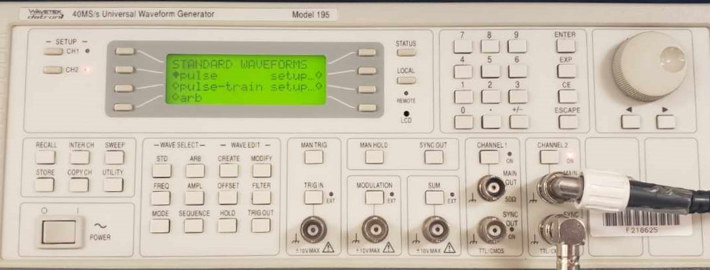

**(Fig. 31: The Universal Waveform Generator)**

Common CMTF module frequencies are as follows:

JLAB (1497 MHz):

Pulse:

* Pulse Period: 450 ms
* Pulse Width: 50 ms

Pulse Train:

* Number of pulses in Train: 2
* Pulse Train Period: 100 us
* Pulse 1:
  + Pulse 1 level: -5V
  + Pulse 1 width: 25 us
* Pulse 2:
  + Pulse 2 level: -5V
  + Pulse 2 width: 25 us
  + Pulse 2 delay: 50 us

# Appendix IV: Pulse Processing Waveform Reconfiguration:

Waveform pulses may now be set from the SRF expert screens for each individual cavity under test. From JMENU (srfl00) > EDM (SRF Main) > CMTF Main > CMTF RF Combo > Cavity OPS screen in the tuner box of the cavity of interest. This yields the following screen:

**(Fig. 32: NAME)**

Pulse configuration settings are present on the top left-hand side of the screen. Typically pulse mode for CEBAF is set up with a 25% (60 msec on, 240 off) or 50% (120 msec on, 240 off) duty factor. To configure a pulsed waveform for the purpose of Pulse Processing through an RF Quench or perhaps multipacting cavity in the CMTF, please use the following paraments:

JLAB (1497 MHz):

* RF on: 5-30 msec
* RF off: 240-1000 msec

The pulse must be short enough for the cavity to stay on/not quench and thus deliver a higher than normal peak power pulse. This has the chance of burning off some contaminant that the average power of a standard configuration pulse might not. As this process may blow up emitters and move contaminants around inside of a cavity or waveguide, we may need to also allow for longer recovery times to allow the cavity to become superconducting again following violent quench events.

# Appendix V: Possible Parameters of Interest for LivePlot

Below is a list of useful parameters to monitor; some are located on the DEV network requiring execution of Mya/LivePlot there:

* Common user directories to load from: /usr/opssite/alha_config/plot.shared/CMTF/
* Configuration (LivePlot): CMTF_Valves+levels+RF+rad
* Signal List:
  + RA2*GMES (Where *=1...8; the cavity under observation + others)
  + DRADCMTASRF** (Where ** = 01...10)
  + SRFCMTFHEPRES100
  + SRFCMTFLLRETURN
  + SRFCMTFLLSUPPLY

Add these signals to the chart:

* SRFCMEPTRAN
* SRFCMPWRFWD

Configuration (LivePlot): CMTF_carms.xml

Signal List:

* rad301_p3
* rad302_p1
* rad302_p2
* rad303_p1

Common user directories to load from: /usr/opssite/alha_config/plot.shared/cmtf/

Configuration (LivePlot): CMTF_Cav# (# == cavity of interest)

Signal List:

* CRFP (Forward Power)
* CRRP (Reflected Power)
* DFQE (Discriminator)
* POFFr (Phase offset)
* GSET (Gradient set point)
* GMES (Gradient read back)
* PMES (Phase Measured)
* CWWT (Cavity Waveguide Window Temperature – IR sensor)

Configuration (LivePlot): CMTF_Cryo.xml

Signal List:

* SRFCMTFLLSUPPLY (Supply end LHe liquid level)
* SRFCMTFLLRETURN (Return end LHe liquid level)
* CTD46017 (Inlet Temperature)
* CTD46009 (Outlet Temperature)
* CEVCMTC2.ORBV (JT Position [%])

Configuration (LivePlot): CMTF_Radmon.xml

Signal List:

* DRADCMTASRF## (where ## = 01..10 for the decarad sensor head of interest)
* DRADCMTAHVMON (Decarad HV – nominally 500V)
* Rad30m_pn (Where m,n = 1..3 to choose the carm and sensor head of interest)

Configuration (LivePlot): CMTF_vacuum.xml

Signal List:

* SRFCMTFBLVAC1 (Beamline vacuum)
* SRFCMTFWGVAC# (# = 1..8 for the waveguide vacuum channel of interest)

# Appendix VI: Interlock Checks

Before starting any sort of cryomodule testing it is necessary to determine if all the cryomodules safety interlocks are in place and functional. This is especially necessary during the commissioning process as this is the first time RF power is being put through most of these components and thus it is when we will expose infant mortality / manufacturing problems before the module heads out to CEBAF.

This process is outside of the scope of this procedure, but for reference for JLAB-style cryomodules interlock checks are as follows:

* Liquid Level:
  + High liquid level: Set the trip point below the current liquid level; observe trip
  + Low liquid level: Set the trip point above the current liquid level; observe trip
* Vacuum (CMTF): Turn off HVPS for pumps 1-by-1; observe and reset trips.
  + Beam-line vacuum
  + Waveguide vacuum (Cavities 1-8)
* IR sensors (Cavities 1-8): Use test diode to observe functionality of channel. Change set point relative to present value to observe trips. Trip levels: LLRF3: 20 mV; LLRF2: 4V
* Arc detectors (Cavities 1-8): Trigger test diode; observe fault.

# Appendix VII: Passband Measurements

Method A: Use of a local Network Analyzer on a roll-around cart in the CMTF Cave:

* Measurement using a Top Hat
  + Connect the Port 1 cable to the Reflected Power port of the Top hat
  + Connect the Port 2 cable to the Probe Cable port of the Cryomodule
  + Measurements may require 2.5W – 5W amplifiers in series with both cables to provide sufficient signal for the network analyzer. This is particularly true when the cryomodule is above 4K.
  + Proceed with Network Analyzer (NWA) Setup step below.
* Measurements using Reflected power and probe ports (Waveguide connected)

**Note: Be aware the circulators will affect your QL measurements.**

* + Connect the Port 1 cable to the Reflected Power port of the Top hat
  + Connect the Port 2 cable to the Probe Cable port of the Cryomodule
  + Measurements may require 2.5W – 5W amplifiers in series with both cables to provide sufficient signal for the network analyzer. This is particularly true when the cryomodule is above 4K.
  + Proceed with Network Analyzer (NWA) Setup step below.

## Method B: Network Analyzer Measurements from the control room:

**Note: In the control room, one is measuring through a cable network. Cable calibrations and losses should be remembered for the purposes of later data analysis of peak Qs. Frequency information is good for direct comparisons.**

* Connect port 2 of the analyzer to the Probe port on the patch panel for the module of interest. Port 1 should be connected to the Reflected Power port for that same cavity.

*NWA Setup:* Turn on the control room Network Analyzer. Configure it in the following manner:

* + Sweep setup > Power > RF Out: off.
  + Measurement (Meas) > S2,1
  + Span > Span 20 MHz
  + Center: Resonant frequency for the module: 1497 MHz CEBAF cavities.
  + Note the insulating vacuum pressure of the cryomodule as well as the approximate module temperature (2K, 3K, 300K, etc.) for later data analysis and comparison.

Procedure:

1. Turn on the RF power from the network analyzer (Sweep Setup > Power > RF Out: On):
   * Verify you can see a peak on the analyzer for each cell in the cavity. For example: a C-100 style cavity will have 7 pi modes - one for each of its 7 cells – whereas a C-75 cavity will have 5, and so on.
   * Press the Marker button: Turn on Marker 1.
   * Use Marker Search & select 'Max' to locate the maximum / peak value.
   * Enable tracking using 'Tracking: On'; this will provide a reference frequency which can be used to monitor the frequency behavior of the cavity.
2. Passbands: In this step we will find the frequencies and loaded Qs for each of the Pi modes.

Configure the Network Analyzer as follows to take frequency data:

* + Set Marker Search > Tracking: Off
  + Enable Marker Search > Bandwidth: On.

Marker > Marker 1 – Using the dial move the marker over to the highest frequency peak. This is you Pi mode peak. Reduce the span to ~50kHz (Span > Span: 50 kHz) and record the frequency and Q of this mode.

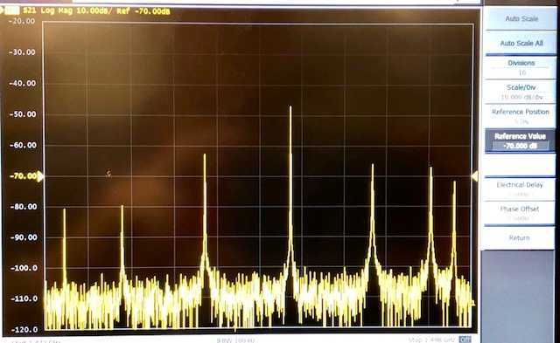

**(Fig 33: 7-cell Cavity Pi Mode [pictured at right] with 6 Side-band Frequencies)**

Note: Identifying Modes: The modes are delineated as follows:

(nth cell of Cavity)  / (m total cavity cells)

So, the next identification of the next frequency mode down from the Pi mode would go as (m-1). For example: in a 5-cell cavity the 2nd highest frequency mode is (5-1) so 4/5, the next 3/5, and so on. In a 7-cell cavity the next to last (second highest frequency) peak is (7-1) = 6/7, the one after that 5/7 and so on. These are known as side-band frequencies.

Increase your span again [Span > up arrow] and move the Marker to the next lower frequency Pi mode. Center at this frequency [Marker – function > Marker: Center], lower Span to 50 kHz [Span > down arrow] and repeat this process until you have recorded all the Pi modes and Qs of the cavity under test with it parked here against its limit switch. Note the insulating vacuum pressure and cavity temperature as well for later analysis.

1. Ensure frequencies and Q's at his location have been recorded (if not already), on the Network Analyzer select Marker Search > Max and Tracking: On. This will allow you to observe the cavity change frequency as you tune it.

# References

|  |  |
| --- | --- |
| **Document No.** | **Title** |
| SRF-01-ML-001 | SRF Quality Manual |
| SSG-PR-03-015 | CMTF PSS Sweep Procedure; Rev. 2 (2/28/2017) |
| S2043B01 | PSS CMTF Sequential Sweep Diagram (7/15/20) |

# Release and Revision History

|  |  |  |
| --- | --- | --- |
| **Rev #** | **Major Changes** | **Revision Date:** |
| 1 | Initial version  (Utilizing SRF-07-FM-005 SRF OPS Procedure Template, R1) | 05 May 2025 |
|  |  |  |

# Approvals

|  |  |  |
| --- | --- | --- |
| **Approved by:** | **Name:** | **Signatures:** |
| Document Owner | Mike McCaughan | *In DocuShare* |
| Document Reviewer 1  JLab SME or SRFOPS WCL | Harshani Senevirathne | *In DocuShare* |
| Document Approver 2  SRFOPS WCL or GL | Mike Drury | *In DocuShare* |

For Project Procedures: Refer to the Project Execution Procedure SRF-11-PR-001

*Document Processor Instructions:*

* *Put valid dates everywhere DD is found and verify they are accurate*
* *Attach DocuShare Approval Picture here*