Activation of C75 FPC waveguide NEXTorr pump
Document Number: | ER5C-PR-WCA-COMP-ACTION | Effective Date: | DD Mmm YYYY
Revision Number: | R1 | Periodic Review Date: | N/A
Document Owner: | J. Fischer | Department Owner: | SRF Operations

Purpose and Scope

This procedure describes the steps required to properly activate the combination NEG+ion pump (NEXTorr D 200-5, SAES Getters) installed in the warm section of the FPC waveguide of each cavity installed in a C75 cryomodule. The same procedure applied for the periodic re-activation of the NEG pump.

Definitions and Diagrams

The following terms have specific meanings within this procedure.

Term | Definition
NEG | Non Evaporable Getter
IP | Ion pump
NP | NEG pump

Roles and Responsibilities

The following roles have responsibilities described in this document.

Role | Responsibility
<Job Title> | <Very short summary of activities this job title performs in this procedure.>

Safety

The following safety items …

Procedure

A drawing of the vacuum installation connecting the combination NEG+Ion pump NEXTorr D 200-5 of SAES Getters to the FPC waveguide is shown in Fig. 1.

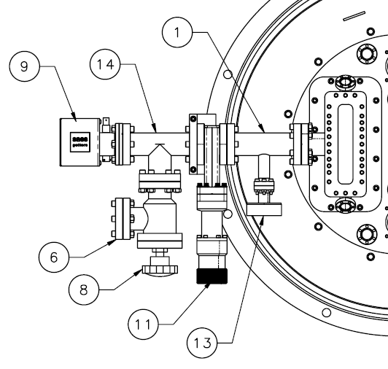
Legend:

- Reducing Tee
6) Blank flange – connection to turbo-pump cart
8) Angle valve
9) NEXTorr model D200-5
11) Gate valve
13) Burst disk
14) Tee
Fig 1. Drawing of the vacuum manifolds connecting the NEXTorr pump to the FPC waveguide.

The power supply NIOPS-03 from SEAS Getters is used for the activation of the NEG pump and operation of the ion pump. Please refer to the link to the Operating Manual of the NIOPS-03 power supply for a detailed description of any function listed in this procedure. The front panel of the power supply and items’ legend are shown in Fig.

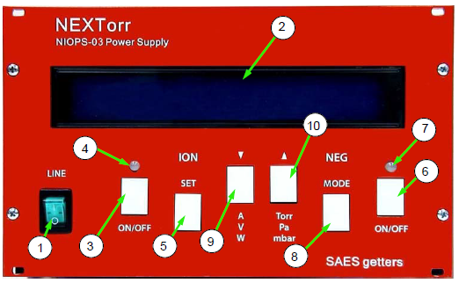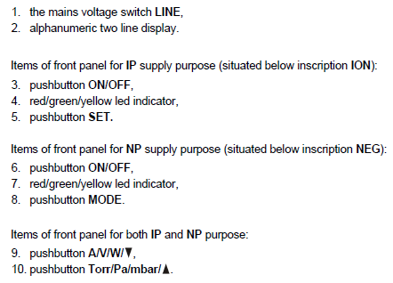
Fig 2. Front panel of the NIOPS-03 power supply and legend of items.
The FPC waveguide and the vacuum manifold shown in Fig. 1 shall be evacuated to a pressure < 10⁻⁶ mbar using a turbo-molecular pump.
- The turbo-pump cart (which should include a vacuum gage) is kept actively pumping the vacuum manifold and waveguide (angle valve open, item 8) throughout the activation process.
- Connect the IP element cable and the NP element cable between the NIOPS-03 power supply and the NEXTorr pump.
- Close the gate valve (item 11), isolating the FPC waveguide from the pumps.
- Turn on the NIOPS-03 power supply.
- Press the MODE button until Tmd Conditioning (timed conditioning) is shown on the 2nd line of the display.
- Press the ON/OFF button in the NEG section to start a 1 h conditioning of the NEG element (15 W power). Power to the NEG element will automatically turn off after 1 h.
- After the conditioning cycle has been completed, press the ON/OFF button in the ION section to turn on the IP. After 2 sec, press again the ON/OFF button in the ION section to turn off the IP. This step “flashes” the ion pump to clean it.
- Open the gate valve (item 11).
- Leak check the whole FPC waveguide assembly in accordance with CEBAF Specification 11141S0029REV_A.
- Once the assembly is leak tight, close the gate valve (item 11)
- Press the MODE button until Tmd Activation (timed activation) is shown on the 2nd line of the display.
- Press the ON/OFF button in the NEG section to start a 1 h activation of the NEG element (60 W power). Power to the NEG element will automatically turn off after 1 h. CAUTION: the tee (item 14 in Fig. 1) will be hot during activation, do not touch!
- After the activation is completed, open the gate valve (item 11).
- The pressure measured by the vacuum gage on the turbo-pump cart should be < 10⁻⁶ mbar. Press the ON/OFF button in the ION section to turn on the IP. The pressure is now shown on the 1st line of the display.
- Close the angle valve.
- Turn off the turbo-pump cart, vent to 1 atm and disconnect from the angle valve.
- Press the ON/OFF button in the ION section to turn off the IP. Turn off the NIOPS-03 power supply and disconnect the cables connected to the ion and NEG connectors on the NEXTorr pump.
- Connect one of the available ion pump power supply to the ion-pump connector on the NEXTorr. ATTENTION: Make sure that the output voltage of the ion pump power supply being used is set to 5 kV!
- Turn on the ion-pump power supply.
Based on the estimated gas load during operation, it is estimated that the NP will saturate after about 3 years of continuous operation, after which a re-activation is required. The procedure for re-activation of the NP is the same as described above, except steps 5)-7) (timed conditioning and flashing of the ion pump) should be skipped.

References

Document No. | Title
SRF-06-PR-001 | Records Management Procedure
SRF-07-PR-001 | Document Management Procedure
JL0064915 | Fundamental waveguide manifold assembly
NIOP-03 User's Manual
Spec 11141S0029REV B | Small items vacuum leak test

Release and Revision History

Rev # | Major Changes | Revision Date:
1 | Initial version (Utilizing SRF-07-FM-005 SRF OPS Procedure Template, R1). Converted from CP-C75-CM-EVAC-NEG-R2. | 15 May 2025

Approvals

Approved by: | Name:
Document Owner | <First Last Name>
Document Reviewer 1  JLab SME or SRFOPS WCL | <First Last Name>
Document Approver 2  SRFOPS WCL or GL | <First Last Name>
For Project Procedures: Refer to the Project Execution Procedure SRF-11-PR-001

Document Processor Instructions:
- Put valid dates everywhere DD is found and verify they are accurate
- Attach DocuShare Approval Picture here

*** Form Approval Page. To be deleted when creating your procedure. ***

Form Release and Revision History

SRF OPS Procedure Template
Document Number: | SRF-07-FM-005 | Effective Date: | 02 Apr 2025
Revision Number: | 1 | Periodic Review Date: | 02 Apr 2028
Document Owner: | Valerie Bookwalter | Department Owner: | SRF Operations

Rev # | Major Changes | Revision Date:
1 | Initial version; Adapted from SRF-07-FM-002 QMS Process Procedure Template R3 | 27 Mar 2025

Form Approvals

Approved by: | Name:
Document Owner | Valerie Bookwalter
Quality Representative | Ashley Mitchell
SRF Department Head | Tony Reilly
