|  |  |  |  |
| --- | --- | --- | --- |
| **Activation of C75 FPC waveguide NEXTorr pump** | | | |
| **Document Number:** | ER5C-PR-WCA-COMP-ACTION | **Effective Date:** | DD Mmm YYYY |
| **Revision Number:** | R1 | **Periodic Review Date:** | N/A |
| **Document Owner:** | J. Fischer | **Department Owner:** | SRF Operations |

# Purpose and Scope

This procedure describes the steps required to properly activate the combination NEG+ion pump (NEXTorr D 200-5, SAES Getters) installed in the warm section of the FPC waveguide of each cavity installed in a C75 cryomodule. The same procedure applied for the periodic re-activation of the NEG pump.

# Definitions and Diagrams

The following terms have specific meanings within this procedure.

|  |  |
| --- | --- |
| **Term** | **Definition** |
| NEG | Non Evaporable Getter |
| IP | Ion pump |
| NP | NEG pump |

# Roles and Responsibilities

The following roles have responsibilities described in this document.

|  |  |
| --- | --- |
| **Role** | **Responsibility** |
| <Job Title> | <Very short summary of activities this job title performs in this procedure.> |
|  |  |

# Safety

The following safety items …

# Procedure

A drawing of the vacuum installation connecting the combination NEG+Ion pump NEXTorr D 200-5 of SAES Getters to the FPC waveguide is shown in Fig. 1.

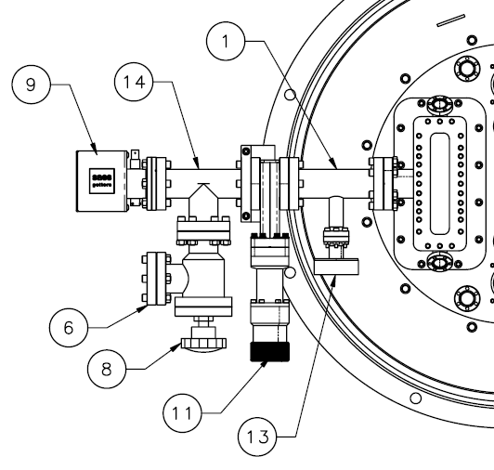

**Legend:**

1. Reducing Tee

6) Blank flange – connection to turbo-pump cart

8) Angle valve

9) NEXTorr model D200-5

11) Gate valve

13) Burst disk

14) Tee

**Fig 1**. Drawing of the vacuum manifolds connecting the NEXTorr pump to the FPC waveguide.

The power supply NIOPS-03 from SEAS Getters is used for the activation of the NEG pump and operation of the ion pump. Please refer to the link to the Operating Manual of the NIOPS-03 power supply for a detailed description of any function listed in this procedure. The front panel of the power supply and items’ legend are shown in Fig.

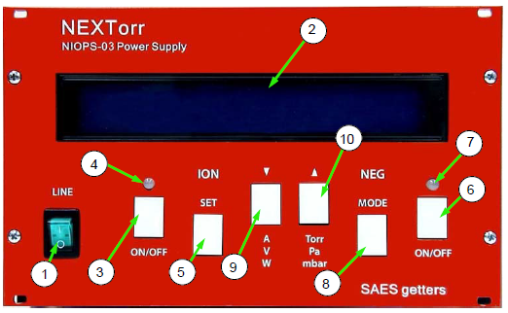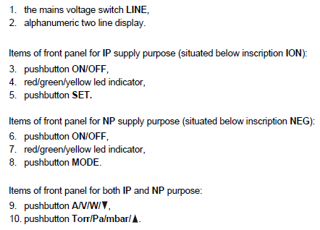

**Fig 2**. Front panel of the NIOPS-03 power supply and legend of items.

The FPC waveguide and the vacuum manifold shown in Fig. 1 shall be evacuated to a pressure < 10-6 mbar using a turbo-molecular pump.

1. The turbo-pump cart (which should include a vacuum gage) is kept actively pumping the vacuum manifold and waveguide (angle valve open, item 8) throughout the activation process.
2. Connect the IP element cable and the NP element cable between the NIOPS-03 power supply and the NEXTorr pump.
3. Close the gate valve (item 11), isolating the FPC waveguide from the pumps.
4. Turn on the NIOPS-03 power supply.
5. Press the **MODE** button until ***Tmd Conditioning*** (timed conditioning) is shown on the 2nd line of the display.
6. Press the **ON/OFF** button in the **NEG** section to start a 1 h conditioning of the NEG element (15 W power). Power to the NEG element will automatically turn off after 1 h.
7. After the conditioning cycle has been completed, press the **ON/OFF** button in the **ION** section to turn on the IP. After 2 sec, press again the **ON/OFF** button in the **ION** section to turn off the IP. This step “flashes” the ion pump to clean it.
8. Open the gate valve (item 11).
9. Leak check the whole FPC waveguide assembly in accordance with CEBAF Specification 11141S0029REV_A.
10. Once the assembly is leak tight, close the gate valve (item 11)
11. Press the **MODE** button until ***Tmd Activation*** (timed activation) is shown on the 2nd line of the display.
12. Press the **ON/OFF** button in the **NEG** section to start a 1 h activation of the NEG element (60 W power). Power to the NEG element will automatically turn off after 1 h. CAUTION: the tee (item 14 in Fig. 1) will be hot during activation, do not touch!
13. After the activation is completed, open the gate valve (item 11).
14. The pressure measured by the vacuum gage on the turbo-pump cart should be < 10-6 mbar. Press the **ON/OFF** button in the **ION** section to turn on the IP. The pressure is now shown on the 1st line of the display.
15. Close the angle valve.
16. Turn off the turbo-pump cart, vent to 1 atm and disconnect from the angle valve.
17. Press the **ON/OFF** button in the **ION** section to turn off the IP. Turn off the NIOPS-03 power supply and disconnect the cables connected to the ion and NEG connectors on the NEXTorr pump.
18. Connect one of the available ion pump power supply to the ion-pump connector on the NEXTorr. **ATTENTION: Make sure that the output voltage of the ion pump power supply being used is set to 5 kV!**
19. Turn on the ion-pump power supply.

Based on the estimated gas load during operation, it is estimated that the NP will saturate after about 3 years of continuous operation, after which a re-activation is required. The procedure for re-activation of the NP is the same as described above, except steps 5)-7) (timed conditioning and flashing of the ion pump) should be skipped.

# References

|  |  |
| --- | --- |
| **Document No.** | **Title** |
| SRF-06-PR-001 | Records Management Procedure |
| SRF-07-PR-001 | Document Management Procedure |
| JL0064915 | [Fundamental waveguide manifold assembly](https://jlabdoc.jlab.org/docushare/dsweb/Get/Document-211569/JL0064915---MANIFOLD%20ASSEMBLY.pdf) |
| [NIOP-03 User's Manual](https://jlabdoc.jlab.org/docushare/dsweb/Get/Document-211568/operating%20instructions%20NIOPS-03.pdf) |  |
| Spec 11141S0029REV B | [Small items vacuum leak test](https://jlabdoc.jlab.org/docushare/dsweb/Get/Document-211729/11141S0029%20Rev%20B%202e-10%20Leak%20Check%20Final.pdf) |

# Release and Revision History

|  |  |  |
| --- | --- | --- |
| **Rev #** | **Major Changes** | **Revision Date:** |
| 1 | Initial version (Utilizing SRF-07-FM-005 SRF OPS Procedure Template, R1). Converted from CP-C75-CM-EVAC-NEG-R2. | 15 May 2025 |
|  |  |  |

# Approvals

|  |  |
| --- | --- |
| **Approved by:** | **Name:** |
| Document Owner | <First Last Name> |
| Document Reviewer 1  JLab SME or SRFOPS WCL | <First Last Name> |
| Document Approver 2  SRFOPS WCL or GL | <First Last Name> |

For Project Procedures: Refer to the Project Execution Procedure SRF-11-PR-001

*Document Processor Instructions:*

* *Put valid dates everywhere DD is found and verify they are accurate*
* *Attach DocuShare Approval Picture here*

**\*\*\* Form Approval Page. To be deleted when creating your procedure. \*\*\***

# Form Release and Revision History

|  |  |  |  |
| --- | --- | --- | --- |
| **SRF OPS Procedure Template** | | | |
| **Document Number:** | SRF-07-FM-005 | **Effective Date:** | 02 Apr 2025 |
| **Revision Number:** | 1 | **Periodic Review Date:** | 02 Apr 2028 |
| **Document Owner:** | Valerie Bookwalter | **Department Owner:** | SRF Operations |

|  |  |  |
| --- | --- | --- |
| **Rev #** | **Major Changes** | **Revision Date:** |
| 1 | Initial version; Adapted from SRF-07-FM-002 QMS Process Procedure Template R3 | 27 Mar 2025 |
|  |  |  |

# Form Approvals

|  |  |
| --- | --- |
| **Approved by:** | **Name:** |
| Document Owner | Valerie Bookwalter |
| Quality Representative | Ashley Mitchell |
| SRF Department Head | Tony Reilly |

