|  |  |  |  |
| --- | --- | --- | --- |
| **CMTF C75 CM Warm-Up Procedure** | | | |
| **Document Number:** | ER5C-PR-CMTF-CM-WARM | **Effective Date:** | DD Mmm YYYY |
| **Revision Number:** | 1 | **Periodic Review Date:** | DD Mmm YYYY |
| **Document Owner:** | David Savransky | **Department Owner:** | SRF Operations |

# Purpose and Scope

The purpose of this document is to outline a procedure to warm-up a C75 Cryomodule in the Cryomodule Testing Facility.

This document applies to the warm-up of any C75 CM in CMTF. This procedure will only outline the steps necessary to be done by an SRF cryo operator, any steps that are to be done by other sources will not be described.

In this procedure, the SRF operator will perform all the pre-checks to begin the warm-up, perform the warm-up of both the primary and shield, and then stabilize the CM at 300K.

# Definitions and Diagrams

The following terms have specific meanings within this procedure.

|  |  |
| --- | --- |
| **Term** | **Definition** |
| CM | Cryomodule |
| CD | Cooldown |
| JB | Junction Box |
| VB | Valve Box |
| SC | Subcooler |
| HP | High Pressure |
| LP | Low Pressure |
| LVDT | Linear variable differential transformer |
| CMTF | Cryomodule Testing Facility |
| CTF | Cryogenics Testing Facility |

# Roles and Responsibilities

The following roles have responsibilities described in this document.

|  |  |
| --- | --- |
| **Role** | **Responsibility** |
| SRY Cryo Operator | Perform and Monitor C75 CM CD |
| Cryo Operator | Perform CM pumpdown and provide support during CD |

# Safety

The following safety items …

# Procedure

## Shield Warm-Up

1. Make a log entry stating that the C75 Shield warm-up in CMTF is about to begin
   * Included LOGS: ELOG,SRFLOG,CLOG,SRFVTALOG
2. Stop the flow through the shield circuit
   * Open the shield CD valve
   * Close shield supply valve and shield return valve

## Primary Circuit Warm-Up (Passive)

1. Make a log entry stating that the C75 warm-up in the CMTF is about to begin
   * Included LOGS: ELOG,SRFLOG,CLOG,SRFVTALOG
2. Ensure that the JB alarm set-points are set to the following values:
   * CPICMTC2H: 2.2
   * CPICMTC2L: 0
   * CLLTC1: -80
   * If any alarms have to be changed, make a log entry to CLOG and ELOG
3. Close all flow going through the CM
   * CEVCMTC2 Fully Closed
   * CEV2452 Fully Closed
4. Turn on the Cavity heaters to 60W
5. Close the RT Valve; this will pressurize the CM
6. Leave the GV on through the whole warm-up process

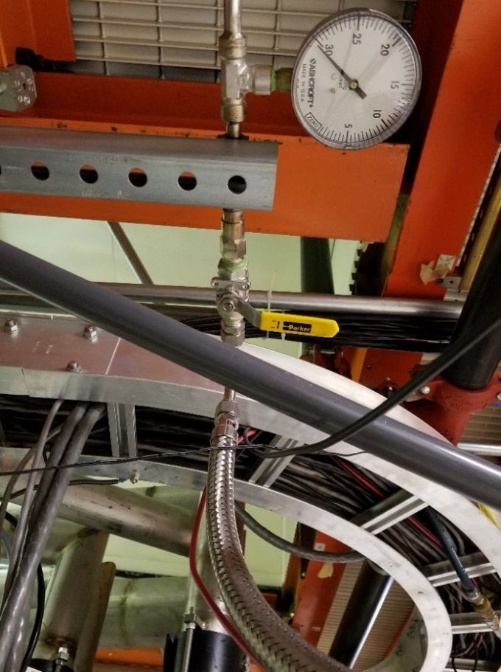

1. Change the JB alarm set-points are set to the following values:
   * CPICMTC2H: 2.2
   * CPICMTC2L: 1
   * CLLTC1: -80
   * If any alarms have to be changed, make a log entry to CLOG and ELOG
2. Once the liquid falls below 0%:
   * Turn off the liquid level readbacks in the CMTF control room
   * Turn off cavity heaters
3. Leave the guard vacuum on through the whole warm-up
4. Once the midplane diodes for all cavities go above 50K, request that the insulating vacuum bumped to 1 torr
   * Ensure that the warm-up rate of any of the midplane diodes does not exceed 50K/hour during this time
5. Once the midplane diodes for all cavities go above 100K, request that the insulating vacuum bumped to 20 torr
   * Ensure that the warm-up rate of any of the midplane diodes does not exceed 50K/hour during this time
6. Once the midplane diodes for all cavities go above 200K, request that the insulating vacuum bumped to 400 torr
   * Ensure that the warm-up rate of any of the midplane diodes does not exceed 50K/hour during this time
7. Once all midplane diodes reach above 290K, the warm-up is done.
8. Make a log entry stating that the C75 warm-up in the CMTF is complete
   * Included LOGS: ELOG,SRFLOG,CLOG,SRFVTALOG

## Primary Circuit Warm-Up (Active)

1. Coordinate the removal of the primary supply u-tube with CM assembly and Cryo groups
   * Inform VTA that this operation will be occurring
2. Make a log entry stating that the C75 warm-up in the CMTF is about to begin
   * Included LOGS: ELOG,SRFLOG,CLOG,SRFVTALOG
3. Ensure that the JB alarm set-points are set to the following values:
   * CPICMTC2H: 2.2
   * CPICMTC2L: 0
   * CLLTC1: -80
   * If any alarms have to be changed, make a log entry to CLOG and ELOG
4. Close all flow going through the CM
   * CEVCMTC2 Fully Closed
   * CEV2452 Fully Closed
5. Turn on the Cavity heaters to 60W
6. Close the RT Valve; this will pressurize the CM
7. Leave the GV up through the whole warm-up process

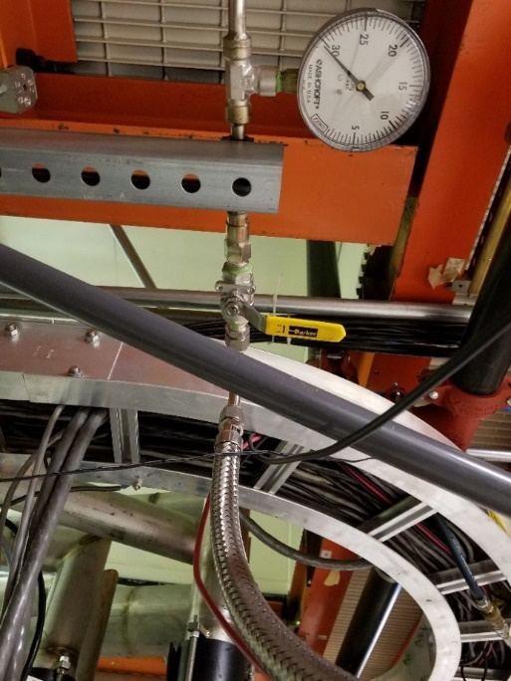

1. Change the JB alarm set-points are set to the following values:
   * CPICMTC2H: 2.2
   * CPICMTC2L: 1
   * CLLTC1: -80
   * If any alarms have to be changed, make a log entry to CLOG and ELOG
2. Once the liquid falls below 0%:
   * Turn off the liquid level readbacks in the CMTF control room
   * Turn off cavity heaters
3. Leave the guard vacuum on through the whole warm-up
4. Ensure that a warm-helium line is hooked up to the primary supply port on the utube
5. Slowly begin opening the JT allowing warm gas to flow through the CM
   * The CM will begin warming up from cavity pairs 1&2 onwards to cavity pair 7&8)
   * Ensure that the warm-up rate of any of the midplane diodes does not exceed 50K/hour during this time
6. Once a consistence warm-up rate is achieved, the CM can be allowed to passably warm-up with the gas flowing through the CM.
7. Once the midplane diodes for all cavities go above 50K, request that the insulating vacuum bumped to 1 torr
   * Ensure that the warm-up rate of any of the midplane diodes does not exceed 50K/hour during this time
8. Once the midplane diodes for all cavities go above 100K, request that the insulating vacuum bumped to 20 torr
   * Ensure that the warm-up rate of any of the midplane diodes does not exceed 50K/hour during this time
9. Once the midplane diodes for all cavities go above 200K, request that the insulating vacuum bumped to 400 torr
   * Ensure that the warm-up rate of any of the midplane diodes does not exceed 50K/hour during this time

Once all midplane diodes reach above 290K, the warm-up is done.

Make a log entry stating that the C75 warm-up in the CMTF is complete

* + Included LOGS: ELOG,SRFLOG,CLOG,SRFVTALOG

# Appendix: All Required Signals

|  |  |
| --- | --- |
| CC CM Temperature Sensors | |
| **Description (Temperature Diodes)** | **Drawing Identification** |
| Cavity 1 HOM Mid | CTDXLXX23 |
| Cavity 2 HOM Mid | CTDXLXX21 |
| Cavity 3 HOM Mid | CTDXLXX31 |
| Cavity 4 HOM Mid | CTDXLXX33 |
| Cavity 5 HOM Mid | CTDXLXX41 |
| Cavity 6 HOM Mid | CTDXLXX43 |
| Cavity 7 HOM Mid | CTDXLXX51 |
| Cavity 8 HOM Mid | CTDXLXX53 |
| Primary Supply U-tube 1 | PS01 |
| Primary U-tube Return 2 | PR02 |
| Primary U-tube Return 3 | PR03 |
| Shield U-tube Supply 1 | SS01 |
| Shield U-tube Supply 2 | SS02 |
| Shield U-tube Return 3 | SS03 |
| *These values can be found on the CC information chart.  Contact Instrumentation Lead for this chart | |

Table 1: CM Temperature for LivePlot 1

|  |  |
| --- | --- |
| Other CM Temperature Sensors | |
| **Description (Temperature Diodes)** | **PV** |
| Temperature before Vaporizer (Junction Box) | CTD2452 |
| Shield Inlet (Endcan) | CTD46011/CTD46012 |
| Shield Outlet (Endcan) | CTD46019/CTD46020 |
| Primary Supply (Endcan) | CTD46017/CTD46018 |
| Primary Return (Endcan) | CTD46009/CTD46010 |

Table 2: Other CM Signals

|  |  |
| --- | --- |
| Liquid Helium Characteristics | |
| **Description** | **PV** |
| Helium Pressure 0 - 5000 Torr | CPICMTC2 (SRFCMTFHEPRES5000) |
| Helium Pressure 0 - 100 Torr | CPICMTC1 (SRFCMTFHEPRES100) |
| Helium Pressure 0 - 50 Torr | SRFCMTFHEPRES50 |
| Cryomodule Downstream Liquid Level | CLLTC1 (SRFCMTFLLRETURN) |
| Cryomodule Upstream Liquid Level | SRFCMTFLLSUPPLY |
| Junction Primary Supply Temperature | CTD23210 |
| Primary Supply to CM Flow Rate | CFI23211 |

Table 3: CM Properties

|  |  |
| --- | --- |
| Characteristic Valves | |
| **Description** | **PV** |
| CM JT Valve | CEVCMTC2ORBV |
| Primary Supply Vaporizer | CEV2452ORBV |
| Primary Sub-Atmospheric Return | CPV23120OVAL |
| Primary Atmospheric Return | CPV23129OVAL |

Table 4: Valves to Watch

|  |  |
| --- | --- |
| Shield Cooldown Characteristics | |
| **Description** | **PV** |
| Shield Supply Valve | CPV23271OVAL |
| Shield Flow Rate | CFI23271 |
| CB1 Output Temperature | CTD23170 |
| CB1 Return Temperature | CTD23180 |

Table 5: Shield Circuit Properties

|  |  |
| --- | --- |
| Return & Recovery Characteristics | |
| Description | **PV** |
| Purifier Line Pressure | CPI284 |
| Purifier Line Flow | CFI282 |
| Junction Box Pressure 100 - 1000 Torr | CIP23221H |
| Junction Box Pressure 0 – 100 Torr | CIP23221L |
| Valve Box Return Pressure | CPI23120 |
| Kinney Return Pressure | CPI2091 |

Table 6: Recovery Pressure and Characteristics

|  |  |
| --- | --- |
| CM Vacuum Properties | |
| Description | **PV** |
| Waveguide Pressure | SRFCMTFWGVAC{1-8} |
| Beamline Pressure | SRFCMTFINSULVAC1 |
| Insulating Vacuum Pressure | SRFCMTFBLVAC1 |

Table 7: CM Vacuum Properties

# References

|  |  |
| --- | --- |
| **Document No.** | **Title** |
| SRF-06-PR-001 | Records Management Procedure |
| SRF-07-PR-001 | Document Management Procedure |

# Release and Revision History

|  |  |  |
| --- | --- | --- |
| **Rev #** | **Major Changes** | **Revision Date:** |
| 1 | Initial version (Utilizing SRF-07-FM-005 SRF OPS Procedure Template, R1) | DD Mmm YYY |
|  |  |  |

# Approvals

|  |  |
| --- | --- |
| **Approved by:** | **Name:** |
| Document Owner | David Savransky |
| SME | Matt Weaks |
| SME | Mike McCaughan |
| Work Center Lead | Mike Drury |
| SRF Department Head | Tony Reilly |

For Project Procedures: Refer to the Project Execution Procedure SRF-11-PR-001

*Document Processor Instructions:*

* *Put valid dates everywhere DD is found and verify they are accurate*
* *Attach DocuShare Approval Picture here*