|  |  |  |  |
| --- | --- | --- | --- |
| **CMTF C75 CM Cooldown Procedure** | | | |
| **Document Number:** | ER5C-PR-CMTF-CM-COOL | **Effective Date:** | DD Mmm YYYY |
| **Revision Number:** | 1 | **Periodic Review Date:** | DD Mmm YYYY |
| **Document Owner:** | David Savransky | **Department Owner:** | SRF Operations |

# Purpose and Scope

The purpose of this document is to outline a procedure to cooldown a C75 Cryomodule in the Cryomodule Testing Facility (CMTF).

This document applies to the cooldown of any C75 CM in CMTF. This procedure will only outline the steps necessary to be done by an SRF cryo operator, any steps that are to be done by other sources will not be described.

In this procedure, the SRF operator will perform all the pre-checks to begin cooldown, perform the cooldown of both the primary and shield, and then stabilize the CM at 4K. Following the stabilization at 4K and a 1 day soak, the CM will be pumped down by Cryo. The SRF operator will then stabilize the CM at 2K.

# Definitions and Diagrams

The following terms have specific meanings within this procedure.

|  |  |
| --- | --- |
| **Term** | **Definition** |
| CM | Cryomodule |
| CD | Cooldown |
| JB | Junction Box |
| VB | Valve Box |
| SC | Subcooler |
| HP | High Pressure |
| LP | Low Pressure |
| LVDT | Linear variable differential transformer |
| CMTF | Cryomodule Testing Facility |
| CTF | Cryogenics Testing Facility |

# Roles and Responsibilities

The following roles have responsibilities described in this document.

|  |  |
| --- | --- |
| **Role** | **Responsibility** |
| SRF Cryo Operator | Perform and Monitor C75 CM CD |
| Cryogenics Operator | Perform CM pumpdown and provide support during CD |

# Safety

The following safety items …

# Procedure

## Signal Verification

* Verify all SRF signals (Table 1)
  + Ensure that all signals are reading back a correct value
  + If any signals read back unrealistic values (e.x the CM is at 300K but a sensor readback is 30K) or have no readback (NAN or Blank EPICS Box)
    - Ensure that cables are connected
    - Contact instrumentation lead for assistance
* Verify all signals are being logged with MyaPlot
  + If signals are not logging or logging a ‘0’ contact the individual in charge of MyaPlot
  + Verify all CryoCon signals are being acquired and logged to Myaplot

## Valve Verification

* Verify that all SRF owned EVs are operational and installed
  + Conduct a walk-through of the CMTF ensuring that all valves and LVDTs are plugged in
  + Drive the valve fully open and closed; if the valve limits change during this test, contact the valve owner in order to get an inspection of the valve body for any loose fittings
    - This should be done before the u-tubes are connected
    - Ensure that this test will not interfere with any ongoing tests
  + Safety Request:
    - This testing should be done before the u-tubes are connected
    - Ensure that this test will not interfere with any ongoing tests
* Ensure that all SRF owned EVs are calibrated
  + Ensure that when the valve is fully closed, the valves readback is approximately ‘0’
  + In some cases, the full open position will go above the LVDT max limit, this is acceptable.
  + Safety Request:
    - This testing should be done before the u-tubes are connected
    - Ensure that this test will not interfere with any ongoing tests
* Ensure that none of the valves are in local mode
  + If a valve is in local mode, contact Cryo and ensure that cooldown operations can continue

# U-Tube Installation Checklist

* After U-Tube Installation, determine that the following operations have been completed
  + Ensure the vaporizer line is connected to the U-Tube
  + Check that the cable is connected to the gauge on the insulating vacuum pump manifold
  + Ensure that the guard vacuum line is connected **(See Below)**

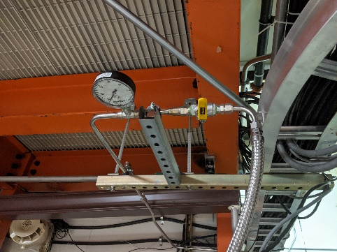

Figure 1: Guard Vacuum Line (Right)

# Shield Cooldown

1. Verify that the CTF dewar (CLL2762MAO on the DEWAR tab) is over 60% full
   1. If the dewar is not full, confirm with cryo before starting
2. Make a log entry stating that the C75 Shield CD in CMTF is about to begin
   1. Included LOGS: ELOG,SRFLOG,CLOG,SRFVTALOG
3. Start the flow through the shield circuit
   1. Open shield supply valve and shield return valve
   2. Ensure that shield CD valve is closed
4. The shield line will now begin to flow
   1. If the shield temperature sensors plateau before reaching the operations temperature while there is liquid helium in the CM (CTP2420/CTP2421), contact Cryo.
5. No further action needs to be taken on the shield line.
   1. Continue to monitor the shield temperature diodes
   2. Monitor the operational statues of cold box 1

# Primary Cooldown

1. Make a log entry stating that the C75 CD in CMTF is about to begin
   1. Included LOGS: ELOG,SRFLOG,CLOG,SRFVTALOG
   2. Include all insulating vacuum values in the log:
      1. Insulating Vacuum
      2. Beam Line Vacuum
      3. Waveguide Vacuum
2. Ensure that the JB alarm set-points are set to the following values:
   1. CPICMTC2H: 2.2
   2. CPICMTC2L: 1
   3. CLLTC1: -80
   4. If any alarms have to be changed, make a log entry to CLOG and ELOG
3. Begin with the following valve settings:
   1. CPV60RT Fully Open
   2. CEVCMTC2 Fully Closed
   3. CEV2452 Fully Closed
4. Things to monitor during the full length of the CD:
   1. Monitor the Purifier line pressures (CPI284) and flow (CFI282) on the CTF Vacuum and Storage page (Recovery tab).
      1. If CPI284 exceeds 1.15 atm **(while CFI282 is at 16 g/s)**, dial back on the JT Valve (CEVCMTC2) to reduce the flow.
      2. If the cryomodule return helium pressure goes above 2.0 atm, back off on JT valve.
      3. Any sudden changes to the JT or vaporizer valve can affect CPI284; follow up any intentional or unintentional fast movements of the JT or vaporizer valves with a check on the recovery pressures.
   2. Once the CM begins to cooldown, the return flow to the CMTF will begin freezing the return line. A new vaporizer has been installed in order to combat these issues as a frozen return line correlates to a shorted main compressor lifetime. The following comments should be maintained until the CM is stable at 4K:
      1. Communicate with Cryo to ensure that the return path does not freeze
         1. Cryo might ask to slow down the cooldown if it is found necessary
         2. Ensure to read the CLOG at start of every shift to ensure that no issues have been found
      2. Ensure that the return line temperature probe (CTP284) does not get below 280K
         1. Slow down the cooldown if this occurs
   3. If the liquid level of the CTF dewar (CLL2762MAO) falls below 25%, use the JT Valve to limit the flow into the CM; the CTF liquid level should stabilize and begin to rise.
      1. Resume cooldown when the dewar level is at least 40%.
      2. Temperatures in the CM may rise during this fill process.
5. Open the vaporizer valve (CEV2452) in steps of 10% per minute until it is fully open.
   1. When the inlet flow gets colder, ice will start to form on the vaporizer coils.
   2. If the return line temperature probe (CTP284) begins to drop below 280K, back off on the vaporizer
6. Slowly crack the JT Valve (CEVCMTC2) in steps of 10% every minute until it is fully open.
   1. Monitor CM helium pressure (CPICMTC2) to ensure that it does not exceed 2 atm.
7. Once the CM Inlet Flow fall below 100K (CTD2452), the vaporizer valve (CEV2452) can begin getting closed.

1. Once the inlet is cold, the first cavity will begin to cool (CTDXLXX23).
   1. Ensure that the rate of cooldown for each of the cavities average at least 100K/hour and a maximum of 140K/hour
2. For the remainder of the cooldown, ensure that the cooling rate of any of the cavity midplane diodes do no exceed 140K/hour
   1. Cavity pairs will usually cooldown together {1&2,3&4, 5&6, 7&8}
3. Once the last pair of cavities goes below 100K, turn on the LL readback cards in the CMTF
4. Continue filling the CM until the LL is at 90% LL.
   1. If the module is not filling or maintaining liquid with the JT valve fully open, refer to the **TOD** for appropriate escalations.
5. Change the JB alarm set-points to the following values:
   1. CPICMTC2H: 2.2
   2. CPICMTC2L: 1
   3. CLLTC1: 80
   4. If any alarms have to be changed, make a log entry to CLOG and ELOG
6. The cryomodule will soak at 4K for at least 24 hours.
7. After the soak, inform the cryo group that the CM is ready to be pumped down to 2K.

# Pumpdown

1. Before pumpdown begins, change the JB alarm set-points to the following values:
   1. CPICMTC2H: 2.2
   2. CPICMTC2L: 0
   3. CLLTC1: -80
   4. If any alarms have to be changed, make a log entry to CLOG and ELOG
2. When the CM goes sub-atmospheric, Open the Guard Vacuum manual valve (**see below**)

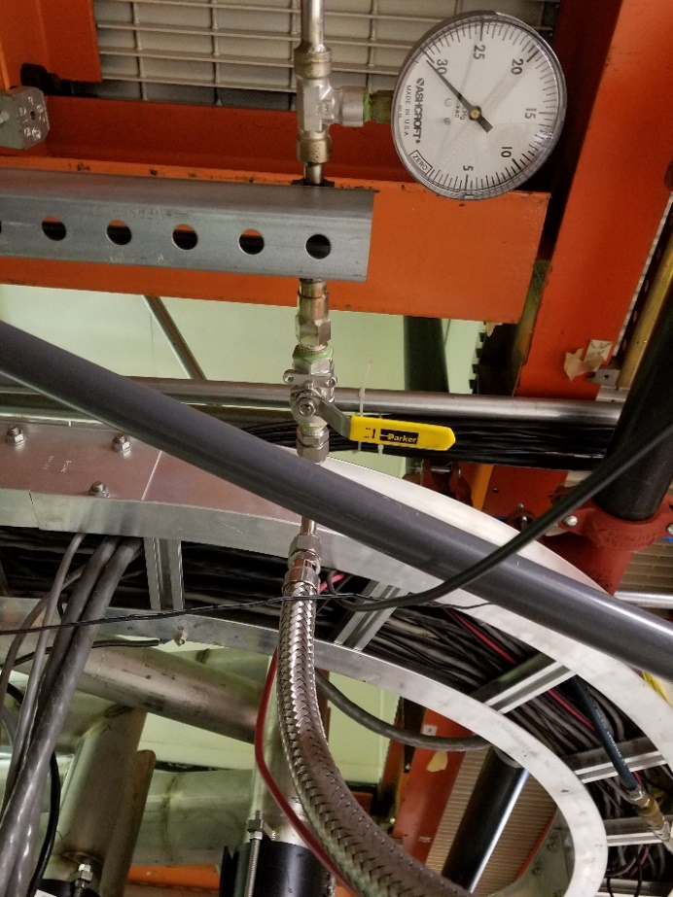

Figure 3: Guard Vacuum Manual Valve

1. Change the JB alarm set-points to the following values once the CM is full and stable at 2K:
   1. CPICMTC2H: 0.05
   2. CPICMTC2L: 0
   3. CLLTC1: 80
   4. If any alarms have to be changed, make a log entry to CLOG and ELOG
2. Once the CM is stable at 2K, set the valves to their 2K overnight position.

# Appendix: All Required Signals

|  |  |
| --- | --- |
| CC CM Temperature Sensors | |
| **Description (Temperature Diodes)** | **Drawing Identification** |
| Cavity 1 HOM Mid | CTDXLXX23 |
| Cavity 2 HOM Mid | CTDXLXX21 |
| Cavity 3 HOM Mid | CTDXLXX31 |
| Cavity 4 HOM Mid | CTDXLXX33 |
| Cavity 5 HOM Mid | CTDXLXX41 |
| Cavity 6 HOM Mid | CTDXLXX43 |
| Cavity 7 HOM Mid | CTDXLXX51 |
| Cavity 8 HOM Mid | CTDXLXX53 |
| Primary Supply U-tube 1 | PS01 |
| Primary U-tube Return 2 | PR02 |
| Primary U-tube Return 3 | PR03 |
| Shield U-tube Supply 1 | SS01 |
| Shield U-tube Supply 2 | SS02 |
| Shield U-tube Return 3 | SS03 |
| *These values can be found on the CC information chart.  Contact Instrumentation Lead for this chart | |

Table 1: CM Temperature for LivePlot 1

|  |  |
| --- | --- |
| Other CM Temperature Sensors | |
| **Description (Temperature Diodes)** | **PV** |
| Temperature before Vaporizer (Junction Box) | CTD2452 |
| Shield Inlet (Endcan) | CTD46011/CTD46012 |
| Shield Outlet (Endcan) | CTD46019/CTD46020 |
| Primary Supply (Endcan) | CTD46017/CTD46018 |
| Primary Return (Endcan) | CTD46009/CTD46010 |

Table 2: Other CM Signals

|  |  |
| --- | --- |
| Liquid Helium Characteristics | |
| **Description** | **PV** |
| Helium Pressure 0 - 5000 Torr | CPICMTC2 (SRFCMTFHEPRES5000) |
| Helium Pressure 0 - 100 Torr | CPICMTC1 (SRFCMTFHEPRES100) |
| Helium Pressure 0 - 50 Torr | SRFCMTFHEPRES50 |
| Cryomodule Downstream Liquid Level | CLLTC1 (SRFCMTFLLRETURN) |
| Cryomodule Upstream Liquid Level | SRFCMTFLLSUPPLY |
| Junction Primary Supply Temperature | CTD23210 |
| Primary Supply to CM Flow Rate | CFI23211 |

Table 3: CM Properties

|  |  |
| --- | --- |
| Characteristic Valves | |
| **Description** | **PV** |
| CM JT Valve | CEVCMTC2ORBV |
| Primary Supply Vaporizer | CEV2452ORBV |
| Primary Sub-Atmospheric Return | CPV23120OVAL |
| Primary Atmospheric Return | CPV23129OVAL |

Table 4: Valves to Watch

|  |  |
| --- | --- |
| Shield Cooldown Characteristics | |
| **Description** | **PV** |
| Shield Supply Valve | CPV23271OVAL |
| Shield Flow Rate | CFI23271 |
| CB1 Output Temperature | CTD23170 |
| CB1 Return Temperature | CTD23180 |

Table 5: Shield Circuit Properties

|  |  |
| --- | --- |
| Return & Recovery Characteristics | |
| Description | **PV** |
| Purifier Line Pressure | CPI284 |
| Purifier Line Flow | CFI282 |
| Junction Box Pressure 100 - 1000 Torr | CIP23221H |
| Junction Box Pressure 0 – 100 Torr | CIP23221L |
| Valve Box Return Pressure | CPI23120 |
| Kinney Return Pressure | CPI2091 |

Table 6: Recovery Pressure and Characteristics

|  |  |
| --- | --- |
| CM Vacuum Properties | |
| Description | **PV** |
| Waveguide Pressure | SRFCMTFWGVAC{1-8} |
| Beamline Pressure | SRFCMTFINSULVAC1 |
| Insulating Vacuum Pressure | SRFCMTFBLVAC1 |

Table 7: CM Vacuum Properties

# References

|  |  |
| --- | --- |
| **Document No.** | **Title** |
| SRF-06-PR-001 | Records Management Procedure |
| SRF-07-PR-001 | Document Management Procedure |

# Release and Revision History

|  |  |  |
| --- | --- | --- |
| **Rev #** | **Major Changes** | **Revision Date:** |
| 1 | Initial version (Utilizing SRF-07-FM-005 SRF OPS Procedure Template, R1) | DD Mmm YYY |

# Approvals

|  |  |
| --- | --- |
| **Approved by:** | **Name:** |
| Document Owner | David Savransky |
| SME 1 | Matt Weaks |
| SME 2 | Mike McCaughan |
| Work Center Lead | Mike Drury |
| SRF Department Head | Tony Reilly |

For Project Procedures: Refer to the Project Execution Procedure SRF-11-PR-001

*Document Processor Instructions:*

* *Put valid dates everywhere DD is found and verify they are accurate*
* *Attach DocuShare Approval Picture here*