|  |  |  |  |
| --- | --- | --- | --- |
| **LCLS-II FPCW Bellows Restraint Installation** | | | |
| **Document Number:** | L2HE-PR-WCA-COMP-INST | **Effective Date:** | DD Mmm YYYY |
| **Revision Number:** | 1 | **Periodic Review Date:** | DD Mmm YYYY |
| **Document Owner:** | <First Last Name> | **Department Owner:** | SRF Operations |

# Purpose and Scope

This procedure is used to describe the steps involved to install a bellows restraint on the FPCW cold coupler bellows of an LCLS-II cryomodule through the tuner access port. The bellows restraint is to be installed prior to cross country shipping to reduce the bellows motion along the axis of the cryomodule. It must be removed after arrival at the destination through a similar procedure.

# Definitions and Diagrams

The following terms have specific meanings within this procedure.

|  |  |
| --- | --- |
| **Term** | **Definition** |
| <Term 1> | <Definition> |
| <Term 2> | <Definition> |
|  |  |

# Roles and Responsibilities

The following roles have responsibilities described in this document.

|  |  |
| --- | --- |
| **Role** | **Responsibility** |
| <Job Title> | <Very short summary of activities this job title performs in this procedure.> |
|  |  |

# Safety

The following safety items …

# Procedure

## List of Material and Tools needed for this Procedures

1. 8 @ Mmount® bellows restraints; accept no substitutes.

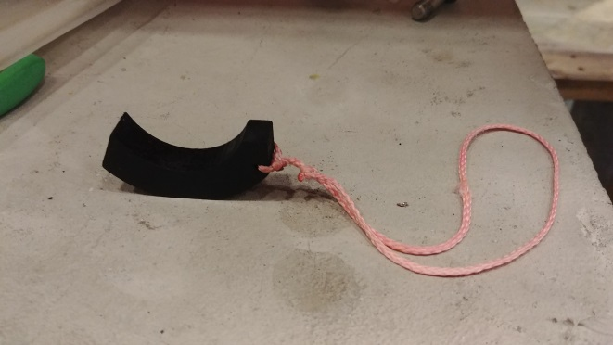

1. Nylon Cable ties; Pro-Power no. VPT-368-C. Newark stock no. 78N510. 15-1/2”, 50# min.
2. Dow-Corning High Vacuum Grease, #2021854-0807
3. Small diagonal cutters

## LCLS-II Procedure for Installing the FPCW Cold Coupler Bellows Restraint

1. Remove the tuner access port cover.
2. Cut back Multi Layer Insulation (MLI) to expose port in 50K shield. Tape back MLI.
3. Remove port in 50K shield by removing the 2 screws. DO NOT DROP SCREWS.
4. Install a work light in port and examine where tuner and heat stationing is.

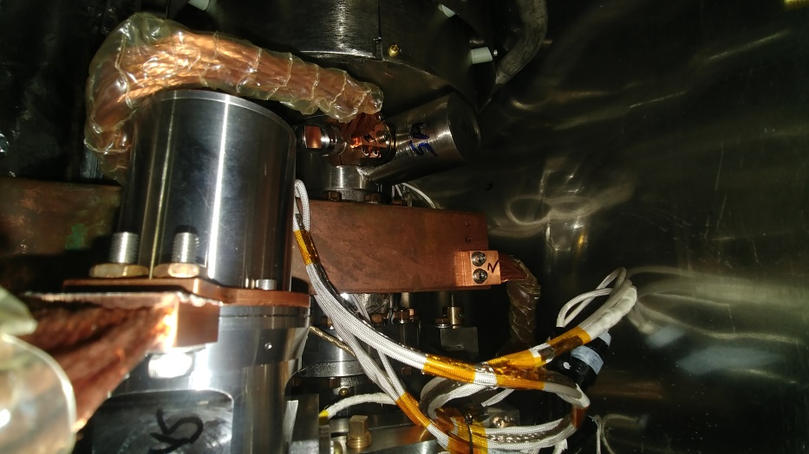

HOM copper strap

L shaped heat station

Tuner motor

HOM copper strap

1. Pre-shape 2 cable ties into basket.

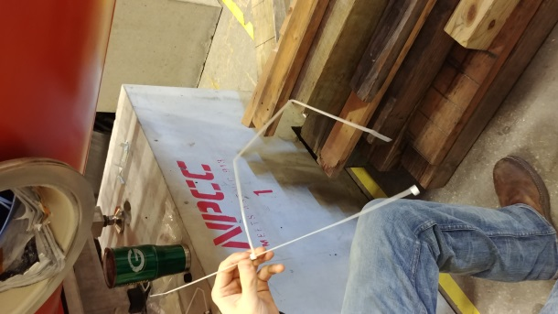

1. Lubricate the Mmount using the Corning vacuum grease.
2. Install a rubber sheet over the beamline bellows to protect it while you reach through the port.
3. The illustration below shows schematically how the bellows restraint should fit on the coupler.

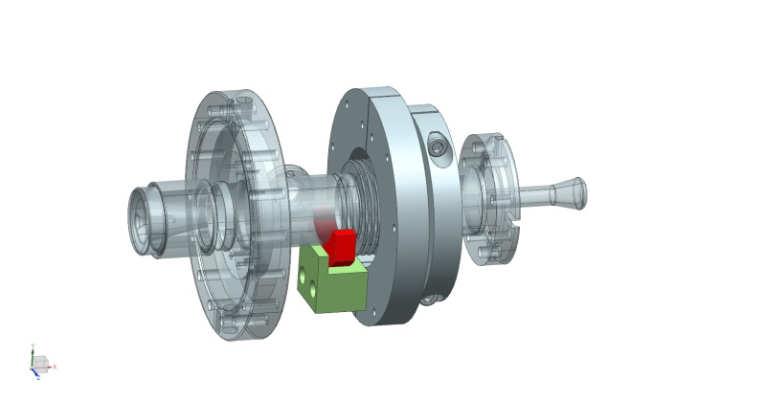

1. To insert the Mmount, insert your hand through the port to your right of the HOM.
   1. Go over the cavity to the right and bend your arm and elbow to form an “L” over the beamline. Find the copper braid to orient yourself to the coupler.

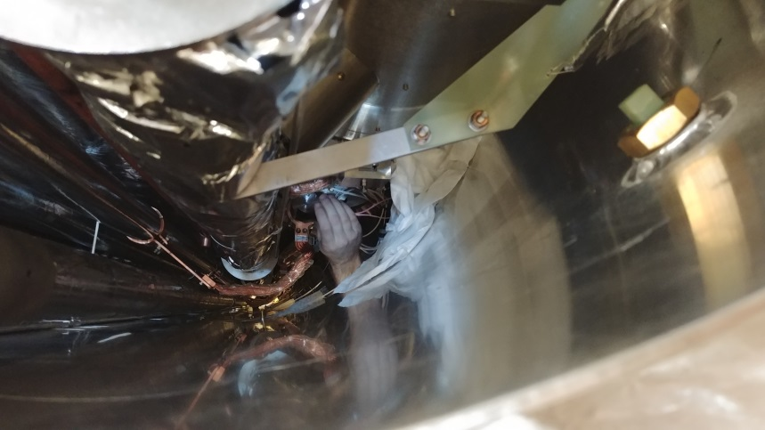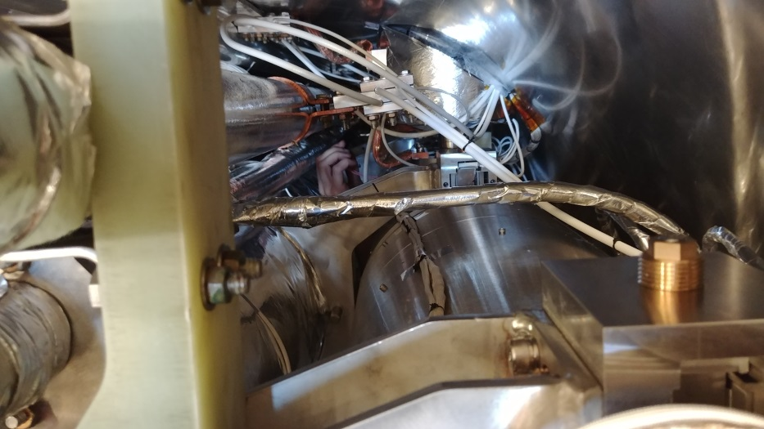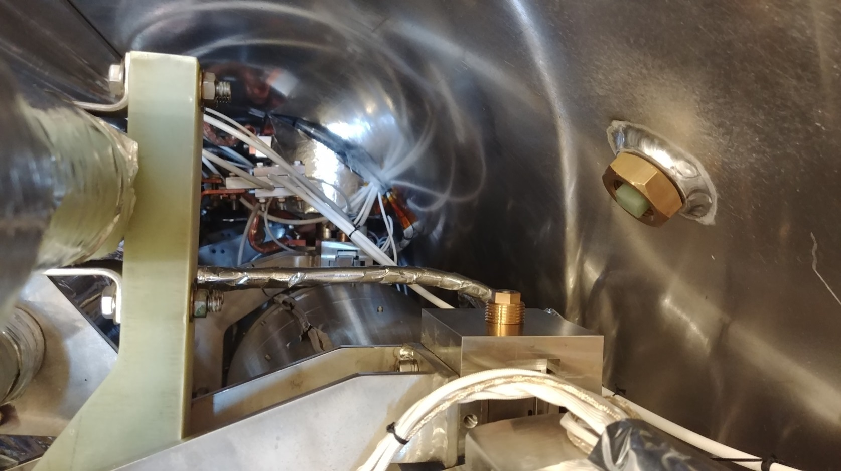

1. Slip the clamp into place on the bellows. The string hangs to the left so that it can be grabbed for removal of the restraint after shipping.
2. Once the M mount has slipped into place, carefully remove arm.
3. Take cable tie and slip arm through over the cavity again. Slip the end of the cable tie between the copper strap and the beam tube.

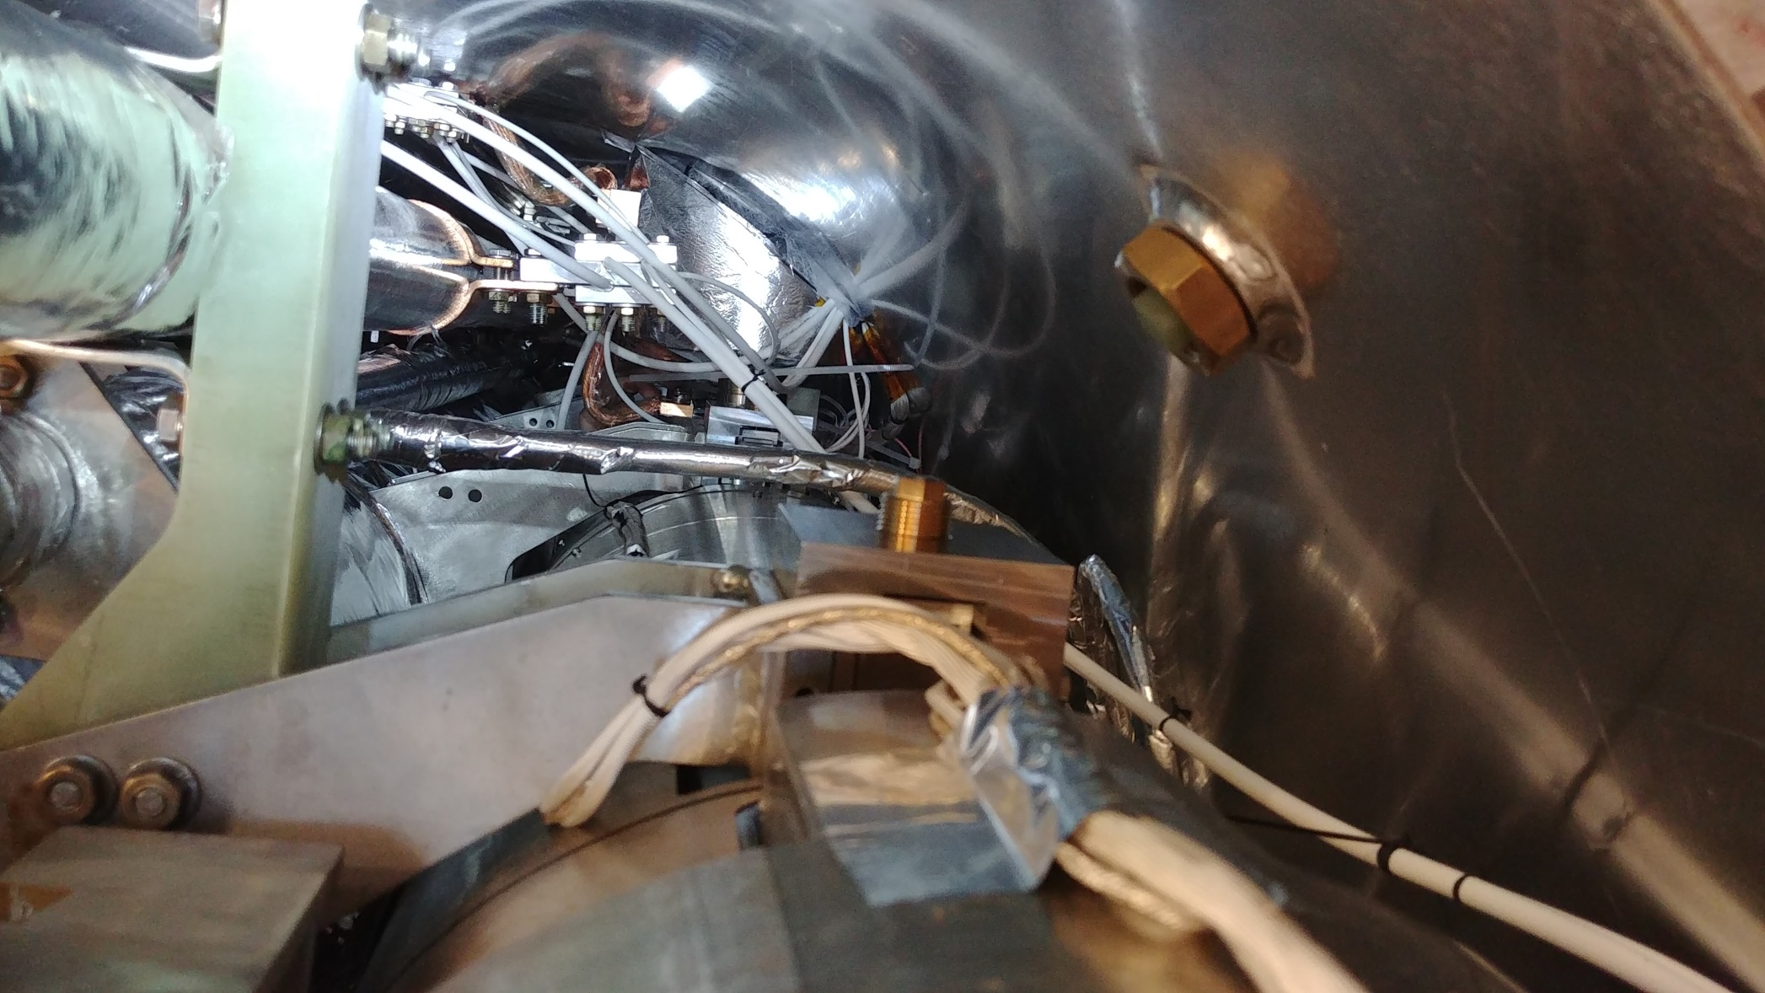

End of cable tie used as a handle during insertion. Slip under copper strap to hold in place while repositioning arm.

Cable tie inserted over the beamline. Borescope must be used during installation to prevent capturing wires under the tie.

1. Slide arm under the cavity string and find ends of cable ties and fit together. Be careful to avoid all wires on the coupler.

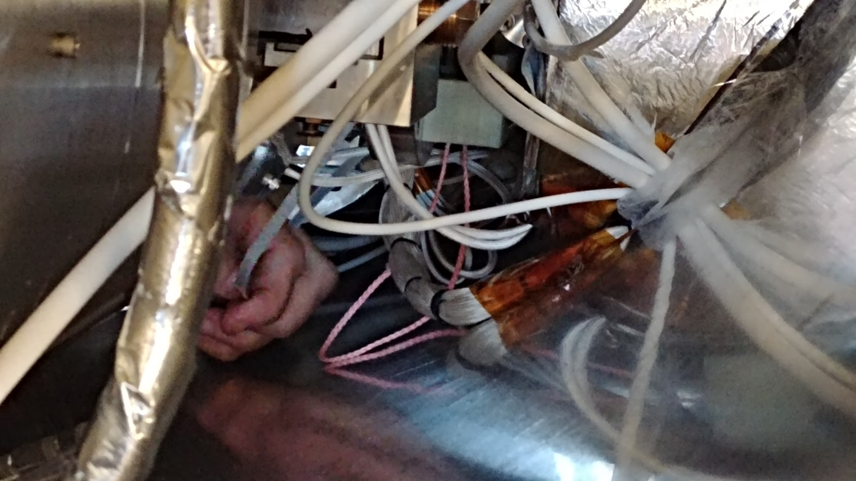

1. Cinch down the cable tie to hold the restraint in place during travel.

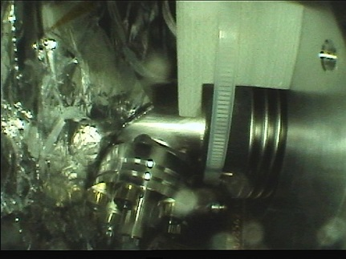

1. Remove the work light. Remove the rubber bellows cover.
2. Sign off on the installation in Table 1 below.
3. Use the Olympus borescope to take a picture of the final installation. Store as part of the shipping traveler.
4. Move to next FPC to install restraint. Go to Step 1.
5. After last restraint is installed, the checker should review the installations through the open port for completeness. The checker will initial the table below after a satisfactory inspection.

|  |  |  |  |
| --- | --- | --- | --- |
| Cavity | Installer Initials | Date | Checker Initials |
| 1 |  |  |  |
| 2 |  |  |  |
| 3 |  |  |  |
| 4 |  |  |  |
| 5 |  |  |  |
| 6 |  |  |  |
| 7 |  |  |  |
| 8 |  |  |  |

TABLE 1: Sign-off for bellows restraint installations

1. Install the instrumentation in the cryomodule according to FNAL sensor instrumentation procedure in Shipping traveler.
2. Check the sensor instrumentation on the cryomodule for damage during installation. Check as part of the Shipping traveler.
3. Check the HOM frequencies to be sure they have not been disturbed during installation. Check as part of the Shipping traveler.
4. Reinstall the 50K shield port covers for shipment.
5. Close up the MLI with tape.
6. Reinstall the tuner port covers on the vacuum vessel.

The module is now ready to finish shipping traveler

## Bellows Restraint Removal Steps

1. Remove the tuner access port cover.
2. Cut back Multi Layer Insulation (MLI) to expose port in 50K shield. Tape back MLI.
3. Remove port in 50K shield by removing the 2 screws. DO NOT DROP SCREWS.
4. Install a work light in port and examine where tuner and heat stationing is.
5. Reach under the beamline to install the sensors according to FNAL procedure.
6. Reach underneath the cavity string with the diagonal cutters and cut cable tie under G10 block. Remove diagonal cutter.
7. Grasp end of cable ties and remove through port.
8. Reach arm around HOM and over cavity on the right. Grab the rip cord attached to the Mmount.
9. Pull the rip cord parallel to the beamline, so the Mmount slips straight out. The intent is to avoid applying a moment to the beam tube during removal.
10. Move to the next port. When all 8 bellows restraints are removed,
11. Check instrumentation values to be sure nothing was damaged during removal.
12. Check HOM notch values to be sure nothing was damaged during removal.
13. Reinstall the 50K shield port covers for shipment.
14. Close up the MLI with tape.
15. Reinstall the tuner port covers on the vacuum vessel.

The module is ready for post shipping receipt inspection.

# References

|  |  |
| --- | --- |
| **Document No.** | **Title** |
| SRF-06-PR-001 | Records Management Procedure |
| SRF-07-PR-001 | Document Management Procedure |
| <Doc Id> | <Document Title> |

# Release and Revision History

|  |  |  |
| --- | --- | --- |
| **Rev #** | **Major Changes** | **Revision Date:** |
| 1 | Initial version (Utilizing SRF-07-FM-005 SRF OPS Procedure Template, R1). Converted from CP-L2PRD-ASSY-BLW-RST-R2 | 23 May 2025 |
|  |  |  |
|  |  |  |

# Approvals

|  |  |
| --- | --- |
| **Approved by:** | **Name:** |
| Document Owner | <First Last Name> |
| Document Reviewer 1  JLab SME or SRFOPS WCL | <First Last Name> |
| Document Approver 2  SRFOPS WCL or GL | <First Last Name> |

For Project Procedures: Refer to the Project Execution Procedure SRF-11-PR-001

*Document Processor Instructions:*

* *Put valid dates everywhere DD is found and verify they are accurate*
* *Attach DocuShare Approval Picture here*