|  |  |  |  |
| --- | --- | --- | --- |
| **SLAM STICK X FUNCTIONALITY VERIFICATION AND TEMPORARY INSTALLATION PROCEDURE** | | | |
| **Document Number:** | L2HE-PR-WCA-COMP-ACTION | **Effective Date:** | DD Mmm YYYY |
| **Revision Number:** | R1 | **Periodic Review Date:** | DD Mmm YYYY |
| **Document Owner:** | <First Last Name> | **Department Owner:** | SRF Operations |

# Purpose and Scope

This procedure will describe the steps necessary for verifying the proper functionality of a Midé Slam Stick X device, as well as the steps necessary for temporarily installing the device for short term data logging.

# Definitions and Diagrams

The following terms have specific meanings within this procedure.

|  |  |
| --- | --- |
| **Term** | **Definition** |
| <Term 1> | <Definition> |
| <Term 2> | <Definition> |
|  |  |

# Roles and Responsibilities

The following roles have responsibilities described in this document.

|  |  |
| --- | --- |
| **Role** | **Responsibility** |
| <Job Title> | <Very short summary of activities this job title performs in this procedure.> |
|  |  |

# Safety

The following safety items …

# Procedure

**MATERIALS REQUIRED TO COMPLETE THIS PROCEDURE**

Midé Slam Stick X accelerometer and data logger

Computer with available USB port

USB A to Micro USB cable (1 per accelerometer)

Voltaic V44 USB battery pack for data logging exceeding 12 hours (1 per accelerometer)

Double sided tape, 3M 950-3/4”

Scissors

Isopropyl alcohol

Goo Gone adhesive remover

Clean rags or paper towels

Black permanent marker

Part I: Slam Stick X Functionality Verification

INITIAL INSPECTION

1. Each Slam Stick X that will be installed on or near a Cryomodule will need to be assigned a number. A previously used device will likely already have a number written in black marker on multiple faces, as shown in *Figure 3.1*. If those numbers appear to be faded or otherwise difficult to read, reapply the numbers with a black permanent marker.

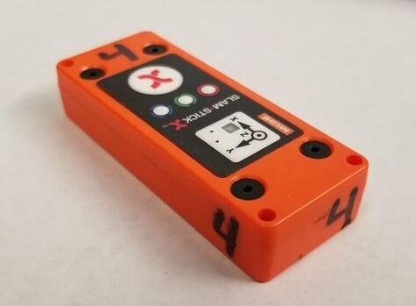

Figure 3.1: Slam Stick X with numbers assigned

1. If this is a new device, or if a number has not already been assigned, determine the next available number and write it in black permanent marker on at least 4 surfaces of the device other than the surface opposite the controls interface.

INSTALLING THE SLAM STICK LAB SOFTWARE

1. Plug the Micro USB connector into the Slam Stick X, and plug the other end of the cable into an available USB port on the computer.
2. The Slam Stick X device will be viewed by the computer as a removable drive. If this is a new device, the drive will be named **“SLAMSTICK X”**. Rename this drive “SSX-[number]”, for which the number will match the one written on the device, e.g. “SSX-4”. Within this drive, open the **“SOFTWARE”** folder. Then open the zipped folder named **“Slam_Stick_Lab_[version number]”**.
3. Open the file **“Slam Stick Lab [version number]”**. This will launch the Slam Stick Lab software. You may be prompted to update the software. If so, follow the link to the download page. If not, select **Help > Check for Updates**. Download the latest software.

CONFIGURE THE DEVICE

1. Open the latest Slam Stick Lab software. Select **Device > Configure Device…**.
2. The **“Select Recorder”** window will open, as shown in *Figure 5.2*. Double click on the device shown that matches the serial number on your Slam Stick X.

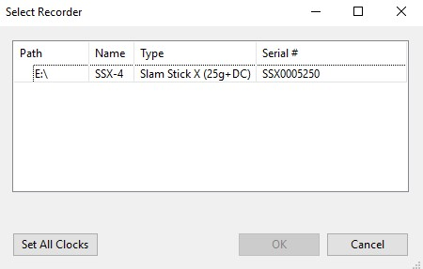

Figure 5.2: Select Recorder window

1. In the **“General”** tab (*Figure 5.3*), enter the Device Name, which should match the name given to the drive. Make sure that the **“Plug-In Action”** box is checked and that the drop down menu is set to **“Ignore”**. This ensures that the device will not stop logging data if a USB cable is inserted while it is logging.

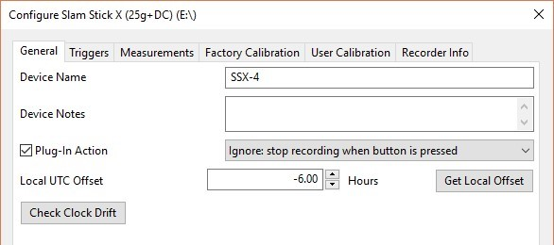

Figure 5.3: General Configuration Tab

1. In the **“Triggers”** tab, make sure the settings match those shown in *Figure 5.4*.

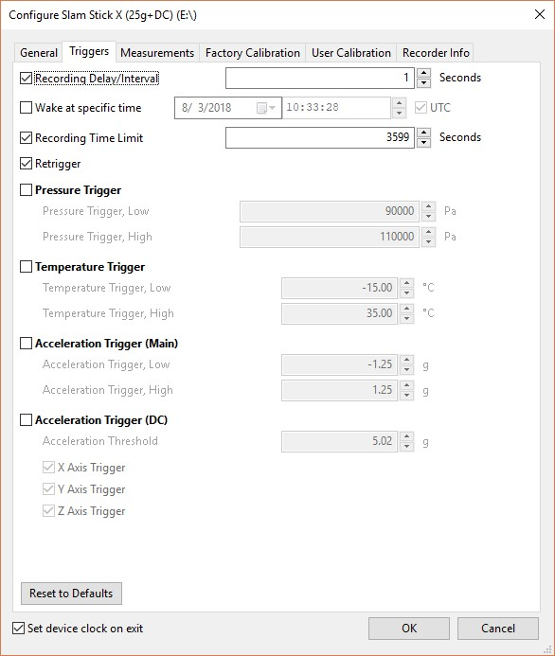

Figure 5.4: “Triggers” Configuration Tab

1. In the **“Measurements”** tab, make sure the settings match those shown in *Figure 5.5*.

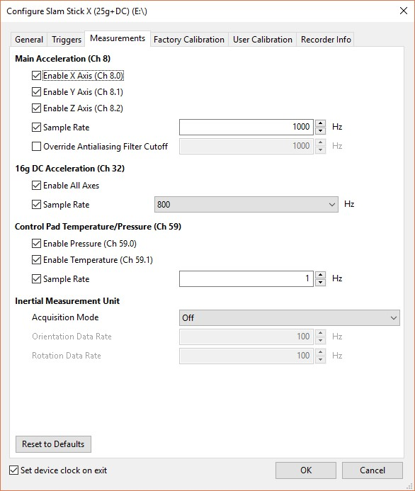

Figure 5.5: “Measurements” Configuration Tab

LOG TEST DATA

1. On your computer, select the option to **“Safely Remove Hardware and Eject Media”** (Windows 10). When prompted, select the Slam Stick X device. The wording and location of this option may vary depending on your computer, but performing this operation is necessary when unplugging the Slam Stick X, as failure to do so will result in errors.
2. When your computer indicates it is safe to do so, remove the Micro USB from the Slam Stick X.
3. Observe the orientation of the X, Y, and Z axes of the device, as shown in the label in *Figure 6.3*.

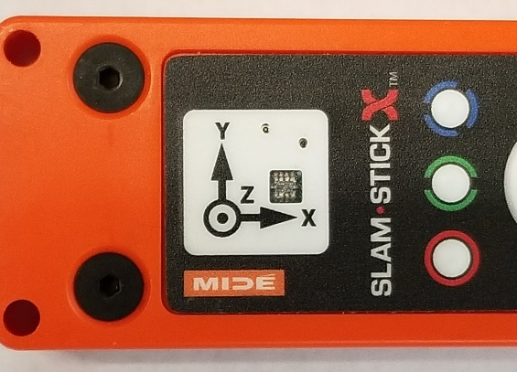

*Figure 6.3: X, Y, and Z orientation*

1. Press the Red “X” button (Figure 5.4) to begin logging data. Wait for the green LED to begin blinking. Try to hold the device as still as possible during the logging process, unless instructed otherwise.

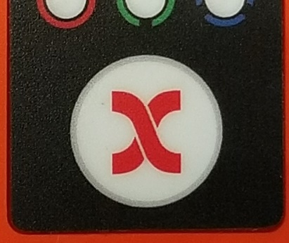

*Figure 6.4: Red “X” button*

1. Hold the device with the “X” arrow pointed up, as shown in *Figure 6.5*, to record motion along the X axis. Thrust the device downward about 1 foot in five sharp motions. Try to keep the device pointed straight up and the motions as consistent as possible.

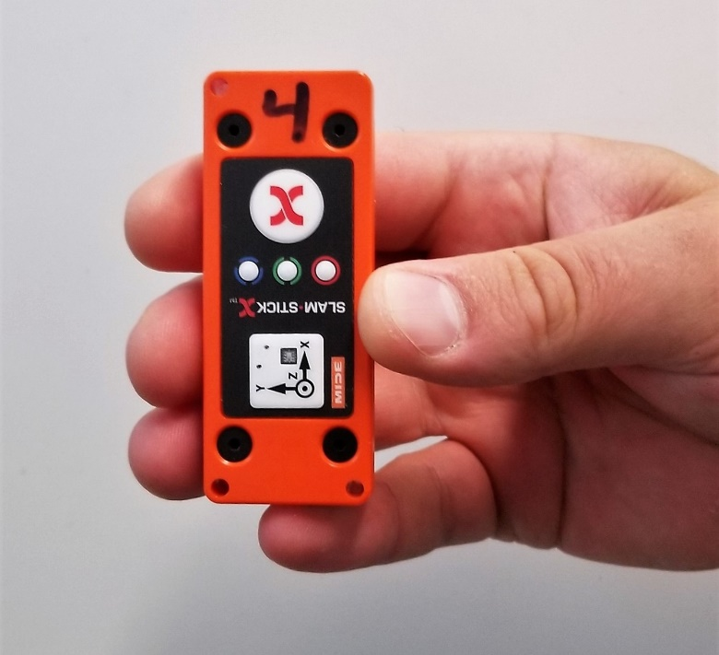

*Figure 6.5: Device being held with “X” arrow up*

1. Hold the device with the “Y” arrow pointed up (*Figure 6.6*) to record motion along the Y axis. With the device held in this orientation, repeat the 5 motions performed is Section 5.5.

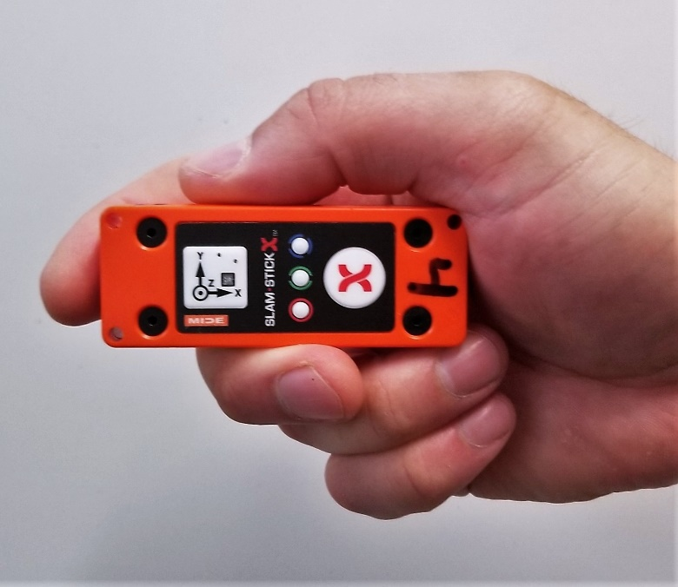

Figure 6.6: Device being held with “Y” arrow up

1. Hold the device with the orientation label facing up (*Figure 6.7*) to record motion along the Z axis. Repeat the 5 motions, keeping the device as flat as possible.

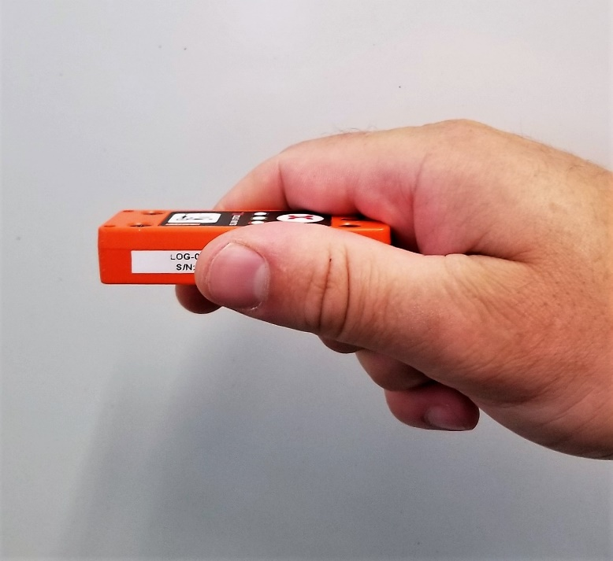

*Figure 6.7: Device held with orientation label facing up*

1. Press the Red X button again to stop logging data. The green light should stop blinking.

VIEW DATA

1. Plug the Micro USB connector back into the device.
2. Open the Slam Stick Lab software if it is not already open.
3. You may be prompted to **“Choose a file”**. If you are not prompted, Select **File > Open** from the top of the program window. Within the **SSX-#** drive, open the **“DATA”** folder.
4. Within the **“DATA”** folder, there should be a folder whose name is the date (**YYYYMMDD**) the data was logged. Open the folder with that date and select the most recent data file.
5. The window will display multiple tabs with graphs of various parameters. Select the first tab labeled **“Acceleration (3 sources)”**, which represents the **“Main Acceleration” (Channel 8)** of the Slam Stick X. There should be a graph displaying the logged acceleration, measured in gravitation force **“g”**, of the X, Y, and Z axes over time. As shown in *Figure 6.5*, the graph should show 5 distinct and prominent peaks for each axis, representing the motions performed in Section 5. The peaks will not likely be equal but should be proportioned similar to those in *Figure 7.5*.

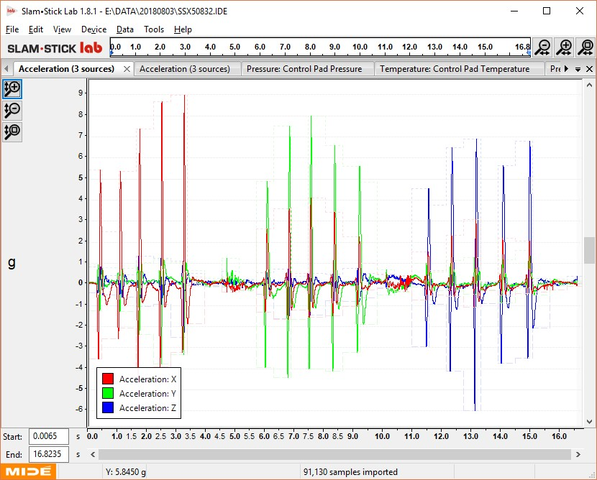

Figure 7.5: Channel 8 - Main Acceleration Output

1. Using your judgment, determine if the data for any of the axes looks significantly different that the others, for example, if the spikes are not as clearly defined, have drastically different amplitudes, or are missing altogether. If the device is not being moved along a particular axis, the g value for that axis should be approximately 0. The objective is to verify that acceleration is being measured consistently along each axis.
2. Select the second tab labeled **“Acceleration (3 sources)”**, which represents **“16g DC Acceleration” (Channel 32)**. Perform the same analysis of this data as you did with the previous graph. The graph should look similar to the one shown in *Figure 7.7*. Unlike the previous graph, when an axis is being tested (i.e., when its respective arrow is pointed up) its g value should be approximately 1 when it is at rest.

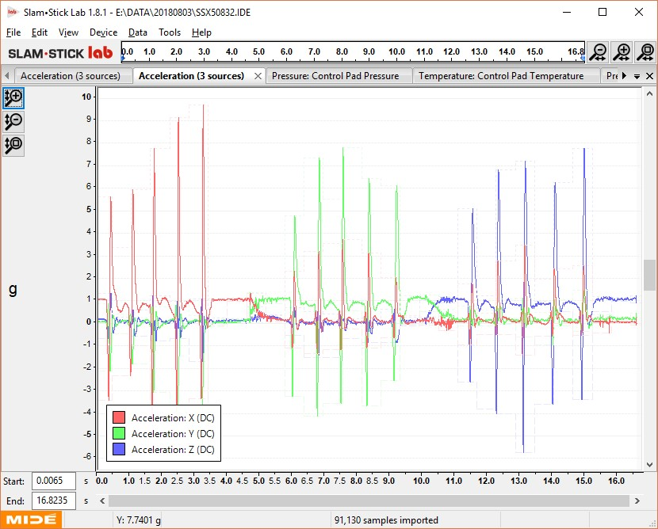

*Figure 7.7: Channel 32 – 16g DC Acceleration Output*

1. It may take multiple attempts at the logging process to get a feel for handling the device and making consistent motions. Repeat Sections 5 and 6, if necessary. If you are satisfied with the logging process, and there are no obvious inconsistencies with the data collected for either channel, then this device is likely functioning properly and can be installed and used for data logging.

## Part II: Slam Stick X Temporary Installation

PREPARING THE SLAM STICK X

1. Ensure that the Slam Stick X device functionality had been verified following the procedure in **Part I**.
2. Delete existing test data from the device
   1. Make sure any data you have collected has been backed up and confirm with any previous users of the device that they have all the data they need.
   2. Following the steps in *Section 7.1-7.4,* locate any existing test data on the device and delete it.
3. Make a note of the number written in marker on the device.
4. If the device has tape or residue from a previous application, remove as much of the tape as you can by hand, and wipe off the residue with Goo Gone applied to a rag or paper towel.
5. Using a different rag or paper towel wipe the underside of the device with isopropyl alcohol and allow it to dry.
6. The alcohol may have removed or affected the number written in marker on the device. If so, write the number again in black permanent marker, as explained in **Part I, Section 3**.
7. Cut a 3” strip of double sided tape and apply it to the underside of the Slam Stick X. Do not peel off the backing of the tape until instructed to do so.
8. Check the battery level of the device.
   1. Press the Red “X” on the device to begin logging data.
   2. If the red LED begins blinking, the battery is at less than 75%. The device may need to charge if it will be logging data without an external power supply.
   3. If the red LED does not begin blinking, the battery is at more than 75%. The device does not need to charge unless it will be logging data for more than 9 hours without an external power supply.
   4. A fully charged battery will allow for 12 hours of data logging.
9. Repeat *Section 8* for all Slam Stick X devices that will be installed.

PREPARING THE TEST SURFACE

1. Determine where each Slam Stick X device will be installed and how the device should be oriented in terms of X, Y, and Z.
2. The immediate area of the surface that the device will adhere to must also be clean and dry. Wipe the area clean with a rag or paper towel. If a cleaning product is required to get the area clean, find out what is safe to use on the surface
3. Wipe the area with isopropyl alcohol and allow it to dry.

INSTALLING THE SLAM STICK X

1. Before peeling the tape backing from the Slam Stick X, place the device in the intended location to be certain you have the necessary clearance and that the device is properly oriented.
2. When you are confident in the location and orientation, peel off the tape backing.
3. Apply the device to its assigned location and press down on it firmly.
4. Gently verify that the device is sufficiently adhered to the testing surface.
5. Make a note of the location and orientation of each device, which will be necessary for analyzing the data.

ADDING A VOLTAIC V44 USB BATTERY PACK (OPTIONAL)

1. If a Slam Stick X device will be logging data for more than 12 hours, or if you are unsure of the battery level, it is advised that you use an external USB power supply during data logging.
2. During testing, the Voltaic V44 should be in **“Always On”** mode. Check which mode the battery is in.
   1. With the LEDs off (*Figure 11.2.1*), press the power button once to turn the battery on.

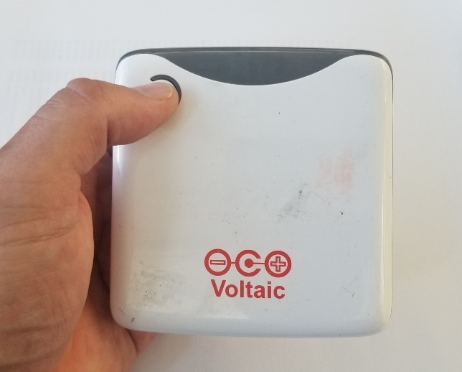

*Figure 6.2.1: Voltaic V44 USB battery pack with LEDs off*

* 1. After the LEDs turn on (*Figure 11.2.2*), wait one second and then double tap the power button.

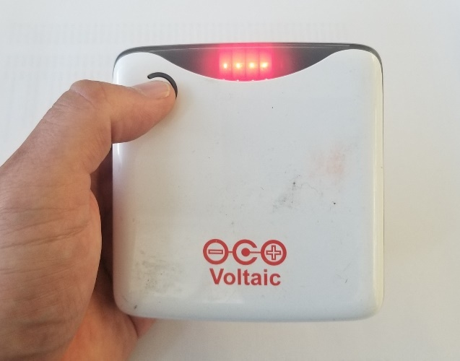

*Figure 6.2.2: Voltaic V44 USB battery pack with LEDs on*

* 1. If after double tapping the power button the LEDs stay on for a few seconds, the battery is in **“Always On”** Mode. If the LEDs turn off immediately, the battery is in **“Auto-Off”** mode. If the V44 is in **“Always On”** mode, proceed to step *6.3*.
  2. If the V44 is in “**Auto-Off”** mode, press the power button once. When the LEDs light up, wait one second and then press and hold the power button for approximately 5 seconds until the LEDs blink 3 times. Immediately release the power button after the start of the third blink. The LEDs should stay on for a few seconds, indicating you have successfully switched to **“Always On”** mode.
  3. Repeat steps *6.2.1 - 6.2.3* to verify the V44 is in **“Always On”** mode.

1. Determine a location for the V44 battery pack.
   1. The V44 should be close enough to the Slam Stick X for the USB cable to reach without straining.
2. Mount the V44 battery pack in the desired location.
   1. Follow the same procedure in *Sections 3* *- 5* for mounting the V44 with double sided tape.
   2. If the structure will allow, cable ties can also be used to secure the V44.

LOGGING DATA

1. About 10 minutes before testing is to begin, press the red “**X**” button on each Slam Stick X to begin logging data. It is OK to press it sooner, but you will be logging data you do not need, which can waste battery life and data storage on the device.
2. Verify that the green LED is blinking on each Slam Stick X, which indicates that it is logging data.
   1. If available, have a second person confirm that each device is logging data.
3. When testing has concluded, verify that all the green LEDs are still blinking. If not, that device may have stopped logging data before testing was complete.
4. Press the red “**X**” on each device to stop data logging.
5. Once again verify the location and orientation of each device.
6. If you are certain that no further testing will be performed, remove the devices and clean off the tape and residue.

REMOVING VOLATIC V44 USB BATTERY PACK

1. When testing has concluded, any V44 battery packs that were installed must also be removed.
2. When not being used for testing, the V44 should be switched back to **“Auto Off”** mode.
   1. Press the power button once. When the LEDs light up, wait one second and then press and hold the power button for approximately 5 seconds until the LEDs blink 3 times. Immediately release the power button after the start of the third blink. The LEDs should turn off immediately, indicating the V44 is in **“Auto Off”** mode.
   2. Repeat steps *6.2.1-6.2.3* to verify the V44 is in **“Auto off”** mode.

EXTRACTING DATA

1. Following the steps in *Section 7.1-7.4*, locate the files on the device that were created during testing.
2. Create a folder on your computer for each device.
3. Copy and paste the files from testing to their respective device folder on your computer.

Date:___________

Cryomodule:_____

|  |  |  |  |  |
| --- | --- | --- | --- | --- |
| **Slam Stick X Location and Orientation** | | | | |
| SSX # | Location | X points | Y points | Z points |
|  |  |  |  |  |
|  |  |  |  |  |
|  |  |  |  |  |
|  |  |  |  |  |
|  |  |  |  |  |
|  |  |  |  |  |
|  |  |  |  |  |
|  |  |  |  |  |
|  |  |  |  |  |
|  |  |  |  |  |
|  |  |  |  |  |
|  |  |  |  |  |
|  |  |  |  |  |
|  |  |  |  |  |
|  |  |  |  |  |
|  |  |  |  |  |
|  |  |  |  |  |
|  |  |  |  |  |
|  |  |  |  |  |
|  |  |  |  |  |
|  |  |  |  |  |
|  |  |  |  |  |
|  |  |  |  |  |
|  |  |  |  |  |
|  |  |  |  |  |
| Indicate which direction the arrow points for each axis on the device: | | | | |
|  | up, down, forward, back, driver side (DS), passenger side (PS) | | | |

# References

|  |  |
| --- | --- |
| **Document No.** | **Title** |
| SRF-06-PR-001 | Records Management Procedure |
| SRF-07-PR-001 | Document Management Procedure |
| <Doc Id> | <Document Title> |

# Release and Revision History

|  |  |  |
| --- | --- | --- |
| **Rev #** | **Major Changes** | **Revision Date:** |
| 1 | Initial version (Utilizing SRF-07-FM-005 SRF OPS Procedure Template, R1). Converted from SLAM STICK X FUNCTIONALITY VERIFICATION AND TEMPORARY INSTALLATION PROCEDURE | 12 May 2025 |
|  |  |  |
|  |  |  |

# Approvals

|  |  |
| --- | --- |
| **Approved by:** | **Name:** |
| Document Owner | <First Last Name> |
| Document Reviewer 1  JLab SME or SRFOPS WCL | <First Last Name> |
| Document Approver 2  SRFOPS WCL or GL | <First Last Name> |

For Project Procedures: Refer to the Project Execution Procedure SRF-11-PR-001

*Document Processor Instructions:*

* *Put valid dates everywhere DD is found and verify they are accurate*
* *Attach DocuShare Approval Picture here*