|  |  |  |  |
| --- | --- | --- | --- |
| **SLAM STICK X FUNCTIONALITY VERIFICATION AND INSTALLATION FOR SHIPPING PROCEDURE** | | | |
| **Document Number:** | L2HE-PR-CMA-SSX-ACTION | **Effective Date:** | DD Mmm YYYY |
| **Revision Number:** | R1 | **Periodic Review Date:** | DD Mmm YYYY |
| **Document Owner:** | Eugene McGough | **Department Owner:** | SRF Operations |

# Purpose and Scope

This procedure will describe the steps necessary for verifying the proper functionality of a Midé Slam Stick X device, as well as the steps necessary for installing the device for data logging during shipping.

# Definitions and Diagrams

The following terms have specific meanings within this procedure.

|  |  |
| --- | --- |
| **Term** | **Definition** |
| Midé Slam Stick | Accelerometer used for tracking significant shipping statistics |
|  |  |
|  |  |

# Roles and Responsibilities

The following roles have responsibilities described in this document.

|  |  |
| --- | --- |
| **Role** | **Responsibility** |
| Shipping Engineer | Handles preparation/inspection, configuration, and data operations surrounding the shipping of a cryomodule with the slam sticks |
| Shipping Technician | Responsible for installing slam sticks in the proper orientation around a cryomodule |

# Safety

* Ladder Safety Training

# Procedure

**MATERIALS REQUIRED TO COMPLETE THIS PROCEDURE**

* Midé Slam Stick X accelerometer and data logger
* Computer with available USB port
* USB A to Micro USB cable (1 per accelerometer)
* Double sided tape, 3M 4008 Heavy Duty Double-Sided Foam Tape
* Scissors
* Clean rags or paper towels
* Black permanent marker

Part I: Slam Stick X Functionality Verification

INITIAL INSPECTION

1. Each Slam Stick X that will be installed on or near a Cryomodule will need to be assigned a number (i.e. F14, J05). A previously used device will likely already have a number written in black marker on multiple faces, as shown in *Figure 1.1*. If those numbers appear to be faded or otherwise difficult to read, reapply the numbers with a black permanent marker.
2. Attach a strain relief to the body of the slam stick. Reference *Figure 1.2* for configuration. Once a USB cable is connected, wrap a zip tie around the insertion/body of the USB cable and the body of the strain relief to provide a firm connection.

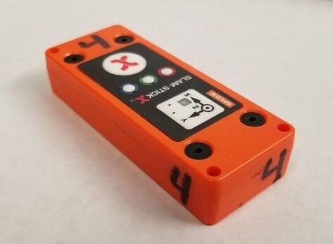

*Figure 1.1: Slam Stick X with numbers assigned*

Figure 1.2: Slam Stick X with Attached Strain Relief

1. If this is a new device, or if a number has not already been assigned, determine the next available number and write it in black permanent marker on at least 4 surfaces of the device other than the surface opposite the controls interface.

INSTALLING THE SLAM STICK LAB SOFTWARE

1. Plug the Micro USB connector into the Slam Stick X and plug the other end of the cable into an available USB port on the computer.
2. The Slam Stick X device will be viewed by the computer as a removable drive. If this is a new device, the drive will be named **“SLAMSTICK X”**. Rename this drive “SSX-[number]”, for which the number will match the one written on the device, e.g. “SSX-4”. Within this drive, open the **“SOFTWARE”** folder. Then open the zipped folder named **“Slam_Stick_Lab_[version number]”**.
3. Open the file **“Slam Stick Lab [version number]”**. This will launch the Slam Stick Lab software. You may be prompted to update the software. If so, follow the link to the download page. If not, select **Help > Check for Updates**. Download the latest software.

## Part II: Slam Stick X Installation for Shipping

EXTRACTING/CLEARING DATA

1. Before preparing slamstick for next shipment, all existing stored data must be extracted to a computer and deleted from the slamstick.
2. Plug in slamstick USB cable to computer. After a few seconds, open file explorer and navigate to the slamstick drive.
3. Locate IDE files within the **DATA** folder. Copy and paste each file into a designated folder within the computer. These files are large and will take some time.
4. Once all IDE files are locally stored, again navigate to the **DATA** folder on the slamstick drive and delete all IDE files.

### CONFIGURING SLAM STICK FOR INSTALLATION

1. Using the enDAQ lab software, click on the “Configure a Recording Device” button located in the enDAQ menu. Once the popup appears, click on the listed device and click the “configure” button.

*Figure 2.1: Select Recorder window*

1. Under the **GENERAL** dropdown, confirm the *device name*, *recording directory*, and *recording file prefix* are consistent with the name on the slamstick.

*Figure 2.2: General Configuration Tab*

1. Under the **TRIGGERS** dropdown, set the *trigger mode* to “Delay Then Trigger”. Turn on the *Recording Time Limit* and set to 30 seconds (This will be changed after installation)

*Figure 2.3: “Triggers” Configuration Tab*

.

1. Under the **MEASUREMENTS** dropdown, activate *Enable All Axes*, *Sample Rate* (800Hz/1600 Hz depending on model), *Enable Pressure*, and *Enable Temperature*.

*Figure 2.4: “Measurements” Configuration Tab*

PREPARING THE SLAM STICK X

1. Make a note of the number written in marker on the device.
2. If the device has tape or residue from a previous application, gently remove as much of the tape as you can.
3. Cut a 3” strip of double-sided tape and apply it to the underside of the Slam Stick X. Do not peel off the backing of the tape until instructed to do so.
4. Plug in USB port to allow slam stick to charge to full battery. Use of a 3d-printed strain relief is advisable for the connection at the slam stick. Reference section 5.1.1 and *Figure 1.2* for configuration of strain relief.

PREPARING THE SURFACE

1. Reference shipping form to determine where each Slam Stick X device will be installed and how the device should be oriented in terms of X, Y, and Z.
2. The immediate area of the surface that the device will adhere to must also be clean and dry. Wipe the area clean with a rag or paper towel. If a cleaning product is required to get the area clean, find out what is safe to use on the surface

Figure 3.1: Example of shipping form used to determine orientation and location of slam sticks

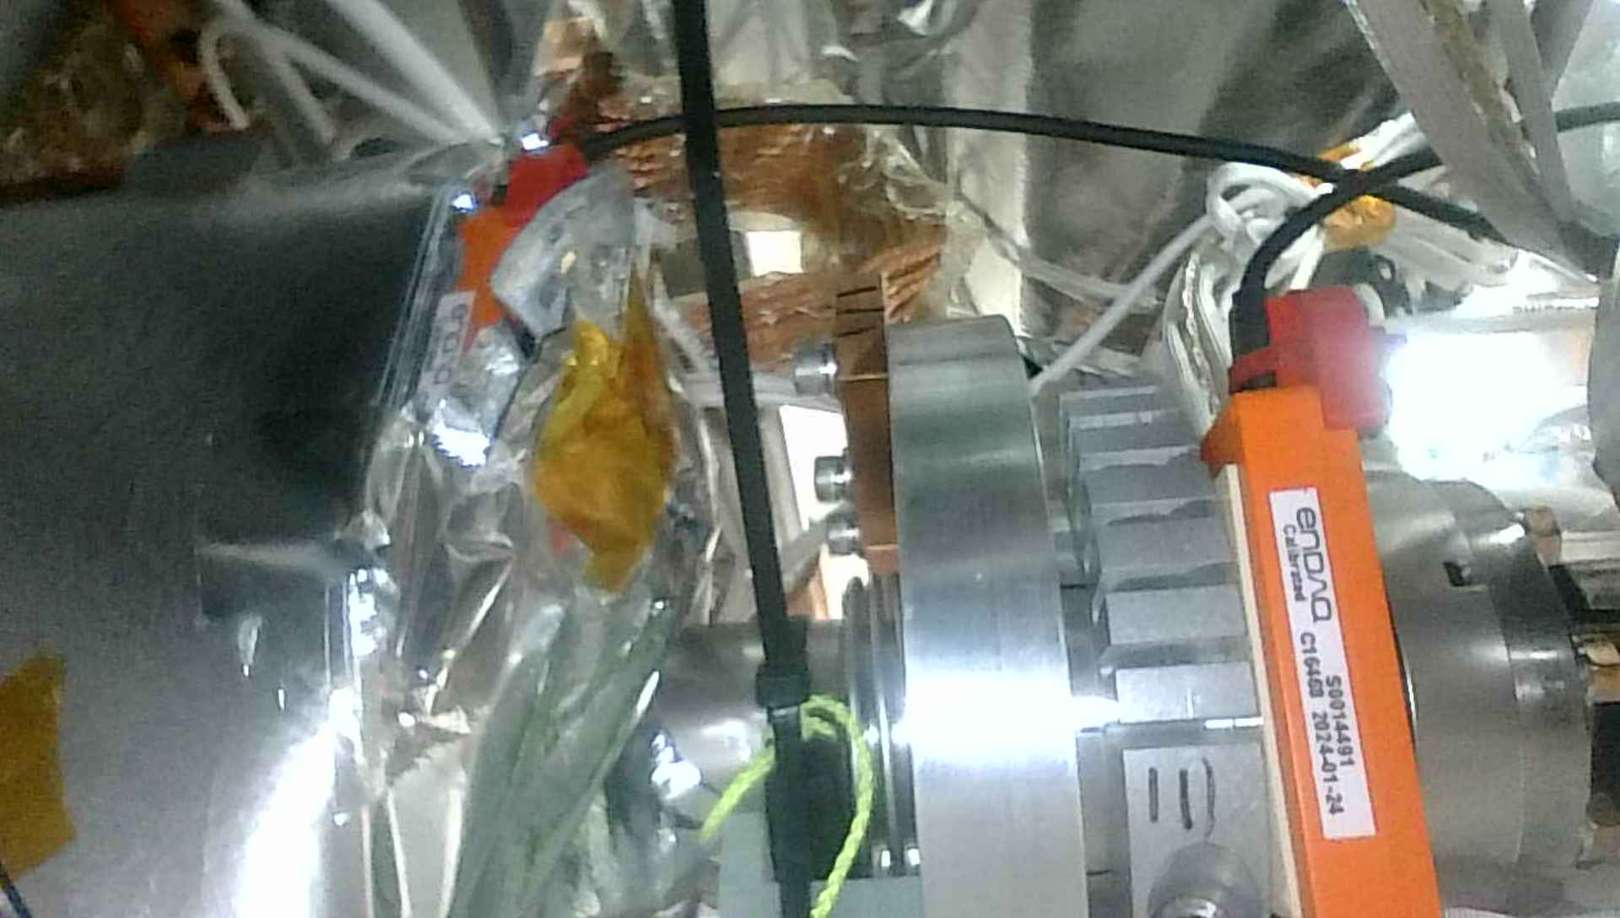

Figure 3.2: Locations of 5K and 50K slam sticks on module FPC

Figure 3.3: Location of gate valve slam stick on module

Figure 3.4: Locations of Inner (Right) and Outer (Left) Frame slam sticks on shipping frame

INSTALLING THE SLAM STICK X

1. Before peeling the tape backing from the Slam Stick X, place the device in the intended location to be certain you have the necessary clearance, and that the device is properly oriented.
2. When you are confident in the location and orientation, peel off the tape backing.
3. Apply the device to its assigned location and press down on it firmly.
4. Gently verify that the device is sufficiently adhered to the testing surface.
5. For the inner and outer frame, locate the USB hub and connect each slam stick.
6. Confirm the USB connection of the device is secure. Do not orient the USB wire in a way which it is dramatically bent or twisted.

FINAL CONFIGURATION BEFORE SHIPPING

1. Before shipping of the module, a final configuration must be made. Plug computer into one of the USB extensions located around the module. Open the enDAQ software to interact with the slam sticks.
2. Navigate to the configuration menu of each slamstick. Under the **TRIGGER** dropdown, change the *Recording Time Limit* to the correct period declared on the shipping form.
3. Once the final configuration is complete, save the changes made and begin recording just before module leaves the shipping bay.

ENDING A RECORDING AFTER SHIPPING

1. Once shipment has concluded, verify that all the green LEDs are still blinking. If not, that device may have stopped logging data before shipment was complete.
2. Press the red “**X**” on each device to stop data logging.
3. Once again verify the location and orientation of each device.

# References

|  |  |
| --- | --- |
| **Document No.** | **Title** |
| SRF-06-PR-001 | Records Management Procedure |
| SRF-07-PR-001 | Document Management Procedure |
| <Doc Id> | <Document Title> |

# Release and Revision History

|  |  |  |
| --- | --- | --- |
| **Rev #** | **Major Changes** | **Revision Date:** |
| 1 | Initial version (Utilizing SRF-07-FM-005 SRF OPS Procedure Template, R1). Converted from SLAM STICK X FUNCTIONALITY VERIFICATION AND TEMPORARY INSTALLATION PROCEDURE | 12 May 2025 |
|  |  |  |
|  |  |  |

# Approvals

|  |  |
| --- | --- |
| **Approved by:** | **Name:** |
| Document Owner | Eugene McGough |
| Document Reviewer 1  JLab SME or SRFOPS WCL | Peter Owen |
| Document Approver 2  SRFOPS WCL or GL | John Fischer |

For Project Procedures: Refer to the Project Execution Procedure SRF-11-PR-001

*Document Processor Instructions:*

* *Put valid dates everywhere DD is found and verify they are accurate*
* *Attach DocuShare Approval Picture here*