|  |  |  |  |
| --- | --- | --- | --- |
| **C100 Cold Tuner Installation Procedure** | | | |
| **Document Number:** | CP-C100-CM-ASSY-CNTR | **Effective Date:** | 13 May 2025 |
| **Revision Number:** | 1 | **Periodic Review Date:** | N/A |
| **Document Owner:** | John Fischer | **Department Owner:** | SRF Operations |

# Purpose and Scope

The purpose of this document is to describe the necessary steps and reference information to properly assemble and set the C100 cold tuner to each of the eight cavities in the Cavity String. This Procedure can be used for new or refurbished Cryomodules installations. For refurbished units; the tuner has been removed from a Cryomodule. It will be partially disassembled, modified to the latest revision (if required), cleaned, then re-installed onto a reworked Cavity String.

# Definitions and Diagrams

The following terms have specific meanings within this procedure.

|  |  |
| --- | --- |
| **Term** | **Definition** |
| Cold Tuner | Half of the C100 tuner that is housed inside the vacuum vessel. Once attached to the Warm Tuner it’s purpose is to adjust the frequency of the cavity as required for accelerator operations. |

# Roles and Responsibilities

The following roles have responsibilities described in this document. The following actions are to be performed by knowledgeable, authorized Technicians only. Consult the Group Lead for details

|  |  |
| --- | --- |
| **Role** | **Responsibility** |
| Cryomodule Assembly Technician | Is trained and executes this Procedure performing described machining and mechanical tasks |
| Cryomodule Assembly Lead/SME | Overlooks the execution of this Procedure and documents the results and any lessons learned |

# Safety

As with any mechanical disassembly or assembly task; the person performing the work shall evaluate the Procedure and steps and define the training, PPE, and have the necessary Competence required to complete the work.

# Procedure

**1.** Remove the Tuner from the storage crate

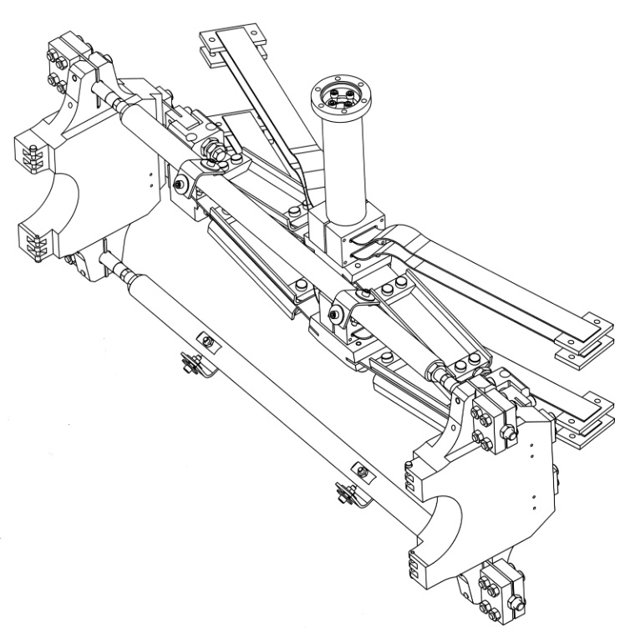

**2.** Disassemble items 33, 34, 35, and 36 if in place (Inner and outer heat stationing straps), and set

aside for later installation.

**3.** Remove the eight bolts (item 23) from the Outer Arm Hinge (Item 13) and Hinge blocks

(item 2), then lift off the complete Jack Arm assy.

**4.** Install the remaining tuner assy; consisting of 2 Pivot Arms (item1), 2 Fulcrum Bars (item 6), 4 pcs

Fulcrum Bar Studs (item 18) and 4 Fulcrum block assemblies (items 7 & 8 already bolted together)

onto the He vessel, then secure with 4 screws (item 31) Torque screws to 30 in/lbs.

**5.** Install 4 mounting bracket assy’s (item 19, 20, 30,32 and 37) to Fulcrum Bars (item 6) and to the He

vessel, ** He vessel tabs may have to be bent to line up correctly**. Center the L – brackets and

Fulcrum Bars (item 6) relative to the cavity end dish locations. Torque hardware to 100 in lbs.

**6**. Measure and record the Pi mode cavity frequencies. Use the Jack Block distance excel sheet to

determine the proper distance between the jack blocks. This will put the Cold tuner into the optimal

position for centering on the Warm tuner ball screw. Example below.

**7**. Install a tuner locking device to secure the Lower Tension shaft (item 14) and Lower Compression

shaft (item 15) together in their optimal position.

**8**. Adjust the toe-in of the Pivot Arm Plates (item 1) to the angle defined in the Jack Block distance

excel sheet by using the custom toe-in square. Adjust the Fulcrum Bar Studs (item 18)

outward until shoulder bottoms in the Hinge Blocks (item 8). Verify the FBS is centered, then torque

the FB Stud Jam Nuts (item 27) 4 places to 110 in/lbs. Install Lock Nuts (item 25) 4 places, torque to

110 in/lbs.

**9**. Loosen the fasteners on Jack Arm Assy, set screws (item 21), and the Ortho block adjusting screw

Assys (item 12). The jack arm assembly should be loose and easy to install. Position the Jack Arm

Assy onto the already installed tuner frame, install the Outer Arm Hinge Blocks (item 2), and

Shoulder screws (item 23), then torque to 140 in/lbs.

**10**. Adjust and center the Jack Arm Assy relative to the Pivot Arms (item 1) using the Ortho block

adjusting screws (item 12). Outer sleeve should be bottomed out onto Jack block hinges (items

10 and 11) next, tighten countering bolts and jamb nuts. Verify center and torque fasteners to 110

in/lbs.

**11.** Re-install the copper Compression Clamps (items 33,34,35 and 36) Position to drawing value, one

on the Lower Tension Shaft and the other on the Lower Compression Shaft. Must be installed over

.010 thick Indium Foil and torqued to 30 in/lbs, a minimum of three times ~eight hours apart.

**12**. Re-torque all fasteners to their respective torque values, verifying the assembly is complete.

# References

|  |  |
| --- | --- |
| **Document No.** | **Title** |
| SRF-06-PR-001 | Records Management Procedure |
| SRF-07-PR-001 | Document Management Procedure |
| [115410-1074](https://misportal.jlab.org/jlabDocs/items/1225) | Cold Tuner Toe-in Square |
| [CRM1207050-0000](https://misportal.jlab.org/jlabDocs/items/54937) | C100 Cold Tuner Assembly |
| [CRM1207050-0022](https://misportal.jlab.org/jlabDocs/items/49768) | C100 Reinforced Pivot Arm |

# Release and Revision History

|  |  |  |
| --- | --- | --- |
| **Rev #** | **Major Changes** | **Revision Date:** |
| 1 | Initial version | 16 Jun 2025 |

# Approvals

|  |  |
| --- | --- |
| **Approved by:** | **Name:** |
| Document Owner | Jared Martin |
| Document Reviewer 1  JLab SME | Jeffrey Campbell |
| Document Approver 2  GL | John Fischer |

For Project Procedures: Refer to the Project Execution Procedure SRF-11-PR-001

*Document Processor Instructions:*

* *Put valid dates everywhere DD is found and verify they are accurate*
* *Attach DocuShare Approval Picture*