Installation Procedure for LCLS-II-HE Warm Fundamental Power Couplers
Document Number: | L2RB-PR-ASSY-FPCW | Effective Date: | DD Mmm YYYY
Revision Number: | 1 | Periodic Review Date: | N/A
Document Owner: | N. Huque | Department Owner: | SRF Operations

Purpose and Scope

This procedure outlines the steps for installing the warm parts of the Fundamental Power Couplers on to LSLC-II-HE cryomodules

This procedure supports the Quality Management System as described in SRF-01-ML-001 Quality Manual.

Definitions and Diagrams

The following terms have specific meanings within this procedure.

Term | Definition
LCLS-II-HE | Linear Coherent Light Source-II High Energy
FPC | Fundamental Power Coupler
SLAC | Stanford Linear Accelerator Center
CM | Cryomodule
RF | Radiofrequency
SSA | Solid State Amplifier
UHV | Ultra-High Vacuum
LFH | Laminar Flow Hood
SHCS | Socket Head Cap Screw
FPCW | Warm Fundamental Power Coupler
FPCC | Cold Fundamental Power Coupler
FPPR | Fundamental Power Coupler Push Rod
PPE | Personal Protective Equipment
RAV | Right Angle Valve
US | Upstream
DS | Downstream

Roles and Responsibilities

The following roles have responsibilities described in this document.

Role | Responsibility
Project Manager/CAM | Approves procedure and scope.
Procedure Author | Develops procedure and revises as necessary. Ensures technical staff has access to latest procedure revision.
Technical Staff | Follows operation steps in accordance with this procedure. Obeys all safety requirements of the room/workcenters. Fills out travelers and writes NCRs as necessary.
Workcenter Lead | Reviews procedure. Assigns technical staff to complete tasks outlined in the procedure. Ensures technical staff performs tasks in accordance with room/workcenter safety requirements.

Safety

The following safety items …

Procedure

Introduction
- The LCLS-II-HE FPCs are UHV components which are designed to transmit RF power from SSAs to cavities, within a CM. The FPC assembly is made up of three parts: the warm FPC (FPCW), cold FPC (FPCC) and the FPC Push Rod (FPPR); this procedure covers the installation steps for the FPCW assemblies, which include the FPPR. This installation process also includes incoming inspection steps

- FPCWs (Figure 1.1) are delivered to partner labs from the vendor, CPI. The internal space of the FPCWs and the waveguide box are under UHV. Each of the pair and waveguide box assemblies are packed within two bags made from MIL-PRF-131K, Class 1 (>4mils thick) bagging material (Figure 1.2).

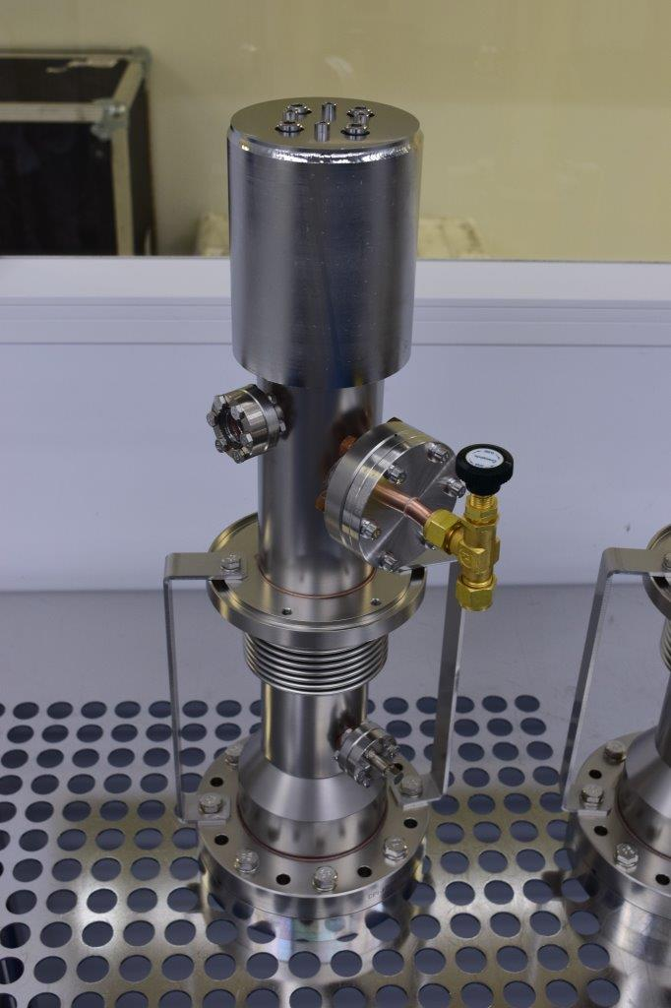
Figure 1.1: FPCW

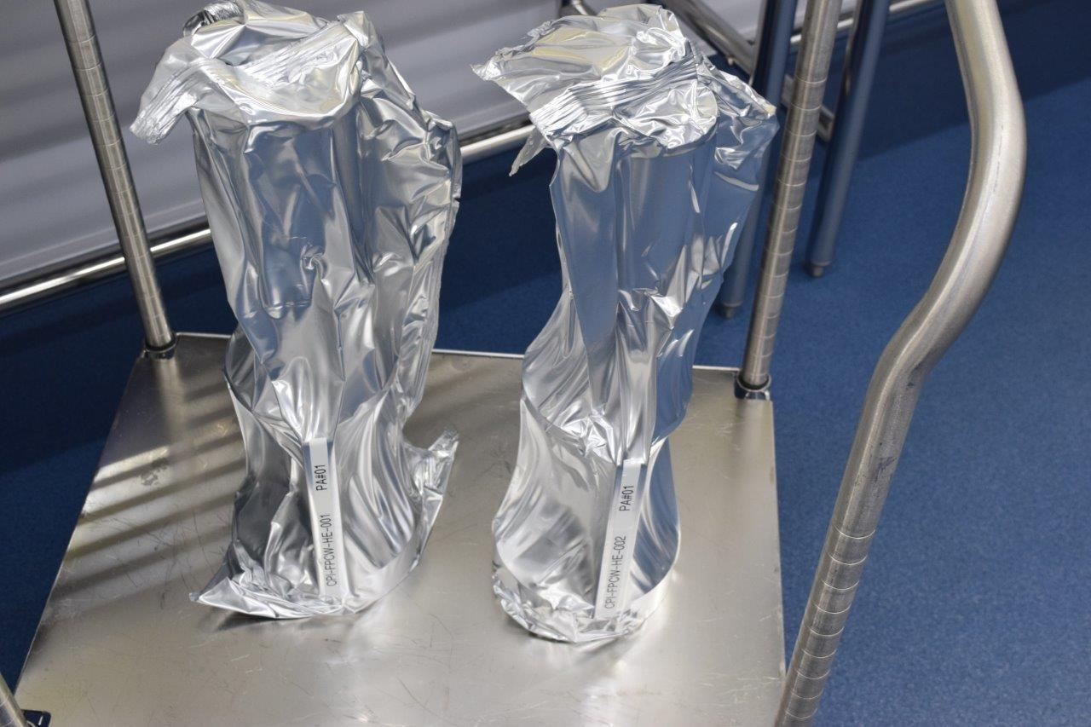
Figure 1.2: Two FPCWs in bags

- Each CM has eight FPCWs which are installed in Workstation 5. The installation procedure for all eight FPCWs is the same. The serial numbers for the FPCWs installed on a particular CM must be recorded in the relevant traveler during the process of the installation. If inspections are also being conducted at this time, then the inspection travelers should also be filled out.

Preparation
- Install plastic sheets on the floor in front of the two FPCW ports for the installation

- Install plastic sheets on the floor in front of the two FPCW ports for the installation

- Position the portable LFH over the plastic, ensuring that there is enough access to the ports to install two FPCWs (Figure 2.1)

- Position the stainless-steel table and shelves under the LFH. Wipe down the surface of the table (Figure 2.1)

- Technicians must don cleanroom garb and the appropriate PPE

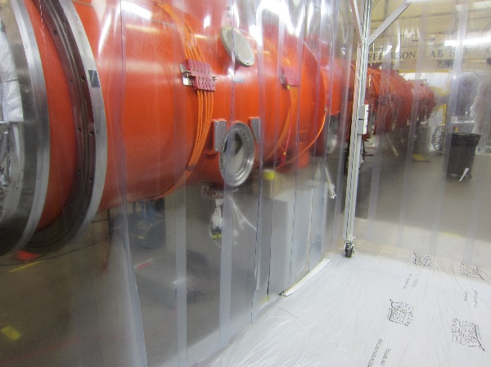 | 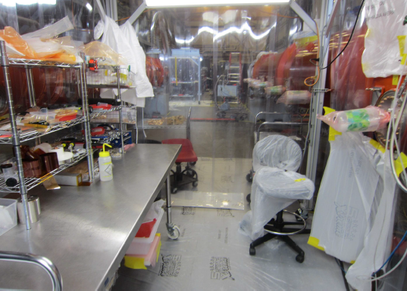
Figure 2.1: LFH setup for FPCW installation

Vacuum vessel preparation
- Ensure that the MLI has been moved and that the cables are routed. If not, pull the MLI aside and secure it using tape. Route all cables through the port directly below the coupler (Figure 3.1).

- Install the plastic ‘surgical field’ cover.

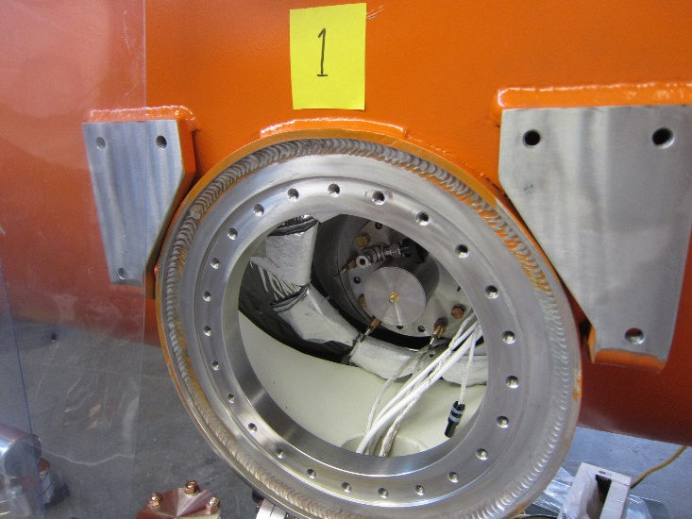
Figure 3.1: MLI moved and secured

FPCC tophat removal
- Remove any M8 bolts that are installed in the bottom two positions on the FPCC (Figure 4.1).

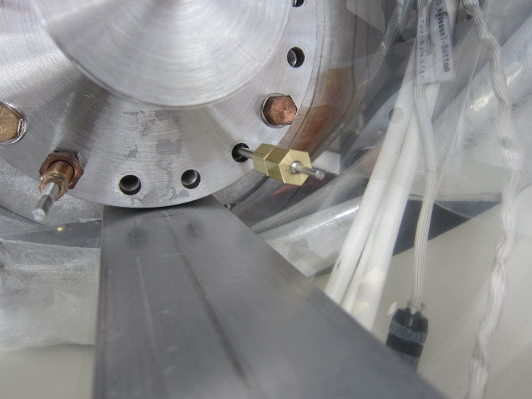
Figure 4.1: Bottom position bolt holes on the FPCC (shown in green)

- Install the upper and lower installation support tooling. Ensure that the connection is rigid (Figure 4.2). Use the gauge block to ensure spacing between the top and lower pieces.

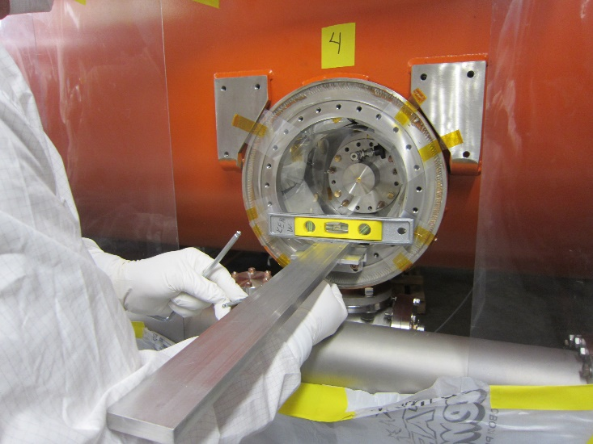
Figure 4.2: Installing Installation Support Tooling

- Mount the brass sled on to the tooling and ensure that it has smooth motion and confirm that it will engage with the bottom holes of the FPCC (Figure 4.3). Remove the sled once the check is complete.

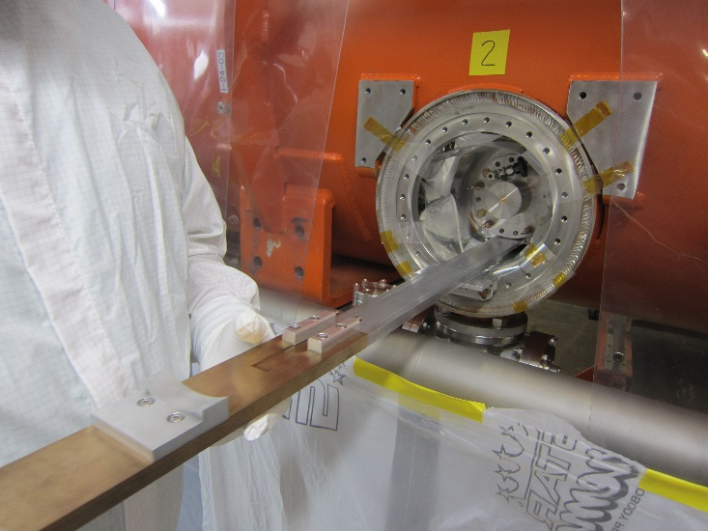
Figure 4.3: Checking Brass Sled engagement

- Remove the four Berry-bolts using the following sequence (Figure 4.4):

- Loosen the four M8 nuts that lock the M8 stud portion of the assembly.
- Remove the four M4 nuts from the shank portion of the assembly.
- Remove the sleeve from the Berry-bolts.
- Unthread the four M8 studs one-by-one; use a double nut for increased grip if necessary.
- Remove the four shanks by unthreading.

- Install four alignment rods on the empty FPCC threaded holes. These will ensure that the tophat does not come in contact with the FPCC ceramic during removal.

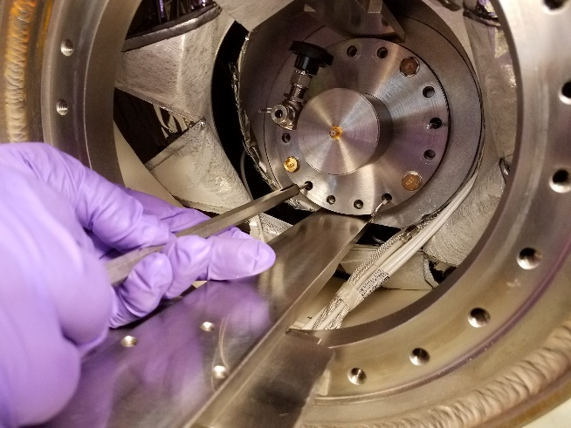
Figure 4.4: Removing Berry Bolts

- Reinstall the brass sled and position it to hold the FPCC Tophat.

- Remove the M8 HHCSs from the FPCC. Hold the tophat with one hand while removing the HHCSs (Figure 4.5).

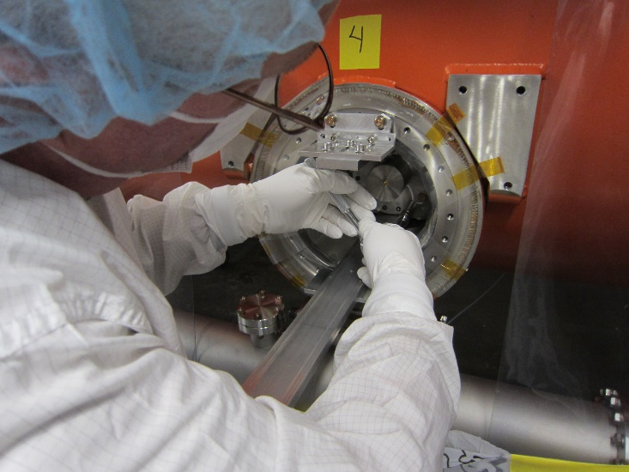
Figure 4.5: Removing M8 bolts from FPCC

- Use the brass sled to slowly retract the tophat. Remove one of the alignment rods if required.

- Unscrew the spring-loaded RF connector from the FPCC (Figure 4.6).

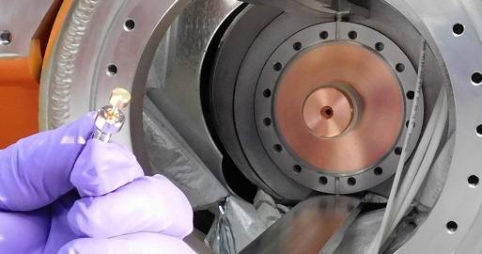
Figure 4.5: Removing spring-loaded RF pin.

Warm FPC Preparation
- Remove the Ceramic Protective Cup and inspect the ceramic as per Section 3 of the inspection procedure (Figure 5.1)

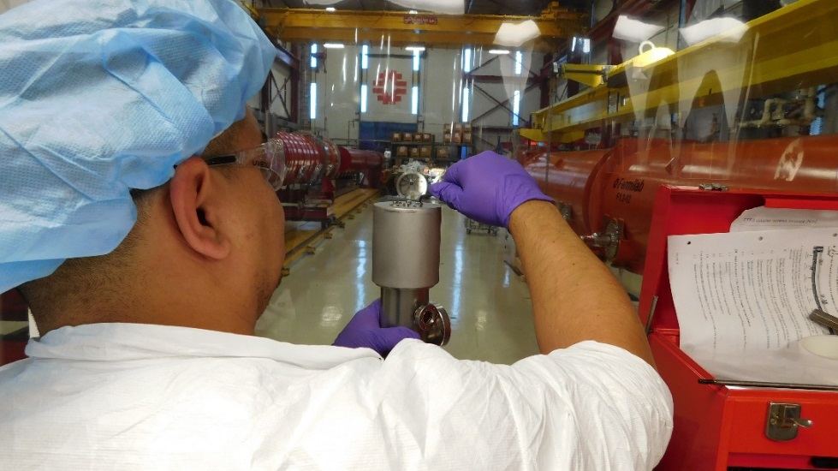
Figure 5.1: Remove Ceramic Protective Cup

- Reinstall the Kapton protective sleeve after inspection

- Remove the DN40 flange and inspect the copper plating and knife edge as per Section 4 of the inspection procedure. Reinstall the flange and flow filtered N2 as a positive purge through the assembly (Figure 5.2).

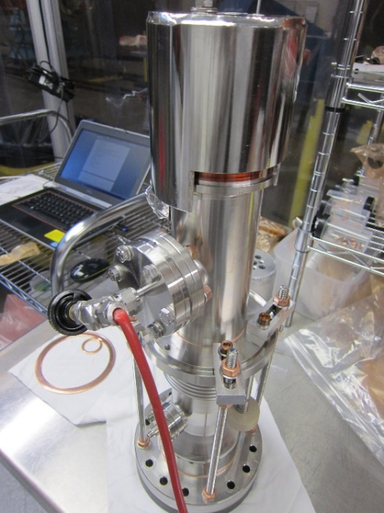
Figure 5.2: Nitrogen line attached for a positive purge

- Remove the Push Rod M6 screws using the strain relief tool (Figure 5.3).

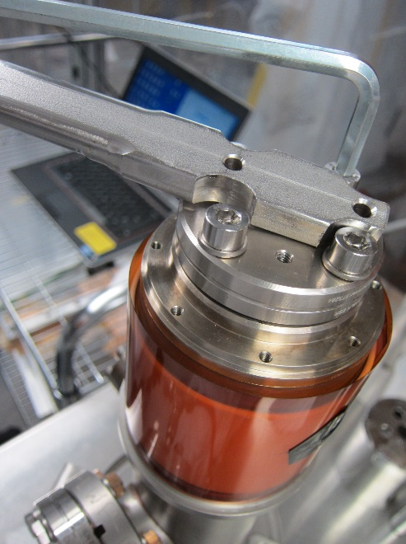
Figure 5.3: Using the strain relief tool to aid in removing the SHCSs

- Using the Push-Rod tool, rotate the FPPR 90 degrees counter-clockwise to disengage the pin from the FPCW’s inner conductor (Figure 5.4).

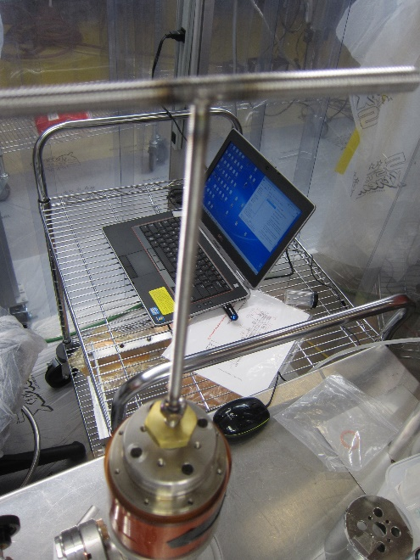
Figure 5.4: Using the push-rod tool to disengage the FPPR pin.

- Perform inspections of the FPPR and the mating flange on the FPCW as per Section 5 of the inspection procedure.

- Store the FPPR in the holder

- Use the Tee-Handle drive to loosen the M6 Antenna Screw (Figure 5.5)

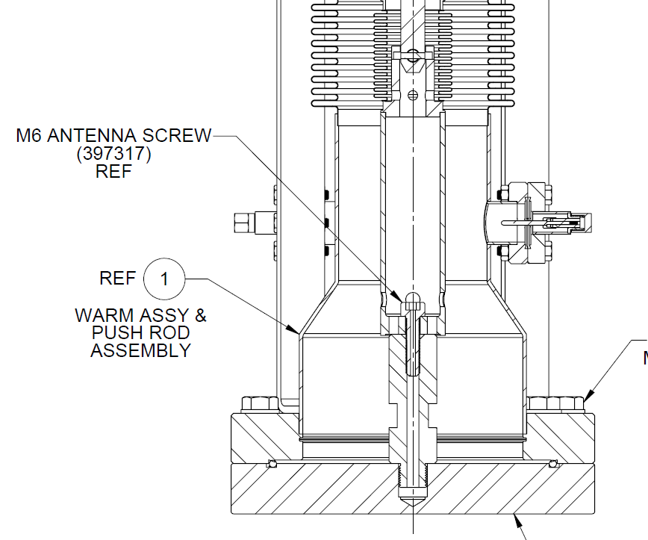
Figure 5.5 – Location of M6 Antenna Screw

- Bring the FPC into a vertical position (DN100 flange up) and remove the M6 Antenna Screw.

- Thread the antenna screw into the threaded home in the FPCC to ensure it doe not bottom out prematurely.

- Place the FPCW on the table vertically (Figure 5.6).

Figure 5.6 – FPCW positioned vertically on the table

- Install the motion damper on the FPCW (Figure 5.7).

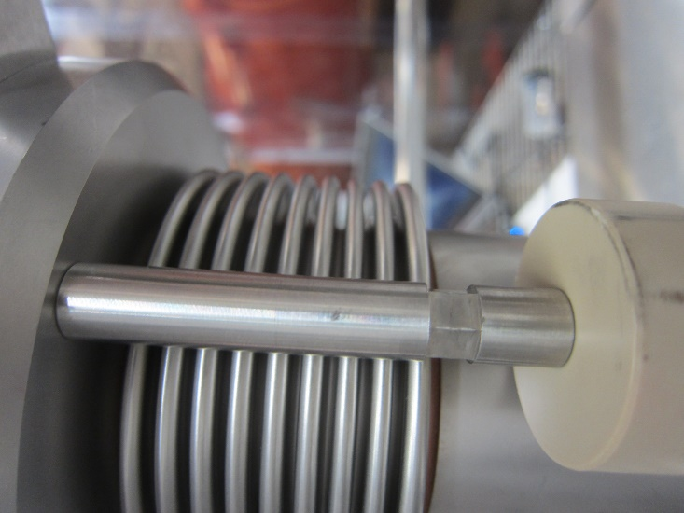
Figure 5.7: Motion damper installed on FPCW

- Remove the M8 screws, apart from those holding the bellows restraints (Figure 5.8)

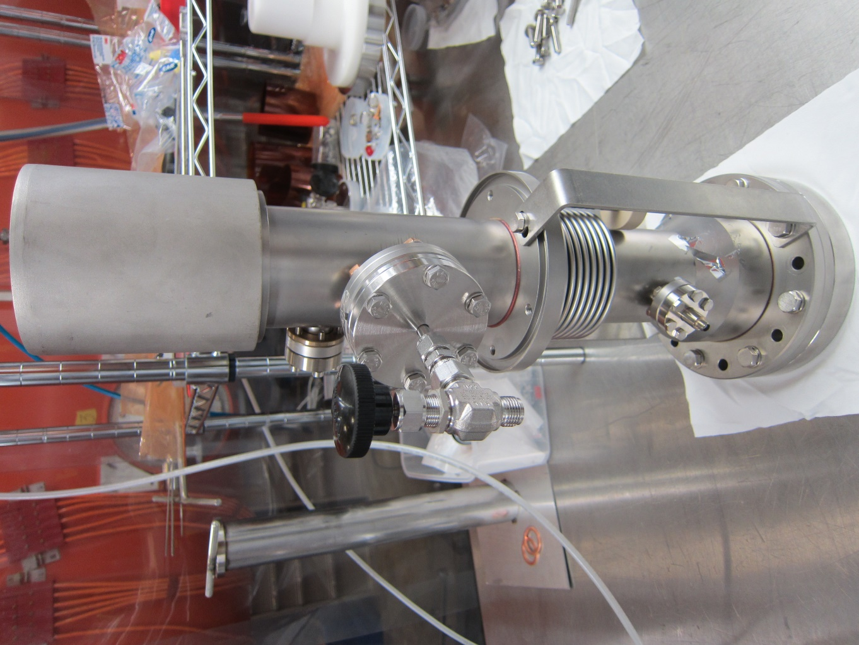
Figure 5.8 – Bellows restraint

- Remove the bellows restraints while supporting the bellows.

- Lift the FPCW vertically off the base and rest the FPCW on the table (Figure 5.9).

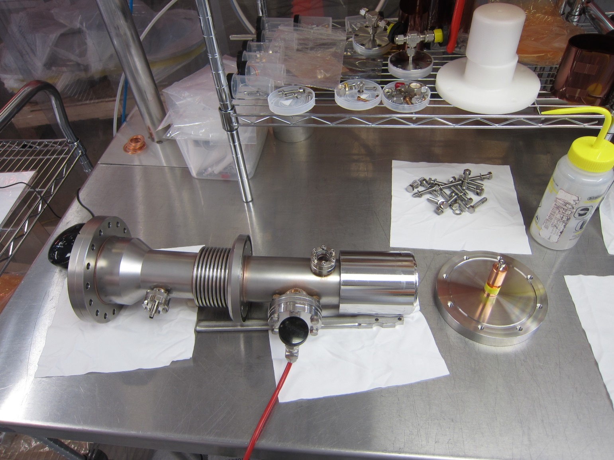
Figure 5.9 – DN100 Shipping Flange removed from the assembly

- Perform the inspections and checks as per Sections 6, 7, 8, and 9 of the inspection procedure.

FPCW Installation

- Install the brass sled on the installation tooling.

- Install the vented screw inside the FPCW inner conductor using the Tee-handled tools. This operation must be carried out by two people (Figure 6.1).

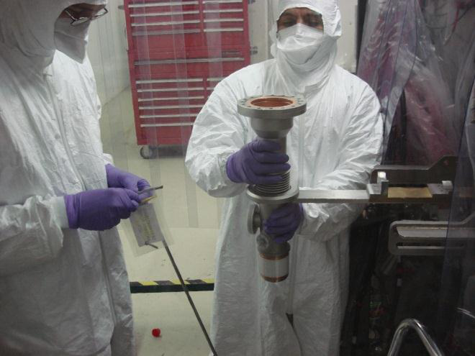 | 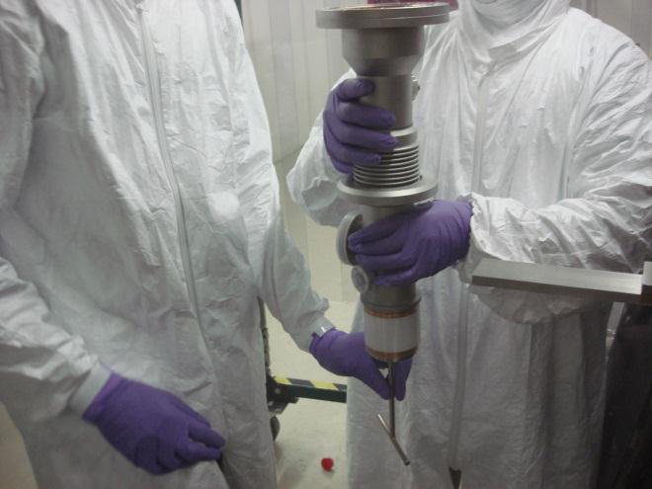
Figure 6.1: Installing the vented antenna screw in the FPCW

- Position the FPCW body on to the brass sled on the installation tool. Ensure that the DN40 pumping port and N2 line points to the left (Figure 6.2).

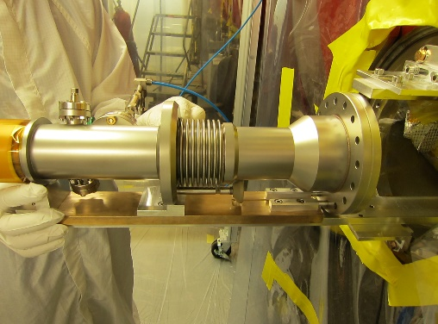
Figure 6.2: FPCW Installed on the Brass Sled

- Wipe down the DN100 flange on the FPCW and the 6” copper gasket

- Strike on a sturdy surface the OFE CF100 gasket, on an edge, to develop a slight out-of-round shape. If the gasket becomes non-flat, discard and try again.

- Snap the gasket into the flange on the Warm End. Check to make sure it is secure.

- Slide the Warm End towards the Cold End to ensure that the 6”CF flange clears the top bar of the installation tooling (Figure 6.3).

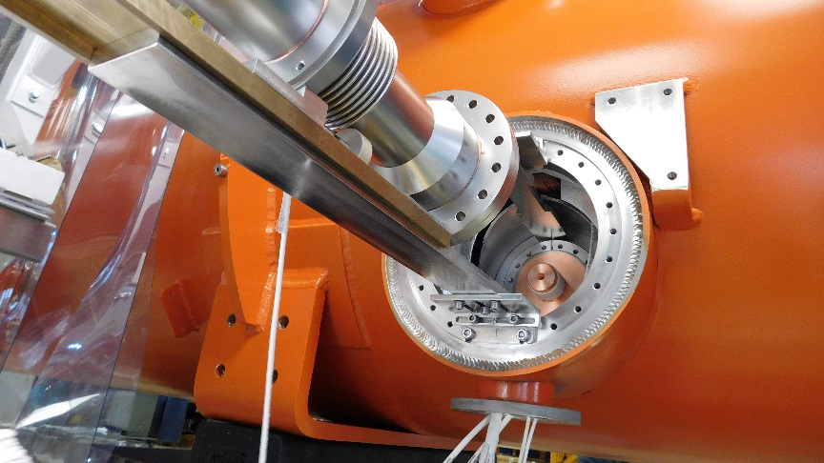
Figure 6.3: Sliding FPCW into position using the Brass Sled

- With the T-handle held, feel for contact of the center conductors. Slowly turn the T-handle to join the center conductors. Align the Warm End flange to the Cold End flange and tighten the screw. Firm up to a solid contact between the surfaces by feel (Figure 6.4).

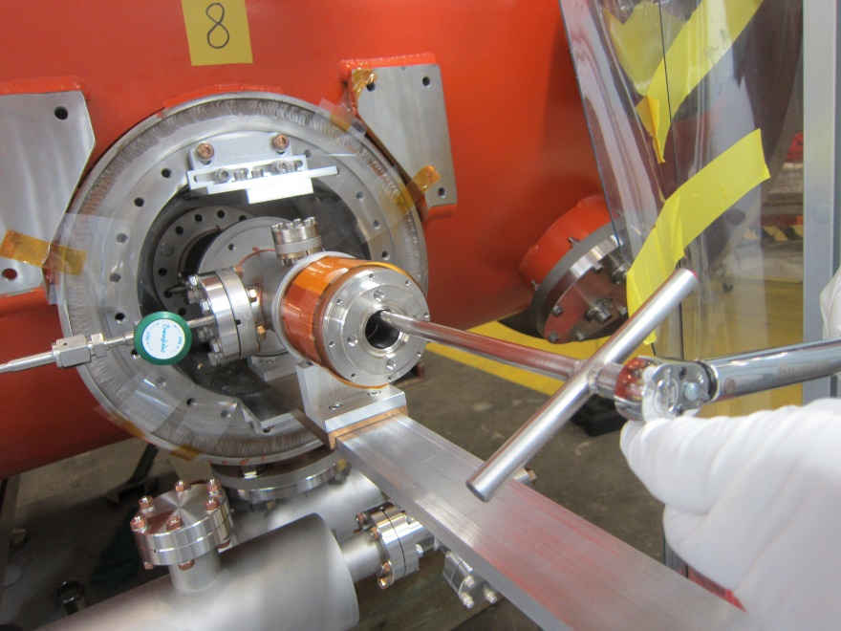
Figure 6.4: Joining the center conductor using T-handle tool
- Insert and tighten four M8 SHCSs and washers into the FPCC flange (at the 2, 5, 7, and 10 o’clock positions) to hold the gasket in place. Use a mirror to check flange uniformity.

- Install the remaining 12 M8 HHCSs. The brass sled will need to be removed in order to access the two bottom holes.

- Install two suspension links between warm end and the vessel port at (approximately) the 10:30 o’clock and the 1:30 o’clock positions and tighten the screws (Figure 6.5).

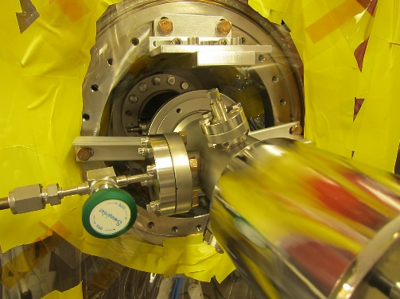
Figure 6.5: Suspension links installed

- Torque the M8 HHCSs in a star pattern (Figure 6.6). The torque must be 20 Nm the first round. The second and third cycles must be torqued to 25 Nm. Use an inspection mirror and flashlight to check for an even gap between the flange pair.

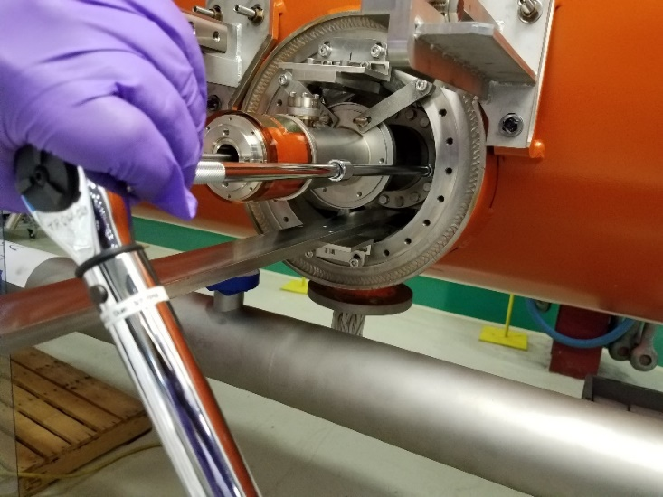
Figure 6.6: Torquing the FPCC screws

- Tighten the antenna screw between the inner conductors together with the T-handle. Torque to 7 Nm (Figure 6.7).

- A second person must confirm that the screw has been torqued

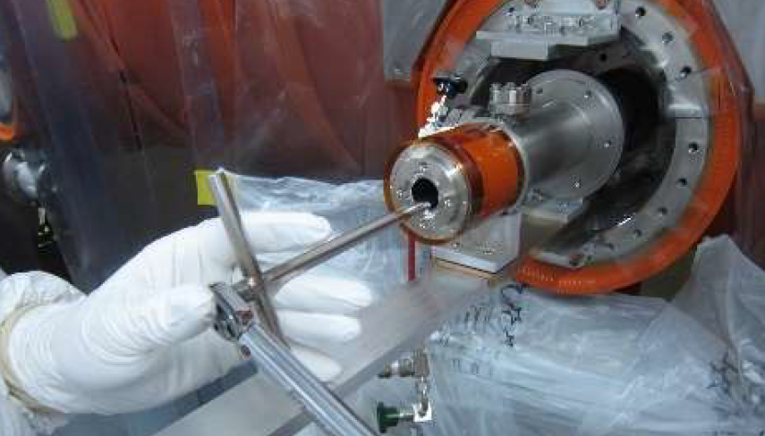
Figure 6.7: Torquing the vented antenna screw

- Uninstall the upper and lower installation tooling

Push Rod Installation

- Remove warm ceramic protection cup.

- Remove the push-rod from the steel storage cylinder

- Place a 2-1/8” gasket on push-rod flange

- Insert the Push Rod into the FPCW inner conductor with the pin at the end oriented horizontally (Figure 7.1).

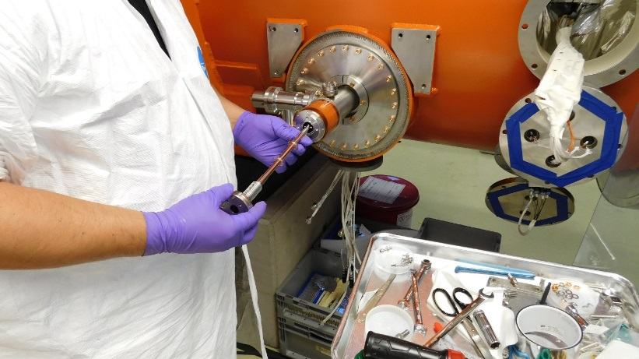
Figure 7.1: Inserting FPPR

- Rotate the Push Rod 90 degrees clockwise using the push-rod tool (Figure 7.2).

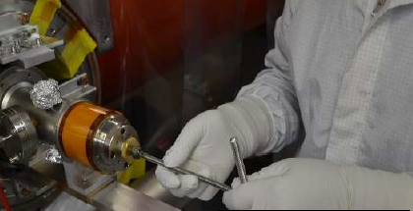
Figure 7.2: Using the push-rod tool to rotate the push rod

- Verify the 2-1/8” gasket is properly seated between the two flanges and align the bolting holes.

- Install four M5 SHCSs into the threaded holes. Do not tighten.

- Use the strain relief tool to torque the FPPR SHCSs. This must be carried out by two people. One person should hold the restraint tool in place while the other torques the SHCSs to 15 Nm (Figure 7.3).

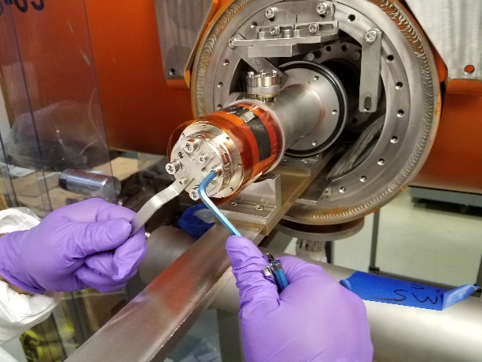
Figure 7.3: Using the strain relief tool to install FPPR hardware

- Install the tuning actuator without the knob. Torque the M4 SHCSs to 2 Nm (Figure 7.4).

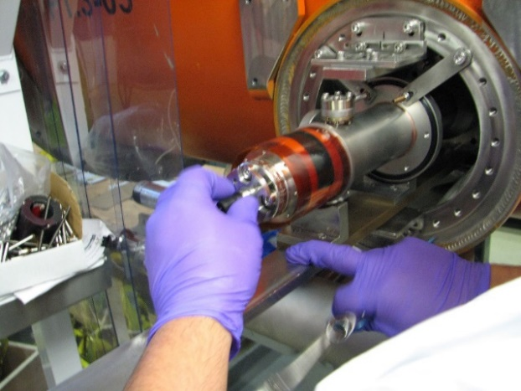
Figure 7.4: Installing the tuning actuator

- Install the ceramic protective cup. Install two M4 x 12mm LG SHCS and tighten until snug. Do not torque (Figure 7.5).

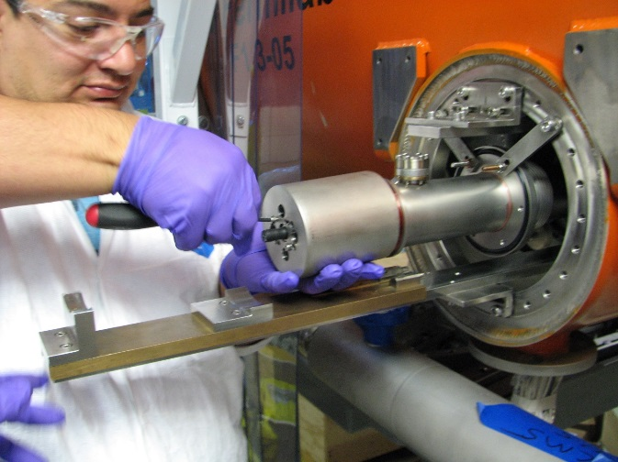
Figure 7.5: Installing ceramic protective cup

Leak Check

- Remove the Nitrogen supply from the DN40 port and attach the leak check setup (Figure 8.1).
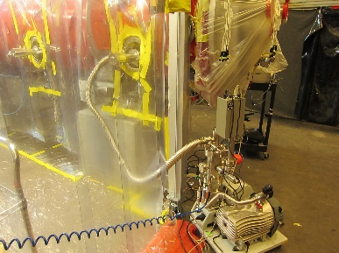
Figure 8.1: Attaching the leak detector setup

- Leak check the coupler assembly. If the leak check fails, swap out the sapphire window. If the window was the cause of the leak create an NCR for the FPCW; in the comments note that the window leaked. On the Modification page note that the window was swapped out with a functional one, attach leak check data. Individually bag each failed window; deliver to group lead or TR.

- Backfill the assembly with N2 and remove the leak detector. Seal the DN40 flange using the plastic cap.

Replace MLI

- Install the pre-cut MLI on to the coupler assembly. Ensure that there is no damage to the bellows during MLI installation, and that none of the MLI hinders bellows movement during tuning.

- Install the connector on the electron probe. Orient the connector to face down (Figure 9.1)

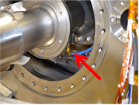
Figure 9.1: Electron probe connector

- Have the RF group check the cable connection

Exterior Flange Installation

- Install the outer portion of the exterior support frame, tighten bolts snug (Figure 10.1).

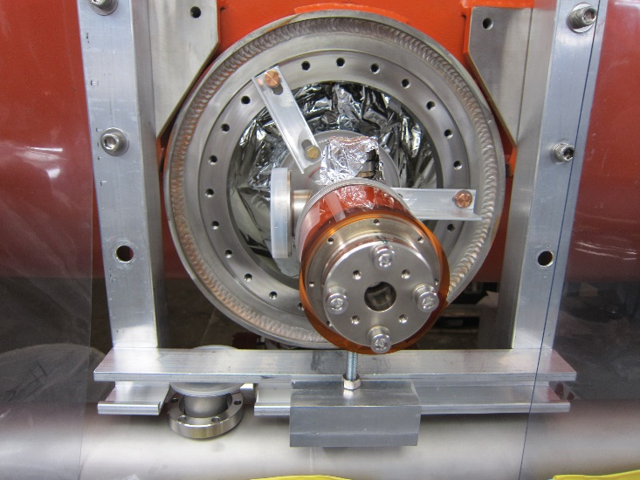
Figure 10.1: Exterior support frame

- Apply a thin film of O-ring grease to both seals used on the port flange.

- Position the O-ring between the FPCW flange and the 1-1/3” port (Figure 10.2).

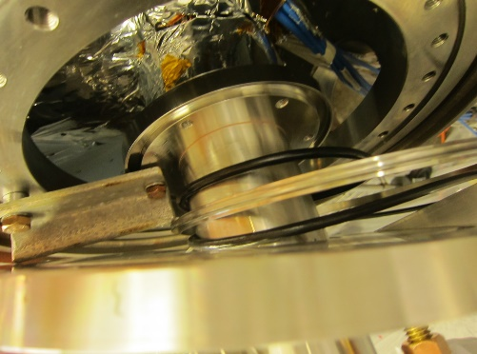
Figure 10.2: O-ring positioned on FPCW

- Install the larger O-ring on the large flange. Use some grease to hold the O-ring in place.

- Slide the large flange over the FPCW body taking care to not contact the ceramic or outer ports. Ensure that there is access to the suspension links (Figure 10.3).

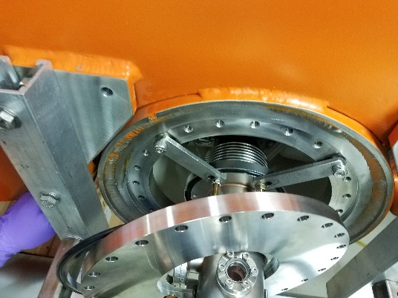
Figure 10.3: Sliding the large flange over the FPCW

- Install and tighten the support arms and the support saddle (Figure 10.4). Ensure that the tooling is secure.

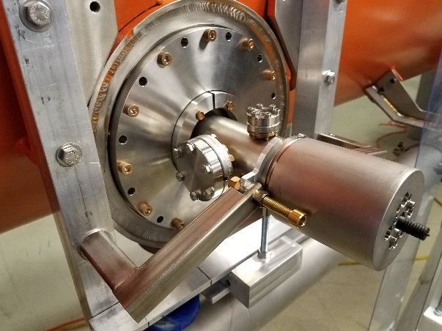
Figure 10.4: Support arms and saddle

- Remove the two suspension links (Figure 10.5).

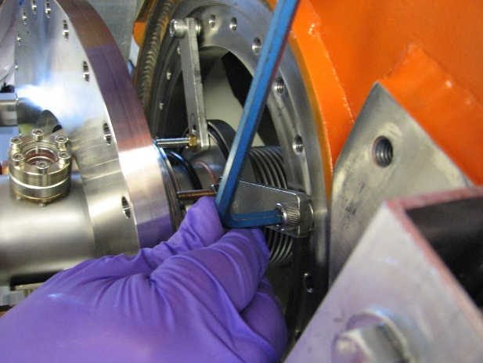
Figure 10.5: Removing the suspension links

- Reposition the large flange on the vacuum vessel flange and install all the M8 SHCSs and washers, tightening until snug (Figure 10.6). Check that the flange ring and o-ring are centered.

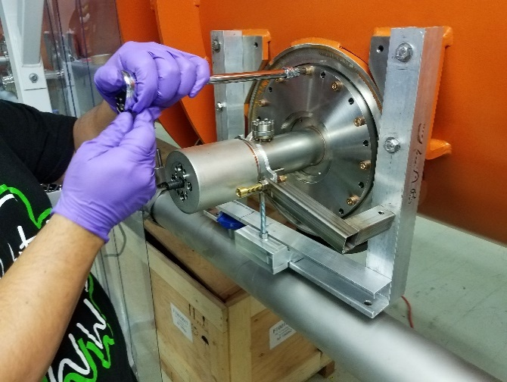
Figure 10.6: Installing hardware on large flange

- Install split rings into vacuum flange and secure with M6 HHCS. The shorter screw needs to be installed in the hole behind the DN40 flange. The split must be oriented perpendicular to the ground (Figure 10.7). Torque the screws to 7 Nm.

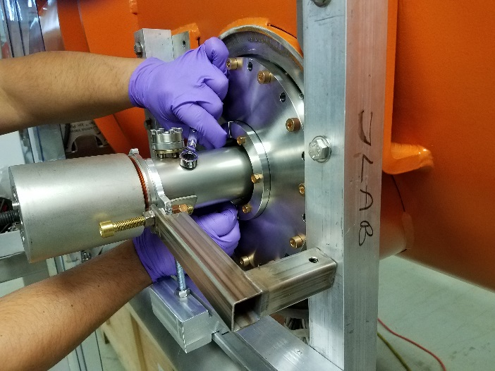
Figure 10.7: Installing center flange

- Remove the external support tooling (Figure 10.8).

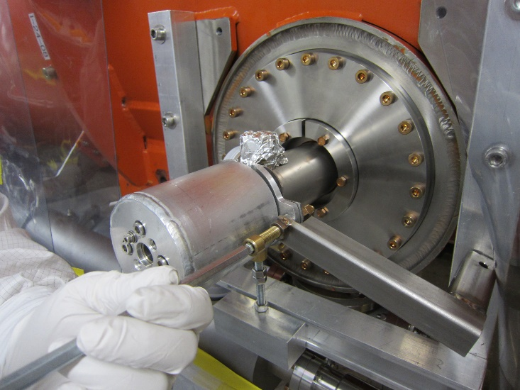
Figure 10.8: Uninstalling FPCW support tooling

- Torque the M8 screws on the large flange to 15 Nm (Figure 10.9).

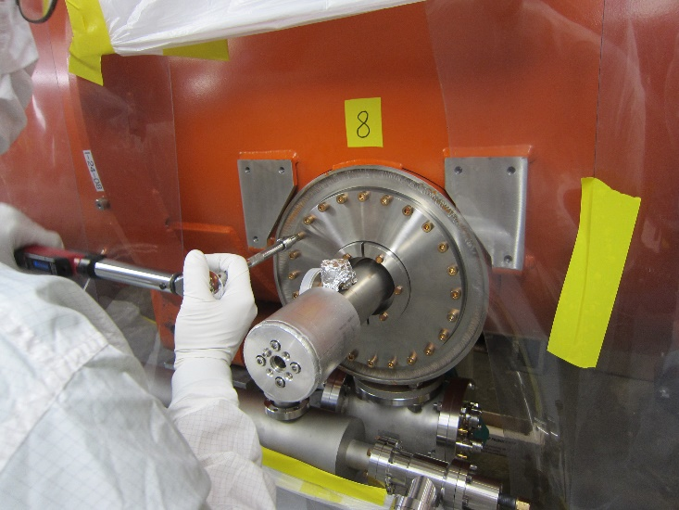
Figure 10.9: Torquing large flange hardware

- A second person must verify the torque on both flanges.

- Install the RAV using a 2-3/4” CF gasket and M6 HHCSs, washers and nuts. Ensure the bottom of the RAV flange is level (Figure 10.10). Torque the screws to 15 Nm.

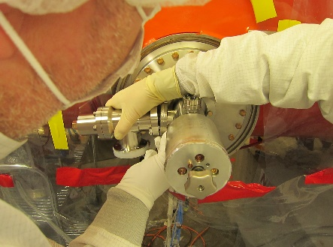 | 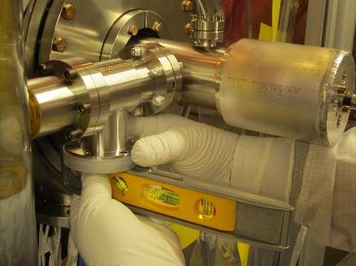
Figure 10.10: Installing the RAV on the FPCW

- Attach a N2 source to the RAV and purge the inside of the FPCW for 30 seconds

- Close the RAV and torque to 15 Nm.

- Remove the ceramic protector cup and install the manual actuator knob (Figure 10.11).

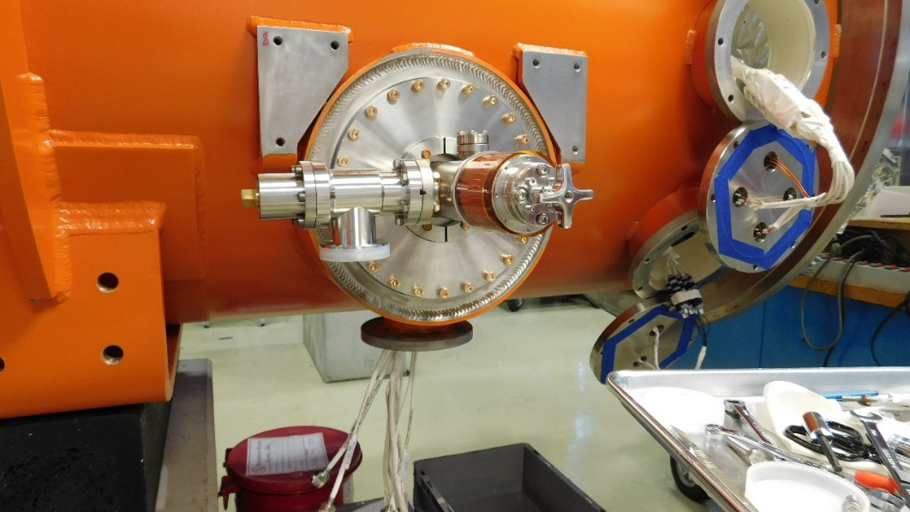
Figure 10.11: Manual actuator valve installed on FPCW

- Cover the FPCW with a protective cover and a thin plastic sheet (Figure 10.12).

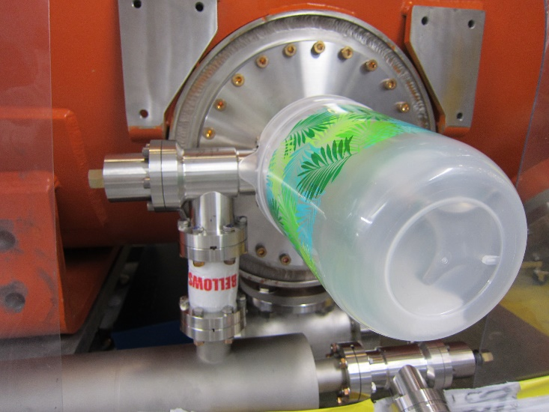
Figure 10.12: Protective cover on FPCW

MC Line connection installation
- The MC line connections are installed after all eight FPCWs have been installed on the CM. The work is carried out under controlled conditions, under a prepared LFH. Personnel must wear the appropriate cleanroom garb and PPE. All MC line parts must be cleaned and prepared for installation prior to starting.

- Move the adjustable supports used to position the MC line under the LFH.

- Start the MC line installation from Cavity 1 (US end).

- Connect and torque the M6 screws on the Tee for vacuum instrumentation (Convection gauge MKS317 and cold cathode gauge MKS 422) on the US end to 9 Nm (Figure 11.1)

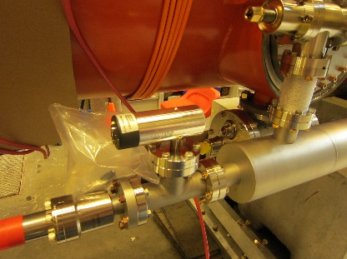
Figure 11.1: US tee with convectron gauge

- Continue installing the next MC line sections and torque the M8 hardware on each 6” CF flange to 15 Nm.

- Connect bellows to the FPCW DN40 port and the MC line pumping port; torque the M6 hardware on the joints to 9 Nm.

- Connect the 75S Titan DI 6” SAFECON ion pump in the middle of the MC line (Figure 11.2). Torque the M8 hardware to 15 Nm.

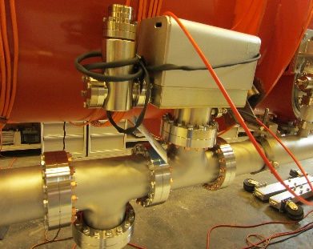
Figure 11.2: Ion pump installed on the MC line

- Connect the RAV at the DS end of the MC line (near cavity 8) and torque the hardware to 9 Nm (Figure 11.3).

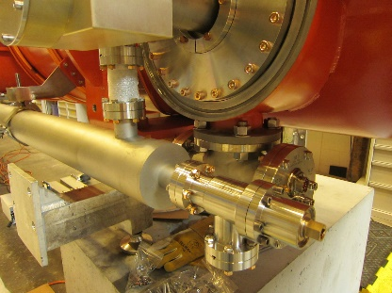
Figure 11.3: RAV installed on the DS end of the MC line

- Install the pumping station to the DS RAV in preparation for leak checking.

Integrated leak check

- Open all RAVs installed on the FPCWs

- Pump down and leak check the connection between the leak detector and the DS RAV on the MC line.

- If the leak check is okay, open the RAV and pump down the MC line and FPCWs

- Perform the leak check on the flange connections and upload He trace and RGA data to the traveler. Generate a D3 if any leak is found and needs to be repaired.

- If no leaks are found, continue pumping until the pressure reaches 10⁻⁶ torr.

- Turn on the MC line Ion Pump and close the RAV connecting the MC line to the pumping station. Record the vacuum pressure in the traveler.

fpc waveguide installation

- Waveguides are not installed under the LFH, but personnel must wear nitrile gloves and appropriate PPE while performing the installation.

- Enter the waveguide serial number into the L2HE-INSP-FPCWG inspection traveler. Check that all the components are present and that there is no damage to the sealing/contact surfaces as per the traveler. Generate an NCR if any issues are found, and move on to another kit. Otherwise, close the traveler.

- Prepare the components listed in the waveguide bill-of-materials, and required tools, on a cart in the workstation 5 area

- Remove the protective plastic from the FPCWs but keep the ceramic protective cup in place.

- Apply Loctite 243 on the threaded studs for the waveguide support arms and thread them into the upper holes next to the FPC port (Figure 13.1).

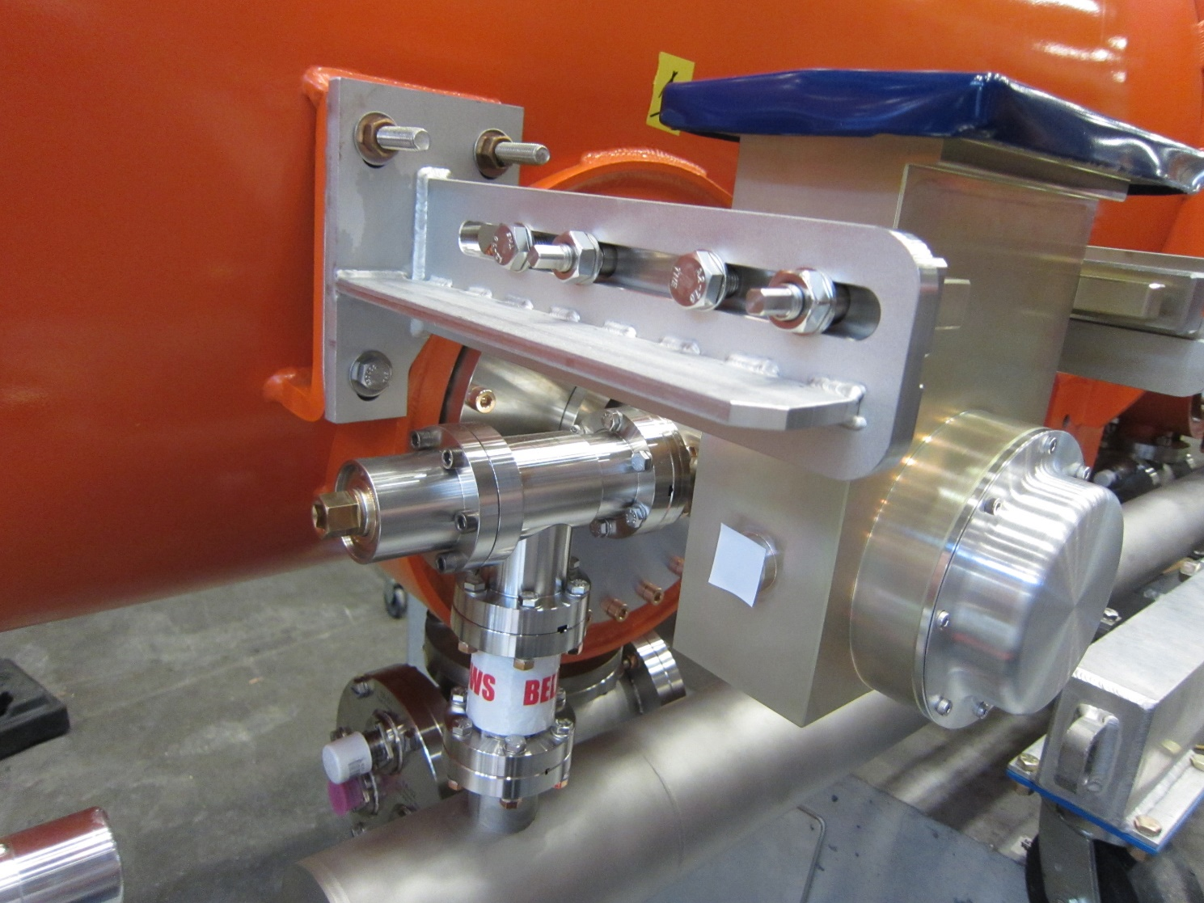
Figure 13.1: Positions of threaded rods on support arm threaded holes

- Install the waveguide support arms. Do not torque the HHCSs at this stage (Figure 13.2).

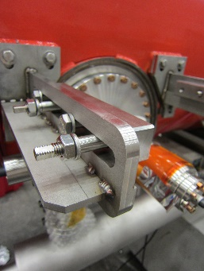
Figure 13.2: Waveguide support arms installed

- Pull back the HHCSs on the support arms to allow clearance for the waveguide box to be installed (Figure 13.3).

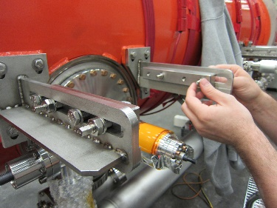
Figure 13.3: Adjusting hardware on the support arms

- Remove the ceramic protective cup from the FPCW. Replace the Kapton sleeve with a Kapton cylinder on which two pieces of tape are attached at the 9 o’clock and 3 o’clock positions.

- Slide the waveguide box over the ceramic of the FPCW with the WR650 flange pointing upwards. Use a level to ensure that the flange is parallel to the ground (Figure 13.4).

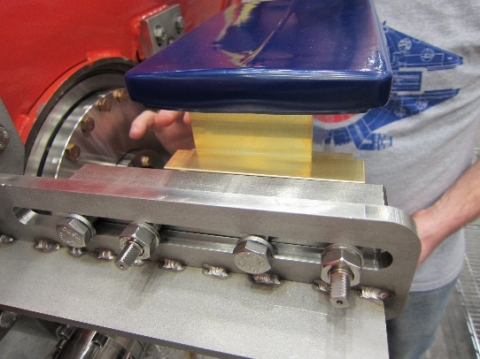 | 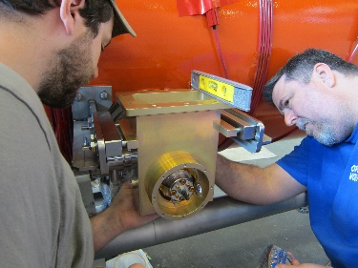
Figure 13.4: Positioning Waveguide Box between the support arms

- Slide the brackets on the support arms until the mounting rods engage with the threaded holes on the waveguide box.

- Once the mounting rods move freely into the waveguide box holes, hand tighten them and then torque the support arm nuts to 15 Nm (Figure 13.5)

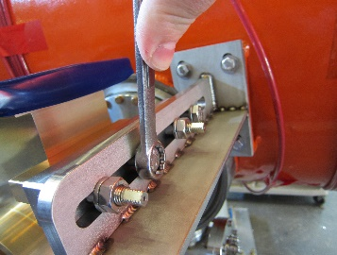 | 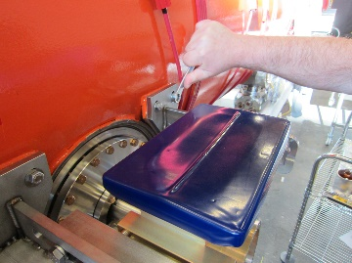
Figure 13.5: Tightening support arm hardware

- Attach the split-rings at the back of the waveguide using the M5 hardware (Figure 13.6). All but two of the M5s are SHCSs, but two of them will need to HHCSs.

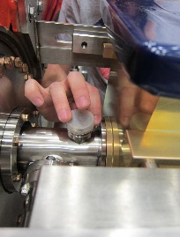
Figure 13.6: Installing waveguide box split rings

- Removed the Kapton sleeve from the ceramic by pulling on the tape (Figure 13.7).

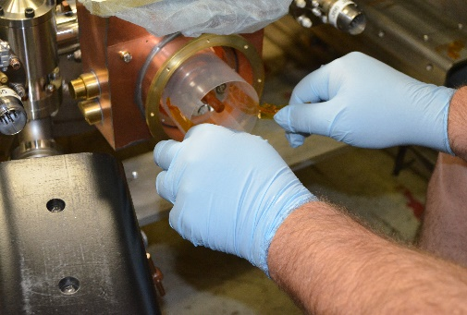
Figure 13.7: Removing Kapton sleeve

- Check for an open loop measurement with a multimeter across the warm ceramic and waveguide.

- Check concentricity of the ceramic inside the waveguide. If needed re-level the waveguide (Figure 13.8).

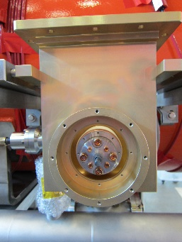
Figure 13.8: Checking concentricity and parallelism

- Install the Copper Ring (Figure 13.9)

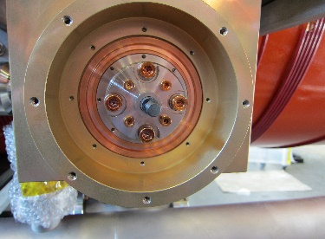
Figure 13.9: Copper ring installed in the Waveguide Box

- Install the stainless-steel rings and torque the M3 SHCSs to 2 Nm (Figure 13.10).

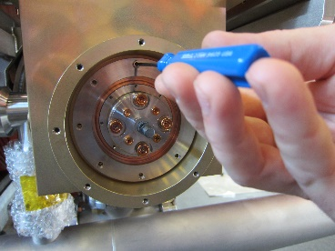
Figure 13.10: Stainless-Steel ring installed on Waveguide Box

- Verify that all hardware on the waveguide assembly has been torqued.

- Install the waveguide protective cover using SHCSs in the 12, 3, 6, and 9 o’clock positions (Figure 13.11).

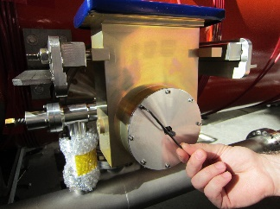
Figure 13.11: Protective cover installed on the Waveguide Box

- Install the manual actuator knob. Check that the actuator rotates freely by turning it clockwise two turns and then turning it back (Figure 13.12)

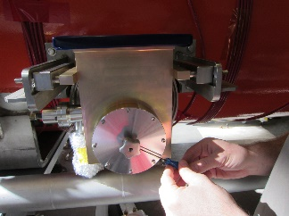
Figure 13.12: Manual actuator knob installed on Waveguide Box

- Install the knob protective cover and the rubber gasket with screws in the holes left empty in step 13.18 (Figure 13.13).

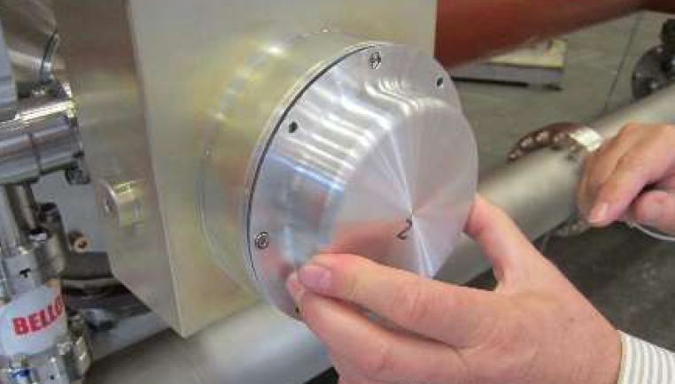
Figure 13.13: Knob protective cover installed on waveguide box

FPCW RF Verfication

- Remove the knob protective cover

- Use a marker to mark the relative starting positions on the knob and the SS cover

- Attach the RF transition to the WR650 flange on cavity 1. Connect a Network Analyzer with Port 1 to the transition and Port2 to the field connector on cavity 1, via an RF amplifier.

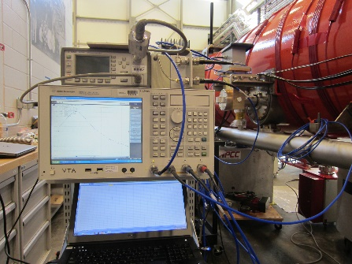

- Measure and record the warm passband pi-mode frequency and loaded Q (Q_{L})

- Turn the knob clockwise for one turn and record the frequency and Q_{L}. Make a note if there is resistance to the turning motion.

- Repeat the measurement for three more clockwise turns.

- Turn the knob four turns counter-clockwise to return it to its original position. Take a final frequency and Q_{L} measurement. Also write down the final S21 loss (dB).

- Generate a D3 if there are any issues with taking the measurements. Generate an NCR if the knob cannot be safely turned four times.

- Repeat steps 4.14.1 – 4.14.8 for cavities 2-8.

- Calculate the average S21 loss across all eight cavities.
- If the loss for any cavity is more than 3dB higher (less negative) than the average, the Qext of the FPC is too low. The tuning needs to be adjusted to ensure the full range at 2K.

- Reconnect the network analyzer to any cavities with this condition as in 4.14.3-4.14.4

- Remove the knob protective cover. Turn the knob counter-clockwise until the S21 loss is within 3dB of the newly calculated average.

- Re-attach the knob protective cover Take a final frequency and Q_{L} measurement.

- Record any retuning in a D3, including the number of additional turns.

Appendix 1 – FPCW Schematic

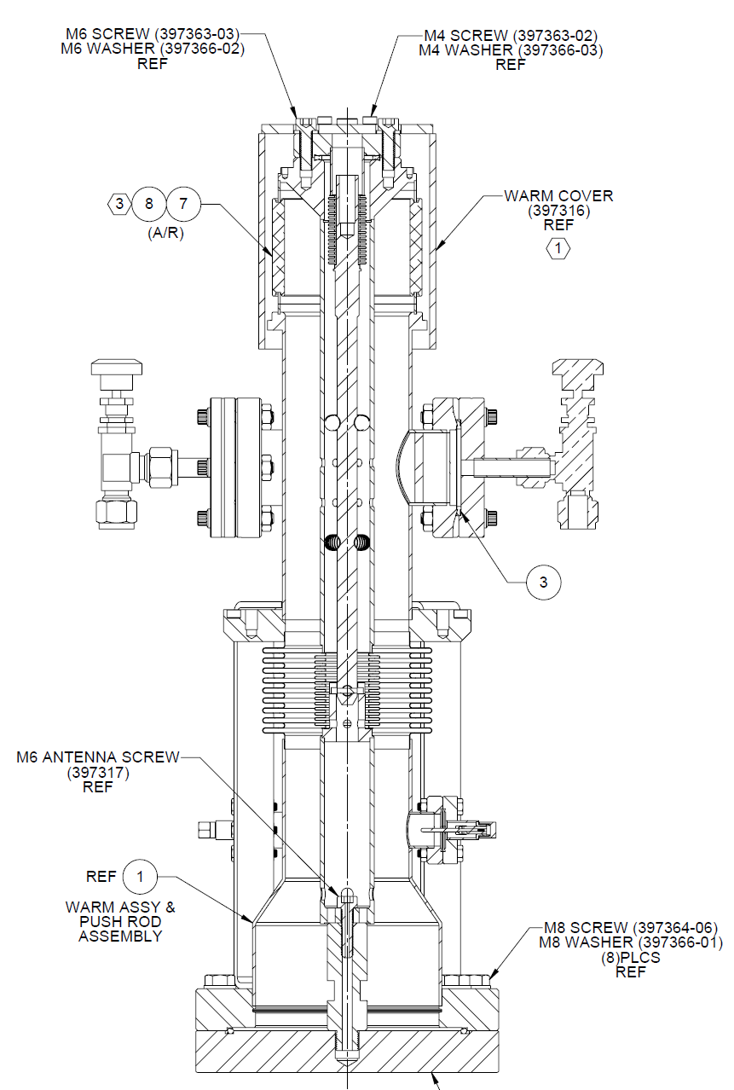

Appendix 2 – Waveguide BOM

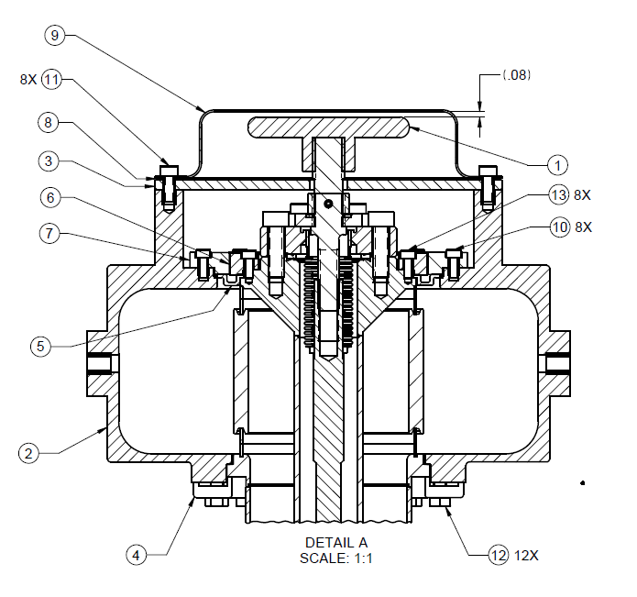

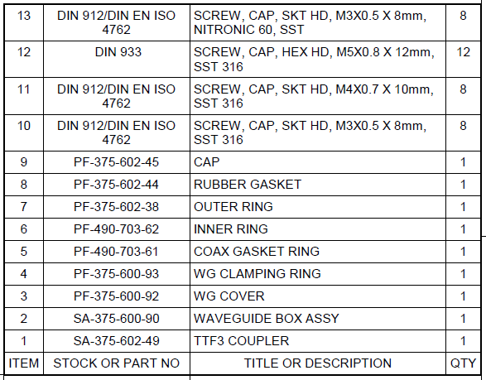

References

Document No. | Title
SRF-06-PR-001 | Records Management Procedure
SRF-07-PR-001 | Document Management Procedure
LCLSII-HE-1.2-ES-0059 | LCLSII-HE Fundamental Power Coupler ESD
L2HE-PR-INSP-FPCW | Inspection Procedure for LCLS-II-HE Warm Fundamental Power Coupler

Release and Revision History

Rev # | Major Changes | Revision Date:
1 | Initial version (Utilizing SRF-07-FM-005 SRF OPS Procedure Template, R1). Converted from L2HE-PR-ASSY-FPCW-R3 | 05 Jun 2025

Approvals

Approved by: | Name:
Document Owner | N. Huque
Document Reviewer 1  JLab SME or SRFOPS WCL | M. Weihl/M. Murphy?
Document Approver 2  SRFOPS WCL or GL | J. Fischer
For Project Procedures: Refer to the Project Execution Procedure SRF-11-PR-001

Document Processor Instructions:
- Put valid dates everywhere DD is found and verify they are accurate
- Attach DocuShare Approval Picture here

