|  |  |  |  |
| --- | --- | --- | --- |
| **<SRF OPS Procedure Title>** | | | |
| **Document Number:** | C100R-PR-CMA-SFTS-ALIGN | **Effective Date:** | DD Mmm 2025 |
| **Revision Number:** | 1 | **Periodic Review Date:** | N/A |
| **Document Owner:** | Jeff Campbell | **Department Owner:** | SRF Operations |

# Purpose and Scope

The purpose and scope of this document will provide the necessary steps to perform alignment on the

C100 style cavity strings in the Cryomodule Assembly area. This procedure begins with a cavity string on lollipop assembly tooling, the 50k shield and spaceframe installed, and all nitronic and axial rods affixed at interface points between the helium vessels and the spaceframe. When completed, the lollipop tooling has been removed, all rods have been adjusted and torqued, and the cavity string is aligned to +/- .010”. This information is then used by the JLAB Alignment Team to position the Cryomodule in the Accelerator vault. Work is to be performed by knowledgeable Technicians that are familiar with the Cryomodule components, tooling, and this Procedure.

# Definitions and Diagrams

The following terms have specific meanings within this procedure.

|  |  |
| --- | --- |
| **Term** | **Definition** |
| Alignment grid | A system of control points in the assembly area used by the JLAB Alignment Team to create a repeatable matrix |
| Monument | A granite pier fixed to the floor, outfitted with precision bases used to accurately support alignment tooling |
| Alignment scope | A calibrated piece of equipment that establishes our line of sight, with adjustable reticles |
| Reference ball | A precision piece of alignment tooling that contains a graduated see thru window |
| Alignment arm | A specially designed article of tooling that transposes the beam line flange location to the dual scope average positions |

# Roles and Responsibilities

The following roles have responsibilities described in this document.

|  |  |
| --- | --- |
| **Role** | **Responsibility** |
| Cryomodule Group SME | Responsible for overseeing the correct application of this Procedure and review of the work performed. |
| Cryomodule Group Assembly Technician | Will perform the required steps from this Procedure. Is properly trained and knowledgeable on the Cryomodule components, required tooling, and information contained with-in this document. |

# Safety

Individuals must keep safety as the first priority in the process. Before beginning any job, the user must ensure they have the correct PPE for the individual job. Maintaining the level of safety and secure nature of the work area is paramount. Assure personal safety by using caution in movement and taking necessary steps to avoid unnecessary personnel in the immediate area.

# Procedure

Verify all Cryomodule traveler steps have been completed prior to beginning alignment.

Position spaceframe

1. Drop plumb bobs from the centerline of the spaceframe; adjust the support tooling to center the spaceframe on the fixed rails. Tighten the tooling hardware.
2. Set the height of spaceframe, tape the ¼ point elevation adjusters to prevent tampering.
3. Set the roll of the spaceframe, using a level on top tube SF extensions. Install the anti-roll fixtures and tighten.
4. Lastly, center the spaceframe over the cavity string (Z), install rail locks.

Confirm all nitronic and axial rods are properly installed. Be sure nuts on helium vessel end of nitronic rods are fully engaged and bottomed out against the HV head boss.

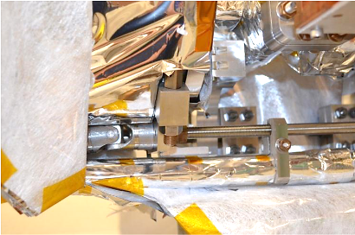

Torque nitronic rods

1. Torque the top nitronic rod nuts to 30 in/lbs, using two people simultaneously on opposing sides. This will ensure an evenly applied load.
2. Repeat the process for the bottom nitronic rods.
3. Verify the spaceframe is centered over the cavity string (Z), then snug the axial rods finger tight, 4 locations.

Remove the lollipop tooling

1. Install dial indicators on the beamline flanges to monitor the movement during the lollipop removal. If excessive movement is seen (>.100”), stop and consult SME/Team Lead.
2. Remove the ¼-28 hardware from the helium vessel head tab to lollipop interface.
3. Loosen and remove the lollipop supports. Protect threads and stow.
4. Remove the carriages, sliding under the ¼ point tooling, off the end of the assembly rails.
5. Cavity string is now hanging in the spaceframe.

Setup alignment equipment

1. Clean all scope and reference ball mount hardware with isopropyl. Wipe a thin coat of light weight oil onto the interface points.
2. Place the reference balls onto the appropriate piers, northern end. Square up to face of pier, rotate crosshairs into correct orientation.
3. Install the alignment scopes onto the correct piers. Articles are identified by #1 and #2. Rotate the scopes to seat them into the supporting cup.
4. Affix the retaining chain to the collar of the scope.

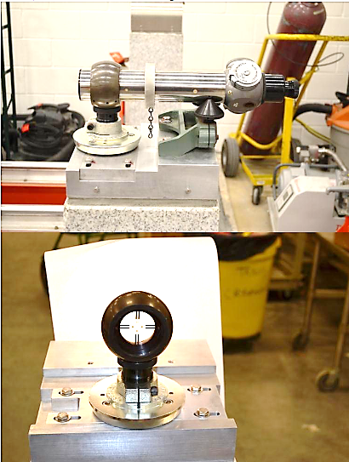

Prepare alignment arms and targets

1. Wipe down targets, target holders, and center helium vessel seat with isopropyl.
2. Verify helium vessel hub is free of tape, MLI, or other potential interferences.
3. Install the alignment arm onto the helium vessel hub; be sure to fully seat it against the machined edge.
4. Install the alignment targets into the arm and secure with the retaining rubber straps. Rotate the crosshairs as needed.

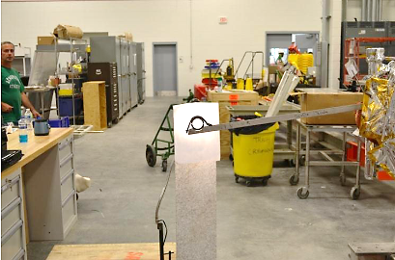

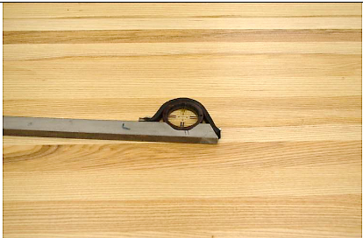

Alignment

1. While looking through the scopes, rough align the arm, rotating it on the helium vessel hub to get within the +/- .050” range. (This is the scopes range).
2. Adjust the dials on the scopes, centering the crosshairs to the target grids. Record the values into the C100 Alignment Spread Sheet (Scope dials are labeled to reflect positive and negative corrections.). An example of the Alignment Spread Sheet is below.

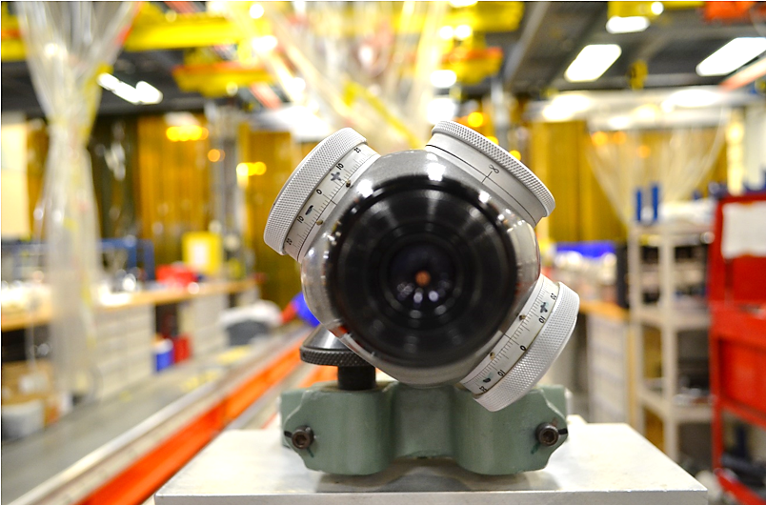

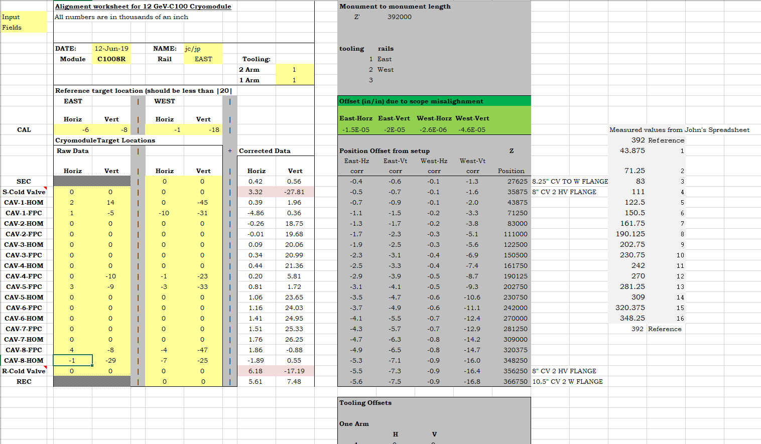

1. The spreadsheet will define the amount a given flange will need to be moved.
2. Move in one direction at a time (vertical or horizontal), do not rotate the cavities. To move, using a torque wrench. Adjust the two corresponding rods for the direction needed. Minium torque is 70 in/lbs, maximum is 150 in/lbs. Consult SME/Team Lead if values cannot achieve the alignment objective.
3. Repeat the process until all cavities are aligned to within +/- .010”. The process will likely take 3 or more passes to complete.
4. Verify all torques values are in range, including the 4 axial rods.
5. The final pass shall be completed with no movement of any rod.

Using the Double Alignment arm, record the cold valve 6” flange locations. These numbers will be used in the future to reposition the Vacuum Vessel once the coldmass has been installed.

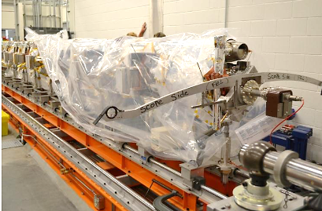

Record the spread sheet into the appropriate folder and Traveler. Alignment is now complete.

# References

|  |  |
| --- | --- |
| **Document No.** | **Title** |
| SRF-06-PR-001 | Records Management Procedure |
| SRF-07-PR-001 | Document Management Procedure |
| [CRM1207014-0160](https://misportal.jlab.org/jlabDocs/items/45676) | C100 Alignment Arm |
| [03103-0001](https://misportal.jlab.org/jlabDocs/items/3918) | 6” Double Ended Alignment Arm |

# Release and Revision History

|  |  |  |
| --- | --- | --- |
| **Rev #** | **Major Changes** | **Revision Date:** |
| 1 | Initial version (Utilizing SRF-07-FM-005 SRF OPS Procedure Template, R1) | DD Mmm YYY |
| <2> | <brief description of major changes>(Utilizing SRF-07-FM-005 SRF OPS Procedure Template, R1) | DD Mmm YYY |
|  |  |  |

# Approvals

|  |  |
| --- | --- |
| **Approved by:** | **Name:** |
| Document Owner | Jeff Campbell |
| Document Reviewer 1  JLab SME or SRFOPS WCL | Jared Martin |
| Document Approver 2  SRFOPS WCL or GL | John Fischer |

For Project Procedures: Refer to the Project Execution Procedure SRF-11-PR-001

*Document Processor Instructions:*

* *Put valid dates everywhere DD is found and verify they are accurate*
* *Attach DocuShare Approval Picture here*