AUP RFD Bare Cavities Incoming RF inspection
Document Number: | AUPCAV-PR-TUNE-CAV-RFIN-BAREC | Effective Date: | 22 Sep 2024
Revision Number: | 1 | Periodic Review Date: | N/A
Document Owner: | Roland Overton | Department Owner: | SRF Operations

Purpose and Scope

This procedure covers the inspections required for RF acceptance of incoming AUP RFD bare.

This procedure outlines the RF acceptance inspections required for incoming AUP RFD cavities.
Inspection Location and Timing:
- Conduct inspections in the RF tuning area immediately after the initial receipt inspection.
Equipment Required:
- Vector Network Analyzer
- 50 Ω RF cables with Type-N connectors
- RF amplifier
- Digital multimeter
- Weather station or electronic data logger (available in RF tuning area) to record ambient conditions (temperature, pressure, relative humidity)
RF Inspection Procedure:
- Perform RF measurements with the cavity in its delivered state (under vacuum unless otherwise noted by the vendor).
- Measure the warm fundamental mode frequency and record the transmission spectrum.
- Check the electrical integrity of all RF antennas.
- Save all data in an Excel spreadsheet and upload it to the designated M-drive location.
Post-Inspection Actions:
- After the RF inspection, transfer the cavity carefully to visual inspection.
- Always handle the cavity with care, including during workstation transfers.
Hardware Configuration on Delivery:
- The cavity is delivered with the same qualification hardware used during bare cavity vertical cold tests. This includes a high-Q fixed antenna (SST) on the FPC coupler port, a pickup antenna feedthrough on the opposite port, a right-angle valve (VAT) on the FPC-side beam tube flange, and a burst disc on the HHOM coupler port. The figure below shows the hardware configuration at delivery.
Additional Information:
- Prior to delivery, the cavity is fully post-processed, including main and final BCP.
- It is tuned to a warm target frequency (~400.06 MHz ±50 kHz). Field flatness is not evaluated for single-cell cavities like the AUP RFD.
- The cavity is delivered under vacuum and without a helium vessel, unless specified otherwise, and has cleared all hold points for shipment to JLab.
- The vendor records the fundamental mode frequency immediately before shipment under the same conditions.
- Repeat the same measurement after delivery to check for any frequency shift, which may indicate deformation from handling or shipping. Pay particular attention to changes caused by potential damage to the cavity walls or poles.

The as-delivered cavity is also equipped with qualification hardware ready for vertical cold tests, which includes one high-Q fixed antenna attached to the FPC coupler port, one pickup antenna feedthrough attached to the pickup port on the opposite side of the main coupler port. The beam tube flange on the FPC side carries a right-angle valve (RAV). A Burst disc is attached to the HHOM coupler port. The figure below highlights the hardware accessories assembled at the time of delivery.

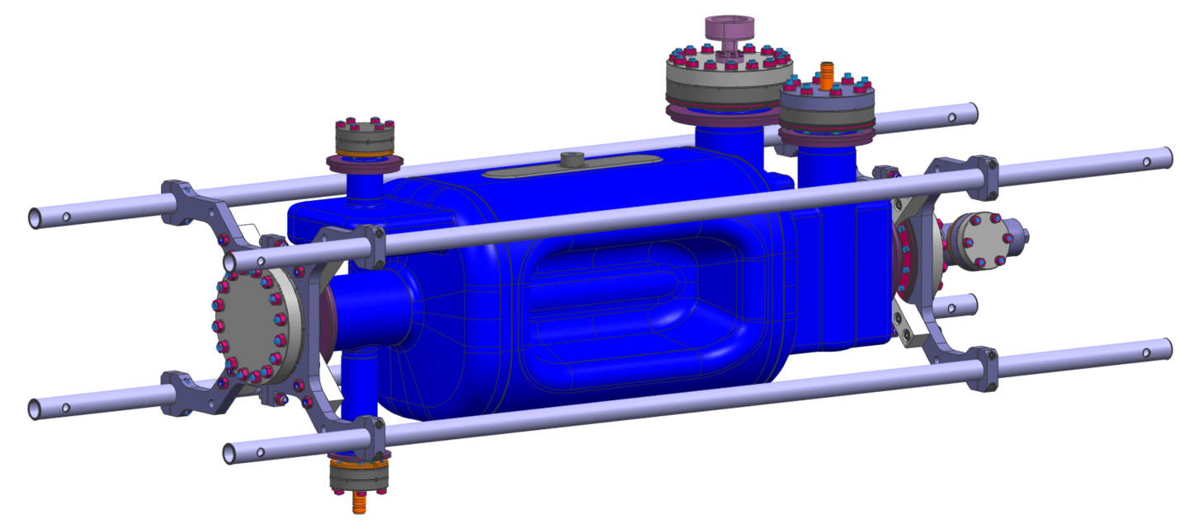
Input antenna
Pickup antenna

Fig. 1: Schematic of the cavity ports.

Definitions and Diagrams

The following terms have specific meanings within this procedure.

Term | Definition
RFD | Radiofrequency dipole.
HHOM | Horizontal Higher Order Mode (coupler)
RAV | Right Angle Valve
NCR | Non-conformity Report.

Roles and Responsibilities

The following roles have responsibilities described in this document.

Role | Responsibility
Project Manger | Approves procedure and scope.
Procedure Author | Develops procedure and revises as necessary. Ensures technical staff has access to latest procedure revision.
Technical Staff | Follows operation steps in accordance with this procedure. Obeys all safety requirements of the room/workcenters. Fills out travelers and writes NCRs as necessary.
Workcenter Lead | Reviews procedure. Assigns technical staff to complete tasks outlined in the procedure. Ensures technical staff performs tasks in accordance with room/workcenter safety requirements.

Safety

The following safety items …

Procedure

Step | Instructions
1 | Note your name and cavity serial number in the traveler.
2 | Record the Fundamental Mode Frequency in Transmission (S21) using a Vector Network Analyzer (VNA). It is recommended to use an Agilent VNA with up to 20001 data point per sweep.  Preparation: Attach cable 1 from VNA port 1 to the input antenna (high-Q fixed antenna, SST Inc.) and cable 2 from VNA port 2 to the pickup antenna (Kyocera). The use of averaging may be necessary due to the poor coupling of the test antennas at room temperature. Use an amplifier in the return path (cable 2) if required to capture modes with low signal transmission.  Technician performing RF measurements  Create a new worksheet (name: ‘Fundamental’). Record data with at least 3 significant digits behind comma (xxxx.xxx MHz) and store results in Excel. Set span width of VNA appropriately for best accuracy (IFBW ~ 50 Hz, at least 1601 points per sweep)  Fundamental frequency (~400.06 MHz)  Was amplifier required?  Enter the frequencies in Spreadsheet ‘Fundamental’ table header in cell A1 is “frequency (MHz)”
3 | Measure and record transmission of the fundamental mode at room temperature (under 1 atm) using the VNA connected to a PC. Leave the cable connected as in Step 2.  Preparation:  Set Center Frequency to 400.06 MHz  Set Span to 600 kHz  Use maximum points per sweep (20001 if possible) when applicable. Set IFBW to 50 Hz.  Set averaging to 50  Capture spectral data (S21) in new Excel spreadsheet (name worksheet: Spectrum).
4 | Record Ambient Conditions in Tuning Area  Temperature (Units in K)  Pressure (Unit in mbar)  Relative Humidity (Units in %)  Denote ambient conditions in same Excel worksheet “Modes”:  Cell E2 = temperature,  Cell F2 = pressure and  Cell G2 = relative humidity with table headers in  E1 = Temperature (K)  F1 = Pressure (mbar)  G1 = Relative Humidity (%)  Note that the fundamental mode frequency at ambient conditions must have been pre-tuned to 400.7MHz ± 150 kHz by the vendor (warm frequency at 22 deg. C with cavity under vacuum).
5 | Upload Excel spreadsheet to M-drive for documentation and storage  Folder link is:  M:\asd\asddata\CavityTuning\AUP\FM_Spectra\  Preparation:  - Save Excel spreadsheet with spectral and all fundamental mode data to M-drive (store locally if required)  - Name Excel spreadsheet referring to date and serial number of cavity:  Naming Convention: YYYY-MM-DD-CAVSN.xlsx  (M:\asd\asddata\CavityTuning\AUP\FM_Spectra\YYYY-MM-DD-CAVSN.xlsx)
6 | Status and RF Antenna Inner Conductors (Pins)  Carefully remove protection caps from RF antennas (at pickup antenna port and input antenna port)  Check if pins are loose by gently trying to move the inner pin laterally (no excess force allowed).
7 | Check of Electrical Short in all Connectors  Use a digital multimeter and measure the resistance between the outer and inner conductor. The conductors should be isolated. A small resistance indicates a short.
8 | The cavity has been accepted to proceed to testing or processing accordingly. If not, inform TR or representative and issue NCR. If vendor documents are present, provide all documents to TR or representative as soon as possible.

References

Document No. | Title
SRF-06-PR-001 | Records Management Procedure
SRF-07-PR-001 | Document Management Procedure
<Doc Id> | <Document Title>

Release and Revision History

Rev # | Major Changes | Revision Date:
1 | Initial version (Utilizing SRF-07-FM-005 SRF OPS Procedure Template, R1) | 01 Jul 2025

Approvals

Approved by: | Name:
Document Owner | Roland Overton
Work Center Lead | Danny Forehand
Group Lead | Kirk Davis
Project Manager | Naeem Huque
For Project Procedures: Refer to the Project Execution Procedure SRF-11-PR-001

Document Processor Instructions:
- Put valid dates everywhere DD is found and verify they are accurate
- Attach DocuShare Approval Picture here

