AUP Dressed Cavity Assembly Procedure
Document Number: | AUPCAV-PR-CLNRM-CAV-ASSY-DRSDC | Effective Date: | DD Mmm YYYY
Revision Number: | 1 | Periodic Review Date: | DD Mmm YYYY
Document Owner: | Alex Wildeson | Department Owner: | SRF Operations

Purpose and Scope
This procedure lists the assembly sequence for the HHOM dampers onto an RFD cavity in preparation for the vertical test.

This procedure applies to dressed RFD cavity assemblies carried out in the cleanroom. Qualified cavities return to JLab from the vendor in a jacketed state. The cavities are opened in the cleanroom to get HOM couplers and testing antennas installed. The assembled cavity is then VTRF tested again for final qualification. Although the images in this document sometimes do not reflect it, all the hardware assembly is done from below the cavity to avoid interposing the technicians’ arms in between the cavity and the laminar flow.

Definitions and Diagrams

The following terms have specific meanings within this procedure.

Term | Definition
CF | Conflat
DN40 | EU flange size equivalent to Imperial 2-3/4”
DN63 | EU flange size equivalent to Imperial 4-1/2”
DN100 | EU flange size equivalent to Imperial 6”
FPC | Fundamental Power Coupler
HHCS | Hex-Head Cap Screw
HHOM | Horizontal Higher-Order Mode
HOM | Higher-Order Mode
RAV | Right Angle Valve
RFD | Radiofrequency Dipole
RF | Radiofrequency
VTRF | Vertical Test with RF
VHOM | Vertical HOM
ZLR | Zero Length Reducer

Roles and Responsibilities

The following roles have responsibilities described in this document.

Role | Responsibility
Project Manager | Responsible for making decisions related to the components and cavities described in this procedure.
Workcenter Lead | Reviews this procedure and ensures that personnel can carry out the process in a safe and timely manner
Technicians | The person(s) performing the steps in this procedure. The technician should be trained and competent or working with a trained and competent person.

Safety

The following safety items …

Procedure

Assembly Overview

- Figure 5.1 shows the dressed cavity with the ports and interfaces labeled; this is the configuration in which the cavity will be received from the vendor. All the hardware will be removed prior to entering the cleanroom. The assembly process shall begin with the cavity installed on the lifter via the rotation tool. An example of the assembly is shown in Figure 5.2.

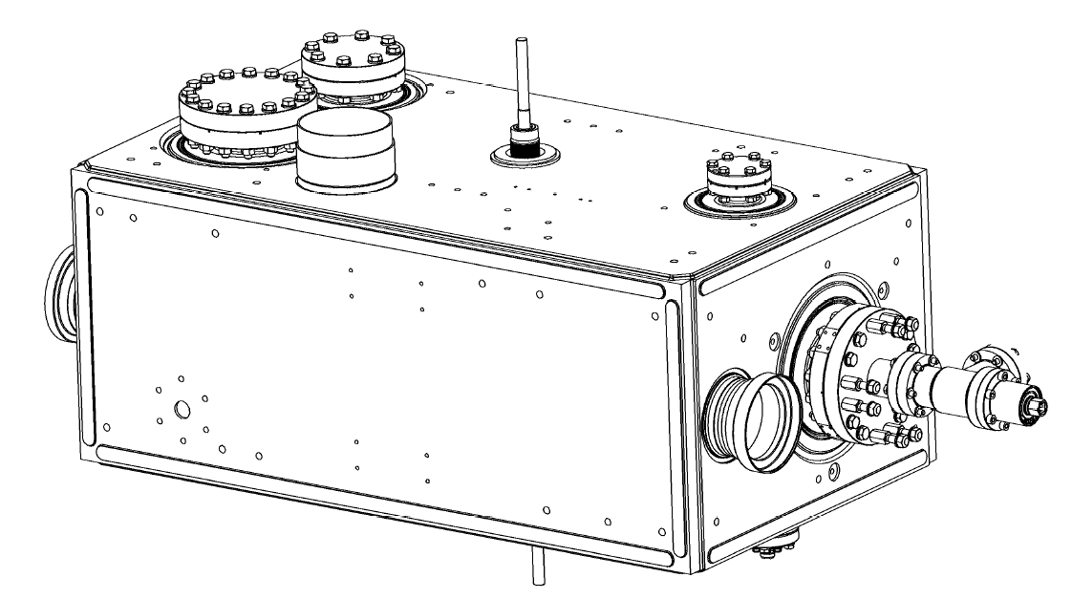
Beampipe 1
Bottom
Top
Pick-Up Port
Beampipe 2
VHOM Port
HHOM Port
FPC Port
Figure 1.1: Jacketed cavity configuration

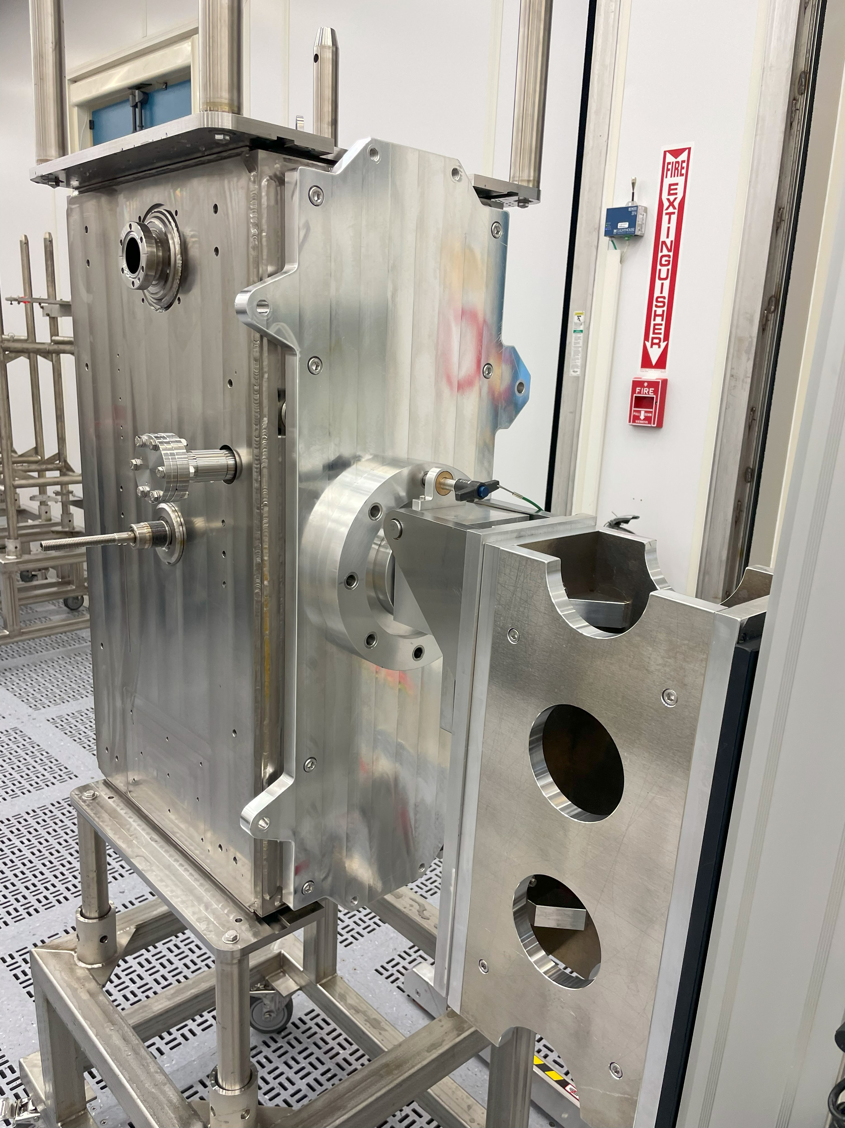
Figure 1.2: Cavity installed on the Lifter

- The sequence of operations is shown in Table 5.1. The table also shows the flange interfaces and gaskets used in each connection.

Step | Component | Cavity port | Gasket
1 | Blank DN100 Flange | Beampipe1 | DN100 CERN
2 | DN40 - 25Ω feedthrough field antenna | Pickup | DN40 CERN
3 | RAV on DN100/DN40 Adapter | Beampipe2 | DN100 CERN
4 | VHOM coupler | VHOM | DN40 CERN
5 | Burst Disc on DN63/DN40 ZLR | FPC | 4-1/2
6 | HHOM coupler subassembly | HHOM | DN100 CERN
Table 1.1: Assembly sequence and Interfaces

- The cavity will arrive in the cleanroom with both adapter plates assembled and installed on both ends (Figure 5.3). One plate shall be removed as part of the HPR process.
- The other adapter plate shall be removed from the cavity prior to assembly. The plate assembly on the HHOM side of the cavity will be installed on to the cavity again after assembly, using the same hardware.

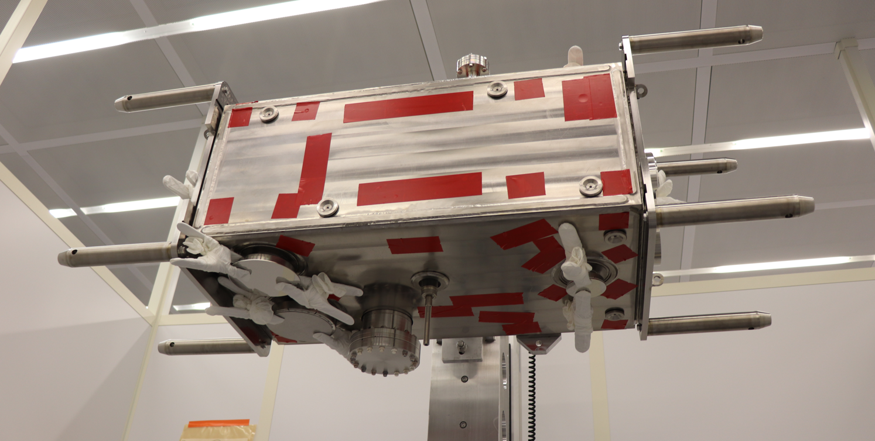
Figure 1.2: Cavity with both adapter plate assemblies attached (pre-HPR).

Hardware and Components

Table 6.1 shows the components that shall be cleaned and brought into the cleanroom for this process. Prepare the parts as per SRF-MSPR-CLNRM-CST-ION (Figure 6.1)

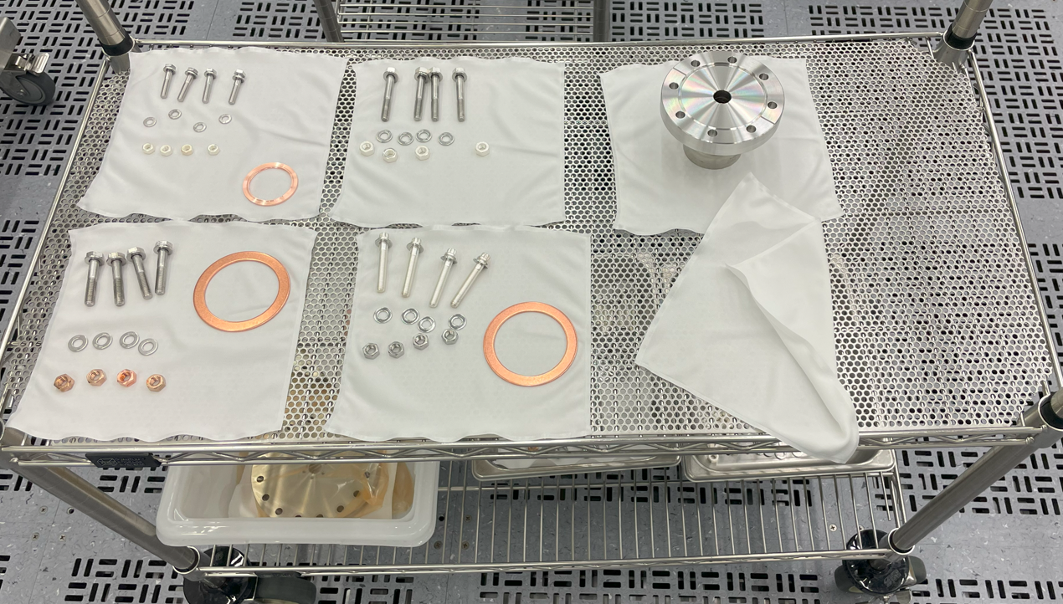
Figure 2.1: Example of prepared hardware

Cavity Hardware | Qty | Spare Qty | Total Qty
M8 x 55mm LG, A4-100, HHCS | 32 | 16 | 48
M8, A4-100 Washer | 112 | 20 | 132
Silver-Plated M8, A4-100, Hex Nut | 42 | 12 | 54
RF Gasket - LHCACFHC0261 vAB | 3 | 6 | 9
M6 x 35mm LG, A4-100, HHCS | 18 | 6 | 24
M6, A4-100, Washer | 42 | 12 | 54
Silver-Plated M6, A4-100, Hex Nut | 30 | 6 | 36
RF Gasket - LHCACFHC0259 | 3 | 4 | 7
M6 x 30mm LG silver-plated Stud | 8 | 2 | 10
M6 SS Washer | 16 | 4 | 20
M6 316 SS Hex Nut | 8 | 2 | 10
2-3/4 CF Copper Gasket | 2 | 4 | 6
M8 x 45mm LG, A4-100, HHCS | 24 | 6 | 30
4-1/2 CF Copper Gasket | 1 | 2 | 3
Silver-plated M6 x 20mm LG, A4-100 | 6 | 2 | 8
M6 A4-100 Hex Nut (non-silver plated) | 6 | 2 | 8
Table 2.1: Hardware for the Dressed Cavity kit

Component | Part Number
Dressed RFD Cavity | F10240823
HHOM Coupler | JL0086007
HHOM Coupler Feedthru | LHCACFHC0324
VHOM Coupler | LHCACFHC0322
Field Antenna | LHCACFHC0321
Right-Angle Valve | VAT 54132-GE02-001
DN100/DN40 Adapter | LHCACF_T0885
DN63/DN40 Zero Length Reducer | RF450X133
Burst Disc | 9100030
DN100 Blank Flange | F0600X000N
DN40 Blank Flange | F0275X000N
Table 2.2: Dressed Cavity components

HHOM Coupler Sub-Assembly

The HHOM coupler is assembled with the HHOM Feedthru as a separate sub-assembly (Figure 7.1). The relevant components and flanges are shown in Figure 7.2. The HHOM Couplers and the HHOM Feedthrus are fixed pairs and cannot be interchanged.

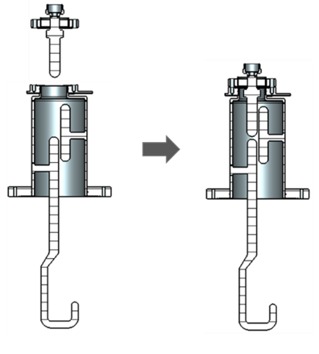
HHOM Coupler
Flange 6 – CERN DN40 CF
Flange 4 – CERN DN100 CF
Flange 5 – CERN DN40 CF
HHOM Feedthru
Figure 3.1: HHOM Sub-assembly

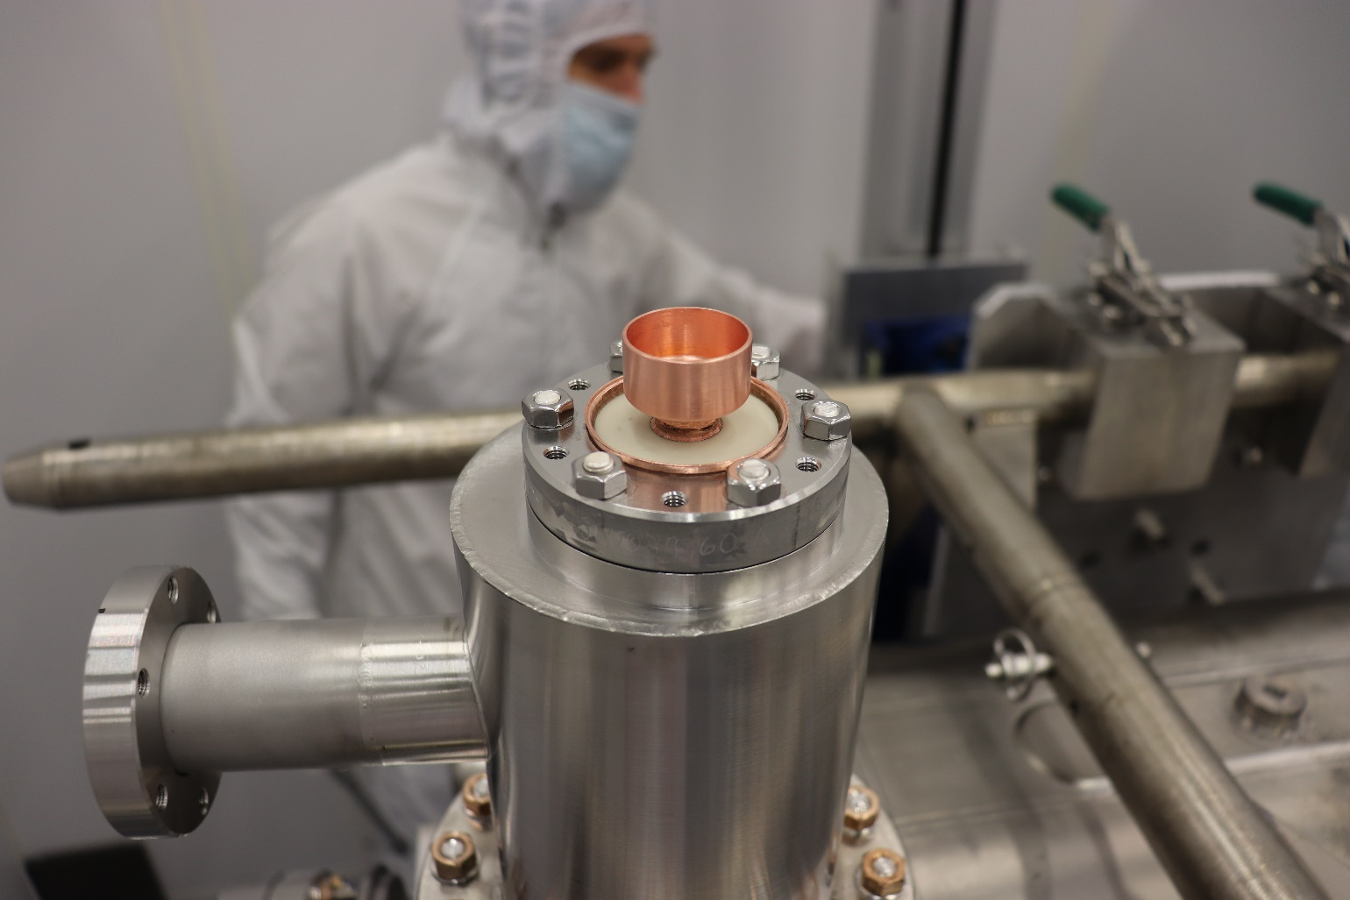
Figure 3.2: Assembled HHOM Coupler

HHOM Sub-Assembly Procedure

Component | Type | Qty
Stud | Silver-plated M6 x 20mm LG, A4-100 | 6
Washer | M6, A4-100 | 6
Nut | M6 A4-100 Hex Nut (non-Silver plated) | 6
Gasket | LHCACFHC0259 | 1
Table 3.1: Hardware list for installing HHOM feedthru on to HHOM Coupler

- Install six silver-plated M6 x 20mm LG studs into the threaded holes in Flange 5.
- Position the CERN DN40 RF gasket (LHCACFHC0259) on to the knife edge on Flange 5.
- Install the HHOM feedthru on to Flange 5 (Figure 6.3)

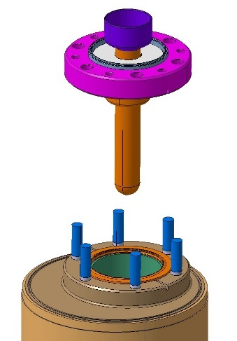
Figure 3.3: Installing HHOM Feedthru

- Position M6 washers on to threaded rods.
- Finger tighten M6 nuts on to the studs.
- Torque the nuts to 5Nm in the pattern shown in Figure 6.4
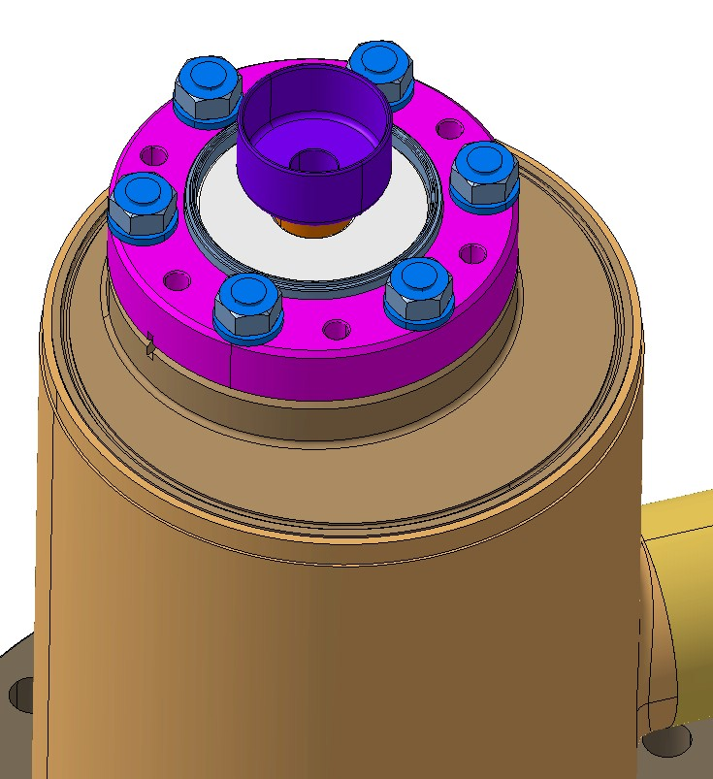
1
3
4
5
6
2
Figure 3.4: Torque sequence

- Torque the nuts to 7 Nm in a circular pattern.
- Repeat the previous step, increasing the torque by 2 Nm each round, until the two flanges are in contact. Use a feeler gauge to ensure that there is no gap between the flanges.

Sub-Assemblies

Burst Disc Sub-Assembly

- Assembly burst disk to the DN63/DN40 zero length reducer using silver-plated M6 studs and a 2-3/4 copper gasket (components shown in Table 8.1).

Component | Type | Qty
Screw | M6 x 30mm LG silver-plated Stud | 8
Washer | M6 SS Washer | 16
Nut | M6 316 SS Hex Nut | 8
Gasket | 2-3/4 CF Gasket | 1
Table 4.1: Hardware for Burst-Disc Sub-Assembly

- Torque the nuts in a star pattern until seal is achieved.

Right-Angle Valve Sub-Assembly

- Assemble the RAV to the DN100/DN40 adapter using silver-plated M8 SS HHCSs and a standard 2-3/4 CF copper gasket (components shown in Table 8.2).

Component | Type | Qty
Screw | M6 x 35mm LG, A4-100, HHCS | 6
Washer | M6, A4-100 | 12
Nut | Silver-Plated M6, A4-100, Hex Nut | 6
Gasket | 2-3/4 CF Copper Gasket | 1
Table 4.2: Hardware for RAV Sub-Assembly

- Torque the screws in a star pattern until seal is achieved.

Cavity Assembly

Beampipe 1

- Install the DN100 blank flange on to the Beampipe 1 flange using the hardware shown in Table 9.1

Component | Type | Qty
Screw | M8 x 55mm LG, A4-100, HHCS | 16
Washer | M8, A4-100 | 32
Nut | Silver-Plated M8, A4-100, Hex Nut | 16
Gasket | LHCACFHC0261 vAB | 1
Table 5.1: Hardware for Beamline 1 Blank

- Torque the nuts using a star pattern to 60 in.lbs
- Repeat the star pattern, increasing the torque by 10 in.lbs for each run.
- Continue torquing until the hardware is at 180 in.lbs.

Field Antenna

- Install the field antenna (Figure 9.1) using the M6x1.0 x 40mm LG silver-plated studs, stainless-steel nuts, and standard DN40 Cu-gasket (components are shown in Table 9.2).
- Orient the hook as shown in Figure 9.2.

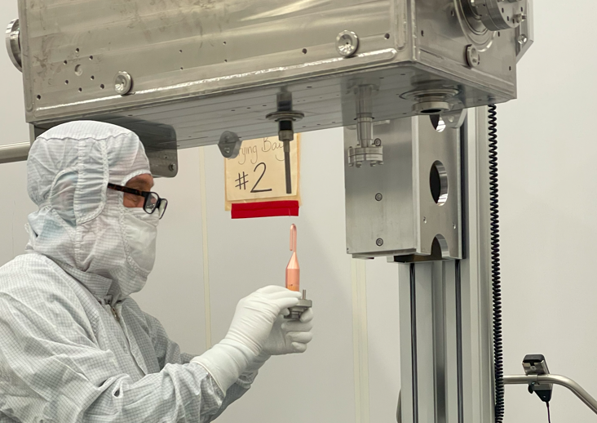
Figure 5.1: Field Antenna being installed on the cavity
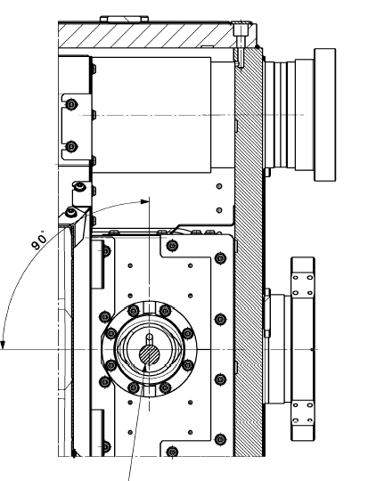
Figure 5.2: Orientation of Field Antenna

Component | Type | Qty
Screw | M6 x 35mm LG, A4-100, HHCS | 6
Washer | M6, A4-100 | 12
Nut | Silver-Plated M6, A4-100, Hex Nut | 6
Gasket | LHCACFHC0259 | 1
Table 5.2: Hardware for Pick-Up

- Finger tighten hex nuts first.
- Torque all hex nuts to 5 Nm as per the pattern shown in Figure 7.4.
- Increase torque to 7 Nm and torque the nuts sequentially.
- Repeat the previous step, increasing the torque by 2Nm each round, until the two flanges are in contact. Use a feeler gauge to ensure that there is no gap between the flanges.

Beampipe 2

- Install the RAV Sub-Assembly on to the Beampipe 2 flange using the hardware shown in Table 9.3.

Component | Type | Qty
Screw | M8 x 55mm LG, A4-100, HHCS | 16
Washer | M8, A4-100 | 32
Nut | Silver-Plated M8, A4-100, Hex Nut | 16
Gasket | LHCACFHC0261 vAB | 1
Table 5.3: Hardware for Beampipe 1.

- Torque the nuts using a star pattern to 60 in.lbs
- Repeat the star pattern, increasing the torque by 10 in.lbs for each run.
- Continue torquing until the hardware is at 180 in.lbs.

VHOM Coupler

- Install the VHOM Coupler (Figure 9.3) using the M6x1.0 x 40mm LG silver-plated studs, stainless-steel nuts, and standard DN40 Cu-gasket (components are shown in Table 8.3).
- Orient the hook as shown in Figure 9.4, following the markings on the cavity helium vessel.

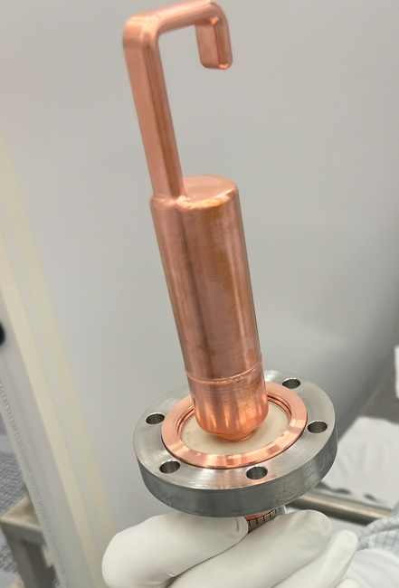
Figure 5.3: VHOM Coupler

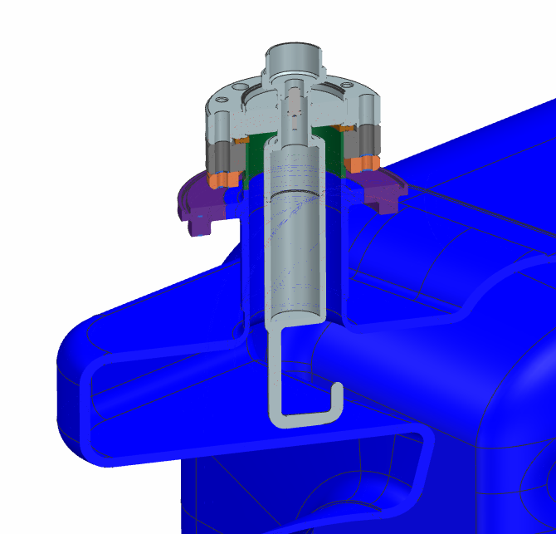 | 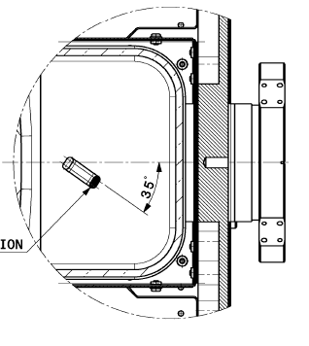
Figure 5.4: Orientation of VHOM Coupler hook

Component | Type | Qty
Screw | M6 x 35mm LG, A4-100, HHCS | 6
Washer | M6, A4-100 | 12
Nut | Silver-Plated M6, A4-100, Hex Nut | 6
Gasket | LHCACFHC0259 | 1
Table 5.4: Hardware for VHOM Coupler

- Finger tighten hex nuts first.
- Torque all hex nuts to 5 Nm as per the pattern shown in Figure 7.4.
- Increase torque to 7 Nm and torque the nuts sequentially.
- Repeat the previous step, increasing the torque by 2 Nm each round, until the two flanges are in contact. Use a feeler gauge to ensure that there is no gap between the flanges.

FPC Flange

- Install the Burst-Disc sub-assembly on to the FPC flange using the M8 x 45mm LG HHCSs and the hardware shown in Table 9.5.

Component | Type | Qty
Screw | M8 x 45mm LG, A4-100, HHCS | 8
Washer | M8, A4-100 | 16
Nut | Silver-Plated M8, A4-100, Hex Nut | 8
Gasket | 4-1/2 CF Copper Gasket | 1
Table 5.5: Hardware for FPC Flange Burst-Disc Subassembly

- Torque the nuts until a seal is achieved.

HHOM Coupler

- Place the CERN 6” RF-gasket (LHCACFHC0261 vAB) on the HHOM knife edge and use two of the M8 x 45mm screws as guides for mounting onto the cavity (see Figure 9.5)
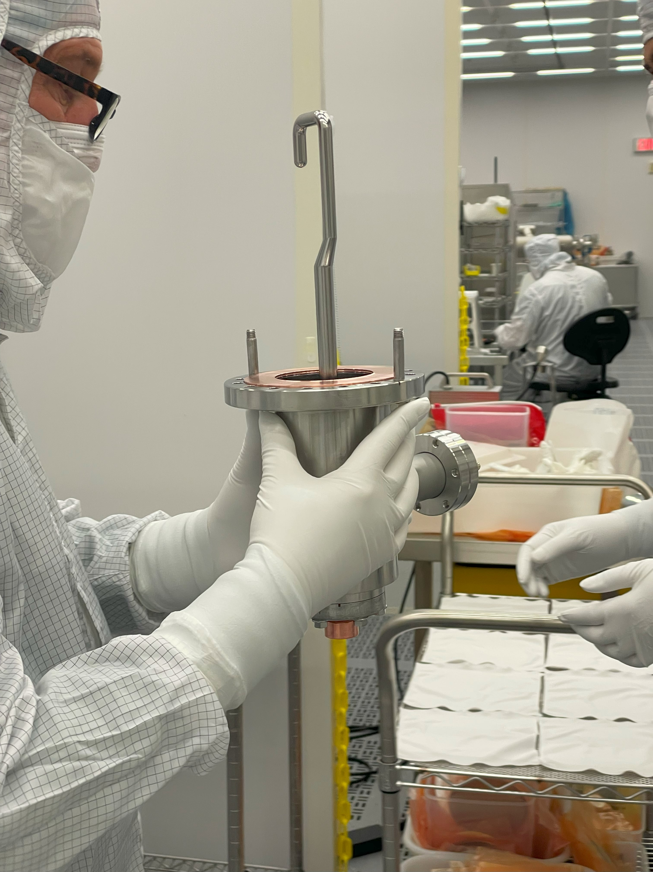
Figure 5.5: Fixing gasket and guiding bolts on the HHOM Coupler

- Install the HHOM Sub-Assembly to the HHOM port on the cavity according to Figure 9.6. The He-outlet can be used as an external reference for the assembly orientation. The required hardware is shown in Table 9.6.

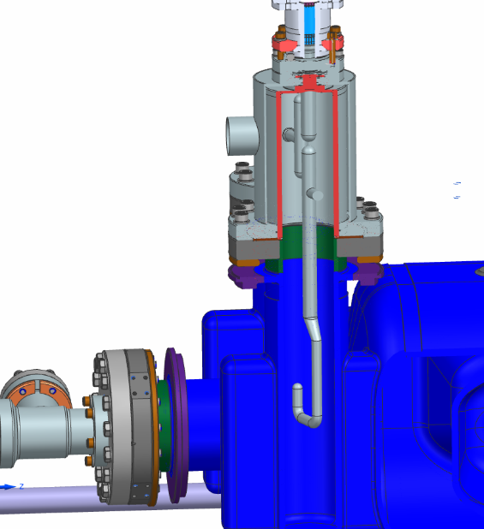 | 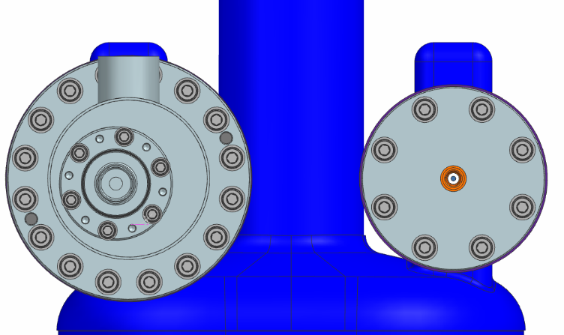
Figure 5.6: Orientation of HHOM Coupler

Component | Type | Qty
Screw | M8 x 45mm LG, A4-100, HHCS | 16
Washer | M8, A4-100 | 32
Nut | Silver-Plated M8, A4-100, Hex Nut | 16
Gasket | LHCACFHC0261 vAB | 1
Table 5.6: Hardware for HHOM Coupler installation

- This operation is to be carried out with the HHOM flange pointing downward.
- Finger tighten the nuts first.
- Make the nuts snug using a wrench.
- Start at 60 in.lbs in a star pattern.
- Check that the gap between the flanges is even. Once the gap is even (within a 0.002 difference), repeat the pattern increasing the torque by 10 in.lbs.
- Continue until there is no gap between the flanges.

Final Assembly

- Install the VTA hanger adapter plate on the HHOM Coupler side of the cavity. See Figure 10.1 as an example.
  - Use adapter plate hardware that was originally installed on the adapter plates.
  - Assemble as per JL0160827.
  - Torque the three M10 silicon-bronze SHCSs to 19 ft.lbs.

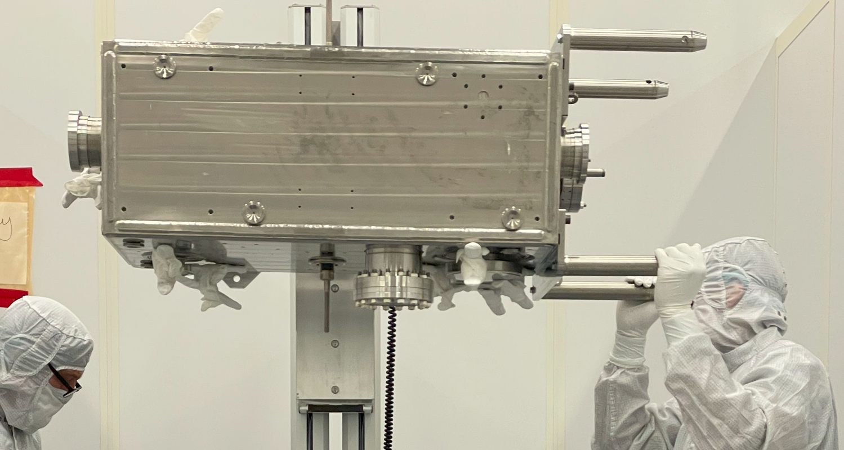
Figure 6.1: Adapter plate installed on HHOM side of cavity

- Ensure that the helium jacket interface caps have been removed (see Figure 10.2).

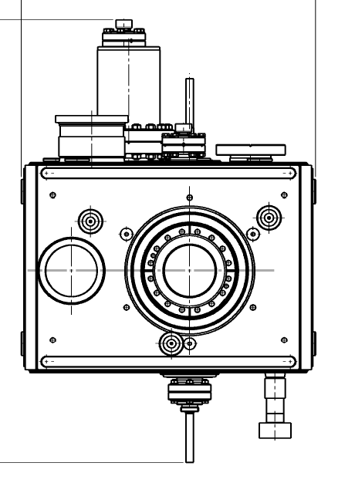
Figure 6.2: Helium line interfaces on the dressed cavity

- Clamp a blank DN40 flange on to the RAV flange.

References

Document No. | Title
SRF-06-PR-001 | Records Management Procedure
SRF-07-PR-001 | Document Management Procedure
JL0160827 | AUP HPR Assy
SRF-MSPR-CLNRM-CST-ION | Ionized Nitrogen Parts Cleaning

Release and Revision History

Rev # | Major Changes | Revision Date:
1 | Initial version (Utilizing SRF-07-FM-005 SRF OPS Procedure Template, R1) | 07 Jul 2025

Approvals

Approved by: | Name:
Document Owner | Alex Wildeson
Work Center Lead | Danny Forehand
Group Lead | Kirk Davis
Project Manager | Naeem Huque
For Project Procedures: Refer to the Project Execution Procedure SRF-11-PR-001

Document Processor Instructions:
- Put valid dates everywhere DD is found and verify they are accurate
- Attach DocuShare Approval Picture here

