Reduced Particle Generation Ion Pump Turn On
Document Number: | SRF-MSPR-VAC-IPON | Effective Date: | DD Mmm YYYY
Revision Number: | 1 | Periodic Review Date: | DD Mmm YYYY
Document Owner: | <First Last Name> | Department Owner: | SRF Operations

Purpose and Scope

This procedure covers the turn-on of any ion pump used in SRF applications. The tasks take place anywhere at JLab and is a best practice which can be used for any application, but in particular is used for particle sensitive applications.

Definitions and Diagrams

The following terms have specific meanings within this procedure.

Term | Definition
Current | Floating current produced by an ion pump inherent in its applications
Voltage | Applied voltage to the ion pump by the controller
Trip | Voltage shutoff which may or may not restart automatically
Processing | Allowing the controller to continuously trip and auto restart
PI/PM/TR | Principal Investigator/Project Manager/Technical Representative. Someone otherwise in charge of the project or item in question. A supervisor may also be referred to if needed

Roles and Responsibilities

The following roles have responsibilities described in this document.

Role | Responsibility
<Job Title> | <Very short summary of activities this job title performs in this procedure.>

Safety

Properly review the manufacturers ion pump controller and installation manual and fully understand the operation before starting. These controllers can produce deadly high voltage shock and proper installation of the cables and connectors is mandatory.

Hardware

Gamma Vacuum SPCe (small pump controller)

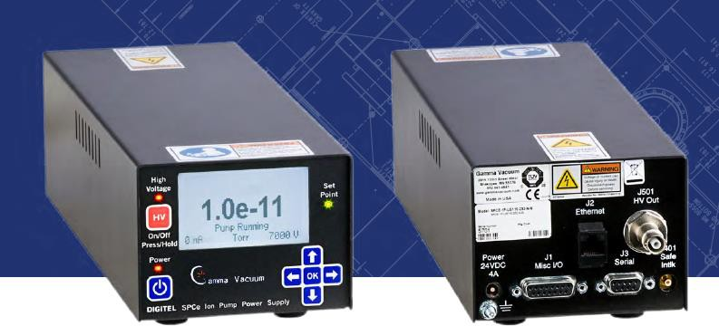

Gamma Vacuum SPCe Power Supply – 24V (4A) Power Brick

Ion Pump cable (10KV) – CAUTION if you do not know how to identify this cable, seek help from an expert as there are 5KV version which require voltage restrictions

Procedure

Level 1 text.

Prior to turn on
- Verify the vacuum system pressure is below 2x10⁻⁷ Torr at the gauge closest to item being pumped, the system has been pumping for a minimum of 12 hours, is leak checked to a leak rate no greater than 2 x 10⁻¹⁰ Torr L/s, and the ratio between 28 and 32 mass on a RGA is greater than 8 amu/e. If there is no gauge on the system the pressure of the cart can be used, but the pumping time must increase to 24 hours before turn-on.
- Verify the ion pump and associated vacuum system is at room temperature, high temperature turn-on is prohibited.
- Verify the ion pump controller is disconnected from the wall outlet and power is off.
- Manually inspect the ion pump high voltage cable to ensure it is in good condition. Connect high voltage cable between the pump and the controller. Verify both connectors are fully engaged.
- Note the pressure of the pumping system attached to the vacuum system. Generally, a turbo pumping cart

Ion Pump Controller beginning setting
- Plug the controller and turn on the 24V (4A) power brick
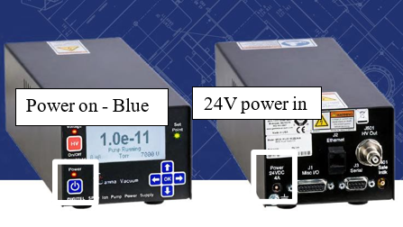
- Set the controller to the pumping size of the pump; most CEBAF beamline pumps are 40 or 45 L/Sec pumps.
- Set the maximum current to 1mA trip setting
- Set the voltage to its lowest setting, generally 3kV

Turn on and ramp
- Turn on the high voltage on the ion pump power suppl (at 3kV) by holding down the HV red button for 2 seconds.
  - If the ion pump voltage rises smoothly to 3kV, wait 30 seconds and proceed to step 2.
  - If the ion pump voltage is limited due to the 1mA current limit, wait up to 20 minutes for the voltage to get to 3 kV (this is referred to as processing). The controller will turn off after a minute and then restart; allow the controller to keep running
    - If the voltage does not reach 3 kV after 20 minutes, increase current limit to 3 mA and turn on high voltage.
    - If the ion pump voltage is limited due to the 3 mA current limit, wait up to 20 minutes to reach 3 kV (process). If the pump will not turn on at a 3 mA current limit, contact PI/PM/SOTR.
    - Once voltage reaches 3 kV, wait until current falls below 1 mA
    - Reduce the controller current limit to 1 mA and proceed to step 2.
- Increase the voltage to 3.5kV and verify the system is stable and does not trip for a minimum of 30 seconds. Do not turn off the high voltage – just increase the setpoint by 500V. The system must be stable before increasing the voltage.
  - If processing occurs, wait up to 20 minutes.
  - If controller does not reach set voltage within 20 minutes, reduce voltage to prior level and wait an hour before ramping up as long as current is falling.
- Increase the voltage to 4kV and verify the system is stable and does not trip for a minimum of 30 seconds. Do not turn off the high voltage – just increase the setpoint by 500V. The system must be stable before increasing the voltage.
  - If processing occurs, wait up to 20 minutes.
- Increase the voltage to 4.5kV and verify the system is stable and does not trip for a minimum of 30 seconds. Do not turn off the high voltage – just increase the setpoint by 500V. The system must be stable before increasing the voltage.
  - If processing occurs, wait up to 20 minutes.
- Increase the voltage to 5kV and verify the system is stable and does not trip for a minimum of 30 seconds. Do not turn off the high voltage – just increase the setpoint by 500V. The system must be stable before increasing the voltage.
  - If processing occurs, wait up to 20 minutes.

Back out and isolation
- Track the ion pump current and/or pressure for 10 minutes.
  - If it is rising, turn off the pump and re-evaluate the situation as the pump is most likely faulty.
  - If the pressure is stable or goes down after 10 minutes, move on.
- Using pump cart gauges, verify that the pressure is lower that the beginning of this procedure.
- Close the valve between the pump cart and the vacuum system.
- Vent the external pump cart and verify the ion pump pressure continues to drop at the same rate as before the disconnection. If this is not the case, the isolation valve is leaking through and must be replaced. See the PI/PM/SOTR for a back-out procedure to remove and replace the ion pump or valve.
- Return at least 4 hours after disconnect to verify the pressure continues to drop, automatic data logging is preferred to ease analysis and data fitting to verify the pumps performance.

References

Document No. | Title
SRF-06-PR-001 | Records Management Procedure
SRF-07-PR-001 | Document Management Procedure
Ion Pump Controller Manual

Release and Revision History

Rev # | Major Changes | Revision Date:
1 | Initial version (Utilizing SRF-07-FM-005 SRF OPS Procedure Template, R1). Derived from CP-WMGRDR-VAC-IPON | 6 Nov 2025

Approvals

Approved by: | Name:
Document Owner | <First Last Name>
Document Reviewer 1  JLab SME or SRFOPS WCL | <First Last Name>
Document Approver 2  SRFOPS WCL or GL | <First Last Name>
For Project Procedures: Refer to the Project Execution Procedure SRF-11-PR-001

Document Processor Instructions:
- Put valid dates everywhere DD is found and verify they are accurate
- Attach DocuShare Approval Picture here

