Traveler Title | L2HE Nine Cell Cavity First Assembly
Traveler Abstract | This traveler collects information from the first assembly of L2HE 9-cell cavities in preparation for VTA testing.
Traveler ID | L2RB-CLNRM-CAV-ASSY1
Traveler Revision | R1
Traveler Author | T. Ganey
Traveler Date | 10-Nov-25
NCR Informative Emails | ganey,hogan,forehand,dreyfuss
NCR Dispositioners | wilson,hannesv,kdavis
D3 Emails | ganey,wilson,hogan,hannesv,kdavis,forehand,dreyfuss
Approval Names | T. Ganey | C. Dreyfuss | D. Forehand | J. Hogan
Approval Signatures
Approval Dates
Approval Title | Author | Reviewer | Reviewer | Project Manager

References | List and Hyperlink all documents related to this traveler. This includes, but is not limited to: safety (THAs, SOPs, etc), drawings, procedures, and facility related documents.
SRF-MSPR-CLNRM-CST-ION-R3 Ionized Nitrogen Cleaning Procedure | Cavity Assembly Part 1 Procedure | SRF-MSPR-CLNRM-LEAK-R2 Leak testing with an RGA procedure | Production Cavity Assembly Drawing, F10023864

Revision Note
R1 | Initial release of this Traveler. Created from L2HE-CLNEM-CAV-ASSY1-R3

Step No. | Instructions | Data Input
1 | Verify that the correct cavity is in the assembly area and has been drying overnight with the covers removed. | [[CAVSN]] <<CAVSN>>  [[Technician1]] <<SRFCVP>>  [[Technician2]] <<SRFCVP>>  [[CavComment]] <<COMMENT>>
2 | Perform the first cavity assembly as per the Cavity Assembly Part 1 procedure.  IMPORTANT: Ensure the cavity is assembled in accordance with the cavity drawing F10023864. Verify that the right angle valve is installed with the flange 180 degrees rotated from the helium vessel lug.  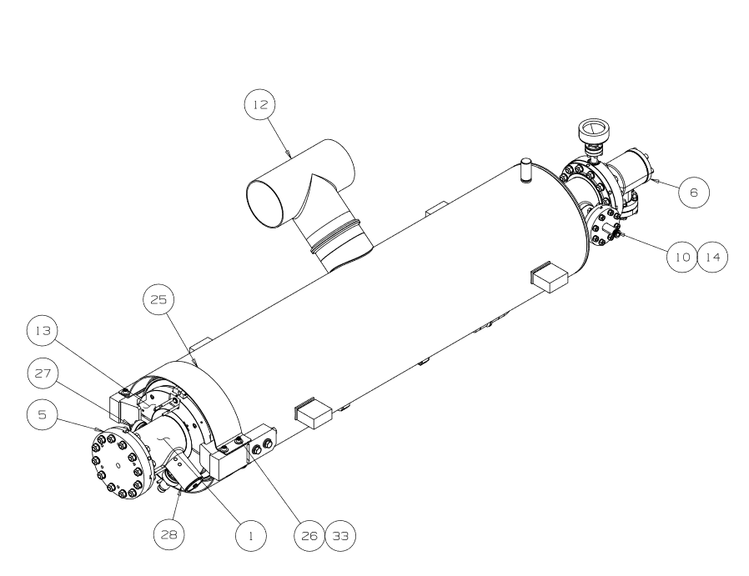  Verify all fasteners are torqued to the correct specification in accordance with the Cavity Assembly Part 1 procedure.  Replace the field probe with a new one that has been made shorter, if required, after the first test of the cavity reveals a low QE2.  Use the comment box to record any notes regarding the assembly. Any issues that arise which require substantial change from the procedure are cause to stop the assembly and get further guidance from the project managers. | The right angle valve is installed with the flange rotated 180 degrees from the helium vessel lug?  [[RAV_Rotated]] <<YESNO>>  The following flanges have been torqued IAW procedure?  [[FPendBeamlineFlange]] <<INTEGER>> ft/lbs  [[FPendHOM_FilterFlange]] <<INTEGER>> in/lbs  [[FieldProbe]] <<INTEGER>> in/lbs  [[NewFieldProbe]] <<YESNO>>  [[FPC_Flange]] <<INTEGER>> ft/lbs  [[FPCendHOM_FilterFlange]] <<INTEGER>> in/lbs  [[AssyComment]] <<COMMENT>>
3 | Record all feed-through serial numbers  Install cover blank on the bottom beam-line flange.  Cavity is now ready to be sent to the chemistry department for its second high pressure rinse. | [[FPFTSN]] <<FPFTSN>>  [[FPCFTSN]] <<SN>>  [[HOM1FTSN]] <<SN>>  [[HOM2FTSN]] <<SN>>  [[BeamlineFlangeCovered]] <<YESNO>>  [[FTComment]] <<COMMENT>>  [[FTDate]] <<TIMESTAMP>>

