Traveler Title | L2HE Nine Cell Cavity Second Assembly
Traveler Abstract | This traveler collects information from the second assembly of L2HE 9-cell cavities in preparation for VTA testing.
Traveler ID | L2RB-CLNRM-CAV-ASSY2
Traveler Revision | R1
Traveler Author | T. Ganey
Traveler Date | 10-Nov-25
NCR Informative Emails | ganey,hogan,forehand,dreyfuss
NCR Dispositioners | wilson,hannesv,kdavis,reece
D3 Emails | ganey,wilson,hogan,hannesv,kdavis,reece,forehand,dreyfuss
Approval Names | T. Ganey | C. Dreyfuss | D. Forehand | J. Hogan
Approval Signatures
Approval Dates
Approval Title | Author | Reviewer | Reviewer | Project Manager

References | List and Hyperlink all documents related to this traveler. This includes, but is not limited to: safety (THAs, SOPs, etc), drawings, procedures, and facility related documents.
SRF-MSPR-CLNRM-CST-ION-R3 Ionized Nitrogen Cleaning Procedure | L2HE Cavity Assembly Part 2 | SRF-MSPR-CLNRM-LEAK-R2 Leak testing with an RGA procedure | Production Cavity Assembly Drawing, F10023864

Revision Note
R1 | Initial release of this Traveler. Created from L2HE-CLNRM-CAV-ASSY2-R2

Step No. | Instructions | Data Input
1 | At this point the cavity has already been partially assembled. The second HPR is complete and the cavity has been drying at least twelve hours with the bottom flange cover removed. | [[CAVSN]] <<CAVSN>>  [[Technician1]] <<SRFCVP>>  [[Technician2]] <<SRFCVP>>  [[CavComment]] <<COMMENT>>
2 | Perform the second cavity assembly as per the L2RB Cavity Assembly Part 2 procedure.  IMPORTANT: Ensure the cavity is assembled in accordance with the cavity drawing F10023864. Verify that the right angle valve is installed with the flange 180 degrees rotated from the helium vessel lug. 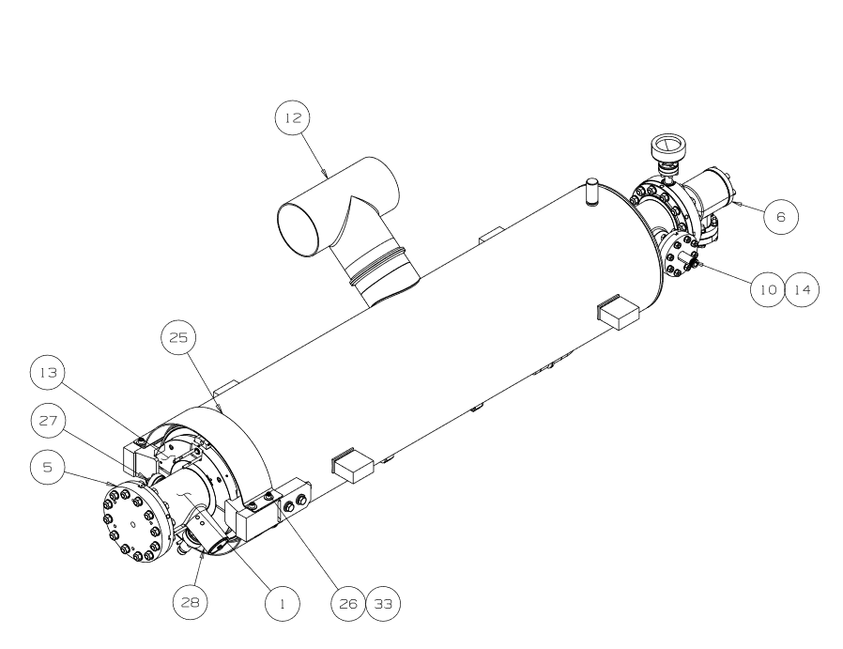  Verify all fasteners are torqued to the correct specification IAW with L2RB Cavity Assembly Part 2.  Cover the open port of the right angle beam-line valve for transport to VAA.  Use the comment box to record any notes regarding the assembly. Any issues that arise which require substantial change from the procedure are cause to stop the assembly and get further guidance from the project managers. | The right angle valve is installed with the flange rotated 180 degrees from the helium vessel lug?  [[RAV_Rotated]] <<YESNO>>  The FPC beam-line flange has been torqued to the following value IAW assembly procedure  [[FPC_BeamlineFlangeAssy]] <<INTEGER>> ft/lbs  [[ValvePortCovered]] <<YESNO>>  [[AssyComment]] <<COMMENT>>
3 | Cavity is now ready to be installed onto the vertical test stand and evacuated for vertical testing. | [[FinishComment]] <<COMMENT>>  [[FinishDate]] <<TIMESTAMP>>

