C50-C20 Indium Joint Locations
Document Number: | ER5C-RF-CMA-DISA-INDIUM | Effective Date: | DD Nov 2025
Revision Number: | 1 | Periodic Review Date: | N/A
Document Owner: | J. Fischer | Department Owner: | SRF Operations

C20/C50 Cavity Pair Indium Joints
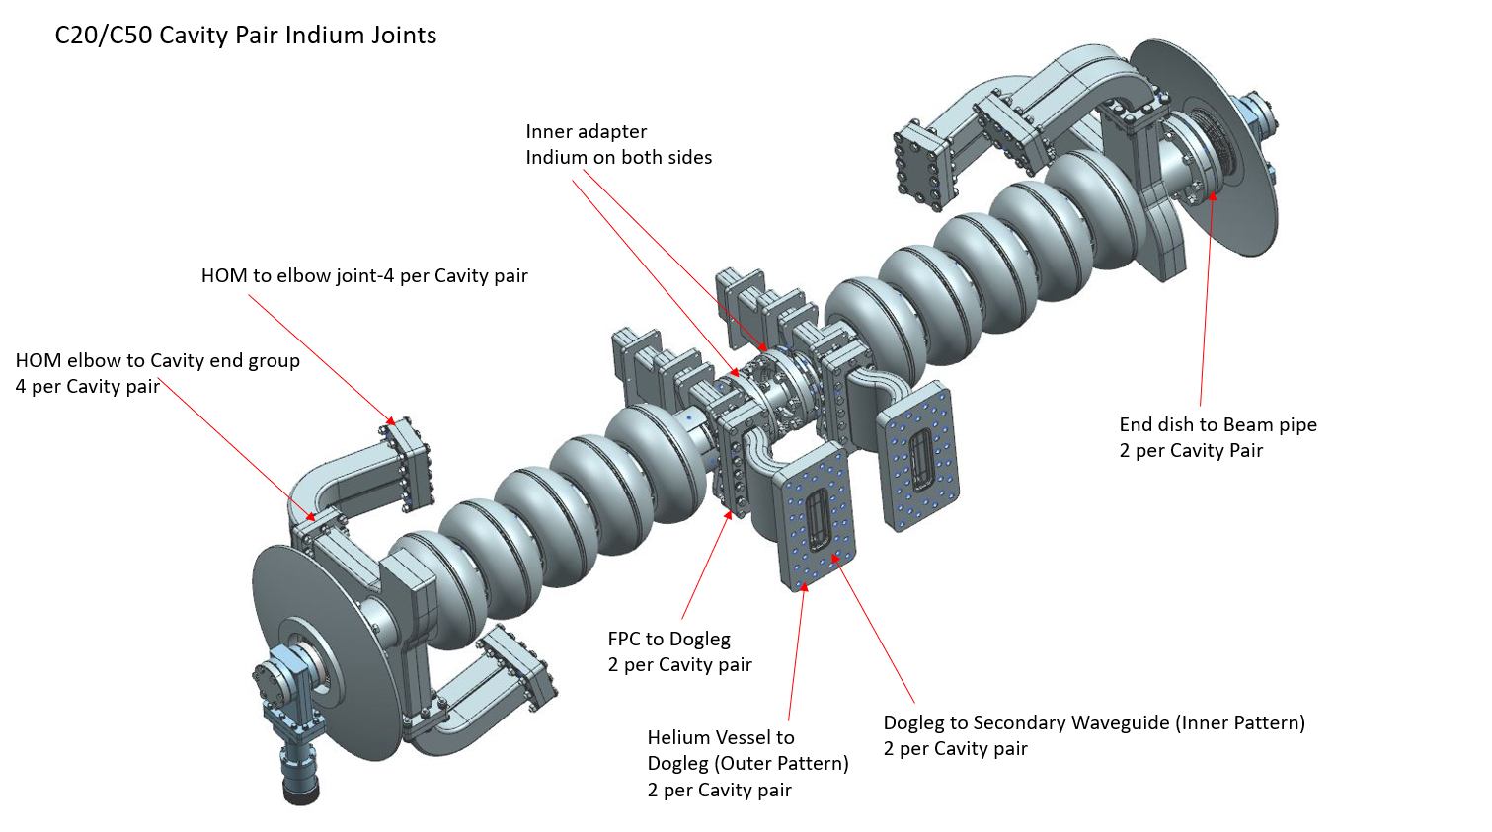

C20/C50 Cryounit Indium Joints
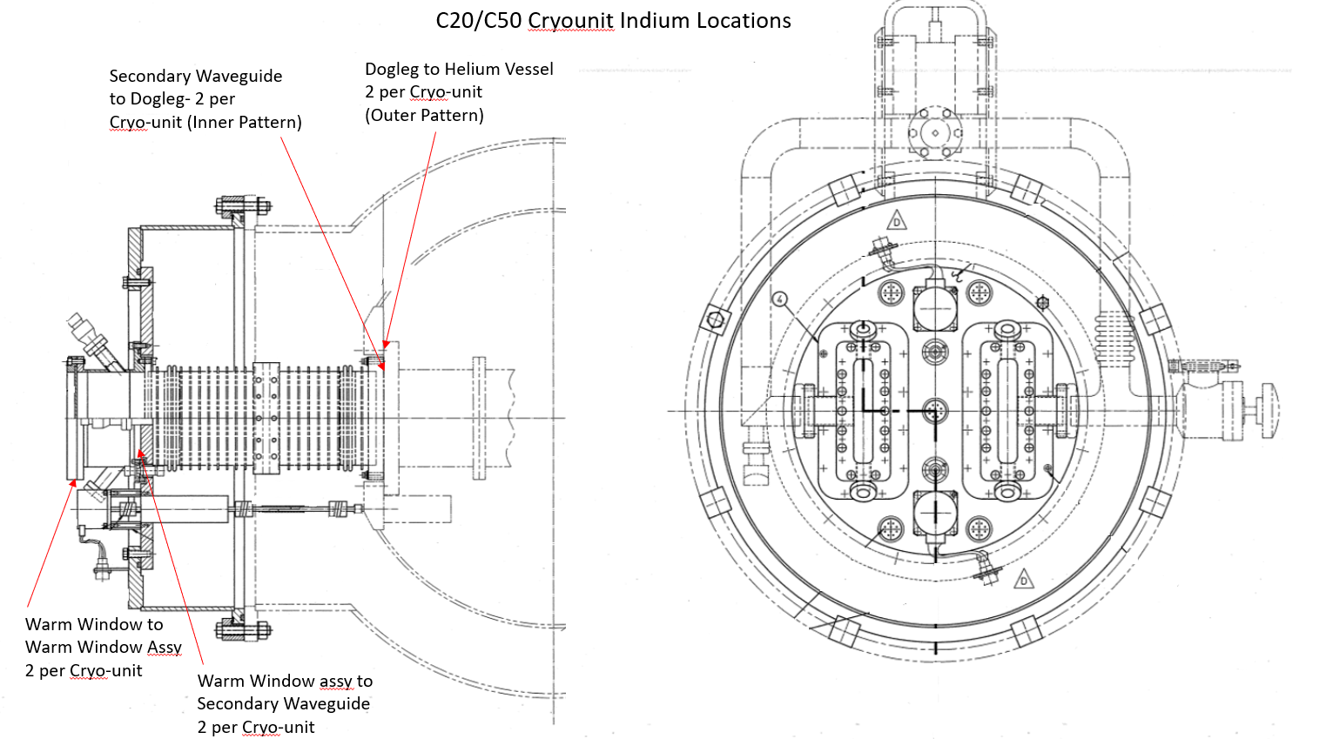

End Can Indium Locations
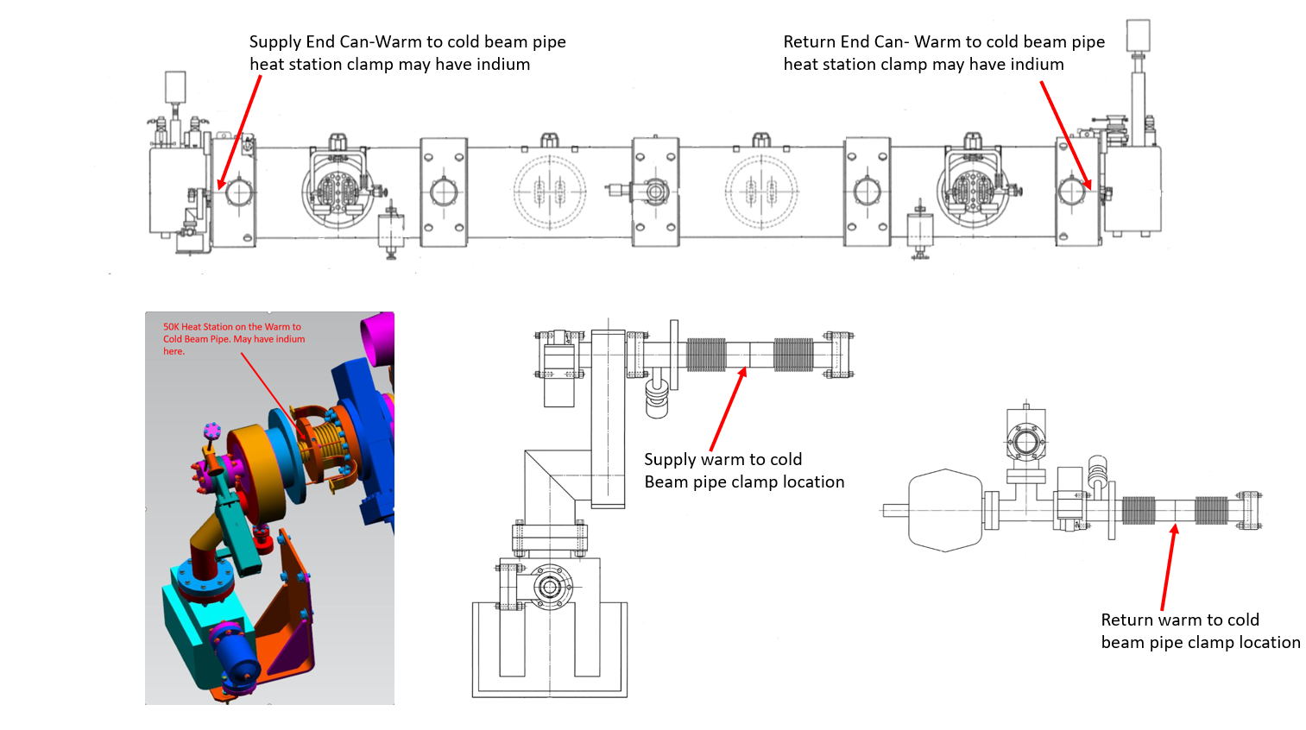

Release and Revision History

Rev # | Major Changes | Revision Date:
1 | Initial version (Utilizing SRF-07-FM-003 Word Document Template, R3) | DD Mmm YYY

Approvals

Approved by: | Name:
Document Owner | J. Fischer
Document Reviewer 1  JLab SME or SRFOPS WCL | J. Fischer
Document Approver 2  SRFOPS WCL or GL | T. Reilly

Document Processor Instructions:
- Put valid dates everywhere DD is found and verify they are accurate
- Attach DocuShare Approval Picture here

