Simulations of the Ce+BAF Injector with Normal and Superconducting Solenoids downstream of a 4 mm Thick Tungsten Target

Andriy Ushakov

Jefferson Lab, Newport News, VA 23606

July 14, 2025

**Abstract**

A comparison of positron injector layouts was performed based on a relatively short (25 m long) superconducting solenoid (Model 1) and a 1.6 T normal conducting solenoid with an iron and a 41 cm coil length (Model 2). This comparison was made by tracking all positrons and only 60  6 MeV positrons. Despite the many differences between these two models, the positron beam parameters at the end of the SRF module are remarkably similar. Work on the injector layout will continue.

# Introduction

The layout of the positron injector for Ce+BAF was developed by Sami Habet in 2023 [1]. A series of simplifications were made in order to simulate the positron beam tracking from the conversion target to the end of the injector. For instance, a simplified field model of a capture solenoid (a hard-edge model and field of an ideal solenoid without coil thickness and iron) has been used. The peak field strength of 2.5 T on the solenoid axis, which is required for the focusing of highly polarized positrons, can only be achieved through the employment of superconducting technologies. The relatively long (6 m) CW normal conducting capture cavities with a field strength of a few MV/m have a relatively small impact on the energy and bunch length of high polarized positrons with an energy of 60 MeV. In this report, the positron injector has been evaluated based on a normal conducting focusing solenoid with a peak field of 1.6 T and a more realistic 3D field map, in combination with a capture cavity that is 1.1 m in length. The updated injector model was compared with the initial injector model used by Sami.

# Positron Injector Layouts

A beam of electrons with a current of 1 mA, an energy of 120 MeV, 90% longitudinal polarization and rms beam size of 1 mm has been used to generate the positrons in conversion target. The electron beam has zero energy spread, divergence, and bunch length. Table 1 shows the main details of two positron injector layouts, one used previously (Sami-2023) and are currently used (Andriy-2025). The electron beam and tungsten target were the same in both injector layouts. The target was 4 mm thick. This thickness is optimal for producing highly polarized positron beams (>60% longitudinal polarization) [2].

Table 1: The parameters of the positron injector have been used in simulations by Sami in 2023 and are currently being used.

|  |  |  |  |
| --- | --- | --- | --- |
| Function | Previous parameters (Model 1 “Sami-2023”) | Current parameters (Model 2 “Andriy-2025”) | Changes in model 2 in comparison to model 1 |
| Primary (drive) e- beam | *E* = 120 MeV  *dE/E* = 0  *σx* = *σy* = 1 mm  Bunch length *σz*= 0  Divergence angle *θ* = 0 | same | no difference |
| Target | Material: tungsten  Thickness = 4 mm | same | no difference |
| Focusing solenoid | Simplified analytic field model  Solenoid without iron  Capture 60 MeV e+  *Bmax* = 2.5 T (hard edge model)  Length *L* = 0.25 m  Inner radius = none | Realistic 3D field map  Solenoid with iron  Capture 60 MeV e+  *Bmax* = 1.63 T  Length *L* = 1.24 m  Inner radius = 20 cm | Field map provided by  J. Benesch [3]  1.6 T is a max peak field achievable for normal conducting coil |
| CW normal conducting capture cavity with *f* = 1497 MHz | *Emax* = 1 MV/m  Length *L* = 6.2 m (5.4 m  active field length)  Number of cavities: 9  Adjustable phase of each cavity  Iris radius = 3 cm  Solenoid field:  *Bmax* = 0.05 T | *Emax* = 4 MV/m  Length *L* = 1.5 m (1.1m active field length)  Number of cavities: 1  Iris radius = 4 cm  Solenoid field:  *Bmax* = 0.9 T | Design of NC CW cavity [4]  Model 1: E-field phase of each cavity was adjusted to reduce bunch length  Model 2: on-crest E-field phase and *Bmax* of 0.9 T around cavity were applied to maximize capture efficiency |
| Matching Section 1 | Number of quadruples: 4  Quad length = 15 cm  Drift length: 3x1.7 m and 1x0.85 m | Number of quadruples: 4  Quad length = 15 cm  Drift length: 4x0.34cm | Strength of quads was adjusted for the best matching (highest e+ current at the end of injector)  Model 2 has shorter drifts |
| Momentum selection chicane | 4 sector dipoles  Dipole length = 0.5 m  Bend angle = 0.204 rad  Entrance and exit edge angles ≠ 0  5 quads  Quad length = 15 cm  Quad half-gap between poles = 1.25 cm  Rectangular collimator in the middle of chicane with  Δ*x*/2 = 1 cm | 4 rectangular dipoles  Dipole length = 0.5 m  Bend angle = 0.204 rad  Entrance and exit edge angles = 0  3 quads  Quad length = 15 cm  Quad half-gap between poles = 5.0 cm  Rectangular collimators in the middle and end of chicane with Δ*x*/2 = 1.5 cm, Δ*y*/2 = 5 cm | Rectangular dipoles with the same bend angle and bigger gap between poles were used  Removed quads (with zero drift space to dipoles) at the begin and end of chicane  Reduced total length  Added 2nd collimator at exit of chicane with same half-gaps as the 1st one |
| Matching Section 2 | Not included | Number of quadruples: 4  Quad length = 15 cm |  |
| SRF module with *f* = 1497 MHz | Number of cavities: 8  Iris radius = 3 cm  Total length = 7.7 m  Length of cavity = 0.7 m  Drift length = 0.3 m (7x) | Number of cavities: 1  Iris radius = 2.65 cm  Effective length = 8 m | Field strength in both models was adjusted to accelerate e+ beam to 123 MeV |
| Matching Section 3 | Number of quadruples: 4  Quad length = 15 cm | Not included |  |
| Bunch Compression Chicane | 4 sector dipoles  Dipole length = 0.15 m  Bend angle = 0.154 rad  Number of quadruples: 1  Quad length = 15 cm  Drift length = 2.2 m | Not included | Bends of transport line from LERF to North Linac can be used for compression of longitudinal bunch length |
| Beam pipe | Not included | Inner radius = 5 cm | No difference |

The injector layouts of Model 1 (“Sami-2023”) and Model 2 (“Andriy-2025”) are shown in Fig. 1. The tungsten target is not shown in Fig. 1. It has a thickness of 4 mm, with the exit side located at *s* = 0. The positrons at the target exit have a very wide energy spectrum, as shown in Fig. 2. The longitudinal polarization of positrons correlates with the energy, see Figure 3. Therefore, the systems that capture positrons and select positron energy allow to control the resulting polarization of the positron injector. Figure 4 shows the *xx'* phase space to complete the characterization of positrons coming out of the target.

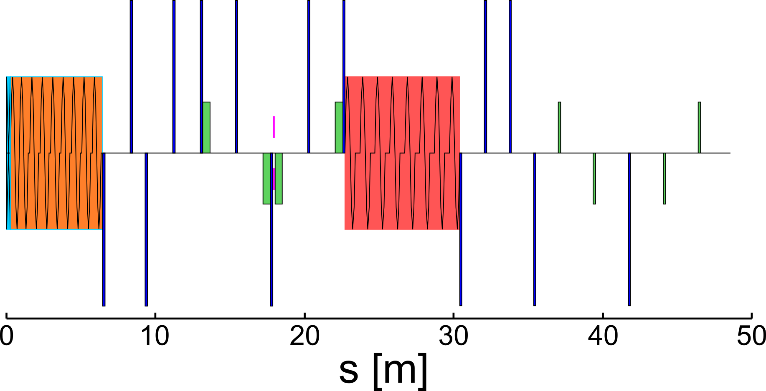

a)

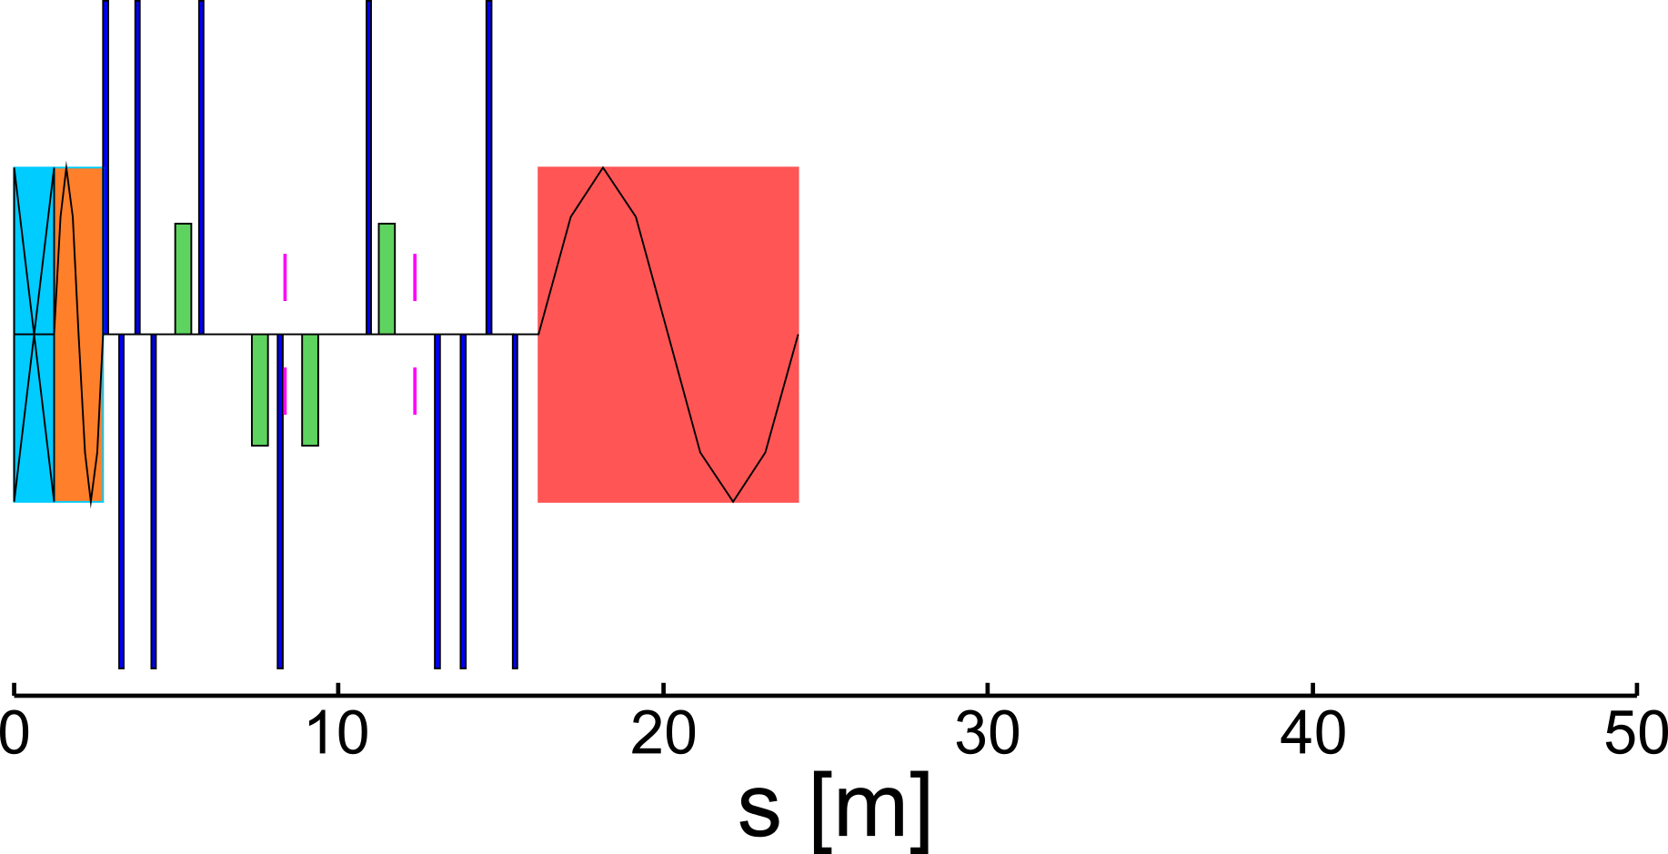

b)

Fig. 1: a) is the initial layout of positron injector (Model 1 “Sami-2023”) and b) is the updated version of injector layout (Model 2 “Andriy-2025”). Beam line elements: exit of tungsten target is at *s* = 0, strong focusing solenoid (light blue), capture cavity inside a weak solenoid (orange), quadrupoles (dark blue), dipoles (green), collimators (magenta), SRF cavities (red).

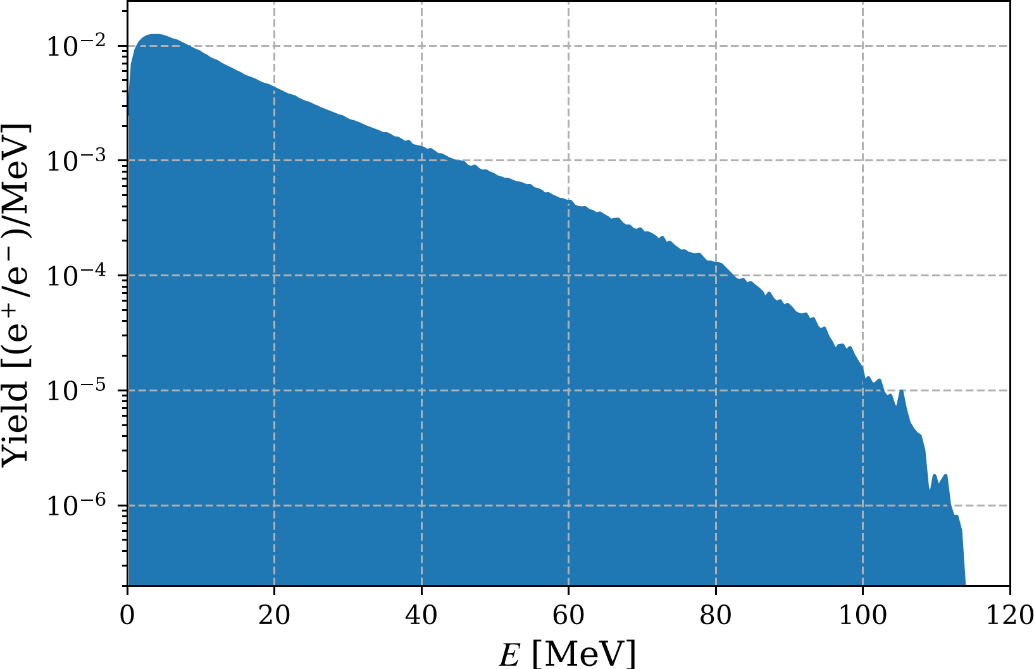

Fig. 2: Positron energy distribution at the target exit (*z* = 0).

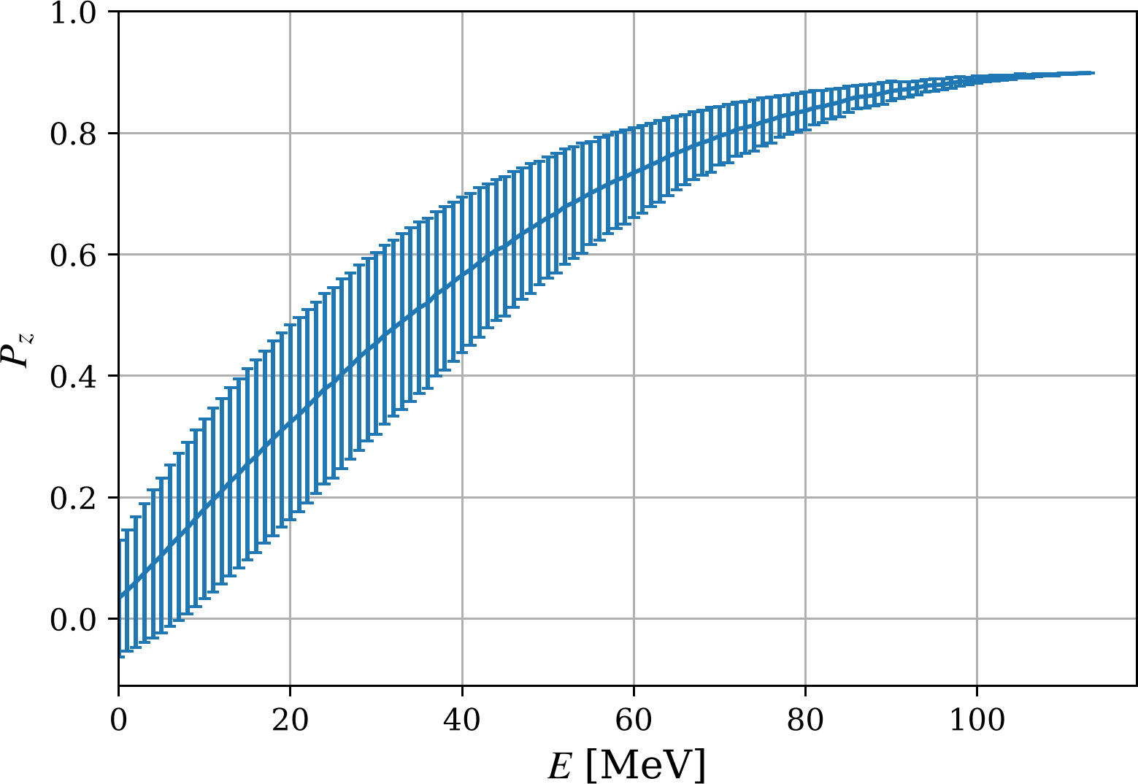

Fig. 3: Longitudinal polarization versus positron energy at the target exit (*z* = 0).

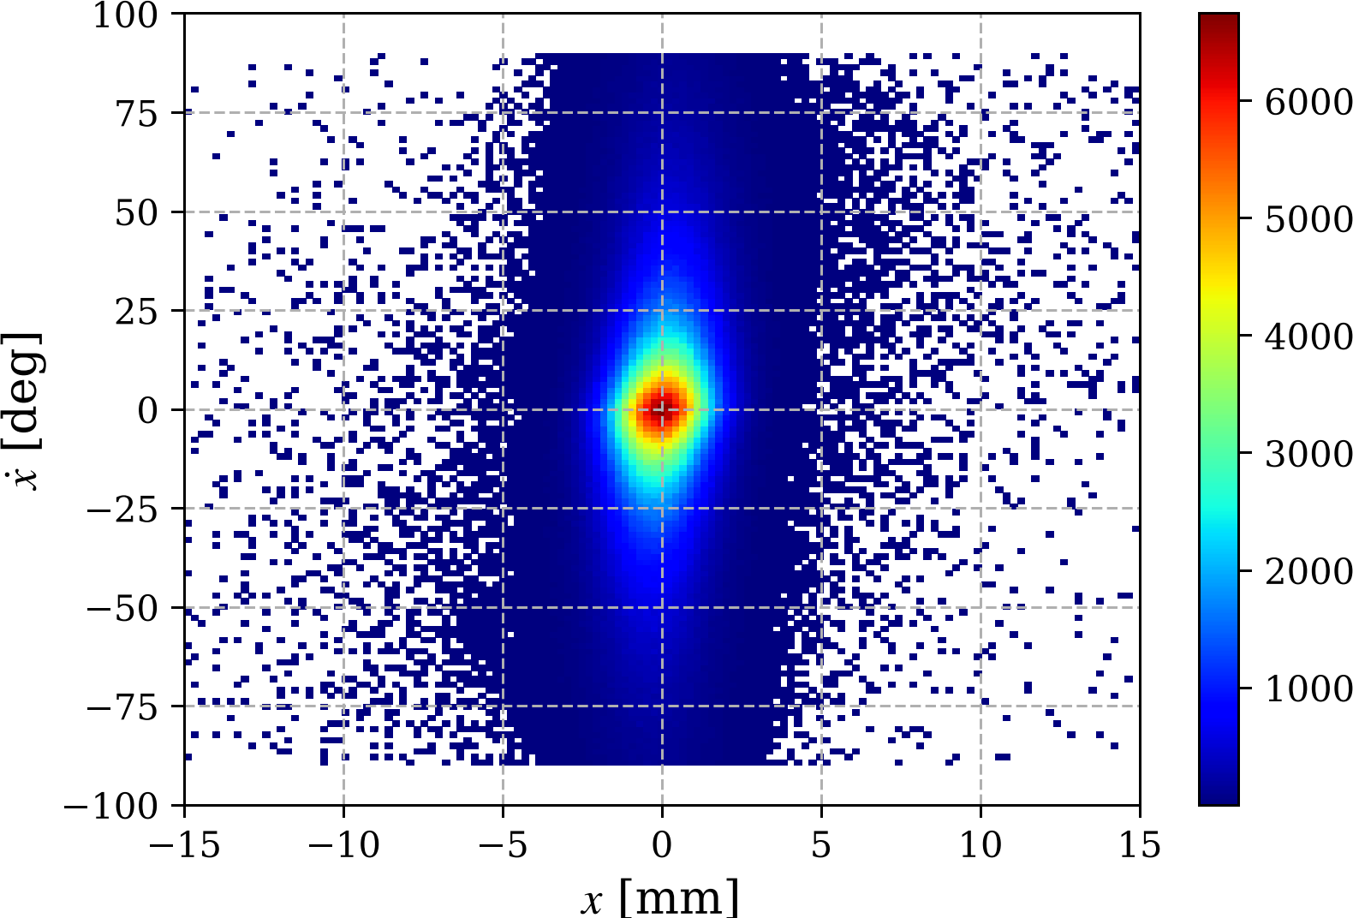

Fig. 4: *xx’* phase space at the target exit (*z* = 0).

For the development and optimization of beam line, positrons with a desired energy we selected at target exit. The positrons with a momentum of 60 MeV/c and momentum spread Δ*p*/*p* of 10% were selected at target exit in the Model 2. In Model 1, all positrons were tracked without cuts. However, the momentum of the reference particle at the target exit was set to 60 MeV/c. Code elegant [5] have been used in both models to design the positron injector layouts. The momentum of the positron beam at the end of the injector must be 123 MeV/c, and the beam's momentum spread (RMS) must not exceed 1%. This limit is defined by CEBAF acceptance. Model 1 includes the chicane for longitudinal bunch compression. However, this compression can also be achieved in the bends of the transfer line from the LERF to the North Linac. Therefore, it was not included in Model 2, and the beam line ends at the exit of the SRF module.

The dispersion of positron beam at the begin and end of the chicane was minimized and beam transmission was maximized to get the highest possible positron beam current at the end of injector. The evolution dispersion (*ηx* and *ηy*) and Twiss parameters *α* and β along beam lines are shown in Fig. 5 for the capture of 60 MeV positrons. The momentum and momentum spread are shown in Fig. 6. The central (or reference) momentum *p*0 is changed only in the cavities. Since Model 1 considers all positrons, its initial relative momentum spread (*σδ*) of 22% is much higher than the 5.5% spread of Model 2, which only considers positrons with a momentum of 606 MeV/c. The final momentum spread for both models at the end of SRF module is near the same: 0.6 % for Model 1 (at *s* = 34.4 m) and 0.7% for Model 2.

The dispersion in Model 2 is not zero at the end of the chicane and at the beginning and end of the SRF module. This needs to be improved. Adding additional quadrupoles and sextupoles to the chicane would minimize aberrations and help to reduce bunch length. Using beam X and Y steering correctors would also improve beam transmission if the beam center is not perfectly aligned with the collimator in the middle or end of chicane.

The evolution of positron beam current along beam line is shown in Fig. 7. A drive electron beam with a current of 1 mA at 120 MeV passing through a 4-mm-thick pure tungsten target generates 0.2 mA of positrons. This is the initial current of Model 1. The current of 60 MeV positrons with a 6 MeV energy spread is 5.15 μA. This is the starting current for Model 2. Most of the positrons with high emittance and high energy spread are removed in the focusing solenoid, the capture cavities, and the collimator located in the middle of the energy selection chicane. The e+ currents at the end of SRF module: *I*1 = 172 nA for Model 1 and *I*2 = 336 nA for Model 2. The Model 1 current is approximately two times lower than the Model 2 current due to the smaller aperture of the beam collimator. Figure 8 shows the change in RMS beam size along the beam line in the x and y directions. The rectangular collimator of Model 1 has a half-aperture Δ*x*col1/2 of 1 cm. The RMS beam size *σx*1 = 5 mm after the collimator located at *s* = 18 m. The aperture size of two Model 2 collimators Δ*x*col2/2 is 1.5 cm, and *σx*2 after the collimator located at the middle of chicane is 7.5 mm. The RMS angles and normalized emittance in x and y directions are shown in Fig. 9 and 10, respectively. Two times higher current in Model 2 results in approximately two times higher emittance. The transverse beam size in both models at the end of the SRF module is quite similar.

Figure 11 shows the change of bunch length along beam line. The bunch lengthening in a normal conducting focusing solenoid with a 1.6 T peak field on the beam axis and 1.24 m distance from the target exit to entrance to the capture cavity is much stronger (>1 order of magnitude) in comparison to 2.5 T super-conducting solenoid with a target-to-cavity distance of 25 cm. However, at the end of the SRF module, the difference in bunch length is not too high: 4.4 mm for Model 2 with a 1.6 T solenoid and 2.9 mm for Model 1 with a 2.5 T solenoid.

|  |  |
| --- | --- |
| Model 1, data from Fig. 6.15 [1] | Model 2 |
|  |  |
|  |  |
|  |  |
| Fig. 5: Twiss parameters along beam line for capture of 60 MeV e+ at target exit. | |

|  |  |
| --- | --- |
| Model 1, data from Fig. 6.18 [1] | Model 2 |
|  |  |
|  |  |
| Fig. 6: Momentum or momentum spread vs *s* for capture of 60 MeV e+ at target exit. At the end of SRF module: momentum spread is 0.6 % for Model 1 and 0.7% for Model 2. | |

|  |  |
| --- | --- |
| Model 1, data from Fig. 6.18 [1] | Model 2 |
|  |  |
| Fig. 7: e+ current vs *s*. At the end of SRF module: *I* = 172 nA for the Model 1 (all e+ at target exit) and *I* = 336 nA for the Model 2 (e+ with energy spread |Δ*p*|/*p*0 < 0.1). | |

|  |  |
| --- | --- |
| Model 1, data from Fig. 6.15 [1] | Model 2 |
|  |  |
| Fig. 8: Transverse rms beam size vs *s*. At the end of SRF module: *σx*1 = 9.2 mm, *σy*1 = 14.0 mm and *σx*2 = 11.2 mm, *σy*2 = 12.0 mm. | |

|  |  |
| --- | --- |
| Model 1 | Model 2 |
| No Data |  |
| Fig. 9: RMS beam angles vs *s*. At the end of SRF module: *σx'* = 1.5 mrad, *σy’* = 1.6 mrad. | |

|  |  |
| --- | --- |
| Model 1, data from Fig. 6.16 [1] | Model 2 |
|  |  |
| Fig. 10: Normalized emittance vs *s*. At the end of SRF module: *εnx*1 = 1.2 mm·rad, *εny*1 = 1.4 mm·rad and *εnx*2  = 2.9 mm·rad, *εny*2  = 3.1 mm·rad. | |

|  |  |
| --- | --- |
| Model 1, data from Fig. 6.17 [1] | Model 2 |
|  |  |
| Fig. 11: Bunch length vs *s*. At the end of SRF module: *σs*1 = 2.9 mm and *σs*2 = 4.4 mm. | |

Spin tracking is not implemented in elegant. To estimate the beam polarization at the end of the positron injector, the positrons exiting the target were enumerated. The positron IDs and their longitudinal polarization *Pz* at the target were used to calculate the polarization at the end of the injector. Figure 12 shows the positron density distribution versus *Pz* and energy. For Model 2 and the primary electron beam with 90% longitudinal polarization, the average polarization at the end of the e+ injector is 70.2  8.2%.

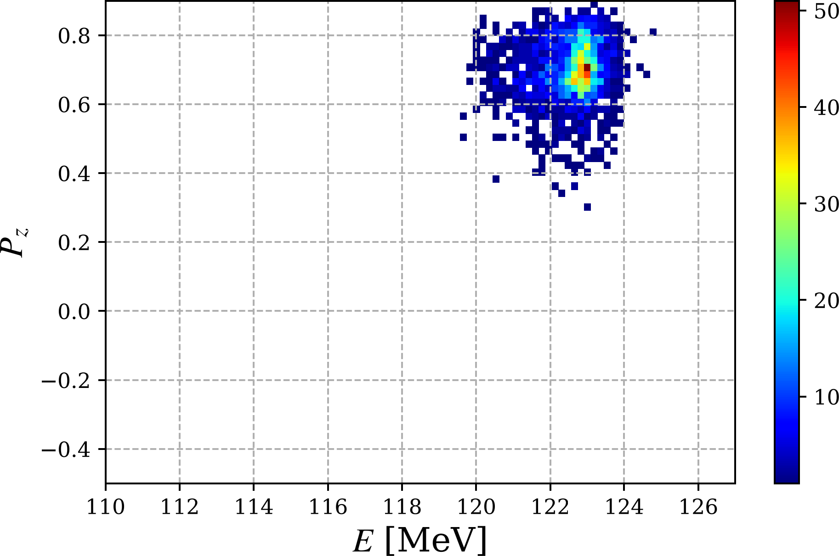

Fig. 12: Longitudinal polarization versus positron energy at the end of injector for capture of 60 MeV e+ at target exit for the Model 2. The average polarization is 70.2%  8.2 % for the drive e- beam with a longitudinal polarization of 90%.

# Outlook

A more detailed analysis of positron losses is needed, mainly in the capture solenoid/cavity, as well as in the matching section, first half of the energy selection chicane and upstream of the SRF module. The analysis should focus on removing positrons outside the desired energy range, removing positrons with high emittance and dumping all electrons. The calculated e+ beam emittance value at the end of the injector is too high (between 1000 and 3000 mm·mrad), and it must be reduced to 100 mm·mrad or less to be accepted by CEBAF.

It would be worth studying in more detail other beamline improvements, such as adding more quadrupoles and sextupoles to the chicane, using solenoid(s) for better matching to the SRF module, and performing a more detailed analysis of beam losses in the SRF cavities.

About 96.5% of the 120 kW of power is absorbed by the target and the capture solenoid/cavity and 2.8% of beam power exits the capture cavity. The design of the shielding, thermal assessment, and activation calculations for the target and capture areas must be performed.

**Acknowledgements**

The research described in this note was conducted under the Laboratory Directed Research and Development Program at Thomas Jefferson National Accelerator Facility for the U.S. Department of Energy.

# References

[1] S. Habet, "Concept of a polarized positron source for CEBAF", Paris-Saclay University, December 2023, [Thesis](https://jeffersonlab.sharepoint.com/:b:/r/sites/PositronSource/Shared%20Documents/Polarized%20Positron%20Beams%20for%20CEBAF/Theses/Habet-2023-12-PhD.pdf?csf=1&web=1&e=U92Hd8)

[2] S. Habet, A. Ushakov, E. Voutier, “Characterization and optimization of polarized and unpolarized positron production”, [PEPPo TN-23-01](https://wiki.jlab.org/ciswiki/images/8/83/Positron_production_optimization.pdf), February 2, 2023

[3] J. Benesch “Intermediate positron capture solenoid”, JLab Tech. Note 25-011, January 7, 2025

[4] S. Wang et al., “Capture cavities for the CW polarized positron source Ce+BAF”, IPAC’24, paper [MOPC51](https://www.jacow.org/ipac2024/pdf/MOPC51.pdf)

[5] M. Borland, "elegant: A flexible SDDS-compliant code for accelerator simulation", Advanced Photon Source LS-287, September 2000