PRIMEX II Light Monitoring System

The status of LMS, August 21, 2010

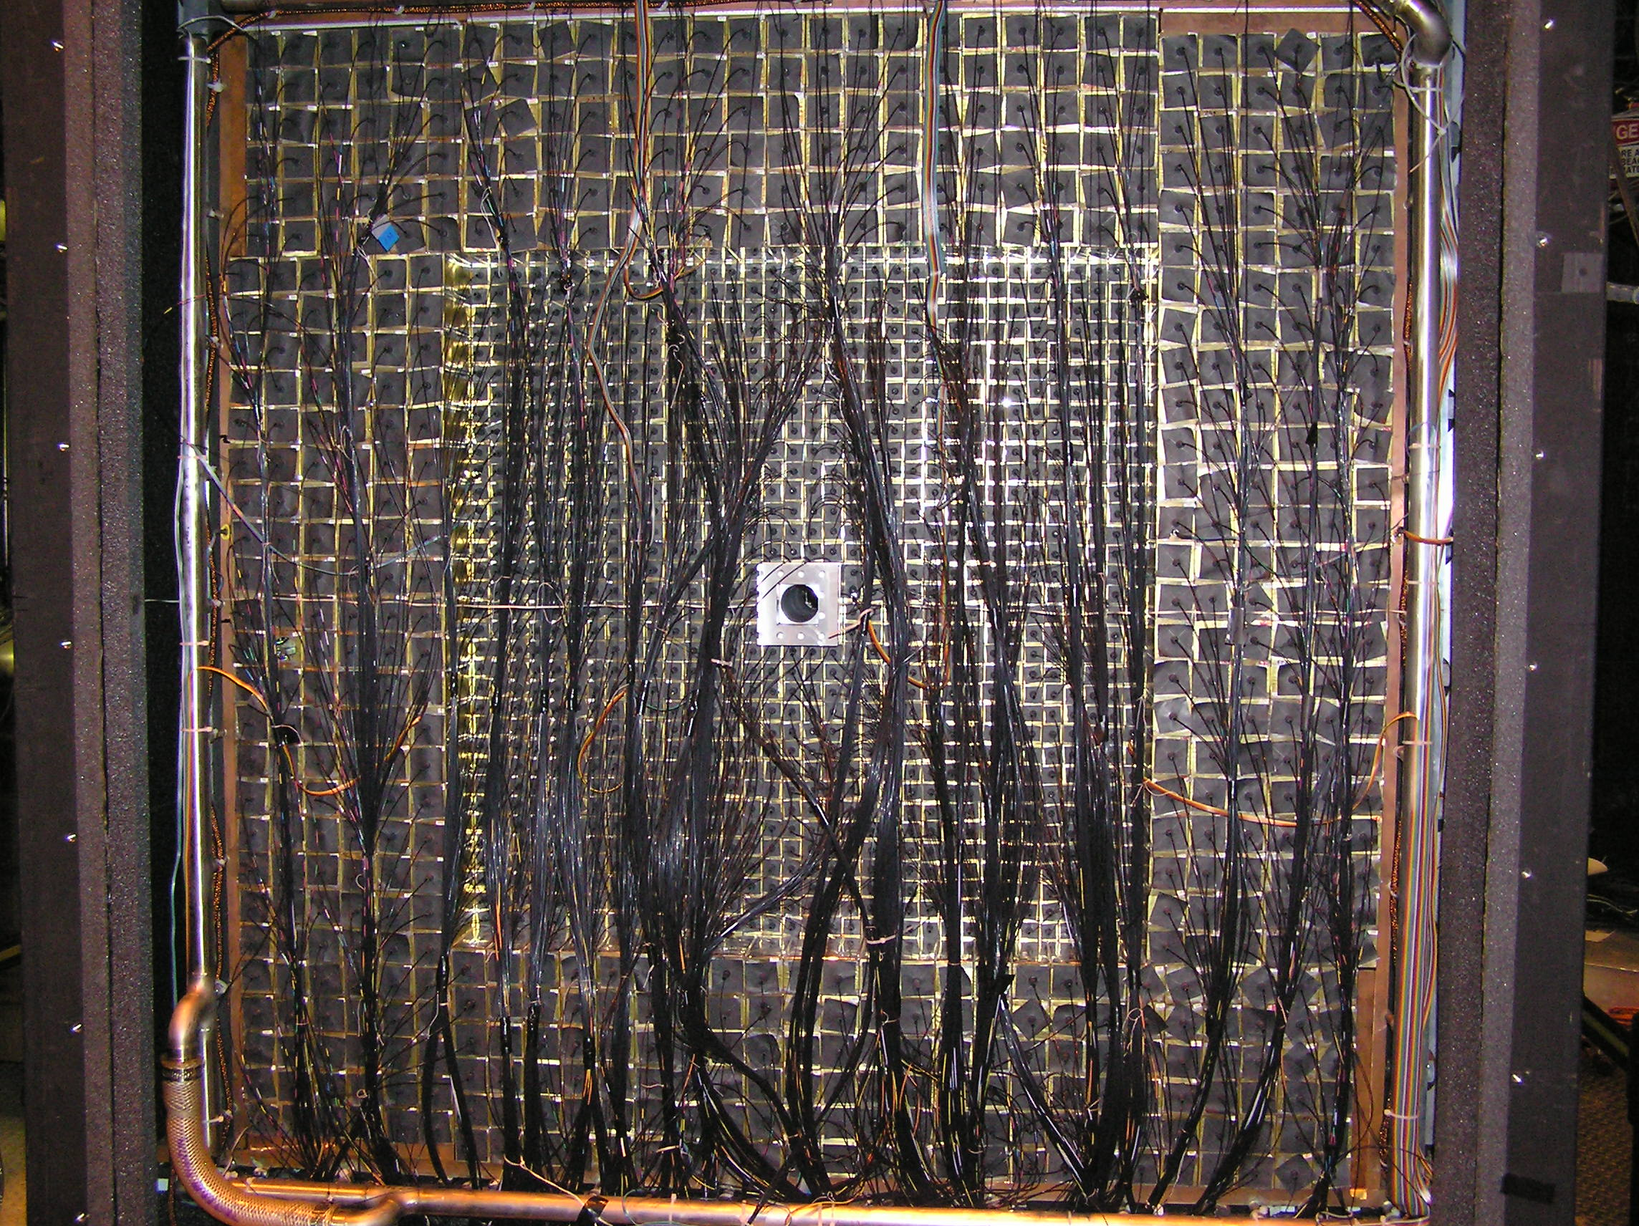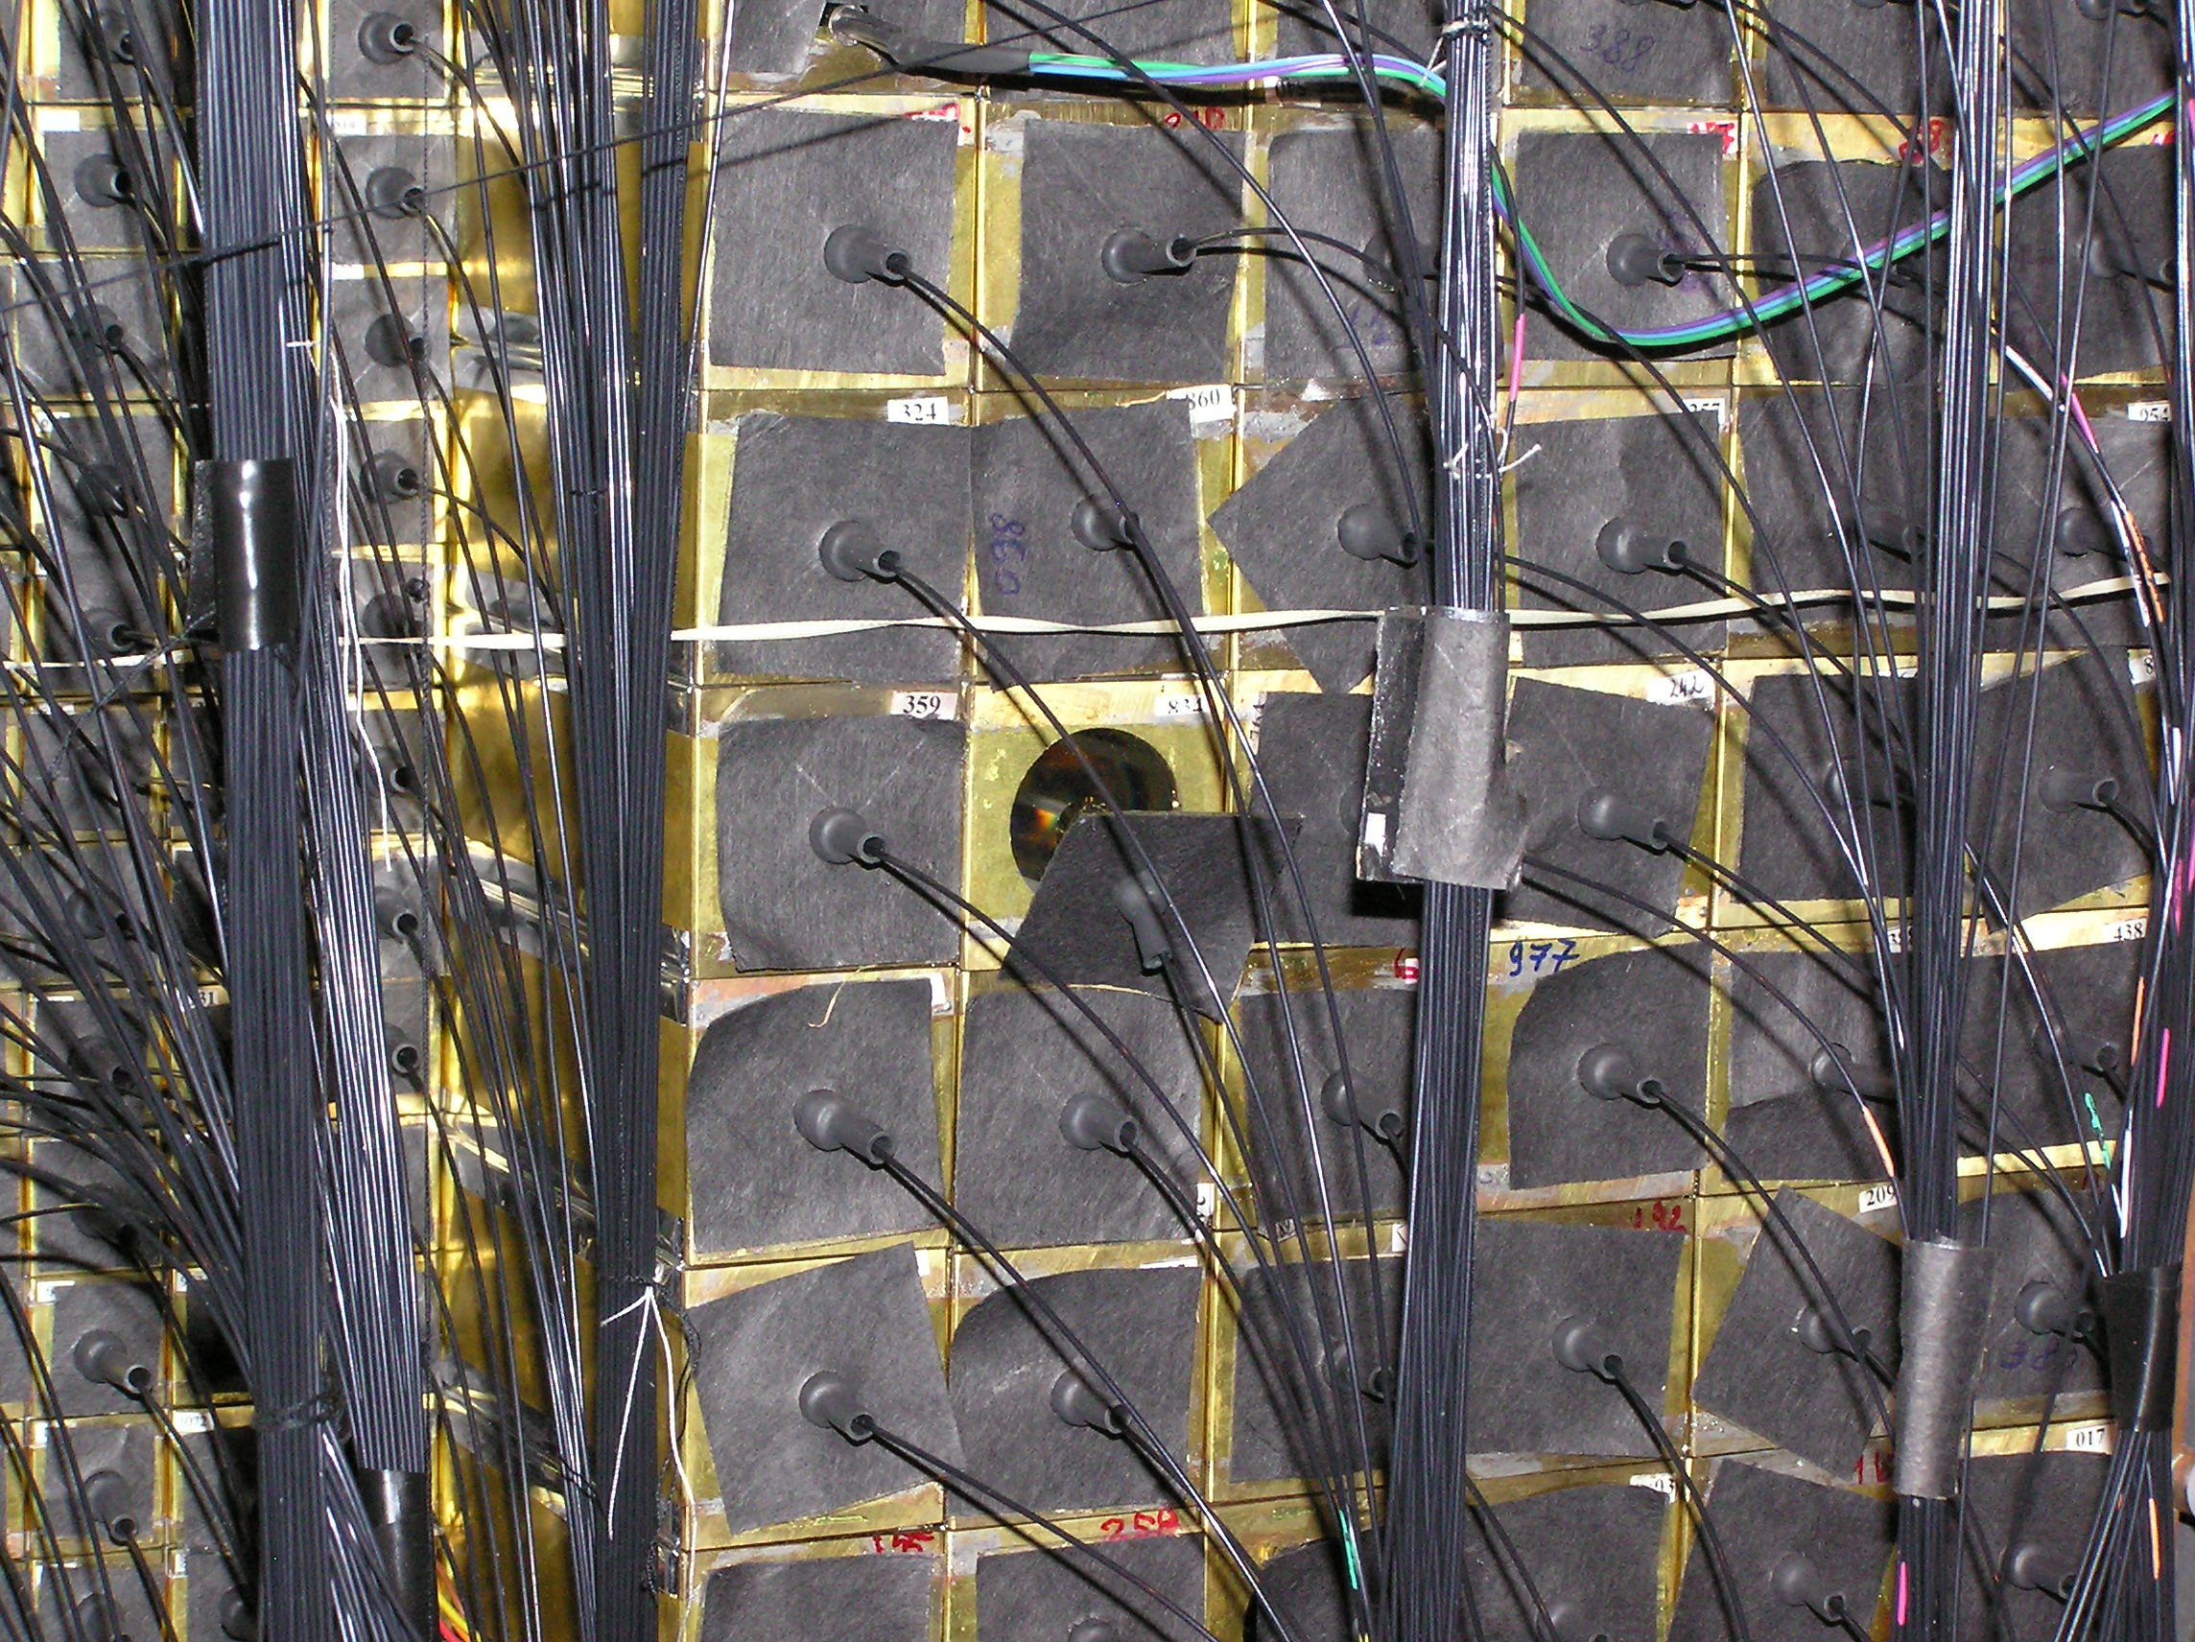

FIG. 1 The front view of the detector HYCAL with LMS fibers after opening on 8/21/2010. One fiber was detached (right picture)

Problems we have encountered during the run in 2004, and suggested solutions.

Light Monitoring System.
Date: 3/22/2006

What was wrong and what should be done to fix these problems.

1. There was one dead channel from the beginning, and very low channels.
Check the fiber connections on the front face of HYCAL.

2. The reference detectors turned out to be magnetic susceptible, although all three detectors were wrapped in 100 μ uncured μ-metal.

The simplest solution would be to wrap the box from outside with a few layers of μ-metal and to check the influence of a magnetic field using a permanent lab magnet. Better solution is to replace the PMT housing with soft iron tube (from outside) and cured μ-metal shielding (inside) which exceeds the length of PMT by at least 5 cm.

3. The light intensity was low for many channels.
The intensity was lowered at the level of the flusher in purpose, which was clipping the signal of the light pulse in attempt to make the signal width smaller. In addition, there was complain in the test lab that the signal in some channels was too strong.
After clipping, the signal did not get shorter. There was a 200 nsec tail which was most likely due to multiple reflections in the 6 inch integrating sphere.
The flusher must be modified to its original schematics, with an optimized clipping resistance.

4. The signal has long (up to 200 nsec) tail.
It is due to reflections in the 6 inch integrating sphere. In the prototype LMS this wasn’t the case since the integrating sphere had 4 inch diameter.

Modify the 4 inch integrating sphere increasing the second port to 1.5” diameter, and replace the existing 6” sphere.

5. It was found in the test lab that a CAMAC crate near the LMS electronics was noisy, which resulted in RF noise on the PIN signal. The instability of PIN diode during the runs 4100-4700 might be related to this noise.

Check again and replace the CAMAC crate if it is noisy. Noise might be also due to grounding loops between the driver, the PIN diode and the LMS box.

6. Filter wheel had different light transmission for different holes. It resulted in “triple curve” distributions in HYCAL LMS data.

The same hole must be used for the LMS events at the beginning of each run.

7. The light transmission of fibers varies many times from fiber to fiber.

Replace/re-glue bad fibers.

8. There is a fiber attachment problem to the detector face.

Modify the detector modules front face, adding fixation for each fiber as it was originally designed. This can be a stiff plastic stick, glued to the front face with hard UV glue.

9. Restore the individual cooling system of LMS. Variation in the box temperature within a degree may affect the stability of the system.

Observations after opening the HYCAL front face.
Date: 8/21/2010

1. The LMS was powered, all three reference PMTs work properly, the signal pulse heights and widths correspond to expectation. Both alfa- and light signals are at the same strength, about 150 - 200 mV at the high voltage 1330 V on the reference PMTs. The nominal value must be 1430 V on PMT1 and PMT2 (ORTEC) and 1500 V on PMT3 (CAMAC power supplie). However, I did not check the PIN, but replaced the battery. Filter wheel works properly.

2. There was no signal from one HYCAL channel in the past. A fiber was detached from the face of the modules as it is visible in the right picture.

3. Some channels had very small LMS signal. Anatoly has discovered that fibers were not well glued in the hole of the plastic ferrule. The fibers must be stripped off the black jacket before gluing.
4. Anatoly will improve the fiber fixation on the face of HYCAL.

5. I have removed the clipping resistor (additional 300 Ohm) in the driver schematics. Hopefully the signal became stronger, but the width did not change (30 ns FWHM).

6. The pulse which triggers the flusher has very long tail, in microsecond range. We will replace the trigger generator and check to understand if the 200 nsec signal tail was present because of the trigger pulse long tail.

7. I will also replace the LED driver which we used for the prototype to check the presence of the tail.

The following modification might be done.

- Lift the HYCAL and unbolt the 6 inch diameter integrating sphere. It is bolted to the bottom plate of the box.
- Replace the 6 inch sphere by 4 inch. This will increase the intensity of the light and remove (?) the 200 nsec tail.
- Refurbish the reference PMTs – provide individual good magnetic shielding. I don’t advise to replace the PMTs. The LED driver or PIN diodes and LEDs are not sensitive to the external magnetic field as it was verified on the prototype LMS recently.
- While the box is open, try to eliminate the RF noise in front of the pulse from the PMTs which might be due to ground loops.
- Let Anatoly to check and fix all fiber connections and provide good fixation. Check the signals on the HYCAL channels from LMS light and replace/re-glue all bad fibers. All signals must be distributed within 20% by pulse height.
- Provide rigorous temperature control of the box. During the first phase the LMS temperature control was not programmed (?).
- I would suggest restoring the LMS individual chiller. Every two days however we would need to have access to add water.

Other suggestions.

- During the run make sure we have excellent LMS data at the spectrometer calibration, intermediate and end of shifts.

- Make sure that the termo-stabilization system is on at least for a week before the calibration run.

- When HYCAL is moved, make sure the LMS reading did not change. If it did, understand what was the reason.

- If we use the PIN diodes for the reference, then we will be able to provide about 0.3% stability without any conditions. BUT...the experiment ELECTRONICS LOGIC or timing should not be modified after the start of the calibration and to the end of shifts. During the first stage of the experiment the logic was modified until the run before or about 4650. Itaru did, and forgot to leave a note in the journal.

- A graduate student should be assigned LMS data analysis. I will help, but I can not spend much time.

