Weekly Reporting SNS PPU

WBS P.02.03 Cryomodule Integration (JLab Scope)

April 30, 2021

**Issues:**

Impact of COVID-19 - JLab remains at MEDCON-5 with limited operations. Staff who can work remotely will continue to do so through at least MAY 2021. Lab continues to evaluate circumstances that would allow a return to MEDCON-4.

Staff are onsite to perform PPU-related work (since 15-JUN).

**Accomplishments this week:**

Management:

* PPU activities are continuing onsite, with testing of production cavities, preparation for string assembly #2, preparation for cold mass assembly and receipt inspection of components.
* Off-site work efforts continue, focused on completion of procurement activities and preparations for production.
* Evaluating impacts of COVID-19 on overall project schedule and developing mitigations.
* Testing tanked cavities for string #2 based on results from string #1 post-tanking tests (3 of 5 passed on first try after tanking).
* Incorporating BCR for 8th CM into baseline.
* Planning for Howell/Mammosser visit week beginning 5/3/21.

Engineering & Design:

* Sustaining engineering activities are continuing in order to revise drawing packages based on feedback during the procurement phase.

Procurement:

* 5 active procurement awards; 83 completed (arrived at JLab).
* End Cans:
  + Supply end can (SEC) 01 is ready to be returned to vendor.
  + SEC 02 is on the end can tool to be inspected.
  + SEC 03 is uncrated and preliminary inspections performed. Bellows and bridge tube orientation look alright. It will wait for more detailed inspections to be done.
  + Return end can 01 & 02 will be shipped together early May.
* Vacuum Vessels:
  + Vessel #2 is currently having final machining stages performed, and is due to ship to JLab on 6/7/21.

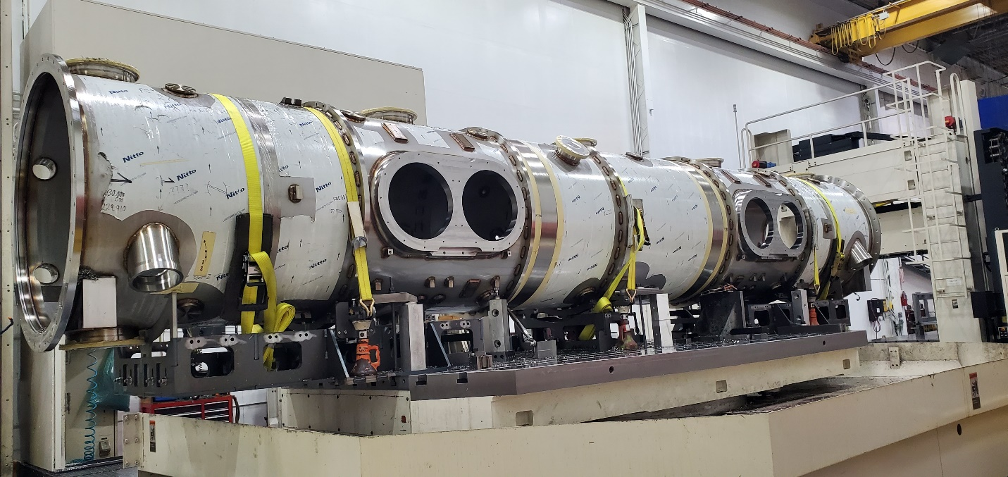

* + Vessel #3 is undergoing final welding steps, will be in machining center for final machining this week. Due to ship to JLab on 7/5/21.

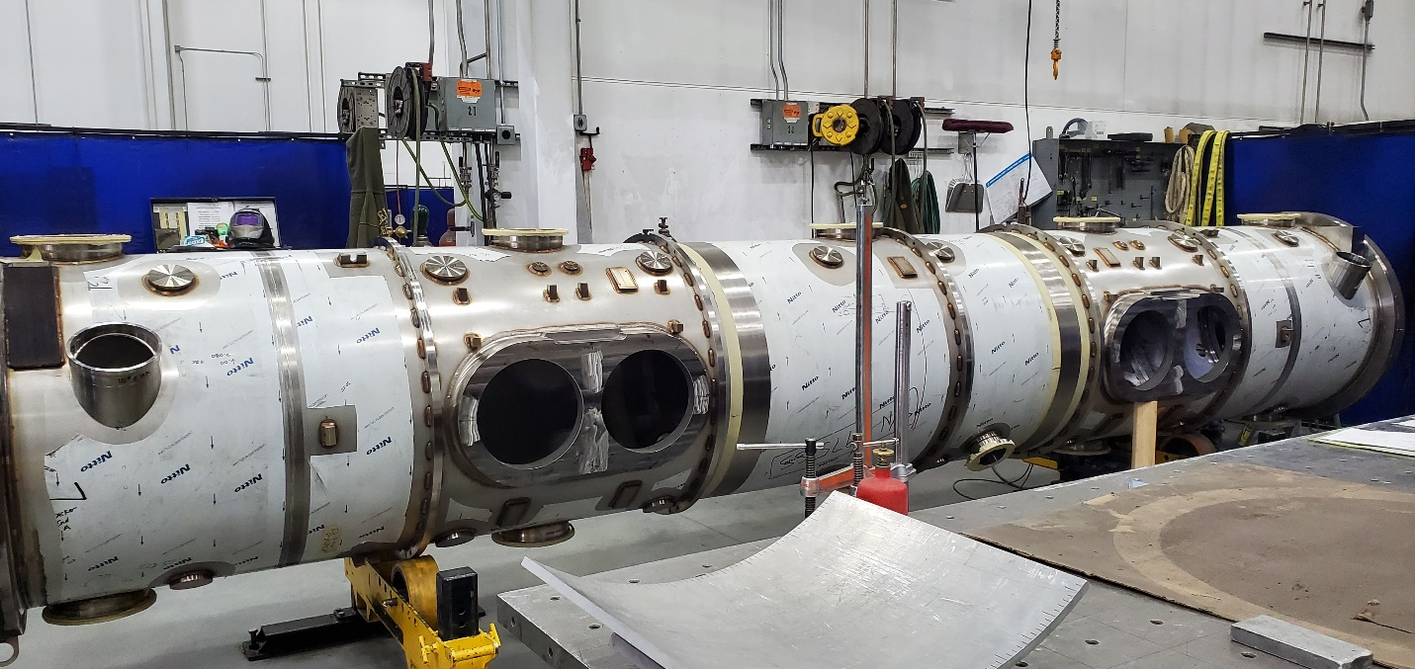

* + Vessel 4 has had the stiffener rings welded completely on and is awaiting its first post weld machining process. Scheduled for delivery to JLAB on 8/2/2021.

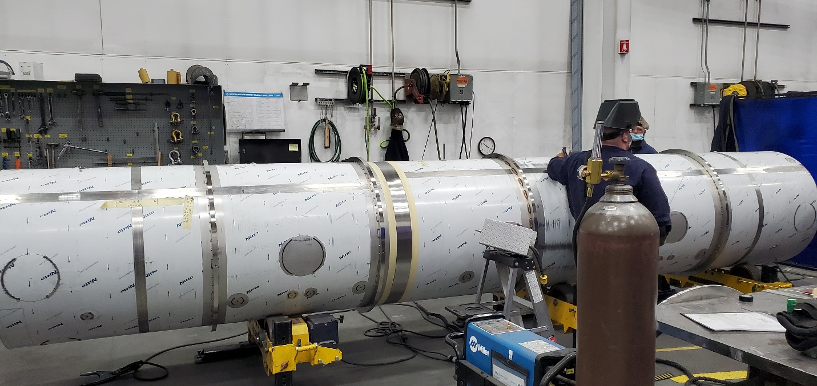

* + Vessel 5 is having its stiffener rings welded on. Scheduled for delivery to JLAB on 8/30/2021.

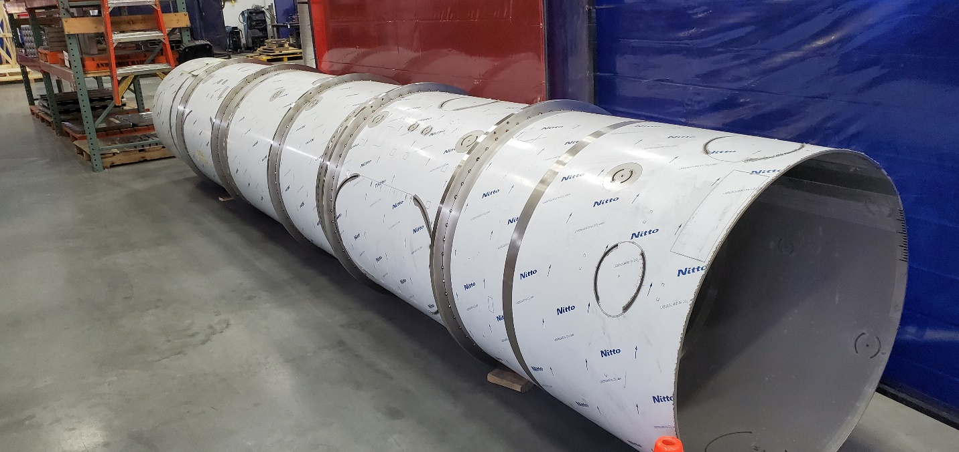

* + Vessel 6 scheduled to ship to JLAB on 9/27/2021.
  + Vessel 7 scheduled to ship to JLAB on 10/11/2021.

Production:

* Cavity Status:
  + PPU-08 tanked cavity successfully RF tested after HV tanking. This is first cavity for CM-2
  + PPU17 is preparation for RF test as received from vendor
  + PPU-06 cavity is being prepared for RF test next week. The cavity initially FE limited after HV welding.
* Cryomodule Status:
  + First string is in cold mass assembly.
    - Coupler cooling lines mocked up
    - Tuner installation on-going
    - Some MLI installed
    - Preparing for 2K process piping leak check
* PPU-13 HV welding in process (string #3), nearly complete
* PPU-11 HV Tacking I.P.
* SEC 2 and 3 inspections on-going
* Spaceframe/thermal shield disassembled to install MLI
* FPCs:
  + Six FPCs have been cleaned and transferred in the clean room and are ready for incoming inspections / preparation for SNSPPU CM02 / ORNL visit.

Project Management:

* Finished BCR 21-005 and associated work authorization documents
* Collected April status
* Sent accrual to ORNL
* Issued mid-month manpower reports
* Updated Responsibility Assignment Matrix

Quality Assurance:

* Space Frame / Thermal Shield PFMEA team conducted its first working session this week. The team analyzed process steps from the Space Frame/Thermal Shield procedure/traveler for potential failure modes. Team will continue identifying failure modes for the remaining process steps in its next session.
* SRF Ops Customer Satisfaction Survey sent to ORNL.
* Improvements to the NCR program are in progress.