Weekly Reporting SNS PPU

WBS P.02.03 Cryomodule Integration (JLab Scope)

April 8, 2022

**Issues:**

Impact of COVID-19 - JLab status changed to MEDCON-3 on 14-MAR-2022. Staff who can effectively work remotely will continue to do so.

**Accomplishments this week:**

Management:

* PPU activities are continuing onsite with testing of production cavities, continuing with cryomodule assembly, and receipt inspection of components.
* Off-site work efforts continue, focused on completion of original procurement activities, continuing procurements for 8th CM and production activities.
* Evaluating impacts of COVID-19 on overall project schedule and developing mitigations.
* Presented slides for JLab Planning and Coordination Mtg on 22-MAR.
* Preparing BCR presentation for Request for Equitable Adjustment submitted by End Can vendor.

Engineering & Design:

* Sustaining engineering activities are continuing in order to revise drawing packages based on feedback during the procurement phase.

Procurement:

* 3 active procurement awards; 91 completed (arrived at JLab).
* Supply End Cans (SECs):
  + SEC 01 is delivered to JLAB on 12/2. Weld & visual inspections completed. NCR on dimensions open. Plan to use on PPU-03.
  + SEC 02 is delivered to JLAB 12/21. Weld inspection done, other inspections pending.
  + SEC 03 is Installed on PPU-01 cryomodule. Delivered to ORNL with PPU-01 cryomodule.
  + SEC 04 is shipped 3/30/23.
  + SEC 05 is at the vendor. On acorn table, in welding. Expect to ship 4/15/22.
  + SEC 06 is at the vendor. In queue after SEC SN 5, Vacuum Vessel Completely Welded.
  + SEC 07 is installed & aligned to PPU-02, support block shortened by 3/4".
  + SEC 08 In pre-weld machining. Almost through all pre-weld machining.
* Return End Cans (RECs):
  + - REC 01 is received on 2/9. This is planned to be used on PPU-03. Visual & weld inspections done, CMA inspections pending
    - REC 02 is Installed on PPU-01. Delivered to ORNL with PPU-01 cryomodule.
    - REC 03 is at the vendor. Final assembly leak check indicates leaks on the primary supply & return circuits. RFI-020 soapy water test performed. Leaky heat exchange to be removed after testing. Scheduled for cut apart next week. Waiting for a qualified heat exchanger. JLab will perform extended testing of three unused heat exchangers. Ship date 5/9/22 assuming JLab returns a good heat exchanger by 4/11.
    - REC 04 is installed on PPU-02 cryomodule with minor modification to the support block.
    - REC 05 - Album #1 work completed. Ship date 6/3/22 assuming JLab returns a good heat exchanger by 5/6.
    - REC 06 - received at JLab, remains crated.
    - REC 07 - In queue for welding top plate. Will be on hold for heat exchanger. Ship date TBD, depending on JLab HX testing/inspection.
    - REC 08 Working through pre-weld machining. External Components being machined (Mounting Bar, Angle Support, Lifting Bracket, etc.).
  + A summary of anticipated end can delivery dates:
    - REC 06 --- Received
    - SEC 04 --- to ship by 3/30
    - SEC 05 --- to ship by 4/15
    - REC 03 --- to ship by 5/9
    - SEC 06 --- to ship by 5/13
    - REC 05 --- to ship by 6/3
    - SEC 08 --- to ship by 6/17
    - REC 07 --- TBD depending on JLAB HX inspection
    - REC 08 --- TBD. depending on JLAB HX inspection
  + Next visit to end can vendor set to be on 4/19.
  + JLab in talk with heat exchanger to return the leaky HX #30.
  + CMA or Matt Weaks will update status on HX testing at JLab.
* Vacuum Vessels:
  + Vessel #8 continues to move forward and appears to still be on track for mid-June delivery.

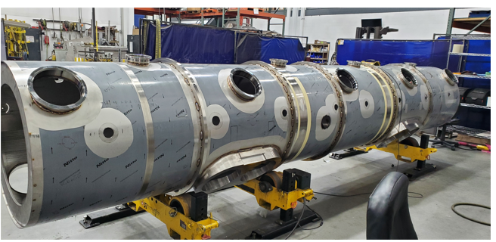

* Spaceframe Thermal Shield Assembly:
  + The SFTS assembly has shipped and will arrive at JLab on 4/1/2022 along with the remaining MLI.

Production:

* Cavity Status:
  + PPU-24 cavity after HE vessel welding was RF tested. The cavity limited at 15 MV/m with high field emission.
  + PPU-05, the cavity initially limited by high FE was reprocess with BCP. The cavity is in preparation for RF test next week.
* Cryomodule Status:
  + CM02: SEC beam pipe being assembled, flowhood setup
  + REC Closed up, awaiting Ion pump removal.
  + CM03: Moved to WS5. SEC inserted into VV. REC receipt inspection I.P.
  + CM04: SF assembled and aligned; ready for use. 2K Magnetic shielding and 2K MLI completed
  + CM05: Adding coupler cooling lines I.P. Instrumentation I.P.
  + HV welding – waiting on HV parts from CMM inspection.
  + HX testing – First unit installed in testing can. Second unit leak checked and is good. Third unit still requires LC.
* FPCs:
  + Total of 10 FPCs in the Annex inventory area. Two FPCs in the clean room cabinet.

Project Management:

* Working on BCR 22-010
* Collected Status and held the March Progress Meeting

Quality Assurance:

* Additional Pressure Test Records for the Supply and Return End Can for CM 1 have been completed. The reports are available to ORNL via the JLab SharePoint site.
* Work continues to create Cavity and Cryomodule Drilldown reports in Pansophy to show the Acceptance Criteria.