Weekly Reporting SNS PPU

WBS P.02.03 Cryomodule Integration (JLab Scope)

November 11, 2022

**Issues:** None.

**Accomplishments this week:**

Management:

* PPU activities are continuing onsite with testing of production cavities, continuing with cryomodule assembly, and receipt inspection of components.
* Off-site work efforts continue, focused on completion of original procurement activities, continuing procurements for 8th CM and production activities.

Engineering & Design:

* Sustaining engineering activities are continuing in order to revise drawing packages based on feedback during the procurement phase.
* ORNL requested a full set of drawings for the PPU CM.

Procurement:

* JLAB plans to visit the end can vendor on 11/16 to witness leak check of REC 5 circuits, likely REC 7 as well.
* End can vendor is informed of the galling issue between cool down valve drive rod and its guide. JLab sent videos on a few types of JT-style valve stem actuation demonstrations, all can be pressed by hand to slide. Of the 2 valve stems at the vendor, one appears to move freely, the other is seized tightly. Vendor plans to cut apart the seized valve and investigate, as well as rebuild the part to ensure it functions correctly.
* Supply End Cans (SECs):

|  |  |  |
| --- | --- | --- |
| S/N | Status | Estimated Delivery Date |
| 01 | Installed on CM-03 | - |
| 02 | Installed on CM-04 | - |
| 03 | Installed on CM-01 | - |
| 04 | Welded onto CM-05 | - |
| 05 | Welded onto CM-06 | - |
| 06 | Delivered to JLab on 6/6. Uncrated, inspections started. Phase 1 dimensional inspection done. Bridge tube angle is off by ~5 degrees. | - |
| 07 | Installed on CM-02 | - |
| 08 | SEC 08 is at the vendor's place. Machine shop has completed all work for SEC-08, parts moving through inspection. Top-Plate fit up to begin shortly. | Late Jan/early Feb |

* Return End Cans (RECs):

|  |  |  |
| --- | --- | --- |
| S/N | Status | Estimated Delivery Date |
| 01 | Installed on CM-03 |  |
| 02 | Installed on CM-01 |  |
| 03 | Delivered to ORNL 9/30. ORNL performed multiple leak checks, leaks are confirmed to be inside the end can body on the LP line. Next is to cut the end can open and proceed with investigations. |  |
| 04 | Installed on CM-02 |  |
| 05 | Spools fit-up completed. Next leak check planned to happen on 11/11. JLAB will witness retest on 11/16 when a portion of thermal shield is in place. | 11/28 |
| 06 | Installed on CM-04. | - |
| 07 | Completed clean-up of thermal shield and has started fit up of spools. Likely to have leak check on 11/16. | Mid-Jan |
| 08 | REC 08 is at the vendor's place. 99% of machining is done. New shell to be complete, to work on the spools next. | TBD |

Production:

* Cavity Status:
* PPU-26t was RF tested. The cavity reached 18 MV/m with some FE.
* PPU-30t and 31t are in preparation for RF test next week.
* Cavity String Status: String #8 – 2 of 4 cavities qualified, considering PPU-26LL as a tentative second cavity.
* Cryomodule Status:
* CM05: Punch list items I.P. awaiting REC.
* CM06: Punch list items I.P. awaiting REC.
* CM07: mag shield installation on-going; welding FPC bellows I.P.
* Helium Vessel Update – Gathering parts for added HV’s.
* FPCs: Total of 10 FPCs in the Annex inventory area. Two FPCs in the clean room cabinet.

Project Management:

* Updated Month end Manpower charts
* Sent cost data package to ORNL
* Updated the CAM Notebook

Quality Assurance:

* Continue to monitor quality data for possible trends.
* Early work gathering data deliverables for CM05 begins.

Project Photos:

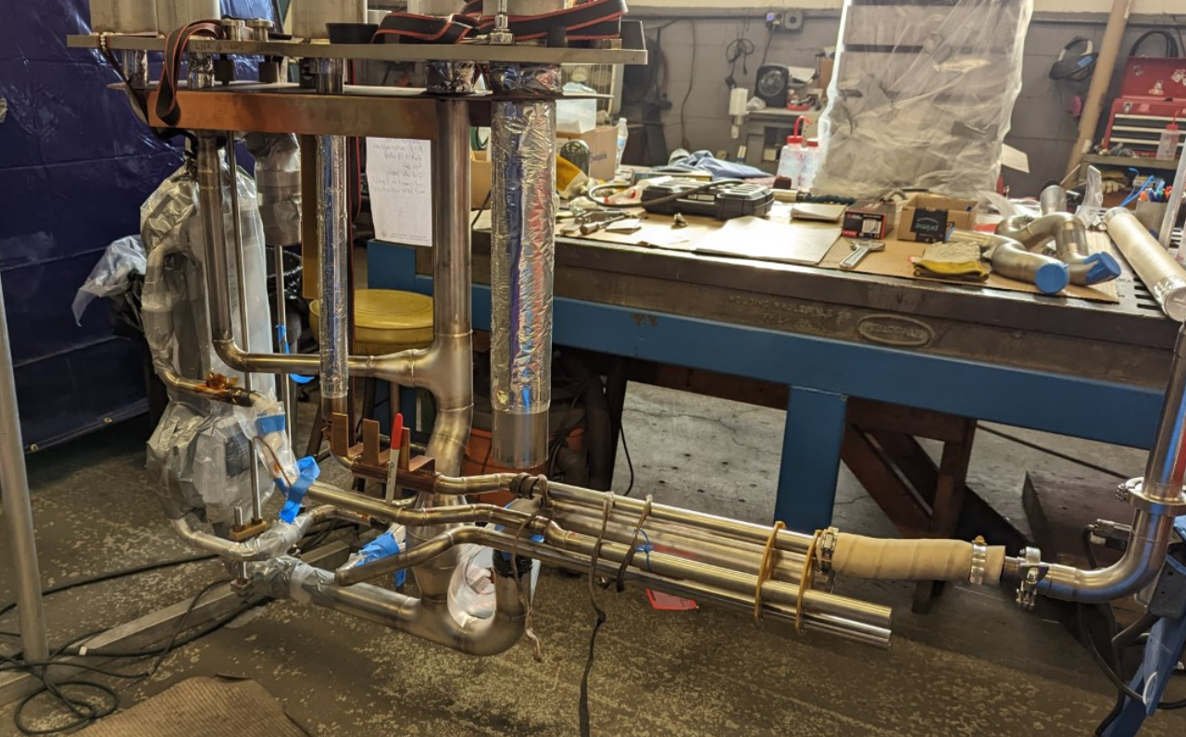

REC-05 During Leak Check