Weekly Reporting SNS PPU

WBS P.02.03 Cryomodule Integration (JLab Scope)

December 9, 2022

**Issues:** None.

**Accomplishments this week:**

Management:

* PPU activities are continuing onsite with testing of production cavities, continuing with cryomodule assembly, and receipt inspection of components.
* Off-site work efforts continue, focused on completion of original procurement activities, continuing procurements for 8th CM and production activities.
* Finalized and signed record of decision for issues related for FPCs needed for string #8.

Engineering & Design:

* Sustaining engineering activities are continuing in order to revise drawing packages based on feedback during the procurement phase.
* Plan for transmitting complete set of CM drawings in progress.

Procurement:

* JLAB visited the end can vendor on 12/16 and witnessed leak check of REC 7 LP circuit. Next visit is anticipated to be in the week of 12/11 to witness REC 7 leak check.
* On the cool down valve galling, vendor found one such valves galls. The valve has been partially cut apart, it appears that the cause may simply be the tight fit between the stem and the guide. Vendor is going to repair the galling stem and make a new stem for the last REC.
* ORNL advises that REC3 vacuum shells weld is not fully penetrated. Vendor says that they perform TIG root pass, then add 3 or 5 layers of flux core passes.
* Supply End Cans (SECs):

|  |  |  |
| --- | --- | --- |
| S/N | Status | Estimated Delivery Date |
| 01 | Installed on CM-03 | - |
| 02 | Installed on CM-04 | - |
| 03 | Installed on CM-01 | - |
| 04 | Welded onto CM-05 | - |
| 05 | Welded onto CM-06 | - |
| 06 | Delivered to JLab on 6/6. Uncrated, inspections started. Phase 1 dimensional inspection done. Bridge tube angle is off by ~5 degrees. JLAB will try installation of SEC 06 and exercise loosening the hardware at both ends of the elbow/bellows and see how well it corrects. | - |
| 07 | Installed on CM-02 | - |
| 08 | SEC 08 is at the vendor. Machine shop has completed all work for SEC-08, parts moving through inspection. Vacuum shells getting weld preps. | Late Feb |

* Return End Cans (RECs):

|  |  |  |
| --- | --- | --- |
| S/N | Status | Estimated Delivery Date |
| 01 | Installed on CM-03 |  |
| 02 | Installed on CM-01 |  |
| 03 | Delivered to ORNL 9/30. ORNL found the leak in the REC3 located to the 1/4" line from the 2K return (not the surge tank) near the top plate. They expect to repair and send to JLab in mid-December. |  |
| 04 | Installed on CM-02 |  |
| 05 | Vendor is working on vacuum shell fit up. | 12/29 |
| 06 | Installed on CM-04. |  |
| 07 | Vendor finished working temperature sensors. More cryo-circuit welding to happen. Vacuum shell weld prep ongoing. | Late-Jan |
| 08 | REC 08 is at the vendor. 99% of machining is done. Sensors to be brazed on spools. | Late-Feb |

Production:

* Cavity Status:
* PPU-31t is qualified for CM8. All 4 cavities are qualified for last CM.
* HB-62 is waiting for RF test.
* Cavity String Status: String #8 – 4 of 4 cavities qualified.
* Cryomodule Status:
* CM05: Awaiting ECs
* CM06: Awaiting ECs
* CM07: Coupler bellows LC’d; 2k mag shields installed into spaceframe; CS alignment I.P.
* FPCs: Total of 10 FPCs in the Annex inventory area. Two FPCs in the clean room cabinet.

Project Management:

* Held November Progress Analysis Meeting
* Provided Schedule Package to ORNL
* Updated CAM Notebook
* Completed BCR 23-001

Quality Assurance:

* Continue to monitor quality data for possible trends.
* Early work gathering data deliverables for CM05 begins.

Project Photos:

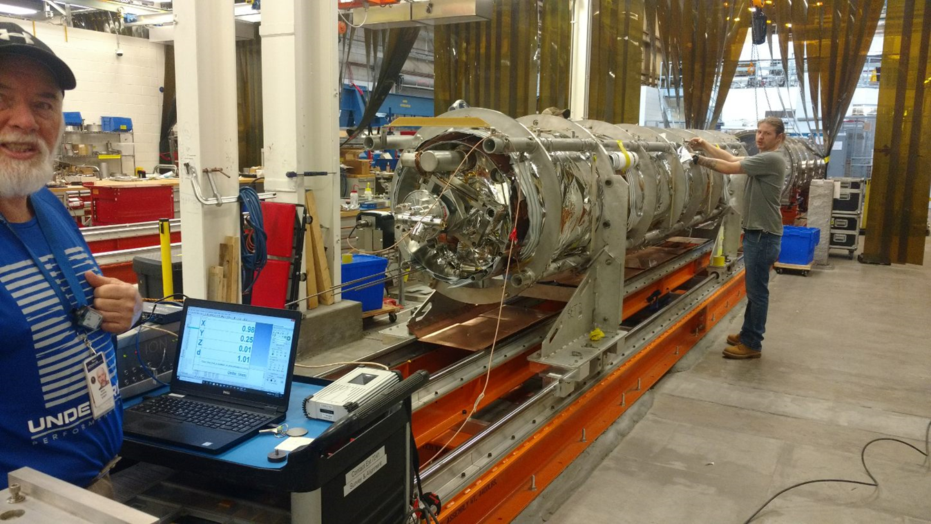

PPU07