Weekly Reporting SNS PPU

WBS P.02.03 Cryomodule Integration (JLab Scope)

January 6, 2023

**Issues:** None.

**Accomplishments this week:**

Happy New Year!

Management:

* PPU activities are continuing onsite with testing of production cavities, continuing with cryomodule assembly, and receipt inspection of components.
* Off-site work efforts continue, focused on completion of original procurement activities, continuing procurements for 8th CM and production activities.

Engineering & Design:

* Sustaining engineering activities are continuing in order to revise drawing packages based on feedback during the procurement phase.
* Plan for transmitting complete set of CM drawings – no progress since December.

Procurement:

* Next visit is estimated to be late next week or the early the following, i.e., Jan 12th-17th.
* On the cool down valve galling, vendor found one such valves galls. The valve has been partially cut apart, it appears that the cause may simply be the tight fit between the stem and the guide. Vendor is going to repair the galling stem and make a new stem for the last REC.
* ORNL advises that REC3 vacuum shells weld is not fully penetrated. Vendor says that they perform TIG root pass, then add 3 or 5 layers of flux core passes.
* Supply End Cans (SECs):

|  |  |  |
| --- | --- | --- |
| S/N | Status | Estimated Delivery Date |
| 01 | Installed on CM-03 | - |
| 02 | Installed on CM-04 | - |
| 03 | Installed on CM-01 | - |
| 04 | Welded onto CM-05 | - |
| 05 | Welded onto CM-06 | - |
| 06 | Delivered to JLab on 6/6. Uncrated, inspections started. Phase 1 dimensional inspection done. Bridge tube angle is off by ~5 degrees. JLAB will try installation of SEC 06 and exercise loosening the hardware at both ends of the elbow/bellows and see how well it corrects. | - |
| 07 | Installed on CM-02 | - |
| 08 | SEC 08 is at the vendor. Machine shop has completed all work for SEC-08, parts moving through inspection. Vacuum shells getting weld preps. | Late Feb |

* Return End Cans (RECs):

|  |  |  |
| --- | --- | --- |
| S/N | Status | Estimated Delivery Date |
| 01 | Installed on CM-03 |  |
| 02 | Installed on CM-01 |  |
| 03 | Shipped from ORNL to JLab. Receiving inspection started. REC 03 is planned to be mounted onto the PPU-05 cryomodule. |  |
| 04 | Installed on CM-02 |  |
| 05 | Vendor is working on vacuum shell fit up. Work paused since the vendor needs to do welder qualification coupons on their FCAW process. | 1/20 (JLab prediction) |
| 06 | Installed on CM-04. |  |
| 07 | All spooling complete, temperatures sensors run and tested. MLI complete. Next step is to surround with thermal shield. | Late-Jan |
| 08 | REC 08 is at the vendor. 99% of machining is done. Sensors to be brazed on spools. Working on top plate weldment. | Late-Feb |

Production:

* Cavity Status:
* HB-062 is in preparation for RF test after HPR.
* Cavity String Status: String #8 – CM-8 string assembly is ongoing with two cavities on the rail.
* Cryomodule Status:
* CM05: Awaiting REC 03 upon completion of receiving inspection.
* CM06: Awaiting ECs
* CM07: Installed in VV with lockdown installation on-going
* FPCs: Four units in the cleanroom supporting string #8 assembly.

Project Management:

* Held Progress Meeting
* Held Progress Analysis Meeting
* Sent Schedule package to ORNL
* Updated CAM Notebook

Quality Assurance:

* Continue to monitor quality data for possible trends.
* Continuing to gather data deliverables for CM05.

Project Photos:

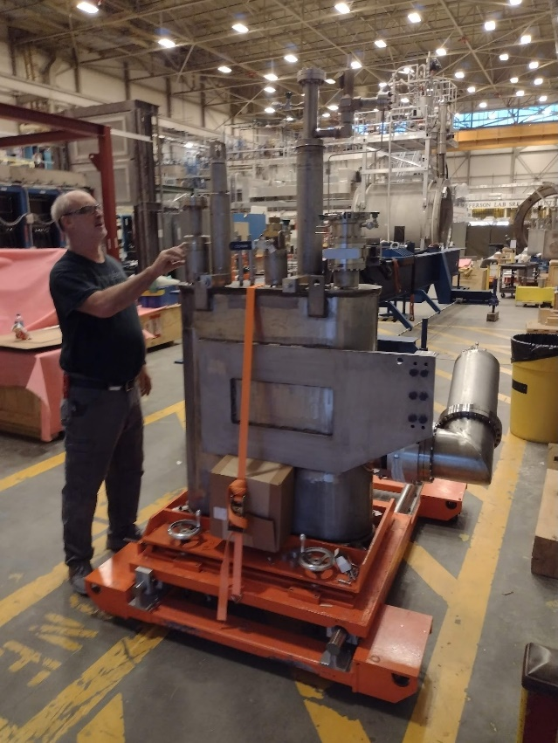

REC 03 uncrated and ready for receipt inspection.

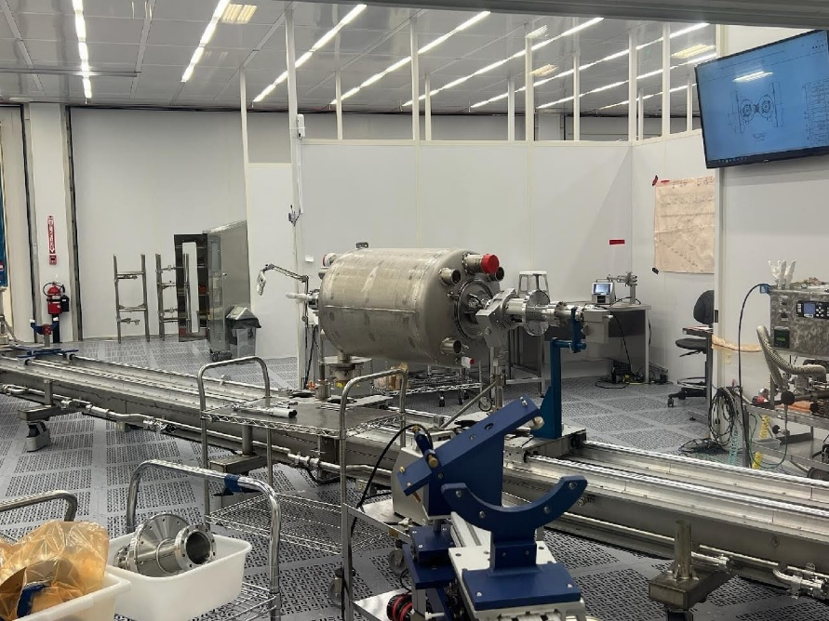

Cavity 26t, first for string #8, installed on rail tooling in cleanroom.