Weekly Reporting SNS PPU

WBS P.02.03 Cryomodule Integration (JLab Scope)

January 20, 2023

**Issues:** None

**Accomplishments this week:**

Management:

* PPU activities are continuing onsite with testing of production cavities, continuing with cryomodule assembly, and receipt inspection of components.
* Off-site work efforts continue, focused on completion of original procurement activities, continuing procurements for 8th CM and production activities.
* Visited End Can vendor and performed systematic review of their leak detection equipment, procedures and methods. Report will be available next week.
* Cryogenic test facility will be back on-line Monday 1/23 providing helium to CMTF and VTA.

Engineering & Design:

* Sustaining engineering activities are continuing in order to revise drawing packages based on feedback during the procurement phase.
* Plan for transmitting complete set of CM drawings – no progress since December.

Procurement:

* Next visit to end can vendor is set to be on 1/20. Purpose is to witness leak check and check overall progress on the remaining end cans.
* On the cool down valve galling, vendor found one such valves galls. The valve has been partially cut apart, it appears that the cause may simply be the tight fit between the stem and the guide. Vendor is going to repair the galling stem and make a new stem for the last REC.
* ORNL advises that REC3 vacuum shells weld is not fully penetrated. Vendor says that they perform TIG root pass, then add 3 or 5 layers of flux core passes.
* Supply End Cans (SECs):

|  |  |  |
| --- | --- | --- |
| S/N | Status | Estimated Delivery Date |
| 01 | Installed on CM-03 | - |
| 02 | Installed on CM-04 | - |
| 03 | Installed on CM-01 | - |
| 04 | Welded onto CM-05 | - |
| 05 | Welded onto CM-06 | - |
| 06 | Delivered to JLab on 6/6. Uncrated, inspections started. Phase 1 dimensional inspection done. Bridge tube angle is off by ~5 degrees. JLAB will try installation of SEC 06 and exercise loosening the hardware at both ends of the elbow/bellows and see how well it corrects. Plan to use on PPU-07. | - |
| 07 | Installed on CM-02 | - |
| 08 | Finished Top Plate welding. To be L/C’ed. Some spools will go through cold shock & LC. All sub-assemblies welding done. | Mar 20 |

* Return End Cans (RECs):

|  |  |  |
| --- | --- | --- |
| S/N | Status | Estimated Delivery Date |
| 01 | Installed on CM-03 |  |
| 02 | Installed on CM-01 |  |
| 03 | Installed on CM-05 |  |
| 04 | Installed on CM-02 |  |
| 05 | Vacuum shell purged; working on shell welding. All vertical up welds done. Laid on side to do horizontal welds. Hope to start bridging tube by Friday 1/20. | Feb 10 |
| 06 | Installed on CM-04. |  |
| 07 | Continuing on thermal shield installation, finishing up the first half. Hope to do MLI by Friday. | Feb 28 |
| 08 | REC 08 is at the vendor. Finished Rod Guide/Top Flange weldment. Working on relief stack components. JT valve next week. | Mar 20 |

Production:

* Cavity Status:
* HB-062 is in preparation for RF test after HPR. Cryogens will be available for testing on 1/23.
* Cavity String Status: String #8 – CM-8 string assembly rolled out on 1/18.
* Cryomodule Status:
* CM05: REC 03 welded to VV. Final alignment complete. Currently welding REC side process piping.
* CM06: Awaiting REC
* CM07: Space frame/thermal shield completed. Cold Mass being aligned in the Vacuum Vessel.
* CM08: Delivered to CMA 1/18. Cold Mass kit delivered.
* U-Tube status: Four bellows on hand; more on the way; first two being assembled.

Project Management:

* Updated CAM Notebook
* Completed BCR 23-002
* Submitted Monthly Director’s Review Information
* Provided December month end EV Reports
* Provided December EV Data to the project Team

Quality Assurance:

* Continue to monitor quality data for possible trends.
* Continuing to gather data deliverables for CM05.

Project Photos:

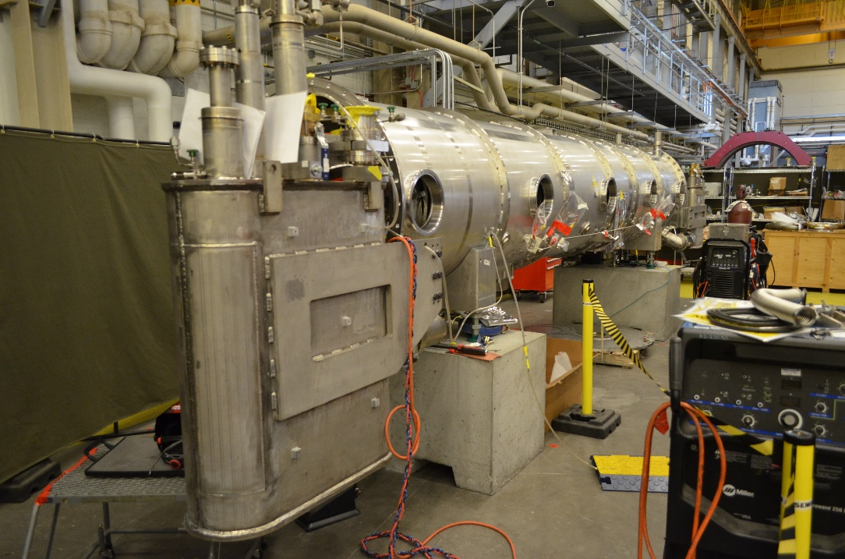

CM05

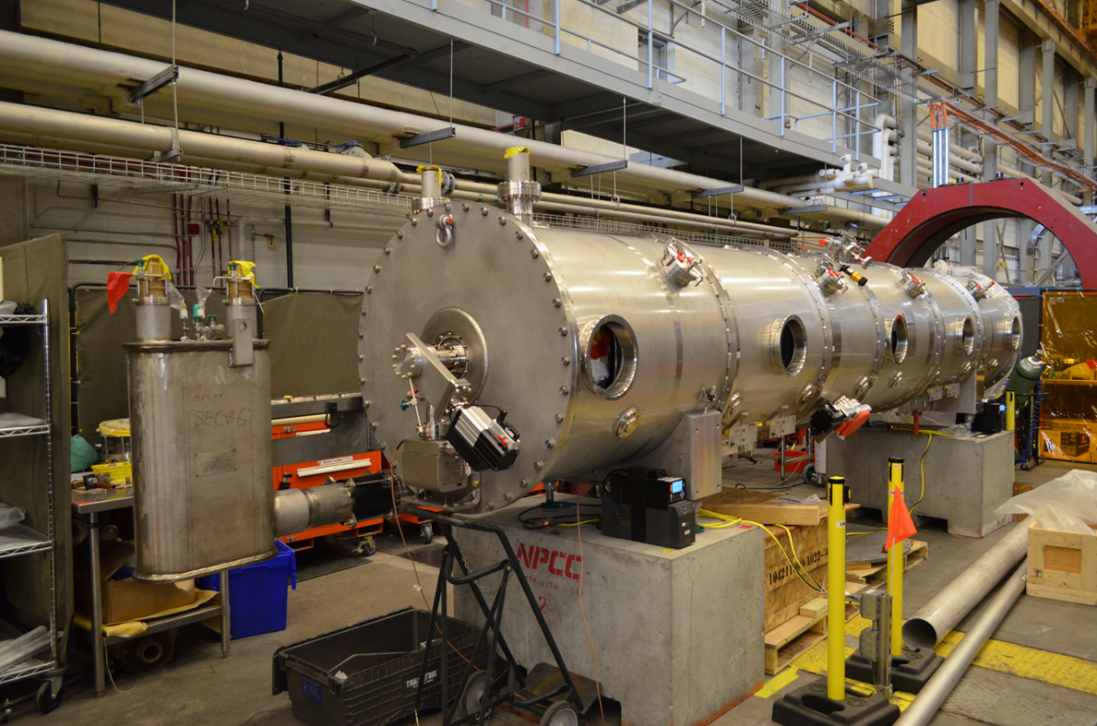

CM06

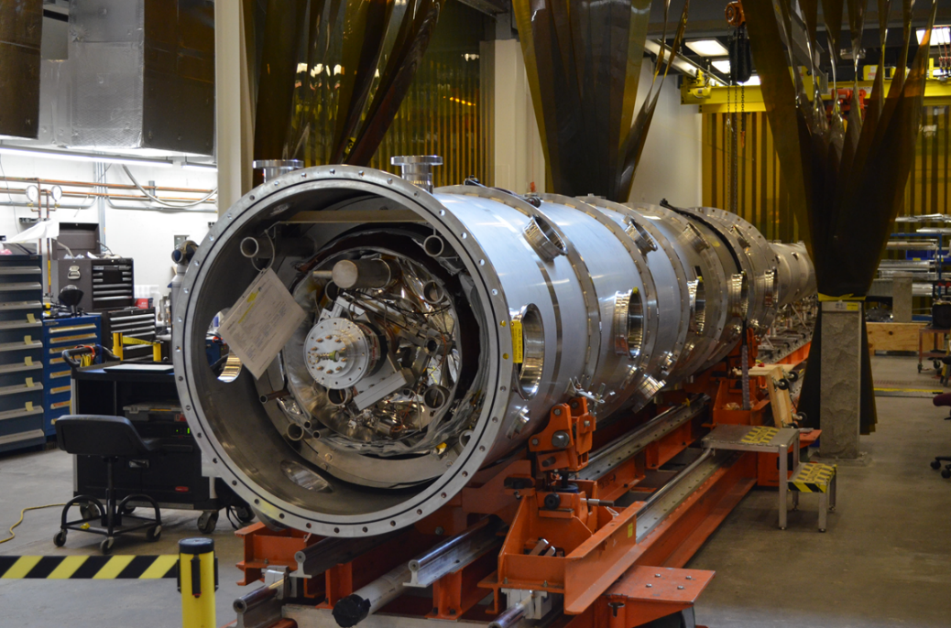

CM07

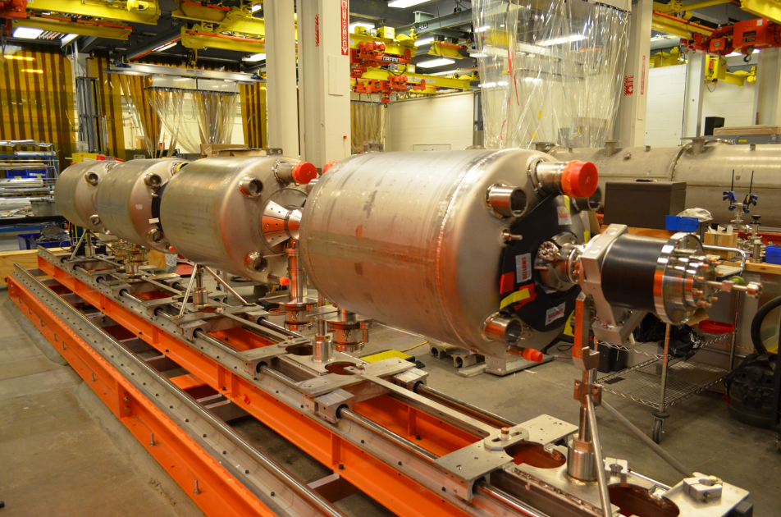

CM08

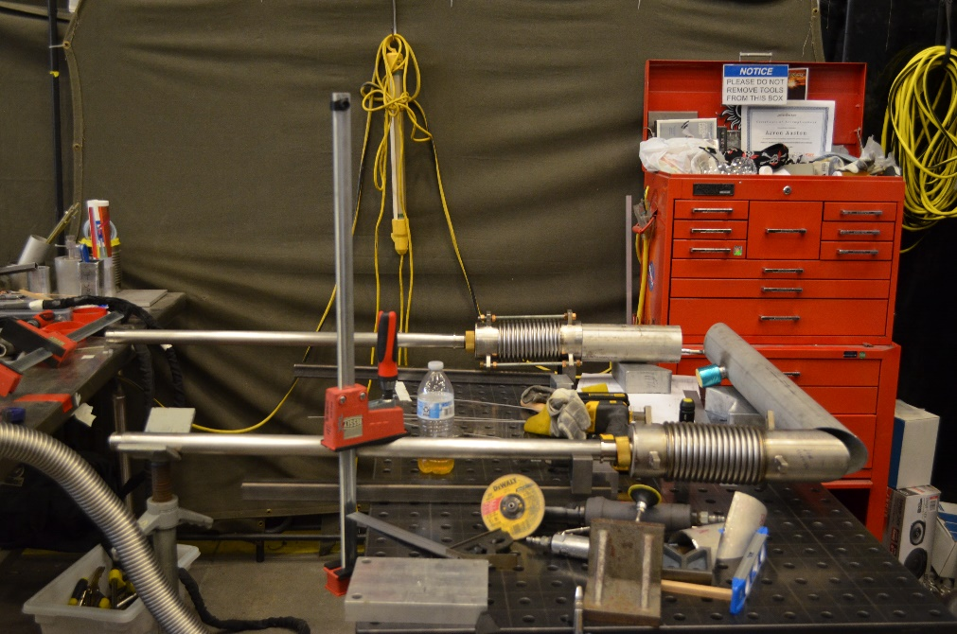

U-Tube assembly