Weekly Reporting SNS PPU

WBS P.02.03 Cryomodule Integration (JLab Scope)

February 3, 2023

**Issues:** None

**Accomplishments this week:**

Management:

* PPU activities are continuing onsite with testing of production cavities, continuing with cryomodule assembly, and receipt inspection of components.
* Off-site work efforts continue, focused on completion of original procurement activities, continuing procurements for 8th CM and production activities.

Engineering & Design:

* Sustaining engineering activities are continuing in order to revise drawing packages based on feedback during the procurement phase.
* Plan for transmitting complete set of CM drawings – Doc Control Group is preparing drawing package. Shared folder at ORNL is identified.

Procurement:

* On the cool down valve galling, vendor found one such valves galls. The valve has been partially cut apart, it appears that the cause may simply be the tight fit between the stem and the guide. Vendor is going to repair the galling stem and make a new stem for the last REC.
* ORNL advises that REC3 vacuum shells weld is not fully penetrated. Vendor says that they perform TIG root pass, then add 3 or 5 layers of flux core passes.
* Supply End Cans (SECs):

|  |  |  |
| --- | --- | --- |
| S/N | Status | Estimated Delivery Date |
| 01 | Installed on CM-03 | - |
| 02 | Installed on CM-04 | - |
| 03 | Installed on CM-01 | - |
| 04 | Welded onto CM-05 | - |
| 05 | Welded onto CM-06 | - |
| 06 | Delivered to JLab on 6/6. Uncrated, inspections started. Phase 1 dimensional inspection done. Bridge tube angle is off by ~5 degrees. JLAB will try installation of SEC 06 and exercise loosening the hardware at both ends of the elbow/bellows and see how well it corrects. Plan to use on PPU-07. | - |
| 07 | Installed on CM-02 | - |
| 08 | All parts and sub-assemblies done. Album 1 pictures uploaded to share folder. | Mar 20 |

* Return End Cans (RECs):

|  |  |  |
| --- | --- | --- |
| S/N | Status | Estimated Delivery Date |
| 01 | Installed on CM-03 |  |
| 02 | Installed on CM-01 |  |
| 03 | Installed on CM-05 |  |
| 04 | Installed on CM-02 |  |
| 05 | Vacuum shell body welds are complete, CWI inspection done. Begin to do fit up of bridging tube welds and the final structure welds. | Feb 15 |
| 06 | Installed on CM-04. |  |
| 07 | Vendor is working on positioning vacuum vessel and the fixtures for bridging tube fabrication. Cold mass/shield assembly complete, album 2 pictures uploaded to share folder. | Mar 3 |
| 08 | Top plate weldment complete. Finished the Relief Stack weldment. Working on sub-assemblies. | Mar 20 |

Production:

* Cryomodule Status:
* CM05: LC process piping complete; MLI/shields in REC I.P.
* CM06: Awaiting REC
* CM07: Alignment measurements taken; meeting scheduled to review data.
* CM08: Fit/weld 2K process piping.
* U-Tube status: Assy in progress; built to drawing; vendor parts needed work; 5 of 6 PTs.

Project Management:

* Provided Schedule Package to ORNL
* Updated CAM Notebook
* Held Progress Meeting
* Held Progress Analysis Meeting

Quality Assurance:

* Continue to monitor quality data for possible trends.
* Continuing to gather data deliverables for CM05.

Project Photos:

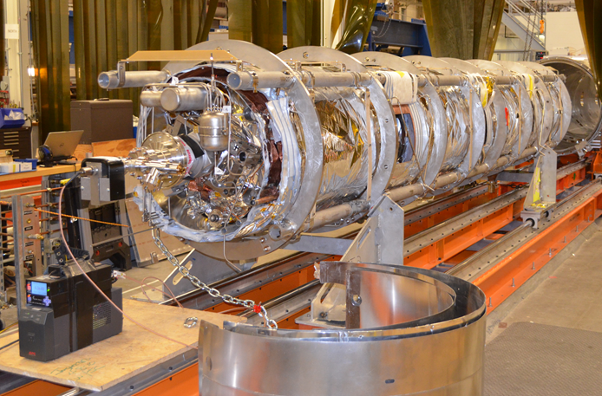

CM-07.

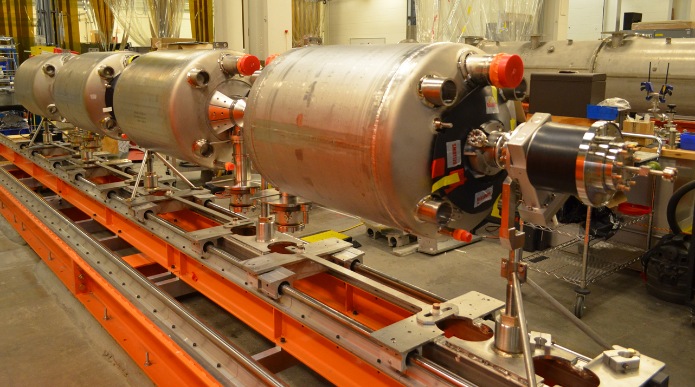

CM-08.