Weekly Reporting SNS PPU

WBS P.02.03 Cryomodule Integration (JLab Scope)

February 10, 2023

**Issues:** None

**Accomplishments this week:**

Management:

* PPU activities are continuing with cryomodule assembly and receipt inspection of components.
* Off-site work efforts continue in the procurement area on end cans.

Engineering & Design:

* Sustaining engineering activities are continuing in order to revise drawing packages based on feedback during the procurement phase.
* Plan for transmitting complete set of CM drawings – Doc Control Group is preparing drawing package. Shared folder at ORNL is identified. Discussing preferred CAD model formats with ORNL colleagues.

Procurement:

* On Feb 14, one JLab visitor will visit the end can vendor to witness REC 5 bridging tube leak test.
* Supply End Cans (SECs):

|  |  |  |
| --- | --- | --- |
| S/N | Status | Estimated Delivery Date |
| 01 | Installed on CM-03 | - |
| 02 | Installed on CM-04 | - |
| 03 | Installed on CM-01 | - |
| 04 | Welded onto CM-05 | - |
| 05 | Welded onto CM-06 | - |
| 06 | Delivered to JLab on 6/6. Uncrated, inspections started. Phase 1 dimensional inspection done. Bridge tube angle is off by ~5 degrees. JLAB will try installation of SEC 06 and exercise loosening the hardware at both ends of the elbow/bellows and see how well it corrects. Plan to use on PPU-07. | - |
| 07 | Installed on CM-02 | - |
| 08 | All parts and sub-assemblies done. Album 1 pictures uploaded to share folder. Estimate to ship 6 weeks after REC 7 is finished. | Apr 14 |

* Return End Cans (RECs):

|  |  |  |
| --- | --- | --- |
| S/N | Status | Estimated Delivery Date |
| 01 | Installed on CM-03 |  |
| 02 | Installed on CM-01 |  |
| 03 | Installed on CM-05 |  |
| 04 | Installed on CM-02 |  |
| 05 | Started welding of fit up bridging tube section. First two welds on bridging is complete | Mar 3 |
| 06 | Installed on CM-04. |  |
| 07 | Vacuum shell welding has begun. Completing the GTAW root passes. Expect to begin FCAW 2/9. | Mar 17 |
| 08 | Top plate weldment complete. Finished the Relief Stack weldment. Working on sub-assemblies. Bayonets done; most of the relief stack is done. Check valve is done; needs LC. Estimate to finish 8 weeks after REC 7 is done | Apr 28 |

Production:

* Cryomodule Status:
* CM05: MLI/shields in REC I.P.; flow hood, BL work
* CM06: Awaiting REC
* CM07: Wheels being machined; re-install next week.
* CM08: Process piping welding complete; cold shock I.P.
* U-Tube status: 4 U-tubes PT’d; 2 PT i.p.; started large u-tubes (CVI pump-out location discussed)

Project Management:

* Provided Monthly Accrual Data to ORNL
* Updated Month End EV Reports
* Updated Month End Manpower
* Updated CAM Notebook

Quality Assurance:

* Continue to monitor quality data for possible trends.
* Continuing to gather data deliverables for CM05.

Project Photos:

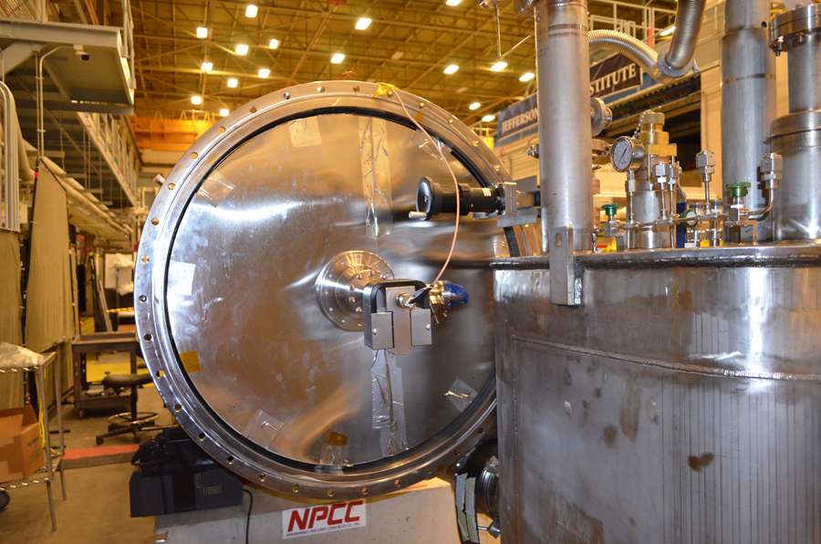

CM05

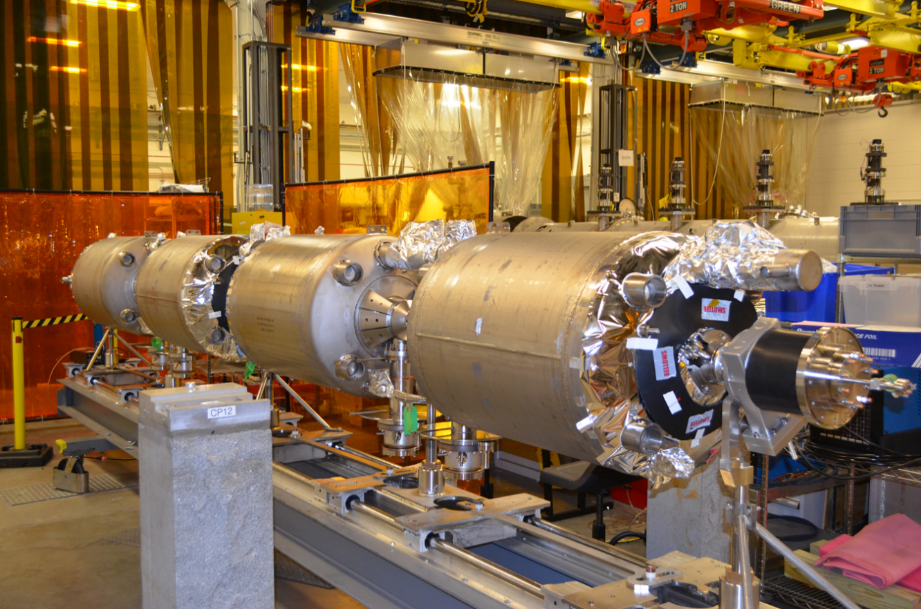

CM08