Weekly Reporting SNS PPU

WBS P.02.03 Cryomodule Integration (JLab Scope)

February 17, 2023

**Issues:** None

**Accomplishments this week:**

Management:

* PPU activities are continuing with cryomodule assembly and receipt inspection of components.
* Off-site work efforts continue in the procurement area on end cans.

Engineering & Design:

* Sustaining engineering activities are continuing in order to revise drawing packages based on feedback during the procurement phase.
* Plan for transmitting complete set of CM drawings – Doc Control Group is preparing drawing package. Shared folder at ORNL is identified. Files will be transferred as STEP for CAD models.

Procurement:

* On Feb 14, one JLab employee visited the end can vendor to witness a successful REC 5 bridging tube leak test.
* Supply End Cans (SECs):

|  |  |  |
| --- | --- | --- |
| S/N | Status | Estimated Delivery Date |
| 01 | Installed on CM-03 | - |
| 02 | Installed on CM-04 | - |
| 03 | Installed on CM-01 | - |
| 04 | Welded onto CM-05 | - |
| 05 | Welded onto CM-06 | - |
| 06 | Delivered to JLab on 6/6. Uncrated, inspections started. Phase 1 dimensional inspection done. Bridge tube angle is off by ~5 degrees. JLAB will try installation of SEC 06 and exercise loosening the hardware at both ends of the elbow/bellows and see how well it corrects. Plan to use on PPU-07. | - |
| 07 | Installed on CM-02 | - |
| 08 | All parts and sub-assemblies done. Album 1 pictures uploaded to share folder. Still in early fit -up, top plate complete, spools still coming together. Estimate to ship 6 weeks after REC 7 is finished. | Apr 14 |

* Return End Cans (RECs):

|  |  |  |
| --- | --- | --- |
| S/N | Status | Estimated Delivery Date |
| 01 | Installed on CM-03 |  |
| 02 | Installed on CM-01 |  |
| 03 | Installed on CM-05 |  |
| 04 | Installed on CM-02 |  |
| 05 | Started welding of fit up bridging tube section. First two welds on bridging is complete. Worked on fit up of bridging tube copper shield and external clam shell. MLI going on the elbow section now, followed by thermal shield, bridging tube shell, and finally test cap install. | Mar 3 |
| 06 | Installed on CM-04. |  |
| 07 | Is progressing well with the vacuum shell being welded up by a welder, who has been focusing strictly on REC-07 to get it caught up. Vacuum shell welding possibly complete by end of this week, then on to the bridging tube. | Mar 17 |
| 08 | Top plate weldment complete. Finished the Relief Stack weldment. Spools are coming together, MTM is rebuilding a part that was machined incorrectly (Part of the return bayonet), and moving the sub-assemblies through cold-shock/leak test as they are able. Worked on sub-assembly in process leak testing and cleaning. | Apr 28 |

Production:

* Cryomodule Status:
* CM05: REC end plate installed; insulating vacuum pumping; flow hood in place for soft shut installation; moving to CMTF next week.
* CM06: Awaiting REC
* CM07: Second install of cold mass too high; adjusting wheels; install this week.
* CM08: Process piping welding complete; cold shock complete; needs Ion pump replaced.
* U-Tube status: 6 U-tubes complete; 2 U-tubes I.P. (3-1/8”); welding complete next week; pressure testing the following week.

Project Management:

* Provided Monthly Director’s Review Data
* Provided info for Data Call
* Provided Project Team with EV Data
* Updated CAM Notebook

Quality Assurance:

* Continue to monitor quality data for possible trends.
* Continuing to gather data deliverables for CM05.

Project Photos:

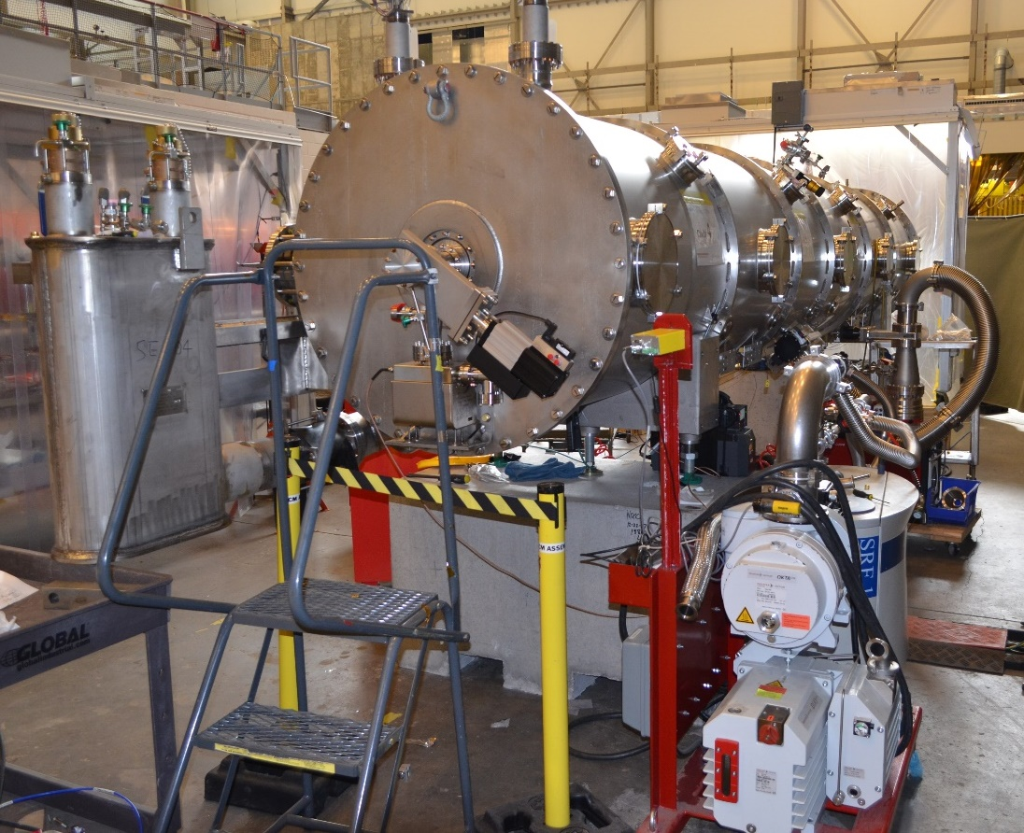

CM05

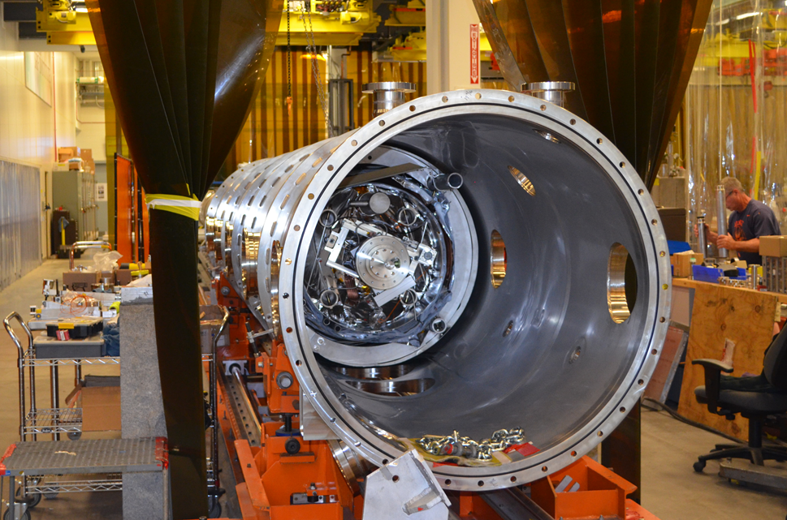

CM07

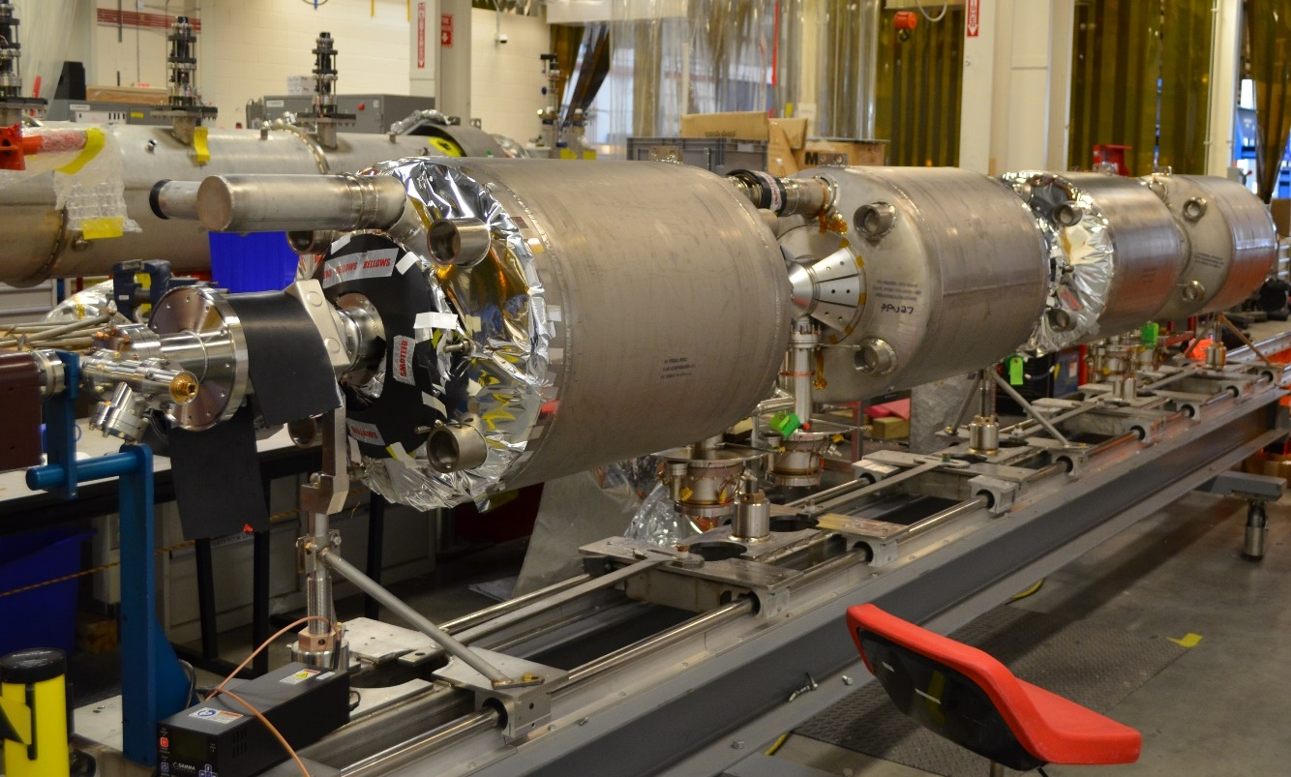

CM08

|  |  |
| --- | --- |
|  |  |

U-tubes