Weekly Reporting SNS PPU

WBS P.02.03 Cryomodule Integration (JLab Scope)

February 24, 2023

**Issues:** None

**Accomplishments this week:**

Management:

* PPU activities are continuing with cryomodule assembly and receipt inspection of components.
* Off-site work efforts continue in the procurement area on end cans.

Engineering & Design:

* Sustaining engineering activities are continuing in order to revise drawing packages based on feedback during the procurement phase.
* Plan for transmitting complete set of CM drawings – Doc Control Group is preparing drawing package. Shared folder at ORNL is identified. Location for STEP file CAD models is identified.

Procurement:

* On Feb 14, one JLab employee visited the end can vendor to witness a successful REC 5 bridging tube leak test.
* Supply End Cans (SECs):

|  |  |  |
| --- | --- | --- |
| S/N | Status | Estimated Delivery Date |
| 01 | Installed on CM-03 | - |
| 02 | Installed on CM-04 | - |
| 03 | Installed on CM-01 | - |
| 04 | Welded onto CM-05 | - |
| 05 | Welded onto CM-06 | - |
| 06 | Delivered to JLab on 6/6. Uncrated, inspections started. Phase 1 dimensional inspection done. Bridge tube angle is off by ~5 degrees. JLAB will try installation of SEC 06 and exercise loosening the hardware at both ends of the elbow/bellows and see how well it corrects. Plan to use on PPU-07. | - |
| 07 | Installed on CM-02 | - |
| 08 | All parts and sub-assemblies done. Album 1 pictures uploaded to share folder. Pulled components and is getting started setting up the final assembly. | Apr 14 |

* Return End Cans (RECs):

|  |  |  |
| --- | --- | --- |
| S/N | Status | Estimated Delivery Date |
| 01 | Installed on CM-03 |  |
| 02 | Installed on CM-01 |  |
| 03 | Installed on CM-05 |  |
| 04 | Installed on CM-02 |  |
| 05 | Started welding of fit up bridging tube section. First two welds on bridging is complete. Finished the entire fit up process of the bridging tube, took apart. Bridging tube's copper shield finished. Worked on exterior tube miter joint. | Mar 3 |
| 06 | Installed on CM-04. |  |
| 07 | Is progressing well with the vacuum shell being welded up by a welder. The welder just worked on GTAW touch ups of the outer welds. | Mar 17 |
| 08 | Top plate weldment complete. Finished the Relief Stack weldment. Spools are coming together, MTM is rebuilding a part that was machined incorrectly (Part of the return bayonet), and moving the sub-assemblies through cold-shock/leak test as they are able. Worked on sub-assembly in process leak testing and cleaning. | Apr 28 |

Production:

* Cryomodule Status:
* CM05: Aligned in CMTF. Cryoplant issue postponed cool down until next week.
* CM06: Awaiting REC
* CM07: Third install of cold mass; alignment outside spec.
* CM08: Process piping leak check complete; setup for ion pump work; MLI and tuners I.P.
* U-Tube status: crated and ready to go.

Project Management:

* Distributed Progress Sheets
* Updated Manpower Charts for February Mid-month
* Updated CAM Notebook

Quality Assurance:

* Continue to monitor quality data for possible trends.
* Continuing to gather data deliverables for CM05.

Project Photos:

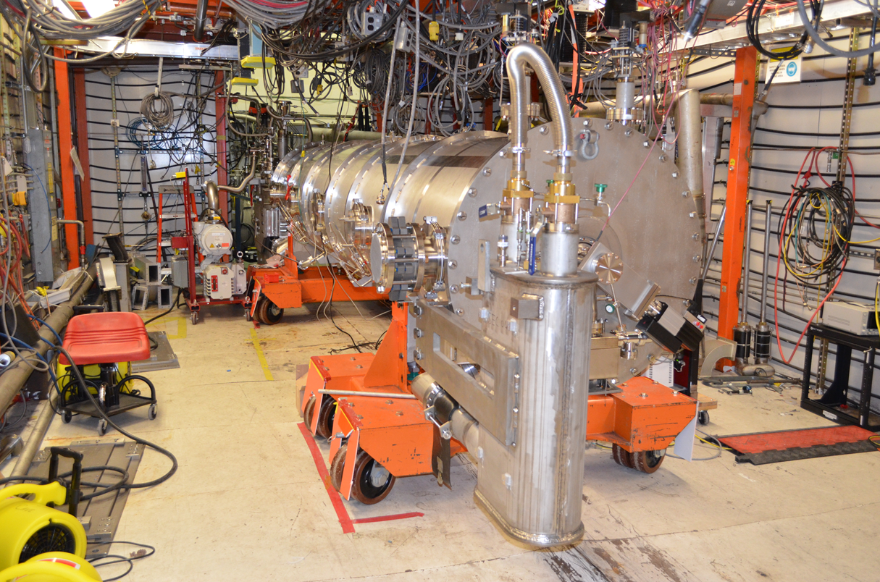

CM05 in CMTF.

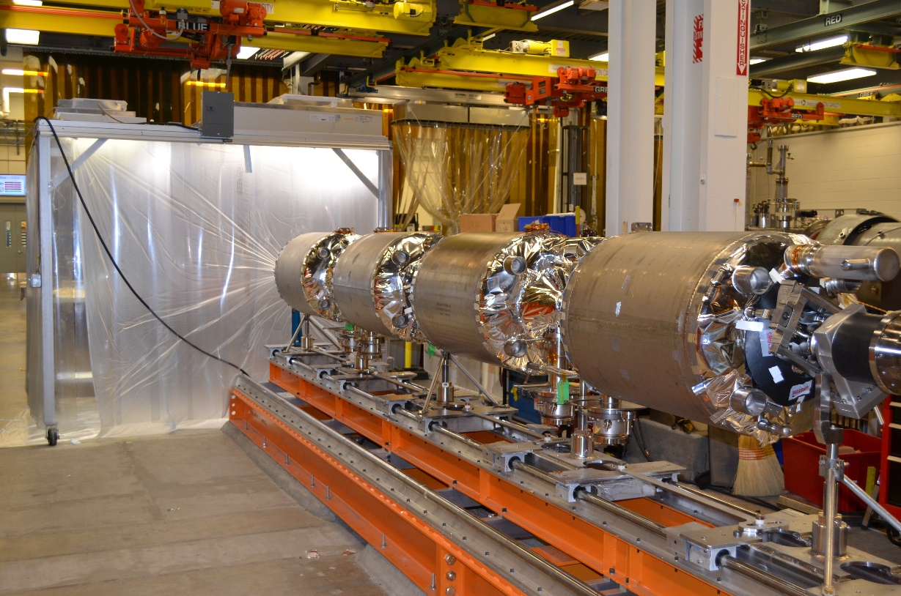

CM08

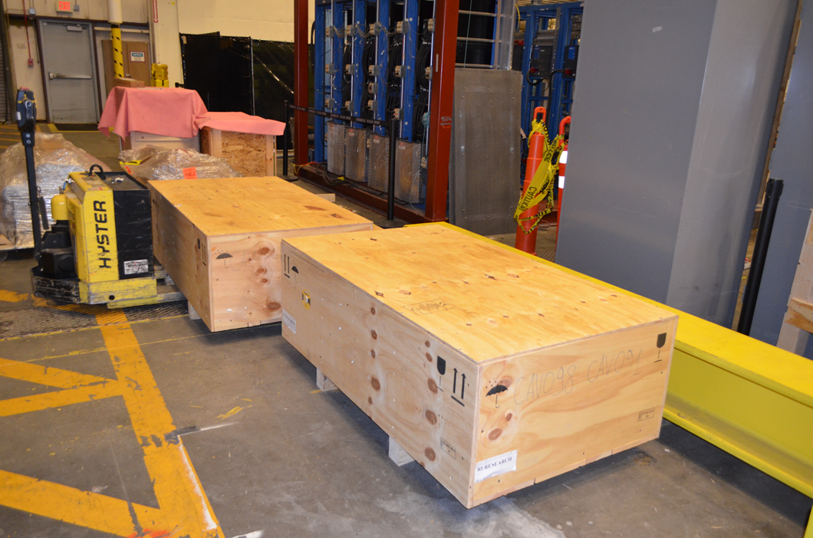

U-tubes crated and ready to go.